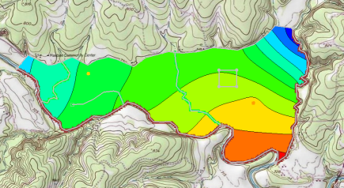

GMS 10.9

GMS 10.9 Tutorial

***MODFLOW – Conceptual Model Approach 4***

Build a multi-layer MODFLOW model using conceptual model techniques

Objectives

The conceptual model approach involves using the GIS tools in the Map module to develop a conceptual model of the site being modeled. The location of sources/sinks, layer parameters such as hydraulic conductivity, model boundaries, and all other data necessary for the simulation can be defined at the conceptual model level without a grid.

Time

* 15–25 minutes

Required Components

* GMS Core
* Geostatistics
* MODFLOW Interface

Prerequisite Tutorials

* MODFLOW – Conceptual Model Approach 1
* MODFLOW – Conceptual Model Approach 3

|  |
| --- |
| 1 Introduction 2  1.1 Getting Started 3  2 Importing the Project 4  3 Saving the Project 4  4 Redefining the Recharge 4  4.1 Creating the Landfill Boundary Polygon 5  4.2 Assigning the Recharge Values 6  5 Redefining the Hydraulic Conductivity 6  5.1 Turning on Vertical Anisotropy 6  5.2 Specifying the Horizontal K 6  6 Modifying the Wells and Drains Coverages 7  6.1 Turn on MNW2 7  6.2 Modifying the Existing Well 7  6.3 Assigning the Drain Elevation 8  7 Converting the Conceptual Model 8  8 Checking and Saving the Simulation 8  9 Running MODFLOW 9  10 Viewing the Flow Budget 9  11 Conclusion 10 |

# Introduction

This tutorial builds on the “MODFLOW – Conceptual Model Approach 3” tutorial. In that tutorial, a one-layer grid was expanded to include multiple layers, and elevations were interpolated to the grid layers.

This tutorial starts with the same model and makes it more complex and realistic. One of the wells will be switched to use the MNW2 package with a well screen that partially penetrates both layers. An imported shapefile will be used to define multiple recharge polygons to simulate a landfill.

The problem being solved in this tutorial is a site in East Texas as illustrated in Figure 1. This tutorial evaluates the suitability of a proposed landfill site with respect to potential groundwater contamination. The results of this simulation are used as the flow field for a particle tracking and a transport simulation in the MODPATH and MT3DMS tutorials.

The tutorial models the groundwater flow in the valley sediments bounded by the hills to the north and the two converging rivers to the south. A typical north-south cross section through the site is shown in Figure 1b. The site is underlain by limestone bedrock which outcrops to the hills at the north end of the site. There are two primary sediment layers: an upper layer modeled as unconfined and a lower layer modeled as confined.

The boundary to the north is a no-flow boundary, and the remaining boundary is a specified head boundary corresponding to the average stage of the rivers. The influx into the system is primarily through recharge due to rainfall. Creek beds in the area are sometimes dry, but occasionally flow due to influx from the groundwater. The tutorial represents these creek beds using drains. Two production wells in the area are included in the model.

Although the site modeled in this tutorial is an actual site, the landfill and the hydrogeological conditions at the site have been fabricated. The stresses and boundary conditions used in the simulation were selected to provide a simple—yet broad—sampling of the options available for defining a conceptual model.



Figure 1 Site to be modeled in this tutorial: (a) plan view of site and (b) Typical north-south cross section through site

This tutorial discusses and demonstrates:

* Defining a recharge polygon by importing a shapefile and converting it to feature objects
* Defining well screens in the conceptual model
* Assigning drain elevations using a raster
* Mapping the conceptual model to MODFLOW
* Checking the simulation and running MODFLOW
* Viewing the results

## Getting Started

Do the following to get started:

1. If necessary, launch GMS.
2. If GMS is already running, select *File |* **New** to ensure that the program settings are restored to their default state.

# Importing the Project

The first step is to import the East Texas project. This will read in the MODFLOW model, the solution, and all other files associated with the model.

To import the project, do as follows:

1. Click **Open** File:Open Macro.svg to bring up the *Open* dialog.
2. Select “Project Files (*.gpr)” from the *Files of type* drop-down.
3. Browse to the *modfmap4\modfmap4* directory and select “start.gpr”.
4. Click **Open** to import the project and close the *Open* dialog.

The Graphics Window will appear as in Figure 2.

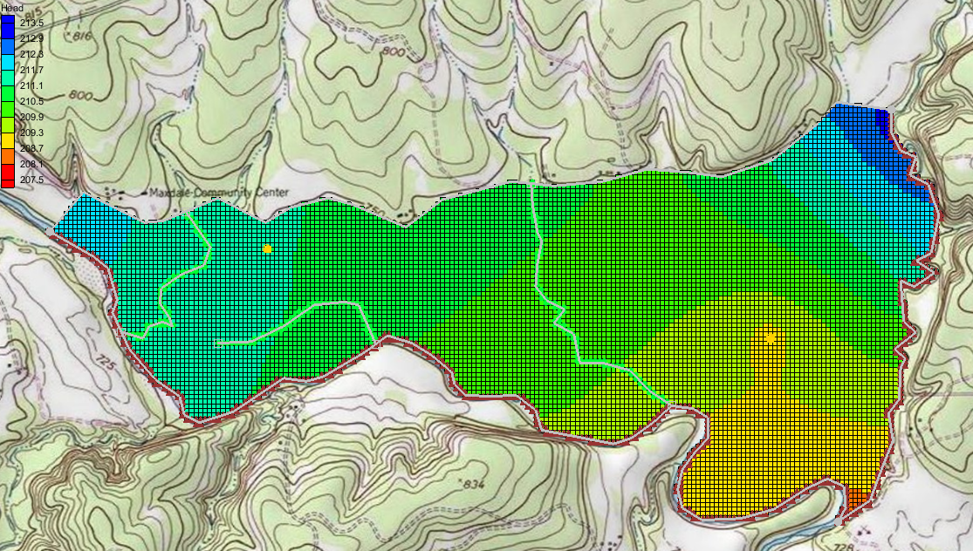

Figure 2 After importing the project

# Saving the Project

Before making any changes, save the project under a new name.

1. Select *File* | **Save As…** to bring up the *Save As* dialog.
2. Select “Project Files (*.gpr)” from the *Save as type* drop-down.
3. Enter “EastTexas4.gpr” as the *File name*.
4. Click **Save** to save the file under the new name and close the *Save As* dialog.

Be sure to **Save** File:Save Macro.svg periodically throughout the tutorial.

# Redefining the Recharge

Assume the recharge over the area being modeled is uniform except for at the landfill. The recharge in the area of the landfill will be reduced due to the landfill liner system.

## Creating the Landfill Boundary Polygon

The first step is to create the arc delineating the boundary of the landfill. For this tutorial, import the boundary from an existing landfill shapefile.

1. Select the “File:GIS Folder.svg GIS Layers” folder in the Project Explorer to make it active.
2. Select *GIS |* **Add Shapefile Data…** to bring up the *Select shapefile* dialog.
3. Select “Shapefile (*.shp)” from the *Files of type* drop-down.
4. Select “landfill_arcs.shp” and click **Open** to import the shapefile and close the *Select shapefile* dialog*.*

Now that the shapefile is imported, convert it into feature objects in the “File:Coverage Active Icon.svg Recharge” coverage.

1. Expand the “File:Map Folder.svg Map Data” folder, including the “File:Conceptual Model Icon.svg East Texas” conceptual model within it.
2. Select the “File:Coverage Active Icon.svg Recharge” coverage to make it active.
3. Select “File:GIS Stream Data Shapefile.svg landfill_arcs.shp”under “File:GIS Folder.svg GIS Layers” in the Project Explorer.
4. Select *GIS |* **Shapes → Feature Objects**. The *Step 1 of 3* page of the *GIS to Feature Objects Wizard* dialog will appear.
5. Click **Next >**to go to the *Step 2 of 3* page of the *GIS to Feature Objects Wizard* dialog.
6. Under the *Mapping preview* section, select “Elevation” from the drop-down on the *Mapping* row and in the *ARC_ELEV* column.
7. Click **Next >**to go to the *Step 3 of 3* page of the *GIS to Feature Objects Wizard* dialog.
8. Click **Finish**to close the *GIS to Feature Objects Wizard* dialog.

The landfill is now created and visible in the Graphics Window (Figure 3). With the landfill boundary defined, it is necessary to rebuild the polygons.

1. Click the **Build Polygons** File:Build Polygons Macro.svgmacro.

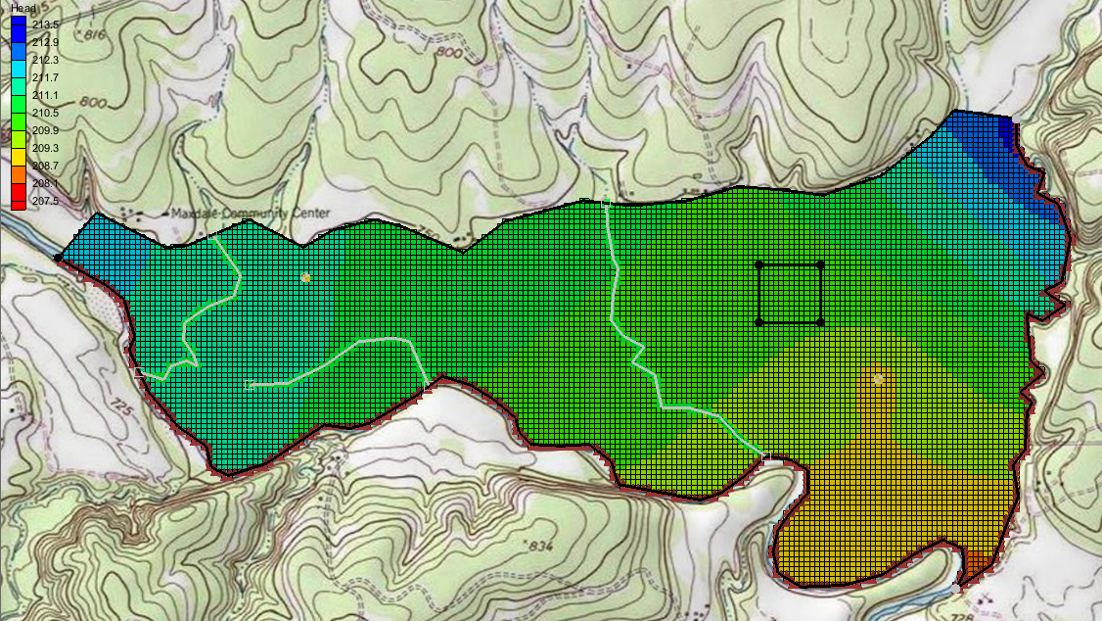

Figure 3 The landfill is outlined as a black square

## Assigning the Recharge Values

Now that the recharge zones are redefined, it is possible to assign the recharge values for the landfill polygon.

1. Select the “File:Coverage Active Icon.svg Recharge” coverage to make it active.
2. Using the **Select Polygons** File:GMS Select Polygon Tool.svg tool, double-click on the landfill polygon to bring up the *Attribute Table* dialog.
3. Enter “0.00006” as the *Recharge rate (m/d)*.

***Note:*** This recharge rate is small relative to the rate assigned to the other polygons. The landfill will be capped and lined and thus will have a small recharge value. The recharge essentially represents a small amount of leachate that escapes from the landfill.

1. Click **OK** to close the *Attribute Table* dialog.

# Redefining the Hydraulic Conductivity

As in the “MODFLOW – Conceptual Model Approach 3” tutorial, a two-layer model will be used here. Thus, it is necessary to define the hydraulic conductivity for the second layer and the vertical anisotropy for both layers. Constant values will be used for the second layer.

## Turning on Vertical Anisotropy

1. Right-click on the “File:Coverage Active Icon.svg Aquifer Layer 1”coverage and select **Coverage Setup…** to bring up the *Coverage Setup* dialog.
2. In the *Areal Properties\** column, turn on *Vertical anis*.
3. Click **OK** to close the *Coverage Setup* dialog.
4. Select “File:Coverage Active Icon.svg Aquifer Layer 1” to make it active.
5. Double-click on the polygon to bring up the *Attribute Table* dialog.
6. Enter “4.0” in the *Vertical anis.* column.

This makes the vertical hydraulic conductivity one fourth of the horizontal conductivity.

1. Click **OK** to close the *Attribute Table* dialog.

## Specifying the Horizontal K

For the new layer, do the following:

1. Select “File:Coverage Active Icon.svg Aquifer Layer 2” in the Project Explorer to make it active.
2. Using the **Select Polygons** File:GMS Select Polygon Tool.svg tool, double-click on the polygon to bring up the *Attribute Table* dialog.
3. Enter “10.0” for the *Horizonal K (m/d)*.
4. Click **OK** to close the *Attribute Table* dialog.

# Modifying the Wells and Drains Coverages

Since our model has two layers, it is necessary to specify in which grid layer the wells should be placed when mapping the conceptual model to the grid. There are three ways to do this.

The simplest way is to specify the grid layer in the conceptual model, but that requires knowing how many grid layers will be in the project and where they will be when building the conceptual model. The conceptual model would also need to be changed if grid layers were later added or subtracted.

The second way is to use a well screen with the WEL package. This allows for specifying the top and bottom of the screened interval of the well. When the conceptual model is mapped to the grid, the well will be placed automatically in the appropriate grid layer (or layers) based on which grid layers intersect the well screen. If multiple grid layers are intersected by the well screen, multiple wells will be created.

The third way is to use the MNW2 package and define the screened interval. The MNW2 package is a more realistic well package that better models partially penetrating wells and wells that have more than one screened interval and/or draw from multiple grid layers. This tutorial will use this option.

The conceptual model will be modified so it uses real terrain data for elevations. The terrain elevations will come from a raster. The raster will also be used to define the drain elevations. When the drain arcs are discretized onto the model grid, the cells that intersect the arcs will be found. Then the drain elevation is interpolated from the raster to the cell centers.

This method is particularly helpful with large models where the elevation for each drain at the arc nodes would otherwise have to be manually determined and entered.

## Turn on MNW2

It is necessary to make the MNW2 properties available in the coverage.

1. Right-click the “File:Coverage Active Icon.svg Wells” coverage in the Project Explorer and select **Coverage Setup…** to bring up the *Coverage Setup* dialog.
2. In the *Sources/Sinks/BCs* column, turn on *Wells (MNW2)*.
3. Click **OK** to close the *Coverage Setup* dialog.

## Modifying the Existing Well

Now edit the eastern well.

1. Select the “File:Coverage Active Icon.svg Wells” coverage in the Project Explorer to make it active.
2. Using the **Select Points\Nodes** File:GMS Select Node Tool.svg tool, select the well on the eastern (right) side of the model.
3. Click the **Properties** File:GMS Properties Macro.svg macro to bring up the *Attribute Table* dialog.
4. In the table, select “well (MNW2)” from the drop-down in the *Type* column.
5. Scroll to the right and enter “-300.0” in the *Qdes (m^3/d)* field.
6. Select “THIEM” from the drop-down in the *LOSSTYPE* column.
7. Check the box in the *Vertical Boreline* column.
8. Click on the http://www.xmswiki.com/w/images/f/fc/Dot_dot_dot_button.pngbutton in the *Boreline* column to bring up the *Table* dialog.
9. In the row marked with a star *, enter “180.0” in the *Z screen begin (m)* column and “165.0” in the *Z screen end (m)* column*.*

These values make the well screen go through both layers 1 and 2.

1. In the row *1*, enter “0.05” in the *Rw* column.
2. Click**OK**to exit the *Table* dialog.
3. Click **OK** to exit the *Attribute Table* dialog.

## Assigning the Drain Elevation

It is now possible to assign drain elevation using this data.

1. Select “File:Coverage Active Icon.svg Drains” in the Project Explorer to make it active.
2. Click on the **Select Points/Nodes** File:GMS Select Node Tool.svg tool, then select *Edit |* **Select All**.
3. Click the **Properties** File:GMS Properties Macro.svg macro to bring up the *Attribute Table* dialog.
4. At the top right, select “drain” from the *BC type* drop-down.
5. In the *All* row, select “<Raster>” from the *Bot. elev. (m)* https://www.xmswiki.com/images/e/e4/Small_drop-down_arrow_button_from_Parameters_dialog.png drop-down to bring up the *Select Raster* dialog.
6. Select “elev_10.tif” and click **OK** to close the *Select Raster* dialog.
7. Click **OK** to exit the *Attribute Table* dialog.

# Converting the Conceptual Model

It is now possible to convert the conceptual model from the feature object-based definition to a grid-based MODFLOW numerical model.

1. Right-click on the “File:Conceptual Model Icon.svg East Texas” conceptual model and select *Map To |* **MODFLOW/MODPATH** to bring up the *Map → Model* dialog.
2. Select *All applicable coverages* and click **OK** to close the *Map → Model* dialog.

The cells underlying the drains, wells, and general head boundaries were all identified and assigned the appropriate sources/sinks. The heads and elevations of the cells were determined by linearly interpolating along the general head and drain arcs. The conductances of the drain cells were determined by computing the length of the drain arc overlapped by each cell and multiplying that length by the conductance value assigned to the arc. In addition, the recharge and hydraulic conductivity values were assigned to the appropriate cells.

# Checking and Saving the Simulation

At this point, the MODFLOW data has been completely defined, and it is possible to run the simulation. First, run the *Model Checker* again to see if GMS can identify any mistakes that may have been made.

1. Select the “File:3D Grid Folder.svg 3D Grid Data” folder in the Project Explorer to switch to the 3D Grid module.
2. Select *MODFLOW* | **Check Simulation…** to bring up the *Model Checker* dialog.
3. Click **Run Check**. There should be no errors.
4. Click **Done** to exit the *Model Checker* dialog.
5. Click **Save** File:Save Macro.svg.

Saving the project not only saves the MODFLOW files but also saves all data associated with the project, including the feature objects and scatter points.

# Running MODFLOW

It is now possible to run MODFLOW.

1. Select *MODFLOW |* **Run MODFLOW** to bring up the *MODFLOW* model wrapper dialog. The process should be completed quickly.
2. When the solution is completed, turn on *Read solution on exit* and *Turn on contours (if not on already)* and click **Close** to exit the *MODFLOW* model wrapper dialog.

The Graphics Window should appear similar to Figure 4. To view the contours for the second layer, do as follows:

1. Click the up arrow up in the *Ortho Grid* *Toolbar*.
2. After viewing the contours, return to the top layer by clicking the down arrow.

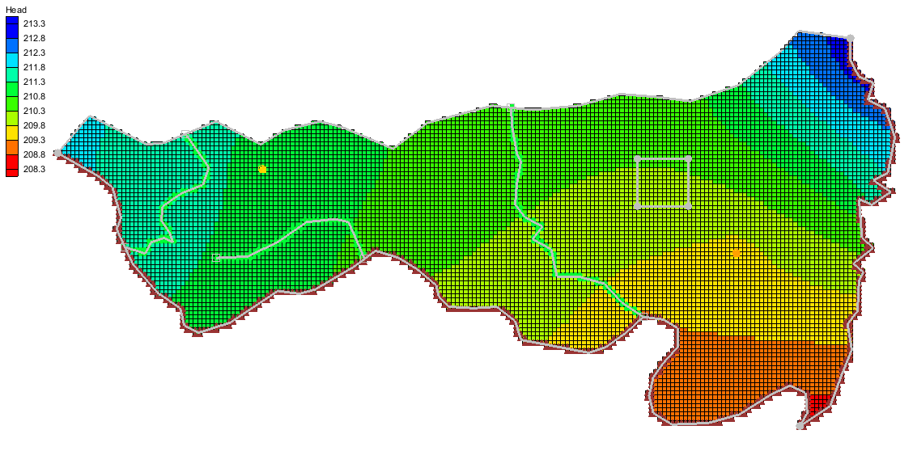

Figure 4 Contours of layer 1 after the model run

# Viewing the Flow Budget

The MODFLOW solution consists of both a head file and a cell-by-cell flow (CCF) file. GMS can use the CCF file to display flow budget values. For example, to know if any water exited from the drains, do the following:

1. Select “File:Coverage Active Icon.svg Drains” to make it active.
2. Using the **Select Arcs** File:GMS Select Arc Tool.svg tool, select on the rightmost drain arc.

Notice that the total flow through the arc is displayed in the strip at the bottom of the window. Next, view the flow to the river.

1. Select “File:Coverage Active Icon.svg Rivers” to make it active.
2. Using the **Select Arcs** File:GMS Select Arc Tool.svg tool, select the head arc at the bottom and view the flow.
3. Using the **Select Arcs** File:GMS Select Arc Tool.svg tool while holding down the *Shift* key, select the other general head arcs.

Notice that the total flow shown is for all selected arcs. Flow for a set of selected cells can be displayed as follows:

1. Select the “File:3D Grid Folder.svg 3D Grid Data” folder in the Project Explorer to switch to the 3D Grid module.
2. Using the **Select Cell** File:Select 3D Cell Tool.svg tool, select a group of cells by dragging a box around the cells.
3. Select *MODFLOW* | **Flow Budget…** to bring up the *Flow Budget* dialog.

This dialog shows a comprehensive flow budget for the selected cells.

1. Click **OK** to exit the *Flow Budget* dialog.
2. Click anywhere outside the model to unselect the cells.

# Conclusion

This concludes the “MODFLOW – Conceptual Model Approach 4” tutorial. The following topics were discussed and demonstrated:

* It is possible to import shapefiles and convert them to feature objects for use in the conceptual model.
* Well screens can be used to automatically locate the correct 3D grid layer in which the wells are located.
* The MNW2 package more accurately models wells that are screened across multiple layers.
* Elevations for boundary conditions, such as drains, can be specified using a raster.