Required Components

* GMS Core
* MODFLOW Interface

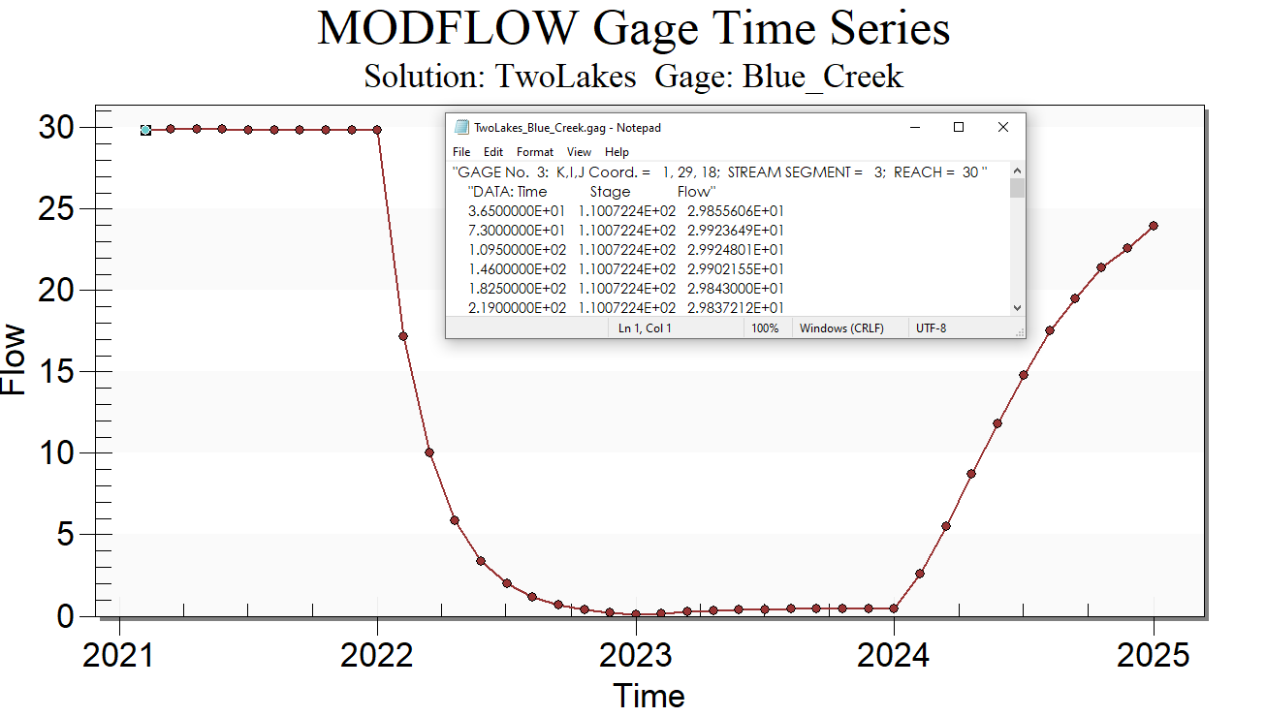

GMS 10.9

GMS 10.9 Tutorial

***MODFLOW – GAGE Package***

The MODFLOW GAGE Package Interface in GMS

Objectives

This tutorial explains how to use the MODFLOW GAGE package interface in GMS.

Time

* 20–30 minutes

Prerequisite Tutorials

* MODFLOW – Grid Approach
* MODFLOW – Conceptual Model Approach I

|  |
| --- |
| 1 Introduction 2  2 Getting Started 3  2.1 Importing the Project 3  2.2 Saving the Model with a New Name 4  3 Adding the Gages 4  3.1 The Lake Package Dialog 4  3.2 The SFR Package Dialog 5  3.3 Enabling the GAGE Package 5  3.4 Adding Gages 5  4 Running MODFLOW 6  5 Examining the Solution 6  5.1 The Head Solution 6  5.2 Gage Output Files 7  5.3 Creating a Gage Plot 7  6 Conclusion 8 |

# Introduction

The Gage package (GAGE) was developed by the United States Geological Survey (USGS) to allow output of detailed time series data for a given lake ID or SFR stream reach.

GAGE provides an extensive list of options for lake time series output including stage, volume, inflows, outflows, lake conductance, UZF interaction, etc.

For an SFR reach associated with a model cell, some of the options include stage, flow, depth, width, diversion specific output, and unsaturated flow routing.

The conceptual model for this tutorial is shown in Figure 1. The model consists of two lakes—Clear Lake and Blue Lake—connected by a stream. The stream flows from Clear Lake and feeds Blue Lake. Additionally, Blue Lake is fed by a second stream. A third stream also flows from Blue Lake into a larger body of water.

The model is transient, with stress periods set to cover a four-year period, and head values for the model set at steady-state initially. The first and fourth years have normal precipitation, while the second and third years are below normal.

This tutorial will discuss and demonstrate:

* Adding gage stations to an existing MODFLOW simulation of the lakes and the streams.
* Analyzing the gage file output to see how the change in precipitation affects the lakes and streams.
* Generating a gage plot.

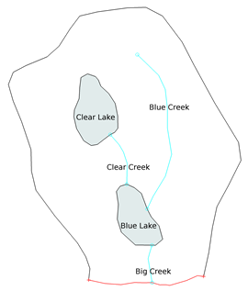

Figure 1 Conceptual model

# Getting Started

Do the following to get started:

If necessary, launch GMS.

If GMS is already running, select the *File |* **New** menu item to ensure that the program settings are restored to their default state. Click **Don’t Save** if asked to save changes.

## Importing the Project

First, import the project:

1. Click the **Open** File:Open Macro.svg macro to bring up the *Open* dialog.
2. From the *Files of type* drop-down, select “Project Files (*.gpr)”.

Browse to the *gage\gage* folder and select “start.gpr”.

Click the **Open** button to import the project and exit the *Open* dialog.

A MODFLOW model should appear in the Graphics Window (Figure 2).

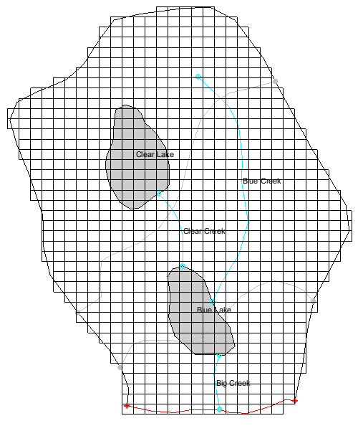

Figure 2 Layer 2 of the MODFLOW model showing elevation contours

## Saving the Model with a New Name

Before making changes, save the model with a new name.

1. From the menu bar, select *File |* **Save As…** to bring up the *Save As* dialog.
2. From the *Save as type* drop-down, select “Project Files (*.gpr)”.

For the *File name,* enter “TwoLakes.gpr”.

Click the **Save** button to save the project under the new name and close the *Save As* dialog.

# Adding the Gages

Before adding gage stations to the simulation, it is necessary to determine the stream segment and reach for each SFR gage. To do this, view the lake and SFR boundary conditions in the package dialogs.

## The Lake Package Dialog

1. From the menu bar, select *MODFLOW | Optional Packages |* **LAK – Lake…** to open the *MODFLOW Lake Package* dialog.

The lake boundary conditions are shown in this dialog. In the table in the *Lake attributes* section, Blue Lake is listed as “Lake 1” and Clear Lake is listed as “Lake 2”.

1. Click the **OK** button to exit the *MODFLOW Lake Package* dialog

## The SFR Package Dialog

1. From the menu bar, select *MODFLOW | Optional Packages |* **SFR2 – Streamflow-Routing…** to open the *MODLFLOW Stream (SFR2) Package* dialog.

The dialog contains two tables. The *Segments* table contains a segment entry for each stream, and the *Reaches* table contains the reaches for all segments. In order to find the appropriate segment and reach, it is necessary to look in the *Reaches* table.

The *ISEG* column of the table contains the segment number, and the *IREACH* column contains the reach number. Reaches are ordered in the direction of flow, so look for the highest numbered reach for each segment. From the table, the segment-reach pairs to be located include 1–10, 2–7, and 3–30.

1. Click the **OK** button to exit the *MODFLOW Stream (SFR2) Package* dialog.

## Enabling the GAGE Package

Before adding gages, ensure that GAGE is enabled.

1. From the menu bar, select *MODFLOW |* **Global Options…**to bring up the *MODFLOW Global/Basic Package* dialog.

On the right side, click the **Packages…** button to open the *MODFLOW Packages / Processes* dialog.

In the *Optional packages / processes* section, turn on *GAGE – Gage*.

Click the **OK** button to exit the *MODFLOW Packages / Processes* dialog.

Click the **OK** button to exit the *MODFLOW Global/Basic Package* dialog.

## Adding Gages

Gages are added in the *GAGE Package* dialog.

1. From the menu bar, select *MODFLOW | Optional Packages |* **GAGE – Gage…**to open the *Gage Package* dialog.

In the *Stream Gages* table at the top, use the **Insert Row** File:Insert Row Icon.svg button at the bottom of the *Stream Gages* table to add three rows.

Enter the following values:

|  |  |  |
| --- | --- | --- |
| Name | GAGESEG | GAGERCH |
| Clear_Creek | 1 | 10 |
| Big_Creek | 2 | 7 |
| Blue_Creek | 3 | 30 |

The *OUTTYPE* column gives options for several different types of gage output. For this tutorial, use the default value.

Below the *Lake Gages* table, click on the **Add All Lakes** button to add gages for both lakes.

Now change the lake names in the *Lake Gages* table.

Replace “Lake 1” with “Blue_Lake” and “Lake 2” with “Clear_Lake”.

Click the **OK** button to exit the Gage Package dialog.

# Running MODFLOW

Now to save these changes and run MODFLOW:

1. Click the **Save** File:Save Macro.svg macro to save the project.

Click the **Run MODFLOW** File:Run MODFLOW Macro.svg macro to bring up the *MODFLOW* model wrapper dialog.

When MODFLOW finishes, at the bottom of the dialog, turn on the *Read solution on exit* and *Turn on contours (if not on already)* checkboxes.

Click the **Close** button to import the solution and close the *MODFLOW* model wrapper dialog.

Click the **Save** File:Save Macro.svg macro to save the project with the new solution.

The new solution will be visible (Figure 3). Notice the contours.

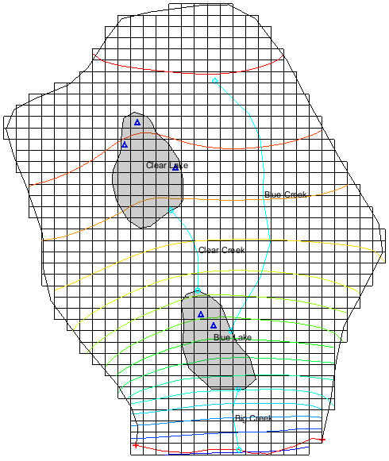

Figure 3 The computed solution after the MODFLOW run

# Examining the Solution

The next sections look more closely at the computed solution.

## The Head Solution

1. In the *Project Explorer*, expand the “File:3D Grid Folder.svg 3D Grid Data” folder and under the “File:Generic Folder Locked.svg TwoLakes (MODFLOW)” solution, select the “File:Dataset Cells Active.svg Head” dataset.

The Time Step window appears at the bottom of the Project Explorer, and the first stress period is selected.

Scroll through the time steps, clicking on a time step near the middle of the simulation and then the time step at the end.

When changing between the different time steps, notice that the first- and last-time steps have similar head contours. For time steps near the middle of the simulation, the head values are lower.

## Gage Output Files

The gage output files can be found in the solution folder in the Project Explorer.

1. In the *Project Explorer* window, in the “3D Grid Data” folder, under the “File:Generic Folder Locked.svg TwoLakes (MODFLOW)” solution, expand the “File:Generic Folder.svg Gage Files” folder.

Double-click on the “File:External Text File Icon.svg TwoLakes_Blue_Creek.gag” file(or right-click on the file and select the **View File** context menu item) to bring up the *View Data File* dialog.

If you have previously turned on the *Never ask this again* option in this dialog, this dialog will not appear. Skip to step 6.

Select the desired text editor from the *Open with* drop-down. If the desired text editor is not on the list, use the **Find Other…** button to add a new text editor to the list.

Click the **OK** button to close the *View Data File* dialog and open the gage output file in the desired text editor.

The gage output file shows columns for time, stage, and flow (Figure 4).

Scroll through the text file that opens, noticing the change in the *Flow* column.

For this stream, the flow rate drops by about 30 percent during the time of below-normal precipitation.

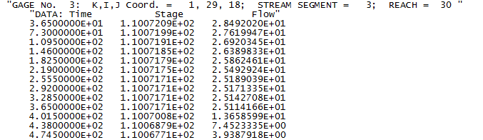

Figure 4 Gage output file for Blue Creek

In the *Project Explorer*, double-click on the “File:External Text File Icon.svg TwoLakes_Clear_Creek.gag” file and repeat Steps 3-5.

This stream shows a less significant change in flow rate. If desired, check the gage output for the other three gage stations as well.

Close the open gage files and return to GMS.

## Creating a Gage Plot

Plots can be generated in GMS from solution gage files.

1. Click the **Plot Wizard** File:Plot Wizard Macro.svg macro to bring up the *Step 1 of 2* page of the *Plot Wizard* dialog.

In the *Plot Type* section, from the list on the left, select *Gage Package Value vs. Time*.

Click the **Next >** button to go to the *Step 2 of 2* page of the *Plot Wizard* dialog.

From the *Gage file* list, select “Blue_Creek”.

From the *Data column* list, select “Flow”.

Click the **Finish** button to close the *Plot Wizard* dialog and open the *Gage Plot* window.

The generated plot is shown in Figure 5. The plot shows that the flow rate drops rapidly for this stream as the period with less precipitation begins and then recovers to near the initial flow rate during the final year.

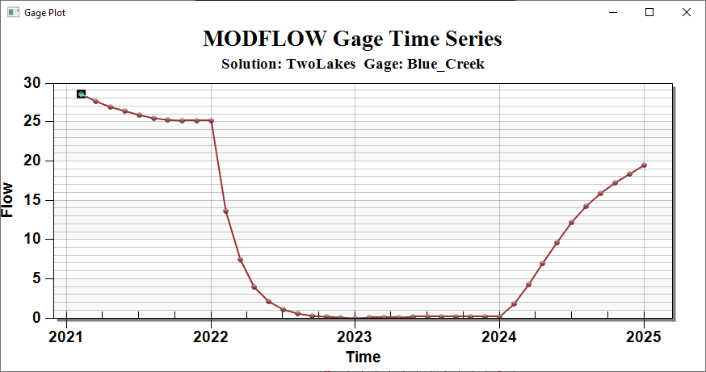

Figure 5 Gage plot for Blue Creek

# Conclusion

This concludes the “MODFLOW – GAGE Package” tutorial. The following key concepts were discussed and demonstrated:

* GMS supports the MODFLOW GAGE package.
* Gages are entered in the *Gage Package* dialog.
* Gage output text files can be viewed by opening them from the Project Explorer.
* Gage plots can be generated using the *Plot Wizard* dialog.