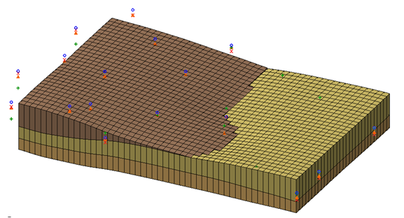

GMS 10.9

GMS 10.9 Tutorial

***MODFLOW – Interpolating Layer Data***

Interpolating MODFLOW elevations and other data from discrete points

Objectives

Learn how to effectively use GMS tools to interpolate MODFLOW layer elevation data and other MODFLOW data from scatter points.

Time

* 20–35 minutes

Required Components

* GMS Core
* Geostatistics

Prerequisite Tutorials

* Geostatistics 2D
* MODFLOW – Grid Approach…

Or

* MODFLOW – Conceptual Model Approach I

|  |
| --- |
| 1 Introduction 2  1.1 Interpolating to MODFLOW Layers 2  1.2 Getting Started 3  2 Case 1 – Complete Layers 3  2.1 Importing the Scatter Point Sets 3  2.2 Switch to Front View 4  2.3 Interpolating the Elevation Values 4  3 Case 2 – Embedded Seam 5  3.1 Interpolating the Values 6  3.2 Correcting the Layer Data 6  4 Case 3 – Outcropping 7  4.1 Interpolating the Values 7  4.2 Correcting the Layer Values 8  5 Case 4 – Bedrock Truncation 9  5.1 Activating the Inactive Cells 9  5.2 Interpolating the Values 10  5.3 Viewing the Results 10  5.4 Correcting the Layer Values 11  5.5 Viewing the Corrected Layers 11  6 Conclusion 12 |

# Introduction

For sites with complex stratigraphy and three-dimensional flow, a multilayer MODFLOW model can be much more accurate than a one-layer, two-dimensional model. When creating multilayer models, defining layer data can be challenging. This is particularly true for cases involving embedded seams, pinchouts, and truncations. Fortunately, GMS contains a suite of tools for interpolating and manipulating layer elevation data.

This tutorial involves the use of scatter points, interpolation, and MODFLOW. Therefore, a familiarity with MODFLOW and scatter points is helpful. Although not required, completing the “Geostatistics – 2D” tutorial and either the “MODFLOW – Grid Approach” or “MODFLOW – Conceptual Model Approach I” tutorial is recommended before completing this tutorial.

To illustrate the process of interpolating the elevations and fixing errors, it is necessary to look at a series of example cases. Each example illustrates a different problem and describes a simple and effective approach for correctly modeling the stratigraphy. This tutorial will discuss and demonstrate importing scatter point datasets, then interpolating elevation values and correcting the layer elevations for complete layers, embedded seams, outcroppings, and bedrock truncation. With the tools in GMS, even complex geologic strata can be modeled quickly and easily.

## Interpolating to MODFLOW Layers

One of the ways to create the top and bottom elevation arrays for each MODFLOW layer is to interpolate them from a set of scatter points. The interpolation can be performed directly on the MODFLOW arrays using the Interpolation | **Interpolate → 2D Grid** menu command in the **2D Scatter Point** File:2D Scatter Icon.svg module.

The scatter points can be imported from a tabular scatter point file. For regions with complex stratigraphy such as embedded seams or outcroppings, the scatter point data must be defined carefully. Once interpolated, the scatter point data may result in overlapping layers. These errors can be automatically corrected using the *Model Checker*.

## Getting Started

Do the following to get started:

If necessary, launch GMS.

If GMS is already running, select *File |* **New** to ensure that the program settings are restored to their default state. Click **Don’t Save** if asked to save changes.

# Case 1 – Complete Layers

The first case examined is shown in Figure 1. This is the simplest of the cases examined in this tutorial. The site has three layers and all three layers extend over the entire domain of the model.



Figure 1 Typical cross section with three layers extending across the entire domain model

## Importing the Scatter Point Sets

The first step in defining the layer data will be creating a grid. The next step is to create a set of points at various *xy* locations in the model. Each point has an elevation for the top and bottom of each layer. In a real problem, this data would come from sources such as exploratory boreholes. The data is entered into a tabular text file, typically through the use of a spreadsheet application. The *Import Wizard* is then used to import the tabular text file into GMS. The “Geostatistics– 2D” tutorial teaches how to do this in detail.

This tutorial will look at four different scenarios. Four different scatter point sets have been prepared in advance using the technique described above. To import the project, do the following:

1. If necessary, launch GMS.

If GMS is already running, select *File |* **New** to ensure that the program settings are restored to their default state. Click **Don’t Save** if asked to save changes.

Click **Open** File:Open Macro.svg to bring up the *Open* dialog.

Select “Project Files (*.gpr)” from the *Files of type* drop-down.

Browse to the *layerdata\layerdata* directory and select “points.gpr”.

Click **Open** to import the project file and close the *Open* dialog.

The Main Graphics Window will appear similar to Figure 2.

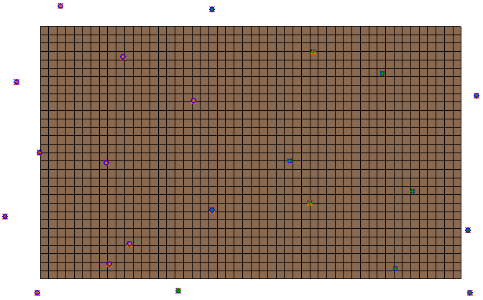

Figure 2 The initial project file for Case 1

## Switch to Front View

Before interpolating, change the view to look at a cross section of the grid. That way, it will be possible to immediately see the results of the interpolation. Before switching the view, first select a cell in the interior of the model. If a cell is selected when switching views, the new view will change to the row or column passing through the selected cell.

1. Using the **Select Cells** File:Select 3D Cell Tool.svg tool, select a cell near the middle of the grid. The exact cell is not important.
2. Switch to **Front View**File:Front View Macro.svg.

The Graphics Window should appear similar to Figure 3. Notice the grid layers are flat.

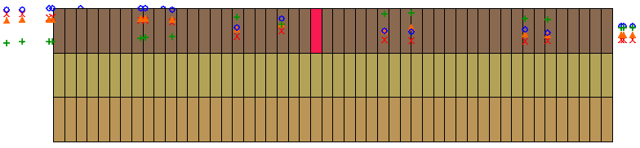

Figure 3 Front view with selected cell

## Interpolating the Elevation Values

A set of points should appear on the screen. The scatter point sets each have four datasets: top1, bot1, bot2, and bot3. The next step is to interpolate each of these datasets to the appropriate layer in the MODFLOW array. Before interpolating the points, initialize the MODFLOW data.

1. Expand the “File:3D Grid Folder.svg 3D Grid Data” folder in the Project Explorer.

Right-click on “File:3D Grid Icon.svg grid” and select **New MODFLOW…**to bring up the *MODFLOW Global/Basic Package* dialog.

Click **OK** to accept the defaults and close the *MODFLOW Global/Basic Package* dialog.

To interpolate the elevation values:

Expand the “File:2D Scatter Folder.svg 2D Scatter Data” folder and the “File:2D Scatter Icon.svg Case 1” scatter set in the Project Explorer.

Select “File:2D Scatter Icon.svg Case 1” to make it active.

Right-click on “File:2D Scatter Icon.svg Case 1” and select *Interpolate To |* **MODFLOW Layers…** to bring up the *Interpolate to MODFLOW Layers* dialog.

This dialog is used to define which scatter point datasets are interpolated to which MODFLOW arrays. The datasets are listed at the top-left and the MODFLOW arrays are listed at the top-right of the dialog. The “mapped” relationships are listed at the bottom of the dialog in the *Dataset → MODFLOW data* section. GMS tries to automatically map the relationships based on the dataset names. In this case, all of the relationships were correctly mapped.

Click the **OK** button to exit the *Interpolate to MODFLOW Layers* dialog.

After a few moments, the display will change (Figure 4). Notice that the interpolated layers match the cross section shown in Figure 1. Use the arrow buttons in the Mini-Grid Toolbar to view the cross sections along other rows.

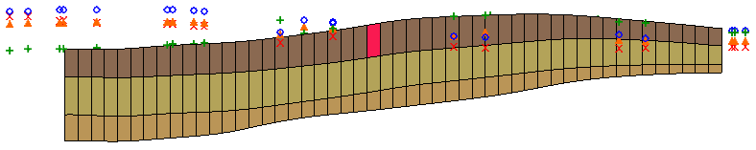

Figure 4 After the scatter sets are interpolated to MODFLOW

# Case 2 – Embedded Seam

The next case to be examined is illustrated in Figure 5. The middle layer is an embedded seam that only exists on the left (west) side of the model. This type of layer is more difficult to model with MODFLOW since a full array of K values must be defined for each layer. Making the cells in the second layer inactive on the right side of the model will not work since this will result in a no-flow boundary between the first and third layers.

To model the seam correctly, use a three-layer model with the second layer extending throughout the entire model domain. Adjusting the layer thickness of the second layer so that the cells will be very small on the right side of the model will simulate the pinchout.



Figure 5 Typical cross section through a site with an embedded seam

## Interpolating the Values

Now interpolate the data from the scatter points for Case 2. The elevations for the second layer on the right side of the model are adjusted so that the bottom of layer 2 is above the top of layer 2. This overlap will be fixed after the values are interpolated.

To interpolate the values, do the following:

1. Collapse the “File:2D Scatter Icon.svg Case 1” scatter point set and expand the “File:2D Scatter Icon.svg Case 2” scatter point set in the Project Explorer.
2. Select “File:2D Scatter Icon.svg Case 2” to make it active.

Right-click on “File:2D Scatter Icon.svg Case 2” and select *Interpolate To |* **MODFLOW Layers…** to bring up the *Interpolate to MODFLOW Layers* dialog.

Click **OK** to close the *Interpolate to MODFLOW Layers* dialog.

Note how the middle layer becomes inverted on the right side of the model (Figure 6).

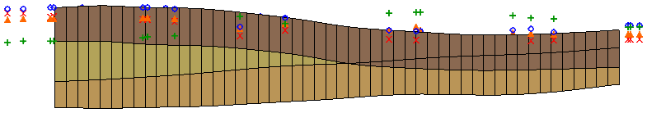

Figure 6 Case 2 after interpolation to MODFLOW, with middle layer inverted on the right side

## Correcting the Layer Data

The next step is to fix the overlap on the right side of the model using the layer data tools in the MODFLOW model checker.

1. Select *MODFLOW* | **Check Simulation…** to bring up the *Model Checker* dialog.

Click **Run Check** to check for errors. Notice the layer elevation errors under the *BASIC PACKAGE*.

Click **Fix Layer Errors…** to bring up the *Fix Layer Errors* dialog.

This dialog provides several options for correcting layer errors. Notice that many errors are listed for layer 2. The correction options are shown on the left. For this case, use the *Average* option. This method computes the average of the top and bottom elevation for each cell and moves the top elevation to be just above the average and the bottom elevation to be just below the average. The final difference between the top and the bottom is set to the *Minimum thickness* value shown in the dialog.

In the *Correction method* section, select **Average**.

In the *Overlap errors* list on the right, select **Layer 2**.

Click **Fix Selected Layer** to initiate the error correction. The process should be very quick.

Click **OK** to exit the *Fix Layer Errors* dialog.

Click **Done** to exit the *Model Checker* dialog.

Note that the seam is now properly modeled (Figure 7). It appears that the middle layer pinches out, but in actuality it only becomes very thin and continues throughout the grid.Use the arrow buttons in the Mini-Grid Toolbar to view the cross sections along other rows.

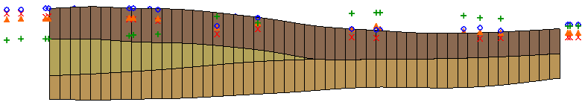

Figure 7 After the layer errors are corrected

# Case 3 – Outcropping

The next case to be examined is shown in Figure 8. In this case, the top layer is an outcropping that only exists on the left side of the model. Demonstrate this case using a three-layer model and adjusting the thickness of the top layer so that it goes to a very small value on the right side of the model.



Figure 8 Typical cross section through a site with outcropping

In this case, the elevations for the scatter points have been adjusted so that the bottom of the first layer extends above the top of the second layer on the right side of the model. After interpolating the values, adjust the elevations.

## Interpolating the Values

To interpolate the values, do the following:

1. Collapse the “File:2D Scatter Icon.svg Case 2” scatter point set and expand the “File:2D Scatter Icon.svg Case 3” scatter point set in the Project Explorer.
2. Select “File:2D Scatter Icon.svg Case 3” to make it active.

Right-click on “File:2D Scatter Icon.svg Case 3” and select *Interpolate To |* **MODFLOW Layers…** to bring up the *Interpolate to MODFLOW Layers* dialog.

Click **OK** to accept the defaults and close the *Interpolate to MODFLOW Layers* dialog.

Note how the bottom of the first layer extends above the ground surface on the right side of the model (Figure 9).

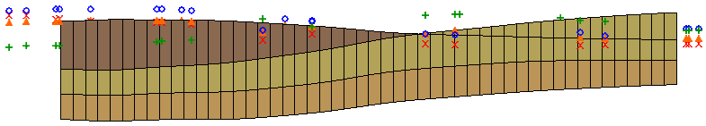

Figure 9 After interpolation to MODFLOW, with top layer extending above the ground on the right

## Correcting the Layer Values

To correct the layer errors, do the following:

1. Select *MODFLOW* | **Check Simulation…** to bring up the *Model Checker* dialog.

Click **Run Check** to check for errors. Notice the layer elevation errors under the *BASIC PACKAGE*.

Click **Fix Layer Errors…** to bring up the *Fix Layer Errors* dialog.

In this case, it is necessary to fix the errors for layer 1 by moving the bottom of layer one down to where it is just below the ground surface. This can be accomplished using the *Preserve top* option.

In the *Correction method* section, select **Preserve top**.

In the *Overlap errors* list on the right, select **Layer 1***.*

Turn on *Inactivate thin cells*.

With this option, instead of having a thin layer extend across the top of the grid, the thin cells are inactivated. This is useful since thin cells on the top of the grid often go dry.

Click **Fix Selected Layer** to initiate the error correction. The process should be very quick.

Click **OK** to exit the *Fix Layer Errors* dialog.

Click **Done** to exit the *Model Checker* dialog.

Notice how the outcropping is now properly modeled (Figure 10).

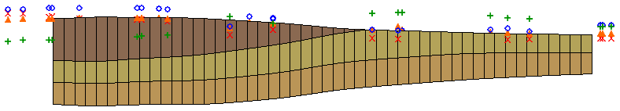

Figure 10 The outcropping after the layer errors are corrected

When finished viewing the cross section, switch to **Plan View** File:Plan View Macro.svg (Figure 11).

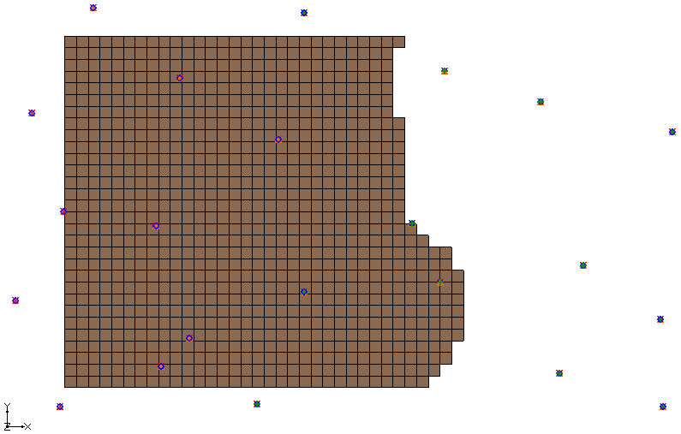

Figure 11 Plan view after outcropping layer errors corrected

# Case 4 – Bedrock Truncation

The final case to be examined is shown in Figure 12. The site has three layers, but the layers are truncated by the bedrock on the sides of the model. Model this situation by inactivating the cells on the perimeter of the model that are below the bedrock elevation. Adjust the layer’s bottom elevations as necessary to accurately model the bedrock.



Figure 12 East/west (a) and north/south (b) cross section with layers truncated by bedrock

## Activating the Inactive Cells

The last interpolation caused cells on the top layer to become inactive. It is necessary to first activate those cells.

1. Select *MODFLOW |* **Global Options…** to bring up the *MODFLOW Global/Basic Package* dialog.

Click **IBOUND…** to bring up the *Ibound Array* dialog.

Click **Constant → Grid…** to bring up the *Grid Value* dialog.

Enter “1” for the *Constant value for grid* and click **OK** to close the *Grid Value* dialog.

Click **OK** to close the *Ibound Array* dialog.

Click **OK** to close the *MODFLOW Global/Basic Package* dialog.

## Interpolating the Values

To interpolate the values, do the following:

1. Collapse the “File:2D Scatter Icon.svg Case 3” scatter point set and expand the “File:2D Scatter Icon.svg Case 4” scatter point set in the Project Explorer.
2. Select “File:2D Scatter Icon.svg Case 4” to make it active.

Right-click on “File:2D Scatter Icon.svg Case 4” and select *Interpolate To |* **MODFLOW Layers…** to bring up the *Interpolate to MODFLOW Layers* dialog.

Click **OK** to accept the defaults and close the *Interpolate to MODFLOW Layers* dialog.

## Viewing the Results

To view the results, do the following:

1. Select the “File:3D Grid Folder.svg 3D Grid Data” folder to make it active.

Using the **Select Cells** File:Select 3D Cell Tool.svg tool, select a cell near the middle of the grid. Again, the exact cell is not important.

Select the **Front View** File:Front View Macro.svg button (Figure 13).

Select the **Side View** File:Side View Macro.svg button (Figure 14).

Notice how the bottom of the third layer (the top of the bedrock) overlaps the upper layers.

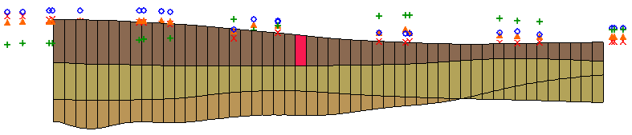

Figure 13 Front view after interpolating to MODFLOW

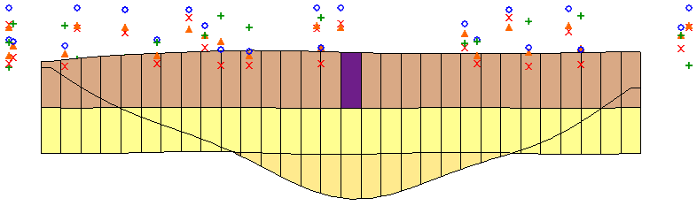

Figure 14 Side view after interpolating to MODFLOW

## Correcting the Layer Values

To correct the layer errors, do the following:

1. Select *MODFLOW* | **Check Simulation…** to bring up the *Model Checker* dialog.

Click **Run Check** to check for errors. Notice the layer elevation errors under the *BASIC PACKAGE*.

Click **Fix Layer Errors…** to bring up the *Fix Layer Errors* dialog.

In this case, a customized option called *Truncate to bedrock* is perfectly suited to this problem. This method examines the elevations for each cell. If the bedrock elevation (the bottom elevation for the bottom layer) is above the top elevation of the cell, the cell is made inactive. If the bedrock elevation is below the top of the cell but above the bottom, the bottom elevation is adjusted to match the bedrock elevation.

In the *Correction method* section, select **Truncate to bedrock**.

In the *Overlap errors* section, select **Layer 3**.

Click **Fix Affected Layers** to initiate the error correction. The process should be very quick.

Click **OK** to exit the *Fix Layer Errors* dialog.

Click **Done** to exit the *Model Checker* dialog.

Notice how the outcropping is now properly modeled (Figure 15).

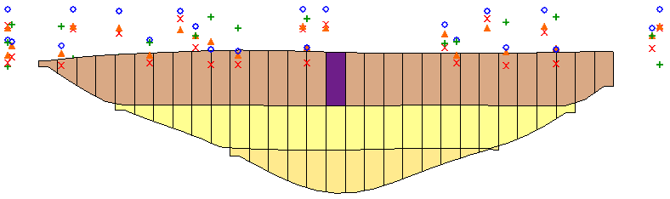

Figure 15 After truncation to bedrock

## Viewing the Corrected Layers

To view the cross sections, do the following:

1. Use the arrow buttons in the Mini-Grid Toolbar to view the grid along different columns.

Switch to **Front View**File:Front View Macro.svg and use the arrow buttons in the Mini-Grid Toolbar to view the grid along different rows.

Switch to **Plan View** File:Plan View Macro.svg and notice how the cells on the perimeter of the grid have been made inactive.

Use the arrow buttons in the Mini-Grid Toolbar to view the grid on different layers.

Turn off **Ortho Mode** File:Ortho View Macro.svg and switch to **Oblique View** File:Oblique View Macro.svg to view the stratigraphy in 3D (Figure 16).

Use the **Rotate** File:Rotate Tool.svg tool to view the grid from different viewpoints.

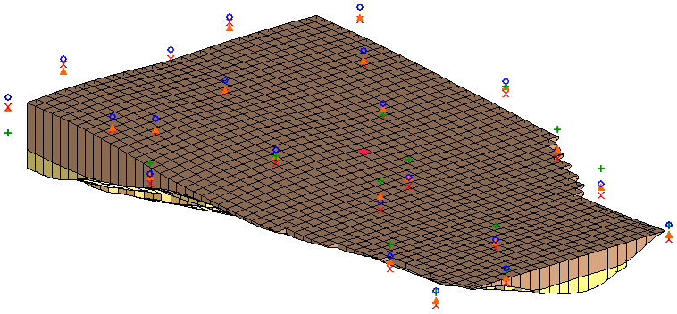

Figure 16 View of the grid in Oblique View

# Conclusion

This concludes the “MODFLOW – Interpolating Layer Data” tutorial. The following topics were discussed and demonstrated:

* It is possible to interpolate from 2D scatter points directly to MODFLOW elevation data arrays.
* Interpolating to MODFLOW elevation data can result in layers that overlap.
* It is possible to correct overlap errors by using the *Fix Layer Errors* dialog, available by selecting *MODFLOW |* **Check Simulation…**.

There are different ways to fix layer errors. Pick the method that best suits the particular problem.