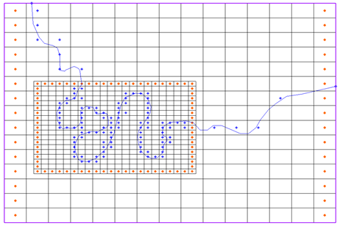

GMS 10.9

GMS 10.9 Tutorial

***MODFLOW–LGR***

Create MODFLOW-LGR models with locally refined grids using GMS

Objectives

GMS supports building MODFLOW-LGR models with nested child grids. This tutorial shows the various parts of the MODFLOW-LGR interface in GMS.

Time

* 30–45 minutes

Required Components

* GMS Core
* MODFLOW Interface

Prerequisite Tutorials

* MODFLOW – Grid Approach
* MODFLOW – Conceptual Model Approach I

|  |
| --- |
| 1 Introduction 2  1.1 Getting Started 3  2 Opening the Non-LGR Model 3  2.1 Saving with a Different File Name 4  2.2 Switching to MODFLOW-LGR 4  2.3 Saving and Running MODFLOW 5  3 Creating the Child Grid 5  3.1 Examining the Child Grid 7  3.2 LGR Options 10  3.3 Map *→* MODFLOW 12  3.4 Checking the Simulation 12  3.5 Saving and Running MODFLOW 12  4 Viewing the Solution 13  4.1 Flow Budget 13  5 BFH Package 15  5.1 Running the Child Model Independently 15  5.2 Running the Parent Independently 17  6 Conclusion 19 |

# Introduction

MODFLOW-LGR enables the creation of MODFLOW models with locally refined regions, allowing for smaller cell sizes in areas requiring greater detail. These refined regions are implemented as child grids nested within a parent grid. MODFLOW-LGR uses an iterative technique to solve for heads and flows in both child and parent grids while maintaining consistency in boundary conditions at their shared interfaces.

The problem in this tutorial is based on one of the example models included with MODFLOW-LGR. It features a meandering river in a regional model (Figure 1). The system is modeled using MODFLOW-2005 with a three-layer grid under steady-state conditions. Specified head boundaries are defined on the left and right, with no-flow boundaries on the north and south. Flow is generally from west to east. A child grid will be inserted in the region where the river bends closely together to improve resolution and accuracy in that area.

This tutorial will cover the following concepts and procedures:

* GMS supports MODFLOW-LGR and parent/child grid models
* MODFLOW-LGR produces results equivalent to MODFLOW-2005 when no child grids are present
* Child grids appear in the Project Explorer beneath the parent grid
* Only one grid and MODFLOW simulation can be active at a time; only cells in the active grid are selectable
* The *LGR Options* dialog displays child grid configuration and the information that will go in the LGR control file
* The BFH package can be used to run the parent or child model independently

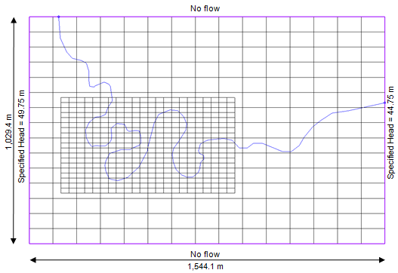

Figure 1 Sample problem to be solved[1]

## Getting Started

Do the following to get started:

1. If necessary, launch GMS.
2. If GMS is already running, select *File |* **New** to ensure that the program settings are restored to their default state. Click **Don’t Save** if asked to save changes.

# Opening the Non-LGR Model

Start by opening the non-LGR regional model that has already been created using MODFLOW-2005.

1. Click **Open** File:Open Macro.svg to bring up the *Open* dialog.
2. Select “Project Files (*.gpr)” from the *Files of type* drop-down.
3. Browse to the *mflgr\mflgr* directory and select “start.gpr”.
4. Click **Open** to import the project and close the *Open* dialog.

The Graphics Window should appear similar to Figure 2.

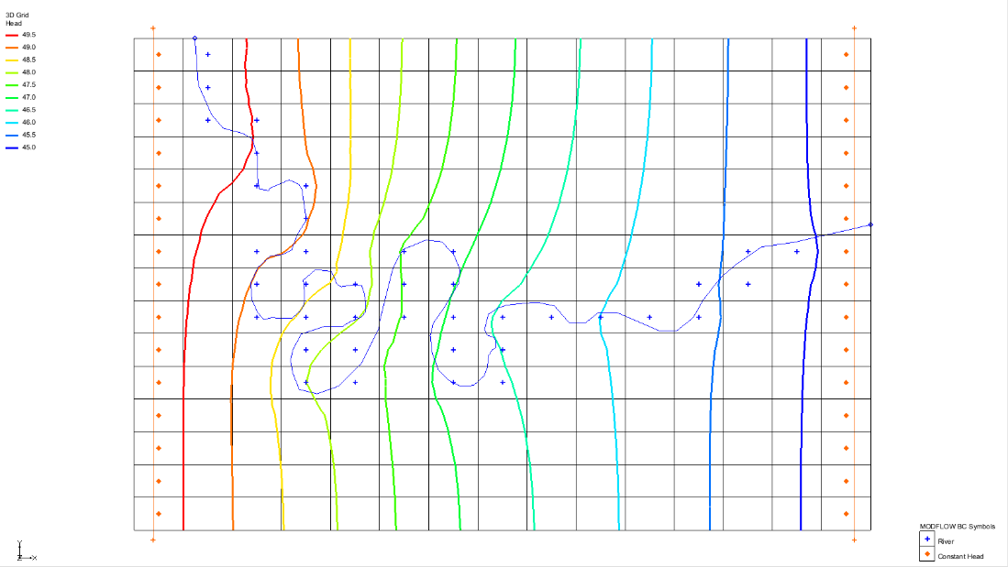

Figure 2 Non-LGR regional model

## Saving with a Different File Name

Before making any changes, save the project under a new name.

1. Select *File |* **Save As…** to bring up the *Save As* dialog.
2. Select “Project Files (*.gpr)” from the *Save as type* drop-down.
3. Enter “lgr.gpr” as the *File name*.
4. Click **Save** to save the project under the new name and close the *Save As* dialog.

It is recommended to periodically **Save** File:Save Macro.svg as the tutorial progresses.

## Switching to MODFLOW-LGR

Now switch the model from MODFLOW-2005 to MODFLOW-LGR.

1. Select *MODFLOW |* **Global Options…** to open the *MODFLOW Global/Basic Package* dialog.
2. In the *MODFLOW version* section, select *LGR*.
3. Click **OK** to close the *MODFLOW Global/Basic Package* dialog.

## Saving and Running MODFLOW

Before adding a child model, save the changes and run MODFLOW to make sure MODFLOW-LGR gives the same results as MODFLOW-2005.

1. **Save** File:Save Macro.svg the project.
2. Click the **Run MODFLOW** File:Run MODFLOW Macro.svg macro to bring up the *MODFLOW* model wrapper dialog.
3. When MODFLOW finishes, turn on *Read solution on exit* and *Turn on contours (if not on already)*.
4. Click **Close** to exit the *MODFLOW* model wrapper dialog and import the solution.

Note that there is no difference in the contours results—the MODFLOW-LGR solution matches the MODFLOW-2005 solution exactly. To verify this, expand the “File:3D Grid Folder.svg 3D Grid Data” folder and switch between the “File:Generic Folder Locked.svg start (MODFLOW)” and “File:Generic Folder Locked.svg lgr (MODFLOW)” solutions. The contour patterns should remain unchanged, confirming that the two solutions are identical.

# Creating the Child Grid

The child grid can now be created by selecting a range of cells within the regional model. The target area is marked by a rectangle that can be displayed for reference. Begin by turning off the contours to improve visibility.

1. Click the **Display Options** File:Display Options Macro.svg macro to bring up the *Display Options* dialog.
2. Select “3D Grid Data” from the list on the left.
3. On the *3D Grid* tab, in the *Active dataset* section, turn off *Contours*.
4. Click **OK** to close the *Display Options* dialog.
5. In the Project Explorer, turn on the “File:Annotations Folder.svg Annotation Data”folder.

A red rectangle should appear.

1. Using the **Select Cells** File:Select 3D Cell Tool.svg tool, drag a box to select all cells within the red rectangle. Ensure that all the cells touched by the rectangle are included. The selected region should be eight cells wide by seven cells high (Figure 3).

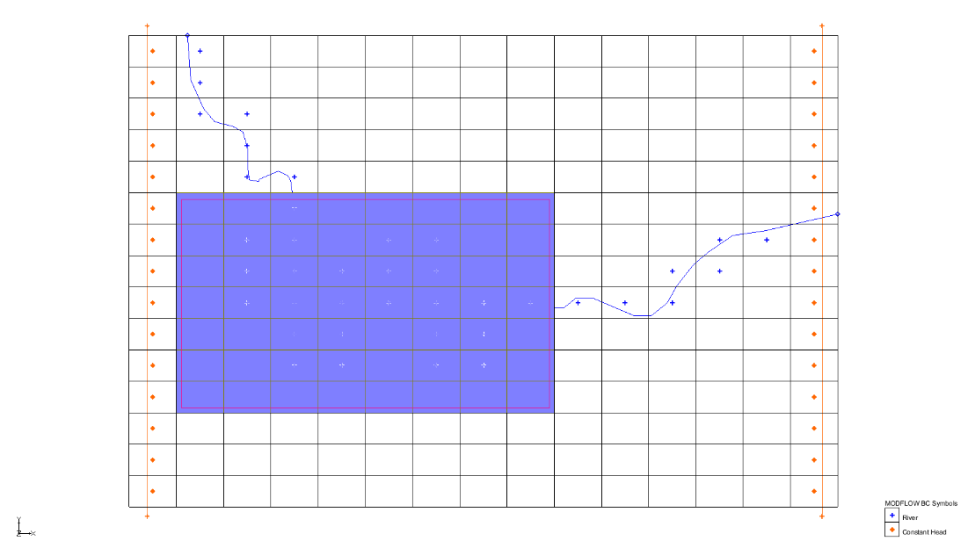

Figure 3 The selected cells for the child grid

1. Right-click in the selected area and select **Create Child Grid…** to bring up the *Create Child Grid* dialog (Figure 4).

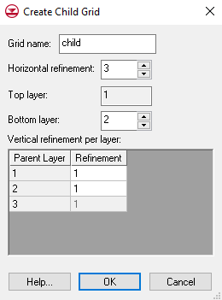

Figure 4 Create Child Grid dialog

1. For the *Bottom layer,* enter “2”.
2. In the *Vertical refinement per layer* section, enter “3” in the *Refinement* column for parent layers 1 and 2.
3. Click **OK** to close the *Create Child Grid* dialog.
4. In the Project Explorer, turn off the “File:Annotations Folder.svg Annotation Data” folder to hide the red rectangle.

A nested child grid should now be visible within the cells that were previously selected (Figure 5).

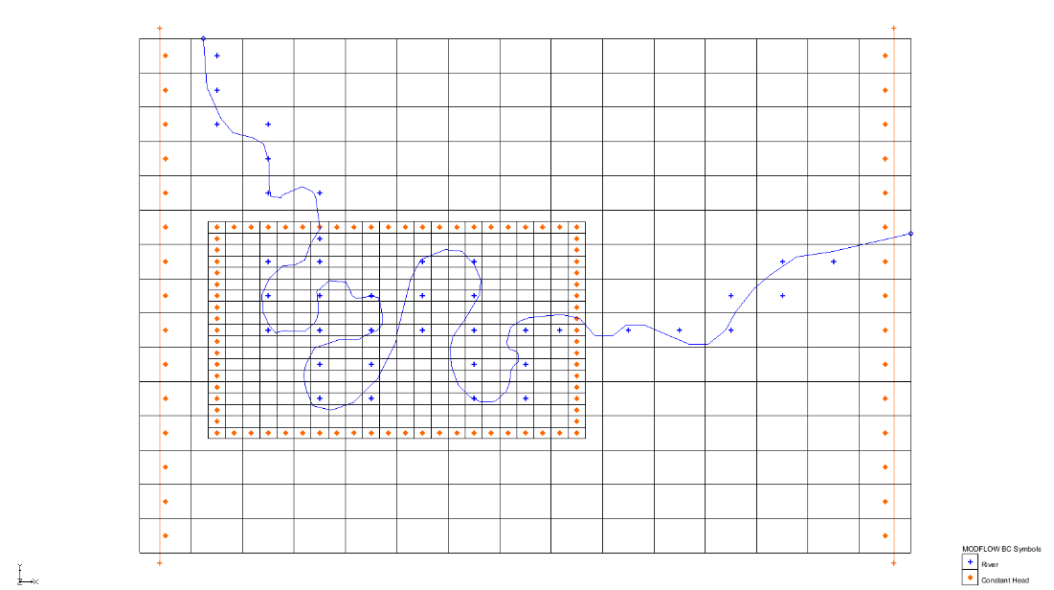

Figure 5 Model with child grid

## Examining the Child Grid

The cells along the outer boundary of the child grid are assigned constant head boundary conditions. In MODFLOW-LGR terminology, the side boundary cells in the child grid are referred to as “half cells”, while corner boundary cells are “quarter cells”. Although GMS visually displays the entire cell, only a portion of each cell (half or quarter) is recognized by MODFLOW.

At locations where the center of a child cell center aligns with the center of a parent cell, a shared node exists. Head and flow values along these shared boundaries are computed iteratively and exchanged between the parent and child models to ensure proper coupling.

Examine the Project Explorer and take note of the following:

* A new 3D grid item called “File:3D Grid Icon.svg child” has been added under the original parent grid (“File:3D Grid Inactive.svg grid”) in the “File:3D Grid Folder.svg 3D Grid Data” folder
* The icon for the original 3D grid File:3D Grid Inactive.svg is now grey, indicating that it is no longer active; only one grid can be active at a time
  + Only cells in the active grid can be selected, and a 3D grid can be activated by clicking its icon
* A “File:MODFLOW Folder.svg MODFLOW” model has been added beneath the new child grid
* The original MODFLOW File:MODFLOW Inactive.svg icon under the parent grid is now grey, indicating it is inactive; similar to 3D grids, only one MODFLOW model can be active at a time.
  + To activate a MODFLOW model, click its icon or the icon of its parent grid (this also activates the associated grid)

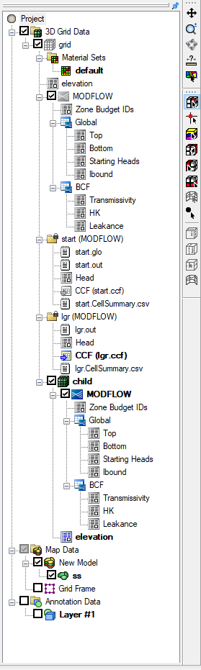

Figure 6 Project Explorer with child grid

Now examine grid activity and the child grid.

1. With the **Select Cells** File:Select 3D Cell Tool.svg tool, try to select a cell in the parent grid, which is inactive.
2. Now try to select cells in the child grid, which is active.
3. In the Project Explorer, click on the parent “File:3D Grid Inactive.svg grid” to make it activate.
4. Now try to select cells in the parent grid and the child grid.

When clicking in the area of the child grid, cells in the parent grid are being selected.

1. Switch to **Front View**File:Front View Macro.svg.

The display should show a grid sloping slightly to the right (Figure 7).

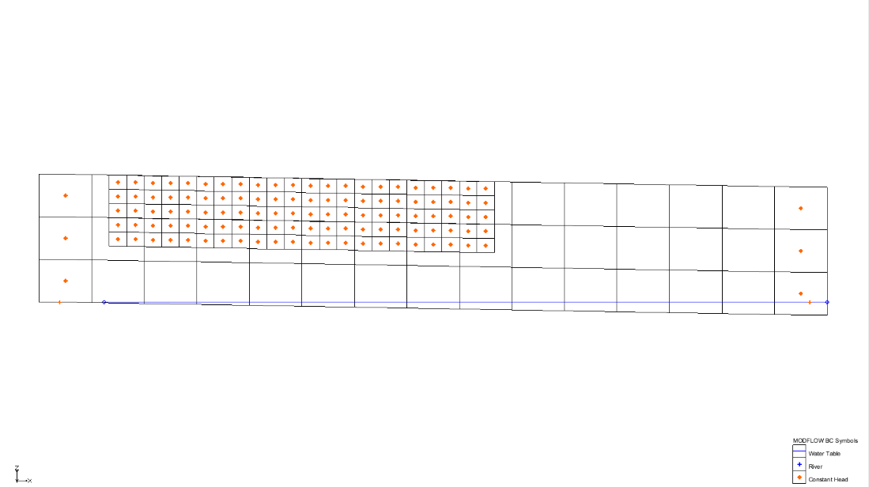

Figure 7 Front view, row 6

1. Change the row being viewed by using the up and down arrows on the *Mini Grid Toolbar*. mini-grid

Note that both the parent and child grids update when viewing different rows. The *Mini Grid* *Toolbar* acts on the active grid, but the child grid’s row remains synchronized with the parent grid’s row.

1. On the *Mini Grid Toolbar*, turn on *Multiple grids* to bring up the *Current Ortho Levels* dialog (Figure 8).

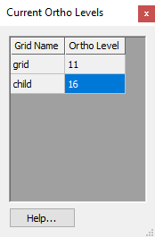

Figure 8 Current Ortho Levels dialog

This dialog displays the row currently visible on all grids. Being modeless, it allows continued interaction with the GMS interface while open. The dialog can be moved to any convenient location on the screen.

1. On the *Mini Grid Toolbar,* change the grid row up and down to demonstrate.

Note that the values change in the *Current Ortho Levels* dialog. The parent grid row changes once for every three child grid rows. GMS identifies and displays the child row corresponding to the current parent row. Now, disable syncing of the ortho levels.

1. Click the **Display Options** File:Display Options Macro.svg macro to bring up the *Display Options* dialog.
2. From the list on the left, select “3D Grid Data”.
3. Under the *3D Grid* tab, in the top section, turn off *Synch ortho levels with all grids*.
4. Click **OK** to close the *Display Options* dialog.

The top and bottom elevations are such that the model slopes down from left to right. Notice that the child grid extends down to the middle of the second layer. This follows the LGR rules for vertical refinement as shown in Figure 9.

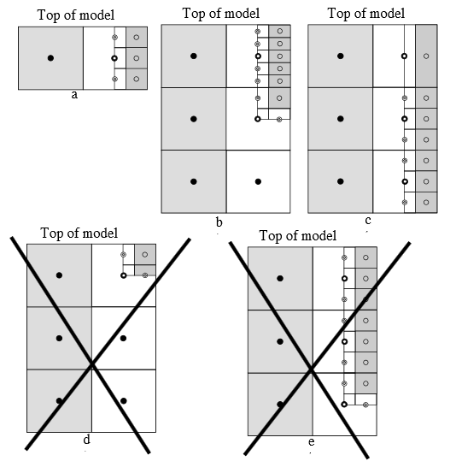

Figure 9 Vertical refinement rules[2]

In reference to Figure 9, the cross-sectional schematics of vertical refinement interface illustrate the following scenarios:

1. A one-layer parent model refined to a three-layer child model
2. A multi-layer parent model with vertically varying child refinement terminating at the shared node of the second parent layer
3. A multi-layer parent model with vertically varying child refinement extending to the bottom of the parent model
4. A multi-layer parent model where the child refinement terminates at the first shared node of the parent, which is not possible
5. A multi-layer parent model where the child refinement terminates at the bottommost shared node, which is not possible[3]
6. Switch to **Plan View**File:Plan View Macro.svg.
7. **Close** Windows - Close button - square the *Current Ortho Levels* dialog.

## LGR Options

Now look at the *LGR Options* dialog.

1. Select the parent “File:3D Grid Icon.svg grid” in the Project Explorer to make it active.
2. Select *MODFLOW |* **Global Options…** to open the *MODFLOW Global/Basic Package – Parent* dialog.

Note that the dialog name ends with “– Parent”. When using LGR, MODFLOW dialogs will end with “– Parent” or “– Child” depending on which MODFLOW simulation is currently active. While grids can be renamed and the new names will appear in MODFLOW dialogs for the child grids, the parent grid’s dialogs will always display “– Parent”, regardless of its name.

The behavior of the options in the main *MODFLOW* menu depends on the active simulation. With the parent simulation active, all main *MODFLOW* menu commands apply to the parent model. If the child model is made active, those commands will apply to the child model.

The same commands are also accessible by right-clicking the “File:MODFLOW Folder.svg MODFLOW” item in the Project Explorer. Using the Project Explorer can help avoid confusion about which model the main menu commands will affect.

1. Click **LGR Options…** to bring up the *LGR Options* dialog (Figure 10).

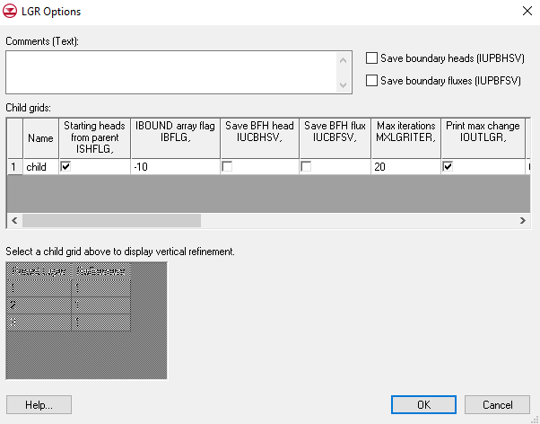

Figure 10 LGR Options dialog

The items in this dialog correspond to the LGR control file, which is used by MODFLOW-LGR during a parent-child paired simulation. This file contains information about both the parent and child models.

The *Child grids* spreadsheet at the top of the dialog lists all defined child grids. The *Vertical refinement for child grid* spreadsheet below it displays the layer-by-layer vertical refinement for the currently selected child grid. A child grid must be selected to view this information.

While the dimensions and refinement settings of the child grids cannot be edited in this dialog, the values that will be written to the LGR Control File (NPLBEG, NPLEND, etc.) are visible for reference.

1. Select the child grid by clicking in any field in the first row of the *Child grids* spreadsheet. This activates the *Vertical refinement for child grid* section at the bottom of the dialog.
2. Click **Cancel** to exit the *LGR Options* dialog.
3. Click **Cancel**to exit the *MODFLOW Global/Basic Package – Parent* dialog.

## Map *→* MODFLOW

Now that a child grid has been created, the conceptual model must be mapped to it so that the river is represented in the child model.

1. Select the “File:3D Grid Icon.svg child” grid in the Project Explorer to make it active.
2. In the *Lay (k)* field of the *Mini Grid Toolbar*, enter “1”.
3. Click the **Map → MODFLOW** File:Map to MODFLOW Macro.svg macro to bring up the *Map → Model* dialog.
4. Click **OK** to accept the defaults and close the *Map → Model* dialog.

The river boundary conditions have now been added to all the cells in the child grid under the river arc (Figure 11).

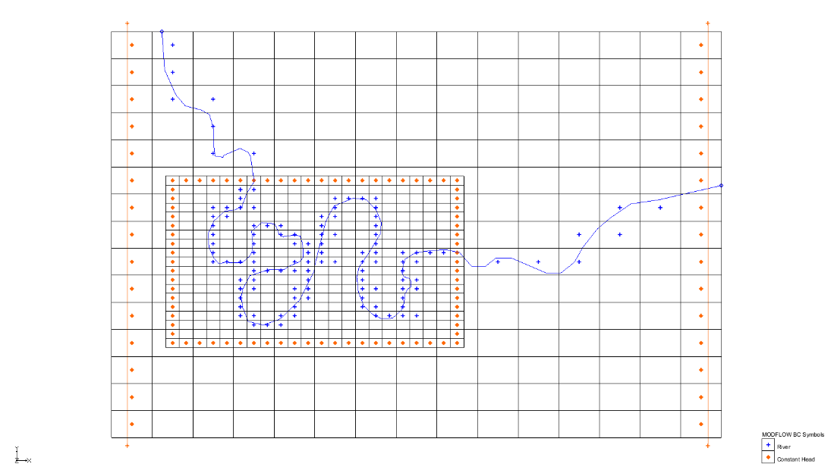

Figure 11 After Map → MODFLOW with child model

## Checking the Simulation

It is recommended to always run the *Model Checker* prior to running MODFLOW.

1. Select *MODFLOW |* **Check Simulation…** to open the *Model Checker* dialog.
2. Click **Run Check**. There should be no warnings or errors detected.

Note that the model checker checked both the parent and the child models. Regardless of which grid/model is active, the model checker will always look at all MODFLOW models.

1. Click **Done** to close the *Model Checker* dialog.

## Saving and Running MODFLOW

Now save the work and run MODFLOW.

1. **Save** File:Save Macro.svg the project.
2. Click the **Run MODFLOW** File:Run MODFLOW Macro.svg macro to bring up the *MODFLOW* model wrapper dialog.
3. When the model finishes, turn on *Read solution on exit* and *Turn on contours (if not on already)*.
4. Click **Close** to import the solution and exit the *MODFLOW* model wrapper dialog.

There are two solutions: one for the parent and one for the child.

# Viewing the Solution

Contours are displayed for both the parent and child grids, with some overlap visible around the edges. Although the cells near the parent-child interface are represented as half and three-quarter cells, GMS displays and contours the full extent of each cell. As a result, the visual overlap at the boundary is expected and does not indicate an error in the model setup.

1. Turn off the “File:3D Grid Icon.svg child” grid.

Note that the parent cells within the child grid region appear inactive and are not displayed. This is because cell activity is controlled by the head solution dataset, not the IBOUND array. In the solution dataset, these cells are marked as inactive due to the presence of the child grid.

However, the IBOUND array still correctly marks these parent cells as active, as required for MODFLOW-LGR. This can be verified by viewing the IBOUND array for the parent model.

1. Turn on the “File:3D Grid Icon.svg child” grid.

Notice the contours of the child and parent seem to match fairly well.

## Flow Budget

Now examine the flow budget.

1. Select the parent “File:3D Grid Icon.svg grid” to make it active.
2. Under “File:Generic Folder Locked.svg lgr (MODFLOW)”, double-click on the “File:External Text File Icon.svg lgr.out” file to bring up the *View Data File* dialog.

This dialog will not appear if *Never ask this again* was previously turned on in this dialog. If this is the case, skip to step 4.

1. Select the desired text editor from the *Open with* drop-down and click **OK** to open the data file and close the *View Data File* dialog.
2. Locate the “PARENT FLUX B.C.” items in the budget summary near the bottom of the file (red stars in Figure 12).

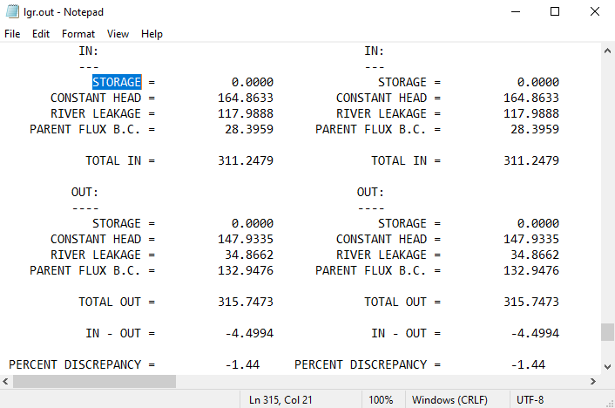

Figure 12 Flow between parent and child grids

This represents the flow exchange between the parent and child models. Approximately 24 m3 flows from the child to the parent, while 120 m3 flows from the parent to the child.

1. Close the “lgr.out” file and return to GMS.
2. Under “File:Generic Folder Locked.svg lgr_child (MODFLOW)”, double-click on the “File:External Text File Icon.svg lgr_child.out” file to bring up the *View Data File* dialog. As before, this dialog may not appear. If this is the case, skip to step 8.
3. Select the desired text editor from the *Open with* drop-down and click **OK** to open the data file and close the *View Data File* dialog.
4. Locate the “FLUX ACROSS PARENT-CHILD INTERFACE” section near the bottom of the file (Figure 13).

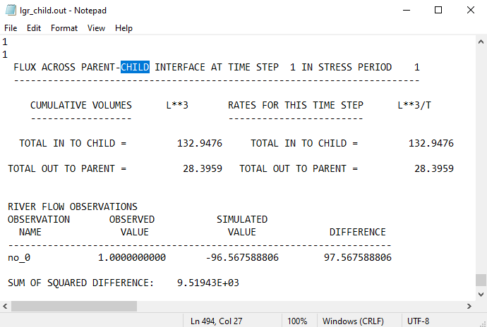

Figure 13 Flux across parent-child interface

The flow into the child and flow out to the parent match the values reported in the “lgr.out” file. Note also that the “PARENT FLUX B.C.” entries are not included in the budget summary of this file.

1. Close the “lgr_child.out” file and return to GMS.
2. Select *MODFLOW |* **Flow Budget…** to bring up the *Flow Budget – Parent* dialog.

Under the *Cells* tab, note that the flow budget does not include the “PARENT FLUX B.C.” item found in the FLOW OUT file. This is because MODFLOW does not write this information to the CCF file for either the parent or child model. Since GMS reads flow budget data from the CCF file, this item is not reflected in the Cells tab budget.

1. Click **OK** to exit the *Flow Budget – Parent* dialog.

# BFH Package

The BFH package was developed to allow parent and child models to be run independently using the coupling head and flow boundary conditions generated by MODFLOW-LGR. This process involves two main steps:

1. Run the model in coupled mode using LGR to calculate and save the boundary head and flow data.
2. Run the parent or child model independently by enabling the BFH package and referencing the saved coupling data from the initial run.

To practice this workflow, first run the child model independently, followed by running the parent model independently.

## Running the Child Model Independently

### Saving the Boundary Heads and Fluxes

To run the child model independently, the option to save the coupling heads (IUCBHSV) must be enabled. To run the parent model independently, the option to save the complimentary fluxes (IUPBFSV) must be enabled. In this case, since the plan is to run the parent model independently, both options must be turned on.

1. Select the parent “File:3D Grid Icon.svg grid” to make it active.
2. Select *MODFLOW |* **Global Options…** to open the *MODFLOW Global/Basic Package – Parent* dialog.
3. Click **LGR Options…** to open the *LGR Options* dialog.
4. Turn on *Save boundary fluxes (IUPBFSV)* at the top-right.
5. In the *Child grids* spreadsheet, turn on *Save BFH head IUCBHSV,*.
6. Click **OK** to exit the *LGR Options* dialog.
7. Click **OK** to exit the *MODFLOW Global/Basic Package – Parent* dialog.

Now save the project with a new name so the solutions can be compared.

1. Select *File |* **Save As…** to bring up the *Save As* dialog.
2. Select “Project Files (*.gpr)” from the *Save as type* drop-down.
3. Enter “lgr2.gpr” as the *File name*.
4. Click **Save** to save the project under the new name and close the *Save As* dialog.

This causes the following line to be written to the name file of the child model:

DATA 1787 "lgr2_child.bfh_hed"

When the model is run, the boundary heads will be saved to this “lgr2_child.bfh_hed” file. As nothing has been changed, the solution will not change.

### Running MODFLOW

Now it is necessary to run MODFLOW in coupled mode.

1. Click the **Run MODFLOW** File:Run MODFLOW Macro.svg macro to bring up the *MODFLOW* model wrapper dialog.
2. When the model finishes, turn on *Read solution on exit* and *Turn on contours (if not on already)*.
3. Click **Close** to import the solution and close the *MODFLOW* model wrapper dialog.

### Turning on BFH Package

Now use the boundary heads saved in the “lgr2_child.bfh_hed” file to run the child model independently. These boundary heads will be applied along the edges of the child model to define the boundary conditions during the standalone run.

1. Under the “File:3D Grid Inactive.svg child” grid in the Project Explorer, right-click on “File:MODFLOW Inactive.svg MODFLOW” and select **Global Options…** to open the *MODFLOW Global/Basic Package – child* dialog.
2. Click **Packages…** to open the *MODFLOW Packages / Processes – child* dialog.
3. In the *Optional packages / processes* section, turn on *BFH – Boundary Flow and Head*.
4. Click **OK** to exit the *MODFLOW Packages / Processes – child* dialog.
5. Click **OK** to exit the *MODFLOW Global/Basic Package – child* dialog.

Now that it has been turned on, look at the options in the BFH Package.

1. Select the “File:3D Grid Inactive.svg child” grid in the Project Explorer to make it active.
2. Under the “File:3D Grid Icon.svg child” grid, right-click on “File:MODFLOW Folder.svg MODFLOW” and select *Optional Packages |* **BFH – Boundary Flow and Head** to open the *BFH Package* dialog (Figure 14).

The *Head file* path will vary depending on the location where the project was saved.

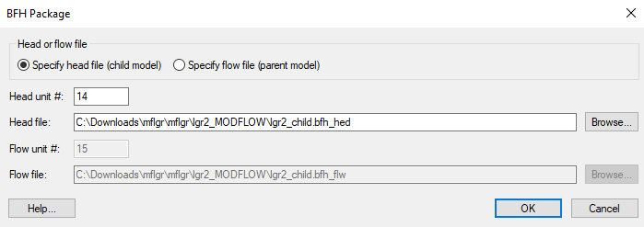

Figure 14 BFH Package dialog

By default, the “lgr2_child.bfh_hed” file created by MODFLOW is automatically listed in the *Head file* field. This file, along with the corresponding *Head unit #*, will be written to the MODFLOW name file. When MODFLOW runs, it will read the boundary heads from this file and apply them to the edges of the child model. No additional changes are necessary, as GMS has already set the required options by default.

1. Click **OK** to exit the *BFH Package* dialog.

### Saving and Running MODFLOW

Now it is possible to run the child model independently.

1. **Save** File:Save Macro.svg the project.
2. Under “File:3D Grid Icon.svg child” in the Project Explorer, right-click on “File:MODFLOW Folder.svg MODFLOW” and select **Run MODFLOW Uncoupled On Just This Model** to bring up the *MODFLOW – child* model wrapper dialog.

This command launches MODFLOW on the child model only. While MODFLOW-LGR is still used, it operates in an uncoupled mode, running the child model independently from the parent.

1. When the model has finished, turn on *Read solution on exit* and *Turn on contours (if not on already)*.
2. Click **Close** to import the solution and exit the *MODFLOW – child* model wrapper dialog.

The contours remain unchanged from the coupled run, confirming that the results are consistent. Note that the BFH package cannot be used when running MODFLOW-LGR in coupled mode. To rerun the models in coupled mode, the BFH package must be turned off in the child model.

## Running the Parent Independently

This section of the tutorial demonstrates how to use the BFH package to run the parent model independently. The option to save the complimentary fluxes (IUPBFSV) has already been enabled. To proceed, simply activate the BFH package in the parent model.

### Turning on BFH Package

To run the parent model independently, it is necessary to use the boundary flows saved in the “lgr2.bfh_flw” file. These flows are applied along the portion of the parent model boundary that interfaces with the child model, allowing MODFLOW to simulate the parent model without the child grid.

1. Under “File:3D Grid Inactive.svg grid” in the Project Explorer, right-click on the parent “File:MODFLOW Inactive.svg MODFLOW” model and select **Global Options…** to open the *MODFLOW Global/Basic Package – Parent* dialog.
2. Click **Packages…** to open the *MODFLOW Packages / Processes – Parent* dialog.
3. In the *Optional packages / processes* section, turn on *BFH – Boundary Flow and Head*.
4. Click **OK** to exit the *MODFLOW Packages / Processes – Parent* dialog.
5. Click **OK** to exit the *MODFLOW Global/Basic Package – Parent* dialog.

At this point, the *BFH Package* dialog for the parent model could be opened to review the options. However, GMS has already set all options to the appropriate defaults, so it is not necessary to make any changes. Simply proceed to run the parent model independently.

### Save and Run MODFLOW

Now it is possible to run the parent model independently.

1. **Save** File:Save Macro.svg the project.
2. Under “File:3D Grid Inactive.svg grid”, right-click on the parent “File:MODFLOW Inactive.svg MODFLOW” model and select **Run** **MODFLOW Uncoupled On Just This Model** to bring up the *MODFLOW – Parent* model wrapper dialog.

This command launches MODFLOW on the parent model only. While MODFLOW-LGR is still used, it operates in an uncoupled mode, running the parent model independently from the child.

1. When the model finishes, turn on *Read solution on exit* and *Turn on contours (if not on already)*.
2. Click **Close** to import the solution and close the *MODFLOW – Parent* model wrapper dialog.

GMS reads the solution and updates the contours display. Compared to the coupled solution, there is a small difference in the contours (Figure 15).

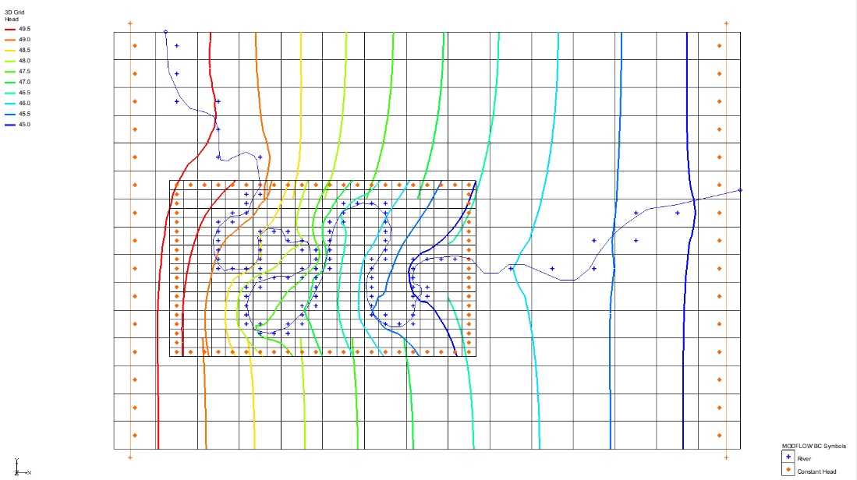

Figure 15 Final view after parent run independently

# Conclusion

This concludes the “MODFLOW – LGR” tutorial. This tutorial demonstrated and discussed:

* Importing an existing MODFLOW model
* Switching the model to MODFLOW-LGR and running it
* Adding a child grid
* Running the parent and child coupled
* Saving the boundary heads
* Turning on the BFH package
* Running the child model independently using the boundary heads

1. Mehl, Steffen W. and Hill, Mary C. (2007). “MODFLOW-2005, The U.S. Geological Survey Modular Ground-Water Model—Documentation of Shared Node Local Grid Refinement (LGR) and the Boundary Flow and Head (BFH) Package” in *U.S. Geological Survey Techniques and Methods 6-A12*, p.43. <http://pubs.usgs.gov/tm/2006/tm6a12/pdf/TM6-A12.pdf>
2. Mehl, p.13. <http://pubs.usgs.gov/tm/2006/tm6a12/pdf/TM6-A12.pdf>
3. Ibid.