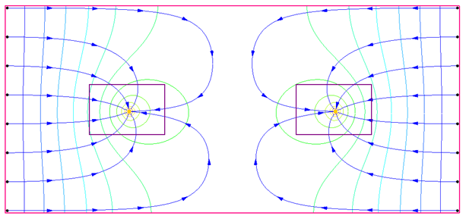

GMS 10.9

GMS 10.9 Tutorial

***MODFLOW-LGR Dual Refinement***

Create a MODFLOW-LGR model with two locally refined grids using GMS

Objectives

This tutorial builds on the MODFLOW-LGR tutorial and shows how to create more than one child grid. This tutorial covers parameters, MODPATH, and using the BFH package to check the accuracy of the coupled boundary heads and flows.

Time

* 20–35 minutes

Required Components

* GMS Core
* MODFLOW Interface
* MODPATH/MP3DU Interface

Prerequisite Tutorials

* MODFLOW-LGR

|  |
| --- |
| 1 Introduction 2  1.1 Getting Started 3  2 Opening the Starting Model 3  2.1 MODPATH 4  2.2 Parameters 4  2.3 Saving with a Different Name 5  3 Creating a Second Child Grid 5  4 LPF Package 6  5 Saving and Running MODFLOW 6  6 Examining Accuracy Using BFH Package 7  6.1 Turning on IUPBFSV and IUCBHSV 7  6.2 Turning on BFH Package 8  6.3 Saving and Running CHILD1 8  6.4 Examining the Accuracy 8  7 Adding Well to Child 9  7.1 Saving and Running CHILD1 10  7.2 Examining the Accuracy 10  8 Adding Well to Parent 11  8.1 Turning on BFH Package in the Parent Model 11  8.2 Saving and Running the Parent 12  8.3 Examining the Accuracy 12  9 Conclusion 13 |

# Introduction

MODFLOW-LGR allows for the creation of MODFLOW models that include locally refined regions, where smaller cell sizes are need for increased resolution. These refined regions are referred to as “child grids”, while the coarser surrounding domain is the “parent grid”. MODFLOW-LGR solves for heads and flows in both the child and parent grids using an iterative technique, ensuring consistency in boundary conditions along the shared grid interfaces.

MODFLOW-LGR supports multiple child grids. This tutorial builds on the “MODFLOW-LGR” tutorial and demonstrates how to create and work with multiple child grids. This tutorial includes the following topics:

* Importing an existing MODFLOW-LGR model
* Examining the MODPATH model
* Examining the parameters on the model
* Adding a second child grid
* Using the BFH package to evaluate the accuracy of coupled boundary heads and flows
* Saving and running MODFLOW-LGR

The problem used in this tutorial is one of the example models included with MODFLOW-LGR.[1] It is a simple, single-layer, confined, steady-state model featuring two extraction wells (Figure 1). No-flow boundaries are defined on the north and south sides, while specified head boundaries are applied on the east and west. Flow is generally directed toward the wells. In the initial setup, a child grid surrounds well on the left. For this tutorial, an additional child grid will be created around the well on the right.

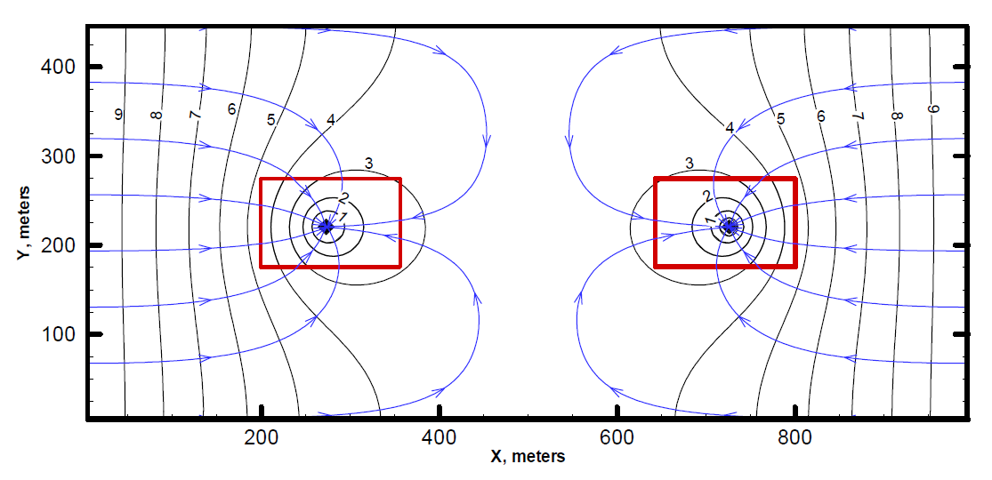

Figure 1 Sample problem to be solved[2]

## Getting Started

Do the following to get started:

1. If necessary, launch GMS.
2. If GMS is already running, select *File |* **New** to ensure that the program settings are restored to their default state. Click **Don’t Save** if asked to save changes.

# Opening the Starting Model

Start by opening the existing model.

1. Click **Open** File:Open Macro.svg to bring up the *Open* dialog.
2. Browse to the *mflgr-dual\mflgr-dual* directory for this tutorial and select “start.gpr”.
3. Click **Open** to import the project and close the *Open* dialog.

The main Graphics Window should appear similar to Figure 2.

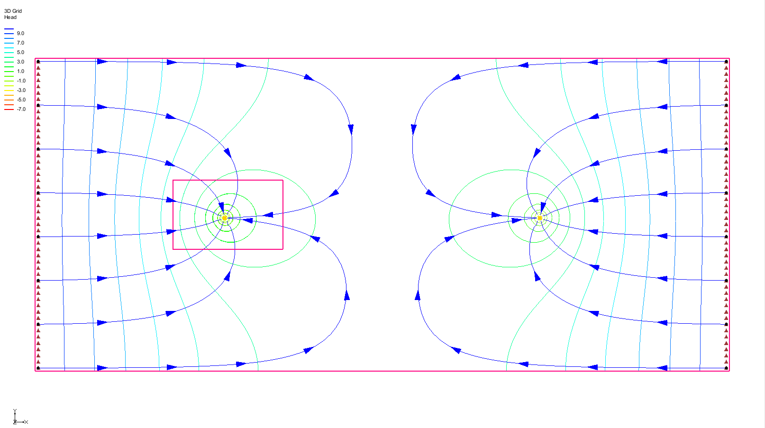

Figure 2 Starting model

## MODPATH

This model includes a child grid surrounding the well on the left side. Although the grid cell edges are turned off, the grid shell remains visible. The model also displays pathlines generated by MODPATH. These pathlines are based on the parent grid and were generated from a solution obtained by running MODFLOW-LGR independently on the parent model.

Note that MODPATH does not support pathlines crossing between parent and child grids. In GMS, both MODPATH particles and MODPATH solutions can be generated only on the parent model.

## Parameters

Both the parent and child models use parameters and clusters to define hydraulic conductivity.

1. Select *MODFLOW* | **Parameters…** to open the *Parameters* dialog.

Note that there are 5 defined parameters.

1. Click **Cancel** to close the *Parameters* dialog.
2. Select *MODFLOW |* **LPF – Layer Property Flow…** to bring up the *LPF Package – Parent* dialog.

Note the warning note at the bottom about LPF parameters. Additionally, in the *Layer data* section, note that the *Layer type* is set to *Confined*.

1. Click **Cancel** to close the *LPF Package – Parent* dialog.

Using parameters to define MODFLOW inputs is fully supported in MODFLOW-LGR. If desired, review the parameters defined for the CHILD1 model or examine the zone array associated with the parameter clusters.

## Saving with a Different Name

Before making any changes, save the project under a new name.

1. Select *File |* **Save As…** to bring up the *Save As* dialog.
2. Select “Project Files (*.gpr)” from the *Save as type* drop-down.
3. Enter “lgr-dual.gpr” as the *File name*.
4. Click **Save** to save the project under the new file name and close the *Save As* dialog.

Use the **Save** File:Save Macro.svg macro to periodically save the model as it is developed.

# Creating a Second Child Grid

Create another child grid around the well on the right.

1. Turn on the “File:Annotations Folder.svg Annotation Data” folder in the Project Explorer. A purple rectangle should appear around the well on the right.
2. Using the **Select Cells** File:Select 3D Cell Tool.svg tool, drag a box to select the cells within the purple rectangle.
3. Right-click in the selected area and select **Create Child Grid…** to bring up the *Create Child Grid* dialog (Figure 3).

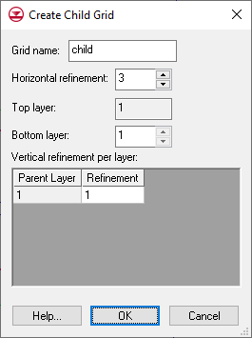

Figure 3 Create Child Grid dialog

1. For the *Grid name,* enter “CHILD2”.
2. For the *Horizontal refinement,* enter “9”*.*
3. Click **OK** to close the *Create Child Grid* dialog.
4. Turn off “File:Annotations Folder.svg Annotation Data” in the Project Explorer.

There are now two child grids (Figure 4).

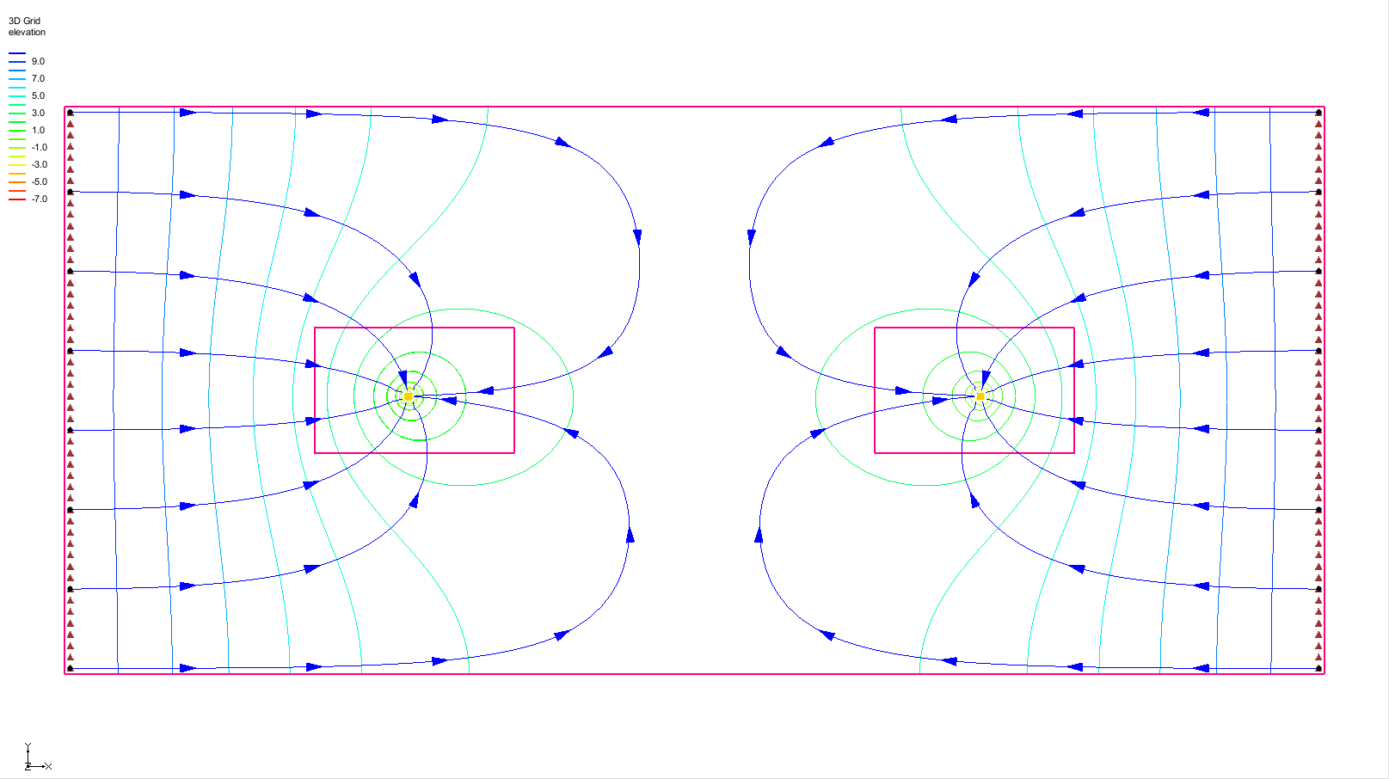

Figure 4 Two child grids visible

# LPF Package

Several settings in the LPF package now need to be modified. While the parent and CHILD1 models use parameters to define hydraulic conductivity, no parameters will be specified for CHILD2 to simplify the process and save time.

1. Select *MODFLOW* | **LPF – Layer Property Flow…** to open the *LPF Package – CHILD2* dialog.
2. In the *Layer data* section, select *Confined* as the *Layer type*.
3. Click **Horizontal Hydraulic Conductivity…** to bring up the *Horizontal Hydraulic Conductivity* dialog.
4. Click **Constant → Grid…** to bring up the *Grid Value* dialog.
5. For the *Constant value for grid*, enter “0.0005” and click **OK** to close the *Grid Value* dialog.
6. Click **OK** to exit the *Horizontal Hydraulic Conductivity* dialog.
7. Click **OK** to exit the *LPF Package – CHILD2* dialog.

# Saving and Running MODFLOW

Now it is possible to save and run MODFLOW.

1. **Save** File:Save Macro.svg the project.
2. Click the **Run MODFLOW** File:Run MODFLOW Macro.svg dialog to bring up the *MODFLOW* model wrapper dialog.
3. When the model finishes, turn on *Read solution on exit* and *Turn on contours (if not on already)*.
4. Click **Close** to import the solution, turn on contours, and close the *MODFLOW* model wrapper dialog.

Note that the pathlines have changed and no longer extend all the way to the wells (Figure 5). This occurs because the parent model terminates at the boundaries where the child models begin, and MODPATH does not track pathlines across parent-child model boundaries. To view the original pathlines, switch the solution back to the “start (MODFLOW)” solution.

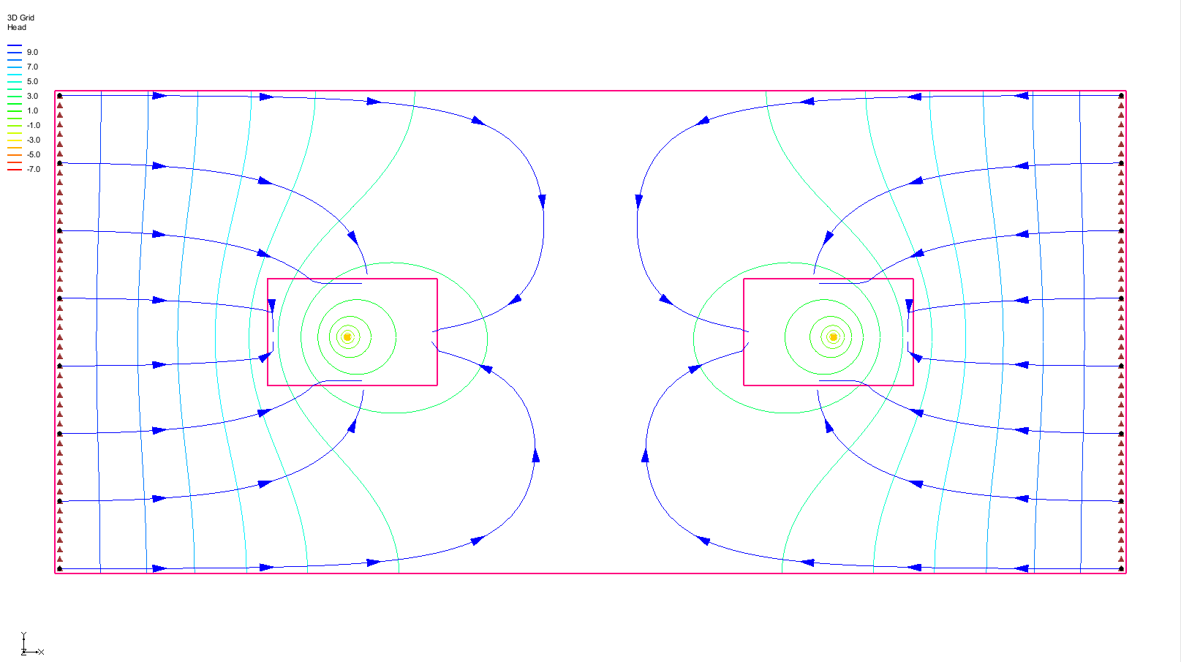

Figure 5 MODPATH pathlines do not continue to wells

# Examining Accuracy Using BFH Package

The “BFH – Boundary Head and Flow” package allows parent or child models to be run independently using coupling head and flow data generated from a previous MODFLOW-LGR run. This functionality was demonstrated in the “MODFLOW-LGR” tutorial. In addition to supporting independent runs, the BFH package can also be used to evaluate the accuracy of the parent-child model coupling. This section of the tutorial will demonstrate how to use the BFH package for this purpose.

## Turning on IUPBFSV and IUCBHSV

1. Expand the “3DGridFolder.png 3D Grid Data” folder in the Project Explorer.
2. Make the parent model active by clicking on its “File:MODFLOW Folder.svg MODFLOW” model or its   
   “File:3D Grid Icon.svg grid”.
3. Select *MODFLOW |* **Global Options…** to bring up the *MODFLOW Global/Basic Package – Parent* dialog.
4. Click **LGR Options…** on the right to bring up the *LGR Options* dialog.

Note that the *Save boundary fluxes (IUPBFSV)* option in the top-right is enabled, and the IUCBHSV option is also enabled for CHILD1 in the spreadsheet. This indicates that the coupling flow and head files were generated during the last coupled MODFLOW-LGR run involving both the parent and child models. If these options were not enabled, they would need to be turned on, and MODFLOW-LGR would need to be rerun in coupled mode to generate the necessary files.

1. Click **Cancel** to exit the *LGR Options* dialog.
2. Click **Cancel** to exit the *MODFLOW Global/Basic Package – Parent* dialog.

## Turning on BFH Package

It is now necessary to activate the BFH package.

1. Make the “CHILD1” model active in the Project Explorer by clicking on its   
   “File:MODFLOW Folder.svg MODFLOW” model or on “File:3D Grid Icon.svg CHILD1”.
2. Select *MODFLOW |* **Global Options…** to open the *MODFLOW Global/Basic Package – CHILD1* dialog.
3. Click **Packages…** to open the *MODFLOW Packages / Processes – CHILD1* dialog.
4. In the *Optional packages / processes* section, turn on *BFH – Boundary Flow and Head*.
5. Click **OK** to exit the *MODFLOW Packages / Processes – CHILD1* dialog.
6. Click **OK** to exit the *MODFLOW Global/Basic Package – CHILD1* dialog.

The file names specified in the BFH package could be reviewed at this point. However, in this case, the default names are automatically derived from the project file names, so manual review is not necessary.

## Saving and Running CHILD1

To save and run MODFLOW on just the CHILD1 model:

1. **Save** File:Save Macro.svg the project.
2. Under “File:3D Grid Icon.svg CHILD1”, right-click on “File:MODFLOW Folder.svg MODFLOW” and select **Run MODFLOW Uncoupled On Just This Model** to bring up the *MODFLOW – CHILD1* model wrapper dialog.
3. When the model finishes, turn on *Read solution on exit* and *Turn on contours (if not on already)*.
4. Click **Close** to import the solution, turn on contours, and close the *MODFLOW – CHILD1* model wrapper dialog.

## Examining the Accuracy

Now look at the accuracy of the parent/child coupling.

1. Expand the “File:Generic Folder Locked.svg lgr-dual_CHILD1 (MODFLOW)” solution in the Project Explorer and double-click on “External text file lgr-dual_CHILD1.out” to bring up the *View Data File* dialog. If *Never ask this again* has previously been turned on, this dialog will not appear. If this is the case, skip to step 3.
2. Select the desired text editor from the *Open with* drop-down and click **OK** to open “lgr-dual_CHILD1.out” and close the *View Data File* dialog.
3. Scroll to the very bottom of the file to find the “BFH: BOUNDARY FLUX COMPARISON” section (Figure 6).

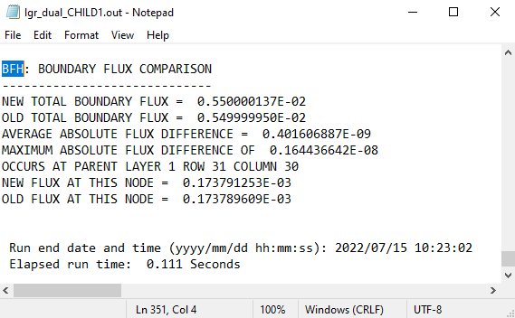

Figure 6 BFH Comparison data

The information displays the difference in flux across the boundary between the coupled and uncoupled model runs. While a difference is present, it is minimal. This comparison helps assess whether the boundary heads and flows remain valid when running or modifying a child model independently.

1. Exit out of the text editor dialog.

# Adding Well to Child

Now add another well to CHILD1 and see how it impacts the boundary flows.

1. Using the **Select Cells** File:Select 3D Cell Tool.svg tool, right-click somewhere in the upper right area of CHILD1 (the exact location is not important, see Figure 7 for approximate location) and select **Sources/Sinks…** to open the *MODFLOW Sources/Sinks – CHILD1* dialog.
2. From the list on the left, select “Wells (WEL)”.
3. Click **Add BC** to create a new entry in the spreadsheet above the button.
4. In the *Q (flow) (ft^3/s)* column, enter “-0.0055” (replacing the “0.0”). This is the same rate as the first well.
5. Click **OK** to close the *MODFLOW Sources/Sinks – CHILD1* dialog.

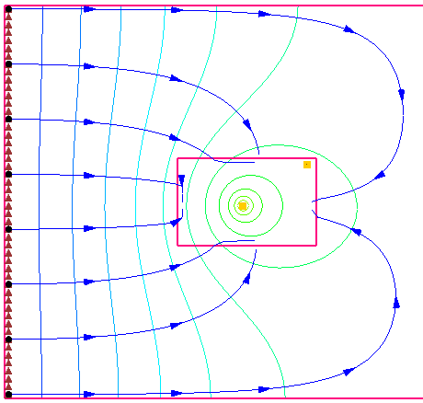

Figure 7 Creating a second well (indicated by arrow) in CHILD1

## Saving and Running CHILD1

Now save and run MODFLOW on just the CHILD1 model.

1. **Save** File:Save Macro.svg the project.
2. Under “File:3D Grid Icon.svg CHILD1”, right-click “File:MODFLOW Folder.svg MODFLOW” and select **Run MODFLOW Uncoupled On Just This Model** to bring up the *MODFLOW – CHILD1* model wrapper dialog.
3. When the model finishes, turn on *Read solution on exit* and *Turn on contours (if not on already)*.
4. Click **Close** to import the solution, turn on contours, and close the *MODFLOW – CHILD1* model wrapper dialog.

## Examining the Accuracy

Now to review the accuracy of the parent/child coupling:

1. Expand “File:Generic Folder Locked.svg lgr-dual_CHILD1 (MODFLOW)” in the Project Explorer.
2. Double-click on “External text file lgr-dual_CHILD1.out” to bring up the *View Data File* dialog. As before, this dialog may not appear. Skip to step 4 if it does not appear.
3. Select the desired text editor from the *Open with* drop-down and click **OK** to open “lgr-dual_CHILD1.out” and close the *View Data File* dialog.
4. Scroll to the bottom of the file and find the “BFH: BOUNDARY FLUX COMPARISON” section (Figure 8).

Notice the differences from the previous results (Figure 6) and determine if the difference is acceptable.

1. Exit out of the text editor dialog.

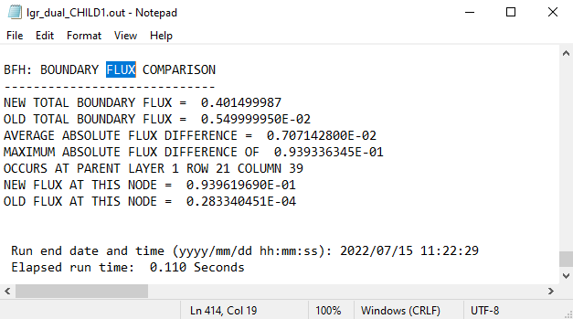

Figure 8 BFH comparison data with two wells in CHILD1

# Adding Well to Parent

Now to add a well to the parent and see how it affects the boundary heads.

1. Select the parent “File:3D Grid Icon.svg grid” in the Project Explorer to make it active.
2. Using the **Select Cells** File:Select 3D Cell Tool.svg tool, right-click somewhere between the two child grids (the exact location is not important as long as it is not within one of the child grids) and select **Sources/Sinks…** to open the *MODFLOW Sources/Sinks – Parent* dialog.
3. From the list on the left, select “Wells (WEL)”.
4. Click **Add BC** to create a new entry in the spreadsheet above the button.
5. In the *Q (flow) (ft^3/s)* column, enter “-0.0055” (replacing the “0.0”). This is the same rate as the other wells.
6. Click **OK** to create the new well and close the *MODFLOW Sources/Sinks – Parent* dialog.

## Turning on BFH Package in the Parent Model

To run the parent model independently, the BFH package must first be turned on.

1. Select *MODFLOW* | **Global Options…** to open the *MODFLOW Global/Basic Package – Parent* dialog.
2. Click **Packages…** to open the *MODFLOW Packages / Processes – Parent* dialog.
3. In the *Optional packages / processes* section, turn on *BFH – Boundary Flow and Head*.
4. Click **OK** to exit the *MODFLOW Packages / Processes – Parent* dialog.
5. Click **OK** to exit the *MODFLOW Global/Basic Package – Parent* dialog.

## Saving and Running the Parent

Now save and run MODFLOW on just the parent model.

1. **Save** File:Save Macro.svg the project.
2. Right-click on the parent “File:MODFLOW Folder.svg MODFLOW” model and select **Run MODFLOW Uncoupled On Just This Model** to bring up the *MODFLOW – Parent* model wrapper dialog.
3. When the model finishes, turn on *Read solution on exit* and *Turn on contours (if not on already)*.
4. Click **Close** to import the solution, turn on contours, and close the *MODFLOW – Parent* model wrapper dialog.

The Graphics Window should appear similar to Figure 9.

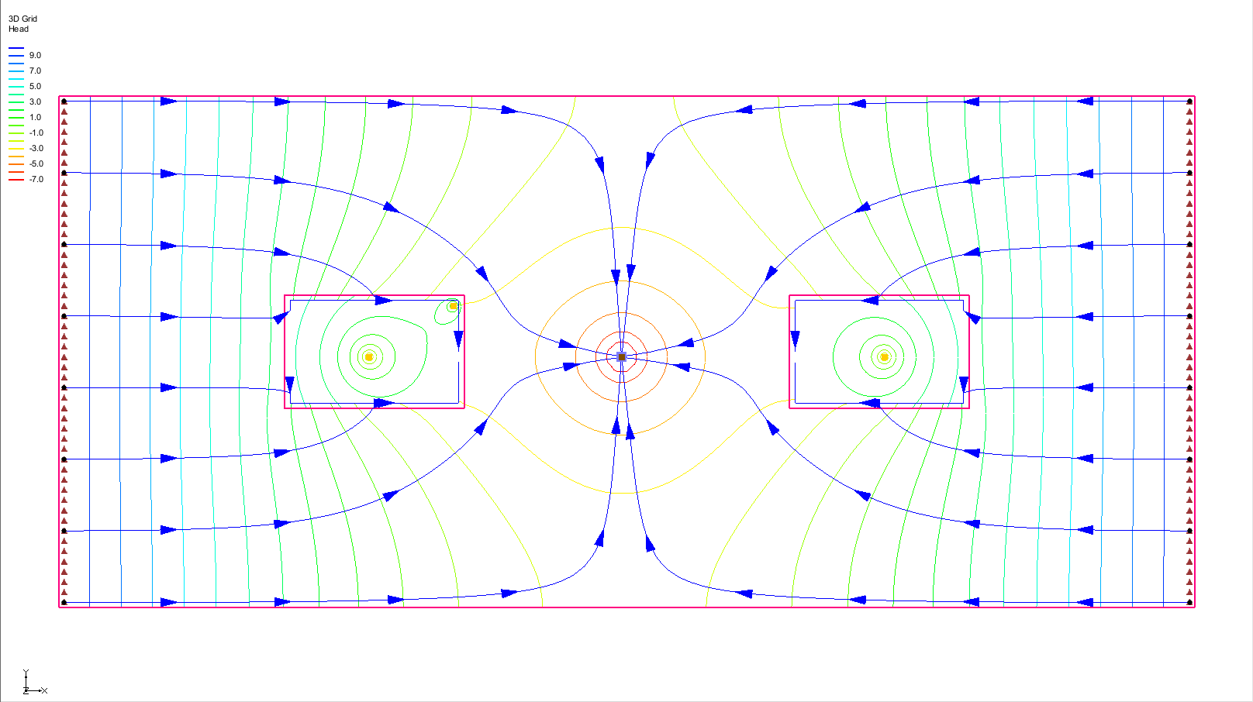

Figure 9 The new well is visible in the parent grid

## Examining the Accuracy

Again, look at the accuracy of the parent/child coupling.

1. Expand the “File:Generic Folder Locked.svg lgr-dual (MODFLOW)” solution in the Project Explorer.
2. Double-click on “External text file lgr-dual.out” to bring up the *View Data File* dialog. As before, this dialog may not appear. If it does not appear, skip to step 4.
3. Select the desired text editor from the *Open with* drop-down and click **OK** to open “lgr-dual.out” and close the *View Data File* dialog.
4. Scroll to the bottom of the file and find the “BFH: BOUNDARY HEAD COMPARISON” section.

This section now displays boundary heads instead of fluxes. Observe the magnitude of the head difference compared to the coupled model and evaluate whether the difference is within an acceptable range.

# Conclusion

This concludes the “MODFLOW – LGR Dual Refinement” tutorial. The following concepts were discussed and demonstrated:

* GMS supports MODFLOW-LGR simulations with multiple children
* MODPATH can be used with MODFLOW-LGR; however, pathlines do not cross parent-child borders
* In GMS, MODPATH can only be applied to the parent model
* Parameters can be used to define properties in MODFLOW-LGR models
* The BFH package can be used to evaluate the accuracy of the parent-child coupling and assess the effects of modifications in uncoupled models on boundary heads and flows

1. Mehl, Steffan W. and Hill, Mary C. (2007). “MODFLOW-2005, The U.S. Geological Survey Modular Ground-Water Model—Documentation of the Multiple-Refined-Areas Capability of Local Grid Refinement (LGR) and the Boundary Flow and Head (BFH) Package” in *U.S. Geological Survey Techniques and Methods 6-A21*, p.6. <http://pubs.usgs.gov/tm/2007/06A21/pdf/TM6-A21_508.pdf>.
2. Mehl (2007).