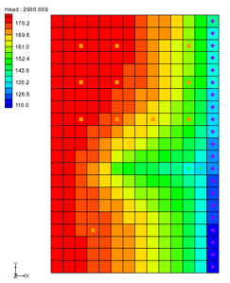

GMS 10.9

GMS 10.9 Tutorial

***MODFLOW – Non Vertical Wells and Pump Curves***

Using non vertical wells and pump performance curves in MNW2

Objectives

Learn how to use the non-vertical wells and pump capacity options from the MNW2 package in GMS.

Time

* 20–40 minutes

Required Components

* GMS Core
* MODFLOW Interface

Prerequisite Tutorials

* MODFLOW – MNW2 Package

|  |
| --- |
| 1 Introduction 2  2 Getting Started 3  2.1 Importing the Existing Model 3  2.2 Saving the Model with a New Name 4  3 Using MNW2 Horizontal Wells for Dewatering 4  3.1 Examining the Diaphragm Wall 4  3.2 Creating an MNW2 Coverage 5  3.3 Creating the Horizontal Well 5  3.4 Converting the Conceptual Model 7  3.5 Viewing the MNW2 Well 7  3.6 Running MODFLOW 8  3.7 Viewing the Water Table 8  4 Using a Pump Capacity Curve 8  4.1 Saving the Model with a New Name 8  4.2 Modifying the Existing Well 9  4.3 Converting the Conceptual Model and Running MODFLOW 9  4.4 Viewing the Water Table 10  5 Conclusion 10 |

# Introduction

This tutorial is divided into two parts. The first part demonstrates using MNW2 horizontal wells for dewatering. The model is a fictitious construction site. The second part demonstrates using a pump capacity curve in the model.

The problem to be solved in this tutorial is shown in Figure 1. The model is divided into 5 unconfined layers. The upper layers (layers 1 to 4) are permeable layers with hydraulic conductivity of 40 ft/day. The lower layer (layer 5) is an impermeable layer with hydraulic conductivity of 0.1 ft/day. A storage coefficient of 0.0001 and specified yield of 0.05 are assigned uniformly to all 5 layers.

The 60000-ft2 area is divided into 40 rows and 60 columns. Uniform, square cells of 5 feet are used in the model. Specified head values are assigned in layer 1 and are maintained at the same elevations for all the stress periods. The construction site is surrounded by a diaphragm wall to prevent water from infiltrating into the site.

This tutorial will discuss and demonstrate:

* Importing an existing MODFLOW simulation.
* Running the simulation.
* Examining the results to understand the MNW2 package options.
* Modifying a conceptual model to use MNW2 instead of the WEL package.



Figure 1 Site model

# Getting Started

Do the following to get started:

1. If necessary, launch GMS.
2. If GMS is already running, select *File |* **New** to ensure that the program settings are restored to their default state. Click **Don’t Save** if asked to save changes.

## Importing the Existing Model

To start with a MODFLOW model that has already been created:

1. Click **Open** File:Open Macro.svg to bring up the *Open* dialog.
2. Select “Project Files (*.gpr)” from the *Files of type* drop-down.
3. Browse to the *mnw2adv\mnw2adv* folder and select "mnw2.gpr".
4. Click **Open** to import the model and exit the *Open* dialog.

A grid with specified head boundary (CHD) conditions on the east side should be visible (Figure 2).

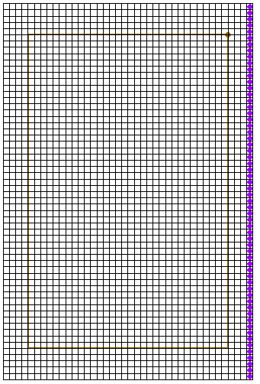

Figure 2 Imported MODFLOW model

## Saving the Model with a New Name

Now it is possible to start making changes. To save the model with a new name:

1. Select *File |* **Save As…** to bring up the *Save As* dialog.
2. Select “Project Files (*.gpr)” from the *Save as type* drop-down.
3. Enter "mnw2_horizontal.gpr" as the *File name*.
4. Click **Save** to save the project under the new name and exit the *Save As* dialog.

# Using MNW2 Horizontal Wells for Dewatering

## Examining the Diaphragm Wall

One of the main purposes of the diaphragm wall is to prevent water from infiltrating into the site. The diaphragm wall can be simulated in GMS by using the Horizontal Flow Barrier (HFB) Package.

1. Uncheck the "File:3D Grid Folder.svg 3D Grid Data" folder in the Project Explorer.
2. Right-click in the Project Explorer and select **Expand All**.
3. Select the "File:Coverage Active Icon.svg diaphragm wall" coverage to make it active.
4. Right-click on the "File:Coverage Active Icon.svg diaphragm wall" coverage and select the **Coverage Setup…** command to bring up the *Coverage Setup* dialog.

The *Default layer range* is from layer “1” to layer “4”. This makes the diaphragm wall extend through grid layers 1 to 4 when mapping to MODFLOW.

1. Click **OK** to close the *Coverage Setup* dialog.
2. Using the **Select Arcs**File:GMS Select Arc Tool.svgtool, double-click on the diaphragm wall arc to bring up the *Attribute Table* dialog.

Notice that the arc is assigned with *Type* of “barrier”and *Hyd. char.* (hydraulic characteristic) of “0.01”.

1. Click **OK** to close the *Attribute Table* dialog.

## Creating an MNW2 Coverage

The next step is to create a shallow horizontal well system to dewater the site. This can be accomplished using the nonvertical well capabilities available in MNW2.

First, it is necessary to create a new coverage.

1. Right-click on the "File:Conceptual Model Icon.svg Construction Site"conceptual model and select **New Coverage…** to bring up the *Coverage Setup* dialog.
2. Enter "MNW2" as the *Coverage name*.
3. Enter "50.0" as the *Default elevation*.
4. In the *Sources/Sinks/BCs* section, turn on *Wells (MNW2)*.
5. Click **OK** to close the *Coverage Setup* dialog.

## Creating the Horizontal Well

Now it is possible to create the horizontal well.

1. Using the **Create Point** File:Create Points Tool.svg tool, click anywhere in the window to create a point.
2. While the new point is selected, enter “42.5”, “247.5”, and “50” (respectively) into the *X*, *Y,* and *Z* edit fields at the top of the GMS window, pressing *Tab* or *Enter* after each one.
3. Using the **Select Points\Nodes** File:GMS Select Node Tool.svg tool, select the point that was just created by clicking on it and click on **Properties** File:GMS Properties Macro.svg to bring up the *Attribute Table* dialog.
4. In the spreadsheet in row *1*, enter “Well_A” in the *Name* column.
5. Select "well (MNW2)" from the drop-down in the *Type* column.
6. Select “<transient>” from the drop-down http://www.xmswiki.com/w/images/e/e4/Small_drop-down_arrow_button_from_Parameters_dialog.png in the *Qdes (ft^3/d)* column.
7. Click the http://www.xmswiki.com/w/images/0/0d/Attribute_Table_dialog_dot_dot_dot_ellipses_button.png button in the *Qdes (ft^3/d)* column to bring up the *XY Series Editor* dialog.
8. Enter the following into the *Time (d)* and *Qdes (ft^3/d)* columns in the spreadsheet on the left:

|  |  |
| --- | --- |
| Time | Qdes (ft^3/day) |
| 0 | -9000 |
| 5 | -9000 |
| 5 | -3000 |
| 30 | -3000 |

1. Click **OK** to close the *XY Series Editor* dialog.
2. Uncheck the box in the *Vertical Boreline* column.
3. Click the  button in the *Boreline* column to bring up the *Table* dialog.
4. Enter the following values:

|  |  |  |  |  |  |
| --- | --- | --- | --- | --- | --- |
| X screen begin (ft) | Y screen begin (ft) | Z screen begin (ft) | X screen end (ft) | Y screen end (ft) | Z screen end (ft) |
| 42.5 | 247.5 | 27.0 | 42.5 | 247.5 | 26.0 |
| 42.5 | 247.5 | 26.0 | 42.5 | 48.5 | 26.0 |
| 42.5 | 48.5 | 26.0 | 157.5 | 48.5 | 26.0 |
| 157.5 | 48.5 | 26.0 | 157.5 | 247.5 | 26.0 |
| 157.5 | 247.5 | 26.0 | 42.5 | 247.5 | 26.0 |

1. Click **OK** to close the *Table* dialog.
2. Select "THIEM" from the drop-down in the *LOSSTYPE* column.
3. Scroll to the right and enter "0.5" in the *Rw* column.
4. Click **OK** to close the *Attribute Table* dialog.

The horizontal well should look similar to one shown in Figure 3:

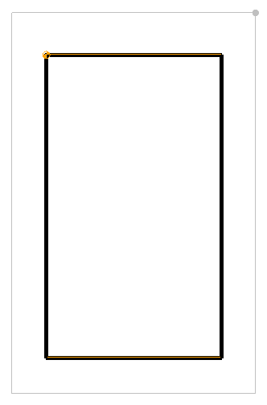

Figure 3 Horizontal well

## Converting the Conceptual Model

It is now possible to convert the conceptual model from the feature object-based definition to a grid-based MODFLOW numerical model.

1. Right-click on the "File:Conceptual Model Icon.svg Construction Site" conceptual model and select *Map To |* **MODFLOW/MODPATH** to bring up the *Map → Model* dialog.
2. Select *All applicable coverages* and click **OK** to close the *Map → Model* dialog.
3. Switch to **Ortho Mode** File:Ortho View Macro.svg.
4. Change to layer 2 using the up arrow Increment up arrow.png by *Lay (k)* in the *Mini Grid Toolbar*.
5. Turn on the "File:3D Grid Folder.svg 3D Grid Data" folder.

Notice that the cells underlying the barrier and wells were all identified and assigned the appropriate sources/sinks.

1. Click on the "File:3D Grid Folder.svg 3D Grid Data" folder to switch to the 3D Grid module.
2. Using the **Select Cells** File:Select 3D Cell Tool.svg tool, select a grid cell somewhere in the middle of the model.
3. Switch to **Front View** File:Front View Macro.svg.

Notice the horizontal barriers extending from layers 1 through 4 on the left and right sides and the horizontal well in layer 2 (Figure 4).

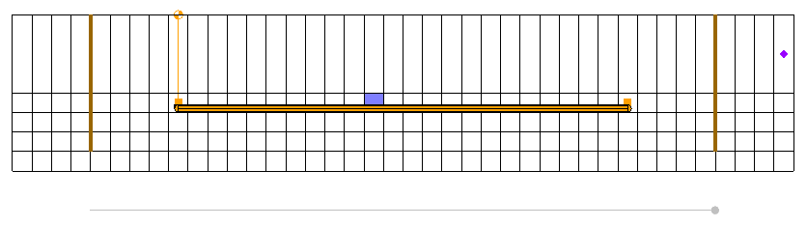

Figure 4 Model in front view

## Viewing the MNW2 Well

Before running the simulation, it is possible to look at the well in the MNW2 package data that was created using the conceptual approach.

1. Select *MODFLOW* | *Optional Packages* | **MNW2 – Multi-Node Well…** to open the *MODFLOW Multi-Node Well (MNW2) Package* dialog.
2. Click **Wells…** to bring up the *MNW2 Wells* dialog.
3. Select any cell in row *1* of the spreadsheet (for “Well_A”).

Notice the nodes for “Well_A” are listed in the *Nodes for WELLID: “Well_A”, row #1* spreadsheet. These nodes are automatically assigned to the appropriate cells based on the conceptual model.

1. Click **OK** to exit the *MNW2 Wells* dialog.
2. Click **OK** to exit the *MODFLOW Multi-Node Well (MNW2) Package* dialog.

## Running MODFLOW

Now it is possible to save the changes and run MODFLOW.

1. **Save** File:Save Macro.svg the project.
2. Click **Run MODFLOW** File:Run MODFLOW Macro.svg to bring up the *MODFLOW* model wrapper dialog.
3. When MODFLOW finishes, turn on *Read solution on exit* and *Turn on contours (if not on already)*.
4. Click **Close** to import the solution and close the *MODFLOW* model wrapper dialog.
5. **Save** File:Save Macro.svg the project with the new solution.

## Viewing the Water Table

Now view the solution at different time steps to see the drawdown.

1. Expand the "File:Generic Folder Locked.svg mnw2_horizontal (MODFLOW)" solution in the Project Explorer and select the "File:Dataset Cells Active.svg Head" dataset.
2. Use the Time Steps window below the Project Explorer to cycle through the different time steps of the solution and see how the pumping schedules of the well affect the water level.

Note that the water level keeps decreasing for the first 5 days. After lowering the pumping rate after 5 days, the water level seems to reach a steady state for the site. This is consistent with the pumping schedule that was entered. Feel free to adjust the pumping rate to see how it affects the water table. The last time step should appear similar to Figure 5.

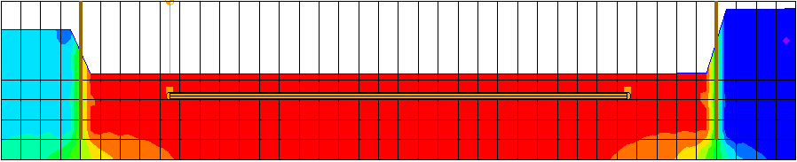

Figure 5 Water table at the end of the simulation

# Using a Pump Capacity Curve

## Saving the Model with a New Name

Before examining the pump-capacity curve option in MNW2, it would be good to save the model with a new name.

1. Select *File |* **Save As…** to bring up the *Save As* dialog.
2. Select “Project Files (*.gpr)” from the *Save as type* drop-down.
3. Enter "mnw2_pumpcurve.gpr" as the *File name*.
4. Click **Save** to save the project under the new name and close the *Save As* dialog.

## Modifying the Existing Well

Now to apply the pumping curve to the existing well:

1. Select the "File:Coverage Active Icon.svg MNW2" coverage in the Project Explorer to make it active.
2. Using the **Select Points\Nodes** File:GMS Select Node Tool.svg tool, click on the well well to select it.
3. Click **Properties** File:GMS Properties Macro.svg to bring up the *Attribute Table* dialog.
4. In the spreadsheet, scroll to the right and check the box in the *PUMPCAP* column.
5. Scroll to the right and enter "50.0" in the *Hlift* column.
6. Scroll to the right and click on the  button in the *Pump capacity curve* column to bring up the *XY Series Editor* dialog.
7. Enter the following data into the spreadsheet:

|  |  |
| --- | --- |
| Yield (ft^3/d) | Total Dynamic Head (ft) |
| 0.0 | 15.0 |
| 3000.0 | 14.0 |
| 5000.0 | 13.0 |
| 7000.0 | 10.0 |
| 9000.0 | 6.0 |

1. Click **OK** to close the *XY Series Editor* dialog.
2. Enter "1.0"in the *Pump capacity mult* column.
3. Click**OK** to close the *Attribute Table* dialog*.*

The option to use pump capacity was turned on in step 4. In step 5, the *Hlift* value was specified as 50 ft. *Hlift* is the reference head (or elevation) corresponding to the discharge point. In this tutorial, the top elevation is at 50 ft. Assume that the pump is placed at the top elevation.

In steps 6–8, the pump capacity curve was defined. The model will calculate the pumping rate based on these numbers. If the water level is from 50 ft (at top elevation) to 44 ft (top elevation minus 6.0 ft), the pump will withdraw water at 9000 ft3/d. The model will interpolate the pumping rate linearly for water levels between 44 ft to 35 ft (top elevation: 15.0 ft) based on the provided numbers. If the water level falls below 35 ft, the model will shut down the well.

In step 9, the pump capacity multiplication was specified as “1.0”. This means that the head-capacity relations defined in step 7 are used. If any value less than or equal to “0.0” is specified, the head-capacity relations will be ignored for that particular stress period. Any other positive value, such as “2.0”, can be specified. The model will adjust the withdrawal rate from the head-capacity curve by multiplying the withdrawal rate by the pump capacity multiplication factor.

For this example, the exact head-capacity curve for all the stress periods was used. Therefore, a constant value of “1.0” was specified for the pump capacity multiplication factor.

## Converting the Conceptual Model and Running MODFLOW

The next step is to convert the changes to MODFLOW, and then run a new simulation.

1. Right-click on the "File:Coverage Active Icon.svg MNW2" coverage and select *Map To |* **MODFLOW/MODPATH** command.

This updates the well and makes it possible to save the changes and run MODFLOW.

1. **Save** File:Save Macro.svg the project.
2. **Run MODFLOW** File:Run MODFLOW Macro.svg to bring up the *MODFLOW* model wrapper dialog.
3. When MODFLOW finishes, turn on *Read solution on exit* and *Turn on contours (if not on already)*.
4. Click **Close** to import the solution and exit the *MODFLOW* model wrapper dialog.
5. **Save** File:Save Macro.svg the project with the new solution.

## Viewing the Water Table

Now to examine the new results:

1. Expand the "File:Generic Folder Locked.svg mnw2_pumpcurve (MODFLOW)" solution in the Project Explorer and select the "File:Dataset Cells Active.svg Head" dataset.
2. Use the Time Steps window to cycle through the time steps of the solution.

Notice that the pump does not always perform at full capacity and the water level at the end of 5 days is much higher compared to the previous scenario (Figure 6). The flow budget may be used to see the change in pumping rate over time.

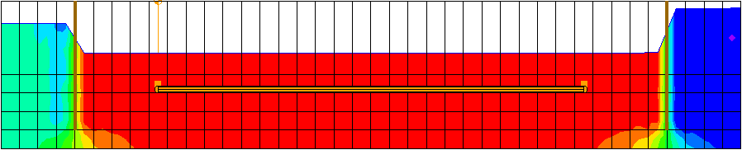

Figure 6 Water table after the first 5 days

# Conclusion

This concludes the “MODFLOW – Nonvertical Wells and Pump Curves” tutorial. The following key concepts were discussed and demonstrated:

* GMS supports the MNW2 package.
* It is possible to specify nonvertical wells using MNW2.
* It is possible to specify head-capacity pumping curves in MNW2.
* MNW2 wells can be created in the conceptual model and mapped to the grid.