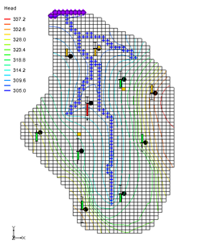

GMS 10.9

GMS 10.9 Tutorial

***MODFLOW – Model Calibration***

Manually vary input values and use observations to calibrate a MODFLOW model

Objectives

GMS contains a suite of tools to assist in the model calibration process, including observation points and different types of plots. These tools are described in this tutorial. A MODFLOW model is manually calibrated by adjusting inputs and watching how the computed values compare to the observed values.

Time

* 25–40 minutes

Required Components

* GMS Core
* MODFLOW Interface

Prerequisite Tutorials

* MODFLOW – Conceptual Model Approach I

|  |
| --- |
| 1 Introduction 2  1.1 Description of Problem 2  1.2 Getting Started 4  2 Importing the Model 4  3 Observation Data 5  4 Entering Observation Points 5  4.1 Creating a Coverage with Observation Properties 5  4.2 Creating an Observation Point 6  4.3 Calibration Target 6  4.4 Point Statistics 7  5 Reading in a Set of Observation Points 8  5.1 Deleting the Observation Point 8  5.2 Importing Points 8  5.3 Text Import Wizard 8  6 Entering the Observed Stream Flow 9  7 Viewing the Solution 10  7.1 Error Summary 10  7.2 Computed vs. Observed Data Plot 11  8 Editing the Hydraulic Conductivity 12  9 Converting the Model 13  10 Computing a Solution 13  10.1 Saving the Simulation 13  10.2 Running MODFLOW 13  11 Error vs. Simulation Plot 14  12 Continuing the Trial-and-Error Calibration 15  12.1 Changing Values vs. Changing Zones 15  12.2 Viewing the Answer 15  13 Conclusion 16 |

# Introduction

An important part of any groundwater modeling exercise is the model calibration process. In order for a groundwater model to be used in any type of predictive role, it must be demonstrated that the model can successfully simulate observed aquifer behavior. Calibration is a process where certain parameters of the model, such as recharge and hydraulic conductivity, are altered in a systematic fashion and the model is repeatedly run until the computed solution matches field-observed values within an acceptable level of accuracy.

The model calibration exercise in this tutorial is based on the MODFLOW model. Thus, it is recommended to complete the “MODFLOW – Conceptual Model Approach I” tutorial prior to beginning this tutorial. Although this particular exercise is based on MODFLOW, the calibration tools in GMS are designed for general-purpose and can be used with any model.

## Description of Problem

A groundwater model for a medium-sized basin is shown in Figure 1. The basin encompasses 72.5 square kilometers. It is in a semi-arid climate, with average annual precipitation of 0.381 m/yr. Most of this precipitation is lost through evapotranspiration. The recharge that reaches the aquifer eventually drains into a small stream at the center of the basin. This stream drains to the north and eventually empties into a lake with elevation 304.8 meters. Three wells in the basin also extract water from the aquifer. The perimeter of the basin is bounded by low-permeability crystalline rock. There are ten observation wells in the basin. There is also a stream flow gauge at the bottom end of the stream.

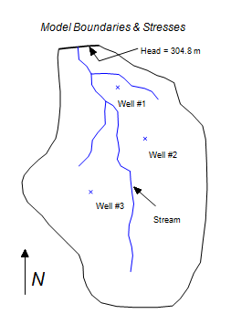

Figure 1 Sample model used in calibration exercise

The assumed recharge and hydraulic conductivity zones for the model are shown in Figure 2. The model region encompasses fractured and weathered bedrock as well as alluvial material, grading from hydraulically tighter materials in the south to more permeable materials in the north. Furthermore, the materials around the stream tend to be coarser, cleaner, and more permeable. The topmost region of the model near the lake has a high level of phreatophytic plant life.

The first task of this exercise will be to import a single-layer, unconfined MODFLOW model that has been constructed for the site. This model contains an initial estimate of hydraulic conductivities and recharge. A solution computed with this initial model will then be imported and the error in the initial solution will be analyzed. New values for hydraulic conductivity and/or recharge will be entered, a new MODFLOW solution will be generated, and a new error estimate will be computed and plotted. These steps should be repeated until the error is reasonably small.

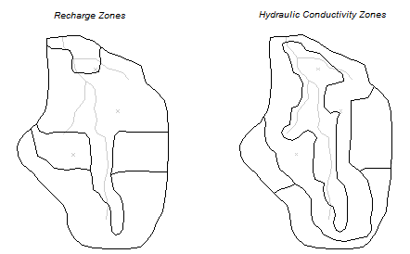

Figure 2 Recharge and hydraulic conductivity zones

## Getting Started

Do the following to get started:

1. If necessary, launch GMS.

If GMS is already running, select *File |* **New** to ensure that the program settings are restored to their default state.

1. If asked to save changes, click **Don’t Save** to close the dialog and restore GMS to a default state.

# Importing the Model

First, import the model:

1. Click **Open** File:Open Macro.svg to bring up the *Open* dialog.
2. Select “Project Files (*.gpr)” from the *Files of type* drop-down.

Browse to the *calib\calib* directory and select “bigval.gpr”.

Click **Open** to import the project and exit the *Open* dialog.

Right-click in the Project Explorer and select **Expand All**.

Both a grid and a conceptual model should appear (Figure 3). The conceptual model was used to construct the MODFLOW model and consists of three coverages. The currently active coverage contains the model boundary, the specified head boundary, the stream, and the wells. There is also a coverage of recharge zones and a coverage of hydraulic conductivity zones. For the initial simulation, a single value of hydraulic conductivity (2.4 m/day) and a single value of recharge (7.62e-5 m/day) have been assigned. The polygonal zones of hydraulic conductivity and recharge will be edited as the tutorial progresses to reduce the model error.

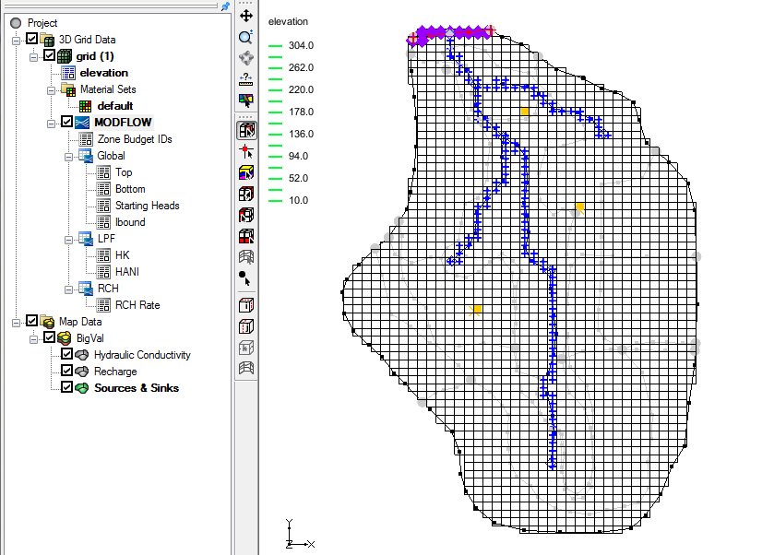

Figure 3 Initial screen showing the model and three coverages

# Observation Data

The tutorial will be using two types of observation data in the calibration process: water table elevations from observation wells and observed flow rates in the stream. Since the model is in a fairly arid region, assume that most of the flow to the stream is from groundwater flow.

# Entering Observation Points

First, it is necessary to enter a set of observation points representing the observed head in the ten observation wells in the region. Observation points are created in the Map module.

## Creating a Coverage with Observation Properties

Before entering observation points, create a coverage with observation properties:

1. Right-click on “File:Conceptual Model Icon.svg BigVal” in the Project Explorer and select **New Coverage…** to bring up the *Coverage Setup* dialog.

For the *Coverage name,* enter “Observation Wells”.

In the *Observation Points* column, turn on *Head*.

From the *3D grid layer option for obs. pts.* drop-down, select “By layer number”.

Click **OK** to exit the *Coverage Setup* dialog.

## Creating an Observation Point

It is now possible to create an observation point. To create the point, do the following:

1. Select the “File:Coverage Active Icon.svg Observation Wells” coverage to make it active.

Using the **Create Point** File:Create Points Tool.svg tool, click once anywhere on the model to create a new point.

In the *XYZS Bar*, enter “4470” for *X* and “9965” for *Y* (Figure 4). This will move the point to those coordinates.



Figure 4 XYZS Bar

To assign the properties to the point:

With the point still selected, click **Properties** File:GMS Properties Macro.svg to bring up the *Attribute Table* dialog.

In the *Name* column of the spreadsheet, enter “Point #1”.

From the drop-down in the *Type* column, select “obs. pt”.

From the *Obs. Head* column, enter “305”.

From the *Obs. Head interval* column, enter “1.5”.

This interval represents the estimated error (±) in the observed value. This confidence value represents the confidence in the error estimate. The interval can be used as a calibration target. Calibration is achieved when the error is within the estimated error interval (± 1.5 m, in this case) of the observed value. In other words, if the computed head falls between 303.5 and 306.5, the calibration target is reached for this observation well.

In the *Obs. Head conf(%)* column, enter “95”.

Click **OK** to close the *Attribute Table* dialog.

## Calibration Target

At this point, a calibration target like the one shown in Figure 5 typically shows up next to the observation point. However, the observation measurement model in this case is MODFLOW. With MODFLOW, the simulation must be run, and the solution imported before the calibration targets appear. This is because the computed values are output by MODFLOW and are not calculated internally by GMS.

To make the calibration targets appear, run MODFLOW and import the solution.

1. Select *File* | **Save As…** to bring up the *Save As* dialog.
2. From the *Save as type* drop-down select “Project Files (*.gpr)”.

For the *File name* enter **“**run2.gpr”.

Click **Save** to exit the *Save As* dialog.

Select the “File:3D Grid Folder.svg 3D Grid Data” folder in the Project Explorer to make it active.

Click **Run MODFLOW** File:Run MODFLOW Macro.svg to bring up the *MODFLOW* model wrapper dialog.

When MODFLOW finishes running, turn on *Read solution on exit* and *Turn on contours (if not on already)*.

Click **Close** to exit the *MODFLOW* model wrapper dialog.

Note: A calibration target is now drawn next to the point (Figure 5).

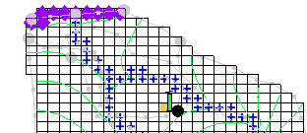

Figure 5 Green error bar on calibration target

The components of a calibration target are illustrated in Figure 6. The center of the target corresponds to the observed value. The top of the target corresponds to the observed value plus the interval and the bottom corresponds to the observed value minus the interval.

The colored bar represents the error. If the bar lies entirely within the target, the color bar is drawn in green. If the bar is outside the target but the error is less than 200%, the bar is drawn in yellow. If the error is greater than 200%, the bar is drawn in red. In this case, the bar should be green.



Figure 6 Calibration target

## Point Statistics

More detailed statistics concerning the error at the point can be viewed by selecting the point.

1. Select the “File:Map Folder.svg Map Data” folder in the Project Explorer to make it active*.*

Using the **Select Points\Nodes** File:GMS Select Node Tool.svg tool, click on the observation point.

Notice that a set of statistics related to the point is displayed in the Status Bar at the bottom left side of the GMS screen (Figure 7).



Figure 7 Status bar showing information on the selected observation point

# Reading in a Set of Observation Points

The next step would be to enter the remaining nine observation points. In the interest of time, simply import a previously prepared map file containing all ten points.

## Deleting the Observation Point

Before importing the map file containing the observation points, delete the point that was created in the *Observation Wells* coverage.

1. Using the **Select Points\Nodes**File:GMS Select Node Tool.svg tool, right-click on the point that was created earlier and select **Delete**.

## Importing Points

Now to import a file containing several observation points:

1. Click **Open** File:Open Macro.svg to bring up the *Open* dialog.
2. From the *Files of type* drop-down, select “Text Files (*.txt;*.csv)”.

Select “obswells.txt” and click **Open** to exit the *Open* dialog and bring up the *Step 1 of 2* page of the *Text Import Wizard* dialog.

## Text Import Wizard

Opening a TXT file in GMS will bring up the *Text Import Wizard*. In the first step of the wizard, it is necessary to identify the delimiters that separate the data into columns. In the second step of the wizard, map the columns to fields that GMS recognizes.

1. In the section below the *File import options* section, turn on *Heading row*.

Click **Next >** to go to the *Step 2 of 2* page of the *Text Import Options* dialog.

From the *GMS data type* drop-down, select “Observation data”.

Note: In the file preview section of the dialog, GMS has mapped the different columns of data in the file into fields recognized by GMS. No changes need to be made here.

Click **Finish** to import the observation data and close the *Text Import Wizard* dialog.

Ten observation wells will appear (Figure 8).

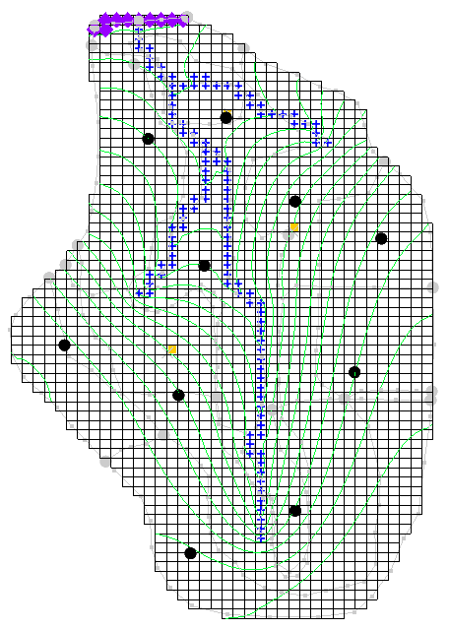

Figure 8 The imported observation wells

# Entering the Observed Stream Flow

Now that the observation points are defined, the observed flow in the stream can be entered. Observed flows are assigned directly to arcs and polygons in the local source/sink coverage of the conceptual model. MODFLOW determines the computed flow from the aquifer to the stream. This flow value will be compared to the observed flow.

GMS provides two methods for assigning observed flow: to individual arcs or to a group of arcs. The stream flow that was measured at the site represents the total flow from the aquifer to the stream at the stream outlet at the top of the model. This flow represents the flow from the aquifer to the stream for the entire stream network. Thus, the observed flow can be assigned to a group of arcs. When reading a solution, GMS will then automatically sum the computed flow for all arcs in the group.

Before assigning the observed flow, first create an arc group:

1. Right-click on the “File:Coverage Active Icon.svg Sources & Sinks” coverage and select **Coverage Setup…** to open the *Coverage Setup* dialog.

In the *Sources/Sinks/BCs* column, turn on *Observed Flow*.

Click **OK** to exit the *Coverage Setup* dialog.

Select “File:Coverage Active Icon.svg Sources & Sinks” to make it active.

Using the **Select Arcs** File:GMS Select Arc Tool.svg tool while holding down the *Shift* key, click on each of the river arcs. Be sure to select all six arcs.

Select *Feature Objects |* **Create Arc Group**.

This creates a new object out of the selected objects. It is now possible to assign an observed flow to the arc group.

Using the **Select Arc Groups** File:GMS Select Arc Group Tool.svg tool, double-click on any of the river arcs to open the *Attribute Table* dialog.

In the spreadsheet check the box in the *Obs. flow* column.

In the *Obs. flow rate (m^3/d)* column, enter “-4644”.

In the *Obs. flow interval* column, enter “210”*.*

The entered values indicate that, to achieve calibration, the computed flow should be between -4434 and -4854 m3/day (4644 +/- 210).

Click **OK** to exit the *Attribute Table* dialog.

Click outside the arc group to deselect it.

**Save**File:Save Macro.svg the project.

Select *MODFLOW* | **Run MODFLOW** to bring up the *MODFLOW* model wrapper dialog.

When the model finishes running, turn on *Read solution on exit* and *Turn on contours (if not on already)*.

Click **Close** to exit the *MODFLOW* model wrapper dialog.

At this point, a calibration target should appear for the observed flow on the arc group (Figure 9).

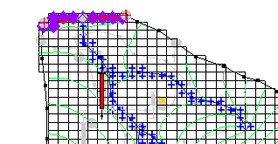

Figure 9 Calibration target for the river arc group observed flow

# Viewing the Solution

The contours currently shown on the 3D grid are the heads from the MODFLOW run with the ideal parameter values.

## Error Summary

Now look at the observation targets in the map model and the error associated with this model run.

1. Select the “File:Coverage Active Icon.svg Sources & Sinks” coverage to make it active*.*

Using the **Select Arc Groups** File:GMS Select Arc Group Tool.svg tool, select the arc group by clicking on the river arc.

Note: The computed and observed flow is reported in the status bar at the bottom of the Graphics Window.

Right-click on the “File:Generic Folder Locked.svg run2 (MODFLOW)”solution in the Project Explorer and select **Properties…** to open the *Properties* dialog.

This dialog shows a spreadsheet giving the error from this model run. The spreadsheet shows the error from the head observations, the flow observations, and the combined weighted observations.

1. When finished viewing the properties, click **OK** to close the *Properties* dialog.

## Computed vs. Observed Data Plot

Next, generate some plots related to the calibration error. Create two plots related to the error at the observation points.

1. Click **Plot Wizard** File:Plot Wizard Macro.svg to open the *Step 1 of 2* page of the *Plot Wizard* dialog.

From the list on the left, select “Computed vs. Observed Data”.

Click **Next >** to go to the *Step 2 of 2* page of the *Plot Wizard* dialog.

Click **Finish** to close the *Plot Wizard* dialog.

In the first plot, a symbol is drawn for each of the observation points (Figure 10). A point that plots on or near the diagonal line indicates a low error. Points far from the diagonal have a larger error.

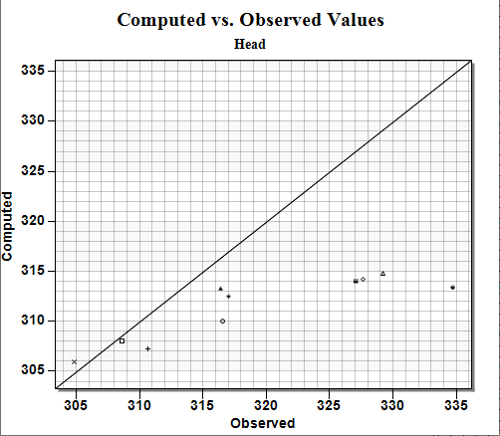

Figure 10 Ten observation points plotted

# Editing the Hydraulic Conductivity

The next step in the calibration exercise is to change the model parameters and re-run the model. Note that the errors are currently mostly red and negative on the “Observation Wells” coverage. This indicates the observed value is much larger than the current computed value. Begin with changing the hydraulic conductivity in these zones. Then edit the hydraulic conductivity by changing the hydraulic conductivity assigned to the polygonal zones in the conceptual model.

Before editing the hydraulic conductivity values, make the hydraulic conductivity zone coverage the active coverage.

1. Select the “File:Coverage Active Icon.svg Hydraulic Conductivity” coverage to make it active.

To edit the hydraulic conductivity values:

Using the **Select Polygons** File:GMS Select Polygon Tool.svg tool while holding the *Shift* key, select polygons 1 and 2 as shown in Figure 11.

Click **Properties** File:GMS Properties Macro.svg to open the *Attribute Table* dialog.

On the *All* row, in the *Horizontal K (m/d)* column, enter “0.6”. This changes the value for both polygons at the same time.

Click **OK** to close the *Attribute Table* dialog.

Double-click on polygon 3 as shown in Figure 11 to open the *Attribute Table* dialog.

In the *Horizontal K (m/d)* column, enter “0.15”.

Click **OK** to close the *Attribute Table* dialog.

Click outside the model to deselect the polygon.



Figure 11 Polygons to be selected

# Converting the Model

Now that the values have been edited, the next step is to convert the conceptual model to the grid-based numerical model:

1. Click**Map → MODFLOW** File:Map to MODFLOW Macro.svg to bring up the *Map → Model* dialog.

Select *All applicable coverages* and click **OK** to close the *Map → Model* dialog.

# Computing a Solution

The next step is to save the MODFLOW model with the new values and compute a new solution.

## Saving the Simulation

To save the simulation:

1. Select *File* | **Save As…** to bring up the *Save As* dialog.
2. Select “Project Files (*.gpr)” from the *Save as type* drop-down.

Enter “run3.gpr” as the *File name*.

Click **Save** to close the *Save As* dialog.

## Running MODFLOW

Do the following to run MODFLOW:

1. Click **Run MODFLOW** File:Run MODFLOW Macro.svg to bring up the *MODFLOW* model wrapper dialog.

When the MODFLOW simulation is completed, turn on *Read solution on exit* and *Turn on contours (if not on already)*.

Click **Close** to import the solution and close the *MODFLOW* model wrapper dialog.

Note: The plot in the *Plot Window* has been updated (Figure 12). Although the error improved for the observation wells, the head is still too low on the left and right sides of the model. Up to this point, the tutorial has not paid attention to the flow target on the arc group. In the next section, create a plot that shows how well the flow target is being met.

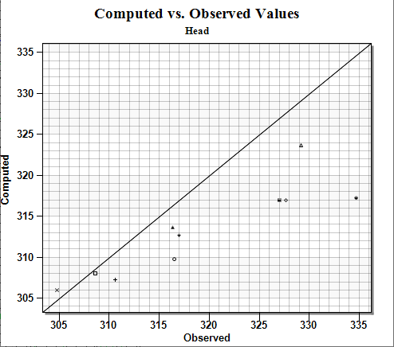

Figure 12 Notice how several of the points are closer to the line

# Error vs. Simulation Plot

When performing trial-and-error calibration, it is important to keep track of the trend in the error as new solutions are repeatedly computed. GMS provides a special calibration plot to simplify this task.

1. Click **Plot Wizard** File:Plot Wizard Macro.svg to bring up the *Step 1 of 2* page of the *Plot Wizard* dialog.

From the list on the left, select “Error vs. Simulation”.

Click **Next >** to go to the *Step 2 of 2* page of the *Plot Wizard* dialog.

Click **Finish** to close the *Plot Wizard* dialog.

The change in each of the three error norms from one solution to the next is clearly visible in the new plot (Figure 13). The plot is updated as each new solution is imported. Ideally, the error should gradually become smaller and smaller as changes are made to the model. If a bad choice is made in changing the model, the error may temporarily increase. In most cases, it is a good idea to keep a log of the changes made and the resulting errors.

When finished viewing the plot, close File:Windows10 Close button.png the *Plot* dialog.

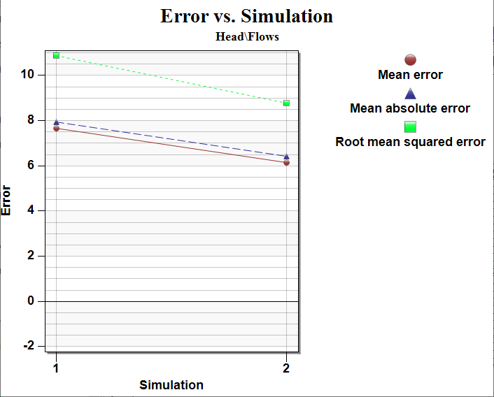

Figure 13 The change in error is more clearly visible

# Continuing the Trial-and-Error Calibration

At this point, continue with the trial-and-error calibration process using the steps outlined above. If changing the recharge and the hydraulic conductivity values, be sure to make the coverage visible by selecting it in the Project Explorer.

## Changing Values vs. Changing Zones

For this tutorial, a good match between the computed and observed values can be obtained simply by changing the hydraulic conductivity and recharge values assigned to the polygonal zones. In a real application, however, the size and distribution of the zones may need to be changed in addition to the values assigned to the zones.

## Viewing the Answer

To view the “answer,” a map file can be imported that contains a set of parameter values that result in a solution that satisfies the calibration target for each of the ten observation wells.

Before importing the new conceptual model, delete the “BigVal” conceptual model:

1. Right-click on the “File:Conceptual Model Icon.svg BigVal” conceptual model and select **Delete**.

To import the new conceptual model:

Click **Open** File:Open Macro.svg to bring up the *Open* dialog.

From the *Files of type* drop-down, select “Map Files (*.map)”.

Select “answer.map”.

Click **Open** to import the project and close the *Open* dialog.

This model can now be converted to the grid, and a new solution can be computed using the steps described above.

# Conclusion

This concludes the “MODFLOW – Model Calibration” tutorial. The following key topics were discussed and demonstrated:

* Observation points will display a target next to them that shows how well the computed values match the observed values.
* With MODFLOW, the computed values at the observation points come from MODFLOW and not GMS. Thus, if creating an observation point, MODFLOW will have to be run before seeing a target.
* If wanting to specify a flow observation that applies to a network of streams, create an arc group.
* A number of different plots are available when doing model calibration.
* It is possible to import data from another GMS project by turning on *Import into current project* in the *Open* dialog after selecting the desired project.
* Whenever changes are made to the conceptual model, the *Feature Objects |* **Map → MODFLOW** command must be used, and the project must be saved before running MODFLOW.