Required Components

* GMS Core
* Subsurface
* Geostatistics
* MODFLOW Interface
* PEST

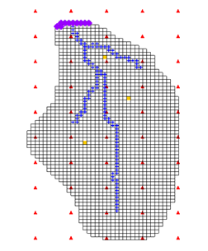

Prerequisite Tutorials

* MODFLOW – Automated Parameter Estimation

Time

* 15–25 minutes

GMS 10.9 Tutorial

***MODLFOW – PEST Pilot Points***

Use pilot points with PEST to automatically calibrate a MODFLOW model

GMS 10.9

Objectives

This tutorial demonstrates the features and options related to pilot points when used with PEST. It will review using fixed-value pilot points, regularization, and multiple parameters.

|  |
| --- |
| 1 Introduction 2  1.1 Getting Started 3  2 Importing the Project 3  3 Creating Pilot Points 4  4 Editing the HK Parameter 6  4.1 Editing the Parameters 6  4.2 Limiting the Number of Parameter Estimation Runs 7  5 Saving the Project and Running PEST 7  5.1 Viewing the Solution 8  5.2 Viewing the Final Hydraulic Conductivity 9  6 Adding Fixed Value Pilot Points 10  6.1 Saving the Project and Running PEST 11  7 Conclusion 12 |

# Introduction

Pilot points can be thought of as a 2D scatter point set. Instead of creating a zone and having the inverse model estimate one value for the entire zone, the value of the parameter within the zone is interpolated from the pilot points. The inverse model then estimates the values at the pilot points. Using pilot points will vary values from cell to cell. When the inverse model runs, the values at the pilot points are adjusted and re-interpolated to the grid cells until the objective function is minimized.

PEST (Parameter ESTimation) provides an option for the pilot point method called regularization. Regularization imposes an additional measure of constraint to the parameter being interpolated. This constraint is imposed by providing PEST with additional information about the parameter in the form of prior information equations. This constraint makes the inversion process more stable and makes it possible to violate one of the typical constraints associated with parameter estimation: namely, the requirement that the number of parameters is less than the number of observations.

With regularization, the number of parameters can exceed the number of observations. As a result, complex hydraulic conductivity distributions can be defined, resulting in low residual error. The pilot point method with regularization is a powerful feature of PEST.

There are two methods available in GMS for defining the prior information equations for PEST. The two methods can be used simultaneously but are usually used separately. The first method is *Preferred homogeneous regularization*. When this option is selected, the prior information equations written to the PEST control file relate the pilot points to one another. These equations indicate to PEST that—in the absence of any strong influence from the PEST objective function—pilot points that are near to one another should have the same value.

The second method of regularization is *Preferred value regularization*. When this option is selected, previous information equations written to the PEST control file relate the pilot points to their starting value. These equations indicate to PEST that—in the absence of any strong influence from the PEST objective function—the pilot point values should be equal to their starting value. Depending on the particular problem being solved, one method may be preferred over the other.

The model being calibrated in this tutorial is the same model featured in the “MODFLOW – Model Calibration” tutorial. The model includes observed flow data for the stream and observed heads at a set of scattered observation wells. The conceptual model for the site consists of a set of recharge and hydraulic conductivity zones. These zones will be marked as parameters and an inverse model will be used to find a set of recharge and hydraulic conductivity values that minimize the calibration error.

This tutorial will discuss and demonstrate the following:

* Opening a MODFLOW model and solution.
* Creating pilot points and running PEST.
* Loading optimal parameter values and viewing the resulting HK field.
* Including pilot points with fixed values and running PEST.
* Changing regularization options and running PEST.
* Using pilot points on different zones and different parameter types.

## Getting Started

Do the following to get started:

1. If necessary, launch GMS.
2. If GMS is already running, from the menu bar, select the *File |* **New** menu item to ensure that the program settings are restored to their default state. If asked to save changes, click the **Don’t Save** button.

# Importing the Project

First, import the modeling project:

1. From the Macro Bar, click **Open** File:Open Macro.svg to bring up the *Open* dialog.
2. From the *Files of type* drop-down, select “Project Files (*.gpr)”.
3. Browse to the *pilotpoints\pilotpoints* directory and select “start.gpr”.
4. Click the **Open** button to import the project and exit the *Open* dialog.

The initial MODFLOW model should appear similar to Figure 1.

1. In the Project Explorer, right-click on the project and select the **Expand All** context menu item.

A MODFLOW model with a solution and a set of map coverages should be visible. Three of the coverages are the source/sink, recharge, and hydraulic conductivity coverages used to define the conceptual model. The active coverage contains a set of observed head values from observation wells. In the source/sink coverage, an observed flow value has been assigned to the stream network.

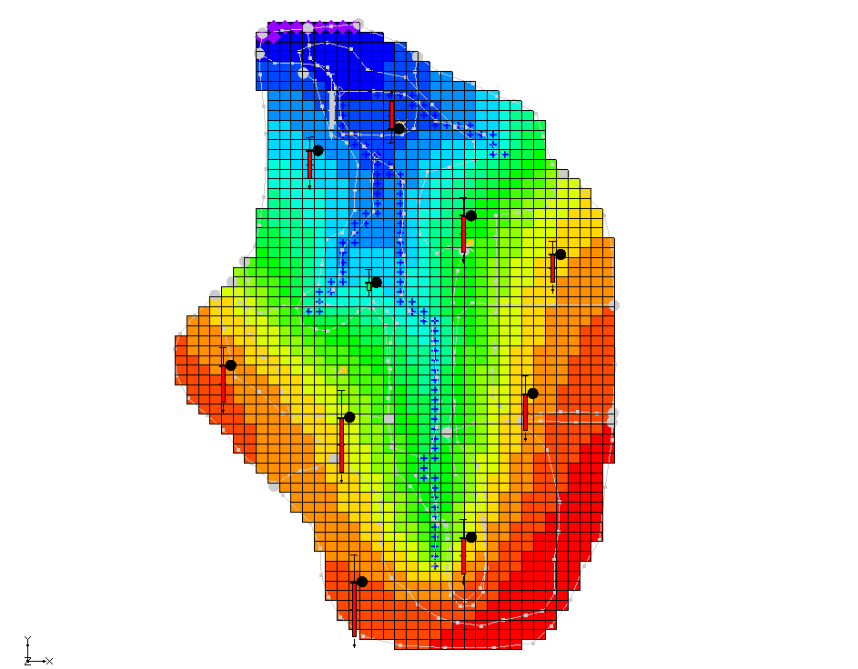

Figure 1: The initial MODFLOW model

This model has already been parameterized, so just create the pilot points and then run PEST.

# Creating Pilot Points

Now, to create the pilot points that define the hydraulic conductivity distribution for the model. The pilot points are defined as 2D scatter point sets in GMS. It should be noted that there are many different ways in GMS to create 2D scatter points such as converting a 2D grid, 2D mesh, TIN, borehole contacts, or map data to a scatter point set. Scatter points can also be created by creating a new scatter point set and then creating points in the Graphics Window.

In this example, a 2D grid will be created and then converted to scatter points. In order to create about 50 pilot points, it is necessary to make a cell-centered 2D grid with 50 cells.

1. In the Project Explorer, right-click on the empty space and select the *New |* **Grid Frame** context menu item.
2. Under the “ Map Data” folder, in the “ BigVal” conceptual model, select the   
   “https://www.xmswiki.com/images/thumb/7/71/Coverage_Active_Icon.svg/56px-Coverage_Active_Icon.svg.png Hydraulic Conductivity” coverage to make it active.
3. Right-click on “File:Grid Frame Icon.svg Grid Frame” and select the **Fit to Active Coverage** context menu item.
4. Select the “https://www.xmswiki.com/images/thumb/7/71/Coverage_Active_Icon.svg/56px-Coverage_Active_Icon.svg.png Observation Wells” coverage to make it active.

It should appear similar to Figure 2 when done.

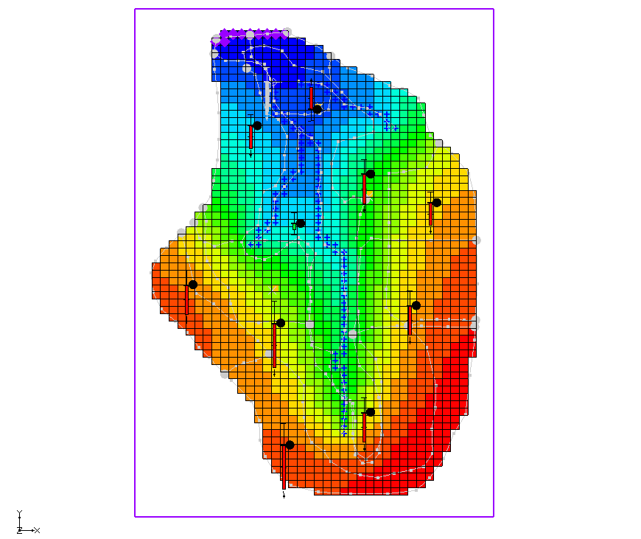

Figure 2: The grid frame should encompass the entire model

With the coverages and the grid frame created, it is now possible to create the grid.

1. From the Menu Bar, select the *Feature Objects* | **Map → 2D Grid** menu item to open the *Create Finite Difference Grid* dialog.
2. In the *X-Dimension* section, for the *Number cells,* enter “5”.
3. In the *Y-Dimension* section, for the *Number cells,* enter “10”.
4. Click the **OK** button to close the *Create Finite Difference Grid* dialog.

The result is a 2D grid with 50 cells. Convert it to 2D scatter points by doing the following:

1. In the Project Explorer, under the “File:2D Grid Folder.svg 2D Grid Data” folder, right-click on the “File:2D Grid Icon.svg grid” item and select the *Convert To* **| 2D Scatter Points** context menu item to bring up the *Scatter Point Set Name* dialog.
2. As the *New scatter point set name,* enter “HK”.
3. Click the **OK** button to close the *Scatter Point Set Name* dialog.
4. Right-click on “File:2D Grid Icon.svg grid” and select **Delete** context menu item to remove the grid.

The default starting value of hydraulic conductivity should be 0.5 m/d, so the next step is to change the data values at the scatter points to this value.

1. Expand the “File:2D Scatter Folder.svg 2D Scatter Data” folder and select the “File:2D Scatter Icon.svg HK” scatter point set to make it active.
2. From the Menu Bar, unlock the scatter points, by selecting the *Scatter Points |* **Lock All Scatter Points** menu item to remove the checkmark to the left of the menu item.
3. From the Dynamic Toolbar, select the **Select Scatter Points** File:Select Point Tool.svg tool and press *Ctrl-A* to select all of the scatter points.
4. In the *XYZF Bar* at the top of the Graphics Window, in the *S* field, enter “0.5” and press *Enter* to set the new value.
5. Deselect the points by clicking anywhere outside the model.

The model should appear similar to Figure 3.

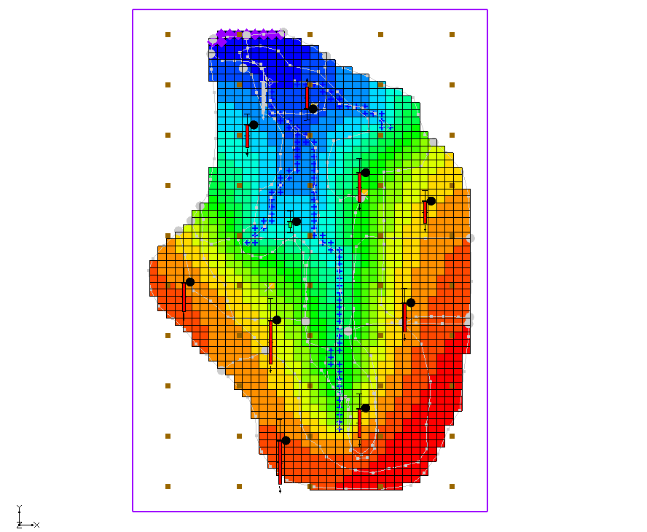

Figure 3: Placement of scatter points

# Editing the HK Parameter

In the “MODFLOW – Automated Parameter Estimation” tutorial, the example had four hydraulic conductivity parameters. For this problem, GMS will estimate the hydraulic conductivity for the entire layer with the pilot points. Only one parameter for hydraulic conductivity is needed. This parameter will then be linked to the pilot points using the *Parameters* dialog.

## Editing the Parameters

The first step is to edit the currently defined parameters for MODFLOW.

1. From the Menu Bar, select the *MODFLOW* | **Parameters…** menu item to open the *Parameters* dialog.
2. In the *Value* column, in the row for the “HK_30” parameter, click the Small drop-down arrow button from Parameters dialog button, from the drop-down, select “<Pilot points>”.
3. In the *Value* column on the “HK_30” row, click on the Blank button from Parameters dialog button to bring up the *2D Interpolation Options* dialog.

This dialog allows selecting the scatter point set and dataset used with the parameter and the interpolation scheme. The defaults are appropriate in this case, so it’s not necessary to change anything.

1. Click the **OK** button to exit the *2D Interpolation Options* dialog.
2. Click the **OK** button to exit the *Parameters* dialog.

## Limiting the Number of Parameter Estimation Runs

In the interest of time, this tutorial will limit the number of iterations that PEST does for the problem.

1. From the Menu Bar, select the *MODFLOW |* **Parameter Estimation…** menu item to bring up the *PEST* dialog.
2. For the *Max number of iterations* *(NOPTMAX),* enter “5”.

Notice the *Tikhonov regularization* section *(only used with pilot points)* of the dialog. This section allows specifying the type of regularization to use with PEST. By default, *Preferred homogeneous regularization* is turned on.

The *Prior information power factor* is used to change the weight applied to the prior information equations for the pilot points. When the prior information equations are created, GMS will compute an inverse distance weight between each pilot point and all other pilot points for a given parameter.

This weight is then raised to the power of the *Prior information power factor* and assigned to the equation for a given pair of points. Increase the homogeneity constraint (assign a higher weight to the prior information equation) by decreasing this value. Decrease the homogeneity constraint (assign a lower weight to the prior information equation) by increasing this value. This tutorial will use the default value of “1.0”.

1. Click the **OK** button to exit the *PEST* dialog.

# Saving the Project and Running PEST

Now that all the parameters are set, the project can be saved and PEST can be run.

1. From the Menu Bar, select the *File* | **Save As…** menu item to bring up the *Save As* dialog.
2. From the *Save as type* drop-down, select “Project Files (*.gpr)”.
3. For the *File name,* enter **“**mfpest_pilot.gpr”.
4. Click the **Save** button to save the project under the new name and exit the *Save As* dialog.
5. From the Macro Bar, click **Run MODFLOW** File:Run MODFLOW Macro.svg to bring up the *MODFLOW/PEST Parameter Estimation* dialog.

PEST is now running. The error and parameter values are updated in the spreadsheet in the upper-right side of the dialog as the model run progresses. The plot on the left shows a graphical representation of the error. In this case, there may be some strange parameter names like sc1v1. These names were automatically generated and assigned to the pilot points.

PEST may take several minutes to run, depending on the speed of the computer being used. The residual error should decrease with each iteration. When PEST is finished, a message will appear in the text portion of the window and the **Abort** button will change to **Close**. Once PEST is finished, it is possible to import the solution.

1. Turn on the *Read solution on exit* and *Turn on contours (if not on already)* checkboxes.
2. Click the **Close** button to exit the *MODFLOW/PEST Parameter Estimation* dialog.

The model should appear similar to Figure 4. The contours shown on the 3D grid are the heads from the MODFLOW run with the optimum parameter values.

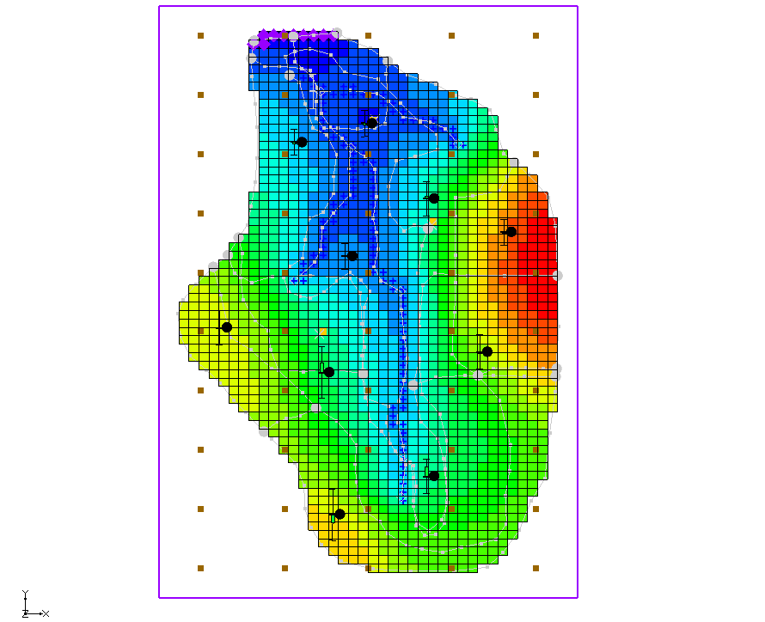

*Figure 4: View of the solution after initial MODFLOW/PEST run*

## Viewing the Solution

The observation targets in the map model and the error associated with this model run can now be reviewed.

1. In the Project Explorer, turn off the “File:3D Grid Folder.svg 3D Grid Data” folder, by clicking the checkbox, in order to see the coverage data better.
2. From the Project Explorer, under the “ Map Data” folder, in the “ BigVal” conceptual model, select the “File:Coverage Active Icon.svg Sources & Sinks” coverage.

Notice that the observation target on the arc group almost exactly matches.

1. From the Dynamic Toolbar, use the **Select Arc Groups** File:GMS Select Arc Group Tool.svg tool to select the river arc group by clicking on the river arc.

In the edit strip at the bottom left of the Graphics Window, notice that the computed and observed flows are reported.

1. In the Project Explorer, select the “File:Coverage Active Icon.svg Observation Wells” coverage to see how closely the computed heads match the field observations.
2. In the Project Explorer, under the “File:3D Grid Folder.svg 3D Grid Data” folder, right-click on the “File:Generic Folder Locked.svg mfpest_pilot (MODFLOW)”solution and select the **Properties…** context menu item to open the *Properties* dialog.

This dialog contains a spreadsheet showing the error from this model run. The spreadsheet shows the error from the head observations, the flow observations, and the combined weighted observations. Note that these values are lower than the values obtained using the zonal parameters approach.

1. After viewing the properties, click the **OK** button to close the *Properties* dialog*.*
2. Turn on the “File:3D Grid Folder.svg 3D Grid Data” folder in the Project Explorer.

## Viewing the Final Hydraulic Conductivity

When PEST ran, a value was estimated at each of the scatter points used with the “HK_30” parameter. The next step is to import the optimal parameter values as determined by PEST. Importing the optimal parameter values will create a new dataset for the scatter point set. The final hydraulic conductivity field will then be seen.

1. From the Menu Bar, select the *MODFLOW |* **Parameters…** menu item to open the *Parameters* dialog.
2. Click the **Import Optimal Values…** button to bring up the *Open* dialog.
3. From the file type drop-down to the right of the *File name* field, select “PAR File (*.par,*.bpa)”.
4. Browse to the *pilotpoints/pilotpoints/mfpest_pilot_MODFLOW* directory and select “mfpest_pilot.par”.
5. Click the **Open** button to exit the *Open* dialog.

Notice that the starting values for the parameters have changed.

1. In the *Value* column for parameter “HK_30”, click the Blank button from Parameters dialog button above the drop-down Small drop-down arrow button from Parameters dialog button to bring up the *2D Interpolation Options* dialog.

Notice that “HK_30 (mfpest_pilot)” is selected in the *Dataset* drop-down. This dataset was imported when the optimal values were imported, and it represents the optimal values at each pilot point as determined by PEST.

1. Click the **OK** button to exit the *2D Interpolation Options* dialog.
2. Click the **OK** button to exit the *Parameters* dialog.
3. In the Project Explorer, under the “File:3D Grid Folder.svg 3D Grid Data” folder, expand the “File:MODFLOW Folder.svg MODFLOW” item, then under the “File:MODFLOW Package Icon.svg LPF” package, select “File:Dataset Cells Active.svg HK”.

The final hydraulic conductivity values for the MODFLOW simulation should now be visible (Figure 5).

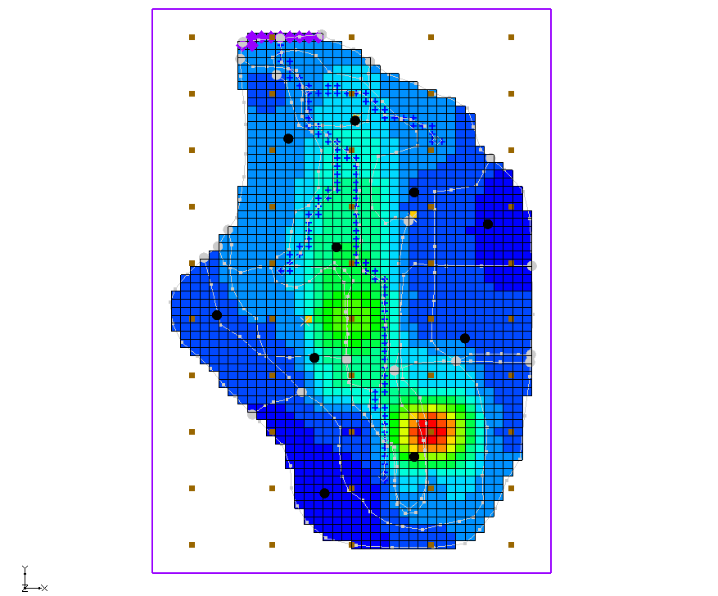

*Figure 5: Showing the final hydraulic conductivity values*

# Adding Fixed Value Pilot Points

Pilot points can be supplemented by field-measured hydraulic conductivity values (such as pump-test data values). Now add additional pilot points to the model and fix the HK value at those points. First, it is necessary to change the display, so it is possible to more easily see the grid.

1. From the Macro Bar, click **Display Options** File:Display Options Macro.svg to bring up the *Display Options* dialog.
2. Select “3D Grid Data” from the list on the left.
3. On the *3D Grid* tab, in the *Active dataset* section, turn off the *Contours* checkbox.
4. Click the **OK** button to close the *Display Options* dialog.

Notice that there are three pumping wells in the model (Figure 6, the center of each green circle). For purposes of illustration, assume that a pump test was performed at each of these wells and the HK was estimated.

Create a pilot point at each of these wells.

1. In the Project Explorer, select the “File:2D Scatter Folder.svg 2D Scatter Data” folder to make it active.
2. From the Dynamic Toolbar, use the **Create Scatter Points**  tool to create a scatter point at each of the pumping wells as shown in Figure 6.

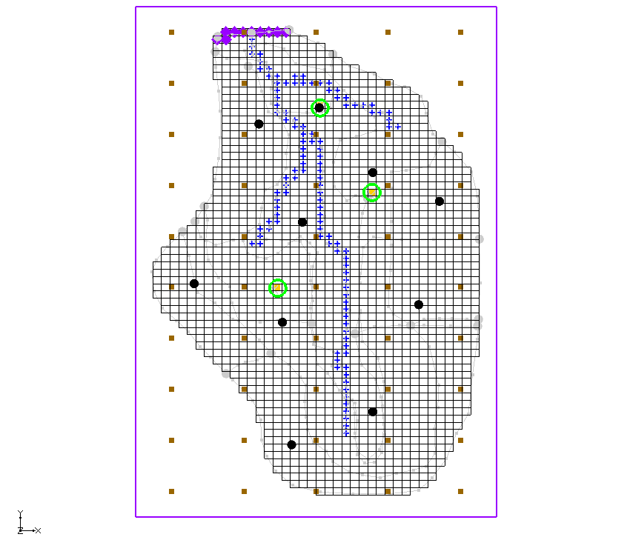

Figure 6: Location of pumping wells

1. From the Dynamic Toolbar, using the **Select Scatter Points** File:Select Point Tool.svg tool, select the new scatter point for the well closest to the top of the model.

Turning off the 3D grid in the Project Explorer makes the new scatter points more visible.

1. In the *XYZF Bar* at the top of the Graphics Window, enter “1.0” in the *S* field and press *Enter* to set the new value.
2. Select the scatter point at the well on the east (right) side of the model, enter “0.1” in the *S* field, and press *Enter* to set the new value.
3. Select the scatter point at the well on the west (left) side of the model, enter “5.0” in the *S* field, and press *Enter* to set the new value.
4. Select all three of the new scatter points by holding *Shift* while selecting each one.
5. From the Menu Bar, select *Edit |* **Properties…** menu item to open the *Properties* dialog.
6. In the *All* row, check the box in the *Fixed Pilot Point* column.
7. Click the **OK** button to close the *Properties* dialog.

## Saving the Project and Running PEST

It is now possible to save and run PEST.

1. From the Menu Bar, select *File* | **Save As…** menu item to bring up the *Save As* dialog.
2. From the *Save as type* drop-down, select “Project Files (*.gpr)”.
3. For the *File name,* enter **“**mfpest_pilot_fixed.gpr”.
4. Click the **Save** button to exit the *Save As* dialog.
5. From the Macro Bar, click **Run MODFLOW** File:Run MODFLOW Macro.svg to bring up the *MODFLOW/PEST Parameter Estimation* dialog.

PEST may take several minutes to run depending on the speed of the computer being used. Once PEST is finished, import the solution.

1. Turn on the *Read solution on exit* and *Turn on contours (if not on already)* checkboxes.
2. Click the **Close**button to exit the *MODFLOW/PEST Parameter Estimation* dialog.
3. In the Project Explorer, under the “File:Generic Folder Locked.svg mfpest_pilot_fixed (MODFLOW)” solution in the “File:Generic Folder.svg Parameters” folder, view the new HK field by selecting the “File:Scalar Dataset Active.svg HK Parameter -30” dataset.

The project should appear similar to Figure 7.

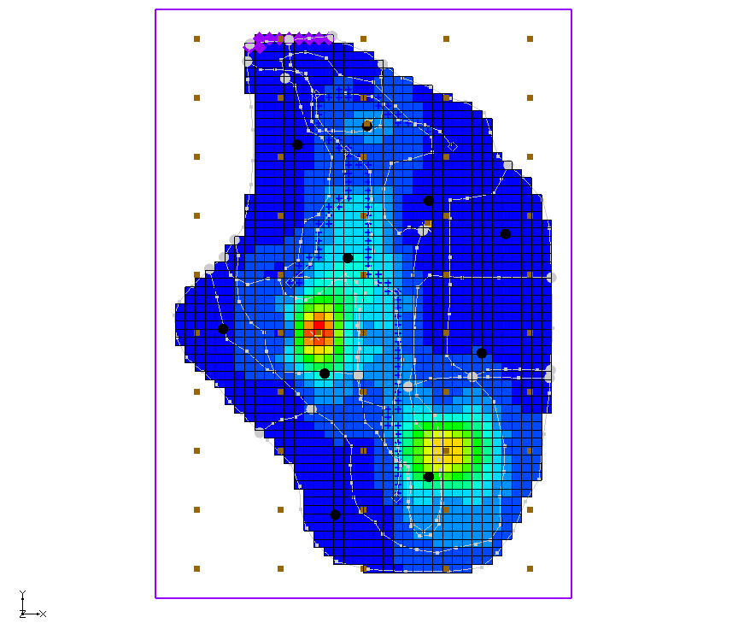

*Figure 7: “HK Parameter -30” solution with fixed pilot points*

# Conclusion

This concludes the “MODFLOW – PEST Pilot Points” tutorial. The following key topics were discussed and demonstrated:

* When using pilot points, there may be more parameters than observations because regularization is included in the parameter estimation.
* In the MODFLOW *Parameters* dialog, change a parameter to use pilot points by using the Small drop-down arrow button from Parameters dialog and Blank button from Parameters dialog buttons.
* 2D scatter points can be used to create pilot points in GMS.