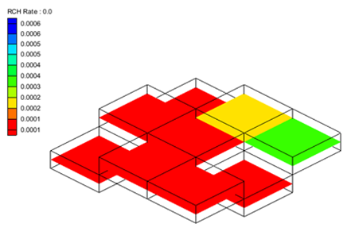

GMS 10.9

GMS 10.9 Tutorial

***MODFLOW – Recharge***

Recharge package in MODFLOW

Objectives

Learn about inputs to the MODFLOW Recharge package.

Time

* 25–40 minutes

Required Components

* GMS Core
* MODFLOW Interface

Prerequisite Tutorials

* MODFLOW – Grid Approach

|  |
| --- |
| [1 Introduction 2](#_Toc110858839)  [1.1 Getting Started 2](#_Toc110858840)  [2 Importing the Project 2](#_Toc110858841)  [3 Recharge Package 3](#_Toc110858842)  [4 Contouring the Recharge Values 4](#_Toc110858843)  [4.1 Effect of IBOUND 5](#_Toc110858844)  [5 Changing the Recharge Option (NRCHOP) 6](#_Toc110858845)  [5.1 Recharge at Specified vertical cells 7](#_Toc110858846)  [6 Transient Model 7](#_Toc110858847)  [6.1 Recharge Dataset 8](#_Toc110858848)  [6.2 Cell Editing of Recharge 9](#_Toc110858849)  [7 Conceptual Model 11](#_Toc110858850)  [8 Model with Parameters 14](#_Toc110858851)  [9 Conclusion 16](#_Toc110858852) |

# Introduction

The Recharge Package (RCH) is used by MODFLOW to simulate the deep percolation of water that reaches an aquifer. The purpose of this tutorial is to demonstrate how recharge can be entered, edited, and visualized in GMS. The example will use a very simplistic model to illustrate the various ways that recharge can be specified.

This tutorial is recommended for users who want to explore in depth all of the options available in the recharge package. This tutorial is not meant to demonstrate common workflows for implementing recharge in a typical groundwater model.

## Getting Started

Do the following to get started:

1. If necessary, launch GMS.
2. If GMS is already running, select *File |* **New** to ensure that the program settings are restored to their default state.

# Importing the Project

First, import the modeling project:

1. Click **Open** File:Open Macro.svg to bring up the *Open* dialog.
2. Select “Project Files (\*.gpr)” from the *Files of type* drop-down.
3. Browse to the *recharge* directory for this tutorial and select “mf2k\_recharge.gpr”.
4. Click **Open** to import the project and close the *Open* dialog.

The imported project should appear similar to Figure 1.

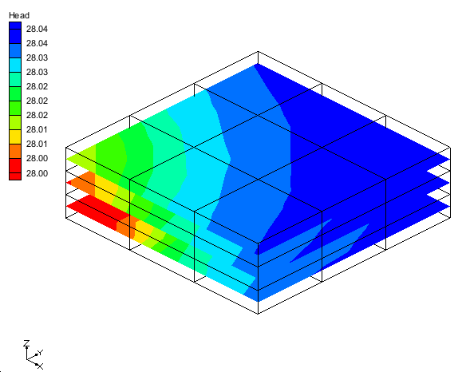

Figure 1 Initial screen after importing the project

This is a three layer steady-state MODFLOW model with nine cells in each layer. The model has one specified head cell and recharge. The recharge is specified to be applied to layer 1.

# Recharge Package

First, look at the inputs in the recharge package.

1. In the Project Explorer, double-click on “File:MODFLOW Package Icon.svg RCH” to bring up the *MODFLOW Recharge Package* dialog.

The top of the dialog has the *Recharge option (NRCHOP)* section. This variable controls where the recharge is specified in the model. The current option, “(1) Recharge only at top layer”, means that recharge will only be applied to cells in layer 1. There are two other options: “(2) Recharge at specified vertical cells”, and “(3) Recharge at highest active cell”. Each of these items will be explained in greater detail later.

The *Stress period* section is where the current stress period is selected. Changing the stress period will change the contents in the spreadsheet at the bottom of the dialog and the value of the multiplier.

The spreadsheet at the bottom of the dialog shows values in the different recharge arrays, with “RECH. Flux” currently shown. This value has units of length/time and is specified for each cell in layer 1. The amount of water that will enter the MODFLOW cell from recharge will be this value multiplied by the area of the cell.

There are five buttons on the upper right side of the dialog. The **Edit All Use previous/Multipliers…** will be explained later. The **2D Dataset → Array** button is used to select a dataset from a matching 2D grid and apply that dataset to the recharge array. The **Array → 2D Dataset** creates a dataset on a matching 2D grid from the recharge data. The **Constant →Array** button assigns a constant value to the recharge array. The **Rasters → Array…** button takes elevation values from a raster and places them in the array.

1. Click **OK** to close the *MODFLOW Recharge Package* dialog.

# Contouring the Recharge Values

The recharge values can be visualized by making the “File:Dataset Cells Active.svg RCH Rate” item the active dataset in the Project Explorer.

1. In the Project Explorer, select “File:Dataset Cells Active.svg RCH Rate”.

The view will look like Figure 2 below.

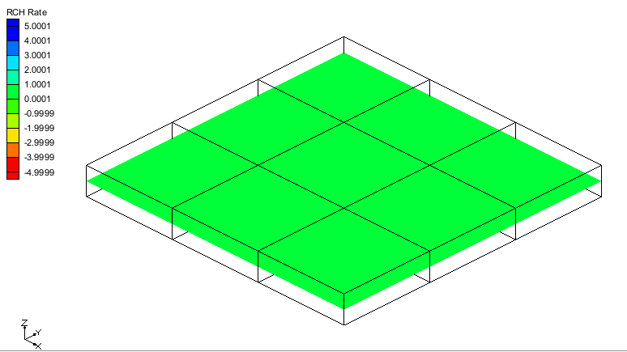

Figure 2 RCH rate contours

Only the top layer of the grid is visible because recharge is only applied to the top of the grid. The color is the same in each cell because the recharge values are constant. The recharge values can be edited in the *MODFLOW* *Recharge Package* dialog and they can be edited by selecting a cell.

1. Using the **Select Cells** File:Select 3D Cell Tool.svg tool, select the cell shown in Figure 3.

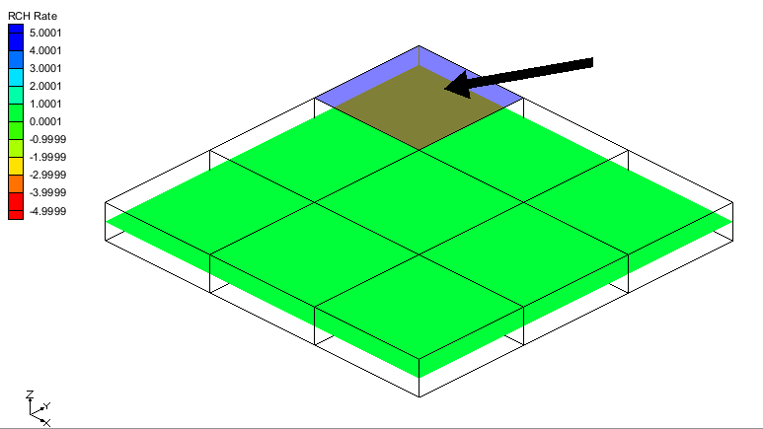

Figure 3 Select the cell indicated by the arrow (IJK: 1,1,1)

1. Right-click on the selected cell and choose **Sources/Sinks…** to open the *MODFLOW Sources/Sinks* dialog.
2. From the list on the left side, select “Recharge (RCH)”.
3. In the spreadsheet, for *Flux (ft/d),* enter “0.0002”.
4. Select **OK** to exit the *MODFLOW Sources/Sinks* dialog.

The view will update and appear like Figure 4.

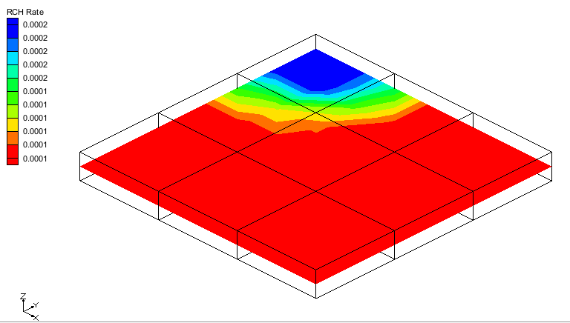

Figure 4 RCH rate contours

## Effect of IBOUND

The IBOUND can affect recharge.

1. Double-click on the same cell from section 4, step 2 to open the *3D Grid Cell Properties* dialog with the *MODFLOW* tab active.
2. For *IBOUND*, use the drop-down and select “Inactive”.
3. Click **OK** to exit the *3D Grid Cell Properties* dialog.

The cell is no longer visible because the IBOUND value is inactive (0) as shown in Figure 5.

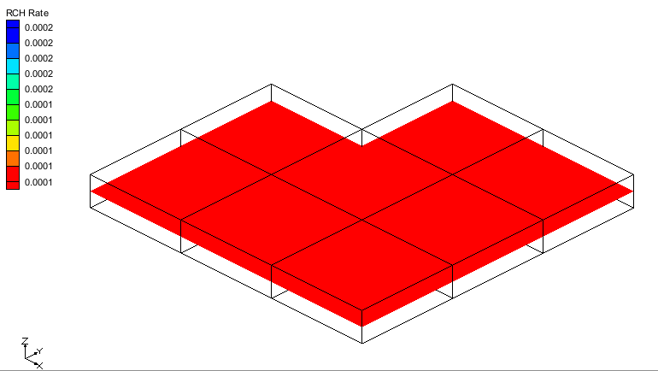

Figure 5 The inactive cell is no longer visible

This cell will not be included in MODFLOW’s computations. The recharge value assigned to that cell will be ignored.

1. In the Project Explorer, double-click on “File:MODFLOW Package Icon.svg RCH” to bring up the *MODFLOW Recharge Package* dialog.

Notice in the spreadsheet that the first cell is not editable. Again, this is because the recharge to that cell will be ignored by MODFLOW.

# Changing the Recharge Option (NRCHOP)

Often it is useful for the recharge that would have been applied to a cell in layer 1 to be applied to a cell in a lower layer below the original cell. If for some reason the cell in layer 1 became dry during a simulation, the recharge applied to that cell would be ignored by MODFLOW. However, it is generally desired that the recharge value would be applied to a lower cell. This can be accomplished by changing the *Recharge option*.

1. Change the *Recharge option (NRCHOP)* to “(3) Recharge at highest active cell”.

Notice that the first item in the spreadsheet is now editable because there is an active cell below the inactive cell in layer 1.

1. Select **OK** to exit the *MODFLOW Recharge Package* dialog.

The recharge dataset has now updated as well. The view will look like Figure 6.

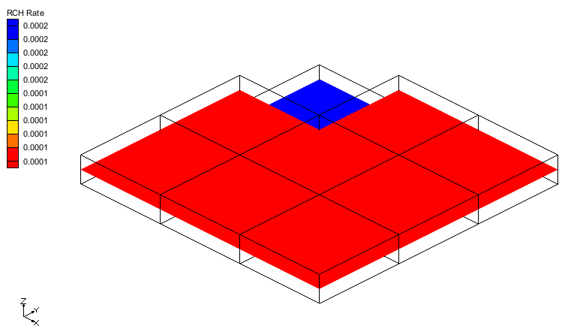

Figure 6 RCH rate contours

Now inactivate all the cells in the column below the inactive cell.

1. In the Project Explorer, right-click on “File:Dataset Cells Active.svg Ibound” and select **Properties…** to open the *Ibound Array* dialog.
2. For *Layer,* change to “2”.

The spreadsheet will update with values from layer 2.

1. In row 1 column 1, change the value to “0”.
2. For *Layer,* change to “3”.
3. In row 1 column 1, change the value to “0”.
4. Click **OK** to exit the *Ibound Array* dialog.

Notice that no cells in the column below cell id 1 are visible.

1. In the Project Explorer, double-click on “File:MODFLOW Package Icon.svg RCH” to bring up the *MODFLOW Recharge Package* dialog.

Notice that the first item in the spreadsheet is not editable. If no cells are active in a column of the grid then the recharge value will be ignored by MODFLOW.

## Recharge at Specified vertical cells

The “Recharge at specified vertical cells” option allows recharge to be assigned to a particular cell. When this option is selected, another array (IRCH) is available for editing.

1. Change the *Recharge option (NRCHOP)* to “(2) Recharge at specified vertical cells”.
2. Change *View/Edit* to “IRCH. Layer indicator” using the drop-down.

Notice that the first item in the spreadsheet is not editable. There are no active cells in this column.

1. For row 1 column 2, change to “2” (for layer 2).
2. For row 1 column 3, change to “3” (for layer 3).
3. Click **OK** to exit the *MODFLOW Recharge Package* dialog.

The “dataset_cells RCH Rate” dataset has updated and the view will look like Figure 7.

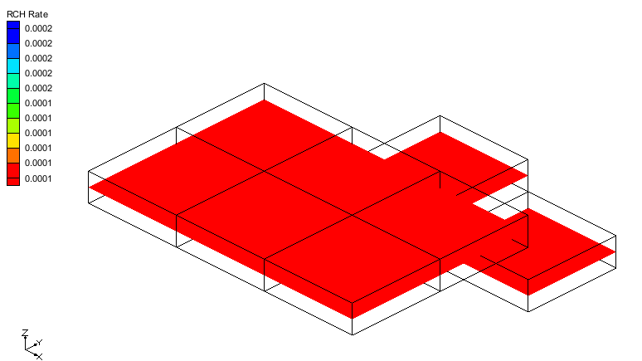

Figure 7 RCH rate contours

# Transient Model

Now look at the recharge package data with a transient model.

1. Select *File* | **New** to reset GMS.
2. Click **Don’t Save** at the prompt.
3. Click **Open** File:Open Macro.svg to bring up the *Open* dialog.
4. Select “Project Files (\*.gpr)” from the *Files of type* drop-down.
5. Browse to the data files for this tutorial and select “mf2k\_recharge\_trans.gpr”.
6. Click **Open** to import the project and close the *Open* dialog.

This is the same MODFLOW model except that it is transient with four stress periods.

1. In the Project Explorer, double-click on “File:MODFLOW Package Icon.svg RCH” to bring up the *MODFLOW Recharge Package* dialog.

This model is using the “(2) Recharge at specified vertical cells” option. The “RECH. Flux” and the “IRCH. Layer indicator” data change with the stress periods.

1. In the *Stress period* section, use the arrow Increment up and down arrows.png buttons to cycle through to see how the “RECH. Flux” data changes in each stress period.

Notice that the *Use previous* checkbox is checked for the third stress period. This means that the data from stress period 2 is reused in stress period 3 for the “RECH. Flux”. Also, notice that the *Multiplier* is “2.0” in stress period 4 instead of “1.0”. This means that the values in the “RECH. Flux” array will be multiplied by 2.0 when MODFLOW runs.

For transient models with many stress periods it can be difficult to edit the *Use previous* and the *Multiplier* by cycling through the stress periods. All of the *Use previous* and *Multiplier* values can be edited by selecting the **Edit All Use previous/Multipliers…** button.

1. Click the **Edit All Use previous/Multipliers…** button to bring up the *Edit All Use Previous / Multipliers* dialog.

This dialog displays the *Use Previous* and *Multiplier* values for each stress period, allowing for quick editing of many stress periods. A value of “0” for *Use previous* will leave the checkbox unchecked while a non-zero value will set the check on.

1. Click **OK** to close the *Edit All Use Previous / Multipliers* dialog.
2. Change *View/Edit* to “IRCH. Layer indicator” using the drop-down.
3. In the *Stress period* section, use the arrow Increment up and down arrows.png buttons to cycle through to see how the “IRCH. Layer indicator” data changes in each stress period.
4. Click **OK** to close the *MODFLOW Recharge Package* dialog.

## Recharge Dataset

1. In the Project Explorer, select “File:Dataset Cells Active.svg RCH Rate” to change the view (Figure 8).

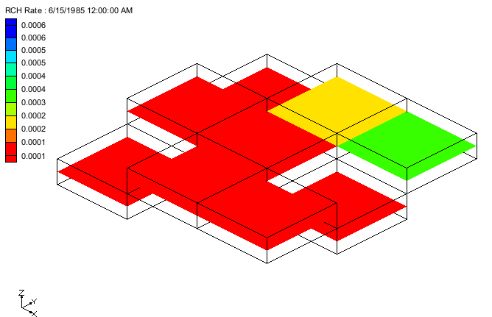

Figure 8 RCH rate contours

Notice that cells in different layers are visible because of the options set in the *MODFLOW Recharge Package* dialog. The *Time Steps* window (Figure 9) is available for selecting different time steps for the “File:Dataset Cells Active.svg RCH Rate” dataset. These time steps correspond to the MODFLOW stress periods. Notice that the times that are displayed are in date/time format because a reference time has been associated with the MODFLOW model.

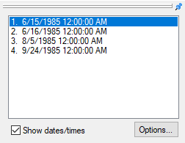

Figure 9 Time Steps window

1. In the *Time Steps* window, cycle through the times steps by selecting each one.

Notice that either the recharge rate or the layer assignment changes with each stress period.

## Cell Editing of Recharge

When the “File:Dataset Cells Active.svg RCH Rate” dataset is active it is clear which cells have recharge applied to them for a particular stress period. When a different dataset is active different cells may be active than those with the recharge dataset. This can cause some confusion when editing the recharge for cells. The clearest way to see which cells have recharge applied is to make the “File:Dataset Cells Active.svg RCH Rate” dataset active.

1. In the *Time Steps* window, select the first time step for the “File:Dataset Cells Active.svg RCH Rate” dataset.

The view will look like Figure 8.

1. Using the **Select Cells** File:Select 3D Cell Tool.svg tool, select the cell shown in Figure 10 (IJK: 1,1,2).
2. Right-click on the selected cell and select **Sources/Sinks…** to bring up the *MODFLOW Sources/Sinks* dialog.

Notice that, for row *1* in the *Layer* column of the spreadsheet, the value is “<transient>”. The assigned layer varies with time. The layer values for each stress period can be edited via the Attribute Table dialog dot dot dot ellipses button.png button above the drop-down arrow in the cell with the “<transient>” value.

1. In the *Layer* column on row *1,* click the Attribute Table dialog dot dot dot ellipses button.png button (right of “<transient>”) to open the *XY Series Editor* dialog.

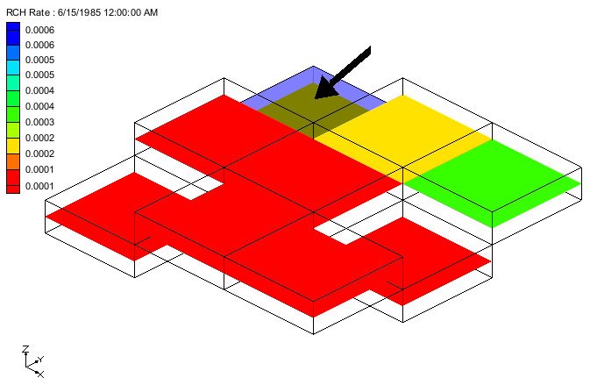

Figure 10 RCH rate cell to select

1. In the *Layer* column on the first row of the spreadsheet, enter “1”.
2. Click **OK** to exit the *XY Series Editor* dialog.
3. Click **OK** to exit the *MODFLOW Sources/Sinks* dialog.

The visible cells on the grid will change (Figure 11).

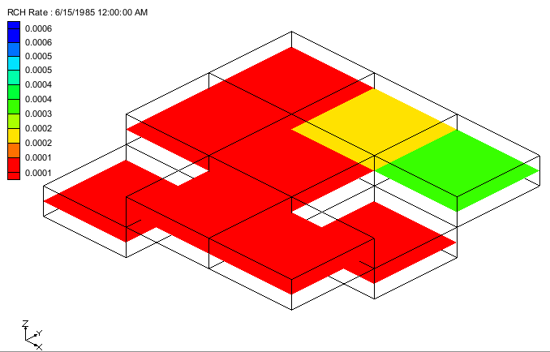

Figure 11 RCH rate contours

Changing the layer updated the “File:Dataset Cells Active.svg RCH Rate” dataset so that a different cell would be active for the first time step of the dataset. This is why the top cell is now visible. In addition, because the layer value changed for the first stress period, making it different from the layer value for the second stress period, the *Use previous* option has been changed in the *MODFLOW Recharge Package* dialog.

1. In the Project Explorer, double-click on “File:MODFLOW Package Icon.svg RCH” to bring up the *MODFLOW Recharge Package* dialog.
2. In the *View/Edit* drop-down, select “IRCH. Layer indicator”.
3. Click the **Edit All Use previous/Multipliers…** button to open the *Edit All Use Previous / Multipliers* dialog.

Notice that the value for *Use Previous* for stress period 2 (row 2) is now “0”. Prior to editing the layer for the selected cell this value was “1”.

1. Click **Cancel** to close the *Edit All Use Previous / Multipliers* dialog.
2. Click **Cancel** to close the *MODFLOW Recharge Package* dialog.

Recharge can be edited even if the “File:Dataset Cells Active.svg RCH Rate” dataset is not the active dataset.

1. In the Project Explorer, select “File:Dataset Cells Active.svg elevation” to make it active.
2. Using the **Select Cells** File:Select 3D Cell Tool.svg tool, select the cell shown in Figure 12 (IJK: 3,3,2).

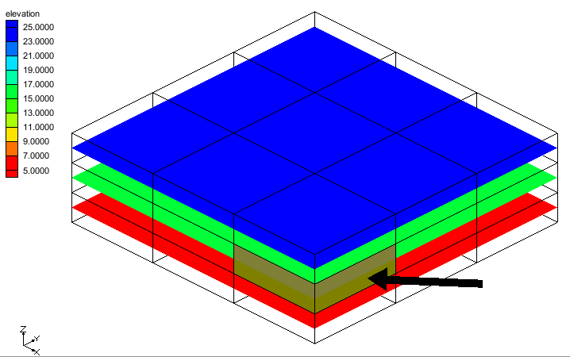

Figure 12 Elevation contours

1. Right-click on the selected cell and select **Sources/Sinks…** to bring up the *MODFLOW Sources/Sinks* dialog.

Even though recharge is not assigned to this cell, GMS allows recharge to be edited when this cell is selected. Recharge could be assigned to the selected cell by editing the value in the *Layer* column.

1. Click **OK** to exit the *MODFLOW Sources/Sinks* dialog.

# Conceptual Model

Using the conceptual model to define recharge is shown in various other GMS tutorials. Here, the focus will be on how Map→MODFLOW is designed to work with recharge.

1. Select the *File* | **New** to reset GMS.
2. Click **Don’t Save** at the prompt.
3. Click **Open** File:Open Macro.svg to bring up the *Open* dialog.
4. Select “Project Files (\*.gpr)” from the *Files of type* drop-down.
5. Browse to the *recharge* directory and select “mf2k\_recharge\_con\_mod.gpr”.
6. Click **Open** to import the project and close the *Open* dialog.

The view will look like Figure 13. The active coverage has a single polygon with recharge assigned to it. The MODFLOW model currently does not include the recharge package.

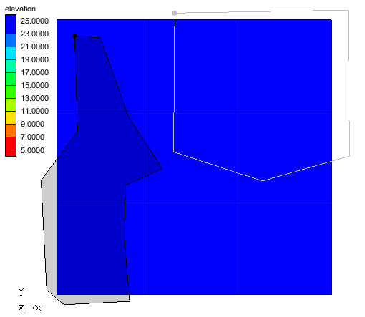

Figure 13 Initial view of the project

1. Right-click on “File:Coverage Active Icon.svg recharge 1” and select *Map To* | **MODFLOW/MODPATH**.

Notice in the Project Explorer that the recharge (RCH) package is now part of the MODFLOW simulation. The values from the polygon in the coverage have been transferred to the associated cells in the grid. Next, view where the values have been assigned:

1. In the Project Explorer, select the “File:Dataset Cells Active.svg RCH Rate” item.

The view will look like Figure 14. The blue cells have been assigned a value for recharge and the red cells have a value of zero. Notice that the cell in the center of the grid was assigned a recharge value even though it is only slightly overlapped by the polygon. Each cell is given the same recharge value even though the area of overlap with the polygon is different for each cell.

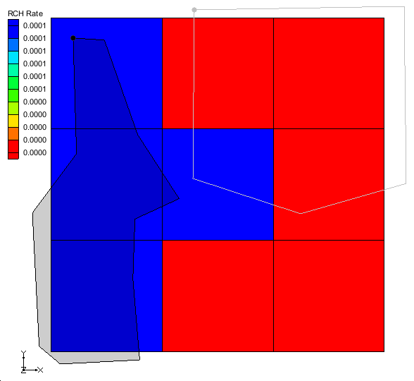

Figure 14 Spatial distribution of recharge

1. In the Project Explorer, double-click on “File:MODFLOW Package Icon.svg RCH” to bring up the *MODFLOW Recharge Package* dialog.

Notice that the *Recharge option (NRCHOP)* is set to “(3) Recharge at highest active cell”. If recharge is not part of the MODFLOW model, and the **Map→MODFLOW** command is executed with a recharge coverage, then the recharge package will be initialized and NRCHOP will be set to (3).

1. Select **OK** to exit the *MODFLOW Recharge Package* dialog.
2. In the Project Explorer, select “File:Coverage Active Icon.svg recharge 2” to make it active.

This coverage has two polygons. Notice that both polygons overlap with the cell in the center of the grid.

1. Right-click on “File:Coverage Active Icon.svg recharge 2” and select *Map To* | **MODFLOW/MODPATH**.

The view will look like Figure 15. The blue cells were assigned recharge from the polygon on the right and the green cells were assigned recharge from the polygon on the left. The red cells have a value of zero assigned. Notice that the center cell is blue. Because the polygon on the right has a larger overlapping area, the center cell is associated with the polygon on the right.

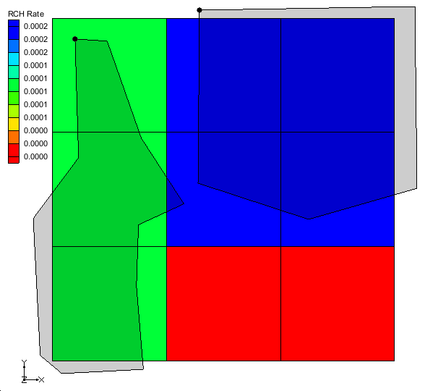

Figure 15 RCH rate contours

1. Right-click on “File:Coverage Active Icon.svg recharge 1” and select *Map To* | **MODFLOW/MODPATH**.

The view should look like Figure 14 again. Notice that the center cell has been assigned a value from the polygon in the “File:Coverage Active Icon.svg recharge 1” coverage. All of the cells that don’t overlap with the “File:Coverage Active Icon.svg recharge 1” coverage have a value of 0.0 assigned. When the **Map→MODFLOW** command is executed with a recharge coverage, the recharge is initially set to zero and then the values from the polygons are applied.

1. In the Project Explorer, right-click on “File:Conceptual Model Icon.svg Conceptual Model” and select *Map To* | **MODFLOW/MODPATH** to open the *Map → Model* dialog.
2. Select *All applicable coverages.*
3. Click **OK** to close the *Map → Model* dialog.

The view will look like Figure 16. Notice that the center cell is blue and has a value of 0.0003 assigned. This is because the “File:Coverage Active Icon.svg recharge 1” coverage assigned a value of 0.0001 and the “File:Coverage Active Icon.svg recharge 2” coverage added a value of 0.0002. So the final value in the cell is the sum of values from each coverage that was mapped.

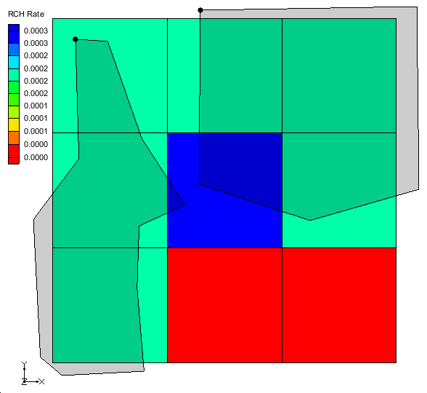

Figure 16 RCH rate contours

The specified layer is not assigned using the conceptual model. If the recharge package is initialized and the NRCHOP is set to “(2) Recharge at specified vertical cells” then GMS will not modify the layer assignments in the recharge package when the **Map→MODFLOW** command is executed.

# Model with Parameters

The final topic covered will be parameters in the recharge package. Information on parameters in MODFLOW models can be found in other GMS tutorials. This section focuses on how parameters affect visualization of recharge in GMS.

1. Select the *File* | **New** to reset GMS.
2. Click **Don’t Save** at the prompt.
3. Click **Open** File:Open Macro.svg to bring up the *Open* dialog.
4. Select “Project Files (\*.gpr)” from the *Files of type* drop-down.
5. Browse to the data files for this tutorial and select “mf2k\_recharge\_param.gpr”.
6. Click **Open** to import the project and close the *Open* dialog.
7. Switch to **Oblique View** File:Oblique View Macro.svg.

The view will look like Figure 17. The MODFLOW model is transient and has multiple recharge parameters.

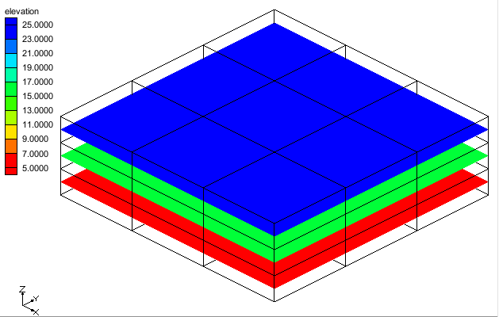

Figure 17 Initial view of project

1. In the Project Explorer, select the “File:Dataset Cells Active.svg RCH Rate” item.

The view will look like Figure 18. This shows the recharge values on the grid.

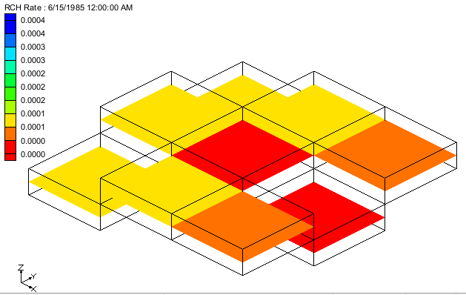

Figure 18 RCH rate contours

1. Cycle through the time steps to view the recharge at the different time steps.
2. In the Project Explorer, double-click on “File:MODFLOW Package Icon.svg RCH” to bring up the *MODFLOW Recharge Package* dialog.

Notice that the values in the spreadsheet include “-3.0”, “-1.0”, “0.0”, “0.0001”. However, in the view of the grid there are values between “0.0” and “0.0004”. These values come from defined parameters.

1. Click **OK** to exit the *MODFLOW Recharge Package* dialog.
2. Select *MODFLOW* | **Parameters…** to open the *Parameters* dialog.

Notice there are four recharge parameters. The values displayed on the grid come from the *Value* specified in this dialog. The RCH\_3 parameter uses the “<Pilot points>” option. This means that the values shown on the grid are interpolated from an associated scatter point set.

1. Click **OK** to exit the *Parameters* dialog.
2. In the Project Explorer, right-click on “File:Dataset Cells Active.svg RCH Rate” and select **Display Key Values**.

The view will change to be like Figure 19. Notice that the values displayed now include the negative numbers from the *MODFLOW Recharge Package* dialog. Cycle through the time steps to see the recharge parameter key values in different stress periods.

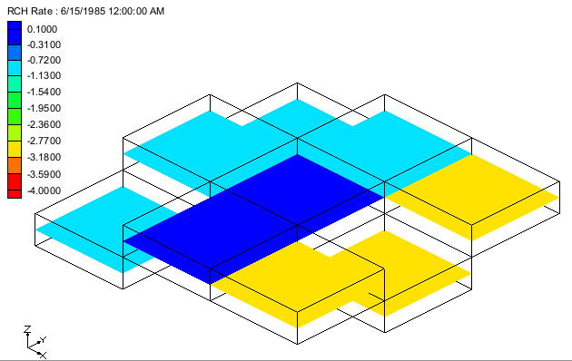

Figure 19 RCH Rate Contours of parameter key values

MODFLOW supports a more complicated way to define recharge parameters using clusters. This is supported in GMS but it cannot be visualized. For more information about these types of parameters see the tutorial “MODFLOW – Advanced Parameter Options”.

# Conclusion

This concludes the “MODFLOW *–* Recharge” tutorial. The following key topics were discussed and demonstrated:

* Recharge package inputs.
* How to visualize the data in the Recharge Package.
* The effect of IBOUND on recharge.
* The effect of the specified layer option on recharge.
* How the **Map→MODFLOW** command works with recharge.
* How parameters affect the display of recharge.