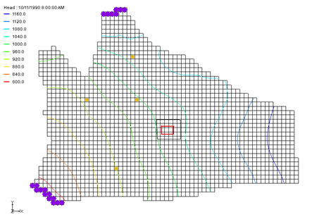

Time

* 25–40 minutes

Required Components

* GMS Core
* Geostatistics
* MODFLOW Interface
* MODAEM

GMS 10.9

GMS 10.9 Tutorial

MODFLOW – Regional-to-Local Model Conversion, Steady-State

Create a local model from a regional model using convenient tools

Objectives

This tutorial will use the convenient tools provided in GMS to perform the steps involved in a typical regional-to-local model conversion. This tutorial uses a steady-state model. A transient example is provided in the “MODFLOW – Regional-to-Local Model Conversion, Transient” tutorial.

Prerequisite Tutorials

* MODFLOW ‒ Conceptual Model Approach II

|  |
| --- |
| [1 Introduction 2](#_Toc202339633)  [1.1 Outline 3](#_Toc202339634)  [1.2 Getting Started 4](#_Toc202339635)  [2 Importing the Regional Model 4](#_Toc202339636)  [3 Converting the Layer Data to a Scatter Point Set 5](#_Toc202339637)  [4 Building the Local Conceptual Model 6](#_Toc202339638)  [4.1 Creating a New Coverage 6](#_Toc202339639)  [4.2 Creating the Boundary Arcs and the Polygon 6](#_Toc202339640)  [4.3 Marking the Specified Head Arcs 7](#_Toc202339641)  [5 Creating the Local MODFLOW Model 8](#_Toc202339642)  [5.1 Creating the Grid 9](#_Toc202339643)  [5.2 Activating the Cells 9](#_Toc202339644)  [5.3 Mapping the Properties 10](#_Toc202339645)  [5.4 Interpolating the Layer Data 10](#_Toc202339646)  [5.5 Saving and Running the Local Model 10](#_Toc202339647)  [6 MODAEM Regional Model 11](#_Toc202339648)  [6.1 Saving MODAEM 12](#_Toc202339649)  [6.2 Adjusting the Coverage Setup 12](#_Toc202339650)  [6.3 Running the Local Model 13](#_Toc202339651)  [7 Conclusion 14](#_Toc202339652) |

# Introduction

Determining appropriate boundary conditions can be challenging, especially when natural boundaries such as rock outcrops, rivers, lakes, or grounwater divides are located far from the site of interest. In such cases, a two-phase modeling approach is often used.

In the first phase, a regional-scale model is constructed that extends to well-defined natural boundaries. In the second phase, a local-scale model is created within the regional model. Groundwater elevations from the regional model are applied as specified head boundaries to the local-scale model. Layer data such as elevations and transmissivities are also interpolated from the regional to the local model. The local model can represent more detailed site conditions, including low-capacity wells and subsurface barriers not included in the regional model.

This approach, known as telescopic grid refinement, is supported by a suite of tools in GMS. This tutorial demonstrates the steps involved in a typical regional-to-local model conversion using MODFLOW.

The site shown in Figure 1 includes a river, four production wells, and mostly no-flow boundaries defined by flow divides and outcrops. The model includes two layers: a lower confined layer and an upper unconfined layer. The local site, located within the regional model, represents a chemical plant with a small containment spill. Once the regional model is complete, a local-scale model will be developed to evaluate various injection and extraction well configurations as part of a treatment system design.

Figure 1 Regional model

The goal of the regional-to-local model conversion process is to transfer computed heads and layer data from the regional model to the local model. This is done by creating a 2D scatter point set containing the MODFLOW heads and layer data arrays from the regional model. A 2D scatter point set is used because interpolation is performed layer by layer using 2D methods.

GMS provides tools that streamline this process. The basic steps are as follows:

1. Generate the regional model and compute a solution.
2. Use the **MODFLOW Layers → 2D Scatter Points…** command to create a scatter point set containing layer and head data from the regional model.
3. Create the 3D grid for the local-scale model.
4. Interpolate the head and layer data from the scatter points to the MODFLOW layer arrays for the local model.

Each of these steps will be described in more detail below.

## Outline

This tutorial will demonstrate and discuss the following:

* Opening a regional conceptual model
* Converting layer data to a scatter point set
* Building a local conceptual model and mapping it to a 3D grid
* Mapping the conceptual model to a MODFLOW simulation
* Interpolating the layer data
* Running MODFLOW
* Running MODAEM
* Replacing the specified head with the MODAEM computed head and rerunning MODFLOW

## Getting Started

Do the following to get started:

1. If necessary, launch GMS.

If GMS is already running, select *File |* **New** to ensure that the program settings are restored to their default state. Click **Don’t Save** if asked to save changes.

# Importing the Regional Model

The first step in the model conversion process is to build a regional model. However, since this tutorial focuses on the conversion workflow, a previously constructed regional model will be imported instead.

1. Click **Open** File:Open Macro.svg to bring up the *Open* dialog.
2. Select “Project Files (\*.gpr)” from the *Files of type* drop-down.

Browse to the \*reg2loc\_ss*\*reg2loc\_ss* directory and select “regmod.gpr”.

Click **Open** to import the project and close the *Open* dialog.

The top layer of the two-layer model is currently displayed (Figure 2). Use the arrow buttons in the *Mini-Grid Toolbar* to view the bottom layer, where the wells are located. When finished, return to the top layer.

This model was constructed using the conceptual model approach. The local site boundary is shown as a red rectangle. The conceptual model includes three coverages:

* A sources and sinks coverage (currently visible)
* A recharge zones coverage
* A hydraulic conductivity zones coverage for the top layer

The imported project also includes the solution for the regional model, with computed head contours visible in the display.

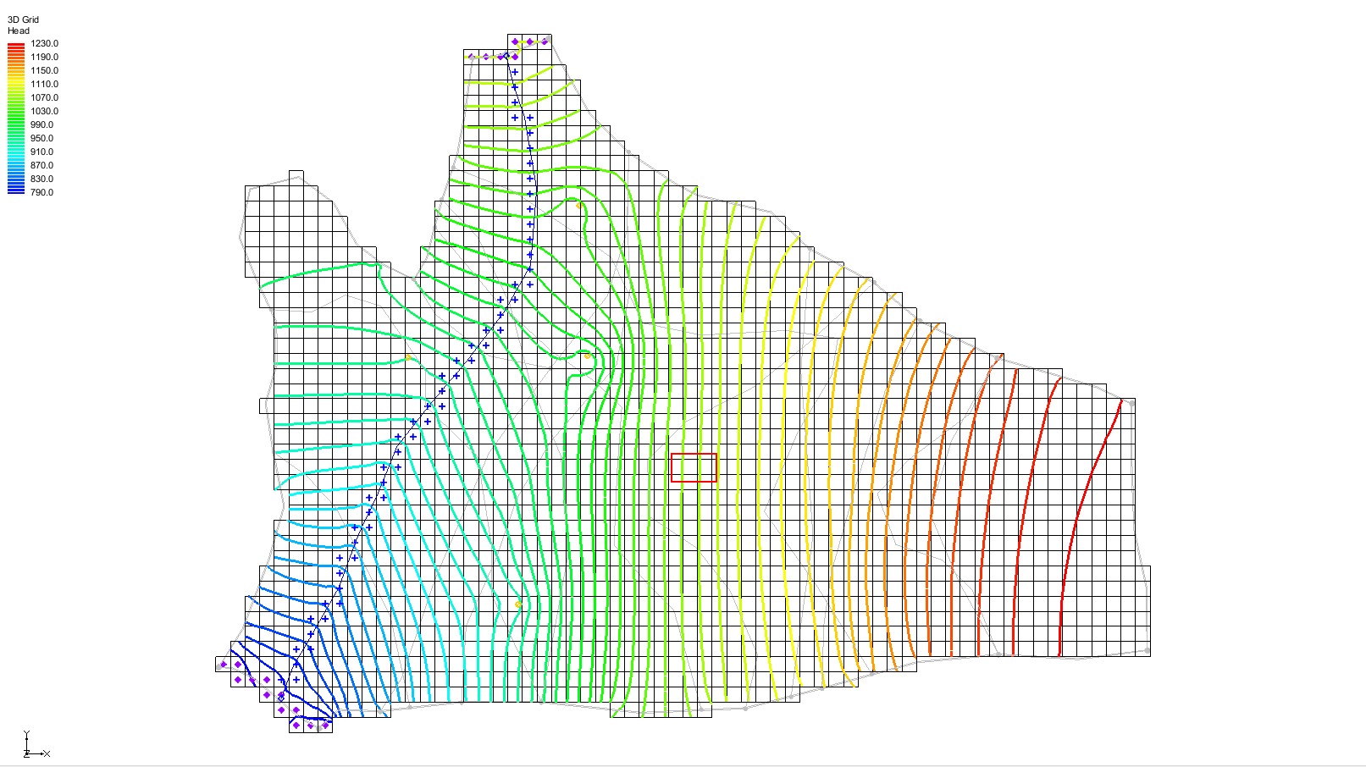

Figure 2 The initial view of the project

# Converting the Layer Data to a Scatter Point Set

The first step in converting the regional model to a local model is to convert the MODFLOW layer data to a 2D scatter point set.

1. Select the “File:3D Grid Folder.svg 3D Grid Data” folder in the Project Explorer to make it active.

Select *Grid |* **MODFLOW Layers → 2D Scatter Points…** to bring up the *MODFLOW Layers → Scatter Points* dialog.

Enter “Regional Data” as the *Scatter point set name*.

In the *Datasets* section, turn on *Layer elevations* and *Computed heads*.

Click **Select Dataset…** under *Computed heads* to bring up the *Select Dataset* dialog.

Select the “Head” dataset under the “120px-Generic_Folder_Locked regmod (MODFLOW)” solution.

Click **OK** to exit the *Select Dataset* dialog.

Click **OK** to exit the *MODFLOW Layers → Scatter Points* dialog.

A set of scatter points appears at the cell centroids (Figure 3). This scatter point set includes a dataset for the computed heads and for the top and bottom elevations of the model layers.

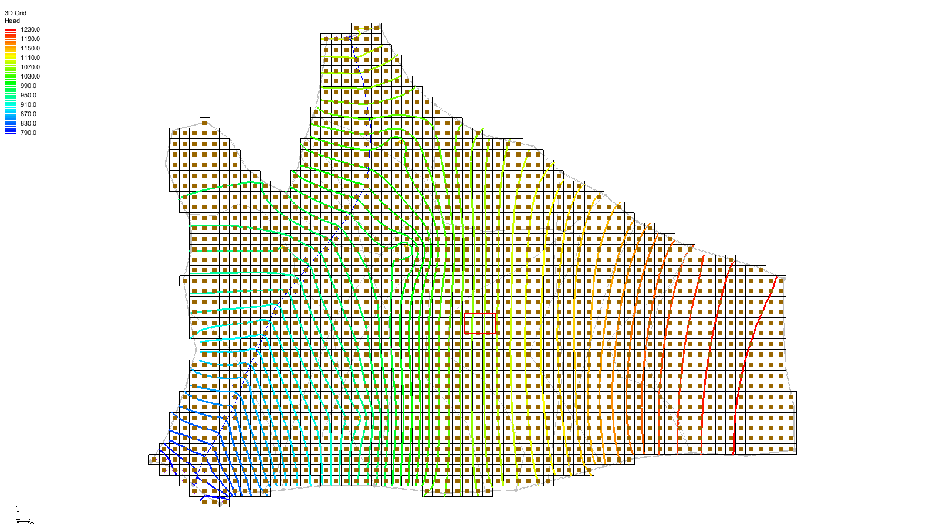

Figure 3 The layer data converted to scatter points

# Building the Local Conceptual Model

There are several methods for constructing the local model. A common approach is to define the local model boundaries as specified head boundaries, using the computed head values from the regional model. The following method accomplishes this objective:

A rectangular grid is created with two opposite boundaries aligned parallel to head contours from the regional model, resulting in a constant head value along each of these boundaries. The remaining two boundaries are defined as no-flow boundaries, oriented perpendicular to the head contours.

The simplest way to construct the local model is by creating a conceptual model in the Map module. Begin by creating a new conceptual model:

1. Expand the “File:Map Folder.svg Map Data” folder in the Project Explorer.

Right-click on the “File:Conceptual Model Icon.svg Regional Model” item and select **Duplicate** to create a new “File:Conceptual Model Icon.svg Regional Model (2)” item.

Right-click on “File:Conceptual Model Icon.svg Regional Model (2)” and select **Properties…** to bring up the *Conceptual Model Properties* dialog.

Enter “Local Model” as the *Name*.

Click **OK** to close the *Conceptual Model Properties* dialog.

## Creating a New Coverage

Next, to create a new source/sink coverage:

1. Expand the “File:Conceptual Model Icon.svg Local Model”, right-click on the “File:Coverage Active Icon.svg ss” coverage and select **Delete**.

Right-click on “File:Conceptual Model Icon.svg Local Model” and select **New Coverage…** to bring up the *Coverage Setup* dialog.

Enter “local ss” as the *Coverage name*.

In the *Sources/Sinks/BCs* column, turn on *Layer range*and*Specified Head (CHD)*.

Change the *Default layer range* to be “1” to “2”.

Click **OK** to close the *Coverage Setup* dialog.

In this tutorial, the recharge and hydraulic conductivity coverages will be used to construct the local model. Since the boundaries of the coverages are larger than they need to be, it is not necessary to change them.

## Creating the Boundary Arcs and the Polygon

1. Use the **Zoom** File:Zoom Tool Icon.svg tool to drag a box around the local site boundary (the red rectangle).

Select the “File:Coverage Active Icon.svg local ss” coverage in the Project Explorer to make it the active coverage.

Now create the boundaries as follows:

Using the **Create Arc** File:GMS Create Arc Tool.svg tool, create four arcs: two parallel to the contours and two perpendicular to them, as shown in Figure 4. Double-click on each corner to finish e­ach arc.

There should be a node at each corner and two vertices on each arc.

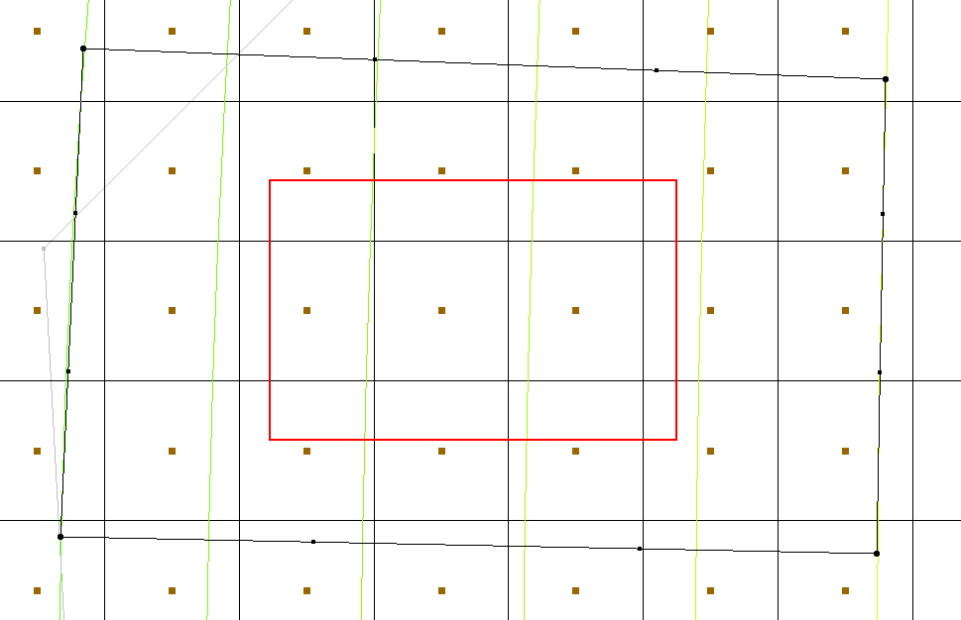

Figure 4 Boundary arcs to be created

Use the arcs to build a polygon defining the model domain.

Click **Build Polygons**File:Build Polygons Macro.svg to create a polygon from the arcs. The polygon is indicated by the area within the arcs changing to a light gray (Figure 5).

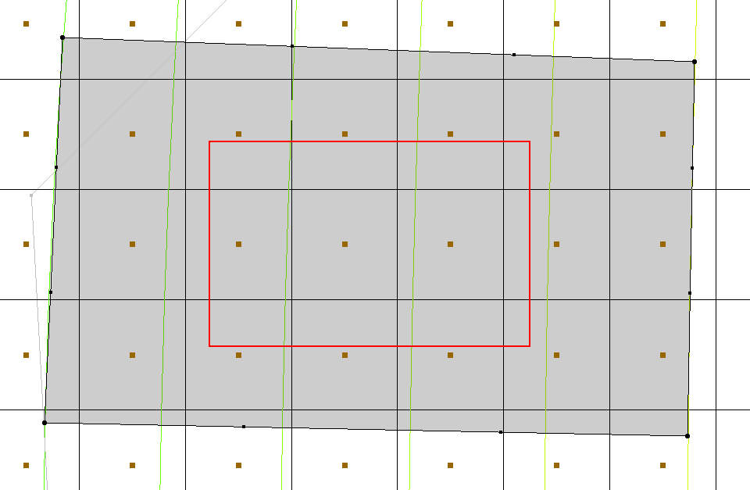

Figure 5 The polygon created from the boundary arcs

## Marking the Specified Head Arcs

The specified head boundaries need to be marked next:

1. While holding down the Shift key, use the **Select Arcs** File:GMS Select Arc Tool.svg tool to select the arcs on the left and right sides of the model.

Click **Properties** File:GMS Properties Macro.svg to open the *Attribute Table* dialog.

In the *All* row of the spreadsheet, from the *Type* drop-down, select “spec. head (CHD)”.

This sets both arcs as specified head arcs.

Click **OK** to close the *Attribute Table* dialog.

At this point, select the nodes along the specified head arcs and assign a head value to each.

Using the **Select Points\Nodes** File:GMS Select Node Tool.svg tool, select the two nodes on the left side of the model by holding down the *Shift* key.

Click the **Properties** File:GMS Properties Macro.svg macro to open the *Attribute Table* dialog.

In the *Head-Stage* *(ft)* column, enter a head value of “1050.0” in the *spec. head (CHD)* rows for each node.

Click **OK** to close the *Attribute Table* dialog.

Repeat steps 5–8 for the two nodes on the right side of the model. In the spec. head (CHD) rows, enter the value “1100.0”.

# Creating the Local MODFLOW Model

The conceptual model can now be converted to a grid model. The first step in this process is to create a new grid frame that aligns with the local model boundary.

1. In the Project Explorer, right-click on a empty space and select *New |* **Grid Frame**to create a new grid frame.

Right-click on “File:Grid Frame Icon.svg Grid Frame” in the Project Explorer and select **Fit to Active Coverage**.

If desired, use the **Grid Frame** File:Select Grid Frame Tool.svg tool to position the grid frame to better match the local grid boundary (Figure 6).

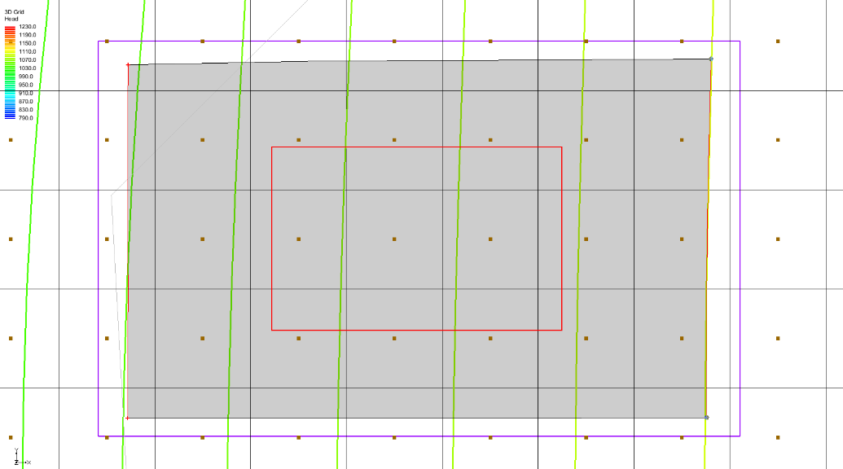

Figure 6 Grid frame encompassing the active coverage

## Creating the Grid

To create the grid:

1. In the Project Explorer, right-click on the “File:Grid Frame Icon.svg Grid Frame” and select *Map To |* **3D Grid** to bring up the *Create Finite Difference Grid* dialog.
2. Click **OK** to confirm deletion of the existing grid.

Click **OK** to confirm deletion of the current MODFLOW and MODPATH data.

In the *X-Dimension* section, enter “60” for the *Number cells*.

In the *Y-Dimension* section, enter “50” for the *Number cells*.

In the *Z-Dimension* section, enter “2” for the *Number cells.*

Click **OK** to create the grid and close the *Create Finite Difference Grid* dialog.

A grid will appear (Figure 7).

1. Using the **Zoom** File:Zoom Tool Icon.svg tool, drag a box around the grid to zoom in to just the grid area.

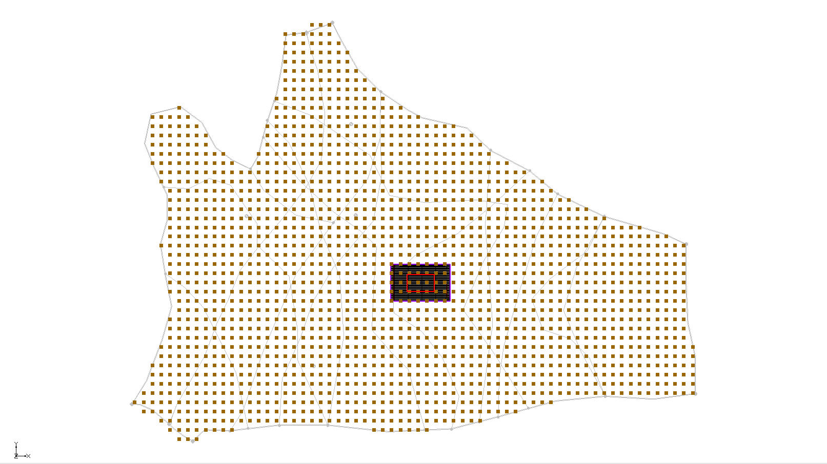

Figure 7 The finite difference grid

## Activating the Cells

Next, to inactivate the exterior cells:

1. Select the “File:3D Grid Folder.svg 3D Grid Data” folder in the Project Explorer to make it active.

Select *MODFLOW* | **New Simulation…** to bring up the *MODFLOW Global/Basic Package* dialog.

Click **OK** to accept the defaults and close the *MODFLOW Global/Basic Package* dialog.

Select the “File:Map Folder.svg Map Data” folder in the Project Explorer to make it active*.*

Select *Feature Objects* | **Activate Cells in Coverage(s)**.

If the arcs closely match the grid boundary, no cells may be inactivated. However, if the grid extends significantly beyond the arcs, cells outside the arcs will be inactivated.

## Mapping the Properties

To convert the MODFLOW data to the grid:

1. Right-click on the “File:Conceptual Model Icon.svg Local Model” conceptual model and select *Map To |* **MODFLOW/MODPATH** to bring up the *Map → Model* dialog.
2. Select *All applicable coverages* and click **OK** to close the *Map → Model* dialog.

Note that, at this point, the local-scale model does not currently include the pump-and-treat system wells. These could be added at a later time if needed.

## Interpolating the Layer Data

The final step in the regional-to-local conversion is to interpolate the regional data from the scatter point set to the MODFLOW layer arrays of the local model.

1. Right-click on the “File:2D Scatter Icon.svg Regional Data” scatter set and select *Interpolate To |* **MODFLOW Layers…** to bring up the *Interpolate to* *MODFLOW Layers* dialog.

Click **OK** to accept the defaults and close the *Interpolate to MODFLOW Layers* dialog.

Turn off “File:2D Scatter Folder.svg 2D Scatter Data” folder to make it easier to see the other information (Figure 8).

Frame Frame the model.

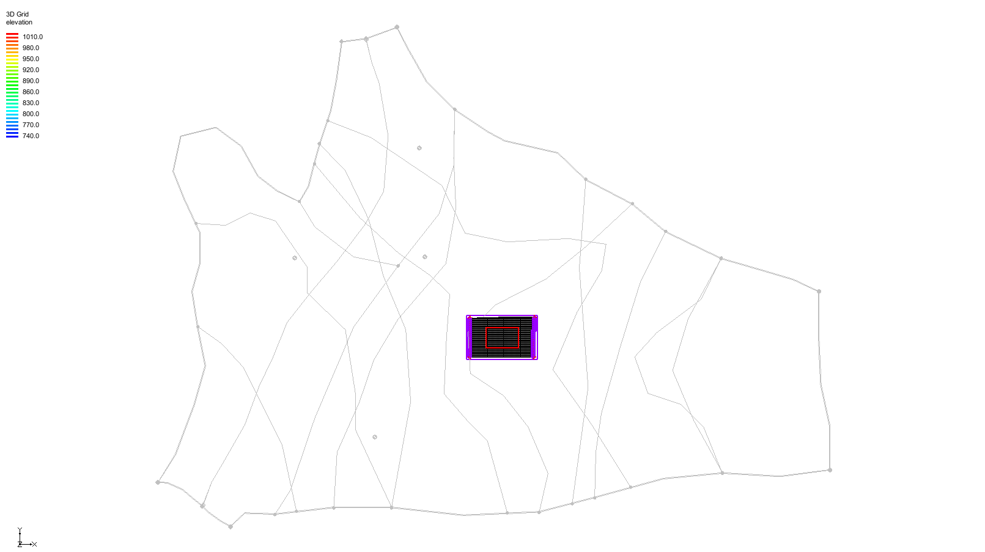

Figure 8 After the scatter point set is turned off

## Saving and Running the Local Model

It is now possible to save the MODFLOW model and run the simulation.

1. Select the “File:3D Grid Folder.svg 3D Grid Data” folder in the Project Explorer to make it active.

Select *File* | **Save As…** to bring up the *Save As* dialog.

Select “Project Files (\*.gpr)” from the *Save as type* drop-down.

Enter “locmod.gpr” as the *File name*.

Click **Save** to save the project under the new name and close the *Save As* dialog.

Select *MODFLOW* | **Run MODFLOW** to bring up the *MODFLOW* model wrapper dialog.

When the simulation is finished, turn on *Read solution on exit* and *Turn on contours (if not on already)*.

Click **Close** to close the *MODFLOW* model wrapper dialog.

**Zoom** File:Zoom Tool Icon.svg in the local model to see the contour lines within it.

A set of head contours, closely matching those from the regional model, should now be visible (Figure 9). At this point, the local-flow model is complete and ready for further refinement, such as adding injection and extraction wells for the pump-and-treatment simulations.

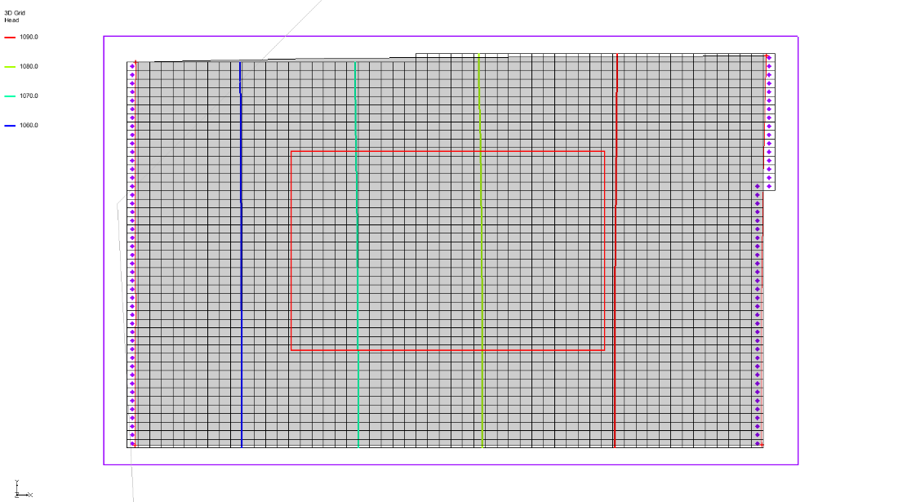

Figure 9 The local model showing contour lines

# MODAEM Regional Model

A regional MODAEM model can also be used to generate a local MODFLOW model. Instead of using a specified head boundary in the “File:Coverage Active Icon.svg local ss” coverage, a MODAEM head boundary—linked to a MODAEM conceptual model—is applied.

When the **Map → MODFLOW** command is used, GMS identifies the cells associated with the MODAEM head boundary, runs in the background, and computes the head at those locations. MODAEM also calculates the flow across the boundary, providing both head input for MODFLOW and a corresponding flow observation.

## Saving MODAEM

Notice that a “File:Conceptual Model Icon.svg Reg MODAEM” conceptual model now appears in the “File:Map Folder.svg Map Data” folder in the Project Explorer. The next step is to run the MODAEM model to generate and view the resulting head contours.

1. Expand the “File:Conceptual Model Icon.svg Reg MODAEM” conceptual model in the Project Explorer and select the “File:Coverage Active Icon.svg ss” coverage within it to make it the active coverage.

Click the **Run MODAEM** File:Run MODAEM Macro.svg macro to bring up the *MODAEM* model wrapper dialog.

This runs the MODAEM model for the “File:Conceptual Model Icon.svg Reg MODAEM” conceptual model.

1. When MODAEM is finished running, click **Close** to exit the *MODAEM* model wrapper dialog.

The head contours from the “File:Conceptual Model Icon.svg Reg MODAEM” conceptual model should now be visible (Figure 10).

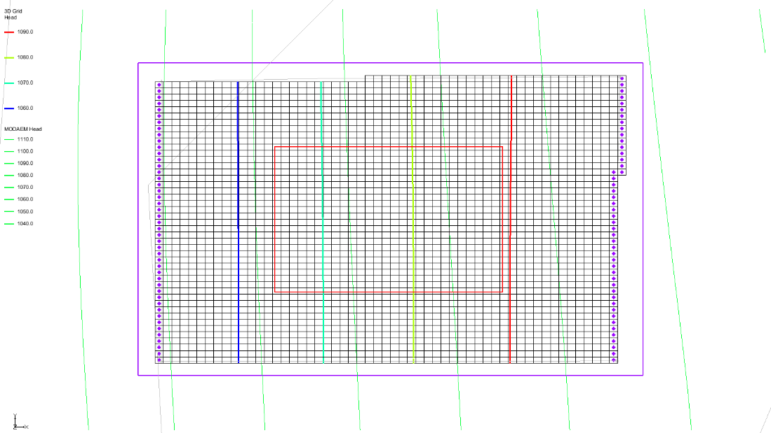

Figure 10 Local model after MODAEM run

## Adjusting the Coverage Setup

To change the “local ss” coverage of the “Local Model” conceptual model to use a MODAEM head boundary instead of a specified head boundary, do the following:

1. Expand the “File:Conceptual Model Icon.svg Local Model” conceptual model and select the “File:Coverage Active Icon.svg local ss” coverage to make it active.

Double-click on the “File:Coverage Active Icon.svg local ss” coverage to bring up the *Coverage Setup* dialog.

In the *Sources/Sinks/BCs* column, turn on “MODAEM head”.

From the *MODAEM models* drop-down at the bottom of the dialog, select “Reg MODAEM”.

Click **OK** to exit the *Coverage Setup* dialog.

While holding down the *Shift* key, use the **Select Arcs** File:GMS Select Arc Tool.svg tool to select the two specified head arcs (the arcs on the left and right sides).

Click the **Properties** File:GMS Properties Macro.svg macro to open the *Attribute Table* dialog.

Ensure that the *Feature type* section has the “Arcs” option selected from the drop-down.

In the *Type* column on the *All* row, select “MODAEM head” from the drop-down.

Click **OK** to exit the *Attribute Table* dialog.

## Running the Local Model

It is now possible to convert the local conceptual model to the 3D grid.

1. Right-click on the “File:Conceptual Model Icon.svg Local Model” conceptual model in the Project Explorer and select *Map To |* **MODFLOW/MODPATH** to bring up the *Map → Model* dialog.

Select *All applicable coverages* and click **OK** to close the *Map → Model* dialog.

Select *File |* **Save As…** to bring up the *Save As* dialog.

Select “Project Files (\*.gpr)” from the *Save as type* drop-down.

Enter “locmod2.gpr” as the *File name*.

Click **Save** to save the project under the new name and close the *Save As* dialog.

Select the “File:3D Grid Folder.svg 3D Grid Data” folder in the Project Explorer.

Select *MODFLOW |* **Run MODFLOW** to bring up the *MODFLOW* model wrapper dialog.

When the model finishes, turn on *Read solution on exit* and *Turn on contours (if not on already)*.

Click **Close** to exit the *MODFLOW* model wrapper dialog.

A set of head contours similar to those from the regional model should now be visible (Figure 11). However, because the regional MODAEM model calculates heads differently than the MODFLOW regional model, the contours may not align as closely. Specifically, the sides of the local-flow model—intended to represent parallel flow—may not be perfectly perpendicular to the MODAEM head contours. As a result, the match between regional and local head contours may be less precise than in the MODFLOW-based conversion.

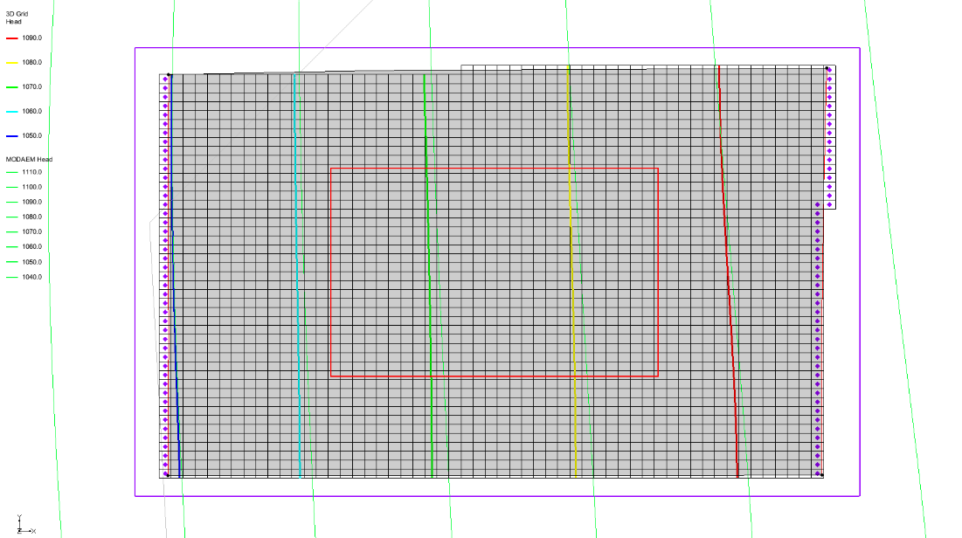

Figure 11 The local head contours are similar to the regional head contours

# Conclusion

This concludes the “MODFLOW – Regional-to-Local Model Conversion, Steady-State” tutorial. The following key concepts were covered:

* The *Grid* | **MODFLOW Layers → 2D Scatter Points…** command is used to convert MODFLOW elevation and head data into scatter points for interpolation
* The main steps for doing regional-to-local model conversion in GMS are:

1. Generating and solving a regional MODFLOW model
2. Converting regional model layer and head data to 2D scatter points
3. Creating a 3D grid for the local-scale model
4. Interpolating the scatter point data to the local model grid layers

* A local-scale MODFLOW model can also be constructed using a regional MODAEM model