10951095

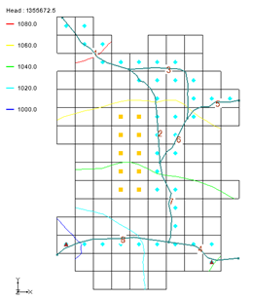

GMS 10.9 Tutorial

***MODFLOW – SFR2 Package***

The MODFLOW Streamflow-Routing (SFR2) Package Interface in GMS

GMS 10.9

Objectives

Learn how to create a model containing SFR1/SFR2-type streams.

Time

* 55–65 minutes

Required Components

* GMS Core
* MODFLOW Interface

Prerequisite Tutorials

* MODFLOW – Conceptual Model Approach I

|  |
| --- |
| 1 Introduction 2  2 Stream Basics 4  2.1 Reaches and Segments 4  2.2 Routing 4  3 Getting Started 4  3.1 Open the Starting Project 5  4 Digitize and Set Up the Stream Arcs 6  4.1 Create a Conceptual Model 6  4.2 Create a Conceptual Model 6  4.3 Create the Arcs 7  4.4 Correct the Arc Directions 7  4.5 Stream Reach and Segment Numbering 9  5 Assign Arc Attributes 9  5.1 Arc A 9  5.2 Arc B through H 11  5.3 Channel Cross Sections 11  5.4 Segment IDS 12  6 Map → MODFLOW 12  6.1 SFR2 Package Dialog 13  6.2 Save the Project and Run MODFLOW 14  6.3 Compare the Solutions 14  6.4 Compare the Solutions 15  6.5 Flow Budget 16  7 Creating an SFR Parameter 17  7.1 Flow Budget 18  8 Conclusion 19 |

# Introduction

The MODFLOW SFR2 package is used to model streamflow routing and unsaturated flow beneath streams. It is an evolution of the SFR1 package, which was derived from STR1, the original MODFLOW stream package. The SFR2 package is very similar to the SFR1 package, with the main difference being support for unsaturated flow beneath streams. The SFR2 package can read files prepared for the SFR1 package.

Because of the grid-independent conceptual model approach that GMS has long supported, GMS is an ideal modeling interface for creating streams. Stream segments and reaches must be listed in a particular order that can be quite tricky to get right if preparing a file by hand. GMS takes care of stream ordering automatically with a simple point-and-click stream creation interface so the user rarely has to worry about it.

This tutorial illustrates how to create a model containing SFR1/SFR2 type streams. The model in this tutorial is from the MODFLOW SFR1 Package documentation. The problem is a hypothetical one “developed for an alluvial basin in a semiarid region in which recharge to the aquifer is primarily leakage from streams that enter the basin from mountains on the northwest, northeast, and southeast”.[1] One grid layer is used.

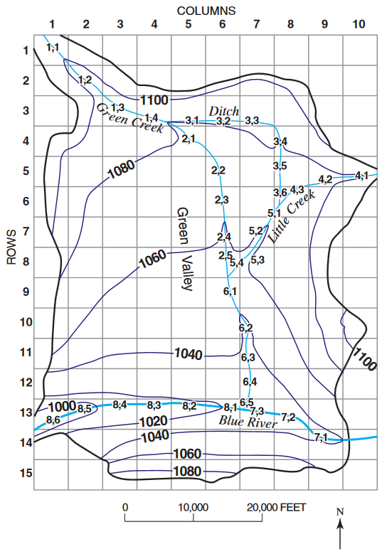

Figure 1 An SFR1 stream network[2]

The simulation has two stress periods. In the first stress period, the wells in the middle of the model extract water from the model and draw down the water table. In the second stress period, the wells are turned off and the head recovers from the draw down. The stream data is held constant for both stress periods.

This tutorial will demonstrate and discuss:

* Adding stream feature arcs by digitizing a background image.
* Ensuring that the stream arcs are pointing in the right direction.
* Assigning attributes to the stream arcs.
* Saving and running the model.

# Stream Basics

## Reaches and Segments

The SFR2 package divides streams into reaches and segments.

A stream reach is a section of a stream that is associated with a particular finite-difference cell used to model ground-water flow and transport. A segment is a group of reaches that have (1) uniform rates of overland flow and precipitation to them; (2) uniform rates of evapotranspiration from them; (3) uniform or linearly changing properties (for example; streambed elevation, thickness, and hydraulic conductivity, and stream depth and width); (4) tributary flows or specified inflow or outflow (only in the first reach); and (5) diversions (only from the last reach).[3]

In GMS, a stream segment corresponds to a single arc. A stream reach doesn’t have a corresponding representation in the conceptual model but exists only on the grid cells after having mapped the conceptual model to the grid.

## Routing

In addition to tracking flow between streams and the underlying aquifer, the MODFLOW stream packages (STR1, SFR1, and SFR2) also route the flow of water through a stream network. The stream network can include tributaries, diversions, and lakes (in conjunction with the Lake Package).

Routing is accomplished by determining the inflows for a reach (which are specified for the most upstream reach), adding or subtracting leakage to the aquifer, and allowing any remainder to pass to the next downstream reach as inflow. The process is repeated for the next downstream reach and so forth.

This is different from the MODFLOW River Package, which only tracks flow between the river and the aquifer. With the River Package, once water has entered the river, it is lost to the model. With the stream packages, that water can travel downstream and possibly reenter the aquifer at another point.

Unlike the River package, the water depth is calculated based on the flow rather than being manually entered. There are several different options available for calculating water depth, including using Manning’s equation or a depth versus flow table.

# Getting Started

Do the following to get started:

1. If necessary, launch GMS.
2. If GMS is already running, select *File |* **New** to ensure that the program settings are restored to their default state.

## Open the Starting Project

The point of this tutorial is to illustrate the SFR2 package, so previously created files will be imported rather than spending time entering the other MODFLOW inputs.

1. Click **Open** File:Open Macro.svg to bring up the *Open* dialog.
2. Select “Project Files (*.gpr)” from the *Files of type* drop-down.
3. Browse to the *sfr2\sfr2* directory and select “start.gpr”.
4. Click **Open** to import the project and exit the *Open* dialog.

A grid with some streams and contour lines should be visible (Figure 2).

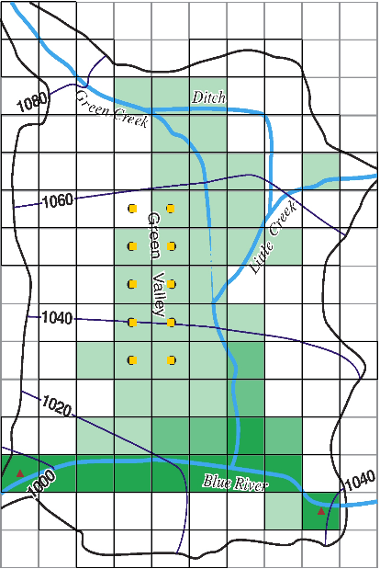

Figure 2 Initial project appearance

1. Right-click in a blank spot in the Project Explorer and select **Expand All**.

Notice the Project Explorer includes a 3D grid and a MODFLOW simulation (Figure 3).

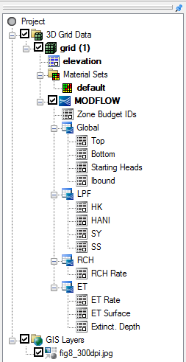

Figure 3 Project Explorer at the project beginning

# Digitize and Set Up the Stream Arcs

In GMS, it is only possible to create streams by using the conceptual model approach. This is done by mapping feature objects to the grid. Streams cannot be created directly on the grid. The stream arcs will be created by digitizing the background image.

## Create a Conceptual Model

First, it is necessary to create a MODFLOW conceptual model.

1. Right-click in the blank space in the Project Explorer and select *New |* **Conceptual Model…** to bring up the *Conceptual Model Properties* dialog.
2. Enter “Test 1” as the *Name*.
3. Click **OK** to close the *Conceptual Model Properties* dialog.

## Create a Conceptual Model

1. Right-click on the “File:Conceptual Model Icon.svg Test 1” conceptual model and select **New Coverage…** to bring up the *Coverage Setup* dialog.
2. Enter “Streams” as the *Coverage name*.
3. In the *Sources/Sinks/BCs* column, scroll down and turn on *Stream* *(SFR2)*.
4. Enter “1500.0” as the *Default elevation* so the coverage will be above the grid.
5. Click **OK** to close the *Coverage Setup* dialog.
6. Select the new “File:Coverage Active Icon.svg Streams” coverage to make it active.

## Create the Arcs

Now, create the arcs for the streams. Refer to Figure 4 for the first four steps below.

1. Using the **Create Arc** File:GMS Create Arc Tool.svg tool, create an arc along the path of Green Creek (from the top left corner down to the Blue River).
2. Create an arc for the Ditch (from Green Creek to Little Creek).
3. Create an arc for Little Creek (from the right edge to Green Creek).
4. Create an arc for the Blue River (from the right edge to the left edge).

Now that the arcs have been digitized, the background image is no longer necessary.

1. In the Project Explorer, turn off the “File:GIS Folder.svg GIS Layers” folder.

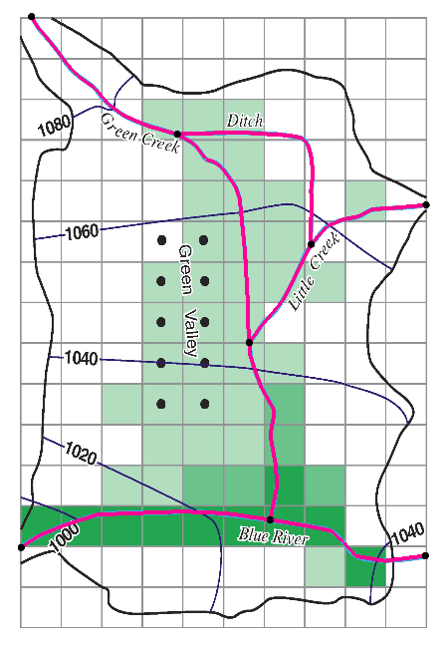

Figure 4 Location of stream arcs after digitizing (arcs bolded for clarity)

## Correct the Arc Directions

Arcs have a direction associated with them. The direction is from the starting node to the ending node and is defined when the arc is first created. Usually the direction doesn’t matter, but with streams, they must go from upstream to downstream (just as water flows). The direction can be displayed and reversed if needed.

To check the arc direction and make sure all the arcs are pointing from upstream to downstream, do the following.

1. Turn off the “GIS Data folder GIS Layers” and “3D Grid Data folder 3D Grid Data” folders to get a clear look at the arcs.
2. Click **Display Options** File:Display Options Macro.svg to bring up the *Display Options* dialog.
3. Select “File:Map Module Icon.svg Map Data” from the list on the left.
4. On the *Map* tab, near the bottom of the first section, turn on *Arc direction arrows*.
5. Click **OK** to close the *Display Options* dialog.

Arrows should now be visible on the arcs. The arrows should be pointing as shown in Figure 5. If any of the arcs are pointing in the wrong direction, do the following:

1. Using the **Select Arcs** File:GMS Select Arc Tool.svg tool, select the arc, then right-click and select **Reverse Arc Direction** to change the direction of the flow along the arc.
2. Repeat step 6 for any arcs pointing the wrong direction.

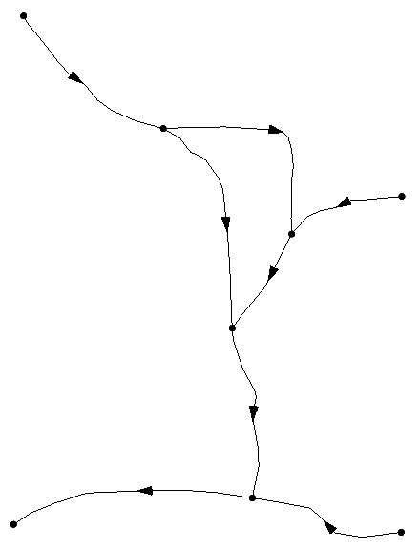

Figure 5 Arc flow directions

With all arcs pointing in the correct direction, the flow arrows can be turned off.

1. Click **Display Options** File:Display Options Macro.svg to bring up the *Display Options* dialog.
2. Select “File:Map Module Icon.svg Map Data” from the list on the left.
3. On the *Map* tab, near the bottom of the first section, turn off *Arc direction arrows*.
4. Click **OK** to close the *Display Options* dialog.

## Stream Reach and Segment Numbering

GMS automatically numbers stream segments and reaches. Numbering in the *MODFLOW Stream (SFR2) Package* dialog is covered later in this tutorial.

The SFR1 package documentation states that “the numbering of segments and reaches is important. Segments are numbered sequentially from the farthest upstream segment to the last downstream segment…. Reaches within a segment must be numbered sequentially from the farthest upstream reach in a segment to the last downstream reach”.[4] Figure 6 gives an example of stream and segment numbering.

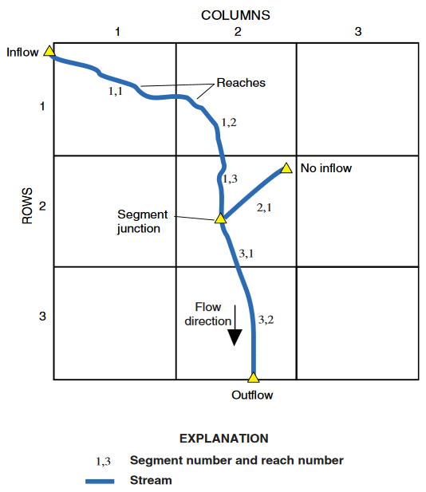

Figure 6 Illustration of stream segment and reach numbering[5]

GMS assigns an integer ID number to each arc automatically as it is created. This ID number is NOT the stream segment number. Stream segment and reach numbers are only determined when the **Map → MODFLOW** command is executed. Be careful to not confuse arc ID numbers with stream segment numbers.

# Assign Arc Attributes

Now review how to assign the stream attributes to the arcs.

## Arc A

1. Using the **Select Arcs** File:GMS Select Arc Tool.svg tool, double-click on arc A (see Figure 7) to bring up the *Attribute Table* dialog.
2. In the spreadsheet section, select “stream (SFR2)” from the drop-down in the *Type* column.
3. Enter the remaining values as given in the following table. Only columns requiring changes are shown, and some require scrolling to the right to see:

|  |  |  |  |  |  |  |  |
| --- | --- | --- | --- | --- | --- | --- | --- |
| ICALC | FLOW (ft^3/s) | HCOND1 (ft/s) | THICKM1 (ft) | ELEVUP (ft) | HCOND2 (ft/s) | THICKM2 (ft) | ELEVDN (ft) |
| table (4) | 25.0 | 0.00003 | 3.0 | 1095.0 | 0.00003 | 3.0 | 1075.0 |

1. Scroll to the far right and click on the http://www.xmswiki.com/w/images/0/02/Narrow_dot_dot_dot_button.png button in the *Flow Table* column to bring up the *Stream Flow Table* dialog.
2. Enter the following into the spreadsheet:

|  |  |  |  |  |  |  |  |  |  |  |  |  |  |  |  |  |  |  |  |  |  |  |  |  |  |  |  |  |  |  |  |  |  |  |  |  |
| --- | --- | --- | --- | --- | --- | --- | --- | --- | --- | --- | --- | --- | --- | --- | --- | --- | --- | --- | --- | --- | --- | --- | --- | --- | --- | --- | --- | --- | --- | --- | --- | --- | --- | --- | --- | --- |
| |  |  |  | | --- | --- | --- | | Flow | Depth | Width | | 0.5 | 0.25 | 3.0 | | 1.0 | 0.4 | 3.5 | | 2.0 | 0.55 | 4.2 | | 4.0 | 0.7 | 5.3 | | 7.0 | 0.8 | 7.0 | | 10.0 | 0.9 | 8.5 | | 20.0 | 1.1 | 12.0 | | 30.0 | 1.25 | 14.0 | | 50.0 | 1.4 | 17.0 | | 75.0 | 1.7 | 20.0 | | 100.0 | 2.6 | 22.0 | |

1. When finished, click **OK** to close the *Stream Flow Table* dialog.
2. Click **OK** to close the *Attribute Table* dialog.
3. Click on a blank spot in the Graphics Window to deselect arc A.

Notice that arc A is now a different color than the rest of the stream arcs.

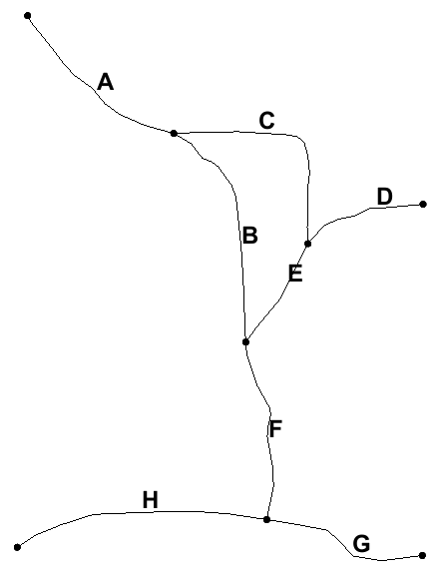

Figure 7 Arcs with letters to distinguish them

## Arc B through H

1. Using the **Select Arcs** File:GMS Select Arc Tool.svg tool, double-click on arc B to bring up the *Attribute Table* dialog.
2. Repeat steps 2–3 from section 5.1 to assign the values shown in Table 1 and Table 2 below.
3. Click **OK** to exit the *Attribute Table* dialog.
4. Repeat steps 1–3 for arcs C through H.

Note that Table 2 is a continuation of Table 1 due to width limitations.

|  |  |  |  |  |  |  |  |  |  |  |
| --- | --- | --- | --- | --- | --- | --- | --- | --- | --- | --- |
| Arc | Type | ICALC | Diversion (SFR2) | FLOW (ft^3/s) | ROUGHCH | ROUGHBK | CDPTH | FDPTH | AWDPTH | BWDTH |
| A | stream (SFR2) | table (4) |  | 25.0 |  |  |  |  |  |  |
| B | wide channel (1) |  |  | 0.03 |  |  |  |  |  |
| C | specified (0) | ✓ | 10.0 |  |  |  |  |  |  |
| D | wide channel (1) |  | 10.0 | 0.03 |  |  |  |  |  |
| E | power function (3) |  |  |  |  | 0.3 | 0.35 | 3.8 | 0.6 |
| F | wide channel (1) |  |  | 0.03 |  |  |  |  |  |
| G | cross section (2) |  | 150.0 | 0.025 | 0.045 |  |  |  |  |
| H | cross section (2) |  |  | 0.025 | 0.045 |  |  |  |  |

Table 1 Stream arc attributes

|  |  |  |  |  |  |  |  |  |  |  |
| --- | --- | --- | --- | --- | --- | --- | --- | --- | --- | --- |
| Arc | HCOND1 (ft/s) | THICKM1 (ft) | ELEVUP (ft) | WIDTH1 (ft) | DEPTH1 (ft) | HCOND2 (ft/s) | THICKM2 (ft) | ELEVDN (ft) | WIDTH2 (ft) | DEPTH2 (ft) |
| A | 0.00003 | 3.0 | 1095.0 |  |  | 0.00003 | 3.0 | 1075.0 |  |  |
| B | 0.00003 | 3.0 | 1075.0 | 12.0 |  | 0.00003 | 3.0 | 1050.0 | 12.0 |  |
| C | 0.00003 | 2.0 | 1075.0 | 10.0 | 2.0 | 0.00003 | 2.0 | 1060.0 | 6.0 | 1.0 |
| D | 0.00003 | 3.0 | 1080.0 | 10.0 |  | 0.00003 | 3.0 | 1060.0 | 10.0 |  |
| E | 0.00003 | 3.0 | 1060.0 |  |  | 0.00003 | 3.0 | 1045.0 |  |  |
| F | 0.00003 | 3.0 | 1045.0 | 12.0 |  | 0.00003 | 3.0 | 1025.0 | 12.0 |  |
| G | 0.00006 | 3.0 | 1040.0 |  |  | 0.00006 | 3.0 | 1025.0 |  |  |
| H | 0.00006 | 3.0 | 1025.0 |  |  | 0.00006 | 3.0 | 990.0 |  |  |

Table 2 Stream arc attributes, continued

## Channel Cross Sections

Because arcs G and H use a cross section to determine the stream depth, the cross-section points need to be entered.

1. Using the **Select Arcs** File:GMS Select Arc Tool.svg tool, double-click on arc G to bring up the *Attribute Table* dialog.
2. Scroll to the right to the *Channel Cross Section* column and click the http://www.xmswiki.com/w/images/0/02/Narrow_dot_dot_dot_button.png button to bring up the *XY Series Editor* dialog.
3. Enter the following values in the *XY Series Editor*:

|  |  |
| --- | --- |
| Distance (ft) | Elevation (ft) |
| 0 | 20 |
| 10 | 13 |
| 80 | 10 |
| 100 | 2 |
| 150 | 0 |
| 170 | 10 |
| 240 | 13 |
| 250 | 20 |

1. Click **OK** to exit the *XY Series Editor* dialog.
2. Click **OK** to exit the *Attribute Table* dialog.
3. Repeat steps 1–5 for arc H, using the table below for the *XY Series Editor* dialog:

|  |  |
| --- | --- |
| Distance (ft) | Elevation (ft) |
| 0 | 25 |
| 10 | 17 |
| 80 | 13 |
| 100 | 4 |
| 150 | 0 |
| 170 | 10 |
| 240 | 16 |
| 250 | 20 |

1. Click in a blank spot in the Graphics Window to deselect all arcs.

All of the arcs should now have changed to the same color as arc A.

## Segment IDS

GMS can display the stream segment ID numbers by doing the following.

1. Click **Display Options** File:Display Options Macro.svg to bring up the *Display Options* dialog.
2. Select “File:Map Module Icon.svg Map Data” from the list on the left.
3. At the bottom of the first section on the *Map* tab, turn on *Segment ID*.
4. Click **OK** to exit the *Display Options* dialog.

Notice the “0” displayed in the middle of each arc. The conceptual model has not yet been mapped to the grid using the **Map → MODFLOW** command. Until this is done, GMS does not know how the stream segments should be numbered. After the **Map → MODFLOW** is done, the stream segment numbers will follow the rule of upstream to downstream.

# Map → MODFLOW

Everything that was needed has been entered into the conceptual model and can now be mapped to the grid.

1. Select *Feature Objects* | **Map → MODFLOW** to bring up the *Map → Model* dialog.
2. Click **OK** to accept the defaults and close the *Map → Model* dialog.

Notice the stream segment numbers are no longer all zeroes. The stream segments have been numbered so that downstream numbers are always greater than upstream numbers.

## SFR2 Package Dialog

The streams in the conceptual model have now been mapped to the grid. The *MODFLOW Stream (SFR2) Package* dialog shows all of the stream segments and reaches on the grid.

1. Turn on and select “File:3D Grid Folder.svg 3D Grid Data” in the Project Explorer to make it active.
2. Select *MODFLOW* | *Optional Packages |* **SFR2 - Streamflow-Routing…** to bring up the *MODFLOW Stream (SFR2) Package* dialog (Figure 8).

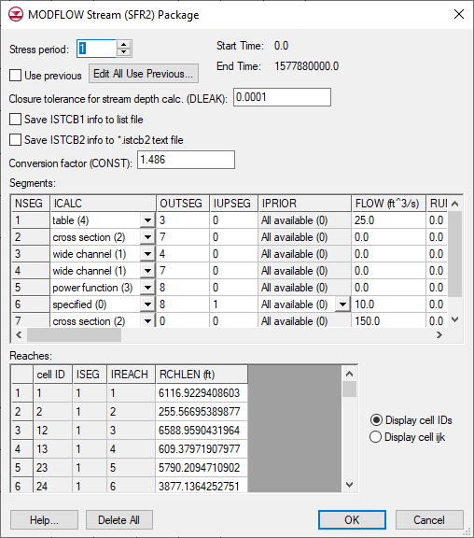

Figure 8 MODFLOW Stream (SFR2) Package dialog

The stream segments are listed in the top spreadsheet and the reaches in the bottom spreadsheet. GMS calculated the reach lengths (RCHLEN) during the **Map → MODFLOW** process.

Segment numbers (NSEG), reach cell IDs, and the ISEG or IREACH numbers cannot be edited—and segments and reaches cannot be added—in this dialog. Stream data can only be created by mapping to MODFLOW from a conceptual model. If a MODFLOW simulation with SFR2 data is imported, it will populate the stream package dialog even if a conceptual model doesn’t exist.

1. Click **OK** to exit the *MODFLOW Stream (SFR2) Package* dialog.

## Save the Project and Run MODFLOW

Now to save the project and run MODFLOW:

1. **Save** File:Save Macro.svg the project.
2. Select *MODFLOW |* **Run MODFLOW** to bring up the *MODFLOW* model wrapper dialog.
3. When the model finishes, turn on *Read solution on exit* and *Turn on contours (if not on already)*.
4. Click **Close** to import the solution and close the *MODFLOW* model wrapper dialog.

The Graphics Window should appear similar to Figure 9.

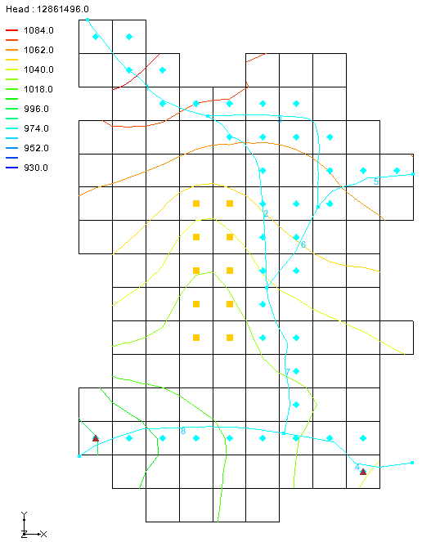

Figure 9 Solution showing the contours

## Compare the Solutions

Compare the new solution with the original one from the USGS.

1. Click **Contour Options** File:Contour Options Macro.svg to bring up the *Dataset Contour Options - 3D Grid - Head* dialog.
2. In the *Contour method* section, select “Linear” from the first drop-down and “Use color ramp” from the second drop-down.
3. In the *Contour interval* section, select “Specified Values” from the drop-down and enter “5” in the field to the right of the drop-down.
4. In the spreadsheet below that, enter “1000.0” for dark blue, “1020.0” for cyan, “1040.0” for green, “1060.0” for yellow, and “1080.0” for red.

The dialog should appear as in Figure 10.

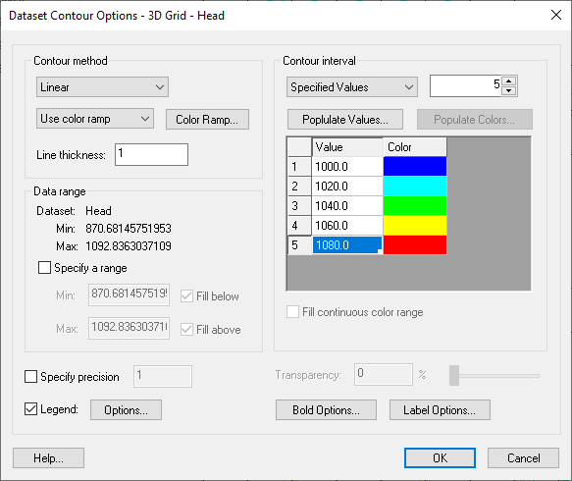

Figure 10 Contour Options dialog

1. Click **OK** to exit the *Dataset Contour Options - 3D Grid - Head* dialog.
2. In the Project Explorer, turn on the “File:GIS Folder.svg GIS Layers” folder.

Notice how the GMS contours match the contours on the background image pretty closely. The match isn’t perfect for a couple of reasons. First, the stream input generated by GMS differs some from the original USGS input. In particular, the reach lengths are different. The original USGS files, which were built by hand, contain rough estimates for the length of the stream channel within each model cell. GMS, on the other hand, calculates this value by intersecting the stream arcs with the grid cells.

The second reason why the contour lines differ is due to the different methods used by the USGS and GMS to interpolate and generate contour lines from gridded data.

1. Turn off the “File:GIS Folder.svg GIS Layers” folder.

## Compare the Solutions

Since this model is transient, a good way to examine the results is to use an animation. In this case, animate the color-filled contours.

1. Click **Contour Options** File:Contour Options Macro.svg to bring up the *Dataset Contour Options - 3D Grid - Head* dialog.
2. In the *Contour method* section, select “Color Fill” from the first drop-down.
3. Click **OK** to close the *Dataset Contour Options - 3D Grid - Head* dialog.
4. Select *Display |* **Animate…** to bring up the *Animation Wizard - Options* dialog.
5. Accept the defaults and click **Next >** to bring up the *Animation Wizard - Datasets* dialog.
6. Click **Finish** to accept the defaults and close the *Animation Wizard - Datasets* dialog.

Depending on the speed of the computer being used, it may take a minute or two to generate the animation. After it is finished generating, the animation file can be viewed in a media player application outside of GMS. The animation clearly shows how the wells draw down the head in the first stress period and how the head recovers in the second stress period.

## Flow Budget

Now to look at the flow budget for streams:

1. Select *MODFLOW |* **Flow Budget…** to bring up the *Flow Budget* dialog.

Notice the entries in the *Flow In* and *Flow Out* columns on the *Stream Leakage* row. There is more flow in than out because the streams are mostly losing water. Water is flowing from the streams into the aquifer in most places, but there is some flow out from the aquifer to the streams.

1. Click **OK** to close the *Flow Budget* dialog.

With other MODFLOW packages, clicking on a feature object in the map module will allow the flow associated with that object to be visible. GMS does this by using the MODFLOW OBS process. Streams are not part of the OBS process, so this is not available. However, the flow can be viewed on a cell-by-cell basis.

1. In the Project Explorer, select the “File:3D Grid Folder.svg 3D Grid Data” item to make it active.
2. Select and then right-click on “File:CCF Dataset Active.svg CCF (start.ccf)” and select **CCF → Datasets**.

Notice that a number of datasets have appeared within the solution folder.

1. Select “File:Dataset Cells Active.svg STREAM LEAKAGE” to make it active.
2. Click **Contour Options** File:Contour Options Macro.svg to bring up the *Dataset Contour Options - 3D Grid - STREAM LEAKAGE* dialog.
3. In the *Contour method* section, select “Block Fill” from the first drop-down.
4. In the *Contour interval* section, select “Number” from the drop-down and enter “10” in the field to the right of the drop-down.
5. Click **OK** to exit the *Dataset Contour Options - 3D Grid - STREAM LEAKAGE* dialog.

The Graphics Window should appear similar to Figure 11.

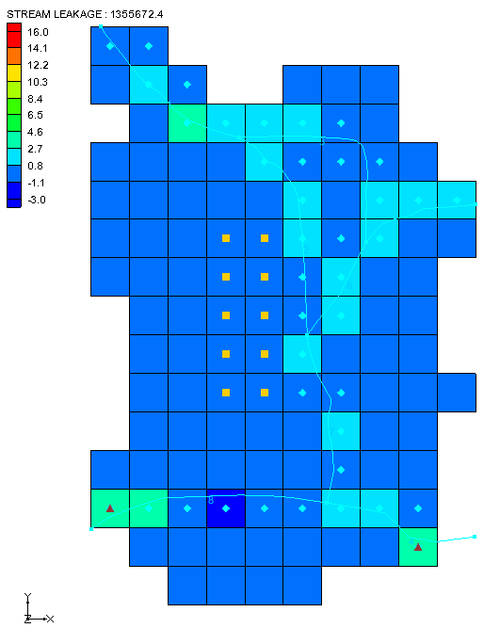

Figure 11 Block Fill showing stream in/out flow

Using the **Select Cells** File:Select 3D Cell Tool.svg tool, move the mouse over the grid cells and watch the status bar at the bottom of the Graphics Window to see what the stream flow is throughout the grid.

# Creating an SFR Parameter

An SFR parameter can be created by changing the conductance on the first SFR segment at the top-left of the model to use a parameter instead of specifying the conductance value.

1. Select “File:Map Folder.svg Map Data” in the Project Explorer to make it active.
2. Using the **Select Arcs** SelectArcs tool, double-click on arc A to open the *Attribute Table* dialog.
3. In the *HCOND1 (ft/s)* and *HCOND2 (ft/s)* columns, enter “-10.0”.
4. Click **OK** to exit the *Attribute Table* dialog.
5. Select *Feature Objects |* **Map → MODFLOW** to bring up the *Map → Model* dialog.
6. Click **OK** to accept the defaults and close the *Map → Model* dialog.
7. Select *MODFLOW |* **Parameters…** to bring up the *Parameters* dialog.
8. Click **Initialize From Model**.

Notice that a new parameter has been created.

1. Enter “0.00003” in the *Value* column. Adjust the column width for *Value* if needed to see the entry.
2. Click **OK** to exit the *Parameters* dialog.
3. Select *MODFLOW | Optional Packages |* **SFR2 - Streamflow-Routing…** to bring up the *MODFLOW Stream (SFR2) Package* dialog.

Notice that the *Segments* table now has *Hc1fact* and *Hc2fact* columns at the far right (scroll all the way to the right to see them). The values listed in these columns are multiplied by the parameter value to give the final conductance values for the SFR boundary condition.

1. Click **OK** to exit the *MODFLOW Stream (SFR2) Package* dialog.

## Flow Budget

Now it is possible to save the changes and run MODFLOW.

1. Select *File |* **Save As…** to bring up the *Save As* dialog.
2. Select “Project Files (*.gpr)” from the *Save as type* drop-down.
3. Enter “SFR2_GMS2.gpr” as the *File name*.
4. Click **Save** to save the project under the new name and close the *Save As* dialog.
5. Select *MODFLOW |* **Run MODFLOW** to bring up the *MODFLOW* model wrapper dialog.
6. When the model finishes, turn on *Read solution on exit* and *Turn on contours (if not on already)*.
7. Click **Close** to import the solution and close the *MODFLOW* model wrapper dialog.

Notice that the new solution is the same as the previous run (Figure 12).

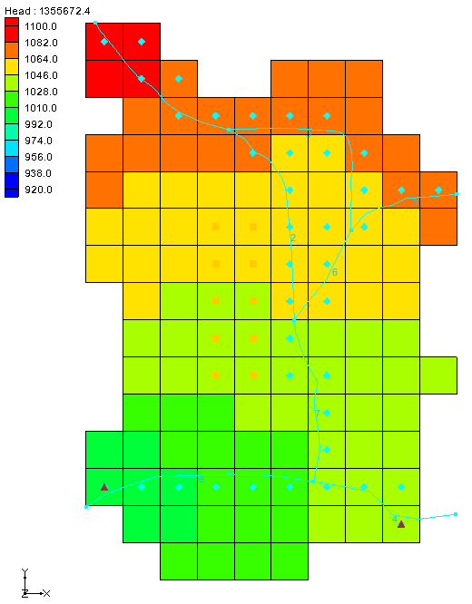

Figure 12 Solution using SFR parameters

# Conclusion

This concludes the “MODFLOW – SFR2 Package” tutorial. The following key concepts were discussed and demonstrated in this tutorial:

* It is possible to use GMS to create MODFLOW models with STR1, SFR1, and SFR2 type streams.
* Streams must be created in the Map module using Feature Objects and cannot be created directly on the grid.
* It is necessary to make sure that the stream arcs are oriented from upstream to downstream correctly.
* The conceptual model does not have to include all aspects of the model. In this case, the conceptual model contained only the streams and the other boundary conditions were already part of the grid.
* GMS automatically determines the proper ordering of the stream data for input to MODFLOW based on the orientation and topology of the stream arcs.
* Other MODFLOW packages allow feature objects to be selected to see the flow in or out of that object. The streams packages do not support this feature.
* GMS supports SFR parameters.

1. Prudic, David E.; Konikow, Leonard F.; and Banta, Edward R., 2004. *A New Streamflow-Routing (SFR1) Package to Simulate Stream-Aquifer Interaction with MODFLOW–2000*, U.S. Geological Survey Open-File Report 2004–1042. <https://pubs.usgs.gov/of/2004/1042/ofr2004-1042.pdf>.
2. Prudic (2004), p.14.
3. Prudic (2004), p.2.
4. Prudic (2004), p.3
5. Ibid.