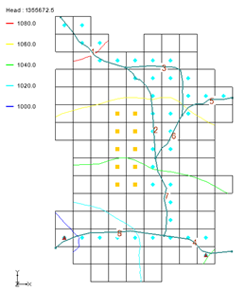

GMS 10.9

GMS 10.9 Tutorial

***MODFLOW – STR Package***

The MODFLOW Stream (STR) Package Interface in GMS

Objectives

Learn how to create a model containing STR-type streams. This tutorial will show how to create a conceptual model of the streams using arcs and orient them from upstream to downstream. It will discuss stream segment and reach numbering. It will also show how to create a parameter for stream conductance.

Time

* 25–40 minutes

Required Components

* GMS Core
* MODFLOW Interface

Prerequisite Tutorials

* MODFLOW – Conceptual Model Approach I

|  |
| --- |
| 1 Introduction 2  2 Stream Package Basics 4  2.1 Reaches and Segments 4  2.2 Routing 4  3 Getting Started 4  3.1 Opening the Starting Project 4  3.2 Saving the Project with a New Name 6  4 Digitizing and Setting Up the Stream Arcs 6  4.1 Creating a Conceptual Model 7  4.2 Creating a Coverage 7  4.3 Creating the Arcs 7  4.4 Correcting the Arc Directions 8  4.5 Stream Reach and Segment Numbering 9  5 Assigning Arc and Node Attributes 10  5.1 Arc A 10  5.2 Arcs B through H 11  5.3 Segment IDs 12  5.4 Assigning Node Attributes 12  6 Map → MODFLOW 13  6.1 STR Package Dialog 13  6.2 Saving the Project and Running MODFLOW 14  6.3 Comparing the Solutions 15  6.4 Flow Budget 16  6.5 Flow from Arcs 17  6.6 Flow in the Stream Channel 18  7 Conclusion 19 |

# Introduction

The MODFLOW STR package is used to model the effects of rivers on aquifers while tracking the amount of flow in the river. The STR package is an evolution of the River package and a precursor to the SFR2 package. Unlike the River package, however, flow is routed through the stream. The STR package also allows rivers to go dry during a given period of the simulation.

For the STR package, simple channel hydraulics and Manning’s equation are used to compute the stage in the stream. GMS supports all three stream packages (SFR2 incorporates all features of the older SFR1 package).

Because of the grid-independent conceptual model approach that GMS supports, GMS is an ideal modeling interface for creating streams. Stream segments and reaches must be listed in a particular order that can be quite tricky to get right if preparing a file by hand. GMS takes care of stream ordering automatically with a simple point-and-click stream creation interface so the user rarely has to worry about it.

This tutorial illustrates how to create a model containing STR type streams. The model in this tutorial is an STR adaptation from the SFR1 documentation (Figure 1). The problem is a hypothetical one “developed for an alluvial basin in a semiarid region in which recharge to the aquifer is primarily leakage from streams that enter the basin from mountains on the northwest, northeast, and southeast”.[1] One grid layer is used.

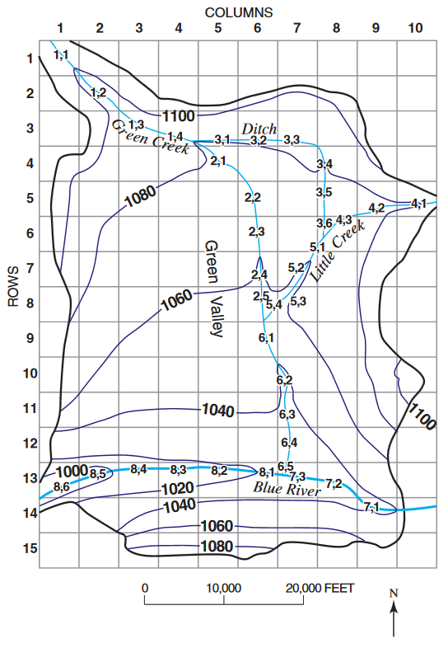

Figure 1 The stream network[2]

The simulation has two stress periods. In the first stress period, the wells in the middle of the model extract water from the model and draw down the water table. In the second stress period, the wells are turned off and the head recovers from the draw down. The stream data is held constant for both stress periods.

This tutorial will demonstrate and discuss:

* Adding stream feature arcs by digitizing a background image.
* Ensuring that the stream arcs are pointing in the right direction.
* Assigning attributes to the stream arcs and nodes.
* Saving and running the model.
* Examining the solution.

# Stream Package Basics

## Reaches and Segments

The STR package divides streams into reaches and segments.

Streams superimposed on the aquifer are divided into reaches and segments. A segment is a stream or diversion in which streamflow from surface sources are added at the beginning of the segment or subtracted (in the case of a diversion) at the end of a segment. A reach is the part of a segment that corresponds to an individual cell in the finite-difference grid used to simulate ground-water flow in an aquifer. A segment may consist of one or more reaches.[3]

In GMS, a stream segment corresponds to a single arc. A stream reach doesn’t have a corresponding representation in the conceptual model but exists only on the grid cells after having mapped the conceptual model to the grid.

## Routing

In addition to tracking flow between streams and the underlying aquifer, the MODFLOW stream packages (STR1, SFR1 and SFR2) also route the flow of water through a stream network. The stream network can include tributaries, diversions, and lakes (in conjunction with the Lake Package).

Routing is accomplished by determining the inflows for a reach (which are specified for the most upstream reach), adding or subtracting leakage to the aquifer, and allowing any remainder to pass to the next downstream reach as inflow. The process is repeated for the next downstream reach and so forth.

This is different from the MODFLOW River Package, which only tracks flow between the river and the aquifer. With the River Package, once water has entered the river, it is lost to the model. With the stream packages, that water can travel downstream and possibly reenter the aquifer at another point.

Unlike the River package, the water depth is calculated based on the flow rather than being manually entered. There are several different options available for calculating water depth, including using Manning’s equation or a depth versus flow table.

# Getting Started

Do the following to get started:

1. If necessary, launch GMS.

If GMS is already running, select *File |* **New** to ensure that the program settings are restored to their default state.

## Opening the Starting Project

The point of this tutorial is to illustrate the STR package, so previously created files will be imported rather than spending time entering the other MODFLOW inputs.

1. Click **Open** File:Open Macro.svg to bring up the *Open* dialog.
2. Select “Project Files (*.gpr)” from the *Files of type* drop-down.

Browse to the *str\str* directory and select “start.gpr”.

Click **Open** to import the project and exit the *Open* dialog.

A grid with some streams and contour lines should appear (Figure 2).

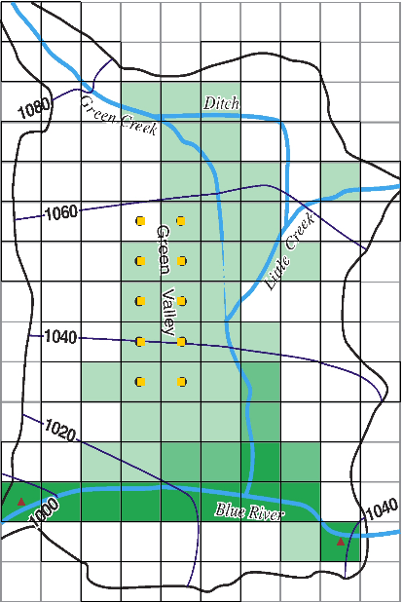

Figure 2 Initial project appearance

In the Project Explorer, right-click in a blank spot and select **Expand All**.

Notice the Project Explorer includes a 3D grid and a MODFLOW simulation (Figure 3).

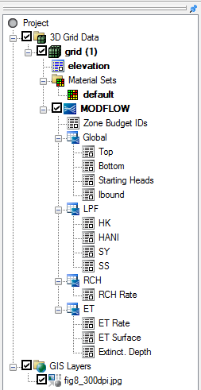

Figure 3 Project Explorer at the project beginning

## Saving the Project with a New Name

Before making changes, it is good to save the project with a new name.

1. Select *File |* **Save As…** to bring up the *Save As* dialog.
2. Select “Project Files (*.gpr)” from the *Save as type* drop-down.

Enter “STR_GMS.gpr” as the *File name*.

Click**Save** to save the project under the new name and close the *Save As* dialog.

It is recommended to **Save** File:Save Macro.svg the project periodically throughout the tutorial.

# Digitizing and Setting Up the Stream Arcs

In GMS, it is only possible to create streams by using the conceptual model approach. This is done by mapping feature objects to the grid. Streams cannot be created directly on the grid. Instead, stream arcs are created by digitizing the background image.

## Creating a Conceptual Model

First, to create a MODFLOW conceptual model:

1. In the Project Explorer, right-click in a blank area and select *New |* **Conceptual Model…** to bring up the *Conceptual Model Properties* dialog.

For *Name,* enter “Test 1”.

1. Click **OK** to close the *Conceptual Model Properties* dialog.

## Creating a Coverage

1. Right-click on the "File:Conceptual Model Icon.svg Test 1" conceptual model and select **New Coverage…** to bring up the *Coverage Setup* dialog.
2. For *Coverage name,* enter "Streams".
3. In the *Sources/Sinks/BCs* column, scroll down and turn on *Stream.*
4. For *Default elevation,* enter “1500.0” so the coverage will be above the grid.
5. Click **OK** to close the *Coverage Setup* dialog.
6. Select the new “File:Coverage Active Icon.svg Streams” coverage to make it active.

## Creating the Arcs

Now, create the arcs for the streams. Refer to Figure 4 for the first four steps below.

1. Using the **Create Arc** File:GMS Create Arc Tool.svg tool, create an arc along the path of Green Creek (from the top left corner down to the Blue River).
2. Create an arc for the Ditch (from Green Creek to Little Creek).
3. Create an arc for Little Creek (from the right edge to Green Creek).
4. Create an arc for the Blue River (from the right edge to the left edge).

Now that the arcs have been digitized, the background image is no longer necessary.

1. In the Project Explorer, turn off the “File:GIS Folder.svg GIS Layers” folder.

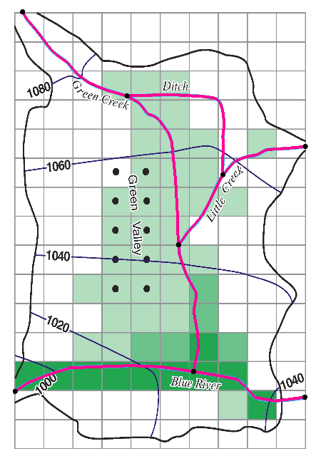

Figure 4 Location of stream arcs after digitizing (arcs bolded for clarity)

## Correcting the Arc Directions

Arcs have a direction associated with them. The direction is from the starting node to the ending node and is defined when the arc is first created. Usually the direction doesn’t matter, but stream arcs must go from upstream to downstream. The direction can be displayed and reversed if needed.

To check the arc direction and make sure all the arcs are pointing from upstream to downstream, do the following.

1. Click **Display Options** File:Display Options Macro.svg to bring up the *Display Options* dialog.
2. Select “File:Map Module Icon.svg Map Data” from the list on the left.
3. On the *Map* tab, near the bottom of the first section, turn on *Arc direction arrows*.
4. Click **OK** to close the *Display Options* dialog.

Arrows should now be visible on the arcs. The arrows should be pointing as shown in Figure 5. If any of the arcs are pointing in the wrong direction, do the following:

1. Using to the **Select Arcs** File:GMS Select Arc Tool.svg tool, select the arc, then right-click and select **Reverse Arc Direction** to change the direction of the flow along the arc.
2. Repeat step 5 for any arcs pointing the wrong direction.

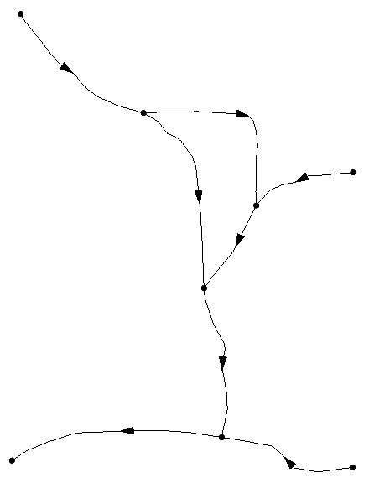

Figure 5 Arc directions.

With all arcs pointing the correct direction, the flow arrows can be turned off.

1. Click **Display Options** File:Display Options Macro.svg to bring up the *Display Options* dialog.
2. Select “File:Map Module Icon.svg Map Data” from the list on the left.
3. On the *Map* tab, near the bottom of the first section, turn off *Arc direction arrows*.
4. Click **OK** to close the *Display Options* dialog.

## Stream Reach and Segment Numbering

GMS automatically numbers stream segments and reaches. However, be aware of the concept as the numbering will be seen in the STR package dialog (covered later in this tutorial).

According to the STR package documentation, “Segments are numbered sequentially from the farthest upstream segment to the last downstream segment, as are reaches within each segment.”[4] Figure 6 illustrates stream and segment numbering.

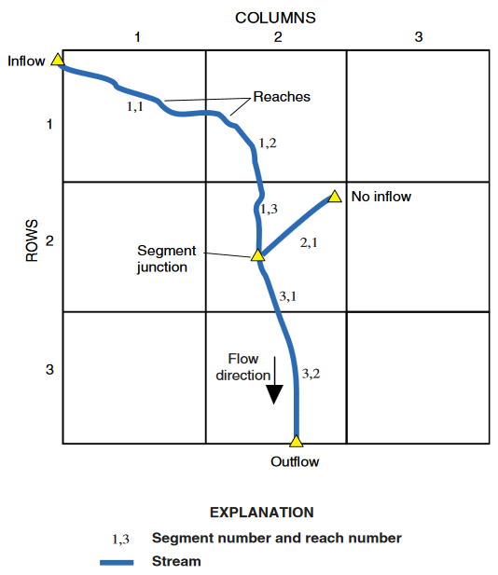

Figure 6 Illustration of stream segment and reach numbering[5]

GMS assigns an integer ID number to each arc automatically as it is created. This ID number is not the stream segment number. Stream segment and reach numbers are only determined when the **Map →MODFLOW** command is executed. Be careful to not confuse arc ID numbers with stream segment numbers.

# Assigning Arc and Node Attributes

Now to assign the stream attributes to the arcs.

## Arc A

1. Using the **Select Arcs** File:GMS Select Arc Tool.svg tool, double-click on arc A (see Figure 7) to bring up the *Attribute Table* dialog.
2. For the *Type* column, select “stream” from the drop-down in.

Enter the remaining values as given in the following table. Only the columns with changes are shown, and some may require scrolling to the right to see:

|  |  |  |  |  |
| --- | --- | --- | --- | --- |
| Name | Cond. | Width | Roughness | Inc. flow |
| A | 0.0003 | 20.0 | 0.03 | 25.0 |

Click **OK** to close the *Attribute Table* dialog.

In the Graphics Window, click on a blank spot to deselect arc A.

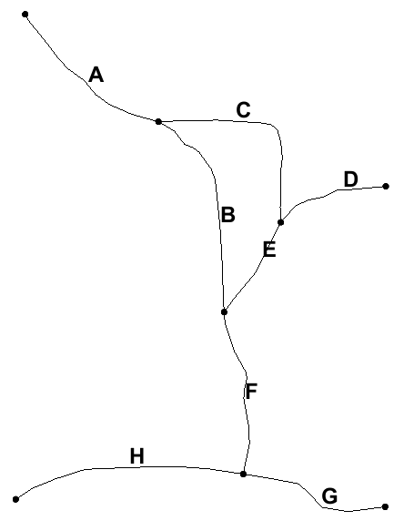

Figure 7 Arcs with letters to distinguish them

## Arcs B through H

1. Using the **Select Arcs** File:GMS Select Arc Tool.svg tool, double-click on arc B to bring up the *Attribute Table* dialog.
2. Repeats steps 2–3 from section 5.1 to assign the values shown in the table below.
3. Click **OK** to exit the *Attribute Table* dialog.
4. Repeat steps 1–3 for arcs C through H, using the values in the table below.

|  |  |  |  |  |  |  |  |  |
| --- | --- | --- | --- | --- | --- | --- | --- | --- |
| ARC (Figure 7) | Name | Type | Cond. | Width | Sinuosity | Roughness | Diversion | Inc. flow |
| B | B | stream | 0.0003 | 20.0 | 1.0 | 0.03 |  | -1.0 |
| C | C | stream | 0.0003 | 5.0 | 1.0 | 0.03 | ✓ | 10.0 |
| D | D | stream | 0.0003 | 12.0 | 1.0 | 0.03 |  | 10.0 |
| E | E | stream | 0.0003 | 15.0 | 1.0 | 0.03 |  | -1.0 |
| F | F | stream | 0.0003 | 27.0 | 1.1 | 0.03 |  | -1.0 |
| G | G | stream | 0.0003 | 45.0 | 1.0 | 0.025 |  | 150.0 |
| H | H | stream | 0.0003 | 52.0 | 1.0 | 0.025 |  | -1.0 |

The default “-1.0” in the *Inc. flow* column denotes that the incoming flow is the sum of the immediately upstream tributary segments.

## Segment IDs

GMS can display the stream segment ID numbers by doing the following:

1. Click **Display Options** File:Display Options Macro.svg to bring up the *Display Options* dialog.
2. Select “File:Map Module Icon.svg Map Data” from the list on the left.
3. At the bottom of the first section on the *Map* tab, turn on *Segment ID*.
4. Click **OK** to exit the *Display Options* dialog.

Notice the “0” displayed in the middle of each arc. The conceptual model has not yet been mapped to the grid using the **Map → MODFLOW** command. Until this is done, GMS does not know how the stream segments should be numbered. After the **Map → MODFLOW** is done, the stream segment numbers will follow the rule of upstream to downstream.

## Assigning Node Attributes

Now to assign the stream attributes to the nodes:

1. Select the “File:Coverage Active Icon.svg Streams” coverage to make it active.
2. Using the **Select Points/Nodes** File:GMS Select Node Tool.svg tool, double-click node A as indicated in Figure 8 to bring up the *Attribute Table* dialog.
3. Enter the top and bottom elevation as indicated in the table below.

|  |  |  |
| --- | --- | --- |
|  | Top elev. | Bot. elev. |
| A | 1095 | 1092 |
| B | 1075 | 1072 |
| C | 1080 | 1078 |
| D | 1060 | 1056 |
| E | 1045 | 1040 |
| F | 1025 | 1020 |
| G | 1040 | 1036 |
| H | 990 | 984 |

Notice that no value is entered in the *Head/Stage* column for the stream nodes. These will be calculated when MODFLOW runs.

1. Click **OK** to close the *Attribute Table* dialog.
2. Repeat steps 2–4 for nodes B through H, using the elevations listed for each in the table above.
3. In the Graphics Window, click on a blank spot to deselect all nodes.

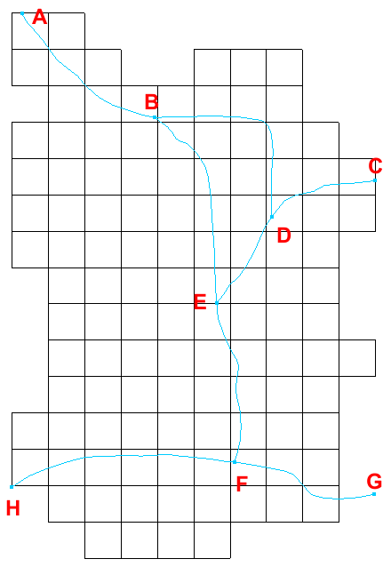

Figure 8 Nodes with letters to distinguish them

# Map → MODFLOW

With everything entered, the stream arcs and nodes can now be mapped to the grid.

1. Select *Feature Objects |* **Map → MODFLOW** to bring up the *Map → Model* dialog.

Click **OK** to accept the defaults and close the *Map → Mod*el dialog.

Notice the stream segment numbers are no longer all zeroes. The stream segments have been numbered so that downstream numbers are always greater than upstream numbers.

## STR Package Dialog

The streams in the conceptual model have now been mapped to the grid. Now to review all of the stream segments and reaches on the grid:

1. In the Project Explorer, select “File:3D Grid Folder.svg 3D Grid Data” to make it active.

Select *MODFLOW | Optional Packages |* **STR – Stream…** to bring up the *MODFLOW Stream (STR) Package* dialog (Figure 9).

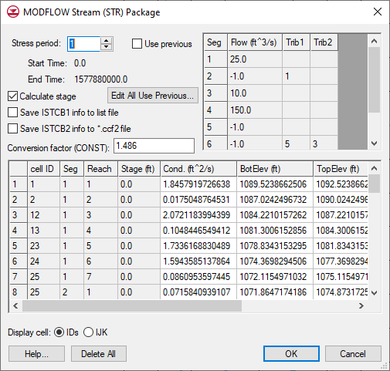

Figure 9 MODFLOW Stream (STR) Package dialog

The stream segments are listed in the top right spreadsheet, and the reaches are listed in the bottom spreadsheet. GMS calculated the conductance during the **Map → MODFLOW** process.

Notice that most fields in this dialog can be edited, though segment numbers and reach cell IDs cannot be edited, and segments and reaches cannot be added. Stream data can therefore only be created by mapping to MODFLOW from a conceptual model. If a MODFLOW simulation with STR data is imported, it will populate the stream package dialog even if a conceptual model is not present.

Just above the bottom spreadsheet, turn on *Save ISTCB2 info to *.ccf2 file*.

This writes stream flow in each stream reach to a CCF2 file. The information written to this file can be reviewed after running MODFLOW.

1. Click **OK** to exit the *MODFLOW Stream (STR) Package* dialog.

## Saving the Project and Running MODFLOW

Now to save the project and run MODFLOW:

1. **Save** File:Save Macro.svg the project.

Select *MODFLOW |* **Run MODFLOW** to bring up the *MODFLOW* model wrapper dialog.

After the model finishes, turn on *Read solution on exit* and *Turn on contours (if not on already)*.

Click **Close** to import the solution and exit the *MODFLOW* model wrapper dialog.

Make sure “File:GIS Folder.svg GIS Layers” is turned off.

The Graphics Window should appear similar to Figure 10.

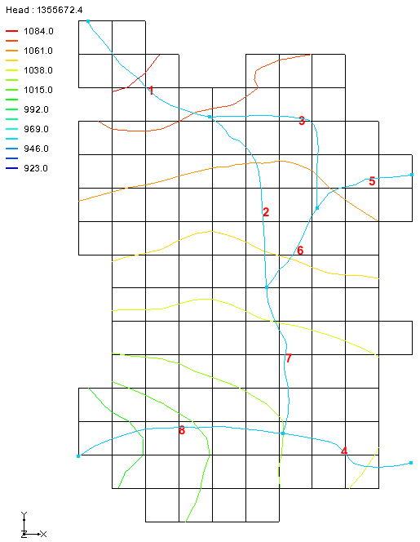

Figure 10 The contours are clearly visible

## Comparing the Solutions

To compare the new solution with the original one from the USGS:

1. Click **Contour Options** File:Contour Options Macro.svg to bring up the *Dataset Contour Options – 3D Grid – Head* dialog.

In the *Contour interval* section, select “Specified Values” from the drop-down*.*

In the field to the right of the drop-down, enter “5”.

1. In the *Start Value* column, enter “1000.0” for dark blue, “1020.0” for cyan, “1040.0” for green, “1060.0” for yellow, and “1080.0” for red.

The dialog should appear similar to Figure 11.

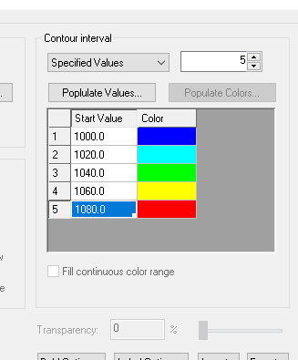

Figure 11 Dataset Contour Options dialog, “Contour intervals” section

Click **OK** to exit the *Dataset Contour Options – 3D Grid – Head* dialog.

Turn on “File:GIS Folder.svg GIS Layers” in the Project Explorer.

Notice how the GMS contours match the contours on the background image pretty closely. The match isn’t perfect for two reasons. First, the stream input generated by GMS differs some from the original USGS input. In particular, the reach lengths are different. The original USGS files, which were built by hand, contain rough estimates for the length of the stream channel within each model cell. GMS, on the other hand, calculates this value by intersecting the stream arcs with the grid cells.

The second reason why the contour lines differ is due to the different methods used by the USGS and GMS to interpolate and generate contour lines from gridded data.

1. Turn off the “File:GIS Folder.svg GIS Layers” folder.

## Flow Budget

Now to look at the flow budget for the streams:

1. Select *MODFLOW |* **Flow Budget…** to bring up the *Flow Budget* dialog.

Notice the entries in the *Flow In* and *Flow Out* columns on the *Stream Leakage* row. There is more flow in than out because the streams are mostly losing water. Water is flowing from the streams into the aquifer in most places, but there is some flow out from the aquifer to the streams.

Click **OK** to close the *Flow Budget* dialog.

In the Project Explorer, select “File:3D Grid Folder.svg 3D Grid Data” to make it active.

Select and then right-click on “File:CCF Dataset Active.svg CCF (STR_GMS.ccf)” and select **CCF → Datasets**.

Notice that a number of datasets have appeared within the solution folder.

Select “File:Dataset Cells Active.svg STREAM LEAKAGE” to make it active.

Click **Contour Options** File:Contour Options Macro.svg to bring up the *Dataset Contour Options – 3D Grid – STREAM LEAKAGE* dialog.

In the *Contour method* section, select “Block Fill” from the first drop-down.

In the *Contour interval* section, select “Number” from the drop-down.

In the field to the right of the drop-down, enter “10”.

Click **OK** to exit the *Dataset Contour Options – 3D Grid – STREAM LEAKAGE* dialog.

The Graphics Window will appear similar to Figure 12 when the first time step is selected.

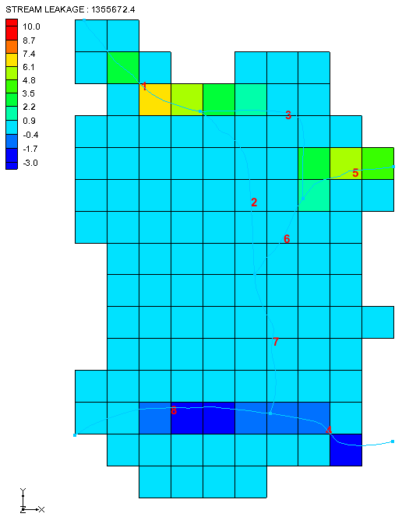

Figure 12 Block Fill showing stream in/out flow

Using the **Select Cells** File:Select 3D Cell Tool.svg tool, move the mouse cursor over the grid cells and watch the status bar at the bottom of the Graphics Window to see what the stream flow is throughout the grid.

## Flow from Arcs

Since the streams are created using the conceptual model, selecting the arcs allows for viewing the computed flow into or out of the aquifer.

1. Select the “File:Dataset Cells Active.svg Head” coverage.
2. In the Project Explorer, select the “File:Coverage Active Icon.svg Streams” coverage to make it active.

Using the **Select Arcs** File:GMS Select Arc Tool.svg tool, select arc A (see Figure 7) in the northwest portion of the model.

Look at the status bar at the bottom of the GMS window to see information on the selected arc.

“COMPUTED FLOW” will be listed, showing a value around “14.5” (depending on the exact geometry of the arc).

1. Select other arcs as desired to see their computed flow.

## Flow in the Stream Channel

In the *MODFLOW Stream (STR) Package* dialog, the *Save ISTCB2 info to *.ccf2 file* option was turned on. This file contains information about the calculated flow out of each stream reach.

1. In the Project Explorer, right-click on “File:CCF Dataset Active.svg CCF (STR_GMS.ccf2)” and select **CCF → Datasets**.

A new dataset should appear at the bottom of the solution folder. This dataset shows the stream reach flow at each cell.

Select “File:Dataset Cells Active.svg STREAM FLOW OUT” to make it active.

Click **Contour Options** File:Contour Options Macro.svg to bring up the *Dataset Contour Options – 3D Grid – STREAM FLOW OUT* dialog.

In the *Contour interval* section, select “Unique Values” from the drop-down.

Click **OK** to exit the *Dataset Contour Options – 3D Grid – STREAM FLOW OUT* dialog.

The Graphics Window will appear similar to Figure 13. Select different time steps to see how the data changes with time.

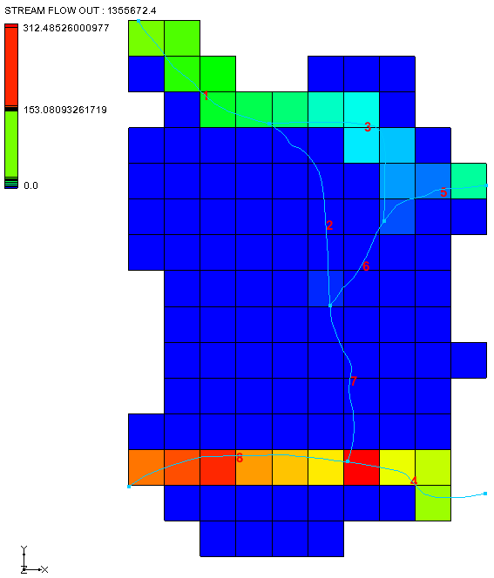

Figure 13 Stream Reach Flow

# Conclusion

This concludes the “MODFLOW – STR Package” tutorial. The following key concepts were demonstrated and discussed in this tutorial:

* Use GMS to create MODFLOW models with STR and SFR type streams.
* Streams must be created in the Map module using Feature Objects and cannot be created directly on the grid.
* Make sure the stream arcs are oriented from upstream to downstream correctly.
* The conceptual model does not have to include all aspects of the model. In this case, the conceptual model contained only the stream arcs and nodes. The other boundary conditions were already part of the grid.
* GMS automatically determines the proper ordering of the stream data for input to MODFLOW based on the orientation and topology of the stream arcs.
* Click on feature objects and see the flow in or out of that object.
* View the computed flow out of each stream reach using the CCF2 file.

1. Prudic, David E.; Konikow, Leonard F.; Banta, Edward R., (2004). *A New Streamflow-Routing (SFR1) Package to Simulate Stream-Aquifer Interaction with MODFLOW-2000*, U.S. Geological Survey Open-File Report 2004–1042, p.13. <https://pubs.usgs.gov/of/2004/1042/ofr2004-1042.pdf>
2. Prudic (2004), p.14.
3. Prudic, David E. (1989). Documentation of a Computer Program to Simulate Stream-Aquifer Relations Using a Modular, Finite Difference, Ground-Water Flow Model, U.S. Geological Surveay Open-File Report 88–729, p.3. <http://pubs.usgs.gov/of/1988/0729/report.pdf>
4. Prudic (1989), p.3
5. Prudic (2004), p.3