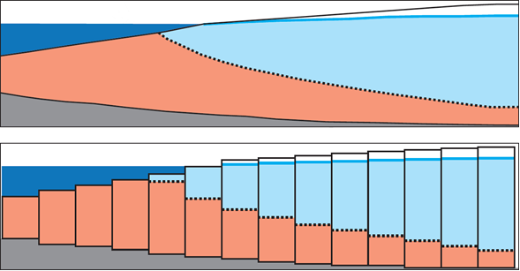

GMS 10.9

GMS 10.9 Tutorial

***MODFLOW – SWI2 Package, Two-Aquifer System***

A Simple Example Using the MODFLOW SWI2 (Seawater Intrusion) Package

Objectives

This tutorial reviews the interface to the MODFLOW SWI2 package in GMS.

Time

* 15–30 minutes

Required Components

* GMS Core
* MODFLOW Interface

Prerequisite Tutorials

* MODFLOW – Grid Approach

|  |
| --- |
| 1 Introduction 2  2 Getting Started 3  2.1 Importing the Flow Model 3  2.2 Saving the Project 4  3 Examining the Model 4  3.1 Wells 4  3.2 Stress Periods 4  3.3 Setting Up the SWI2 Package 5  3.4 Creating the 2D Grid 7  3.5 Importing the Dataset 8  3.6 Copying the 2D Dataset to the Zeta Arrays 8  4 Setting the Effective Porosity (SSZ) 9  4.1 Seeing the Source Types (ISOURCE) 9  5 Saving the Running MODFLOW 10  6 Viewing the Solution 10  6.1 Creating the Zeta Surface Dataset 10  6.2 Creating a 2D Dataset of the Surface 11  6.3 Animating the Surface 11  7 Conclusion 12 |

# Introduction

GMS includes an interface to the SWI2 (Seawater Intrusion) package available in MODFLOW-2005. The SWI2 documentation describes the package as follows:

The SWI2 Package is designed to simulate regional seawater intrusion in coastal aquifer systems. The main advantage of using the SWI2 Package instead of variable-density groundwater flow and dispersive solute transport codes, such as SEAWAT and SUTRA, is that fewer model cells are required for simulations using the SWI2 Package because every aquifer can be represented by a single layer of cells. This reduction in number of required model cells and the elimination of the need to solve the advective-dispersive transport equation results in substantial model run-time savings.[1]

For a more detailed general explanation of the SWI2 package, please refer to the SWI2 package documentation. This tutorial is based off of the third example problem included with the SWI2 documentation.

The model is a simple, two-dimensional simulation that illustrates the SWI2 package. There is one interface separating seawater from freshwater and the model shows how the interface between the seawater and the freshwater moves over time.

The problem is further described in the SWI2 package documentation as follows:

Example 3 simulates transient movement of the freshwater-seawater interface in response to changing freshwater inflow in a two-aquifer coastal aquifer system. The problem domain is 4,000 m long, 41 m high, and 1 m wide. Both aquifers are 20 m thick and are separated by a leaky layer 1 m thick. The aquifers are confined, storage changes are not considered (all MODFLOW stress periods are steady-state), and the top and bottom of each aquifer is horizontal. The top of the upper aquifer and bottom of the lower aquifer are impermeable.

The domain is discretized into 200 columns that are each 20 m long (DELR), 1 row that is 1 m wide (DELC), and 3 layers that are 20, 1, and 20 m thick. A total of 2,000 years are simulated using two 1,000-year stress periods and a constant time step of 2 years. The hydraulic conductivity of the top and bottom aquifers are 2 and 4 m/d, respectively, and the horizontal and vertical hydraulic conductivity of the confining unit are 1 and 0.01 m/d, respectively. The effective porosity is 0.2 for all model layers.

The left 600 m of the model domain extends offshore and the ocean boundary is represented as a general head boundary condition (GHB) at the top of model layer 1. A freshwater head of 0 m is specified at the ocean bottom in all general head boundaries. The GHB conductance that controls outflow from the aquifer into the ocean is 0.4 square meter per day (m2/d) and corresponds to a leakance of 0.02 d-1 (or a resistance of 50 days).[2]

This tutorial will discuss and demonstrate importing a simple two-dimensional MODFLOW model, turning on the SWI2 package, and entering the required data. It will also demonstrate creating a matching 2D grid, importing a 2D dataset representing the starting surface (fresh/salt interface), and importing the dataset to the SWI package.

The model will then be saved and MODFLOW will be run. A 2D grid will be created to visualize the freshwater-seawater surface, and the surface will be animated to visualize its action over time.

# Getting Started

Do the following to get started:

1. If necessary, launch GMS.
2. If GMS is already running, select *File |* **New** to ensure that the program settings are restored to their default state.
3. If asked to save changes, click **Don’t Save** to close the dialog and restore GMS to a default state.

## Importing the Flow Model

The tutorial will begin by importing an existing model that does not use the SWI2 package. The SWI2 package will be added to the model later in the tutorial.

1. Click File:Open Macro.svg **Open** to bring up the *Open* dialog.
2. Select “Project Files (*.gpr)” from the *Files of type* drop-down.
3. Browse to the *swi2ex03\swi2ex03*directory and select “start.gpr”.
4. Click **Open** to import the project and exit the *Open* dialog.

A model grid like the one shown in Figure 1 should appear. Notice that it is in front view, showing the X-Z plane. The Z magnification has been exaggerated by a factor of 20 in order to view the model better.

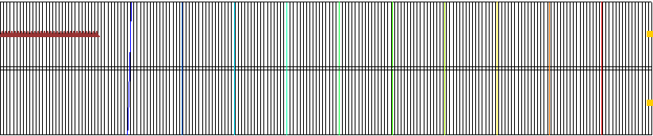

Figure 1 Initial flow model

Also notice that there are two wells on the right edge of the model and some symbols in the top layer on the left indicating general head boundary conditions. The wells inject freshwater into the model and the general head boundary represents the ocean floor. The contours are of the head dataset and indicate that flow is occurring from right to left.

## Saving the Project

Before making changes, save the project with a new name indicating this is the SWI2 package example 3.

1. Select *File |* **Save As…** to bring up the *Save As* dialog.
2. Select “Project Files (*.gpr)” from the *Save as type* drop-down.
3. Enter “swi2ex3.gpr” as the *File name*.
4. Click **Save** to save the project under the new name and close the *Save As* dialog.

It is recommended to periodically **Save** File:Save Macro.svg while progressing through the tutorial.

# Examining the Model

Now to review the flow model:

## Wells

1. In the Project Explorer, fully expand the “File:3D Grid Folder.svg 3D Grid Data” folder.
2. Right-click on “File:MODFLOW Folder.svg MODFLOW” and select *Optional Packages |* **WEL – Well…**to open the *MODFLOW Well Package* dialog.
3. In the *Stress period* field, switch between “1” and “2”.

Notice how the value in the *Q (flow)(m^3/d)* during the second stress period is halved.

1. Click **Cancel** to exit the *MODFLOW Well Package* dialog.

## Stress Periods

1. In the Project Explorer, double-click on the “File:MODFLOW Package Icon.svg Global” package to bring up the *MODFLOW Global/Basic Package* dialog.

Notice the *Model type* is *Transient*.

1. Click **Stress Periods…** to open the *Stress Periods* dialog.

Notice there are two stress periods, and both are set as steady state. There are two stress periods because the pumping rate for the wells changes halfway through the simulation. Each stress period is 1,000 years long (365,000 days), with 500 time-steps. Each time-step is therefore 2 years long.

1. Click **Cancel** to exit the *Stress Periods* dialog.

## Setting Up the SWI2 Package

Now it is time to turn on the SWI2 Package and enter the data.

1. Click **Packages…** to bring up the *MODFLOW Packages / Processes* dialog.
2. In the *Optional packages / processes* section, turn on *SWI2 – Seawater Intrusion*.
3. Click **OK** to exit the *MODFLOW Packages / Processes* dialog.
4. Click **OK** to exit the *MODFLOW Global/Basic Package* dialog.

### The SWI2 Package Dialog

The package is now enabled so the required data can be entered.

1. In the Project Explorer, right-click on “File:MODFLOW Folder.svg MODFLOW” and select *Optional Packages |* **SWI2 – Seawater Intrusion…** to bring up the *SWI2 Package* dialog (Figure 2).

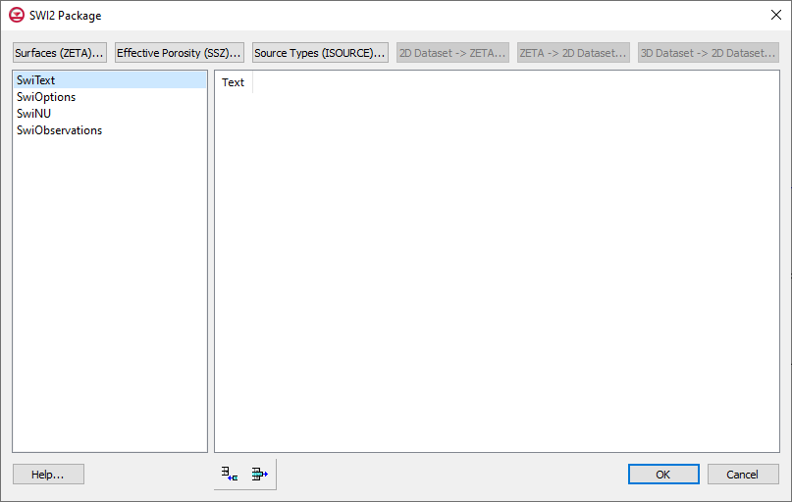

Figure 2 SWI2 Package dialog

The data required by the SWI2 package is entered in this dialog. The package consists of four tables (listed on the left) and some arrays (the large area on the right). The tables are as follows:

* “SwiText”: A list of lines of text (or comments) that can appear at the top of the SWI2 package file.
* “SwiOptions”: A list of variables that control the SWI2 package, consisting of datasets 1–4 in the SWI2 input file. Refer to the SWI2 documentation for the meaning of each variable.
* “SwiNU”: A list of the dimensionless densities for each zone or for each surface, depending on whether a stratified (ISTRAT = 1) or continuous (ISTRAT = 0) simulation is being used (respectively).
* “SwiObservations”: A list of observations.

There are also three arrays accessed by the buttons at the top of the dialog: **Surfaces (ZETA)…**, **Effective Porosity (SSZ)…**, and **Source Types (ISOURCE)…**.

### Setting the Number of Surfaces

1. Select “SwiOptions” from the list on the left.
2. For *NSRF,* enter “1”.

NSRF is the number of surfaces, zeta, or interfaces (these three terms are used interchangeably) between zones of differing water density. This model will have two zones—freshwater and seawater—so just one surface needs to divide them.

1. For *ISTRAT,* enter “1”.

If ISTRAT = 1, it is a stratified model, meaning the density of the water in each zone is specified. If ISTRAT = 0, a continuous model is used, meaning the density of each surface is specified, and the density varies linearly between the surfaces. This affects how many density values need to be specified.

1. Leave the rest of the options in the “SwiOptions” table at their default settings.

### Setting the Fluid Density for Each Zone

Because a stratified (ISTRAT = 1) model is being used, specify the dimensionless density of the water in each zone. Dimensionless density *ν* (unitless) is defined as the following:

ν = (ρ - ρf) / ρf

where ρ = the fluid density [M/L3] and ρf = the density of freshwater [M/L3]

To set the fluid density, do the following:

1. Select “SwiNU” from the list on the left.
2. In the *NU* column of row *1,* enter “0”.

This is the dimensionless density for zone 1, which is freshwater.

1. In the *NU* column of row *2,* enter “0.025”.

This is the dimensionless density for zone 2, which is seawater.

### Setting the Surfaces (Zeta)

This model has one surface, so the starting location must be entered.

1. Click **Surfaces (ZETA)…** to open the *MODFLOW SWI Package – Surfaces (ZETA)* dialog.

The resulting dialog shows the zeta arrays, which are the surfaces between different zones (i.e., freshwater, brackish-water, seawater).

1. Using the *Layer* field to change between the three layers.

Notice that the surface is specified in each model layer and that there is data for each layer. This can be confusing. Although, the freshwater-seawater interface is typically thought of as a two-dimensional array, the SWI2 package requires the surface be specified for every layer, which makes it a 3D array. The documentation explains this:

An elevation for each surface needs to be specified for every cell in the model… For the case of a surface that is present at only one point in the vertical everywhere, the same grid of zeta values may be entered for every model layer and SWI2 will determine in which cells the elevation of the zeta surface falls between the top and model of each layer.[3]

The surface must be reasonably smooth or MODFLOW may have a harder time converging. There are a number of options for entering the surface data, including the following:

* Entering the data by hand in the dialog or copying/pasting from a spreadsheet for each layer.
* Copying a 2D dataset to each layer of the zeta surface array via the **2D Dataset → ZETA…** button in the *SWI2 Package* dialog. This requires a 2D grid which matches the 3D grid. A dataset on the 2D grid is chosen and intelligently copied to the zeta arrays.
* Copying a 3D dataset on the 3D grid to the zeta surface array using the **3D Dataset → Grid…** button in the array editor dialog. The 3D dataset may be created by interpolating from 2D scatter points or a raster.

In this case, since this is a contrived example, the most likely scenario is that the zeta surface was created in a spreadsheet. It would be preferable to see the surface, so create a 2D grid, import the surface as a dataset on the 2D grid, and then use the **2D Dataset →****ZETA…** button in the *SWI2 Package* dialog to get the data to the zeta array.

1. Click **OK** to exit the *MODFLOW SWI Package – Surfaces (ZETA)* dialog.
2. Click **OK** to exit the *SWI2 Package* dialog.

## Creating the 2D Grid

First to create a 2D grid which matches the 3D grid:

1. In the Project Explorer, right-click on “File:3D Grid Icon.svg grid” and select *Convert To |* **2D Grid** to bring up the *Z Value* dialog.
2. Click **OK** to accept the default *z* value and close the *Z Value* dialog.

Notice the line which appeared above the 3D grid (Figure 3). This is the 2D grid that will represent the zeta surface once it is in place with the correct dataset mapped to it.

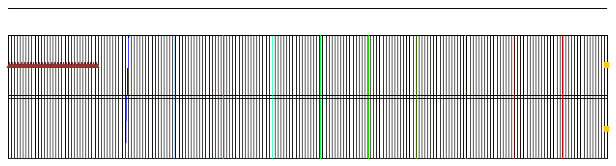

Figure 3 The 2D grid appears as a horizontal line above the 3D grid in this view

## Importing the Dataset

Now to import a dataset to the 2D grid:

1. Right-click on the 2D “File:2D Grid Icon.svg grid” item and select **Import Dataset…** to bring up the *Dataset Filename* dialog.
2. Select “Text Files (*.txt;*.csv)” from the *Files of type* drop-down.
3. Select “Zeta_1.txt” and click **Open** to close the *Dataset Filename* dialog and bring up the *Step 1 of 2* page of the *Text Import Wizard* dialog.
4. Below the *File import options* section, turn on *Heading row.*
5. Click **Next >** to go to the *Step 2 of 2* page of the *Text Import Wizard* dialog.
6. Click **Finish** to import the dataset and close the *Text Import Wizard* dialog.

The 2D grid line that was previously above the 3D grid is now slanting down from left to right through the 3D grid (Figure 4). This represents the zeta surface.

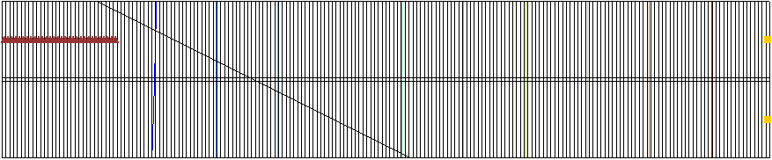

Figure 4 Slanting zeta surface visualized using a 2D grid. Seawater is on the left, freshwater on the right

## Copying the 2D Dataset to the Zeta Arrays

1. In the Project Explorer, right-click “File:MODFLOW Folder.svg MODFLOW” and select *Optional Packages |* **SWI2 – Seawater Intrusion…** to bring up the *SWI2 Package* dialog.
2. Click **2D Dataset → ZETA…** to bring up the *Select Dataset* dialog.
3. Select “Zeta_1” and click **OK** to close the *Select Dataset* dialog.

The zeta arrays have now been set. To view this, do the following:

1. Click **Surfaces (ZETA)…** to bring up the *MODFLOW SWI Package – Surfaces (ZETA)* dialog.
2. Scroll to the right to see how the values for layer 1 change along the grid profile.
3. Use the *Layer* field to change the layers and scroll to the right to view the values for layers 2 and 3.
4. Click **OK** to close the *MODFLOW SWI Package – Surfaces (ZETA)* dialog.

# Setting the Effective Porosity (SSZ)

To set the effective porosity:

1. Click **Effective Porosity (SSZ)…** to bring up the *MODFLOW SWI Package – Effective Porosity (SSZ)* dialog.
2. Click **Constant → Grid…** to bring up the *Grid Value* dialog.
3. For *Constant value for grid,* enter “0.2”.
4. Click **OK** to close the *Grid Value* dialog.
5. Click **OK** to close the *MODFLOW SWI Package – Effective Porosity (SSZ)* dialog.

## Seeing the Source Types (ISOURCE)

The ISOURCE array is used to indicate what type of water (freshwater, seawater, etc.) the sources and sinks should be injecting/extracting from the model. The ISOURCE array is the same size as the grid, so there is one value per cell.

The wells need to be on the right side of the model to inject freshwater. The default ISOURCE value of “0” means that “sources and sinks have the same fluid density as the active zone at the top of the aquifer.”[4] Since freshwater is on the right side of the model, and the wells will be injecting freshwater, the default ISOURCE value of “0” is fine.

If the ISOURCE is less than “0”, “sources have the same fluid density as the zone with the number equal to the absolute value of ISOURCE. Sinks have the same fluid density as the active zone at the top of the aquifer. This option is useful for modeling of the ocean bottom where infiltrating water is salt, yet exfiltrating water is of the same type as the water at the top of the aquifer.”[5] The general head cells on the left of the model represent the bottom of the ocean, so set them as follows.

1. Click **Source Types (ISOURCE)…** to bring up the *MODFLOW SWI Package – Source Types (ISOURCE)* dialog.
2. For column *1,* row *1* in the spreadsheet enter “-2”.
3. Repeat step 2 for columns *2* through *30*.
4. Click **OK** to close the *MODFLOW SWI Package – Source Types (ISOURCE)* dialog.
5. Click **OK** to close the *SWI2 Package* dialog.

# Saving the Running MODFLOW

Before running MODFLOW, it is important to save the project. Because the file name is different than the existing solution, both the old and the new solution will be present for comparison in the project.

1. **Save** File:Save Macro.svg the project.
2. Click **Run MODFLOW** File:Run MODFLOW Macro.svg to bring up the *MODFLOW* model wrapper dialog.
3. When the model finishes, turn on *Read solution on exit* and *Turn on contours (if not on already)*.
4. Click **Close** to import the solution and close the *MODFLOW* model wrapper dialog.

The Graphics Window should appear similar to Figure 5.

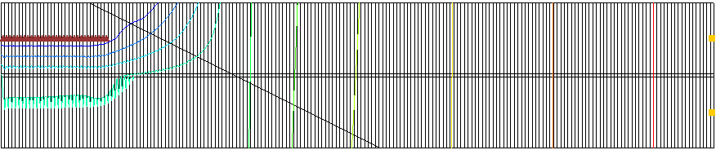

Figure 5 After the MODFLOW run

# Viewing the Solution

The solution includes the position of the surface between the freshwater zone and the seawater zone, for every time step. This surface is saved in the budget, or CCF file, labeled “swi2ex3.swizeta”.

## Creating the Zeta Surface Dataset

1. In the Project Explorer, under the “File:Generic Folder Locked.svg swi2ex3 (MODFLOW)” solution, select “File:CCF Dataset Active.svg CCF (swi2ex3.swizeta)”.
2. Right-click on “File:CCF Dataset Active.svg CCF (swi2ex3.swizeta)” and select **View Values…** to bring up the *View Values* dialog.

Notice the column labeled “ZETASRF 1”. This is the location of the surface. In order to visualize the surface, first extract it as a dataset.

1. Click **Done** to close the *View Values* dialog.
2. Right-click on “File:CCF Dataset Active.svg CCF (swi2ex3.swizeta)” and select **CCF → Datasets**.

Notice the new “ZETASRF 1” dataset.

1. Select “ZETASRF 1” to make it active.

## Creating a 2D Dataset of the Surface

GMS is now contouring the surface dataset. A zeta surface 3D array (instead of a 2D surface) is not a very good way to visualize the surface as it causes the same issue as experienced before. It is preferable to see a 2D surface instead of a 3D array in this case. The SWI2 interface in GMS includes a way to convert the 3D array into a 2D surface.

1. In the Project Explorer, right-click on “File:MODFLOW Folder.svg MODFLOW” and select *Optional Packages |* **SWI2 - Seawater Intrusion…** to bring up the *SWI2 Package* dialog.
2. Click **3D Dataset → 2D Dataset…** to bring up the *Select Dataset* dialog.
3. In the *Solution* section, select “ZETASRF 1”.
4. Turn on *All time steps*.
5. Click **OK** to close the *Select Dataset* dialog and open the *New Dataset Name* dialog.
6. Click **OK** to accept the default name and close the *New Dataset Name* dialog.
7. Click **OK** to close the *SWI2 Package* dialog.

A new 2D dataset named “File:Dataset Cells Active.svg ZETASRF 1” will appear under “File:2D Grid Icon.svg grid” in the Project Explorer.

1. Under “File:2D Grid Icon.svggrid”, select “File:Dataset Cells Active.svg ZETASRF 1” to make it active.
2. Below the Project Explorer, in the time step window, select different time steps to see how the surface changes with time.

Notice that the seawater zone expands under the freshwater zone over time. Also, the freshwater zone pushes to the left due to the injection of the freshwater wells. The last time step is shown in Figure 6.

1. **Save** File:Save Macro.svg the project.

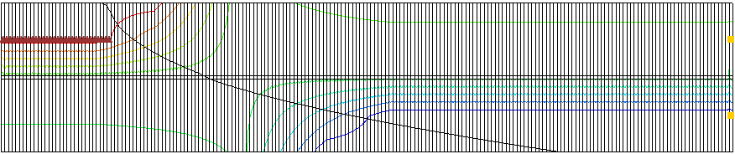

Figure 6 Time step 1000

## Animating the Surface

Now it is possible to create an animation that shows the surface moving.

1. Select *Display |* **Animate…** to bring up the *Animation Wizard* – *Options* dialog.
2. Click **Next >** to accept the defaults and go to the *Animation Wizard* – *Datasets* dialog.
3. Select *Use constant interval*.
4. For *Time interval,* enter “7300”.
5. Click **Finish** to close the *Animation Wizard* dialog.

If desired, view the generated animation file in a media application outside of GMS. The animation may take a few moments to generate, depending on the speed of the computer used. Notice that the freshwater pushes to the left at the beginning of the simulation, and the seawater pushes back to the right in the second half of the simulation when the well injection rate is reduced.

# Conclusion

This concludes the “MODFLOW – SWI2 Package, Two-Aquifer System” tutorial. The following key concepts were discussed and demonstrated:

* GMS includes an interface to the SWI2 Seawater Intrusion package.
* GMS includes methods to do the following:
  + Convert a 2D dataset to a 3D zeta surface
  + Convert a 3D zeta surface to a 2D dataset
  + Convert a 3D dataset representing a zeta surface solution to a 2D dataset

1. Bakker, Mark; Schaars, Frans; Hughes, Joseph D.; Langevin, Christian D.; and Dausman, Alyssa M. (2013). “Documentation of the seawater intrusion (SWI2) package for MODFLOW” in *Techniques and Methods Book 6, Modeling Techniques*. U.S. Geological Survey, chapter A46, pp. iii, 1. <http://pubs.usgs.gov/tm/6a46/tm6-a46.pdf>.
2. Bakker, et al (2013), pp. 21–22.
3. Bakker, et al (2013), p. 18.
4. Bakker, et al (2013), p. 44.
5. Ibid.