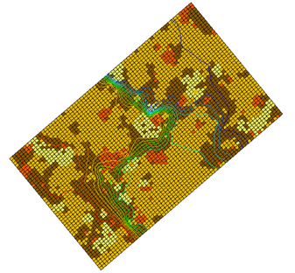

GMS 10.9

GMS 10.9 Tutorial

***MODFLOW – Stochastic Modeling, Indicator Simulations***

Use T-PROGS to create multiple material sets and run MODFLOW stochastically

Objectives

This tutorial teaches how to use the indicator simulation approach to perform a stochastic simulation in GMS.

Time

* 35–50 minutes

Required Components

* GMS Core
* MODFLOW Interface
* Stochastic & T-PROGS

Prerequisite Tutorials

* MODFLOW – Stochastic Modeling, Parameter Randomization
* T-PROGS

|  |
| --- |
| 1 Introduction 2  2 Getting Started 3  2.1 Importing the Project 3  3 The Indicator Simulation 4  3.1 The MODFLOW Model Data 4  3.2 Selecting the Stochastic Option 5  3.3 Saving the Project and Running MODFLOW 5  4 Analyzing the Results 5  4.1 Importing and Viewing the MODFLOW Solutions 5  4.2 Displaying Pathlines 6  4.3 Probabilistic Capture Zone Analysis 7  5 Conclusion 9 |

# Introduction

GMS supports three methods for performing stochastic simulations: parameter randomization, indicator simulations, and PEST Null Space Monte Carlo. The indicator simulation approach is described in this tutorial. With the indicator simulation approach, multiple equally probable “realizations” of the aquifer stratigraphy are generated. These realizations represent different distributions of material (indicator) zones within the aquifer. A set of aquifer properties is associated with the materials, and the model is run once for each of the *n* realizations.

In GMS, the multiple realizations of the aquifer heterogeneity are typically generated using the T-PROGS software. T-PROGS can be used to generate two types of output: multiple material sets (arrays of material IDs), or multiple MODFLOW HUF input sets. In each case, GMS can launch MODFLOW in batch mode and generate a flow solution for each model instance. This tutorial uses a predefined set of materials generated by T-PROGS. The steps involved in running a T-PROGS simulation are described in the “T-PROGS” tutorial.

The model imported in this tutorial is based on the Longhorn Army Ammunition Production (LHAAP) site in Texas used in the “T-PROGS” tutorial. While using the same site boundaries, the grid used in this simulation will have only one layer to facilitate a shorter run time. A predefined T-PROGS simulation containing 30 material sets will be used.

The material sets will be used with the stresses and boundary conditions depicted in Figure 1. There is a small drinking water well on the right side of the model. This well averages 25 m3/d. The regional ground water flows from left to right. Specified head boundaries will be used at the left and right edges of the model at 180 m and 170 m, respectively.

Once the model is set up, MODFLOW will run in stochastic mode to generate 30 solutions. Pathlines will be created. A dataset will be generated representing probability of capture by the extraction well. This dataset will then be contoured to illustrate capture zone boundaries for different probabilities of capture.



Figure 1 Conceptual representation of site to be modeled

# Getting Started

Do the following to get started:

1. If necessary, launch GMS.
2. If GMS is already running, select *File |* **New** to ensure that the program settings are restored to their default state.

## Importing the Project

First, import a project containing the MODFLOW model and the material sets generated by T-PROGS by doing the following:

1. Click **Open** File:Open Macro.svg to bring up the *Open* dialog.
2. Select “Project Files (*.gpr)” from the *Files of type* drop-down.
3. Browse to the *sto_matset* *\sto_matset* directory and select “lhaap.gpr”.
4. Click **Open** to import the project and exit the *Open* dialog.

A one-layer MODFLOW model should appear (Figure 2). It is rotated at a 40˚ angle and showing a four-material distribution. Now view the different material sets generated by T-PROGS:

1. Fully expand the “File:3D Grid Folder.svg 3D Grid Data” folder in the Project Explorer.
2. Review the material sets in the “File:Generic Folder Locked.svg Simulation” folder by selecting each in turn. Use the up and down arrow keys on the keyboard to cycle through the material sets.

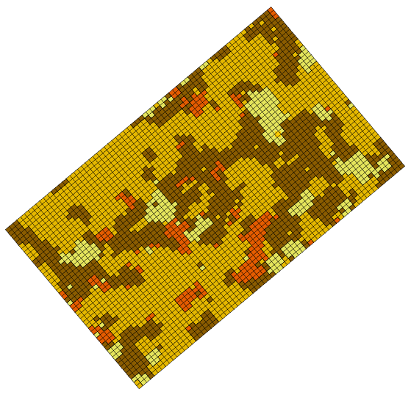

Figure 2 The initial model, showing four material sets

# The Indicator Simulation

## The MODFLOW Model Data

Most of the MODFLOW data for this model (boundary conditions, well pumping rate, top and bottom elevations, etc.) has already been entered. However, review the MODFLOW data that are somewhat more unique to this type of simulation.

1. Select *MODFLOW* | **LPF – Layer Property Flow…** to open the *LPF Package* dialog.

At the top of the dialog, notice that the *Use material IDs* option is selected for the *Layer property entry method*. This means that an array of *K* (hydraulic conductivity) values will not be entered as is normally the case with MODFLOW. Instead, material IDs are used to define the *K* values.

1. Click **Material IDs…** to open the *Materials* dialog.

This dialog illustrates the material IDs assigned to cells. These material IDs are inherited from the active material set generated by T-PROGS.

1. Click **OK** to exit the *Materials* dialog.
2. Click **Material Properties…** to open the *Materials* dialog.

This dialog is used to assign aquifer properties—including hydraulic conductivity—to each of the materials used by the model. Notice that a value has been assigned for *Horizontal k* and *Vertical k* for each material. Since this is a one-layer model only the hydraulic conductivity value will be used. When the MODFLOW model is saved, GMS uses the array of material IDs and the list of material properties to automatically generate the array of *K* values required by MODFLOW.

1. Click **OK** to exit the *Materials* dialog.
2. Click **OK** to exit the *LPF Package* dialog.

## Selecting the Stochastic Option

Before running MODFLOW, it is necessary to turn on the appropriate stochastic simulation options. First, select the stochastic run option:

1. Select *MODFLOW* | **Global Options…** to open the *MODFLOW Global/Basic Package* dialog.
2. In the *Run options* section, select *Stochastic*.
3. Click **OK** to exit the *MODFLOW Global/Basic Package* dialog.

Next, specify the use of the material set method (as opposed to parameter randomization) in this stochastic simulation. When choosing the material set option, specify which group (folder) of material sets to use. In this case, only one group called “Simulation” is specified.

1. Select *MODFLOW* | **Stochastic…** to open the *Stochastic Options* dialog.
2. Select *Material sets\**.
3. Select “Simulation” from the drop-down to the right of *Material sets\**.
4. Click **OK** to exit the *Stochastic Options* dialog.

## Saving the Project and Running MODFLOW

Now to save the project and run MODFLOW in stochastic mode:

1. Select *File* | **Save As…** to bring up the *Save As* dialog.
2. Select “Project Files (*.gpr)” from the *Save as type* drop-down.
3. Enter “matsto.gpr” as the *File name*.
4. Click **Save** to save the project under the new name and close the *Save As* dialog.
5. Select *MODFLOW* | **Run MODFLOW** to bring up the *Stochastic MODFLOW* model wrapper dialog.

MODFLOW is now running in stochastic mode. As each model run finishes, the spreadsheet at the top will indicate whether or not the run converged.

# Analyzing the Results

## Importing and Viewing the MODFLOW Solutions

Once all the MODFLOW runs are completed, import the solutions.

1. Turn on *Read solution on exit* and *Turn on contours (if not on already)*.
2. Click **Close** to close the *Stochastic MODFLOW* dialog and open the *Reading Stochastic Solutions* dialog.
3. Click **OK** to import the solutions and close the *Reading Stochastic Solutions* dialog.

Contour lines and other symbols will appear on the model (Figure 3).

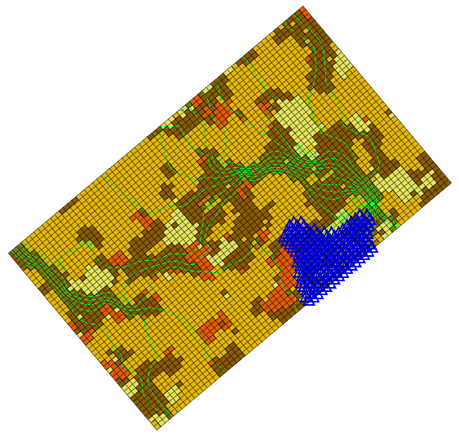

Figure 3 The model after the stochastic MODFLOW run

Notice the new “File:Generic Folder.svg matsto (MODFLOW)(STO)” folder in the Project Explorer. The folder can be expanded in order to view the individual solutions. Notice that the contours vary greatly depending on the distribution of materials. The head loss occurs primarily in the clay zones. While viewing a particular solution, notice that the material set is updated to correspond to the material set used to generate that particular solution.

## Displaying Pathlines

Before performing the probabilistic capture zone analysis, first view the capture zones corresponding to individual solutions.

1. Select *MODPATH |* **Create Particles at Wells…** to bring up the *Generate Particles at Wells* dialog.
2. Click **OK** to accept the default options and close the *Generate Particles at Wells* dialog.

A set of pathlines should appear (Figure 4). When clicking on different MODFLOW solutions in the Project Explorer, the pathlines will be automatically updated. Notice how dramatically the capture zone changes from one solution to the next.

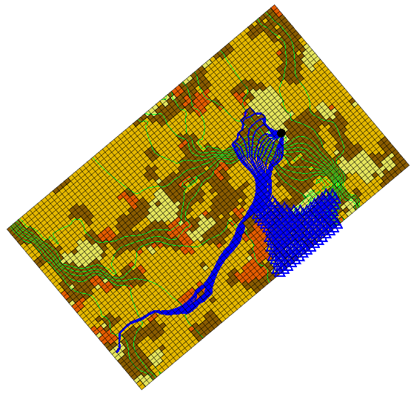

Figure 4 Pathlines stretching from the well

## Probabilistic Capture Zone Analysis

With a MODFLOW stochastic solution set, it is possible to perform a probabilistic capture zone analysis for the wells in the model. A probabilistic capture zone analysis is performed by placing one or more particles in each cell and tracking the particles forward in time using MODPATH to see if they reach a well. If any of the particles from a cell reach the well, a counter for the cell is updated. After running MODPATH on each of the MODFLOW solutions, the percentage of particles from a particular cell that are eventually captured by the well is computed and saved as the capture probability for the cell. The capture probability dataset can then be contoured.

1. Right-click on “File:Generic Folder.svg matsto (MODFLOW)(STO)” and select **Risk Analysis…** to bring up the *Risk Analysis Wizard* dialog.
2. Select “MODFLOW” from the box at the top.
3. Select *Probabilistic capture zone analysis* below the box.
4. Click **Next >** to go to the *Capture Zone Analysis* dialog.

This dialog can be used to specify options for the position and number of particles for each cell.

1. In the *Particle starting locations* section, select *Distribute particles on water table surface*.
2. In the *Tracking duration* section, select *To end*.
3. Click **Finish** to close the *Capture Zone Analysis* dialog.

A progress bar should appear at the bottom of the Graphics Window, showing the progress of computing the number of particles captured at the well. When the computations are finished, a new “File:Dataset Cells Active.svg well” dataset will be added to the bottom of the   
“File:Generic Folder.svg matsto (MODFLOW)(STO)” folder. This dataset contains the probability that any particles placed at the water table will reach the well.

The best way to view this dataset is to turn on color filled contours.

1. Click **Contour Options** File:Contour Options Macro.svg to open the *Dataset Contour Options – 3D Grid – well* dialog.
2. From the top *Contour method* drop-down, select “Color Fill”.
3. Click **Color Ramp…** to open the *Choose color ramp* dialog.
4. Select the *Hue 1* color palette.
5. Click **OK** to exit the *Choose color ramp* dialog.
6. Turn on *Legend*.
7. Click **OK** to exit the *Dataset Contour Options – 3D Grid – well* dialog.
8. Turn off the “File:Generic Folder.svg Particle Sets” folder in the Project Explorer to make the contours more visible.

A zone of probability now extends from the well (Figure 5).

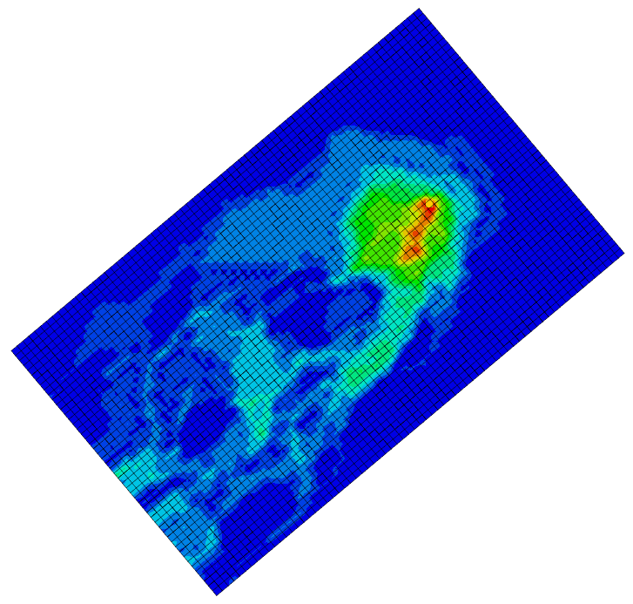

Figure 5 Zone of probability in contours

# Conclusion

This concludes the “MODFLOW – Stochastic Modeling, Indicator Simulations” tutorial. The following key concepts were discussed and demonstrated in this tutorial:

* GMS supports two types of stochastic approaches: parameter randomization and indicator simulations.
* The *Risk Analysis Wizard* can be used to do a probabilistic capture zone analysis.