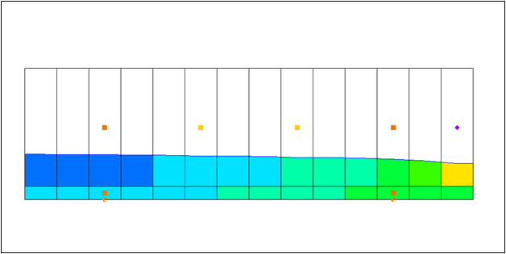

GMS 10.9

GMS 10.9 Tutorial

***MODFLOW-USG – CLN Process***

Create CLN process with MODFLOW-USG in GMS

Objectives

Learn how to use the CLN process in GMS using the conceptual model interface to create multi-layer wells.

Time

* 30–45 minutes

Required Components

* GMS Core
* MODFLOW Interface

Prerequisite Tutorials

* MODFLOW – Managing Transient Data

|  |
| --- |
| 1 Introduction 2  1.1 Description of Problem 2  2 Getting Started 3  3 Creating the Conceptual Model 5  4 Importing the Well Data 5  5 Setting the CLN Map Data 6  6 Mapping the CLN Wells 6  7 Saving and Running MODFLOW 8  8 Examining the Results 8  9 Conclusion 10 |

# Introduction

The Connected Linear Network (CLN) process was developed for MODFLOW-USG to model one-dimensional connected features that are much smaller than a groundwater flow model’s cells.[1] For MODFLOW-USG, the CLN process can be used to replace wells that would use the MNW1 or MNW2 package in other versions of MODFLOW.

This tutorial demonstrates how to use multi-node wells with MODFLOW-USG. An existing simulation that uses the MNW2 package will be opened. That simulation will be changed to use MODFLOW-USG. CLN wells will be added using a conceptual model. The new simulation will then be run and the results will be examined.

## Description of Problem

The problem in this tutorial is the same simulation (Figure 1) described in the MNW1 documentation as follows:

The system consists of two aquifers that are separated by a 50-foot-thick confining unit. The upper aquifer is unconfined, has a hydraulic conductivity of 60 ft/d, and has a uniform base of 50 ft above the datum. The lower aquifer is confined and has a transmissivity of 15,000 ft2/d. Storage coefficients of 0.05 and 0.0001 were assigned to layers 1 and 2, respectively. The 66-mi2 area of the test problem was divided into 21 rows of 14 columns. Uniform square cells that measured 2,500 ft on a side were used throughout the simulated area. Specified heads and drains are assigned in layer 1 and are maintained at the same elevations for all stress periods.

A period of 1,000,970 days was simulated with 5 stress periods. The first two stress periods simulated steady-state conditions, which were achieved by having each stress period be 500,000 days long. Recharge during stress periods 1 and 2 was a uniform 7 inches per year (in./yr). No pumpage was extracted during stress period 1 but multi-node wells were simulated. About 950,000 ft3/d of pumpage was extracted during stress period 2; this is about 35 percent of the total volumetric budget. Transient conditions were simulated during stress periods 3, 4, and 5, which were periods of 60, 180, and 730 days, respectively. Uniform recharge rates of 2, 0, and 12 in./yr, respectively, were applied during stress periods 3, 4, and 5. In addition to the simulation of two multi-node wells (wells A and B), there are 15 other single-node wells that have a combined discharge of 935,350 ft3/d for stress periods 2 through 5.[2]

For this tutorial, the single cell wells will be modeled using the WEL package, and the multi-cell wells (Well-A and Well-B) will be modeled using the CLN package.

|  |  |
| --- | --- |
|  |  |

Figure 1 Flow model from MNW1 documentation[3]

# Getting Started

Do the following to get started:

1. If necessary, launch GMS.
2. If GMS is already running, select *File |* **New** to ensure that the program settings are restored to their default state.
3. Click **Open** File:Open Macro.svg (or *File |* **Open…**) to bring up the *Open* dialog.
4. Browse to the *ClnProcess* directory and select “mnw2.gpr”.
5. Click **Open** to import the file and close the *Open* dialog.

The Graphics Window should appear as in Figure 2. Purple circle-shaped symbols representing the specified head boundary conditions appear along the right column of the grid. Wells are represented by yellow squares grouped mostly in the top half. The drain package boundary conditions are represented by the row of green circles near the center of the grid.

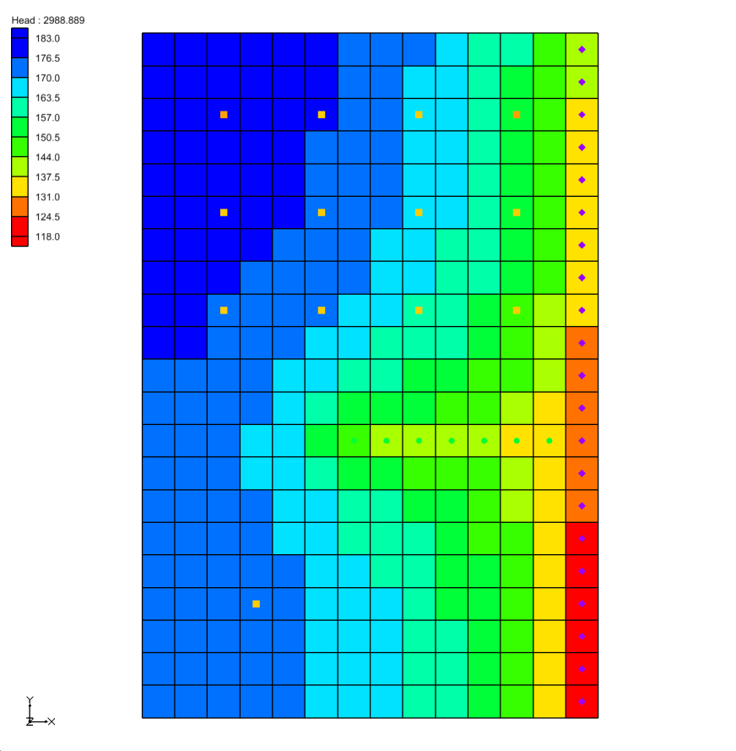

Figure 2 Imported CLN package example

In order to use the CLN process, MODFLOW-USG needs to be used.

1. Select *MODFLOW* | **Global Options** to bring up the *MODFLOW Global/Basic Package* dialog.
2. In the *MODFLOW version* section, select the *USG* button.
3. Click **OK** to close the *MODFLOW Global/Basic Package* dialog.
4. An alert will appear, advising that MODFLOW-USG doesn’t support the MNW2 package. Click **Yes** to turn off the package and continue.
5. An alert will appear, stating that MODFLOW-USG only supports the SMS solver, and the solver has been switched to that one. Click **OK** to continue.

Before making any further changes, save the project with a new name.

1. Select *File* | **Save As…** to bring up the *Save As* dialog.
2. Browse to the *Tutorials\MODFLOW-USG\ClnProcess* directory.
3. Enter “CLNwells.gpr” as the *File name*.
4. Select “Project Files (*.gpr)” from the *Save as type* drop-down.
5. Click **Save** to save the project file and close the *Save As* dialog.

# Creating the Conceptual Model

Now create a conceptual model and coverage for the CLN wells by doing the following:

1. Right-click on an empty spot in the Project Explorer and select *New* | **Conceptual Model…** to bring up the *Conceptual Model Properties* dialog.
2. As the *Name,* enter “CLN”.
3. From the *Type* drop-down, select “MODFLOW”.
4. From the *Flow package* drop-down, select “BCF”.
5. Click **OK** to close the *Conceptual Model Properties* dialog.

A new “File:Conceptual Model Icon.svg CLN” conceptual model should appear under “File:Map Folder.svg Map Data” in the Project Explorer.

1. Right-click on “File:Conceptual Model Icon.svg CLN*”* in the Project Explorer and select **New coverage…** to bring up the *Coverage Setup* dialog.
2. For the *Coverage name,* enter “CLN wells”.
3. In the *Sources/Sinks/BCs* section, turn on “Wells” and “Wells (CLN)”.
4. Set the *Default layer range* to go from “1” to “2”.
5. Click **OK** to close the *Coverage Setup* dialog.

A new “File:Coverage Active Icon.svg CLN wells” coverage will appear in the Project Explorer.

# Importing the Well Data

Now import the well data that contains the well locations and the well screen elevations by doing the following:

1. Select *File* | **Open…** to bring up the *Open* dialog.
2. From the *Files of type* drop-down, select “Text Files (*.txt; *.csv)”.
3. Select “wells.txt” and click **Open** to close the *Open* dialog and bring up the *Text Import Wizard – Step 1 of 2* dialog.
4. Below the *File import options* section, turn on *Heading row* and click **Next** to go to the *Text Import Wizard – Step 2 of 2* dialog.
5. From the *GMS data type* drop-down, select “Well data”.

The type row in the *File preview* section should fill with *Name*, *X*, *Y*, *Screen Top*, and *Screen Bottom* data from the imported file.

1. Click on **Finish** to import the well data and close the *Text Import Wizard – Step 2 of 2* dialog.

Wells should appear near the end and beginning of the third row from the top in the Graphics Window. Now to go through the same process to import the pumping data:

1. Select *File* | **Open…** to bring up the *Open* dialog.
2. From the *Files of type* drop-down, select “Text Files (*.txt; *.csv)”.
3. Select “pumping.txt” and click **Open** to close the *Open* dialog and bring up the *Text Import Wizard – Step 1 of 2* dialog.
4. Below the *File import options* section, turn on *Heading row* and click **Next** to go to the *Text Import Wizard – Step 2 of 2* dialog.
5. From the *GMS data type* drop-down, select “Pumping data”.
6. Click **Finish** to import the pumping data and close the *Text Import Wizard – Step 2 of 2* dialog.
7. An alert will appear asking if the time series should be a step function. Click **Yes** to continue.

# Setting the CLN Map Data

The well data has been imported with the “Wells” boundary condition type. To change the type to “Wells (CLN)” and enter some additional data:

1. Right-click on the “File:Coverage Active Icon.svg CLN wells” coverage and select **Attribute Table…** to bring up the *Attribute Table* dialog.
2. Using the *All* row, set the following (scrolling to the right as needed):

* From the *Type* column drop-down, select “well (CLN)”.
* From the *IFCON* column drop-down, select “Thiem with skin (1)”.
* In the *FSKIN* column, enter “1.0”.
* In the *FANISO* column, enter “1.0”.
* In the *FRAD* column, enter “0.5”.
* In the *CONDUITK* column, enter “4.31e7”. The display will change this to “43100000.0”.

1. Click **OK** to exit the *Attribute Table* dialog.

# Mapping the CLN Wells

The CLN wells in the conceptual model should now be mapped to the MODFLOW simulation.

1. Right-click on the “File:Coverage Active Icon.svg CLN wells” coverage and select *Map To* | **MODFLOW/MODPATH**. The CLN wells should now be mapped to the MODFLOW model.
2. Uncheck the “File:Coverage Active Icon.svg CLN wells” coverage in the Project Explorer.

The two outer wells in the third row should now be orange. The two inner wells on the third row should remain yellow (Figure 3). The values mapped to the MODFLOW-USG simulation can now be viewed.

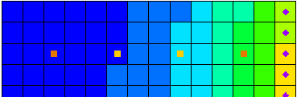

Figure 3 Mapped CLN wells are in orange, unmapped wells are in yellow

1. Select *MODFLOW | Optional Packages* | **CLN – Connected Linear Network…** to bring up the *CLN Process* dialog.
2. From the list on the left select “Segment Nodes”. A table will appear to the right of the list.

The CLN process contains nodes that can be connected together. For this simulation there are two CLN wells, and each well consists of two nodes. Each well has a unique *ClnSegmentId*, and each node has a unique *IFNO* value. Well-A is made up of the two nodes with a *ClnSegmentId* of 1, and Well-B is made up of the two nodes with a *ClnSegmentId* of 2.

1. From the list on the left select “Nodes”. The table on the right will change to show node information.

This table shows the values for each CLN node. In the MNW2 simulation, Well-A is active during the first stress period, but isn’t pumping. When the well is active but not pumping, the well connection between the two layers allows flow between them.

When mapping multi-cell wells to MODFLOW in GMS, by default they don’t become active until the stress period where pumping begins. To make Well-A active in the first stress period, change the *IBOUND* value for its nodes.

1. In the rows with *IFNO* values of “1” and “2,” in the *IBOUND* column enter “1” (scroll to the right as needed).
2. From the list on the left, select “Groundwater Connections”.

The table on the right will change to show the connections between the CLN process and nodes and the groundwater process cells. The *IGWNOD* column contains the cell ID of the connected groundwater node.

1. From the list on the left, select “Conduit Types”.

This table shows the conduit types generated for each CLN node and the associated mapped values for *FRAD* and *CONDUITK* previously entered in the Map module.

1. From the list on the left, select “Transient IBOUND”.

This table can be edited when cells become active and inactive. The nodes for Well-A have been changed to be active from the beginning of the simulation. There are currently no entries in this table.

1. Click **OK** to close the *CLN Process* dialog.
2. Select *MODFLOW | Optional Packages* | **CLN WEL – CLN Well…** to bring up the *MODFLOW CLN Wells Package* dialog.

This dialog shows the wells for the CLN process along with the associated flow rates for the different stress periods. The *Cell ID* column toward the left is the CLN node ID (or IFNO). GMS has moved the CLN wells into their own dialog, but the well data for all wells will be saved out as one wells file for the model run.

1. Click **OK** to close the *MODFLOW CLN Wells Package* dialog.

# Saving and Running MODFLOW

The changes should now be saved before running MODFLOW.

1. Click **Save** File:Save Macro.svg to save the project.
2. Click the **Run MODFLOW** File:Run MODFLOW Macro.svg macro in the toolbar to bring up the *MODFLOW* model wrapper dialog.
3. When MODFLOW finishes, check the *Read solution on exit* and *Turn on contours (if not on already)* boxes.
4. Click **Close** to close the *MODFLOW* model wrapper dialog.
5. Click **Save** File:Save Macro.svg to save the project with the new solution.

The simulation should now appear similar to Figure 4.

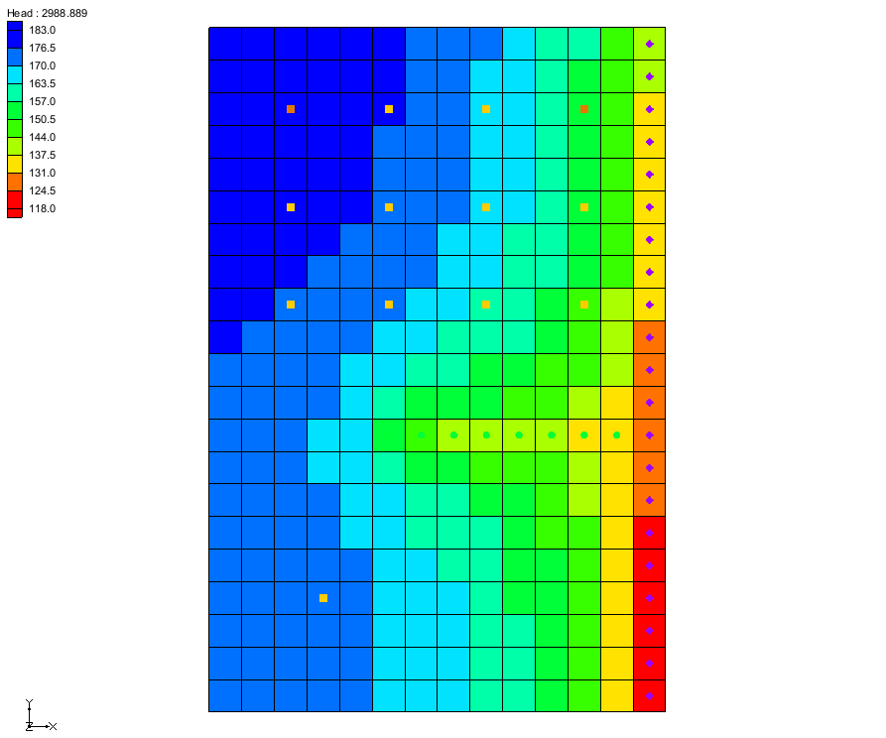

Figure 4 Solution with CLN wells

# Examining the Results

Examine the solution and compare it to the solution using the MNW2 package.

1. If necessary, expand the “File:Generic Folder Locked.svg CLNwells (MODFLOW)” item in the Project Explorer.
2. In the “File:Generic Folder Locked.svg CLNwells (MODFLOW)” folder select the “File:Dataset Cells Active.svg Head” dataset.
3. In the *Time Steps* window select the last time step (step 110).
4. If necessary, expand the “File:Generic Folder Locked.svg mnw2 (MODFLOW)” item in the Project Explorer.
5. In the “File:Generic Folder Locked.svg mnw2 (MODFLOW)” folder select the “File:Dataset Cells Active.svg Head” dataset.
6. In the *Time Steps* window select the last time step (step 110).

In changing between the MNW2 head dataset and the CLN head dataset, notice the slight difference between the head values. The difference in drawdown can also be seen when switching between the “DrawDown” datasets in the solution folders.

To get a more accurate comparison of the two solutions, use the *Data Calculator* to calculate the difference in the head values for the last stress period.

1. Select *Edit* | **Dataset Calculator…** to bring up the *Data Calculator* dialog.
2. Expand the “CLNwells (MODFLOW)” folder and select the “Head” dataset.
3. Scroll the *Time steps* list to the last time step (110) and click on it to select it.
4. Double-click on the “Head” dataset under “CLNwells (MODFLOW)”. The dataset label with the time step (“d5:110”) should be added to the *Expression* field.
5. Click on **subtract** **-** to enter it in the *Expression* field.
6. Expand the “mnw2 (MODFLOW)” folder and select the “Head” dataset.
7. Scroll the *Time steps* list to the last time step (110) and click on it to select it.
8. Double-click on the “Head” dataset under “mnw2 (MODFLOW)”. The dataset label with time step (“d3:110”) should be added to the *Expression* field.

The *Expression* field should now be “d5:110 – d3:110”.

1. Enter “difference” in the *Result* field and click on **Compute**.
2. Click on the **Done** button to exit the *Data Calculator* dialog.

A newly calculated “File:Dataset Cells Active.svg difference” dataset should appear in the Project Explorer giving the difference in the head values for each cell. The maximum difference value should be approximately -0.6 ft near the upper left corner of the grid (Figure 5).

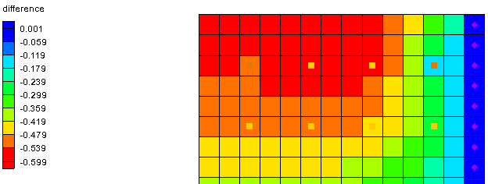

Figure 5 Final result, showing the difference in Head values

# Conclusion

This concludes the tutorial. Here are the key concepts from this tutorial:

* GMS has the ability to create multi-cell wells using the CLN Process with the Map module.
* CLN Process values can be edited viewed in the *CLN Process* dialog.
* CLN well flow rates can be edited and viewed in the *CLN Well* dialog. Well data is still saved out in the wells package file.

1. Panday, Sorab, Langevin, C.D., Niswonger, R.G., Ibaraki, Motomu, and Hughes, J.D. (2013). MODFLOW–USG version 1: An unstructured grid version of MODFLOW for simulating groundwater flow and tightly coupled processes using a control volume finite-difference formulation: U.S. Geological Survey Techniques and Methods. Book 6, chap. A45, 66 p., http://pubs.usgs.gov/tm/06/a45.
2. K.J. Halford and R.T. Hanson. (2002). User Guide for the Drawdown-Limited, Multi-Node Well (MNW) Package for the U.S. Geological Survey’s Modular Three-Dimensional Finite Difference Ground-Water Flow Model, Versions MODFLOW-96 and MODFLOW-2000. Open-File Report 02-293, pp15–17. https://water.usgs.gov/nrp/gwsoftware/modflow2000/MNW_text.pdf.
3. Ibid, p.16.