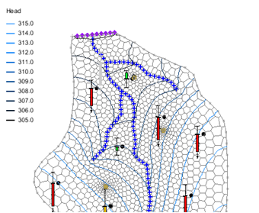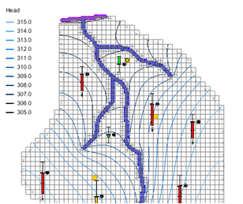

GMS 10.9

GMS 10.9 Tutorial

***MODFLOW-USG – Calibration***

Generate observation data in a MODFLOW-USG model

Objectives

This tutorial instructs how to use the GMS tools to create observation data for MODFLOW-USG.

Time

* 15–30 minutes

Required Components

* GMS Core
* MODFLOW Interface

Prerequisite Tutorials

* MODLOW – Model Calibration
* MODFLOW-USG – Quadtree

|  |
| --- |
| [1 Introduction 2](#_Toc109734249)  [2 Getting Started 3](#_Toc109734250)  [2.1 Importing the Starting Project 3](#_Toc109734251)  [2.2 Saving with a Different Name 3](#_Toc109734252)  [3 Converting to MODFLOW-USG 4](#_Toc109734253)  [4 Generating Observation Data for MODFLOW-USG 4](#_Toc109734254)  [5 Saving and Running MODFLOW 7](#_Toc109734255)  [5.1 Viewing the Model Error 8](#_Toc109734256)  [5.2 Changing the Observation Target Display Options 10](#_Toc109734257)  [6 Creating a MODFLOW-USG Model on a Voronoi UGrid 10](#_Toc109734258)  [6.1 Creating the UGrid 10](#_Toc109734259)  [6.2 Creating the MODFLOW-USG Simulation 11](#_Toc109734260)  [6.3 Saving and Running MODFLOW-USG 12](#_Toc109734261)  [7 Creating a MODFLOW-USG Model on a Quadtree UGrid 12](#_Toc109734262)  [7.1 Creating the UGrid 12](#_Toc109734263)  [7.2 Creating the MODFLOW-USG Simulation 13](#_Toc109734264)  [7.3 Saving and Running MODFLOW-USG 14](#_Toc109734265)  [8 Conclusion 14](#_Toc109734266)  [9 References 14](#_Toc109734267) |

# Introduction

An important part of any groundwater modeling exercise is the model calibration process. In order for a groundwater model to be used in any type of predictive role, it must be demonstrated that the model can successfully simulate observed aquifer behavior. Calibration is a process wherein certain parameters of the model, such as recharge and hydraulic conductivity, are altered in a systematic fashion. Then, the model is repeatedly run until the computed solution matches field-observed values within an acceptable level of accuracy.

Most versions of MODFLOW include an observation process within the model. MODFLOW-USG does not, so the steps to set up observation data vary slightly from other versions of MODFLOW. Various utility programs have been developed as part of the PEST suite of tools. They are used to compute observation data with MODFLOW-USG. After MODFLOW-USG successfully runs a model, these PEST utilities are used to post-process the MODFLOW outputs in order to compare the model simulated values with the field-observed values.

This tutorial starts with a MODFLOW 2000 model that includes observation data, and converts that model to a MODFLOW-USG model. Different types of UGrids are generated using the same conceptual model to show how observations work with Quadtree and Voronoi grids.

Familiarity with conceptual modeling, model calibration, MODFLOW-USG, and unstructured grid generation is assumed. The prerequisite tutorials should be completed prior to starting this tutorial.

This tutorial discusses and demonstrates opening a MODFLOW 2000 model and converting it to a MODFLOW-USG simulation. It then generates observation data for the MODFLOW-USG model, runs MODFLOW-USG, and reviews the results. Creation of a Voronoi UGrid and MODFLOW-USG simulation, as well as quadtree UGrid and MODFLOW-USG simulation, will be shown.

# Getting Started

Do the following to get started.

1. If necessary, launch GMS.
2. If GMS is already running, select *File |* **New** to ensure that the program settings are restored to their default state.

## Importing the Starting Project

Begin by importing a previously constructed MODFLOW-2000 model.

1. Click **Open** File:Open Macro.svg to bring up the *Open* dialog.
2. Select “Project Files (\*.gpr)” from the *Files of type* drop-down.
3. Browse to the *Tutorials\MODFLOW‑USG\Calibration\* directory and select “bigval.gpr”.
4. Click **Open** to import the project and exit the *Open* dialog.

A model similar to Figure 1 should appear.

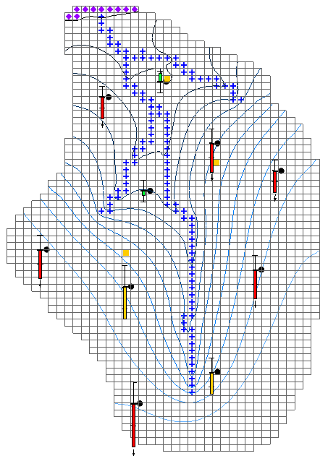

Figure 1 MODFLOW-2000 model

The model has observation wells with calibration targets displayed next to each point. There is also a flow observation associated with the river boundary condition (blue symbols).

## Saving with a Different Name

Before making any changes, save the project under a new name.

1. Select *File |* **Save As…** to bring up the *Save As* dialog.
2. From the *Save as type* drop-down, select “Project Files (\*.gpr)”.
3. As the *File name,* enter “calib-usg.gpr”.
4. Click **Save** to save the project under the new name and close the *Save As* dialog.

It is recommended to **Save** File:Save Macro.svg periodically while progressing through the model.

# Converting to MODFLOW-USG

Now to create a MODFLOW-USG model from the MODFLOW 2000 model:

1. Right-click on the “**** MODFLOW” in the Project Explorer and select **Convert to MODFLOW-USG Simulation**.
2. Click **No** when prompted to include inactive cells in the new UGrid.
3. Click **OK** when prompted regarding the PCG package not being copied to the MODFLOW-USG simulation.

The PCG package is a solver package that is not supported in USG. USG supports the SMS solver package and this has been included in the new simulation.

1. Turn off the “ 3D Grid Data” folder in the Project Explorer.

Notice that the UGrid looks identical to the 3D Grid but is not displaying any contours (Figure 2). The calibration targets are still visible and are showing the computed values from the MODFLOW-2000 model on the 3D Grid.

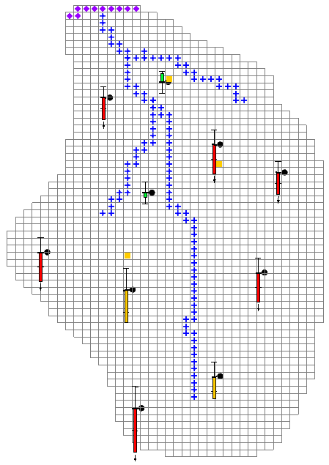

Figure 2 After conversion to USG

# Generating Observation Data for MODFLOW-USG

Now to create observation data for this MODFLOW-USG model:

1. Under “Ugrid_lock ugrid” in the Project Explorer, right-click on “ MODFLOW” and select **Observations…** to bring up the *MODFLOW-USG Observations* dialog.

This dialog displays a series of tables representing field-measured data, generated from data entered in the coverages of the conceptual model.

1. Click on **Generate PEST Obs. Data…** to bring up the *Generate Observations* dialog (Figure 3).

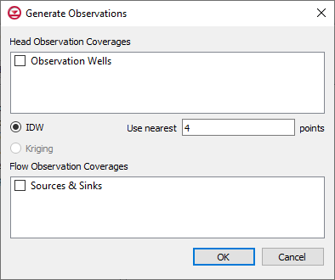

Figure 3 Generate Observations dialog

The dialog allows choosing from the coverages in the current project that have observation data. In this case, two coverages have observation data. Head measurements are in the “File:Coverage Active Icon.svg Observation Wells” coverage and flow measurements are in the “File:Coverage Active Icon.svg Sources & Sinks” coverage.

Notice that below the *Head Observation Coverages* section, there is an option to select an interpolation scheme (IDW, Kriging). This is used to interpolate from the model grid cells to the observation wells.

1. In the *Head Observation Coverages* section, turn on “Observation Wells”.
2. In the *Flow Observation Coverages* section, turn on “Sources & Sinks”.
3. Leave all other options at the defaults and click **OK** to generate the observation data.

A new “Wells” table should be visible in the right side of the dialog (Figure 4).

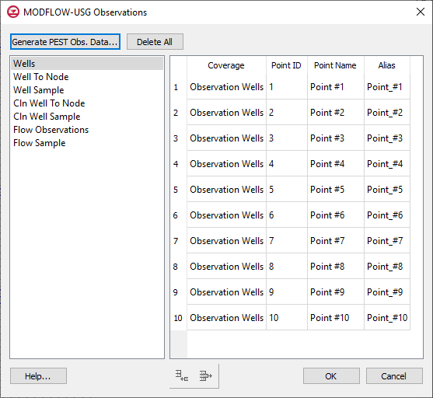

Figure 4 MODFLOW-USG Observations dialog Wells table

The items in this table represent the observation well data found in the “File:Coverage Active Icon.svg Observation Wells” coverage, showing the coverage name, point id, and point name. The last column is an alias. The PEST utilities used to compute observation information have certain rules for the names of observations. The alias column ensures that these rules are met without any required interaction. If the user-defined name assigned to the point meets these rules, then the user-defined name will be used as the alias.

1. From the list on the left, select “Well To Node”.

The entries in this table represent the interpolation from the UGrid cells to the observation point. The table shows the alias of the well, the UGrid cell id (*Node ID*), and an interpolation factor. The PEST utility uses the cell ids and factors to interpolate from the MODFLOW head output file to each observation well.

1. From the list on the left, select “Well Sample”.

This table represents the measurements taken at the observation wells. The table lists a well alias, a date/time, and a head value. If the model was transient, it would most likely have multiple measurements at each well with a different date/time for each measurement. Since this model is steady state, only one measurement for each well and the date of 1950-01-01 00:00:00 has been assigned. The date is meaningless in this case, but a date must be assigned for the PEST utility to function so GMS uses this date as the default.

1. From the list on the left, select “Flow Observations”.

This table lists any flow observations that are included in the coverages of the conceptual model and is similar to the “Wells” table. The table lists the coverage name, the type of feature (i.e., POINT, ARC, ARCGROUP, POLYGON), the feature ID, the feature name, and an alias. This alias is just like the alias for the observations wells. In this model, notice that one flow observation is on an arc group. This arc group comprises several arcs that are used to define the river in the middle of the model.

1. From the list on the left, select “Flow Sample”.

This table lists the flow measurements taken from field data. It is just like the “Well Sample” table.

1. Click **OK** to exit the *MODFLOW-USG Observations* dialog.

# Saving and Running MODFLOW

Now to run MODFLOW:

1. **Save** File:Save Macro.svg the project.
2. Right-click on the “File:MODFLOW Folder.svg MODFLOW” item under “Ugrid_lock ugrid” item and select **Open Containing Folder** to bring up the *\Tutorials\MODFLOW-USG\Calibration\calib-usg\_MODFLOW-ugrid* directory in Windows Explorer.

This is the directory where the MODFLOW-USG input files are saved. Notice that there are several files with “calib-usg.obsusg.” and “calib-usg.obsusgf.” as part of the file name. These are not MODFLOW input files, but are used as inputs for the PEST utilities.

There are also several batch files in the folder. These batch files are used to call the PEST utilities after MODFLOW runs. The main batch file is named “usgobs.bat”. This is the batch file that runs once MODFLOW has terminated successfully

1. Close Windows Explorer and return to GMS.
2. Click **Run MODFLOW** File:Run MODFLOW Macro.svg to bring up the *MODFLOW* model wrapper dialog.
3. When the model finishes, turn on Read solution on exit and Turn on contours (if not on already).
4. Click **Close** to import the solution, exit the *MODFLOW* model wrapper dialog, and bring up a GMS prompt.

The prompt states that “The current project includes both a 3D Grid and a UGrid. The observation targets will be drawn using data from the active dataset on the active 3D Grid. This display option can be edited in the Map Data Display Options under the section ‘Projects including 3D Grid & UGrid, MODFLOW targets use’.”

1. Click **OK** to close the prompt.

The model should update to appear similar to Figure 5.

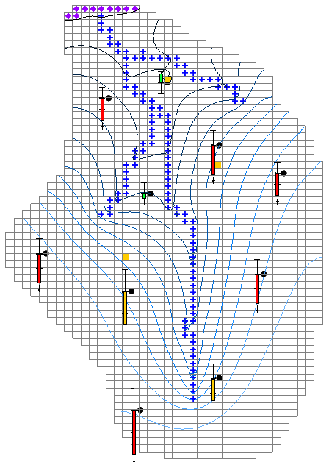

Figure 5 Contours after the initial MODFLOW run

## Viewing the Model Error

Now to compare the model error for the MODFLOW-USG model to the MODFLOW-2000 model:

1. Right-click on the “File:Generic Folder Locked.svg calib-usg (MODFLOW)” solution and select **Properties…** to bring up the *Properties* dialog.

The values should match those shown in Figure 6.

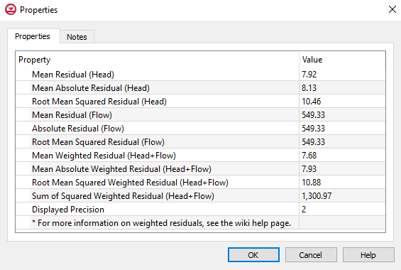

Figure 6 Model error for MODFLOW-USG model

1. Select **OK** to exit the *Properties* dialog.
2. Right-click on the “File:Generic Folder Locked.svg bigval (MODFLOW)” solution under “File:3D Grid Icon.svg grid”and select **Properties…** to bring up the *Properties* dialog.

The values should match those shown in Figure 7. Note that the error is slightly different for the two models. This is expected since this MODFLOW-USG model is a copy of the 3D grid model. The difference in the observations comes by using the PEST utilities to calculate the computed values instead of using the MODFLOW OBS package.

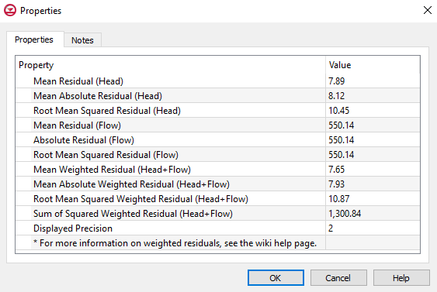

Figure 7 Model error for MODFLOW-2000 model

1. Select **OK** to exit the *Properties* dialog.

## Changing the Observation Target Display Options

Now to change the display options so that the targets will reflect the computed values from the MODFLOW-USG simulation.

1. Click **Display Options** File:Display Options Macro.svg to bring up the *Display Options* dialog.
2. From the list on the left, select “File:Map Module Icon.svg Map Data”.
3. On the *Map* tab at the bottom of the section on the right, from the *Project including 3D Grid & UGrid, MODFLOW targets use* drop-down, select “UGrid”.
4. Click **OK** to exit the *Display Options* dialog.

As expected, the targets look nearly the same as the targets did when using the data from the 3D grid. If there is only a 3D Grid or only a UGrid, then this display option has no effect on the observation points. However, when a project has both a 3D Grid MODFLOW simulation and a UGrid MODFLOW simulation, this display option is used to determine the source of the computed values for the observation points.

# Creating a MODFLOW-USG Model on a Voronoi UGrid

Now, create a second UGrid using the Voronoi criteria.

## Creating the UGrid

1. Right-click on “File:3D Grid Folder.svg 3D Grid Data” in the Project Explorer and select **Delete**.

Deleting the 3D Grid before creating Voronoi and quadtree UGrids with corresponding MODFLOW-USG simulations avoids the message about having both a 3D Grid and a UGrid associated with the observation data.

1. In the Project Explorer, select “File:Coverage Active Icon.svg Sources & Sinks” to make it active.
2. Right-click on “File:Coverage Active Icon.svg Sources & Sinks” and select *Map To |* **UGrid** to bring up the *Map → UGrid* dialog.
3. From the *Dimension* drop-down, select “3D”.
4. From the *UGrid type* drop-down, select “Voronoi”.
5. In the *Z-Dimension* section, in the *Number of cells* field, enter “1”.
6. Click **OK** to close the *Map → UGrid* dialog.
7. Uncheck the box next to “ ugrid” in the Project Explorer to better see the newly created “File:Ugrid-icon.png ugrid (2)”.

The new UGrid should be similar to Figure 8.

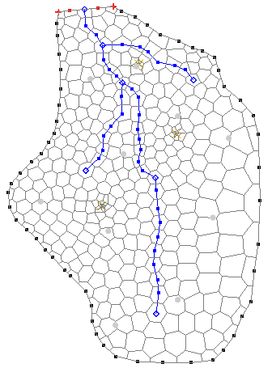

Figure 8 Voronoi UGrid

## Creating the MODFLOW-USG Simulation

Now, create a MODFLOW-USG simulation on the UGrid. Start with creating a new MODFLOW simulation. Then, use the layer interpolation tools to set the elevations of the grid and convert the conceptual model by mapping it to MODFLOW.

1. Right-click on “File:Ugrid-icon.png ugrid (2)” and select **Rename**.
2. Enter “voronoi” and press *Enter* to set the new name.
3. Right-click on “File:Ugrid-icon.png voronoi” and select **New MODFLOW…** to bring up the *MODFLOW Global/Basic Package* dialog.
4. Click **OK** to exit the *MODFLOW Global/Basic Package* dialog.
5. Right-click on “File:2D Scatter Icon.svg Layers” and select *Interpolate to |* **MODFLOW Layers** to bring up the *Interpolate to MODFLOW Layers* dialog.
6. Click **OK** to accept the defaults, close the *Interpolate to MODFLOW Layers* dialog, and interpolate the layer elevations to “File:Ugrid-icon.png voronoi”.
7. Right-click on “File:Conceptual Model Icon.svg BigVal” and select *Map to |* **MODFLOW/MODPATH** to bring up the *Map → Model* dialog.
8. Click **OK** to accept the defaults, close the *Map → Model* dialog, and convert the conceptual model to “File:Ugrid-icon.png voronoi”. This process may take a few moments.
9. Underneath “File:Ugrid-icon.png voronoi”, right-click on “File:MODFLOW Folder.svgMODFLOW” and select **Observations…** to bring up the *MODFLOW-USG Observations* dialog.

Notice that the observation data has already been populated. This happens as part of mapping the data to MODFLOW.

1. Click **Generate PEST Obs. Data…** to bring up the *Generate Observations* dialog.

Notice that both coverages listed have a check next to them.

1. Click **OK** to exit the *Generate Observations* dialog.
2. Click **OK** to exit the *MODFLOW-USG Observations* dialog.

## Saving and Running MODFLOW-USG

Now to run MODFLOW using the Voronoi UGrid:

1. **Save** File:Save Macro.svg the project.
2. Click **Run MODFLOW** File:Run MODFLOW Macro.svg to bring up the *MODFLOW* model wrapper dialog.
3. When the model finishes, turn on *Read solution on exit* and *Turn on contours (if not on already)*.
4. Click **Close** to import the solution and exit the *MODFLOW* model wrapper dialog.
5. Select the “File:Coverage Active Icon.svg Observation Wells” coverage to make the observation targets visible.

Notice that the observation targets are similar to those in the original model.

# Creating a MODFLOW-USG Model on a Quadtree UGrid

Now, create the quadtree UGrid and its corresponding MODFLOW-USG simulation.

## Creating the UGrid

1. Select “File:Coverage Active Icon.svg Sources & Sinks” to make it active.
2. Right-click on “File:Coverage Active Icon.svg Sources & Sinks” and select *Map To |* **UGrid** to bring up the *Map → UGrid* dialog.
3. From the *Dimension* drop-down, select “3D”.
4. From the *UGrid type* drop-down, select “Quadtree / Octree”.
5. In both the *X-Dimension* and *Y-Dimension* sections, select the *Cell size* option and enter “200.0” in the *Cell size* field.
6. Click **OK** to close the *Map → UGrid* dialog.
7. Turn off “File:Ugrid-icon.png voronoi” to better view the new “ ugrid (2)”.

The new UGrid should appear similar to Figure 9.

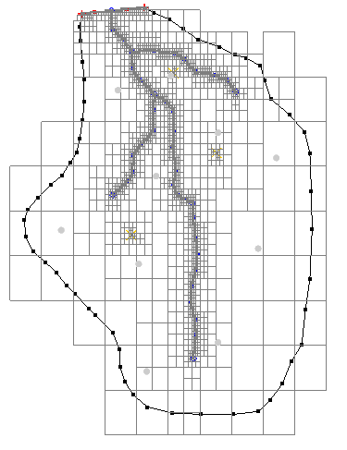

Figure 9 Quadtree UGrid

## Creating the MODFLOW-USG Simulation

Now to create a MODFLOW-USG simulation using the procedure show in section 6.2.

1. Right-click on “ ugrid (2)” and select **Rename**.
2. Enter “quadtree” and press *Enter* to set the new name.
3. Right-click on “ quadtree” and select **New MODFLOW…** to bring up the *MODFLOW Global/Basic Package* dialog.
4. Click **OK** to exit the *MODFLOW Global/Basic Package* dialog.
5. Right-click on “File:2D Scatter Icon.svg Layers” and select *Interpolate to |* **MODFLOW Layers** to bring up the *Interpolate to MODFLOW Layers* dialog.
6. Click **OK** to close the *Interpolate to MODFLOW Layers* dialog.
7. Right-click on “File:Conceptual Model Icon.svg BigVal” and select *Map to |* **MODFLOW/MODPATH** to bring up the *Map → Model* dialog.
8. Click **OK** to accept the defaults and close the *Map → Model* dialog. This process may take a few moments.
9. Right-click on “File:MODFLOW Folder.svgMODFLOW” under “ quadtree” and select **Observations…** to bring up the *MODFLOW-USG Observations* dialog.
10. Click **Generate PEST Obs. Data…** to bring up the *Generate Observations* dialog.
11. Click **OK** to exit the *Generate Observations* dialog.
12. Click **OK** to exit the *MODFLOW-USG Observations* dialog.

## Saving and Running MODFLOW-USG

Now to run MODFLOW using the quadtree UGrid:

1. **Save** File:Save Macro.svg the project.
2. Click **Run MODFLOW** File:Run MODFLOW Macro.svg to bring up the *MODFLOW* model wrapper dialog.
3. When the model finishes, turn on *Read solution on exit* and *Turn on contours (if not on already)*.
4. Click **Close** to exit the *MODFLOW* model wrapper dialog.
5. Select “File:Coverage Active Icon.svg Observation Wells” to make the observation targets visible.

Notice the observation targets are similar to the original model. Feel free to compare the model error of the three MODFLOW-USG simulations.

# Conclusion

This concludes the “MODFLOW-USG – Calibration”tutorial. The following key concepts were discussed and demonstrated in this tutorial:

* PEST utilities are used to calculate model computed values at observations.
* Use the conceptual model tools in GMS to generate observation data for MODFLOW-USG.

# References

* Panday, Sorab; Langevin, C.D.; Niswonger, R.G.; Ibaraki, Motomu; and Hughes, J.D. (2013). “MODFLOW–USG version 1: An Unstructured Grid Version of MODFLOW for Simulating Groundwater Flow and Tightly Coupled Processes Using a Control Volume Finite-Difference Formulation”. U.S. Geological Survey, *Techniques and Methods 6–A45*. <http://pubs.usgs.gov/tm/06/a45/pdf/tm6-A45.pdf>.
* Doherty, John. (January 2014). Groundwater Data Utilities: Part C: Programs Written for Unstructured Grid Models. Watermark Numerical Computing.