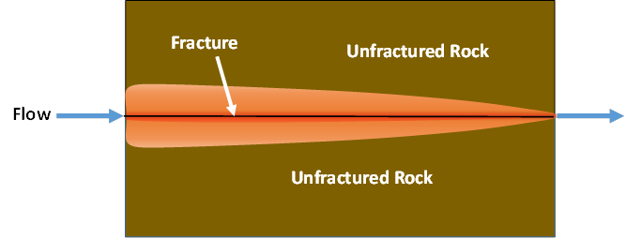

GMS 10.9

GMS 10.9 Tutorial

***MODFLOW-USG Transport – MDT Equivalent Porous Media Approach***

Use the Matrix Diffusion Transport (MDT) package in GMS to simulate diffusion from fractures using a semi-analytic approximation

Objectives

Learn how to use the Matrix Diffusion Transport (MDT) package with MODFLOW-USG Transport to simulate diffusion from a single fracture or from a set of parallel fractures.

Time

* 15–30 minutes

Required Components

* GMS Core
* MODFLOW-USG Transport

Prerequisite Tutorials

* MODFLOW-USG Transport

|  |
| --- |
| 1 Introduction 2  2 Getting Started 3  3 Activating the MDT Package 4  4 Defining the MDT Package 5  5 Run MODFLOW and Examine the Results 5  6 Conclusion 6 |

# Introduction

The Matrix Diffusion Transport (MDT) package works with MODFLOW-USG Transport to upgrade existing flow and chemical transport models by fully accounting for matrix diffusion effects. MDT is based on the semi-analytic matrix diffusion method implemented in the REMChlor-MD model[1], [2], [3]. This capability was developed through collaboration between Clemson University, GSI Environmental, and Aquaveo, supported by the Department of Defense’s Environmental Security Technology Certification Program (ESTCP).

Conceptually similar to dual-porosity methods, the MDT method divides each element into mobile and immobile zones. Solute transport occurs by advection and dispersion in the mobile zone, and by diffusion only in the immobile zone. MDT approximates the immobile fraction’s concentration profile using a dynamic function based on distance from the mobile/immobile interface. This function is updated at each time step for every element using current and previous concentrations, plus the integral of the immobile concentration profile. Mass transfer between zones is then calculated as a linear, concentration-dependent source term.

This tutorial shows how to use the MDT package with a MODFLOW-USG Transport simulation to model diffusion in a series of parallel fractures. The example is based on a benchmarking problem developed with REMChlor-MD. For more detail on the semi-analytic method, see the REMChlor-MD user’s guide1 and related journal papers2, 3. MDT input variables are described in the MDT Process for MODFLOW-USG Transport User’s Guide[4].

The simulation uses a single-layer, one-dimensional unstructured grid (UGrid) with head values specified throughout the domain.

This tutorial will demonstrate the following topics:

* Opening an existing MODFLOW-USG Transport simulation
* Activating the MDT package
* Running the simulation and examining the results

# Getting Started

Do the following to get started:

1. If necessary, launch GMS.
2. If GMS is already running, select *File |* **New** to ensure that the program settings are restored to their default state.
3. Click **Open** File:Open Macro.svg (or *File |* **Open…**) to bring up the *Open* dialog.
4. Browse to the data files *\MDT_EquivalentPorous\MDT_EquivalentPorous* and select “start.gpr”.
5. Click **Open** to import the file and close the *Open* dialog.

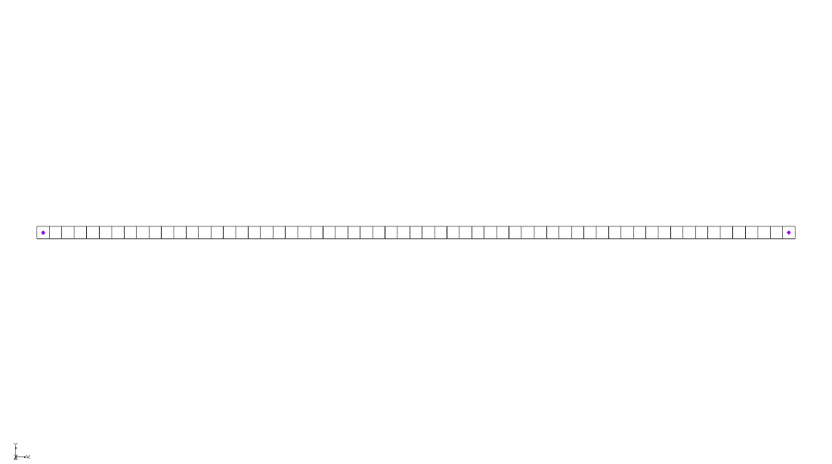

Figure 1 Imported MODFLOW-USG Transport model

The Graphics Window should appear as shown in Figure 1. This model uses a single-layer UGrid with 61 elements arranged in a one-dimensional configuration. Each element measures 1 meter in the flow direction (x-direction), 1 meter perpendicular to the flow (y-direction), and 1 meter vertically (z-direction).

Specified heads (CHD) are applied to both ends: the leftmost element is held at a constant head of 11 meters, while the rightmost element is held at a head of 10 meters.

A tracer (Species 1) is introduced at the upstream end using a transient concentration boundary (PCB package), with a concentration of 1 for 50 years, followed by 0 for the remaining 150 years.

This example demonstrates a general approach for modeling systems with multiple embedded fractures using equivalent porous media. In this method, full-sized grid elements are used, and the fractures are represented internally within each element. The hydraulic conductivity is averaged over the entire domain to reproduce the same Darcy velocity as the fractured medium.

Since fractures occupy only a small fraction of the volume, the pore velocity within the fractures is much higher than the bulk Darcy velocity of the rock mass.

The MDT package simulates matrix diffusion in such a system using the method described by Muskus and Falta3. To apply this method:

* Use a grid with full-sized elements
* Specify fracture spacing and aperture
* Set the volume fraction of fractures (VOLFRACMD) equal to:
  + fracture aperture ÷ fracture spacing
* Set the characteristic diffusion length (DIFFLENMD) equal to half the fracture spacing

This example is based on a test case from Muskus and Falta2, using parallel fractures with a spacing of 0.5 meters and an aperture of 100 µm. The volume fraction of fractures is 0.0001 m/0.5 m = 0.0002.

Assuming a pore velocity of 100 m/year in the fractures, the corresponding bulk Darcy velocity is 100 x 0.0002 = 0.02 m/year. And with a hydraulic gradient of 1/60, the required hydraulic conductivity (HK) is 1.2 m/year.

Additional model parameters used in this example are given in Table 2.

Table 2. Parameters used in the fractured rock matrix diffusion simulation

|  |  |  |
| --- | --- | --- |
| **Parameter** | **Fracture** | **Matrix** |
| Fracture aperture, μm | 100 |  |
| Porosity, *ϕ* | 1.0 | 0.1 |
| Tortuosity, *τ* | 1.0 | 0.1 |
| Retardation factor, *R* | 1.0 | 2.0 |
| Pore velocity, (m/yr) | 100 | 0 |
| Diffusion coefficient, *D*(m2/s) | 1.0E-9 | 1.0E-9 |
| decay rate (1/yr) | 0.0 | 0.0 |
| Loading period, *t1*, (years) | 50 |  |

Before continuing, save the project with a new name.

1. Select *File* | **Save As…** to bring up the *Save As* dialog.
2. Enter “model-mdt_parallel.gpr” as the *File name*.
3. Select “Project Files (*.gpr)” from the *Save as type* drop-down.
4. Click **Save** to save the project file and close the *Save As* dialog.

# Activating the MDT Package

With the flow model set up, the MDT package can now be activated and added to the MODFLOW simulation. To activate the MDT package:

1. Switch to the **UGrid** File:UGrid Icon Unlocked.svg module.
2. Select *MODFLOW |* **Global Options…** to bring up the *MODFLOW Global/Basic Package* dialog.
3. Click **Packages…** to bring up the *MODFLOW Packages / Processes* dialog.
4. In the *Optional packages / processes* section, turn on *MDT – Matrix Diffusion Transport*.
5. Click **OK** to exit the *MODFLOW Packages / Processes* dialog.
6. Click **OK** to exit the *MODFLOW Global/Basic Package* dialog.

# Defining the MDT Package

Now the matrix diffusion package parameters can be entered. To achieve a retardation factor value of 2.0 in the matrix, set the bulk density (RHOBMD) to 2.0 and a soil-water distribution coefficient (KDMD) to 0.05.

1. Select *MODFLOW | Optional Packages* | **MDT – Matrix Diffusion Transport…** to bring up the *MDT Package* dialog.
2. From the list on the left, select *Aquifer Properties*.
3. Enter the following for the *Constant Value* column:
   1. *MDFLAG*: “2.0”. This variable is a flag that defines how the MDT package handles matrix diffusion. A value of 2 enables diffusion into embedded matrix blocks with a finite diffusion length. This option is used in this example because it follows an equivalent porous media approach.
   2. *VOLFRACMD*: “0.0002”. This represents the volume fraction of high-permeability material within the element. In this case, it is calculated as the fracture aperture divided by the fracture spacing.
   3. *PORMD*: “0.1”.
   4. *RHOBMD*: “2.0”.
   5. *DIFFLENMD*: “0.25”. The characteristic diffusion length is defined as half of the fracture spacing.
   6. *TORTMD*: “0.1”.
4. From the list on the left, select *Species Properties*.
5. Enter the following for the *Constant Value* column:
   1. *KDMD*: “0.05”.
   2. *DECAYMD*: “0.0”.
   3. *DIFFMD*: “0.03159”.
6. Click **OK** to close the *MDT Package* dialog.

It is necessary to change the decay rate in the high permeability zone using the BCT package.

1. Select *MODFLOW | Optional Packages* | **BCT – Block Centered Transport…** to bring up the *BCT Process* dialog.
2. In the list on the left, select *Species Properties*.
3. In the *FODRW* row under the *Constant Value* column, enter “0.0”.

This variable is the decay rate for the species.

1. Click **OK** to close the *BCT Process* dialog.

# Run MODFLOW and Examine the Results

The changes should now be saved before running MODFLOW-USG Transport.

1. Click **Save** File:Save Macro.svg to save the project.
2. Click the **Run MODFLOW** File:Run MODFLOW Macro.svg macro in the toolbar to bring up the *MODFLOW* model wrapper dialog.
3. When MODFLOW finishes, check the *Read solution on exit* and *Turn on contours (if not on already)* boxes.
4. Click **Close** to close the *MODFLOW* model wrapper dialog.
5. Click **Save** File:Save Macro.svg to save the project with the new solution.

The solution set should now appear in the Project Explorer. To better visualize the impact of the MDT package, compare the results by using the *Plot Wizard* tool to create a time series plot.

1. In the Project Explorer, select the “File:Dataset Cells Active.svg Species 1” dataset to make it active.
2. Using the **Select Cells** File:Select UGrid Cell Tool.svg tool, select the second cell from the left.
3. Click the **Plot Wizard** File:Plot Wizard Macro.svg macro to open the *Plot Wizard* dialog.
4. Under *Plot Type*, select the *Active Dataset Time Series* option.
5. Click **Finish** to close the *Plot Wizard* dialog and generate the plot.

The *Active Dataset Time Series* plot should appear similar to Figure 2.

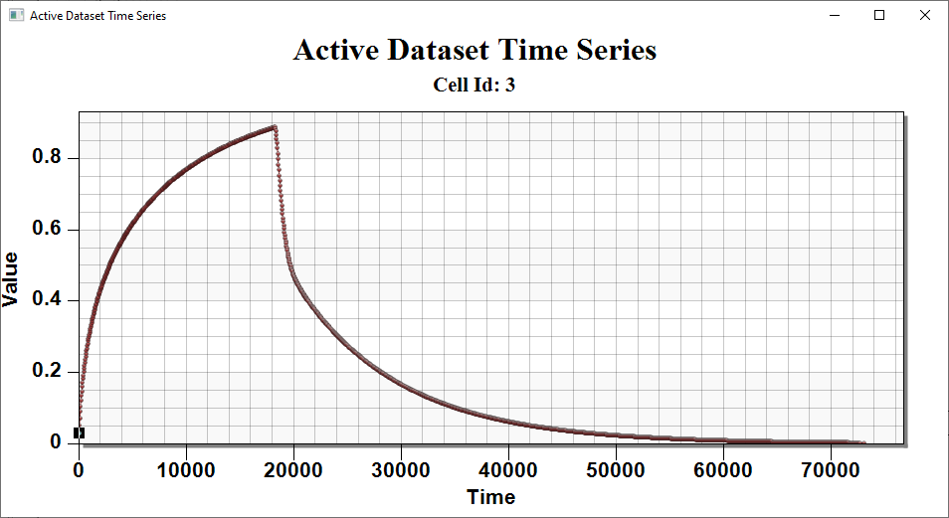

Figure 2 The Active Dataset Time Series for the second cell

# Conclusion

This concludes the tutorial. Here are the key concepts from this tutorial:

The MODFLOW-USG Transport MDT package can simulate matrix diffusion from multiple fractures in fractured porous materials

The equivalent porous media approach allows standard grid elements to represent embedded matrix diffusion over a finite distance within each element

1. Farhat, S. K., Newell, C. J., Falta, R. W., & Lynch, K. (2018). *REMChlor-MD user’s manual*. Environmental Security Technology Certification Program (ESTCP). <https://www.serdp-estcp.org/Program-Areas/Environmental-Restoration/Contaminated-Groundwater/Persistent-Contamination/ER-201426>
2. Falta, R. W., & Wang, W. (2017). A semi-analytical method for simulating matrix diffusion in numerical transport models. *Journal of Contaminant Hydrology, 197*, 39–49.
3. Muskus, N., & Falta, R. W. (2018). Semi-analytical method for matrix diffusion in heterogeneous and fractured systems with parent-daughter reactions. *Journal of Contaminant Hydrology, 218*, 94–109.
4. Panday, S., Falta, R. W., Farhat, S., Pham, K., & Lemon, A. (2021). *Matrix diffusion transport (MDT) process for MODFLOW-USG Transport*. GSI Environmental Inc. <https://www.gsienv.com/product/modflow-usg/>