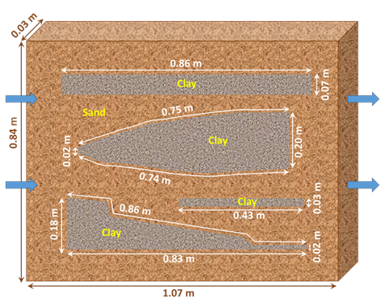

GMS 10.9

GMS 10.9 Tutorial

***MODFLOW-USG Transport – MDT Matrix Diffusion***

Use the Matrix Diffusion Transport (MDT) package in GMS to simulate matrix diffusion in heterogeneous sand/clay system using a semi-analytic approximation

Objectives

Learn how to use the Matrix Diffusion Transport (MDT) package with MODFLOW-USG Transport to simulate matrix diffusion in a heterogeneous sand/clay system.

Time

* 30–40 minutes

Required Components

* GMS Core
* MODFLOW-USG Transport

Prerequisite Tutorials

* MODFLOW-USG Transport

|  |
| --- |
| 1 Introduction 2  2 Getting Started 3  3 Activating the MDT Package 4  4 Defining the MDT Package 5  5 Saving and Running MODFLOW 5  6 Examining the Results 6  7 Conclusion 8 |

# Introduction

The Matrix Diffusion Transport (MDT) package enhances MODFLOW-USG Transport by incorporating matrix diffusion effects using a semi-analytic matrix diffusion method adapted from the REMChlor-MD model[1], [2], [3]. Developed with support from the Department of Defense Environmental Security Technology Certification Program (ESTCP) and in collaboration with Clemson University, GSI Environmental, and Aquaveo, MDT allows existing models to account for solute diffusion into low-permeability zones.

The MDT approach is conceptually similar to dual-porosity methods, where each element includes both mobile and immobile zones. Solute transport occurs by advection and dispersion in the mobile zone, and by diffusion in the immobile fraction. The concentration profile in the immobile zone is dynamically updated each time step using current and previous mobile concentrations. Mass exchange between zones is calculated as a linear, concentration-dependent source term.

This tutorial demonstrates how MDT can be used with MODFLOW-USG Transport to simulate diffusion in a heterogeneous porous media system, with sub-grid-scale heterogeneity represented through average properties. This example is based on a REMChlor-MD benchmarking problem.

For details on MDT input variables, refer to the MDT Process for MODFLOW-USG Transport User’s Guide4. Background on the semi-analytic method is provided in the REMChlor-MD User’s Guide and related publications2,3.

This example replicates the Doner[4] (2008) laboratory matrix diffusion experiment, performed in a 1.07 x 0.03 x 0.84 meter tank filled with sand and four embedded clay lenses. A tracer solution (400 mg/L of fluorescein) was injected for 22 days, followed by 100 days of flushing with clean water. Significant back diffusion was observed as solute diffused from the clay lenses.

Chapman[5] et al. (2012) simulated this experiment using detailed 2D numerical models with 9,000–24,000 elements. The MDT approach achieves similar results with a 1D unstructured grid (UGrid) of just 50 elements. Rather than discretizing the clay lenses, MDT represents them using the volume fraction of matrix diffusion material (VOLFRACMD) and the characteristic diffusion length (DIFFLENMD), allowing efficient modeling of localized diffusion.

This test problem is based on the work of Muskus and Falta³, with model parameters listed in Table 1.

Table 1. Input parameters used to simulate Doner5 (2008) experiment

|  |  |
| --- | --- |
| **Parameter** | **Value** |
| Darcy velocity, *vx* (m/yr) | 31.29 |
| Sand porosity, *ϕ* | 0.45 |
| Matrix porosity, *ϕl* | 0.6 |
| Sand retardation (fl), *R* | 1.39 |
| Matrix retardation, *Rl* | 1 |
| Matrix tortuosity, *τl* | 0.3 |
| Diffusion coefficient (fl), *D* (m2/yr) | 1.73E-02 |
| Source concentration (fl), *C0* (mg/L) | 400 |
| Δ*x* (m) | 0.0214 |
| Δ*y* (m) | 0.03 |
| Δ*z* (m) | 0.84 |
| Sand volume fraction, *Vf* | 0.711 |
| Characteristic diffusion length, *L* (m) | 0.0405 |
| Number of elements (*x*-dir) | 50 |
| Δ*t* (d) | 0.5 |
| Number of time steps | 244 |

This tutorial will demonstrate the following topics:

1. Opening an existing MODFLOW-USG Transport simulation.
2. Activating the MDT package.
3. Running the simulation and examining the results.

# Getting Started

Do the following to get started:

1. If necessary, launch GMS.
2. If GMS is already running, select *File |* **New** to ensure that the program settings are restored to their default state.
3. Click **Open** File:Open Macro.svg (or *File |* **Open…**) to bring up the *Open* dialog.
4. Browse to the data files of *\MDT_Matrix\MDT_Matrix* and select “start.gpr”.
5. Click **Open** to import the file and close the *Open* dialog.
6. Click on the **Front View** File:Front View Macro.svg macro to show the sand tank model from the side.

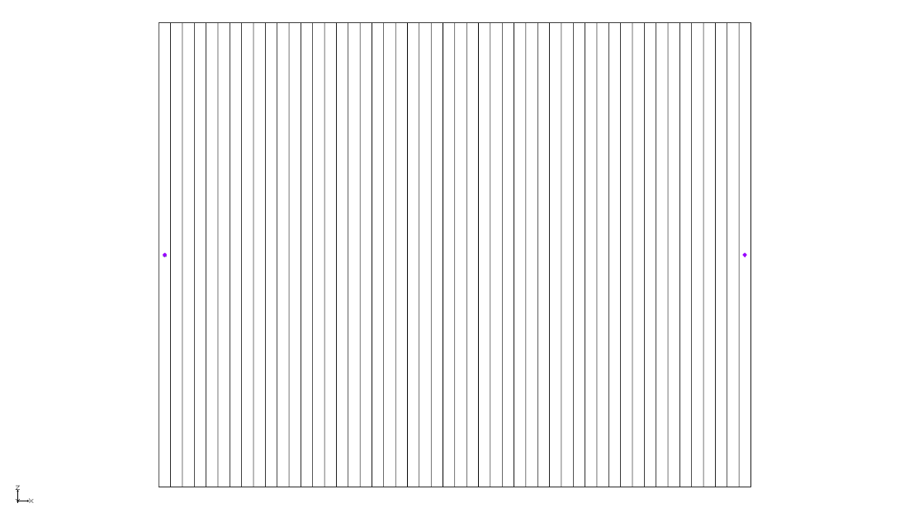

Figure Imported MODFLOW-USG Transport model

The Graphics Window should appear as shown in Figure 1. This model uses a single-layer UGrid with 50 elements arranged in a 1D grid. Each element measures 0.0214 meters in the flow direction (x-direction), 0.03 meters perpendicular to the flow (y-direction), and 0.84 meters vertically (z-direction).

Specified heads (CHD) are applied at both ends; the leftmost element is held at a constant head of 1.3281 meters, while the rightmost element is set to 1 meter. The horizontal hydraulic conductivity is 100 m/year, producing a Darcy velocity of 31.29 m/year.

Fluorescein (Species 1) is introduced at the upstream end via a transient concentration boundary (PCB package), at 400 mg/L for 0.06023 years (22 days), then reduced to 0 for the following 0.2738 years (100 days).

Before continuing, save the project with a new name.

1. Select *File* | **Save As…** to bring up the *Save As* dialog.
2. Browse to the directory for this tutorial.
3. Enter “model-mdt2.gpr” as the *File name*.
4. Select “Project Files (*.gpr)” from the *Save as type* drop-down.
5. Click **Save** to save the project file and close the *Save As* dialog.

# Activating the MDT Package

The MDT package can now be activated and added to the MODFLOW simulation. To activate the MDT package:

1. Switch to the **UGrid** File:UGrid Icon Unlocked.svg module.
2. Select *MODFLOW |* **Global Options…** to bring up the *MODFLOW Global/Basic Package* dialog.
3. Click **Packages…** to bring up the *MODFLOW Packages / Processes* dialog.
4. In the *Optional packages / processes* section, turn on *MDT – Matrix Diffusion Transport*.
5. Click **OK** to exit the *MODFLOW Packages / Processes* dialog.
6. Click **OK** to exit the *MODFLOW Global/Basic Package* dialog.

# Defining the MDT Package

With the MDT package activated, the parameters for the MDT package can now be defined.

1. Select *MODFLOW | Optional Packages* | **MDT – Matrix Diffusion Transport…** to bring up the *MDT Package* dialog.
2. From the list on the left, select *Variables*.

Review the options here. For this example, the default settings will be used.

1. From the list on the left, select *Aquifer Properties*.
2. Enter the following into the *Constant value* column:
   1. *MDFLAG*: “2.0”. This variable is a flag that directs the MDT package on how to handle matrix diffusion. Setting it to 2 enables diffusion into embedded low-permeability zones with defined diffusion lengths.
   2. *VOLFRACMD*: “0.711”. This represents the volume fraction of sand in the laboratory tank, calculated by subtracting the clay volume from the total tank volume and dividing by the total volume3.
   3. *PORMD*: “0.6”. This represents the porosity of the clay.
   4. *RHOBMD*: “1.6”. This represents the dry bulk density of the clay.
   5. *DIFFLENMD*: “0.04052”. The characteristic diffusion length in the clay lenses was estimated using the surface area (*Amd*) of 0.193 m2. Given the total tank volume (*V*) of 0.027 m3 and the sand volume fraction (*Vf*) of 0.711, the diffusion length (*L*) is calculated from the clay volume balance3: .
   6. *TORTMD*: “0.3”. This represents the tortuosity of the clay.
3. From the list on the left, select *Species Properties*.
4. Enter the following into the *Constant value* column:
   1. *KDMD*: “0.0”. Kd value for fluorescein in the clay; set to zero for R=1.
   2. *DIFFMD*: “0.0173”. The fluorescein diffusion coefficient, m2/yr.
5. Click **OK** to close the *MDT Package* dialog.

# Saving and Running MODFLOW

The changes should be saved before running MODFLOW-USG Transport.

1. Click **Save** File:Save Macro.svg to save the project.
2. Click the **Run MODFLOW** File:Run MODFLOW Macro.svg macro in the toolbar to bring up the *MODFLOW* model wrapper dialog.
3. When MODFLOW finishes, check on the *Read solution on exit* and *Turn on contours (if not on already)* boxes.
4. Click **Close** to close the *MODFLOW* model wrapper dialog.
5. Click **Save** File:Save Macro.svg to save the project with the new solution.

The solution set should appear in the Project Explorer.

# Examining the Results

To better observe the impact of the MDT package on the simulation, compare the results by creating a time series plot using the *Plot Wizard* tool.

1. In the Project Explorer, select the “File:Dataset Cells Active.svg Species1” dataset to make it active.
2. Using the **Select Cells** Select Cells tool, select cell 50 (the last cell on the right).
3. Click the **Plot Wizard** File:Plot Wizard Macro.svg macro to open the *Plot Wizard* dialog.
4. Under *Plot Type*, select the “Active Dataset Time Series” option.
5. Click **Finish** to close the *Plot Wizard* dialog and generate the plot.
6. Using the **Select Cells** File:Select UGrid Cell Tool.svg tool, select the last cell on the right in the Graphics Window.

The *Active Dataset Time Series* plot should appear similar to Figure 2.

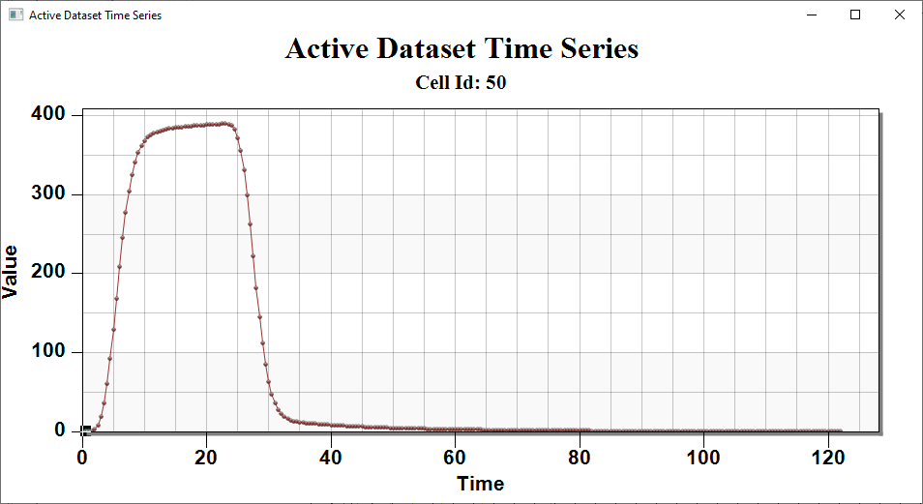

Figure The Active Dataset Time Series for the last cell

1. Right-click in the plot and select **Display Options…** to open the *Active Dataset Time Series Customization…* dialog*.*
2. Select the *Axis* tab.
3. Under the *Y Axis* section, select the *Log* option.
4. Under the *X Axis* section, select *Min/Max* and set *Min* to “0.01” and *Max* to “130”.
5. Click **OK** to exit the *Active Dataset Time Series Customization* dialog.

The *Active Dataset Time Series* plot should update to appear similar to Figure 3. The extensive tailing of fluorescein that occurs after about 35 days is due to matrix diffusion.

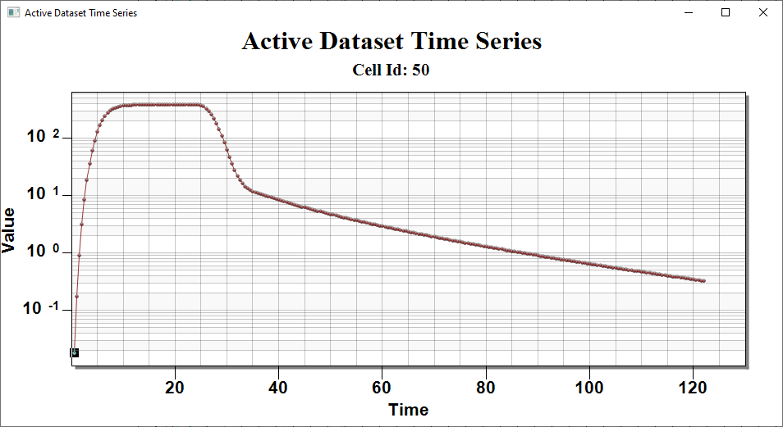

Figure The Active Dataset Time Series with applied log scale

Figure 4 compares results from the MDT Package in MODFLOW-USG Transport4 with both the experimental data and the REMChlor-MD solution. The MDT results are identical to the REMChlor-MD solution and approximate the laboratory observations. For reference, results from Chapman6 et al. (2012), who used a fine-grid MODFLOW/MT3DMS model with 8,988 cells to explicitly discretize the clay lenses, are shown as the yellow line.

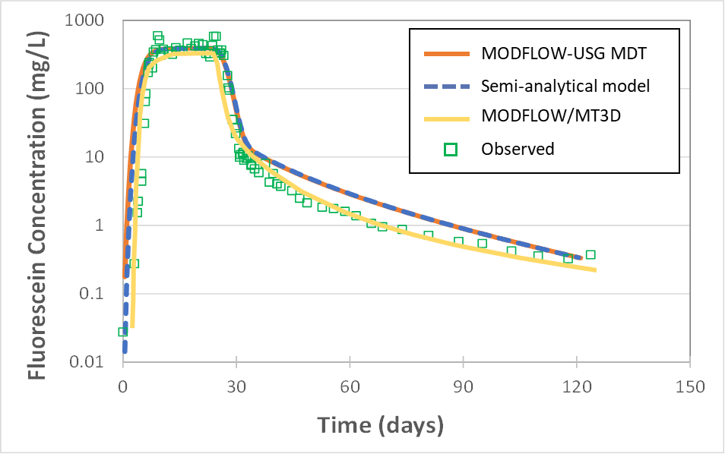

Figure Comparison of MODFLOW-USG MDT model (50 model cells) output with Chapman et al. (2012) MODFLOW/MT3DMS model (8,988 model cells), REMChlor-MD (semi-analytic) model (50 model cells), and observed concentrations

# Conclusion

This concludes the tutorial. Here are the key concepts from this tutorial:

The MODFLOW-USG Transport MDT package simulates matrix diffusion in heterogeneous porous media, capturing diffusion at the sub-grid scale

Standard grid elements are used, with matrix diffusion embedded over a finite distance within each element

1. Farhat, S. K., Newell, C. J., Falta, R. W., & Lynch, K. (2018). *REMChlor-MD user’s manual*. Clemson University and GSI Environmental Inc. <https://www.serdp-estcp.org/Program-Areas/Environmental-Restoration/Contaminated-Groundwater/Persistent-Contamination/ER-201426>
2. Falta, R. W., & Wang, W. (2017). A semi-analytical method for simulating matrix diffusion in numerical transport models. *Journal of Contaminant Hydrology, 197*, 39–49. <https://doi.org/10.1016/j.jconhyd.2016.12.002>
3. Muskus, N., & Falta, R. W. (2018). Semi-analytical method for matrix diffusion in heterogeneous and fractured systems with parent-daughter reactions. *Journal of Contaminant Hydrology, 218*, 94–109. <https://doi.org/10.1016/j.jconhyd.2018.10.002>
4. Doner, L. A. (2008). Tools to resolve water quality benefits of upgradient contaminant flux reduction (Master’s thesis). Colorado State University, Fort Collins, CO.
5. Chapman, S. W., Parker, B. L., Sale, T. C., & Doner, L. A. (2012). Testing high resolution numerical models for analysis of contaminant storage and release from low permeability zones. *Journal of Contaminant Hydrology, 136–137*, 106–116. <https://doi.org/10.1016/j.jconhyd.2012.03.002>