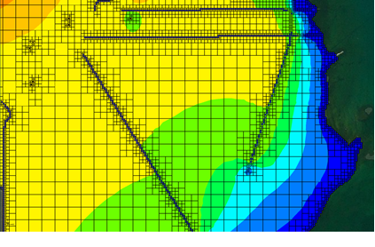

GMS 10.9

GMS 10.9 Tutorial

***MODFLOW-USG – Quadtree***

Create a MODFLOW-USG model with a locally refined UGrid using GMS

Objectives

GMS supports building MODFLOW-USG models with quadtree UGrids. This tutorial shows how to generate a smoothed quadtree UGrid for a complex model.

Time

* 25–40 minutes

Required Components

* GMS Core
* MODFLOW Interface

Prerequisite Tutorials

* MODFLOW – Conceptual Model Approach I
* UGrid Creation

|  |
| --- |
| [1 Introduction 2](#_Toc109831011)  [2 Getting Started 3](#_Toc109831012)  [2.1 Open the Starting Project 3](#_Toc109831013)  [2.2 Save with a Different Name 4](#_Toc109831014)  [3 Create the Conceptual Model 4](#_Toc109831015)  [3.1 Create the Areal Coverage 4](#_Toc109831016)  [3.2 Setup the Sources and Sinks Coverage 5](#_Toc109831017)  [3.3 Assign Specified Head 5](#_Toc109831018)  [3.4 Assign Rivers 6](#_Toc109831019)  [3.5 Assign Wells 7](#_Toc109831020)  [3.6 Refinement for Grid Generation 7](#_Toc109831021)  [4 Create the Unstructured Grid 8](#_Toc109831022)  [5 Create a MODFLOW-USG Model 10](#_Toc109831023)  [6 Set Grid Elevations 10](#_Toc109831024)  [7 Map to MODFLOW 11](#_Toc109831025)  [8 Save and Run MODFLOW 12](#_Toc109831026)  [9 Conclusion 13](#_Toc109831027) |

# Introduction

MODFLOW-USG was developed to allow for a wide variety of grid geometries, including the ability for increased grid resolution around rivers, wells, and other areas of interest.[[1]](#footnote-1) One such type of unstructured grid (UGrid) is a smoothed quadtree UGrid. In a smoothed quadtree UGrid, the largest sized cell is refined near areas of interest by splitting each successive neighboring cell into four cells until the desired cell size is reached.

GMS has the ability to easily generate smoothed quadtree UGrids from a conceptual model. Areas of interest can be identified on specific conceptual model objects including points, arcs, and polygons.

The problem in this tutorial is illustrated in Figure 1. The model is based on the quadtree example problem included with MODFLOW-USG.[[2]](#footnote-2) The model consists of a specified head boundary along the ocean to the right of the model. It also includes a network of canals modeled using the RIV package and wells modeled using the WEL package.

The locations of the boundary conditions are provided by shapefiles and the elevations by raster files. The generated grid is one layer thick and contains base cells (the largest cells) that are 800 m by 800 m. At specified head and river boundary conditions, the cells are refined down to 100 m; and at wells, the cells are refined down to 50 m.

This tutorial will demonstrate and discuss:

* Importing an existing GMS project containing model shapefiles.
* Creating a conceptual model using the shapefile geometry.
* Turning on refinement for grid generation.
* Creating a quadtree UGrid.
* Creating a MODFLOW-USG model.
* Mapping to MODFLOW.
* Running the model and examining the results.

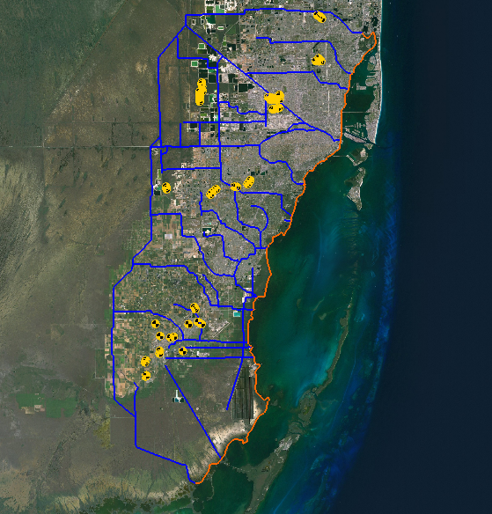

Figure The Biscayne Bay area of Miami, Florida

# Getting Started

Do the following to get started:

1. If necessary, launch GMS.
2. If GMS is already running, select *File |* **New** to ensure that the program settings are restored to their default state.

## Open the Starting Project

To open a GMS project that already has the shapefiles which contain the model geometry:

1. Click **Open** File:Open Macro.svg to bring up the *Open* dialog.
2. Select “Project Files (\*.gpr)” from the *Files of type* drop-down.
3. Browse to the *Quadtree\Quadtree\* directory and select “start.gpr”.
4. Click **Open** to import the project and exit the *Open* dialog.

## Save with a Different Name

Before making any changes, it is best to save the project under a new name.

1. Select *File |* **Save As…** to bring up the *Save As* dialog.
2. Select “Project Files (\*.gpr)” from the *Save as type* drop-down.
3. Enter “biscayne.gpr” as the *File name*.
4. Click **Save** to save the project under the new name and close the *Save As* dialog.

**Save** File:Save Macro.svg periodically throughout the project.

# Create the Conceptual Model

To create a conceptual model:

1. Right-click in a blank space in the Project Explorer and select *New |* **Conceptual Model…** to open the *Conceptual Model Properties* dialog.
2. Enter “Biscayne” as the *Name*.
3. Click **OK** to close the *Conceptual Model Properties* dialog.

## Create the Areal Coverage

To create a coverage with horizontal conductivity and recharge areal properties:

1. Right-click on “File:Conceptual Model Icon.svg Biscayne” in the Project Explorer and select **New Coverage…** to open the *Coverage Setup* dialog.
2. Enter “Areal” as the *Coverage name*.
3. In the *Areal Properties\** column, turn on *Recharge rate* and *Horizontal K*.
4. Turn on *Use to define model boundary (active area)*.
5. Click **OK** to create the coverage and close the *Coverage Setup* dialog.

Next, to convert the shape files to feature objects and build polygons:

1. Under “File:GIS Folder.svg GIS Layers” in the Project Explorer, turn on “File:GIS Stream Data Shapefile.svg Biscayne.shp”.
2. Right-click on “File:GIS Stream Data Shapefile.svg Biscayne.shp” and select *Convert To |* **Feature Objects** to open the *GIS to Feature Objects Wizard* dialog.
3. Click **Next >** to go to the *Step 2 of 3* page of the *GIS to Feature Objects Wizard* dialog.
4. Click **Next >** to go to the *Step 3 of 3* page of the *GIS to Feature Objects Wizard* dialog.
5. Click **Finish** to create the feature objects and close the *GIS to Feature Objects Wizard* dialog.
6. Select “File:Coverage Active Icon.svg Areal” in the Project Explorer to make it active.
7. Click the **Build Polygons** File:Build Polygons Macro.svg macro.
8. Right-click on “File:Coverage Active Icon.svg Areal” and select **Attribute Table…** to open the *Attribute Table* dialog.
9. From the *Feature type* drop-down, select “Polygons”.
10. In the *All* row in the *Recharge rate (m/d)* column, enter “1.0e-4”.
11. In the *All* row in the *Horizontal K (m/d)* column, enter “400.0”.
12. Click **OK** to save the values and close the *Attribute Table* dialog.

## Setup the Sources and Sinks Coverage

To create a coverage containing the specified head, river, and well boundary conditions:

1. Right-click on “File:Conceptual Model Icon.svg Biscayne” in the Project Explorer and select **New Coverage…** to bring up the *Coverage Setup* dialog.
2. Enter “Sources-Sinks” as the *Coverage name*.
3. In the *Sources/Sinks/BCs* column, turn on *Wells*, *Specified Head (IBOUND)*, and *River*.
4. Click **OK** to create the coverage and close the *Coverage Setup* dialog.

Now it is possible to copy the specified head, river, and well geometry from the shapefile to the coverage.

1. Turn on “File:GIS Scatter Point Shapefile.svg Wells.shp” in the Project Explorer.
2. Right-click on “File:GIS Scatter Point Shapefile.svg Wells.shp” and select *Convert To |* **Feature Objects** to bring up the *GIS to Feature Objects Wizard* dialog.
3. Make certain both “Biscayne.shp” and “Wells.shp” are selected under *Select shapefiles to map*.
4. Click **Next >** to go to the *Step 2 of 4* page of the *GIS to Feature Objects Wizard* dialog.
5. Click **Next >** to go to the *Step 3 of 4* page of the *GIS to Feature Objects Wizard* dialog.
6. Click **Next >** to go to the *Step 4 of 4* page of the *GIS to Feature Objects Wizard* dialog.
7. Click **Finish** to create the feature objects and close the *GIS to Feature Objects Wizard* dialog.
8. Turn off “File:GIS Stream Data Shapefile.svg Biscayne.shp” and “File:GIS Scatter Point Shapefile.svg Wells.shp” in the Project Explorer.

## Assign Specified Head

Now it is necessary to set the arc types by setting up the specified head arcs.

1. Select “File:Coverage Active Icon.svg Sources-Sinks” in the Project Explorer to make it active.
2. Using the **Select Arcs** File:GMS Select Arc Tool.svg tool, select the 14 arcs along the coastline by holding down the *Shift* key and clicking on each arc. **Zoom** File:Zoom Tool Icon.svg in if necessary.
3. Right-click on one of the selected arcs and choose **Attribute Table…**to open the *Attribute Table* dialog.
4. Select “spec. head (IBOUND)” from the drop-down in the *All* row of the *Type* column. This changes the arcs to specified head.
5. Click **OK** to save the values and close the *Attribute Table* dialog.
6. Do not unselect the arcs.

The map should now look similar to Figure 2 (note that the arcs are all still selected). If necessary, select any missed arcs and assign the boundary condition by following the steps above. Once done, reselect all of the coastline arcs by following step 2 above.

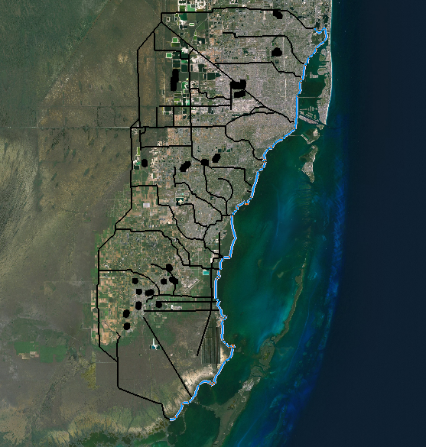

Figure Specified head boundary condition applied to arcs on coastline

## Assign Rivers

To set up the river arcs:

1. With the coastal arcs still selected, select *Edit |* **Invert Selection**.
2. Right-click on “File:Coverage Active Icon.svg Sources-Sinks” and select **Attribute Table…** to bring up the *Attribute Table* dialog.
3. In the *All* row, select “river” from the drop-down in the *Type* column.
4. In the *All* row, enter “5000.0” in the *Cond. (m^2/d)/(m)* column.
5. Select “Nodes” from the *Feature type* drop-down.
6. Select “river” from the *BC type* drop-down.

To set the river stage and bottom elevation, the rasters that were included in the starting project will be used.

1. In the *All* row, click on the http://www.xmswiki.com/w/images/e/e4/Small_drop-down_arrow_button_from_Parameters_dialog.png button in the *Head-Stage (m)* column and select “<Raster>” from the drop-down to bring up the *Select Raster* dialog.
2. Select “RiverStage.tif” and click **OK** to close the *Select Raster* dialog.
3. In the *All* row, click on the http://www.xmswiki.com/w/images/e/e4/Small_drop-down_arrow_button_from_Parameters_dialog.png button in the *Bot. elev. (m)* column and select “<Raster>” from the drop-down to bring up the *Select Raster* dialog.
4. Select “RiverBottoms.tif” and click **OK** to close the *Select Raster* dialog.
5. Click **OK** to close the *Attribute Table* dialog.
6. Do not unselect the arcs.

## Assign Wells

To assign the wells:

1. Right-click on “File:Coverage Active Icon.svg Sources-Sinks” and select **Attribute Table…** to bring up the *Attribute Table* dialog.
2. Select “Points” from the *Feature type* drop-down.
3. In the *All* row, select “well” from the drop-down in the *Type* column.
4. In the *All* row, enter “-700.0” in the *Flow rate (m^3/d)* column.
5. Click **OK** to save the values and close the *Attribute Table* dialog.
6. Deselect the arcs by clicking in a blank area in the Graphics Window.

The map should now appear similar to Figure 3.



Figure Biscayne area conceptual model

## Refinement for Grid Generation

To generate the quadtree grid, it is necessary to turn on refinement for the areas of interest. For this model, this involves turning on refinement for the specified head, river boundary conditions, and wells.

1. Right-click on “File:Coverage Active Icon.svg Sources-Sinks” and select **Coverage Setup…** to open the *Coverage Setup* dialog.
2. In the *Sources/Sinks/BCs* column, turn on *Refinement*.
3. Click **OK** to close the *Coverage Setup* dialog.

Now it is necessary to turn on refinement for each object, beginning with the wells.

1. Right-click on “File:Coverage Active Icon.svg Sources-Sinks” and select **Attribute Table…** to open the *Attribute Table* dialog.
2. Select “Points” from the *Feature type* drop-down.
3. In the *All* row, check the box in the *Refine* column.
4. In the *All* row, enter “60.0” in the *Base size (m)* column. Scroll over to the column if necessary.

When the grid is generated, the cells that contain the wells will be sized to the first cell size below “60.0”. To generate the grid, the cell size starts at the base cell size and then gets divided by two until the size is below “60.0”. The base cell is 800 m, so a *Base size* of 60 m will result in cell refined to 400 m, 200 m, 100 m, and then 50 m.

The next step is to set the refinement for the specified head and river arcs. For the river arcs, it is ideal for the cells to be refined to 100 m, so set the size slightly above 100 m.

1. Select “Arcs” from the *Feature type* drop-down.
2. In the *All* row, check the box in the *Refine* column.
3. In the *All* row, enter “110.0” in the *Base size (m)* column.
4. Click **OK** to close the *Attribute Table* dialog.

# Create the Unstructured Grid

Now it is necessary to set the dimensions of the unstructured grid by using a grid frame. The quadtree UGrid can be generated without a grid frame, but a grid frame gives more precise control over the size of the generated cells.

For this model, it is ideal to set the base grid cell size (or largest cell size) to 800 m. To do so, use a grid frame set with dimensions that are a multiple of 800 m.

1. Right-click in a blank space in the Project Explorer and select *New |* **Grid Frame**. A new grid frame should appear.
2. Right-click on “File:Grid Frame Icon.svgGrid Frame” in the Project Explorer and select **Fit to Active Coverage**.
3. Right-click on “File:Grid Frame Icon.svgGrid Frame” and select **Properties…**to open the *Grid Frame Properties* dialog.
4. In the *Value* column, enter the values from the table below:

|  |  |
| --- | --- |
| **Origin x:** | 543750.0 |
| **Origin y:** | 2793450.0 |
| **Origin z:** | 0.0 |
| **Dimension x:** | 44000.0 |
| **Dimension y:** | 79200.0 |
| **Dimension z:** | 10.0 |

1. Click **OK** to exit the *Grid Frame Properties* dialog.

The grid frame will adjust to the more specific dimensions just entered. This gives a base grid with 44 columns and 99 rows.

Now it is possible to create the quadtree UGrid. While a grid frame can be used to determine the dimensions of the grid cells, the polygons in the active coverage determine the boundary of the generated cells. If there are no polygons in the active coverage, the generated cells will fill the grid frame.

For the grid, use the polygons in the “Areal” coverage.

1. Select “File:Coverage Active Icon.svg Areal” in the Project Explorer to make it active.
2. Right-click on “File:Grid Frame Icon.svg Grid Frame” and select *Map To |* **UGrid** to open the *Map → UGrid* dialog.
3. From the *UGrid type* drop-down, select “Quadtree / Octree”.
4. From the *Arc/poly refinement* drop-down, select “Quadtree on assigned layers”.
5. In the *X-Dimension* section, select *Cell size* as the *Cell size method* and enter “800.0” as the *Cell size.*
6. In the *Y-Dimension* section, select *Cell size* as the *Cell size method* and enter “800.0” as the *Cell size*.
7. In the *Z-Dimension* section, enter “1” as the *Number of cells*.
8. The options in the *Map → UGrid* dialog should match those shown in Figure 4.

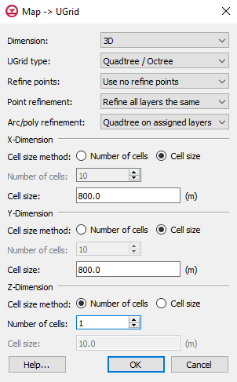

Figure Map → UGrid dialog

1. Click **OK** to exit the *Map → UGrid* dialog and generate the unstructured grid.
2. Right-click on “File:GIS Image Icon.svg Biscayne.tif” in the Project Explorer and select **Transparency…** to bring up the *Layer Transparency* dialog.
3. Set the *Transparency* slider to “30%” and click **OK** to close the *Layer Transparency* dialog. This makes the UGrid easier to see.

The new quadtree UGrid should appear similar to Figure 5.

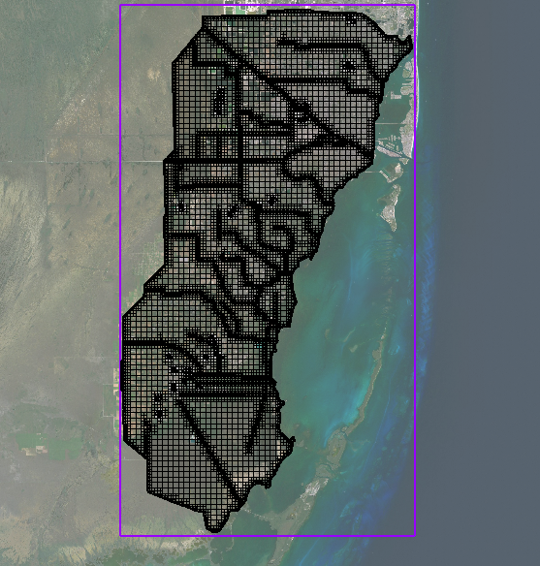

Figure Quadtree grid

It is now possible to check how many cells were generated.

1. Right-click on “Ugrid_lock ugrid” in the Project Explorer and select **Properties…** to open the *UGrid Properties* dialog.

The generated unstructured grid has around 28,000 cells. Generating a structured grid for the same model using a cell size of 100 m results in a grid with about 185,000 cells.

1. Click **OK** to exit the *UGrid Properties* dialog.

# Create a MODFLOW-USG Model

Now it is possible to create the MODFLOW-USG model.

1. Select *MODFLOW |* **New Simulation…** to bring up the *MODFLOW Global/Basic Package* dialog.
2. Click **OK** to accept the defaults and exit the *MODFLOW Global/Basic Package* dialog.

# Set Grid Elevations

The top and bottom elevations for the model need to be set up. This tutorial will interpolate raster elevations to MODFLOW layers.

1. Right-click on “File:GIS Image Icon.svg Tops.tif” in the “File:GIS Folder.svg GIS Layers” folder in the Project Explorer and select *Interpolate To |* **MODFLOW Layers…**to bring up the *Interpolate to MODFLOW Layers* dialog.

The “Tops.tif” dataset has automatically been mapped to “Top Elevations Layer 1” in the array in the *Dataset → MODFLOW data* section. Now map “Bottoms.tif” to “Bottom Elevation Layer 1”.

1. In the *Dataset → MODFLOW* *data* section, select “Tops.tif” under the *Dataset* column and select **Unmap**.
2. In the *Rasters* list, select “Bottoms.tif”.
3. In the *MODFLOW data* list, click on “Bottom Elevations Layer 1”.
4. Click **Map** to add the mapping to the array in the *Dataset → MODFLOW data* section.
5. Click **OK** to interpolate the top and bottom values to the MODFLOW model and close the *Interpolate to MODFLOW Layers* dialog.

# Map to MODFLOW

To assign the conceptual model values to the MODFLOW model:

1. Select “File:Conceptual Model Icon.svg Biscayne” in the Project Explorer to make it active.
2. Select *Feature Objects |* **Map → MODFLOW**to bring up the *Map → Model* dialog.
3. Click **OK** to accept the defaults and close the *Map → Model* dialog. It may take a moment for the model to load.

The boundary condition symbols for specified head, rivers, and wells should appear (Figure 6).

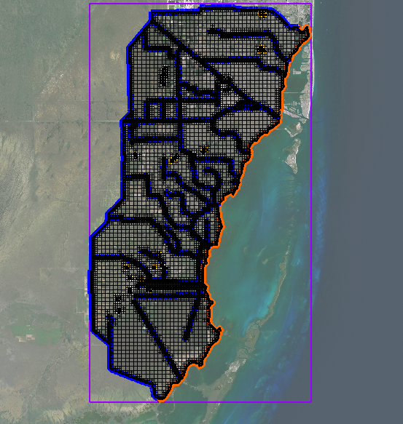

Figure MODFLOW boundary conditions assigned from the conceptual model

# Save and Run MODFLOW

Now it is possible to run MODFLOW.

1. **Save** File:Save Macro.svg the project.
2. Click the **Run MODFLOW** File:Run MODFLOW Macro.svg macro to bring up the *MODFLOW* model wrapper dialog.
3. When the model finishes, turn on *Read solution on exit* and *Turn on contours (if not on already)*.
4. Click **Close** to import the solution and exit the *MODFLOW* model wrapper dialog.

The Graphics Window should appear similar to Figure 7.

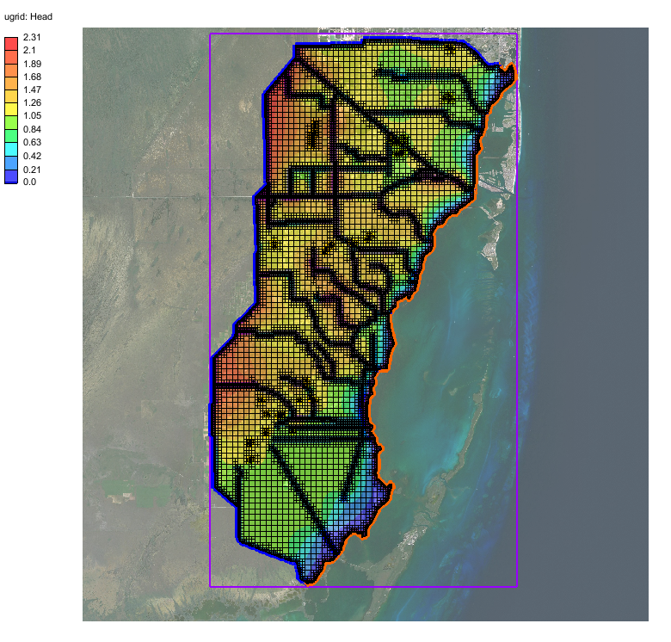

Figure MODFLOW-USG head contours

# Conclusion

This concludes the “MODFLOW-USG – Quadtree” tutorial. The following key concepts were discussed and demonstrated in this tutorial:

* GMS supports generating smoothed quadtree UGrids that can be used with MODFLOW-USG.
* The localized cell refinement for a generated grid can be controlled by turning on refinement and setting the base size in the conceptual model.
* Polygons in the active coverage determine the area in which cells are generated.
* A grid frame can be used to further control the size and position of the generated cells.

1. Panday, Sorab; Langevin, Christian D.; Niswonger, Richard G.; Ibaraki, Motomu; and Hughes, Joseph D., (2013). “MODFLOW–USG version 1: An Unstructured Grid Version of MODFLOW for Simulating Groundwater Flow and Tightly Coupled Processes Using a Control Volume Finite-Difference Formulation” in *Techniques and Methods 6–A45*, U.S. Geological Survey, 66 p. [↑](#footnote-ref-1)
2. Panday, et al (2013). [↑](#footnote-ref-2)