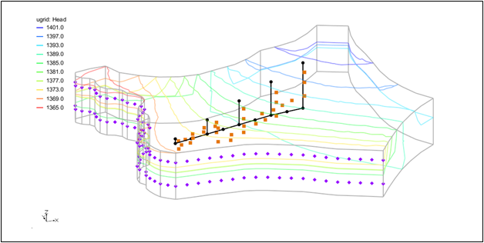

GMS 10.9

GMS 10.9 Tutorial

***MODFLOW-USG – Map Shapefile to CLN***

Map a Shapefile to the CLN package with MODFLOW-USG in GMS

Objectives

This tutorial shows how to map shapefile geometry and attributes to the CLN package in GMS.

Time

* 20–30 minutes

Required Components

* GMS Core
* MODFLOW Interface

Prerequisite Tutorials

* None

|  |
| --- |
| [1 Introduction 2](#_Toc110264025)  [1.1 Description of Problem 2](#_Toc110264026)  [1.2 Getting Started 3](#_Toc110264027)  [2 Opening a MODFLOW-USG Project 3](#_Toc110264028)  [3 Mapping to CLN 4](#_Toc110264029)  [4 Viewing the Mapped Data 5](#_Toc110264030)  [5 Saving and Running MODFLOW 6](#_Toc110264031)  [6 Viewing the Results 6](#_Toc110264032)  [7 Conclusion 8](#_Toc110264033) |

# Introduction

The Connected Linear Network (CLN) process was developed for MODFLOW-USG to have the ability to model complex one-dimensional connected features that are much smaller than a groundwater flow model’s cells.[[1]](#footnote-1) A three-dimensional arc shapefile can be used to store the geometry and attributes of such a linear network.

This tutorial demonstrates how to use a 3D arc shapefile to map geometry and attributes to the CLN process in GMS.

The following topics will be demonstrated in this tutorial:

Opening an existing MODFLOW-USG simulation.

Mapping a shapefile to the CLN process.

Running the simulation and examining the results.

## Description of Problem

The problem in this tutorial is shown in Figure 1. It consists of a three layer MODFLOW-USG model. The first and third layers contain specified head boundary conditions along one side of the model. The middle layer has a low hydraulic conductivity and acts as a confining layer. The model will be modified to include a network of mine tunnels consisting of five vertical shafts connected by a declining tunnel. When filled with groundwater, the network of tunnels will allow groundwater to travel between the model layers. The first mine shaft is toward the southwest side of the model. It descends 50 m from the surface to an elevation of 1350 m. From the first shaft, the descending tunnel connects to each successive shaft with the last shaft descending 500 m to an elevation of 900 m.

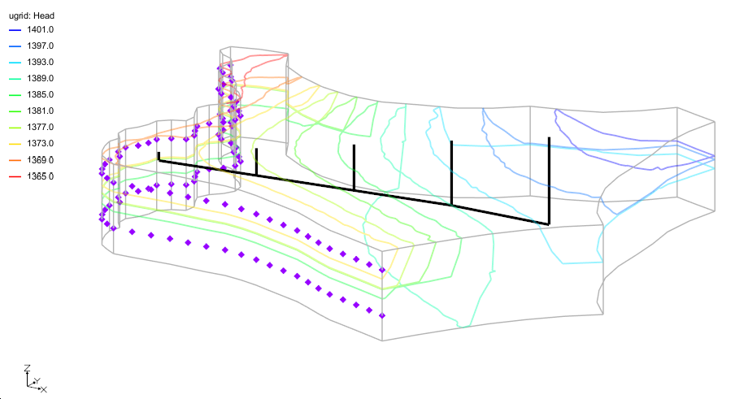

Figure Description of problem

## Getting Started

Do the following to get started:

1. If necessary, launch GMS.
2. If GMS is already running, select *File |* **New** to ensure that the program settings are restored to their default state.

# Opening a MODFLOW-USG Project

To open a project file that already contains the MODFLOW-USG simulation:

1. Click **Open** File:Open Macro.svg (or *File |* **Open…**) to bring up the *Open* dialog.
2. Browse to the *ShapefileToCLN\ShapefileToCLN\* directory and select “start.gpr”.
3. Click **Open** to import the file and close the *Open* dialog.

The Graphics Window should appear as shown in Figure 2. Before making any further changes, it is best to save the project with a new name.

1. Select *File* | **Save As…** to bring up the *Save As* dialog.
2. Browse to the *ShapefileToCLN\ShapefileToCLN\* directory.
3. Enter “ShapefileToCLN.gpr” as the *File name*.
4. Select “Project Files (\*.gpr)” from the *Save as type* drop-down.
5. Click **Save** to save the project file and close the *Save As* dialog.

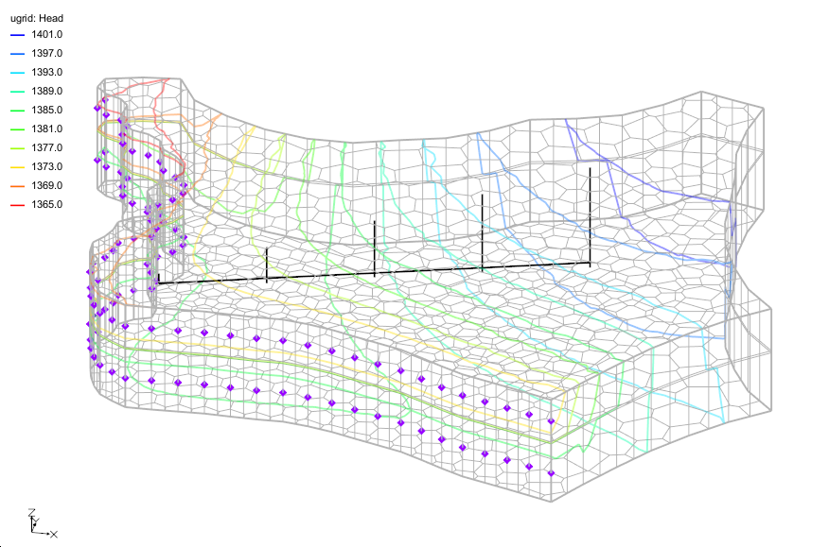

Figure Starting project

# Mapping to CLN

The shapefile containing the mine tunnel geometry is included in the project. To view the attributes included in the shape file:

1. Under “File:GIS Folder.svg GIS Layers” in the Project Explorer, right-click on the “File:GIS Stream Data Shapefile.svg mine.shp” file and select **Attribute Table...** to open the *Attributes* dialog.

Attributes have been specified for the conduit radius (FRAD) and the conductivity for flow inside the conduit (CONDUITK).

1. Click on **OK** to close the *Attributes* dialog.

To map the shapefile to the CLN process, the CLN process must first be enabled.

1. Select *MODFLOW* | **Global Options…** to bring up the *MODFLOW Global/Basic Package* dialog.
2. Click **Packages...** to open *MODFLOW Packages / Processes* dialog.
3. Turn on the *CLN – Connected Linear Network Process* option.
4. Click **OK** to exit the *MODFLOW Packages / Processes* dialog.
5. Click **OK** to exit the *MODFLOW Global/Basic Package* dialog.

Now to map the shapefile to the CLN process:

1. Select the *MODFLOW | Optional Packages |* **CLN – Connected Linear Network...** menu item to open the *CLN Process* dialog.
2. In the list on the left-hand side of the dialog, select the “Nodes” item.
3. Click on the **Map Shapefile to CLN...** button. The *Select UGrid* dialog should appear.
4. Highlight the “File:GIS Stream Data Shapefile.svg mine.shp” file.
5. Click **OK** to close the *Select UGrid* dialog and open the *Map Shapefile to CLN* dialog.

The settings items in this dialog are used when attributes are not specified as arc attributes by the shapefile. Since the “File:GIS Stream Data Shapefile.svg mine.shp” file has attributes for the FRAD and CONDUITK values, the settings for FRAD and CONDUITK in this dialog will be ignored.

Also included is a *Duplicate Point Tolerance* item. It is used to determine when to combine arc points that are within the given distance of each other into a single point to connect the arcs.

For this problem, adjust the leakance and turn on the setting to generate a UGrid of the CLN network.

1. For the *Skin leakance 1 (FSKIN)* item set the value to “5.0”.
2. For the *Maximum CLN node length (MAXNODELEN)* set the value to “1500”.
3. Set the *Generate CLN UGrid* value to “On”.
4. Click on **OK** to close the *Map Shapefile to CLN* dialog and finish mapping the shapefile values to the CLN process.

The segments of the shapefile arcs were split based on the MAXNODELEN setting and then intersected with the UGrid to generate the CLN data. The “Nodes” table in the *CLN Package* dialog should be filled with 13 new CLN nodes (or cells) for the mapped data.

In the table, the *IFNO* value is the CLN cell number, *FLENG* is the length of the cell, and *FELEV* is the elevation at the bottom of the cell. *STRT* is the starting head value which, by default, is set to the bottom elevation. Descriptions of the other values can be found in the MODFLOW-USG documentation.

# Viewing the Mapped Data

Now to view other data mapped from the shapefile:

1. In the list on the left-hand side of the *CLN Process* dialog, select the “Groundwater Connections” item.

The “Groundwater Connections” table contains the values for each CLN cell to groundwater cell connection. The table should contain rows for 44 connections. The *IFNO* value is the CLN cell number and the *IGWNOD* value is the groundwater cell number. The *FSKIN* value for each cell should be 5.0, which matches the value entered in the *Map Shapefile to CLN* dialog.

1. Select **OK** to close the *CLN Process* dialog.

In the Graphics Window, orange square point symbols should have been added to designate the groundwater cells that have groundwater to CLN connections as shown in Figure 3.

In the Project Explorer a new UGrid has appeared entitled “File:UGrid 3D Locked.svg CLN Cells”. This newly created UGrid has line segment cells matching the CLN cells. The cell numbers for this UGrid can be turned on to identify the location of the CLN cells.

1. Turn off the “File:GIS Stream Data Shapefile.svg mine.shp” file in the Project Explorer.
2. Select the “Ugrid_lock_3D CLN Cells” item in the Project Explorer.
3. Select *Display |* **Display Options...** to open the *Display Options* dialog.
4. Check the *Define UGrid specific options* box.
5. Turn on the *Cell numbers* option. If desired, increase the font size.
6. Select **OK** to close the *Display Options* dialog.

The CLN cells and cell numbers should now appear in the graphics view along with the orange symbols for CLN groundwater connections as shown in Figure 3.

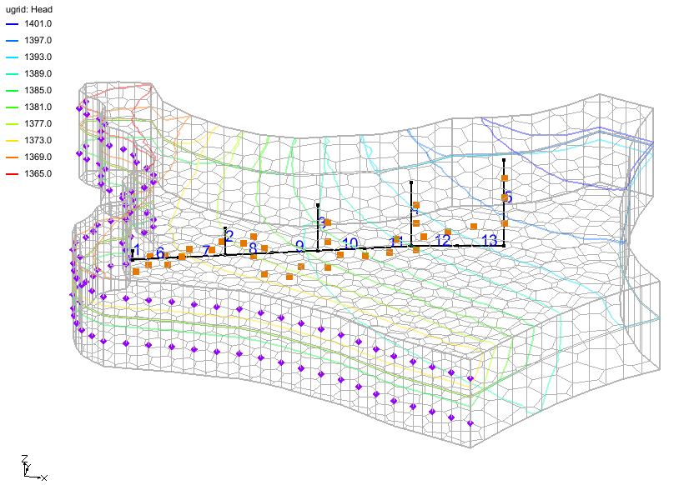

Figure Mapped CLN data

# Saving and Running MODFLOW

The changes should now be saved before running MODFLOW.

1. **Save** File:Save Macro.svg the project.
2. Click the **Run MODFLOW** File:Run MODFLOW Macro.svg macro in the toolbar.
3. When MODFLOW finishes, check on the *Read solution on exit* and *Turn on contours (if not on already)* boxes.
4. Click **Close** to close the *MODFLOW* model wrapper dialog.

# Viewing the Results

After running MODFLOW, there will be a slight change in the head contours. A new solution folder named “File:Generic Folder Locked.svg ShapefileToCLN (MODFLOW)” has been generated in the Project Explorer. Under the solution folder there should be two CCF files. The first CCF file, “File:CCF Dataset Active.svg CCF (ShapefileToCLN.ccf)”, contains the flow budget information for the groundwater process. The second CCF file, “File:CCF Dataset Active.svg CCF (ShapefileToCLN.cln\_cb)”, contains the flow budget information for the CLN process. First, look at the groundwater flow budget.

1. Right-click on the “File:CCF Dataset Active.svg CCF (ShapefileToCLN.ccf)” file and select the **Flow Budget...** menu item to open the *Flow Budget* dialog.

Notice that there is a flow budget item entitled *CLN*. This item gives the amount of flow between the groundwater grid and the CLN grid. There should be a total flow in of approximately 112,077.0 and total flow out of approximately -112,077.0, signifying the amount of groundwater that was transferred through the CLN network. .

1. Select **OK** to close the *Flow Budget* dialog.

To get a better feel for the water transfer between the layers, set up flow budget zones for each layer and then view the zone budget.

1. Double-click on the “File:Dataset Cells Active.svg Zone Budget IDs” dataset item in the Project Explorer to bring up the *Zone Budget IDs* dialog.
2. Change the *Layer* to layer “2”.
3. Click **Constant → Layer**to bring up the *Layer Value* dialog.
4. Enter “2” for the *Constant value for layer* field.
5. Select **OK** to close the *Layer Value* dialog.
6. Change the *Layer* to layer “3”.
7. Click **Constant → Layer**to bring up the *Layer Value* dialog.
8. Enter “3” for the *Constant value for layer* field.
9. Select **OK** to close the *Layer Value* dialog.
10. Select **OK** to close the *Zone Budget IDs* dialog.
11. Right-click on the “File:CCF Dataset Active.svg CCF (ShapefileToCLN.ccf)” file and select the **Flow Budget...** menu item to open the *Flow Budget* dialog.
12. At the top of the dialog, select the *Zones* tab.
13. Change the *Zone* popup menu to “All Zones”.

In the flow budget table, an overall balance should appear at the top followed by entries for zones corresponding to each layer. Notice that for layers 2 and 3 all of the *CLN* flow is leaving each layer, and for layer 1 the majority of the flow is entering the layer.

1. Select **OK** to close the *Flow Budget* dialog.

Now to view the CLN network flow budget:

1. Right-click on the “File:CCF Dataset Active.svg CCF (ShapefileToCLN.cln\_cb)” file and select the **Flow Budget...** menu item to open the *Flow Budget* dialog for the CLN network.

Notice that there is also a *GWF* item for the CLN network and the amount is close to the amount for the groundwater flow budget.

The flow budget for the CLN network can also be viewed for each CLN cell.

1. Select **OK** to close the *Flow Budget* dialog.
2. Right-click on the “File:CCF Dataset Active.svg CCF (ShapefileToCLN.cln\_cb)” file and select the **View Values...** menu item.

This dialog shows the flow budget values for each CLN cell. For the CLN cells touching groundwater cells in only the first layer (1, 2, 6, 7, and 8), the flow is leaving the CLN network, and for the cells that touch layer 3, the flow is entering the CLN network.

# Conclusion

This concludes the “MODFLOW-USG Shapefile to CLN” tutorial. Here are the key concepts from this tutorial:

GMS has the ability to map a 3D arc shapefile to the CLN process.

The shapefile can include CLN attributes that get mapped to the CLN process.

The CLN process flow budget can be viewed in GMS.

1. Panday, Sorab, Langevin, C.D., Niswonger, R.G., Ibaraki, Motomu, and Hughes, J.D. (2013). MODFLOW–USG version 1: An unstructured grid version of MODFLOW for simulating groundwater flow and tightly coupled processes using a control volume finite-difference formulation: U.S. Geological Survey Techniques and Methods. Book 6, chap. A45, 66 p., http://pubs.usgs.gov/tm/06/a45. [↑](#footnote-ref-1)