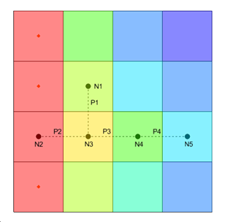

GMS 10.9

GMS 10.9 Tutorial

***MODFLOW – Unsupported Packages***

Running and editing unsupported packages in GMS

Objectives

This tutorial explains how to import and use unsupported MODFLOW packages in GMS.

Time

* 30–45 minutes

Required Components

* GMS Core
* MODFLOW Interface

Prerequisite Tutorials

* MODFLOW – Grid Approach

|  |
| --- |
| [1 Introduction 2](#_Toc110330395)  [2 Unsupported Package and Supported Executable 2](#_Toc110330396)  [2.1 Description of Problem 2](#_Toc110330397)  [2.2 Getting Started 4](#_Toc110330398)  [2.3 Importing the MODFLOW Model 4](#_Toc110330399)  [2.4 Viewing the Unsupported Packages 5](#_Toc110330400)  [2.5 Saving and Running MODFLOW 6](#_Toc110330401)  [2.6 Examining the Solution 7](#_Toc110330402)  [3 Unsupported Package and GMS Compatible Executable 8](#_Toc110330403)  [3.1 Importing the Project 9](#_Toc110330404)  [3.2 Importing the MODFLOW Model 10](#_Toc110330405)  [3.3 Viewing the Unsupported Packages 11](#_Toc110330406)  [3.4 Saving and Running MODFLOW CFP 11](#_Toc110330407)  [3.5 Reading the Solution 12](#_Toc110330408)  [3.6 Adding a Well 12](#_Toc110330409)  [3.7 Running MODFLOW CFP 14](#_Toc110330410)  [3.8 Reading the Solution 14](#_Toc110330411)  [4 Unsupported Package and Third-Party Executable 14](#_Toc110330412)  [4.1 Importing the MODFLOW Model 15](#_Toc110330413)  [4.2 Copying Unsupported Package Data 16](#_Toc110330414)  [4.3 Running MODFLOW FMP2 17](#_Toc110330415)  [4.4 Reading the Solution 18](#_Toc110330416)  [5 Conclusion 19](#_Toc110330417) |

# Introduction

GMS has the ability to use MODFLOW packages that are not yet supported directly through the user interface. It also has the ability to run MODFLOW through a text interface with a third-party (external) MODFLOW executable.

This tutorial discusses and demonstrates:

* Importing, running, and analyzing a MODFLOW 2005 simulation using an unsupported package.
* Importing, running, and analyzing a MODFLOW CFP simulation with unsupported packages using an executable with GMS H5 support.
* Adding a well to the MODFLOW CFP simulation and examining the change.
* Importing, running, and analyzing a MODFLOW FMP2 simulation with unsupported packages using a third-party executable.

# Unsupported Package and Supported Executable

This section demonstrates how to import and run a MODFLOW model which includes a package not supported in GMS. This is done using a MODFLOW executable available from the GMS interface.

## Description of Problem

This model (Figure 1) is a sample distributed with MODFLOW 2005.

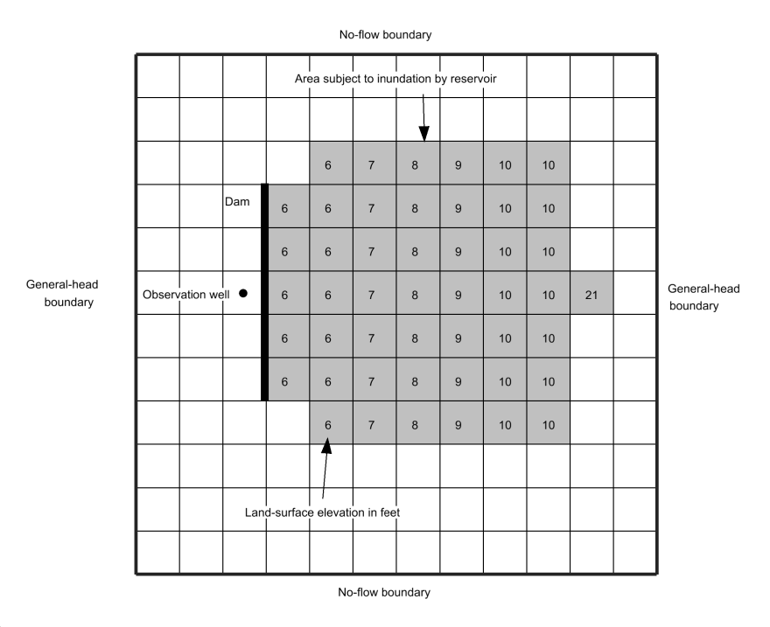

Figure 1 RES Package example problem

The test problem[[1]](#footnote-1) illustrates the use of RES1 and shows the comparison of results between RES1 and the River package. The test problem uses a model grid consisting of one layer, 12 rows, and 12 columns. Cell dimensions in the horizontal directions are 100 feet on each side. The shaded area in Figure 1 represents the area of potential inundation behind a dam and is defined by nonzero values in the IRES array.

For the example problem, the groundwater system is homogeneous and isotropic and has a transmissivity of 10,000 ft2/d and a storage coefficient (specific yield) of 0.20. The thickness of reservoir-bed sediments is two feet. The vertical hydraulic conductivity of the reservoir-bed sediments is 1 ft/d.

The combination of reservoir-bed hydraulic conductivity, thickness, and cell area results in a reservoir-bed hydraulic conductance of 5,000 ft2/d for each cell in the area subject to inundation by the reservoir. The land-surface elevation in the area subject to inundation increases along rows from a minimum of six feet in column 4 to a maximum of 10 feet in column 10.

An additional reservoir cell in column 11 with a land-surface elevation of 21 feet was included to allow RESl to compute design characteristics over the range from six to 21 feet. The cell has no effect on calculations of flow between the reservoir and the groundwater system because the maximum stage for the simulation is 14 feet.

Recharge from precipitation and evapotranspiration were assumed to be negligible for this problem. The General-Head Boundary (GHB) package was used to represent flow along the outside edges of columns 1 and 12 and flow was not allowed to cross the boundaries along the outside edges of rows 1 and 12.

Initial groundwater levels were set at zero throughout the modeled area. Initially, the impoundment area is specified to be dry and a flood results in the reservoir filling for seven days. The problem simulates transient flow for a total of nine days. Three stress periods were used to represent the flood with one-day time steps.

## Getting Started

Do the following to get started:

1. If necessary, launch GMS.
2. If GMS is already running, select *File |* **New** to ensure that the program settings are restored to their default state.

## Importing the MODFLOW Model

Import the model by doing the following:

1. Click **Open** File:Open Macro.svg to bring up the *Open* dialog.
2. Browse to the *unsupported\restest* folder*.*
3. Select “MODFLOW Name Files (\*.mfn;\*.nam)” from the *Files of type* drop-down.
4. Select “restest.nam” and click **Open** to close the *Open* dialog and bring up the *MODFLOW Translator* dialog.
5. Select *MODFLOW 2005* and click **OK** to initiate the translator.
6. Once MODFLOW 2005 has terminated successfully, click **Done** to close the *MODFLOW Translator* dialog.

This imports the model. In the Graphics Window, there should be a grid with symbols representing the specified head boundary conditions along the left and right columns of the grid as shown in Figure 2.



Figure 2 Imported RES Package example

1. Select *File* | **Save As…** to bring up the *Save As* dialog.
2. Select “Project Files (\*.gpr)” from the *Save as type* drop-down.
3. Enter “restest.gpr” as the *File name* and click **Save** to save the file and close the *Save As* dialog.

## Viewing the Unsupported Packages

Before running the simulation, view the list of files included in the simulation’s name file.

1. Select *MODFLOW |* **Name File…**to bring up the *MODFLOW Name File* dialog (Figure 3).

This dialog lists the files in the MODFLOW simulation’s name file, including unsupported packages that will be included when the simulation runs. Files that are listed as unsupported can be opened and edited from this dialog and can also be removed from the simulation. Toward the bottom of the list of name file items, the RES package is listed as unsupported.

The RES package sample problem as shipped with MODFLOW 2005 doesn’t have binary head and flow budget output turned on. In order to view the head and flow budget solution through the GMS interface, these need to be turned on.

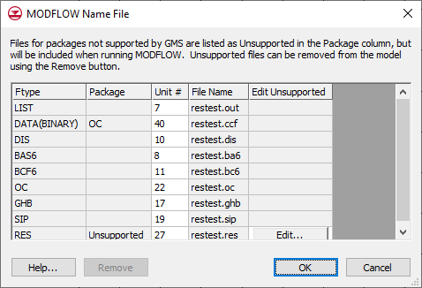

Figure 3 The MODFLOW Name File dialog

1. Click **OK** to exit the *MODFLOW Name File* dialog.
2. Select *MODFLOW |* **OC - Output Control…** to bring up the *MODFLOW Output Control* dialog.
3. In the *Output interval* section, select *Output at every time step* and turn on *Save heads to \*.hed file* and *Save cell by cell flow terms to \*.ccf file*. No other changes should be made.
4. Click **OK** to exit the *MODFLOW Output Control* dialog.

To view the RES package contribution to the flow budget, CCF file binary output must be turned on for the RES package text file. The text file can be opened and edited from the *MODFLOW Name File* dialog.

1. Select *MODFLOW |* **Name File…**to bring up the *MODFLOW Name File* dialog.

Notice that the unit number for the “restest.ccf” file (near the top of the list) is “40”. This number will be used later.

1. Scroll down to the “RES” line and click **Edit…** to bring up the *View Data File* dialog. If a text editor has already been designated and the “Never ask this again” box was checked in the dialog, the dialog will not appear and step 8 can be followed directly.
2. Select the desired text editor from the *Open with* drop-down and click **OK** to close the *View Data File* dialog and open the RES package file in the selected text editor.

In the text file, the second value on the first line needs to be changed to the CCF unit number. The RES package uses a fixed file format, with each integer taking 10 characters. When changing the value, make sure it stays within the 10 character boundary.

1. Change the space before the “0” value on the first line to “4” so the value is now “40” (red arrow in Figure 4). To avoid an error, ensure that the “4” took the place of the space before the “0”.
2. Select *File* | **Save** to save the change.
3. Return to GMS and click **OK** to exit the *MODFLOW* *Name File* dialog.

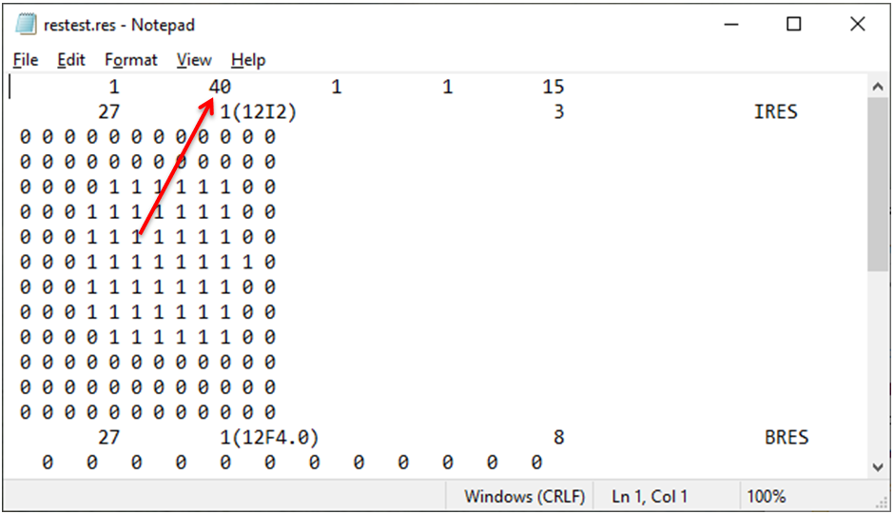

Figure 4 RES Package text file

## Saving and Running MODFLOW

Now save the simulation and run MODFLOW. When using unsupported packages from a version of MODFLOW supported by the GMS interface, MODFLOW can be run directly.

1. **Save** File:Save Macro.svg the project.
2. Click **Run MODFLOW** File:Run MODFLOW Macro.svg (or select *MODFLOW* | **Run MODFLOW**) to bring up the *MODFLOW* model wrapper dialog.
3. When MODFLOW finishes, turn on *Read solution on exit* and *Turn on contours (if not on already)*.
4. Click **Close** to import the solution and close the *MODFLOW* model wrapper dialog.
5. **Save** File:Save Macro.svg the project with the MODFLOW solution.

## Examining the Solution

The contours for the “Head” dataset should now appear (Figure 5). Now examine the solution.

1. Click on the “File:Dataset Cells Active.svg Head” dataset in the Project Explorer to make it active.
2. Use the *Time Steps* window to cycle through the different time steps of the solution to see how the head values change as the reservoir fills.

The head values across the grid begin to equalize as the reservoir fills over the simulation.

1. In the *Time Steps* window, select the first time step (“1.0”).
2. Select *MODFLOW* | **Flow Budget…** to bring up the *Flow Budget* dialog.

On the *Cells tab* in the *Flow In* column, the *TOTAL FLOW* is 345,000 ft3/d. This is the flow into the model due to reservoir leakage.

1. Click **OK** to exit the *Flow Budget* dialog.

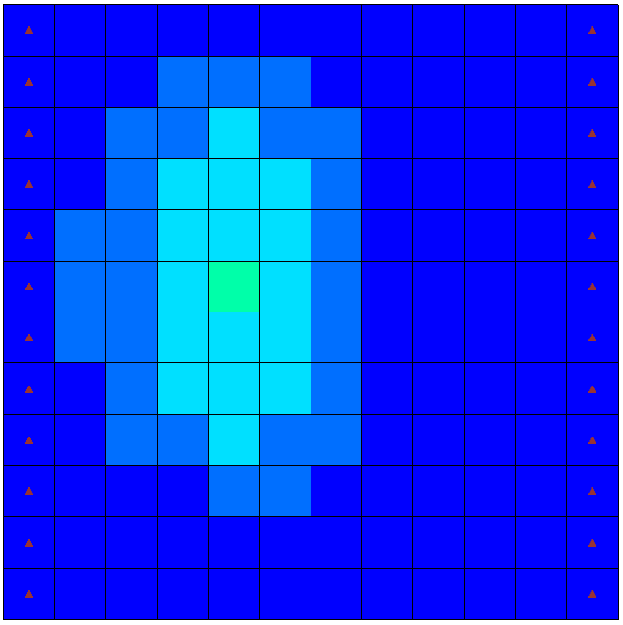

Figure 5 RES Package head contours

# Unsupported Package and GMS Compatible Executable

This section of the tutorial describes and demonstrates how to import and run a MODFLOW model that includes an unsupported package. It uses a MODFLOW executable compiled to work with the GMS H5 file format.[[2]](#footnote-2)

The model in Figure 6 is based on a sample model distributed with MODFLOW CFP, described as follows:

An example problem consisting of four model rows and columns, three model layers, and five stress periods is presented. Model cells are 10 meters in length and width and one meter thick. A constant-head boundary is assigned along column 1 for all three model layers, with a value equal to 20 meters above an arbitrary datum. No-flow boundaries exist around the outer edges of the model domain.

Each layer was assigned as a convertible layer in the LPF package, with constant horizontal and vertical hydraulic conductivity equal to 1,000 and 200 m/d, respectively. Specific yield and storage coefficient for each layer were assigned values of “0.2” and “0.00002”, respectively.

For the CFPM1 example problem, conduit pipes were activated, and five nodes and four pipes (10 meters in length) were designed with the geometry and connections presented in Figure 6. Mean pipe water temperature was assigned a value of 25°C. The elevations of the pipes were assigned as 4.5 meters above the datum, and SA\_EXCHANGE was set to “1” so the CFP would use the surface area of pipes in cells to compute the pipe conductance.

Solution controls for the pipe flow equations included a value of “0.000001” for convergence criterion (EPSILON), 100 maximum iterations (NITER), and the relaxation parameter (RELAX) equal to “1.0”. Each pipe diameter, tortuosity, and roughness heights were set to constant values of “0.1”, “1.0”, and “0.01” meters, respectively. The critical Reynolds numbers (NRe) for each pipe were assigned constant values equal to “10.0” for LCRITREY\_P and “20.0” for TCRITREY\_P.

These values may be lower than generally expected for straight, non-tortuous, and rough pipes. Nevertheless, they were chosen so that both laminar and turbulent pipe flow equations could be demonstrated using this example problem. A constant node head equal to 20.0 meters above the datum was assigned for node 2, and a solution was desired for the remaining node heads.

Conduit wall permeabilities were assigned values of 5.0 m/d. The transient model boundary is net recharge. Values of “0.003”, “0.001”, “0.002”, “0.003”, “0.002” m/d were assigned for net recharge to the uppermost active model layer for stress periods 1 through 5, respectively, using the RCH Package. The CRCH Package was employed, which routed all of the net recharge assigned to MODFLOW cell 3,3,1 (j,i,k) into conduit node 4.[[3]](#footnote-3)

For this tutorial, the model was changed to have a horizontal hydraulic conductivity of 10 m/d.



Figure 6 Conduit Flow Process Mode 1 (CFPM1) example problem

## Importing the Project

Begin with opening a project showing the location of conduit network:

1. Select *File |* **New** to restore program settings to their default state. If prompted to save changes to the project, select **Don’t Save**.
2. Click **Open** File:Open Macro.svg to bring up the *Open* dialog.
3. Select “Project Files (\*.gpr)” from the *Files of type* drop-down.
4. Browse to the *unsupported* directory and select “start.gpr”.
5. Click **Open** to import the project and close the *Open* dialog.

The project should show a diagram of the conduit network (Figure 7).

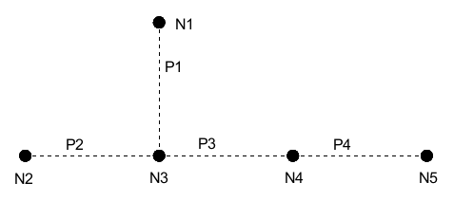

Figure 7 Starting CFP project with conduit network

## Importing the MODFLOW Model

The next step is to import the MODFLOW CFP model. The sample problem contains three packages that are currently not supported by GMS: the CFP, CRCH, and COC packages, which are only available in MODFLOW CFP. Use the MODFLOW-2005 importer to import the model, as MODFLOW CFP is based on MODFLOW-2005 and supports all the other packages used by the model.

1. Click **Open** File:Open Macro.svg to bring up the *Open* dialog.
2. Select “MODFLOW Name Files (\*.mfn;\*.nam)” from the *File of type* drop-down.
3. Browse to the *unsupported\CFPM1* folder and select “CFPM1.nam”.
4. Click **Open** to close the *Open* dialog and bring up the *MODFLOW Translator* dialog.
5. Select *MODFLOW 2005* and click **OK** to initiate the translator.
6. Once MODFLOW 2005 has terminated successfully, click **Done** to finish importing the file and close the *MODFLOW Translator* dialog.

A grid should appear with symbols representing the specified head boundary conditions on the left (Figure 8).

1. Select *File* | **Save As…** to bring up the *Save As* dialog.
2. Select “Project Files (\*.gpr)” from the *Save as type* drop-down.
3. Enter “CFPM1.gpr” for the *File name* and click **Save** to create the new project file and close the *Save As* dialog.

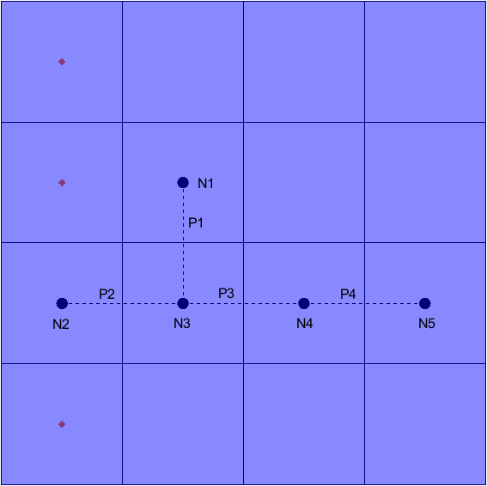

Figure 8 Specified head boundary conditions on the left

## Viewing the Unsupported Packages

Before running the simulation, view the unsupported packages.

1. Select *MODFLOW |* **Name File…**to bring up the *MODFLOW Name File* dialog.

This dialog lists the files included in the simulation’s name file. Toward the bottom of the list of name file items, the CFP, COC, and CRCH packages should be listed.

1. Click **OK** to exit the *MODFLOW Name File* dialog.

## Saving and Running MODFLOW CFP

Now the project is ready to run MODFLOW CFP. When using unsupported packages from a version of MODFLOW supported by the GMS interface, MODFLOW can be run directly. Because this project uses MODFLOW CFP, which isn’t supported by the GMS interface, it is necessary to first change the simulation to use the *Run MODFLOW* dialog in order to use a different executable.

1. Select *MODFLOW* | **Global Options…** to bring up the *MODFLOW Global/Basic Package* dialog.
2. In the *MODFLOW version* section, turn on *Use custom Run dialog*.
3. Click **OK** to exit the *MODFLOW Global/Basic Package* dialog.
4. **Save** File:Save Macro.svg the project.
5. Click **Run MODFLOW** File:Run MODFLOW Macro.svg (or select *MODFLOW* | **Run MODFLOW**) to bring up the *Run MODFLOW* dialog.

This dialog allows custom options to be entered for running MODFLOW, including a different name file, MODFLOW executable, and added command line options. The *Command line* section at the bottom of the dialog shows the command line that will run MODFLOW. To run MODFLOW CFP, it is necessary to change to a different executable. GMS includes a MODFLOW CFP executable compatible with the GMS MODFLOW H5 file format used by this tutorial.

1. In the *MODFLOW version* section, select *2005*.

Note the path to the MODFLOW 2005 executable in the *Command line* section of the dialog. To change to the MODFLOW CFP executable, do the following:

1. In the *MODFLOW version* section, select *Custom* and click the **Browse** File:Open Macro.svg button to the right to bring up the *Open* dialog*.*
2. Browse to the *\models\mf-cfp\* directory under the GMS folder for the installation of GMS. In a typical installation of the 64-bit version, this will be *C:\Program Files\GMS 10.9 64-bit\models\mf-cfp\*.
3. Select “MODFLOW executable (\*.exe)” from the *Files of type* drop-down.
4. Select “mf2k5cfp\_h5.exe”and click on **Open** to close the *Open* dialog.
5. Click **OK** to close the *Run MODFLOW* dialog and open a DOS command prompt window which will run MODFLOW.
6. When MODFLOW 2005 terminates successfully, press any key to continue. This closes the DOS command prompt window and returns to GMS.

## Reading the Solution

When using the *Run MODFLOW* dialog, it is necessary to manually import the MODFLOW solution.

1. Select *MODFLOW* | **Read Solution…** to bring up the *Open* dialog.
2. Select “MODFLOW Name File (\*.mfn)” from the drop-down to the right of the *File name* field.
3. Browse to the *unsupported\CFPM1\CFPM1\_MODFLOW* directory and select “CFPM1.mfn”.
4. Click **Open** to read the solution.
5. **Save** File:Save Macro.svg the project with the new solution.

The solution should change the contours to show the solution head values (Figure 9).

1. Click on the “File:Dataset Cells Active.svg Head” dataset in the Project Explorer and change between time steps to further examine the head values.
2. The solution can also be further reviewed by right-clicking on the “CFPM1.out” file in the Project Explorer and selecting **View File**.
3. When done, return to GMS.
4. Select “File:Dataset Cells Active.svg Head” to make it active and select the “100.0” time step.

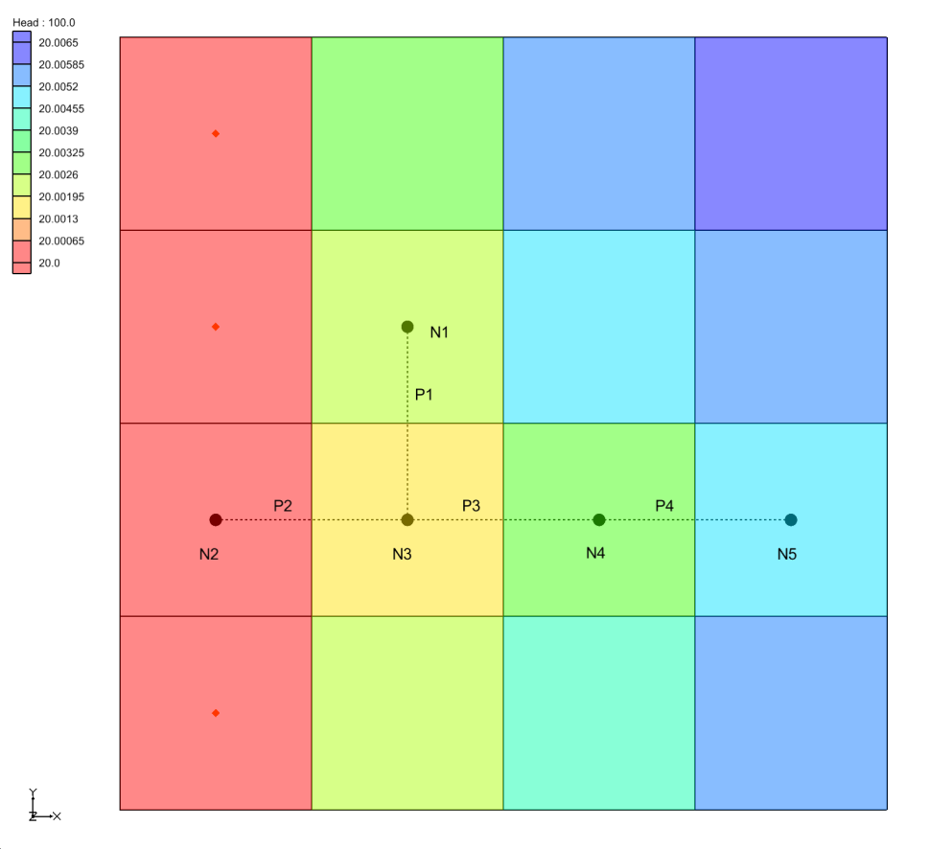

Figure 9 CFPM1 contours

## Adding a Well

Now add a well to the simulation to see how it affects the results:

1. Select *File |* **Save As…** to bring up the *Save As* dialog.
2. Select “Project Files (\*.gpr)” from the *Save as type* drop-down.
3. Enter “CFPM1-well.gpr” as the *File name*.
4. Click **Save** to save the project and close the *Save As* dialog.
5. Using the **Select Cells** http://www.xmswiki.com/w/images/d/de/Tool_SelectCells.png tool, select the cell in row 2 and column 4 (*IJK* = 2,4,1, see Figure 10).

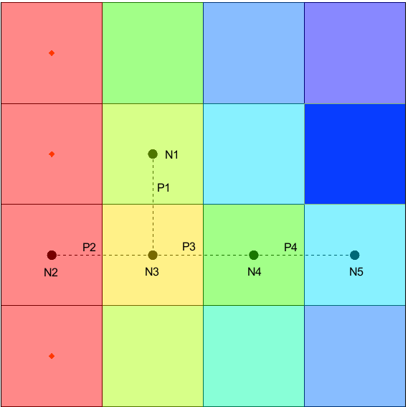

**Select this cell**

Figure 10 Cell to select for added well

1. Right-click on the selected cell and select **Sources/Sinks…** to bring up the *MODFLOW Sources/Sinks* dialog.
2. Select “Wells (WEL)” from the list on the left.
3. Click on the **Add BC** button. Two rows should be added to the spreadsheet above the button.
4. On row *8* in the *Q (flow) (m^3/d)* column, enter “-1.0”.
5. Click **OK** to close the *MODFLOW Sources/Sinks* dialog.

A well boundary condition symbol should appear in the cell (Figure 11).

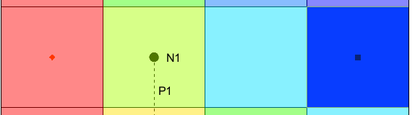

Figure 11 The well has appeared in cell 2,4,1

## Running MODFLOW CFP

Next, run the simulation with the added well:

1. **Save** File:Save Macro.svg the project.
2. Click **Run MODFLOW** run_modflow (or select *MODFLOW* | **Run MODFLOW**) to bring up the *Run MODFLOW* dialog.
3. In the *MODFLOW version* section, select *Custom* and make sure “mf2k5cfp\_h5.exe” is the executable in the file path to the right of *Custom*.
4. Click **OK** to close the *Run MODFLOW* dialog and bring up a DOS command prompt window that runs MODFLOW CFP.
5. Once MODFLOW finishes, press any key to close the window and return to GMS.

## Reading the Solution

Now import the solution with the well by doing the following:

1. Select *MODFLOW* | **Read Solution…** to bring up the *Open* dialog.
2. Select “MODFLOW Name File (\*.mfn)” from the drop-down to the right of the *File name* field.
3. Browse to the *unsupported\CFPM1\CFPM1-well\_MODFLOW* directory and select “CFPM1-well.mfn”.
4. Click **Open** to import the solution.
5. **Save** File:Save Macro.svg the project.

Both simulation solutions are available in the Project Explorer.

1. Click back and forth between the “File:Dataset Cells Active.svg Head” datasets under “File:Generic Folder Locked.svg CFPM1” and   
   “File:Generic Folder Locked.svg CFPM1-well” to see the difference adding the well has made.

Differences can also be found by inspecting the solution output files.

# Unsupported Package and Third-Party Executable

This section of the tutorial looks at importing and running a model using an unsupported package using a third-party MODFLOW executable. To run MODFLOW using a third-party executable, turn on the options to save a native text copy of the simulation and then use the *Run MODFLOW* dialog to run the simulation.

The sample model distributed with MODFLOW FMP2 is shown in Figure 12. It includes the FMP2, SFR2, UZF1, and MNW1 packages, and is a complex model which is described in further detail in the MODFLOW FMP2 documentation.[[4]](#footnote-4) This section of the tutorial will demonstrate using unsupported packages and third-party executables within GMS.



Figure 12 FMP2 example problem

## Importing the MODFLOW Model

In this section, import the MODFLOW FMP2 model. The model is distributed with a MODFLOW FMP2 executable that is based on MODFLOW-2005, so MODFLOW-2005 can be used to import the model.

1. Select *File |* **New** to restore program settings to their defaults. If prompted to save changes to the project, select **Don’t Save**.
2. Click **Open** File:Open Macro.svg to bring up the *Open* dialog.
3. Select “MODFLOW Name Files (\*.mfn;\*.nam)” from the *Files of type* drop-down.
4. Browse to the *\unsupported\ex1* folder and select “ex1.nam”*.*
5. Click **Open** close the *Open* dialog and bring up the *MODFLOW Translator* dialog.
6. Select *MODFLOW 2005* and click **OK** to initiate the translation.
7. Once MODFLOW 2005 has terminated successfully, click **Done** to close the *MODFLOW Translator* dialog.

A grid should appear with symbols representing the general head, SFR2, and MNW1 boundary conditions (Figure 12).

In order to run MODFLOW, it is necessary to create a native text export using the *Run MODFLOW* dialog.

1. Select *MODFLOW |* **Global Options…** to bring up the *MODFLOW Global/Basic Package* dialog.
2. In the *MODFLOW version* section, turn on *Save native text copy* and *Use custom Run dialog*.
3. Click **OK** to exit the *MODFLOW Global/Basic Package* dialog.
4. Select *MODFLOW |* **OC - Output Control…** to bring up the *MODFLOW Output Control* dialog.
5. In the *Output interval* section, select *Output at every time step.*
6. Click **OK** to exit the *MODFLOW Output Control* dialog.
7. Select *File* | **Save As…** to bring up the *Save As* dialog.
8. Select “Project Files (\*.gpr)” from the *Save as type* drop-down.
9. Enter “ex1.gpr” as the *File name*.
10. Click **Save** to create the new project file and close the *Save As* dialog.

## Copying Unsupported Package Data

Before running the simulation, view the unsupported package file.

1. Select *MODFLOW* **| Name File…**to bring up the *MODFLOW Name File* dialog.

Toward the bottom of the list of name file items, notice the unsupported FMP package along with several unsupported data files.

1. Click the **Edit…** button at the right of the *FMP* package row to bring up the *View Data File* dialog.
2. Select the desired text editor from the *Open with* drop-down.
3. Click **OK** to close the *View Data File* dialog and open the file in the selected text editor.

There are several lines that begin with “OPEN/CLOSE” or “EXTERNAL” (Figure 13). When the MODFLOW reads the FMP package data, these lines direct MODFLOW to read data from different files. The lines beginning with “OPEN/CLOSE” read the file contents for the named file on the fly. The lines beginning with “EXTERNAL” read the contents from a file listed in the name file with the given unit number.

Because the GMS importer copies unsupported package files without interpreting the contents, these files are not copied. For the simulation to run correctly, the associated files will need to be copied into the native text folder.

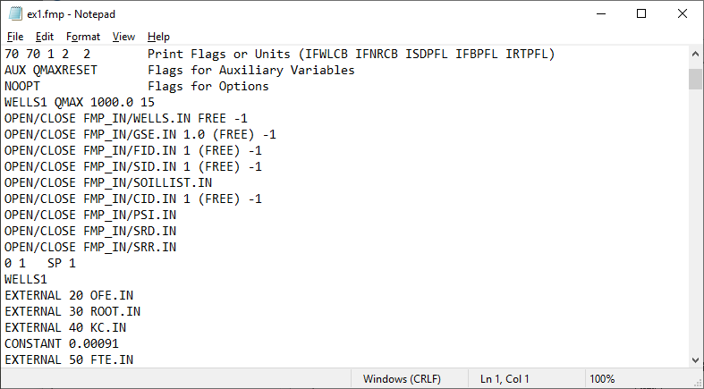

Figure 13 The ex1.fmp file as viewed in Notepad

1. Close the text editor.
2. Open a Windows Explorer window outside of GMS and browse to the *\unsupported\unsupported\ex1* folder.
3. Open a second Windows Explorer window and browse to the *\unsupported\unsupported\ex1\ex1\_MODFLOW\_text* folder.
4. In the first Windows Explorer window, copy the *FMP\_IN* folder and all of the files beginning with “ex1.IN\_” to the *ex1\_MODFLOW\_text* folder. Be careful to only copy the files instead of moving them. There should be six files copied in addition to the folder.
5. Close both windows and return to GMS.
6. Click **OK** to exit the *MODLFOW Name File* dialog.

## Running MODFLOW FMP2

Now run MODFLOW:

1. Click **Run MODFLOW** File:Run MODFLOW Macro.svg (or select *MODFLOW* | **Run MODFLOW**) to bring up the *Run MODFLOW* dialog.
2. The *Run MODFLOW* dialog will open. In this window, select the name file from the *ex1\_MODFLOW\_text* folder and switch to the custom executable that comes with the sample simulation.Click on the *Name file* **Browse** File:Open Macro.svg button to bring up the *Open* dialog.
3. Select “Name file or super file (\*.mfn, \*.nam, \*,mfs)” from the *Files of type* drop-down.
4. Navigate to the *\unsupported\unsupported\ex1\ex1\_MODFLOW\_text* folder and select “ex1.mfn”.
5. Click **Open** to close the *Open* dialog. Notice that the *Name file* path has changed.
6. In the *MODFLOW version* section, select *Custom*.
7. Click on the *Custom* **Browse** File:Open Macro.svg button to bring up the *Open* dialog.
8. Select “MODFLOW executable (\*.exe)” from the *Files of type* drop-down.
9. Browse to the *\unsupported\unsupported\ex1* folder and select “MF2K5\_FMP2\_rls32.exe”.
10. Click **Open** to close the *Open* dialog. Notice that the *Custom* path has changed.
11. Click **OK** to close the *Run MODFLOW* dialog and run MODFLOW.

A DOS command prompt window will show the progress of the MODFLOW run. When the simulation is completed, the text “Normal termination of simulation” will appear near the bottom of command window.

1. When MODFLOW finishes, press any key to close the DOS command prompt window.

## Reading the Solution

Next, import the MODFLOW solution:

1. Select *MODFLOW* | **Read Solution…** to bring up the *Open* dialog.
2. Select “MODFLOW Name File (\*.mfn)” from the drop-down to the right of the *File name* field.
3. Navigate to the *\unsupported\unsupported\ex1\ex1\_MODFLOW\_text* folder and select “ex1.mfn”.
4. Click **Open** to import the solution and close the *Open* dialog.
5. Click the **Contours** File:Contour Options Macro.svg macro to open the *Dataset Contour Options - 3D Grid - Head* dialog.
6. Click **OK** to accept the defaults and close the *Dataset Contour Options - 3D Grid - Head* dialog.
7. When the alert appears, click **Yes** to turn on contours.

The contours will appear, reflecting the head solution values (Figure 14).

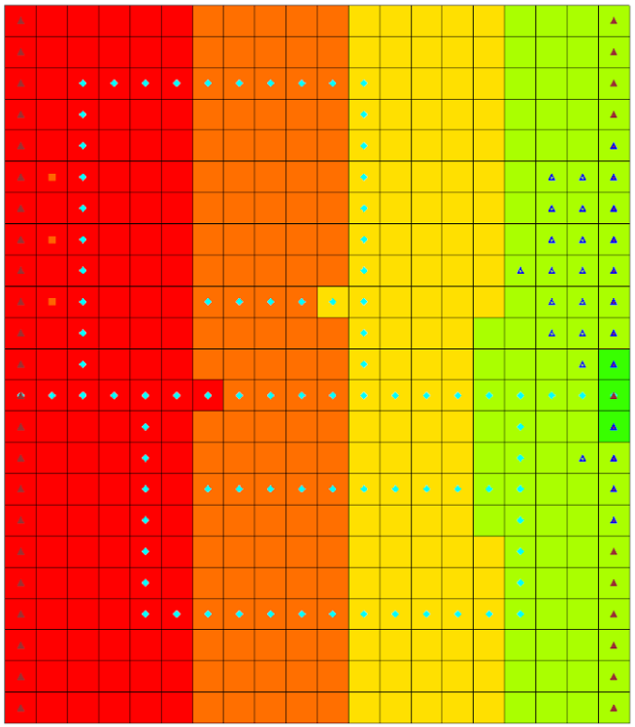

Figure 14 FMP2 contours

1. Select *MODFLOW* | **Flow Budget…** to bring up the *Flow Budget* dialog.

Notice the values for the FMP package on the “FARM WELLS” and “FARM NET RECH.” rows.

1. Once done examining the flow budget information, click **OK** to close the *Flow Budget* dialog.

# Conclusion

This concludes the “MODFLOW – Unsupported Packages” tutorial. The following topics were demonstrated and discussed:

* GMS has the ability to import and run MODFLOW simulations with unsupported packages.
* The *Name File* dialog shows the supported and unsupported packages used by a MODFLOW simulation.
* The *MODFLOW Run* dialog provides the ability to run a simulation using an external MODFLOW executable.
* When using an external executable, the solution can be manually imported and examined in GMS.

1. Fenske, John P.; Leake, S.A.; and Prudic, David E. 1996. “Documentation of a computer program (RES1) to simulate leakage from reservoirs using the modular finite-difference ground-water flow model (MODFLOW)” in *U.S. Geological Survey Open-File Report 96-364*, p.51. <http://pubs.usgs.gov/of/1996/0364/report.pdf>. [↑](#footnote-ref-1)
2. See https://aquaveo.com/software/gms/models-utilities/modflow for more details. [↑](#footnote-ref-2)
3. Shoemaker, W. Barclay; Kuniansky, Eve L.; Birk, Steffen; Bauer, Sebastian; and Swain, Eric D. 2008, “Documentation of a Conduit Flow Process (CFP) for MODFLOW-2005” in *U.S. Geological Survey Techniques and Methods 6-A24*, p.33. <http://pubs.usgs.gov/tm/tm6a24/pdf/tm6-A24.pdf>. [↑](#footnote-ref-3)
4. Schmid, W., Hanson, R.T., 2009, The Farm Process Version 2 (FMP2) for MODFLOW-2005—Modifications and Upgrades to FMP1: U.S. Geological Survey Techniques and Methods 6-A32, 102 p. [↑](#footnote-ref-4)