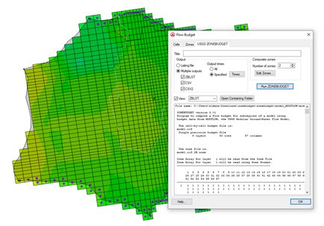

GMS 10.9

GMS 10.9 Tutorial

***MODFLOW – ZONEBUDGET***

Use ZONEBUDGET with a Multi-layer Model

Objectives

Learn how to use ZONEBUDGET with MODFLOW in GMS.

Time

* 15–25 minutes

Required Components

* GMS Core
* MODFLOW Interface

Prerequisite Tutorials

* MODFLOW – Grid Approach
* MODFLOW – Conceptual Model Approach I

|  |
| --- |
| 1 Introduction 2  1.1 Getting Started 3  2 Import the MODFLOW 2000 Model 3  2.1 Viewing the Flow Budget 3  2.2 Running ZONEBUDGET 4  3 Assigning Zone Budget IDs 5  3.1 Running ZONEBUDGET 6  4 Assigning Zone Budget IDs from a Conceptual Model 7  4.1 Reading a Transient MODFLOW Solution 8  5 Advanced ZONEBUDGET Options 8  5.1 Running ZONEBUDGET 9  6 Conclusion 9 |

# Introduction

ZONEBUDGET is a USGS program that reads cell-to-cell flow data produced by MODFLOW and calculates water budgets for subregions of the modeled area.

This tutorial builds on the “MODFLOW – Grid Approach” and the “MODFLOW –Conceptual Model” tutorial. Those tutorials should be completed before this one. The purpose of this tutorial is not to teach all about ZONEBUDGET, but simply to demonstrate the ZONEBUDGET interface in GMS.

This is a multi-layer MODFLOW model of a site with complex stratigraphy. It is the same model used in the “MODFLOW – Generating Data from Solids” tutorial. A cross section of the site is shown in Figure 1.

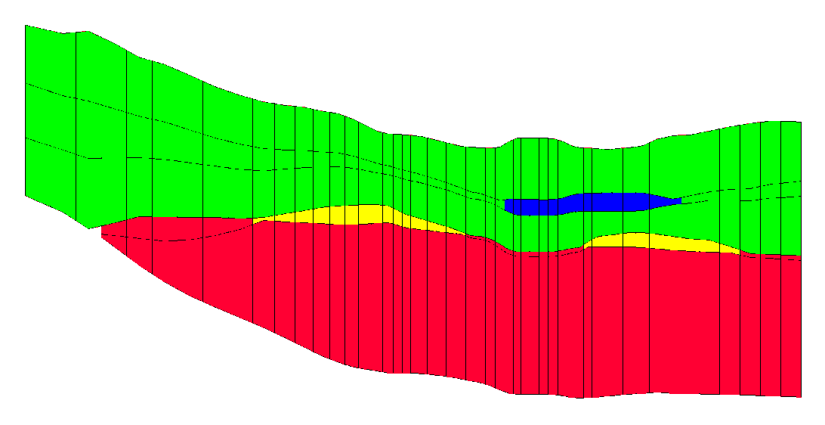

Figure 1 Multi-layer MODFLOW model

This tutorial discusses and demonstrates:

* Importing an existing MODFLOW 2000 model.
* Running ZONEBUDGET and viewing the outputs for a steady state MODFLOW solution.
* Assigning zone budget IDs to the model grid and running ZONEBUDGET.
* Assigning zone budget IDs using a conceptual model.
* Running ZONEBUDGET on a transient MODFLOW solution.

## Getting Started

Do the following to get started:

1. If necessary, launch GMS.
2. If GMS is already running, select *File |* **New** to ensure that the program settings are restored to their default state.

# Import the MODFLOW 2000 Model

First, it is necessary to import an existing model:

1. Click **Open** File:Open Macro.svg to bring up the *Open* dialog.
2. Browse to the *zonebudget\zonebudget* directory and select “model.gpr”.
3. Click **Open** to close the *Open* dialog and import the project file.

A MODFLOW model with color contours of the head solution should appear (Figure 2).

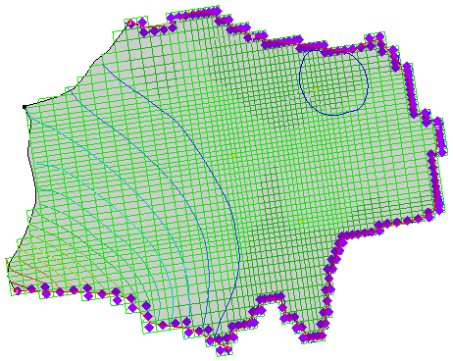

Figure 2 Color contours of the head solution

## Viewing the Flow Budget

Now to look at the flow budget for the MODFLOW model:

1. Select *MODFLOW |* **Flow Budget…** to bring up the *Flow Budget* dialog.

The *Cells* tab shows the flow budget for selected cells or, if no cells are selected, the budget is shown for the entire model domain. This model has flow into the model domain from the constant head and recharge boundary conditions, and flow out through the constant head and well boundary conditions.

1. Select the *Zones* tab.

This tab provides features similar to USGS ZONEBUDGET, including a more concise summary of the flow budget. The information displayed in this tab comes from GMS reading the MODFLOW cell-to-cell flow output file (CCF).

## Running ZONEBUDGET

Now to run ZONEBUDGET and view the outputs:

1. On the *USGS ZONEBUDGET* tab, click the **Run ZONEBUDGET** button to bring up the *USGS ZONEBUDGET* dialog.
2. Once USGS ZONEBUDGET has finished running, click **Close** to close the *USGS ZONEBUDGET* dialog.

A spreadsheet containing the ZONEBUDGET output will appear on the tab. This output is very similar to the output on the *Zones* tab. This is the CSV output from ZONEBUDGET. Two other output files were also created. In the *Output* section, notice that *ZBLST*, *CSV*, and *CSV2* are selected under *Multiple outputs* (Figure 3).

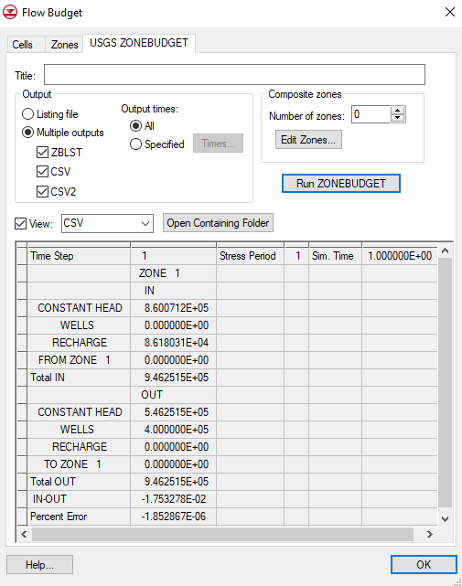

Figure 3 USGS ZONEBUDGET tab of the Flow Budget dialog

1. Select “ZBLST” from the *View* drop-down.

This is the ZONEBUDGET listing file. It provides information on the inputs to ZONEBUDGET as well as the outputs. Scroll to the end of the file to see a report similar to what was viewed with the CSV output file.

1. Click **Open Containing Folder** to open a Windows Explorer window showing the directory where all of the ZONEBUDGET input and output files are located.

The files are in the same location as the MODFLOW CCF that is used in the ZONEBUDGET run (Figure 4).

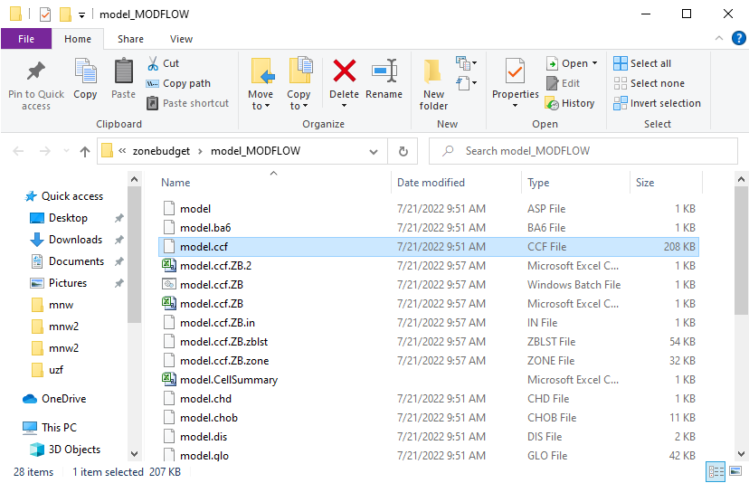

Figure 4 ZONEBUDGET input and output files

All of the ZONEBUDGET files have the same name as the CCF file, with the added “.ZB” to clearly identify the files. The 2.CSV file is the CSV2 file. The IN and ZONE files are inputs to ZONEBUDGET. The BAT file is a Windows batch file that can be used to rerun ZONEBUDGET.

1. Close the Windows Explorer window and return to GMS.
2. Click **OK** to exit the *Flow Budget* dialog.

# Assigning Zone Budget IDs

When running ZONEBUDGET previously, every cell in the model grid was assigned a Zone Budget ID of 1. The next step is to assign different Zone Budget IDs to parts of the grid. First, assign different Zone Budget IDs to the layers of the grid.

1. Expand the folders under “File:3D Grid Folder.svg 3D Grid Data” in the Project Explorer until the “File:Dataset Cells Active.svg Zone Budget IDs” datasetis visible (Figure 5).

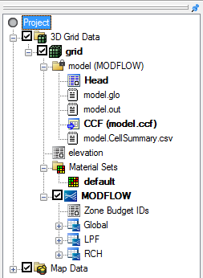

Figure 5 Zone Budget IDs dataset

1. Right-click on “File:Dataset Cells Active.svg Zone Budget IDs” and select **Properties…** to bring up the *Zone Budget IDs* dialog.

This dialog contains an array editor that can be used to edit the Zone Budget IDs. This is the same editor that is used to edit all array inputs for MODFLOW. Now assign a different ID to each layer in the grid. The dialog is currently showing the IDs for layer 1.

1. Change *Layer* to “2”.
2. Click **Constant → Layer…** to bring up the *Layer Value* dialog.
3. Enter “2” as the *Constant value for layer* and click **OK** to close the *Layer Value* dialog.
4. Repeat steps 3–5 for layers 3, 4, and 5. Assign the layer number as the Zone Budget ID for each layer.
5. Once all five layers have had Zone Budget IDs assigned, click **OK** to exit the *Zone Budget IDs* dialog.
6. In the Project Explorer, select “File:Generic Folder Locked.svg model (MODFLOW)” to make it active.

## Running ZONEBUDGET

The next step is to run ZONEBUDGET again.

1. Select *MODFLOW |* **Flow Budget…**to bring up the *Flow Budget* dialog.
2. On the *USGS ZONEBUDGET* tab, click **Run ZONEBUDGET** to bring up the *USGS ZONEBUDGET* dialog.
3. Once USGS ZONEBUDGET has finished, click **Close** to exit the *USGS ZONEBUDGET* dialog.

Notice that information is available about both the flows from the boundary conditions and the flows exchanged between zones.

1. Select “CSV2” from the *View* drop-down.

The CSV2 output file contains the same information that the CSV output file contains, but in a different format.

1. Click **OK** to exit the *Flow Budget* dialog.

# Assigning Zone Budget IDs from a Conceptual Model

The next step is to assign Zone Budget IDs using coverages that are part of a conceptual model. This can be done by using polygons to assign Zone Budget IDs to different areas of the model grid.

1. Fully expand the “File:Map Folder.svg Map Data”folder in the Project Explorer.

There are several coverages. Five will be used to assign Zone Budget IDs.

1. Select the “File:Coverage Active Icon.svg Zones_layer_2” coverage.
2. Change the current grid layer by changing *Lay (k)* to “2” in the *Mini Grid* *Toolbar* (Figure 6).

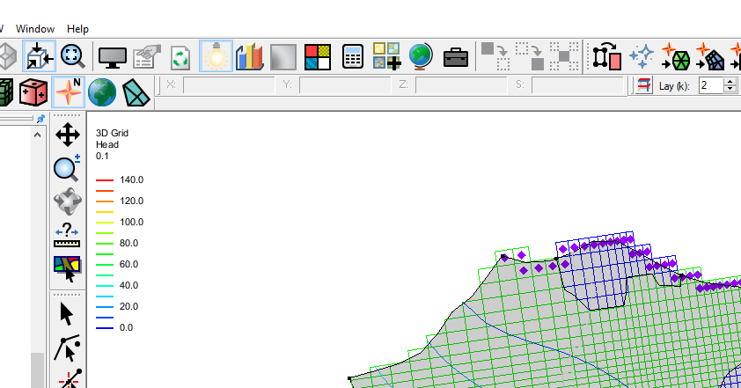

Figure 6 Mini Grid Toolbar

Notice there are polygons which match with the different material zones (the color of the grid cells changes with the feature polygon boundaries). This model has four major material zones. Polygons have been created in the different coverages in order to assign IDs to these zones.

1. Using the **Select Polygon** File:GMS Select Polygon Tool.svg tool, double-click on the polygon that overlaps the blue material zone at the top right of the model to bring up the *Attribute Table* dialog.
2. Notice that a Zone Budget ID of “2” is assigned.
3. Click **OK** to exit the *Attribute Table* dialog.
4. Click the **Map → MODFLOW** File:Map to MODFLOW Macro.svg macro to bring up the *Map → Model* dialog.
5. Click **OK** to accept the defaults and close the *Map → Model* dialog.

The Zone Budget IDs have now been assigned to the grid.

## Reading a Transient MODFLOW Solution

Before running ZONEBUDGET again, it is necessary to import a transient MODFLOW solution.

1. Select *MODFLOW |* **Read Solution…** to bring up the *Open* dialog.
2. Select “MODFLOW Name File (*.mfn)” from the drop-down to the right of the *File name* field.
3. Browse to the *zonebudget\zonebudget\trans_MODFLOW* directory and select “trans.mfn”.
4. Click **Open** to import the file.
5. Select the “File:Generic Folder Locked.svg trans (MODFLOW)” folder in the Project Explorer to make it active.

When the *Flow Budget* dialog appears, the CCF file associated with this solution will be shown.

# Advanced ZONEBUDGET Options

The next step is to look at some of the advanced inputs to ZONEBUDGET.

1. Select *MODFLOW |* **Flow Budget…** to bring up the *Flow Budget* dialog.
2. Select the *USGS ZONEBUDGET* tab.

When previously running ZONEBUDGET, the model was steady state so there was only one time step in the CCF file. The current model solution comes from a transient model with multiple time steps. With ZONEBUDGET, time steps can be analyzed all together or individually.

1. In the *Output* section under *Output times*, select *Specified* (Figure 7).

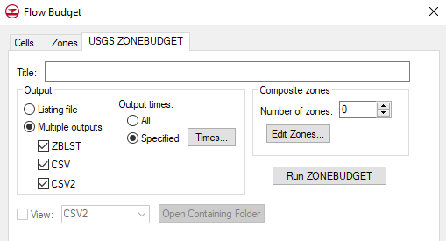

Figure 7 Specified output times

1. Click **Times…** to bring up the *Properties* dialog.
2. In the *Select* column, turn on “300.0”, “450.0”, and “600.0” (rows 11, 21, and 31).
3. Click **OK** to exit the *Properties* dialog.

ZONEBUDGET also provides functionality to combine zones into composite zones. In this problem, there are four zones. A composite zone comprising zones 1 and 2, and one comprising zones 3 and 4 can be made, and then ZONEBUDGET will provide a report for zones 1, 2, 3, and 4 individually, and another report for each composite zone.

1. In the *Composite Zones* section, enter “2” for the *Number of zones*.
2. Click **Edit Zones…** to bring up the *Properties* dialog (Figure 8).
3. In row *1*, enter “upper” in the *Name* column and “1,2” in the *Zone IDs* column.
4. In row *2*, enter “lower” in the *Name* column and “3,4” in the *Zone IDs* column.
5. Click **OK** to close the *Properties* dialog.

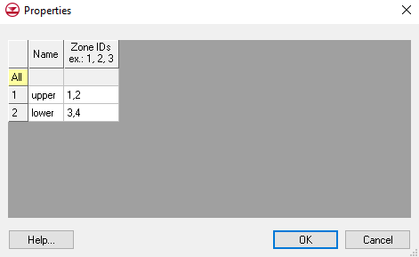

Figure 8 Composite zones

## Running ZONEBUDGET

1. Click **Run ZONEBUDGET** to bring up the *USGS ZONEBUDGET* dialog.
2. Once USGS ZONEBUDGET is finished running, click **Close** to exit the *USGS ZONEBUDGET* dialog.

Notice that the output contains data from 3 different time steps. To view information about the composite zones, look at the listing file (ZBLST).

1. Select “ZBLST” from the *View* drop-down and scroll to the bottom to see information on the “lower” composite zone.
2. Click **OK** to exit the *Flow Budget* dialog.

# Conclusion

This concludes the “MODFLOW–ZONEBUDGET” tutorial. The following topics were discussed and demonstrated

* GMS includes an interface to the USGS program ZONEBUDGET.
* It is possible to view ZONEBUDGET output in GMS.
* GMS supports all features of ZONEBUDGET.
* Zone Budget IDs can be assigned to the grid by manual means or by using the conceptual model approach.