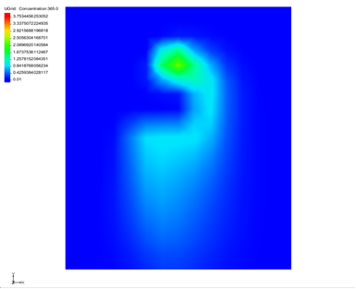

GMS 10.9

GMS 10.9 Tutorial

***MODFLOW 6 – Transport Grid Approach***

Add a MODFLOW 6 transport model to a simulation

Objectives

The tutorial demonstrates a creating a MODFLOW 6 simulation that uses both a flow and a transport model.

Time

* 25–45 minutes

Required Components

* GMS Core
* MODFLOW-USG Model & Interface

Prerequisite Tutorials

* Getting Started

|  |
| --- |
| 1 Introduction 2  2 Getting Started 3  2.1 Opening the Existing Model 3  3 Saving the Project 4  4 Creating the Transport Model 4  5 Advection Package 5  6 Dispersion Package 5  7 Source and Sink Mixing Package 5  8 Initial Conditions Package 6  9 Mobile Storage and Transfer Package 6  10 Output Control Package 6  11 GWF-GWT Exchange 6  12 Iterative Model Solution Package 7  13 Saving and Checking the Simulation 7  14 Running MODFLOW 8  15 Viewing the Solution 8  16 Conclusion 9 |

# Introduction

GMS allows having multiple models attached to a MODFLOW 6 simulation. This tutorial will show how to add a transport model to a MODFLOW 6 simulation that has a flow model already.

The problem is hypothetical: “originally used for comparing different MT3DMS solutions (e.g., finite-difference, method-of-characteristics, and TVD advection schemes) to each other.”

The tutorial uses one grid layer. An initial MODFLOW 6 simulation with a flow model has already been created for the grid.

This tutorial discusses and demonstrates the following key concepts:

* Adding a transport model to an existing MODFLOW 6 simulation.
* Defining packages for the transport model.
* Saving and running the MOFLOW 6 simulation.

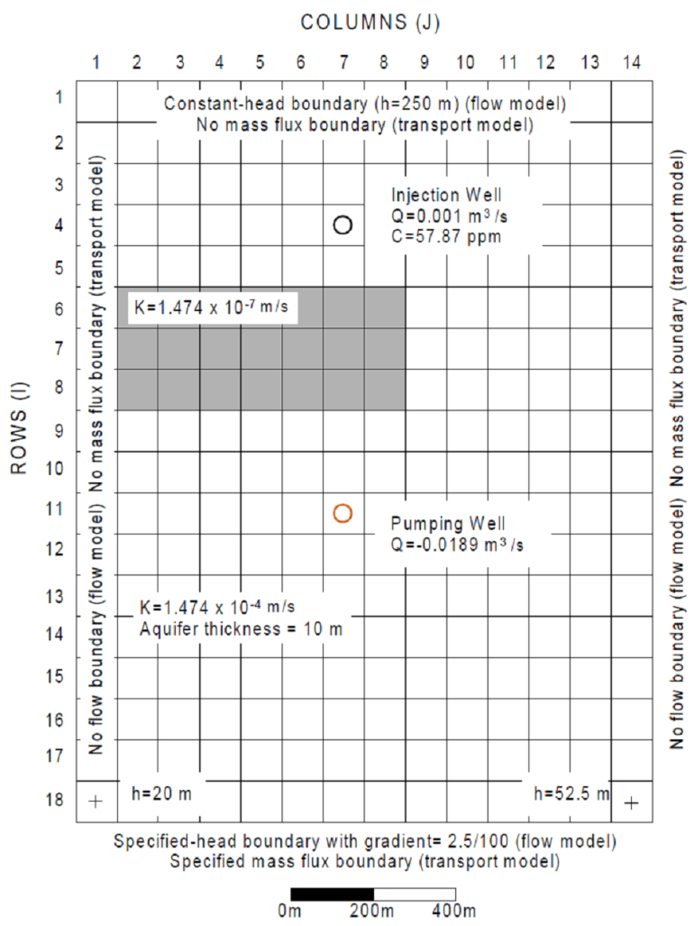

Figure 1 Plan view of site to be modeled

# Getting Started

Do as follows to get started:

1. If necessary, launch GMS.
2. If GMS is already running, select *File |* **New** command to ensure that the program settings are restored to their default state.

## Opening the Existing Model

Start with a previously-created project.

1. Click **Open** File:Open Macro.svg to bring up the *Open* dialog.
2. Select “Project Files (*.gpr)” from the *Files of type* drop-down.
3. Browse to the *mf6_transport_p09* folder and select “start.gpr”.
4. Click **Open** to import the project and exit the *Open* dialog.

The project should be visible in the Graphics Window (Figure 2). The project contains a MODFLOW 6 simulation along with a 3D UGrid. Wells and general head boundary conditions have already been defined. A solution also exists. But there is no transport model.

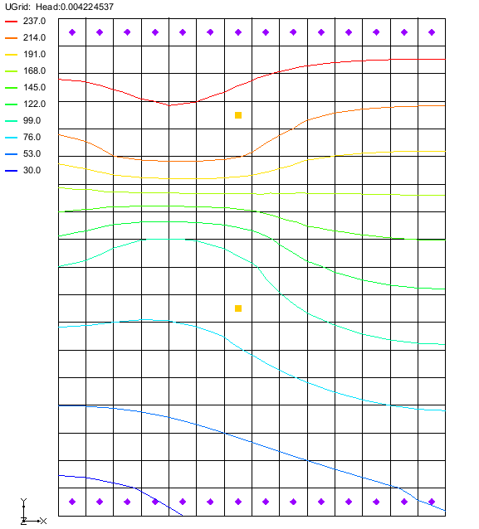

Figure 2 Initial project

# Saving the Project

Before making any changes, save the project under a new name.

1. Select *File* | **Save As…** to bring up the *Save As* dialog.
2. Select “Project Files (*.gpr)” from the *Save as type* drop-down.
3. Enter “p09.gpr” for the *File name*.
4. Click **Save** to save the project under the new name and close the *Save As* dialog.

It is recommended to periodically **Save** File:Save Macro.svg while working through the tutorial and while working on any project.

# Creating the Transport Model

The current MODFLOW 6 simulation contains a flow model. This tutorial will demonstrate adding a transport model to the simulation. Building off the same simulation will save time and make it easier to compare the flow and transport models.

To begin:

1. Right-click on “File:MODFLOW Folder.svg p09-mf6” and select *New Package* | **GWT** to bring up the *New Groundwater Transport (GWT) Model* dialog.
2. Set the *Model name* to “trans” (the default name).
3. Under *Select UGrid*, ensure that “UGrid” is checked.
4. Under *GWT – Groundwater Transport Model,* select the following options:
   * *ADV – Advection*
   * *DSP – Dispersion*
   * *SSM – Source and Sink Mixing*
5. Click **OK** to close the *New Groundwater Transport (GWT) Model* dialog.

In the Project Explorer, notice that a new “ trans” model has been added to the MODFLOW 6 simulation. Before running the transport model, the packages need to be reviewed and defined.

# Advection Package

Review the advection package by doing the following:

1. In the Project Explorer, under the “ trans” model, right-click on “Thumbnail for version as of 22:49, February 4, 2020 ADV” and select **Open…** to bring up the *Advection (ADV) Package* dialog.
2. Under *OPTIONS,* set the *SCHEME* to “TVD”.
3. Click **OK** to close the *Advection (ADV) Package* dialog.

# Dispersion Package

The dispersion package needs to be defined by doing the following:

1. Under the “ trans” model, double-click on “Thumbnail for version as of 22:49, February 4, 2020DSP” to open the *Dispersion (DSP) Package* dialog.
2. Under *GRIDDATA,* select the *ALH* tab which allows defining longitudinal dispersivity in the horizontal direction.
3. Turn on the *Define* option.
4. Set the *Constant* to “20.0”.
5. Under *GRIDDATA,* select the *ATH1* tab which allows defining the transverse dispersivity in the horizontal direction.
6. Turn on the *Define* option
7. Set the *Constant* to “4.0”.
8. Click **OK** to close the *Dispersion (DSP) Package* dialog.

# Source and Sink Mixing Package

To define the source and sink mixing package:

1. Under the “ trans” model, double-click on “Thumbnail for version as of 22:49, February 4, 2020SSM” to open the *Source and Sink Mixing (SSM) Package* dialog.
2. Click **Set Up From Flow Model** near the bottom to open the *Select GWF6* dialog.
3. Check the “16-mf6 flow” model.
4. Click **OK** to close the *Select GWF6* dialog.

Notice two lines were added to the table. GMS searched the flow model for any packages with an AUXILIARY variable named “CONCENTRATION”. It found one in the WEL and the CHD packages.

1. Click **OK** to close the *Source and Sink Mixing (SSM) Package* dialog.

# Initial Conditions Package

Review the initial conditions package by doing the following:

1. Under the “ trans” model, double-click on “Thumbnail for version as of 22:49, February 4, 2020IC” to open the *Initial Conditions (IC) Package* dialog.

For this example, the default constant of 0 will be used.

1. Click **OK** to close the *Initial Conditions (IC) Package* dialog.

# Mobile Storage and Transfer Package

Review the mobile storage and transfer package by doing the following:

1. Under the “ trans” model, double-click on “Thumbnail for version as of 22:49, February 4, 2020MST” to open the *Mobile Storage and Transfer (MST) Package* dialog.

For this example, the default porosity of 0.3 will be used.

1. Click **OK** to close the *Mobile Storage and Transfer (MST) Package* dialog.

# Output Control Package

Review the output control package by doing the following:

1. Under the “ trans” model, double-click on “Thumbnail for version as of 22:49, February 4, 2020OC” to open the *Output Control (OC) Dialog*.
2. Under *PERIODS*, change the *Preset output* to “At every time step”.

This sets the output to use all time steps.

1. Click **OK** to close the *Output Control (OC) Dialog*.

# GWF-GWT Exchange

Now to connect the flow model and the transport model using the GWF-GWT exchange.

1. Right-click on “File:MODFLOW Folder.svg p09-mf6” and select *New Package* | **GWF-GWT**.

The “GWF-GWT” item will appear in the Project Explorer. There are no options that need to be set with the GWF-GWT exchange. Still, the GWF-GWT exchange requires that the models it is exchanging be specified.

1. Double-click on “File:MODFLOW Folder.svg p09-mf6” to open the *Simulation Options* dialog.
2. Under *Sections*, turn on the *EXCHANGES* option.
3. Click the field in the *EXGMNAMEA* column to open the *Select Model* dialog.
4. Select the “16-mf6 flow” model and click **OK** to close the *Select Model* dialog.
5. Click the field in the *EXGMNAMEB* column to open the *Select Model* dialog.
6. Select the “ trans” model and click **OK** to close the *Select Model* dialog.
7. Click **OK** to close the *Simulation Options* dialog.

# Iterative Model Solution Package

The IMS solver package needs to be defined for the transport model. Do this by completing the following:

1. Right-click on “File:MODFLOW Folder.svg p09-mf6” and select *New Package* | **IMS**.
2. In the Project Explorer, right-click on “Thumbnail for version as of 22:49, February 4, 2020 IMS” and select **Rename**.
3. Enter “IMS-trans” as the new name and press *Enter*.
4. Double-click on “Thumbnail for version as of 22:49, February 4, 2020IMS-trans” to open the *Iterative Model Solution (IMS)* dialog.
5. Under *Sections*, turn on *OPTIONS*.
6. Under the *OPTIONS* section, turn off *COMPLEXITY*.
7. Under the *NONLINEAR* section, turn on the *OUTER_DVCLOSE* option and set it to “1e-6”.
8. Also under the *NONLINEAR* section, turn on the *OUTER_MAXIMUM* option and set it to “100”.
9. Under the *LINEAR* section, turn on and set the following:
   * Set *INNER_MAXIMUM* to “300”.
   * Set *INNER_DVCLOSE* to “1e-6”.
   * Set *INNER_RCLOSE* to “1e-6”.
   * Set *LINEAR_ACCELERATION* to “BICGSTAB”.
   * Set *RELAXATION_FACTOR* to “1”.
10. Click **OK** to close the *Iterative Model Solution (IMS)* dialog.

Before running the model, the new IMS package needs to be specified for the transport model:

1. Double-click on “File:MODFLOW Folder.svg p09-mf6” to open the *Simulation Options* dialog.
2. Under *Sections*, turn on the *SOLUTIONGROUPS* option.
3. Under *SOLUTIONGROUPS*, click the blank field under *SLNMNAMES* to open the *Select Model(s)* dialog.
4. Select the “ trans” model and click **OK** to close the *Select Model(s)* dialog.
5. Click **OK** to close the *Simulation Options* dialog.

The transport model has now been set up.

# Saving and Checking the Simulation

To export the simulation and check the model, complete the following:

1. Click the **Save** File:Save Macro.svg macro to save the project.
2. In the Project Explorer, right-click on “File:MODFLOW Folder.svg p09-mf6” and select **Save Simulation**.
3. Right-click on “File:MODFLOW Folder.svg p09-mf6” and select **Check Simulation** to bring up the *Check MODFLOW 6 Simulation* dialog.

No errors should be reported.

1. Click **OK** to close the *Check MODFLOW 6 Simulation* dialog.

# Running MODFLOW

It is now possible to run MODFLOW:

1. Right-click on “File:MODFLOW Folder.svg p09-m6” and select **Run Simulation** to bring up a warning message.

Because a solution was already loaded into the project, this solution will have to be unloaded in order for MODFLOW 6 to run.

1. Click **OK** to close the warning dialog and start the *Simulation Run Queue* model wrapper dialog.

The *Simulation Run Queue* shows all simulation model runs currently in progress. Since this project only has one simulation, only one is shown.

1. When MODFLOW 6 finishes, click **Load Solution**.
2. Click **Close** to exit the *Simulation Run Queue* dialog.

# Viewing the Solution

Now to review the solution by doing the following:

1. In the “File:Generic Folder.svg trans*”* folder underneath “File:Generic Folder.svg UGrid Data*”*, make sure the “File:Dataset Cells Active.svg Concentration” dataset is active in the Project Explorer.
2. Click **Display Options** File:Display Options Macro.svg to bring up the *Display Options* dialog.
3. Select “UGrid: UGrid – [Active]” from the list on the left.
4. Turn off *Cell edges*.
5. Turn on *Face contours* and click **Options** to open the *Dataset Contour Options– UGrid – Concentration* dialog.
6. Change the *Contour method* to “Color Fill”.
7. Under *Data range*, turn on *Specify a range*.
8. Under *Specify a range*, enter “0.01” for the *Min* and leave the *Max* at the default.
9. Click **OK** to close the *Dataset Contour Options– UGrid – Concentration* dialog.
10. Click **OK** to close the *Display Options* dialog.
11. Select different time steps to see how the solution varies with time.

# Conclusion

This concludes the “MODFLOW 6 – Transport Grid Approach” tutorial. The following topics were discussed and demonstrated:

* Adding a transport model to a MODFLOW 6 simulation.
* Defining packages for a transport model for use in MODFLOW 6.
* Saving and running a MODFLOW 6 simulation that contains both a flow model and a transport model.