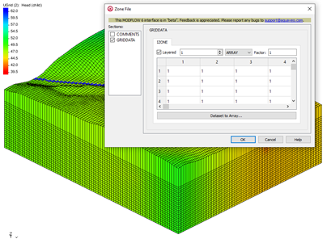

GMS 10.9

GMS 10.9 Tutorial

***MODFLOW 6 – ZONEBUDGET***

Use ZONEBUDGET to analyze model results

Objectives

Learn how to use ZONEBUDGET with MODFLOW 6 in GMS.

Time

* 15–25 minutes

Required Components

* GMS Core
* MODFLOW-USG Model & Interface

Prerequisite Tutorials

* Getting Started
* MODFLOW 6 – Grid Approach
* MODFLOW 6 – Conceptual Model Approach

|  |
| --- |
| 1 Introduction 2  2 ZONEBUDGET for a DISV MODFLOW 6 Simulation 2  2.1 Opening the Existing Model 2  2.2 Accessing the Zone Package 3  2.3 Assigning IZONE Values 3  2.4 Saving the Zone Package File 4  2.5 Running ZONEBUDGET 4  3 ZONEBUDGET for a DIS MODFLOW 6 Simulation 4  3.1 Opening the Existing Model 4  3.2 Checking the data 5  3.3 Opening the Zone Package 6  3.4 Assigning IZONE Values Using a Dataset 6  3.5 Saving and Running ZONEBUDGET 6  4 Running ZONEBUDGET for Multiple Models 7  4.1 Opening the Existing Model 7  4.2 Running ZONEBUDGET 8  5 Conclusion 8 |

# Introduction

ZONEBUDGET is a USGS program that reads cell-to-cell flow data produced by MODFLOW 6 and calculates water budgets for sub-regions of the modeled area.

This tutorial builds on the “MODFLOW 6 – Grid Approach” and the “MODFLOW –Conceptual Model” tutorial. Those tutorials should be completed before this one. The purpose of this tutorial is not to teach all about ZONEBUDGET, but simply to demonstrate the ZONEBUDGET interface in GMS.

To learn how to create conceptual models, refer to the “MODFLOW 6 – Conceptual Model Approach” tutorial.

This tutorial discusses and demonstrates:

* Importing an existing MODFLOW 6 model.
* Assigning zone budget IDs to the model grid and running ZONEBUDGET.
* Running ZONEBUDGET and viewing the outputs for a MODFLOW 6 solution that used the DISV package.
* Running ZONEBUDGET on a MODFLOW 6 solution that used the DIS package.
* Running ZONEBUDGET for multiple GWF models.

# ZONEBUDGET for a DISV MODFLOW 6 Simulation

Start with generating and viewing the zone budget for a MODFLOW 6 model that used the DISV package for discretization. Do as follows to get started:

1. If necessary, launch GMS.
2. If GMS is already running, select *File |* **New** command to ensure that the program settings are restored to their default state.

## Opening the Existing Model

Start with a previously-created project.

1. Click **Open** File:Open Macro.svg to bring up the *Open* dialog.
2. Select “Project Files (*.gpr)” from the *Files of type* drop-down.
3. Browse to the *mf6_zonebudget* folder and select “disv.gpr”.
4. Click **Open** to import the project and exit the *Open* dialog.

The project should be visible in the Graphics Window (Figure 1). The project contains a MODFLOW 6 simulation. It is a DISV model with two layers. Solution files containing the cell-by-cell flows data are also included.

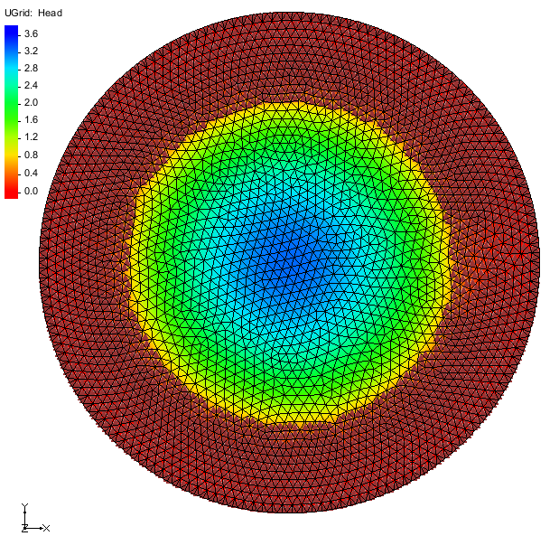

Figure Initial project for DISV model

## Accessing the Zone Package

Now to look at the flow budget for the MODFLOW 6 model:

1. Right-click on “File:MF6 GWF Model.svg ex-gwf-disvmesh” and select the *New Package* | **Zones** command.

This will create a new “File:Mf6package.svgZones” objects in the Project Explorer. The package values now need to be set.

1. Double-click on the “File:Mf6package.svgZones” package item to open the *Zone File* dialog.

The *Zone File* dialog allows defining the sub-regions by specifying zone numbers. This is done in the IZONE section of the dialog.

## Assigning IZONE Values

The IZONE array is associated with each layer. In this example, the first layer has an IZONE value of 1 and the second layer has a value of 2. The default settings already set the first layer to have a value of 1. To set the value for layer 2, complete the following:

1. Change the *Layered* field to “2”.
2. Change the *Constant* field to “2”.
3. Select **OK** to exit the *Zone File* dialog.

## Saving the Zone Package File

Before running ZONEBUDGET, the zone file needs to be saved. To do this:

1. Right-click on “File:MODFLOW Folder.svg ex-gwf-disvmesh” and select the **Save Simulation** command.

This will export the zone package file.

## Running ZONEBUDGET

Now to run ZONEBUDGET and view the outputs:

1. Right-click on “File:Mf6package.svgex-gwf-disvmesh.cbc” and select the **Run ZONEBUDGET** command to start the *MODFLOW 6 Zone Budget* model wrapper dialog.
2. When it has finished, click **OK** to the *MODFLOW 6 Zone Budget* dialog.

Three items will be added to the “File:Simulation Folder Icon.svg Package” folder in the Project Explorer: “File:Generic Folder.svg ex-gwf-disvmesh_zone_budget”, “File:External text MF6.png ex-gwf-disvmesh.lst” and “File:External text MF6.png ex-gwf-disvmesh.csv”.

1. Double-click on the “File:External text MF6.png ex-gwf-disvmesh.lst” item to open a text file.
2. Scroll to the bottom of the file to see the budget summary for the two zones.
3. When done, close the text file and return to GMS.

The “File:External text MF6.png ex-gwf-disvmesh.csv” file contains the same information in a different format. The column with the IN terms shows how much water flows into the zone. The column with the OUT terms shows how much water flows out of the zone. The column with the FROM terms shows how much water flows from one zone into the current zone. Finally, the column with the TO term shows how much water flows from the current zone into a given zone.

# ZONEBUDGET for a DIS MODFLOW 6 Simulation

Now to generate and view the zone budget for a MODFLOW 6 model that used the DIS package for discretization. Do as follows to get started:

1. If necessary, launch GMS.
2. If GMS is already running, select *File |* **New** command to ensure that the program settings are restored to their default state.

## Opening the Existing Model

Start with a previously-created project.

1. Click **Open** File:Open Macro.svg to bring up the *Open* dialog.
2. Select “Project Files (*.gpr)” from the *Files of type* drop-down.
3. Browse to the *mf6_zonebudget* folder and select “dis.gpr”.
4. Click **Open** to import the project and exit the *Open* dialog.

The project should be visible in the Graphics Window (Figure 2). The project contains a MODFLOW 6 simulation. It is a DIS model with two layers.

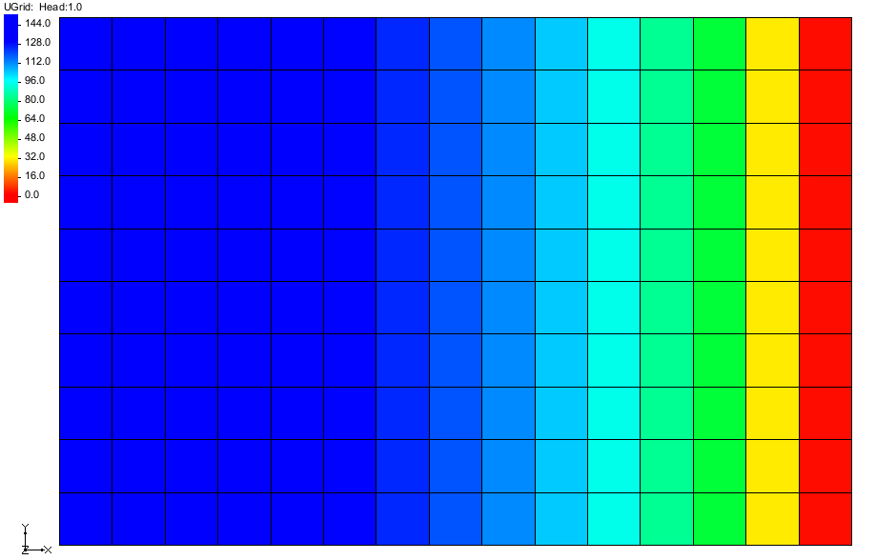

Figure Initial project for DIS model

## Checking the data

This project has a predefined zone data.

1. Click on the “ zones” dataset under “ Ugrid”.

There are three zones that transition from left to right in the model (Figure 3). Zone 1 is on the left. Then zone 2 is in the middle and zone 3 is on the right. These data will be assigned to the zonebudget input.

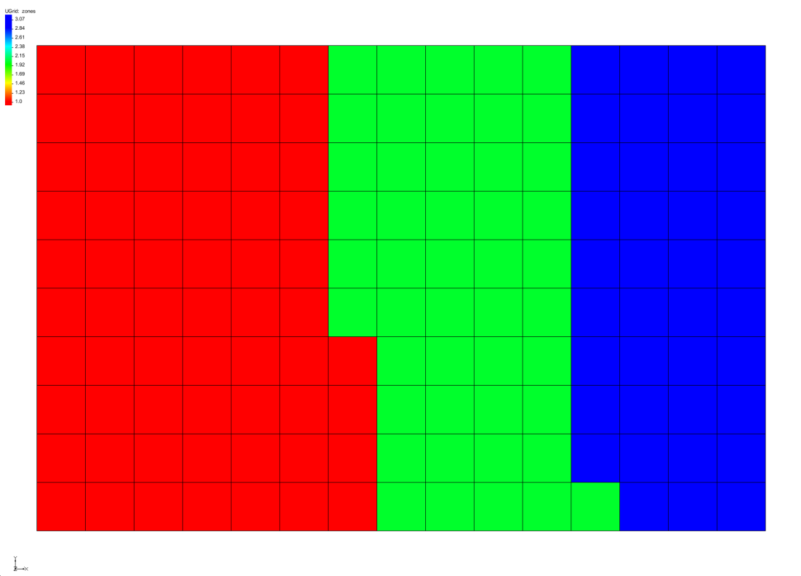

Figure Predefined Zone ID.

## Opening the Zone Package

Now to look at the flow budget for the MODFLOW 6 model:

1. Right-click on “File:Mf6package.svgZones”” and select the **Unlock** command.

By default, MODFLOW 6 data and packages are locked when first read into GMS.

1. Right-click on the “File:Mf6package.svgZones” package item and select **Open…** to open the *Zone File* dialog.

## Assigning IZONE Values Using a Dataset

For the zone values, use the predefined dataset for each of the layers. To do this:

1. On the *IZONE* tab, turn off the *Layered* check box and change “CONSTANT” to “ARRAY”.
2. Click the **Dataset to Array…** button to open the *Select Dataset* dialog.
3. Select the “ zones” dataset.
4. Click **OK** to close the *Select Dataset* dialog.

This will assign all of the values of the predefined array to the values in the zones dataset.

1. Turn on the *Layered* check box to see the data in layered format.

The values are the same as the predefined dataset shown in Figure 3.

1. Click **OK** to close the *Zone File* dialog.

## Saving and Running ZONEBUDGET

Now to save and run ZONEBUDGET then view the outputs:

1. Right-click on “File:MODFLOW Folder.svg ex-gwf-bcf2ss” and select the **Save Simulation** command.
2. Right-click on “File:Mf6package.svgex-gwf-bcf2ss.cbc” and select the **Run ZONEBUDGET** command to start the *MODFLOW 6 Zone Budget* model wrapper dialog.
3. When it has finished, click **OK** to the *MODFLOW 6 Zone Budget* dialog.

Three items will be added to the “File:Simulation Folder Icon.svg Package” folder in the Project Explorer: “File:Generic Folder.svg ex-gwf-bcf2ss_zone_budget”, “File:External text MF6.png ex-gwf-bcf2ss.lst” and “File:External text MF6.png ex-gwf-bcf2ss.csv”. This model is transient so the budget output is for each output time step.

1. Double-click on the “File:External text MF6.png ex-gwf-bcf2ss.lst” item to open a text file.
2. Scroll to the bottom of the file to see the budget summary for the three zones.
3. When done, close the text file and return to GMS.

# Running ZONEBUDGET for Multiple Models

ZONEBUDGET can be used with a MODFLOW 6 simulation that contains multiple models.

Do as follows to get started:

1. If necessary, launch GMS.
2. If GMS is already running, select *File |* **New** command to ensure that the program settings are restored to their default state.

## Opening the Existing Model

Start with a previously-created project.

1. Click **Open** File:Open Macro.svg to bring up the *Open* dialog.
2. Select “Project Files (*.gpr)” from the *Files of type* drop-down.
3. Browse to the *mf6_zonebudget* folder and select “lgr.gpr”.
4. Click **Open** to import the project and exit the *Open* dialog.

The project should be visible in the Graphics Window (Figure 4). This is MODFLOW 6 model that has multiple GWF models. The zones have been set up on the "File:Generic Folder.svg child" model. The first 5 layers of the grid are zone 1, the next 10 layers are zone 2, and the last 10 layers are zone 3. The parent model also has zones set up: one zone for each layer in the nine layer grid.

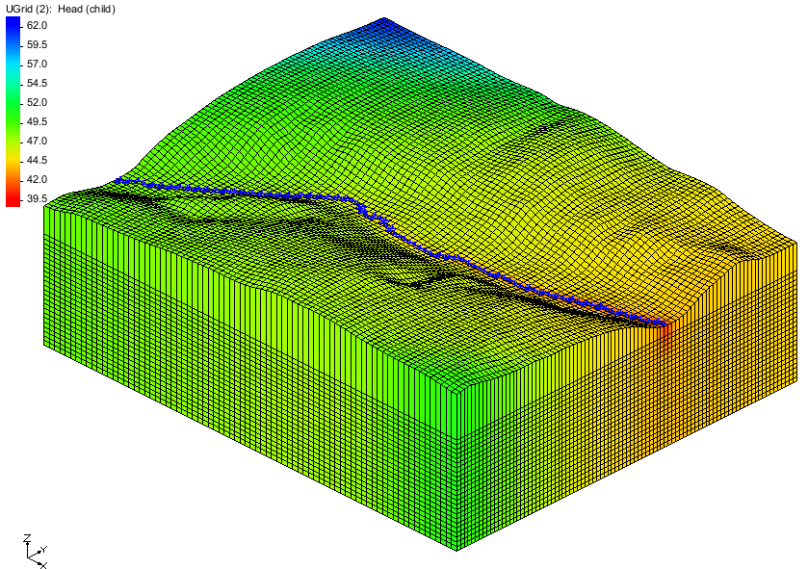

Figure Initial project for model with multiple GWF models

## Running ZONEBUDGET

Now to run ZONEBUDGET then view the outputs:

1. Right-click on “File:Mf6package.svgchild.cbc” and select the **Run ZONEBUDGET** command to start the *MODFLOW 6 Zone Budget* model wrapper dialog.
2. When it has finished, click **OK** to close the *MODFLOW 6 Zone Budget* dialog.

It was not necessary to save the simulation in this case because the Zone file data was not edited. Three items will be added to the “File:Simulation Folder Icon.svg Package” folder in the Project Explorer: “File:Generic Folder.svg child_zone_budget”, “File:External text MF6.png child.lst” and “File:External text MF6.png child.csv”.

1. Double-click on the “File:External text MF6.png child.lst” item to open a text file.
2. Scroll to the bottom of the file to see the budget summary for the zones.
3. When done, close the text file.

# Conclusion

This concludes the “MODFLOW 6 – ZONEBUDGET” tutorial. The following topics were discussed and demonstrated:

* Adding the Zone File to a MODFLOW 6 simulation.
* Running ZONEBUDGET.
* Reviewing budget summary.
* Assigning zone ids from a dataset.