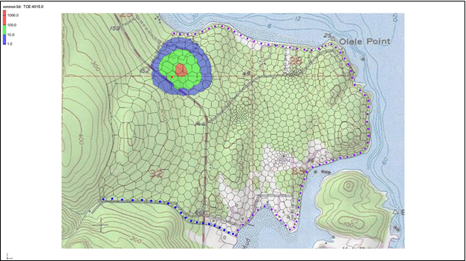

GMS 10.9

GMS 10.9 Tutorial

***MODFLOW 6 – MDT Package 3D Transport***

Use the Matrix Diffusion Transport (MDT) package in GMS to simulate matrix diffusion in a three-dimensional model using a semi-analytic approximation

Objectives

Learn how to use the Matrix Diffusion Transport (MDT) package with MODFLOW 6 to simulate matrix diffusion in a three-dimensional field scale model with an unstructured grid.

Time

* 20–30 minutes

Required Components

* GMS Core
* MODFLOW-USG Model & Interface

Prerequisite Tutorials

* MODFLOW-USG – Complex Stratigraphy
* MODFLOW 6 Transport – Grid Approach

|  |
| --- |
| 1 Introduction 2  2 Getting Started 3  3 Enable Groundwater Transport 4  4 Defining the MST Package 5  5 Defining a CNC Package 5  6 Defining the MDT Package 5  7 Output Control 6  8 Linking the Simulations 6  9 Saving and Running MODFLOW 6 7  10 Examining the Results 7  11 Conclusion 8 |

# Introduction

The Matrix Diffusion Transport (MDT) package works with MODFLOW-USG Transport and MODFLOW 6. The MDT package allows existing flow and chemical transport models to be upgraded to include a full accounting of matrix diffusion effects. The MDT package is based on the semi-analytic matrix diffusion method implemented in the REMChlor-MD model[1], [2], [3]. The development of this simulation capability has been supported by the Department of Defense Environmental Security Technology Certification Program (ESTCP) and represents a collaborative effort between Clemson University, GSI Environmental, and Aquaveo.

The MDT matrix diffusion method is conceptually similar to dual porosity methods, where the volume of each element is divided into “mobile” and “immobile” fractions. Solute transport occurs by advection and dispersion in the mobile fraction, but only by diffusion in the immobile fraction. With the MDT package, the concentration profile in the immobile fraction is approximated using a dynamic function that expresses the concentration as a function of distance from the mobile/immobile interface. This function is recomputed at each time step in each element using the current and previous concentrations in the mobile fraction, along with the integral of the concentration profile in the immobile fraction. The mass transfer to or from the mobile/immobile fractions is then computed as a linear concentration-dependent source term.

This tutorial demonstrates how the MDT package can be used with a MODFLOW 6 simulation to simulate diffusion in a three-dimensional heterogeneous porous media system where the heterogeneity occurs at the sub-gridblock scale. This example is based on the unstructured grid flow model developed in the MODFLOW-USG – Complex Stratigraphy tutorial, with a hypothetical release of trichloroethylene (TCE) into the aquifer.

For a more detailed description of the semi-analytic method used in the MDT package, please refer to the REMChlor-MD user’s guide1 and related journal papers2, 3. The input variables used in the MDT package are described in the MDT Process for MODFLOW-USG Transport User’s Guide[4].

This example uses a five-layer Voronoi UGrid from the *MODFLOW-USG Complex Stratigraphy tutorial* and adds the MODFLOW-USG BCT and MDT packages. The layers are discontinuous, and have different properties, but the properties are assumed to be constant within each layer. The conceptual model is that there are sub-gridblock scale heterogeneities such as discontinuous sand, silt, and clay layers that exist throughout the model domain. These local-scale heterogeneities give rise to strong matrix diffusion effects during contaminant transport.

With the MDT approach, the transport in the model is simulated with localized matrix diffusion into and out of the low permeability (low-K) parts of each cell using the semi-analytic method. The local low permeability zones in each cell are not specifically discretized; rather they are represented in the model in an average sense, using the volume fraction (VOLFRACMD) of higher permeability (high-K) material, and the characteristic diffusion length in the low-K material (DIFFLENMD). The conceptual model for transport is that advective flow occurs in only 20% of the overall volume (the high-K fraction) with local matrix diffusion into and out of the remaining 80% low-K fraction.

This tutorial will demonstrate the following topics:

1. Opening an existing MODFLOW 6 flow simulation.
2. Adding the transport simulation.
3. Activating the MDT package.
4. Running the simulation and examining the results.

# Getting Started

Do the following to get started:

1. If necessary, launch GMS.
2. If GMS is already running, select *File |* **New** to ensure that the program settings are restored to their default state.
3. Click **Open** File:Open Macro.svg (or *File |* **Open…**) to bring up the *Open* dialog.
4. Browse to the data files for this tutorial and select “olele.gpr”.
5. Click **Open** to import the file and close the *Open* dialog.

The Graphics Window should appear as in Figure 1.

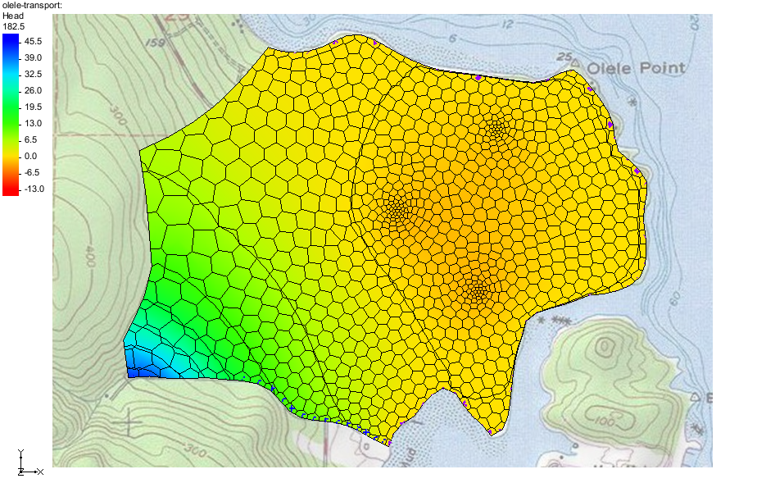

Figure 1 Imported MODFLOW 6 flow model

This model has a five-layer Voronoi UGrid with local refinement around three pumping wells. General heads have been set along the coastal boundary, and a river boundary condition exists along the lower left of the model. The no-flow boundary to the left occurs as the aquifer thins and the no-flow boundary in the upper left of the model is a parallel flow boundary.

The five model layers are discontinuous and can be viewed by turning on the *Single layer* option in the *Mini-Grid Toolbar* and changing the layer values. A total of 2627 elements are used in this 3D grid.

Before continuing, save the project with a new name.

1. Select *File* | **Save As…** to bring up the *Save As* dialog.
2. Browse to the directory for this tutorial.
3. Enter “olele_transport.gpr” as the *File name*.
4. Select “Project Files (*.gpr)” from the *Save as type* drop-down.
5. Click **Save** to save the project file and close the *Save As* dialog.

# Enable Groundwater Transport

MODFLOW 6 transport simulations use the GWT model. To set up this model, complete the following:

1. Right-click on “File:MF6 Simulation.svg olele-transport” and select *New Package* | **GWT** to bring up the *New Groundwater Transport (GWT) Model* dialog.
2. Under *GWT – Groundwater Transport Model,* select the following options:
   * *CNC – Constant Concentration*
   * *SSM – Source and Sink Mixing*
   * *MDT – Matrix Diffusion*
3. Click **OK** to close the *New Groundwater Transport (GWT) Model* dialog.

# Defining the MST Package

The parameters for the MST transport package can now be defined.

1. Double-click on the “File:Mf6package.svg MST” package to bring up the *Mobile Storage and Transfer (MST) Package* dialog.
2. Select the POROSITY tab and enter a *Constant* of “0.4”. This is the effective porosity used for transport. This value is based on our conceptual model where the overall porosity is 0.4, but the flow only occurs in 20% of the material (the high-K fraction).
3. Select the *BULK_DENSITY* tab and turn on *Define*.
4. Enter a *Constant* of “1.6”. This is the dry bulk density value used for adsorption.
5. Select the *DISTCOEF* tab and turn on *Define*.
6. Enter a *Constant* of “0.05”. This value will give a retardation factor R=2.
7. Click **OK** to close the *Mobile Storage and Transfer (MST) Package* dialog.

# Defining a CNC Package

Next to impose a time-dependent prescribed concentration for a single cell.

1. Double-click on the “File:Mf6package.svg CNC” package to bring up the *Constant Concentration (CNC) Package* dialog.
2. Click **Add Rows** File:Row-add.svg to open the *Add Stresses* dialog.
3. For the *CELLID* row in the *Value* column, enter “886”.
4. For the *CONC* row in the *Value* column, enter “1000”.
5. Click **OK** to close the *Add Stresses* dialog.
6. Change the *Period* to “2”.
7. Click the **Define Period** File:Add Note Icon.svg button to bring up the *Define Period* dialog.
8. Ensure that *Copy from previous period (1)* is selected and click **OK** to close the *Define Period* dialog.
9. In the *CONC* column, change to “1”.
10. Click **OK** to close the *Constant Concentration (CNC) Package* dialog.

This will maintain the concentration in cell 886 at a value of 1000 µg/L for 10 years, and then will switch it to a value of 1 µg/L for the remaining 90 years of the simulation. This is intended to simulate a contaminant source that is removed (mostly) after 10 years.

# Defining the MDT Package

With the MDT package activated, the parameters for the MDT package can now be defined.

1. Double-click on the “File:Mf6package.svg MDT” package to bring up the *Matrix Diffusion Transport (MDT) Package* dialog.
2. On the *MD_TYPE_FLAG* tab, set the *Constant* value to “2”.

This variable is a flag that tells the MDT package how matrix diffusion will be handled. Choosing a value of 2 tells the package to allow matrix diffusion into embedded low permeability zones with a finite diffusion length.

1. On the *MD_FRACTION* tab, set the *Constant* value to “0.2”.

This is the volume fraction of high-K material in each cell.

1. On the *MD_POROSITY* tab, set the *Constant* value to “0.4”.

This sets the porosity of the low-K material.

1. On the *BULK_DENSITY* tab, set the *Constant* value to “1.6”.

This is the dry bulk density of the low-K material.

1. On the *MD_DIFF_LENGTH* tab, set the *Constant* value to “1.64”.

This is the characteristic diffusion length in the low-K material in each cell. The value here was chosen to be 0.5m, but since the dimensions of this model are in feet, the value is converted to units of feet. More information on the estimation of the diffusion length is available in the REMChlor-MD User’s Guide1.

1. On the *MD_TORTUOSITY* tab, set the *Constant* value to “0.3”.

This sets thetortuosity of the low-K material in each cell.

1. On the *MD_DIST_COEFF* tab, set the *Constant* value to “0.0”.
2. On the *MD_DECAY* tab, set the *Constant* value to “0.25”.
3. On the *MD_DIFF_COEFF* tab, set the *Constant* value to “9.3e-4”.

This defines the TCE diffusion coefficient, ft2/d due to the choice of units in this model

1. Under *Sections*, turn on *OPTIONS.*
2. Under *OPTIONS*, turn on *SORPTION*.
3. Click **OK** to close the *Matrix Diffusion Transport (MDT) Package* dialog.

# Output Control

To specify the output options:

1. Double-click on the “File:Mf6package.svg OC” package under the “File:MF6 GWT Model.svg trans” model to bring up the *Output Control (OC) Dialog*.
2. Change the *Preset output* option to “At every time step”.
3. Click **OK** to exit the *Output Control (OC) Dialog*.

# Linking the Simulations

1. Right-click on “File:MODFLOW Folder.svg olele-transport” and select *New Package* | **GWF-GWT**.

The “GWF-GWT” item will appear in the Project Explorer. There are no options that need to be set with the GWF-GWT exchange. Still, the GWF-GWT exchange requires that the models it is exchanging for are specified.

1. Double-click on “File:MODFLOW Folder.svg olele-transport” to open the *Simulation Options* dialog.
2. Under *Sections*, turn on the *EXCHANGES* option.
3. Under the *EXCHANGES* section near the bottom, click the field under *EXGMNAMEA* to open the *Select Model* dialog.
4. Select the “16-mf6 GWF_Model” model and click **OK** to close the *Select Model* dialog.
5. Click the field under *EXGMNAMEB* to open the *Select Model* dialog.
6. Select the “ trans” model and click **OK** to close the *Select Model* dialog.
7. Under *Sections*, turn on the *SOLUTIONGROUPS* option.
8. Click the field under *SLNMNAMES* to open the *Select Model(s)* dialog.
9. Select the “ trans” model to add it and click **OK** to close the *Select Model(s)* dialog.
10. Click **OK** to close the *Simulation Options* dialog.
11. **Save** File:Save Macro.svg the project.

# Saving and Running MODFLOW 6

It is now possible to run MODFLOW:

1. Right-click on “File:MODFLOW Folder.svg olele-transport” and select **Save Simulation**
2. Right-click on “File:MODFLOW Folder.svg olele-transport” and select **Run Simulation** to bring up a warning message.

Because a solution was already loaded into the project, this solution will have to be unloaded in order for MODFLOW 6 to run.

1. Click **OK** to close the warning dialog and start the *Simulation Run Queue* model wrapper dialog.

The *Simulation Run Queue* shows all simulation model runs currently in progress. Since this project only has one simulation, only one is shown.

1. When MODFLOW 6 finishes, click **Load Solution**.
2. Click **Close** to exit the *Simulation Run Queue* dialog.

# Examining the Results

Next to make some adjustments to improve the appearance of the Concentration contours.

1. In the Project Explorer, select the “File:Dataset Cells Active.svg Concentration” dataset to make it active.
2. Click the **Display Options** File:Display Options Macro.svg macro to open the *Display Options* dialog.
3. Next to *Face contours* click *Options* to open the *Dataset Contour Options – UGrid – Concentration* dialog.
4. Under *Contour Method* select “Color Fill and Linear” and “Use color ramp”.
5. Click the **Color Ramp** button to open the *Color Options* dialog.
6. Select **Reverse** in the *Palette preview* section.
7. Click **OK** to close the *Color Options* dialog
8. Under *Data range*, turn on *Specify a range* and enter a “1” for *Min* and “1000” for *Max*.
9. Turn off the *Fill below* and *Fill above* boxes.
10. Under *Contour interval* select “Specified Values” and enter “3”.
11. Turn off the *Fill continuous color range* option.
12. In the *End Value* column, enter “10” for row *1*and enter “100” for row *2*.
13. Click **OK** to exit the *Dataset Contour Options* dialog.
14. **OK** to exit the *Display Options* dialog.
15. In the *Time Steps* Window, scroll though the time steps.

This is 20 years after the source has been removed. The plume is discharging into the ocean and also migrating towards two of the extraction wells (in layer 5 where the wells are screened).

# Conclusion

This concludes the tutorial. Here are the key concepts from this tutorial:

The MODFLOW 6 MDT package can be used to simulate matrix diffusion in heterogeneous porous media for cases where diffusion occurs at the sub-grid block scale.

Normal grid elements are used with embedded matrix diffusion occurring over a finite distance in the matrix material in each element.

1. Farhat, S.K., C.J. Newell, R.W. Falta, and K. Lynch, 2018. REMChlor-MD User’s Manual, developed for the Environmental Security Technology Certification Program (ESTCP) by Clemson University, Clemson, SC and GSI Environmental Inc., Houston, TX, <https://www.serdp-estcp.org/Program-Areas/Environmental-Restoration/Contaminated-Groundwater/Persistent-Contamination/ER-201426>
2. Falta, R.W., and W. Wang, 2017, A semi-analytical method for simulating matrix diffusion in numerical transport models, J*ournal of Contaminant Hydrology, V. 197, p. 39-49.*
3. Muskus, N., and R.W. Falta, 2018, Semi-analytical method for matrix diffusion in heterogeneous and fractured systems with parent-daughter reactions, *Journal of Contaminant Hydrology*, *V. 218, p. 94-109.*
4. Panday, S., R.W. Falta, S. Farhat, K. Pham, and A. Lemon, 2021, Matrix Diffusion Transport (MDT) Process for MODFLOW-USG Transport, <https://www.gsienv.com/product/modflow-usg/>