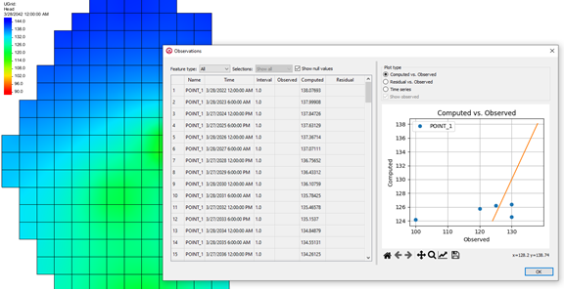

GMS 10.9

GMS 10.9 Tutorial

***MODFLOW 6 – PEST Observations, Transient***

Use PEST Observations with a Transient MODFLOW 6 Simulation

Objectives

Learn how to use PEST observations with a transient MODFLOW 6 simulation.

Time

* 15–25 minutes

Required Components

* GMS Core
* MODFLOW-USG Model & Interface

Prerequisite Tutorials

* Getting Started
* MODFLOW 6 – Grid Approach
* MODFLOW 6 – Conceptual Model Approach

|  |
| --- |
| 1 Introduction 2  2 Opening an Existing MODFLOW 6 Model 2  3 Examine the MODFLOW 6 Simulation 3  4 Adding Transient Head Observation Data 4  5 Adding Transient Flow Observation Data 5  6 Creating the PEST Observations Package 6  7 Saving and Running the Simulation 7  8 Examining the Solution 7  8.1 Statistics 7  8.2 Solution Coverages and Whisker Plots 8  8.3 Observation Plots 8  9 Using Dates/Times 9  9.1 TDIS Package 9  9.2 Observations 9  9.3 PEST Observations 10  10 Conclusion 10 |

# Introduction

PEST can be used for observations and calibration. This tutorial is based off the model from “CSUB Package Problem 4” from the MODFLOW 6 example problems. The model is transient with three stress periods.

In this tutorial, transient observation well points and flow arcs have been added in a GMS conceptual model. PEST utilities are used to determine computed head and flow at measured times and at MODFLOW output times. Some considerations for transient data are discussed. For a steady-state example, refer to the “MODFLOW 6 – PEST Observations, Steady State” tutorial.

GMS includes additional observation features beyond what comes with MODFLOW 6, including observations at arbitrary locations and times, comparison of observed and computed values, whisker plots, and other plots. This functionality is done with the help of utility programs that come with PEST, and is very similar to the observation functionality GMS provides for MODFLOW-USG. GMS prepares the input files needed by the PEST utilities to determine the computed values from the model solution. For more information about using PEST with MODFLOW-USG, refer to the “MODFLOW-USG – Calibration” tutorial.

This tutorial discusses and demonstrates:

* Adding transient head observation data.
* Adding transient flow observation data.
* Setting up the PEST Observation package.
* Saving and running the MODFLOW 6 simulation.
* Reviewing the solution.

# Opening an Existing MODFLOW 6 Model

Start with opening an existing MODFLOW 6 model:

1. If necessary, launch GMS.
2. If GMS is already running, select the *File |* **New** command to ensure that the program settings are restored to their default state.
3. Click **Open** File:Open Macro.svg to bring up the *Open* dialog.
4. Select “Project Files (*.gpr)” from the *Files of type* drop-down.
5. Browse to the *mf6_pest_obs_transient* folder and select “start.gpr”.
6. Click **Open** to import the project and exit the *Open* dialog.

The project should be visible in the Graphics Window (Figure 1). The project contains a MODFLOW 6 simulation.

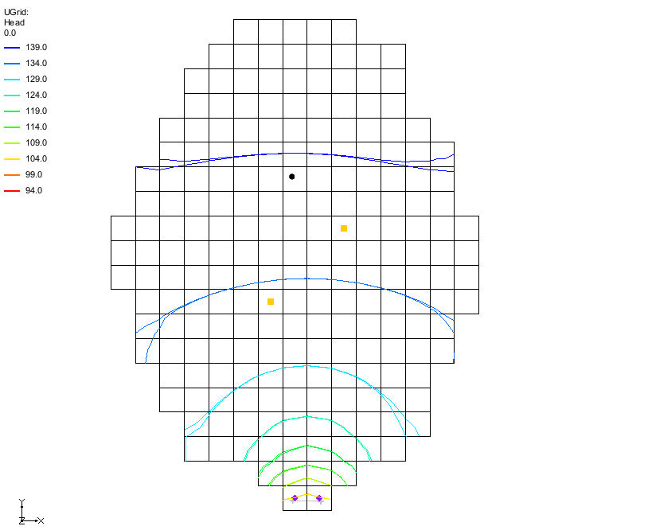

Figure Initial project for the MODFLOW-USG model

Before continuing, save the project under a different name:

1. Select *File* | **Save As…** to open the *Save As* dialog.
2. For the *File Name*, enter “pest_obs_trans”.
3. Click **Save** to close the *Save As* dialog and save the new files.

# Examine the MODFLOW 6 Simulation

The tutorial example has an aquifer system consisting of an unconfined upper aquifer, an extensive confining unit, and a confined lower aquifer. The example uses two layers to represent the water-table aquifer. It uses one layer to represent the confining unit and one layer to represent the lower aquifer. The recharge package is used to simulate inflow to the flow system. The inflow throughout the entire simulation is at a rate of 5.5x10-4 meters per day. Since the model is under steady-state conditions, all of the flow exits the system at eight constant-head cells, two of which are in each layer at the bottom of the model. The eight constant-head cells have head values specified to be 100 meters. During stress period 2, each of the two wells draw water from the upper and lower aquifer at a rate of 72,000 cubic meters per day. ([MODFLOW 6 – Example problems](https://modflow6-examples.readthedocs.io/en/master/_examples/ex-gwf-csub-p04.html))

1. In the Project Explorer, double-click on the “File:Mf6package.svgTDIS” package to open the *Temporal Discretization (TDIS) Package* dialog.

The example simulation contains three stress periods. The first stress period is an initial steady-state stress period used for computing the head distribution. The second stress period is used to simulate 60 years of pumping by the two wells. The third stress period is used to simulate 60 years of recovery following cessation of pumping. The second and third stress periods are divided into 60, 1-year time steps.

1. Click **Cancel** to close the *Temporal Discretization (TDIS) Package* dialog.
2. In the Project Explorer, select the “File:Dataset Cells Active.svg Head” dataset.
3. Scroll through the different time steps in the Time Step Window.

Notice how the head contours change.

# Adding Transient Head Observation Data

Two coverages exist, one called “File:Coverage Active Icon.svg sources and sinks” which includes an arc at the bottom of the model to define the CHD cells, and one called “File:Coverage Active Icon.svg observation wells” which includes one feature point that is to be used as an observation well. This section shows how to set up the observation well. To do this:

1. Select the “File:Coverage Active Icon.svg observation wells” coverage to make it active.
2. Double-click on the “File:Coverage Active Icon.svg observation wells” coverage to open the *Coverage Setup* dialog.
3. Under the *Observation Points* section, turn on the *Trans. Head* option.
4. Click **OK** to close the *Coverage Setup* dialog.
5. Using the **Select Points/Nodes** File:GMS Select Node Tool.svg tool, double-click on the feature point to open the *Attribute Table* dialog.

The “File:Coverage Active Icon.svg observation wells” coverage has only one feature point.

1. In the first row of the table, change the *Type* column to “obs. pt”.
2. Check that the *Layer* column is set to “1”.
3. Click the Dot dot dot button.png button under the *Obs. Trans. Head* column to open the *XY Series Editor* dialog.
4. Click the **Import** button to bring up the *Open File* dialog.
5. Browse to the directory for the tutorial files and select the “obs_trans_head.xys” file.
6. Click **Open** to import the observation transient head values.

The MODFLOW simulation does not use a starting date so the observation data does not either. The times are in days.

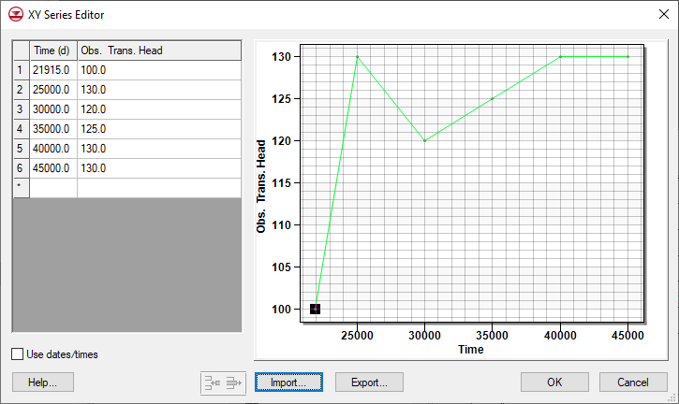

Figure The observation transient head data

1. Click **OK** to close the *XY Series Editor* dialog.
2. Click **OK** to close the *Attribute Table* dialog.

# Adding Transient Flow Observation Data

This tutorial seeks to know how much flow is passing through the CHD cells. To enable the CHD arc to be used as a flow observation arc:

1. Select the “File:Coverage Active Icon.svg sources and sinks” coverage to make it active.
2. Double-click on the “File:Coverage Active Icon.svg sources and sinks” coverage to open the *Coverage Setup* dialog.
3. Under the *Source/Sinks/BCs* section, turn on the *Trans. Observed Flow* option.
4. Click **OK** to close the *Coverage Setup* dialog.
5. Using the **Select Arcs** File:GMS Select Arc Tool.svg tool, double-click on the feature arc to open the *Attribute Table* dialog.

The “File:Coverage Active Icon.svg sources and sinks” coverage has only one feature arc.

1. In the first row of the table, turn on the *Obs. flow* option.
2. Click the Dot dot dot button.png button under the *Obs. flow rate (m^3/d)* column to open the *XY Series Editor* dialog.
3. Click the **Import** button to bring up the *Open File* dialog.
4. Browse to the directory for the tutorial files and select the “obs_trans_flow.xys” file.
5. Click **Open** to import the observation transient flow values.

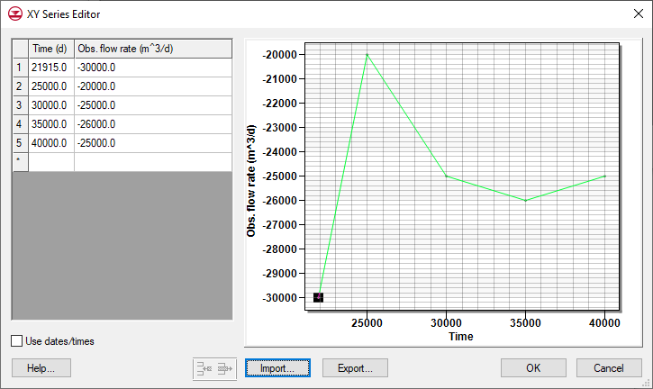

Figure The observation flow rate data

1. Click **OK** to close the *XY Series Editor* dialog.
2. Change the *Obs. Flow interval* to -2500.0.
3. Click **OK** to close the *Attribute Table* dialog.

# Creating the PEST Observations Package

To add the observation data to the MODFLOW 6 model, complete the following:

1. Right-click “File:MF6 GWF Model.svg ex-gwf-csub-p04” and select the *New Package* | **PEST Observations** command.

This adds a new component in the Project Explorer. It is not a MODFLOW 6 package, but a GMS component that uses PEST with MODFLOW 6 to determine computed values.

1. Double-click on the “File:Mf6package.svgPEST Observations” package item to open the *MODFLOW 6 PEST Observations* dialog.

This dialog is somewhat similar to the *MODFLOW-USG Observations* dialog. Here the PEST input files are created from the MODFLOW 6 simulation.

1. Click the **Generate PEST Observation Data…** button to open the *Generate Observations* dialog.
2. For the *Head observation coverages*, turn on “observation wells”.
3. For the *Flow observation coverages*, turn on “sources and sinks”.
4. Click **OK** to close the *Generate Observations* dialog.
5. Click **OK** to close the error message that appears.
6. In the *Errors* tab of the *MODFLOW 6 PEST Observations* dialog, review the errors.

There should be one error: “Observation time outside of MODFLOW output time range. Coverage: observation wells; Feature type: point; Id: 1; Name: point_1; Time: 45000.0;” One of the observed values occurs after the end of the simulation. While it is possible to remove that observation, for this tutorial ignore it as it won’t affect the results.

1. Click the **Files** tab.

Take a moment to click on the different files in the list of files on the left and examine what they are and the file contents. These are the files that PEST uses to calculate the observed values. The files can be edited but it is almost never necessary to do so.

Although the MODFLOW simulation and the observation data are not using dates and times, PEST always uses dates and times. PEST uses January 1, 1950 as time zero if no other date is provided.

1. Click **OK** to exit the *MODFLOW 6 PEST Observations* dialog.

# Saving and Running the Simulation

Now to save and run the simulation again:

1. Right-click on “File:MODFLOW Folder.svg ex-gwf-csub-p04” and select **Save Project, Simulation and Run** to start the *Simulation Run Queue* dialog.
2. If it appears, click **OK** on the *Info* dialog to unload the previous solution.
3. Click **Load Solution** to import the solution files.
4. Click **Close** to exit the *Simulation Run Queue* dialog.

Several things just happened:

* When the simulation was saved, GMS saved the PEST input files with the simulation along with some batch files used to run PEST.
* When the simulation was run, MODFLOW calculated the head and flow solutions.
* When the solution was read, GMS ran some PEST utilities using the input files and batch files. PEST used the model solution to determine the computed values at the observation points. GMS read the PEST output and added the data to the solution as it was imported.

# Examining the Solution

Now to examine the results of the PEST observations using statistics tools, whisker plots, and observation plots.

## Statistics

Notice that in addition to the “File:Dataset Cells Active.svg Head” dataset, there are some PEST related items including links to two coverages and a “pest_obs_stats.txt” file.

1. Expand the “solution Solution” item and the “File:Generic Folder.svg ex-gwf-csub-p04” item below it.
2. Double-click the “ pest_obs_stats.txt” file to open the file in a text editor.

This file contains observation statistics similar to the statistics that can be found by right-clicking on a MODFLOW-USG solution.

## Solution Coverages and Whisker Plots

Now look at the solution coverages and whisker plots:

1. In the Project Explorer, turn off the “File:Ugrid-icon.png UGrid” to see the coverages better.
2. Under “File:Map Folder.svg Map Data”, expand both the “solution ex-gwf-csub-p04 (MODFLOW 6)” item and the “File:Generic Folder.svgex-gwf-csub-p04” item.
3. Select the “File:Coverage Active Icon.svg PEST obs arcs” coverage to make it active.

The whisker plot gives an indication of how well the observed flow to or from the river system matches the computed value. The “MODFLOW – Model Calibration” tutorial explains whisker plots.

1. Using the **Select Arcs** File:GMS Select Arc Tool.svg tool, click anywhere on the arc to select it.

Notice the data in the status bar at the bottom of the GMS window.

1. Select the “File:Coverage Active Icon.svg PEST obs points” coverage.

Again, the whisker plots indicate how well the computed and observed values match.

1. In the Project Explorer, select the “File:Dataset Cells Active.svg Head” dataset.
2. Scroll through the different time steps in the Time Step Window.

Notice how the whisker plot changes with the time steps.

## Observation Plots

To view an observation plot from the calibration data, complete the following:

1. Right-click the “File:Coverage Active Icon.svg PEST obs points” coverage and select the **Observations…** command to open the *Observations* dialog.

In the *Observations* dialog (Figure 4), the observation data is shown on the left, and a plot of the data is shown on the right.

1. Select the different plot types and examine the plots.
2. Turn off *Show null values* and see how it changes the plots.
3. Click **OK** to exit the *Observations* dialog.

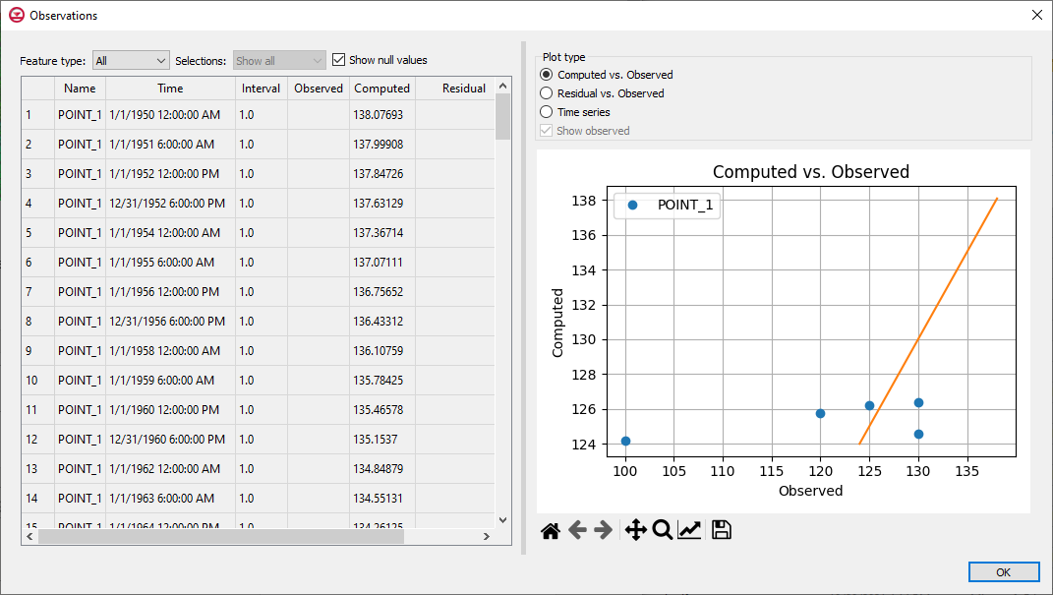

Figure  The Observations dialog

# Using Dates/Times

If wanting the model to use dates/times, use the steps in this section to change the TDIS package and the observation XY series.

## TDIS Package

Start with making changes to the TDIS package.

1. In the Project Explorer, right-click on the “File:Mf6package.svgTDIS” package and select **Unlock**.
2. Double-click on the “File:Mf6package.svgTDIS” package to open the *Temporal Discretization (TDIS) Package* dialog.
3. Under the *Sections* area of the dialog, turn on *OPTIONS*.
4. Turn on the *START_DATE_TIME* option.
5. Enter a date of “March 28, 2022”, or use the **Date/Time** button to select this date and time.

Notice how the *START_DATE_TIME* option affects the *ENDDATE* column.

1. Click **OK** to close the *Temporal Discretization* *(TDIS) Package* dialog.

## Observations

Now to turn on the date/time options for the observations by doing the following:

1. Select the “File:Coverage Active Icon.svg observation wells” coverage to make it active.
2. Using the **Select Points/Nodes** File:GMS Select Node Tool.svg tool, double-click on the feature point to open the *Attribute Table* dialog.
3. Click the Dot dot dot button.png button under the *Obs. Trans. Head* column to open the *XY Series Editor* dialog.
4. Turn on the *Use dates/times* option to bring up the *Reference Time* dialog.
5. Enter the same date and time used in the TDIS package: March 28, 2022, at 12:00:00 AM.
6. Click *Select* to close the *Reference Time* dialog
7. Click **OK** to close the *XY Series Editor* dialog.
8. Click **OK** to close the *Attribute Table* dialog.

In a similar manner, convert the XY series for the CHD observed flow arc to use dates/times.

1. Select the “File:Coverage Active Icon.svg source and sinks” coverage to make it active.
2. Using the **Select Arcs** File:GMS Select Arc Tool.svg tool, double-click on the feature arc to open the *Attribute Table* dialog.
3. Click the Dot dot dot button.png button under the *Obs. flow rate* column to open the *XY Series Editor* dialog.
4. Turn on the *Use dates/times* option to bring up the *Reference Time* dialog.
5. Enter the same date and time used in the TDIS package: March 28, 2022, at 12:00:00 AM.
6. Click *Select* to close the *Reference Time* dialog
7. Click **OK** to close the *XY Series Editor* dialog.
8. Click **OK** to close the *Attribute Table* dialog.

## PEST Observations

The PEST files now need to be regenerated.

1. Double-click on the “File:Mf6package.svgPEST Observations” package item to open the *MODFLOW 6 PEST Observations* dialog.
2. Click the **Generate PEST Observation Data…** button to open the *Generate Observations* dialog.
3. For the *Head observation coverages*, turn on “observation wells”.
4. For the *Flow observation coverages*, turn on “sources and sinks”.
5. Click **OK** to close the *Generate Observations* dialog.
6. Click **OK** to close the error message that appears.
7. In the *Errors* tab of the *MODFLOW 6 PEST Observations* dialog, review the errors.

This is the same error that was seen before but now reported using a date/time.

1. Click **OK** to close the *MODFLOW 6 PEST Observations* dialog.
2. Right-click on “File:MODFLOW Folder.svg ex-gwf-csub-p04” and select **Save Project, Simulation and Run** to start the *Simulation Run Queue*.
3. If it appears, click **OK** on the *Info* dialog to unload the previous solution.
4. Click **Load Solution** to import the solution files.
5. Click **Close** to exit the *Simulation Run Queue*.
6. In the Project Explorer, select the “File:Dataset Cells Active.svg Head” dataset to make it active.
7. Turn on *Show dates/times* in the Time Step window.

Notice the time steps start at March 28, 2022. Examine the observation data in the solution coverages as before and notice that now the dates start at March 28, 2022.

# Conclusion

This concludes the “MODFLOW 6 – PEST Observations, Transient” tutorial. The following topics were discussed and demonstrated:

* Adding transient head and transient flow observation data.
* Adding the PEST Observation Package to MODFLOW 6.
* Running MODFLOW 6 with PEST.
* Reviewing the PEST solution.
* Adding dates and times to show in the model.