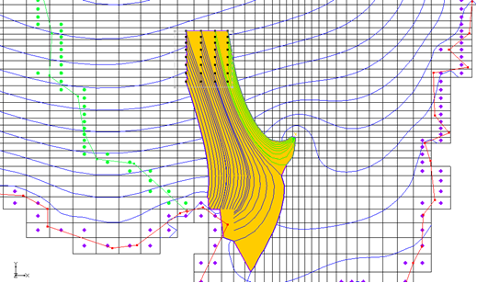

GMS 10.9

GMS 10.9 Tutorial

***MODPATH***

The MODPATH Interface in GMS

Objectives

This tutorial shows how to set up a MODPATH simulation in GMS and view the results. It instructs about assigning porosity, creating starting locations, displaying pathlines in different ways, and displaying capture zones.

Time

* 20–40 minutes

Required Components

* GMS Core
* MODFLOW Interface
* MODPATH/MP3DU Interface

Prerequisite Tutorials

* MODFLOW – Conceptual Model Approach I

|  |
| --- |
| 1 Introduction 2  1.1 Description of the Problem 2  2 Getting Started 3  2.1 Importing the Project 3  2.2 Turning on the MODPATH Menu 3  3 Assigning the Porosities 4  4 Defining the Starting Locations 4  4.1 Viewing the Pathlines in Cross Section View 5  5 Display Options 6  6 Particle Sets 6  6.1 Particle Sets Dialog 6  6.2 Duplicating Particle Sets 7  6.3 Changing the Display Order 7  7 Tracking Particles from the Landfill 8  7.1 Creating a New Particle Set 8  7.2 Defining the New Starting Locations 8  7.3 Capturing Landfill Particles at the Well 10  8 Color by Zone Code 11  9 Pathline Length/Time 11  10 Capture Zones by Zone Code 12  11 Conclusion 13 |

# Introduction

This tutorial describes the steps involved in setting up a MODPATH simulation in GMS. MODPATH is a particle-tracking post-processing model developed by the U.S. Geological Survey. It tracks the trajectory of a set of particles from user-defined starting locations using the MODFLOW solution as the flow field. The particles can be tracked either forward or backward in time. Particle tracking solutions have a variety of applications, including the determination of zones of influence for injection and extraction wells.

This tutorial covers how to open a MODFLOW Conceptual Model project, create pathlines from various starting locations, edit the particle sets, edit zone codes, and view capture zones.

## Description of the Problem

The problem discussed in this tutorial is an extension of the one described in the “MODFLOW – Conceptual Model Approach”tutorial. In thattutorial, a site in East Texas was modeled. The solution from that model is used as the flow field for the particle tracking simulation. The model includes a proposed landfill.

For this tutorial, two particle tracking simulations will be performed to analyze the long-term effects of contamination from the landfill. First, one simulation will use reverse particle tracking from the well on the east side of the model to see if the zone of influence of the well overlaps the landfill. Another simulation will use forward tracking using an array of particles starting at the landfill to analyze the region of potential contamination for the landfill.

# Getting Started

To get started, do the following:

1. Launch GMS.
2. If GMS is already running, select *File* | **New…** to ensure the program settings are restored to their default state.

## Importing the Project

To import the project, which includes the MODFLOW model and solution, as well as all other files associated with the model, do the following:

1. Click **Open** File:Open Macro.svg to bring up the *Open* dialog.
2. Browse to the *modpath\start* directory and select “modfmap2.gpr”.
3. Click **Open** to import the project file and close the *Open* dialog.

The Graphics Window should appear similar to Figure 1.

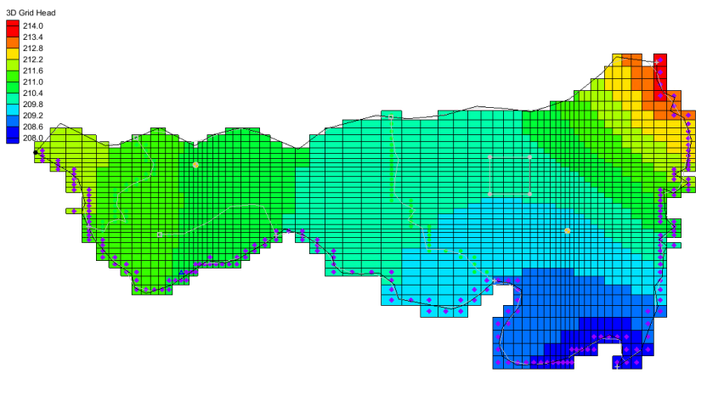

Figure 1 Initial appearance of the Graphics Window

## Turning on the MODPATH Menu

If the MODPATH menu is not visible, do the following:

1. Select *Edit |* **Model Interfaces…** to bring up the *Model Interfaces* dialog.
2. Below *Models to use in project,* turn on *MODPATH*.
3. Click **OK** to close the *Model Interfaces* dialog.

The menu should now be visible.

# Assigning the Porosities

At this point, it is possible to create particles. A porosity value must first be defined for each of the cells in the grid in order to calculate the tracking times. By default, GMS automatically assigns a porosity of “0.3” to all the cells in the grid. This value is acceptable, so nothing needs to be done.

If a different porosity is desired, the value can be set three different ways:

* Porosities can be assigned to the polygons in the conceptual model, followed by right-clicking and selecting *Map To* | **MODFLOW/MODPATH**.
* When in the 3D Grid module, select MODPATH | **Porosity…** to bring up the *Aquifer Layer Porosity* dialog. This dialog allows for editing a spreadsheet of values.
* When in the 3D Grid module, select one or more grid cells, then right-click and select **Properties…** to bring up the *3D Grid Cell Properties* dialog. This dialog allows editing of various values, including the porosity of the selected cells.

# Defining the Starting Locations

It is necessary to create a set of particle starting locations surrounding the cell containing the well on the east (right) side of the model.

To generate the starting locations:

1. In the Project Explorer, right-click “File:3D Grid Folder.svg 3D Grid Data” and select **Expand All** so everything within the folder is visible.
2. Select *MODPATH |* **Create Particles at Wells…** to bring up the *Generate Particles at Wells* dialog.
3. Fo*r Number of particles per well,* enter “20”.
4. In the *Well Type* section, select *Extraction wells*.
5. Click **OK** to close the *Generate Particles at Wells* dialog.

At this point, GMS does the following:

* Creates particles at every cell that contains an extraction well.
* Extends a set of pathlines from each well in the direction the particles will flow. Notice that the pathlines from the east well extend to the northeast and miss the area covered by the proposed landfill (the gray square to the northwest of the east well, see Figure 1).

The particles and pathlines extending from the west (left) well are not needed and can be deleted by doing the following:

1. Using the **Select Particle Starting Locations** File:Select Particle Start Location Tool.svg tool, drag a box surrounding the west well.

This selects all the particle and pathlines from that well.

1. Press the *Delete* key to delete these particles and pathlines.
2. **Frame** File:Frame Macro.svg the project.

The Graphics Window will appear similar to Figure 2.

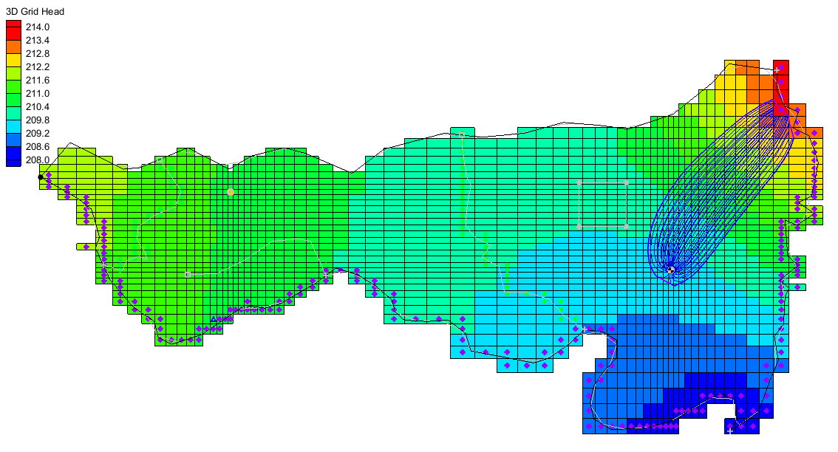

Figure 2 After west well pathlines and particles are deleted

## Viewing the Pathlines in Cross Section View

The 3D nature of the pathlines is best seen in cross section view.

1. Using the **Select Cells** File:Select 3D Cell Tool.svg tool, select a cell near the right side of the landfill.
2. Switch to **Side View** File:Side View Macro.svg.

The project should appear similar to Figure 3. If desired, move back and forth through the columns using the arrows GMS Mini-grid Toolbar arrows in the Mini-Grid Toolbar.

1. When finished, switch back to **Plan View** File:Plan View Macro.svg to return to the top-down view.
2. Click anywhere outside the grid to deselect the cell.

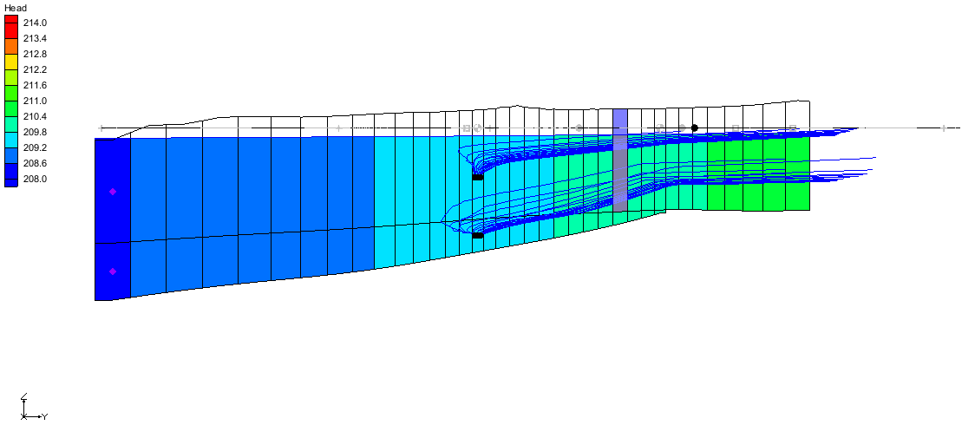

Figure 3 Particle path lines in side view near the landfill

# Display Options

In addition to displaying the pathlines, GMS can draw a closed boundary around the pathlines connected to the well. This boundary is referred to as a “capture zone.” Capture zones can only be displayed in plan view. GMS has a number of options for the display of pathlines and capture zones.

1. Select *MODPATH* | **Display Options…** to open the *Display Options* dialog.
2. Select “3D Grid Data” from the list on the left.
3. On the *Particles* tab, turn on *Direction arrows*.
4. In the *Time interval* field, enter “2000.0”.
5. In the *Capture zones* section, turn on *Boundary* and *Poly fill*.
6. Click **OK** to close the *Display Options* dialog.

There are now arrows on the pathlines pointing in the direction of flow, and the capture zone is filled with a solid color.

# Particle Sets

GMS organizes starting locations into “particle sets”. When the starting locations at the wells were created, GMS automatically created a particle set and put the new starting locations in it.

1. In the Project Explorerunder the“File:3D Grid Folder.svg 3D Grid Data” folder and “File:3D Grid Icon.svg grid” item, expand the “File:Generic Folder.svg Particle Sets” folder, if it is not already expanded.
2. Right-click on “File:Particle Set Icon.svg particle set” and select **Properties…** to bring up the *Particle Sets* dialog.

## Particle Sets Dialog

In this dialog, changes are made to the particle set properties, including the tracking direction and the tracking duration. One particle set is always designated as the active particle set. Whenever new points are created, they are added only to the active particle set. Similarly, only points from the active particle set can be deleted.

By default, the tracking duration is set to track to the end, meaning MODPATH will track the particles until they run into something (e.g., a sink, the water table, the edge of the model). Now change the tracking duration to a specific value.

1. In the *Track* column, select “Duration” from the drop-down.
2. In the *Duration* column, enter “3000.0”.
3. Click **OK** to close the *Particle Sets* dialog.

Notice that the capture zone is much smaller now. The capture field should appear similar to Figure 4.

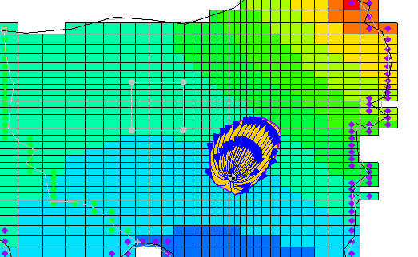

Figure 4 Capture field is greatly reduced in size

## Duplicating Particle Sets

The next step is to display a 1,500-day capture zone as well as a 3,000-day capture zone. First, turn the arrows off so they don’t obscure the display of the capture zones:

1. Select *MODPATH |* **Display Options…** to open the *Display Options* dialog.
2. Select “3D Grid Data” from the list on the left.
3. On the *Particles* tab, turn off *Direction arrows*.
4. Click **OK** to close the *Display Options* dialog.
5. Right-click “File:Particle Set Icon.svg particle set” and select **Rename**.
6. Type “3000 days” and press the *Enter* key to set the new name.

Create another particle set by copying the existing one, do the following:

1. Right-click “File:Particle Set Icon.svg 3000 days” and select **Duplicate** to create the “File:Particle Set Icon.svg Copy of 3000 days (2)” particle set.
2. Right-click “File:Particle Set Icon.svg Copy of 3000 days (2)” and select **Rename**.
3. Type “1500 days” and press *Enter* to set the new name.

When there are multiple particle sets, it is recommended to give each set an appropriate name in order to differentiate between the results.

1. Right-click “File:Particle Set Icon.svg 1500 days” and select **Properties…** to bring up the *Particle Sets* dialog.
2. On row *2*, in the *Duration* column, enter “1500.0”.
3. Click **OK** to close the *Particle Sets* dialog.

## Changing the Display Order

The order of the particle sets in the Project Explorer is the top-down order in which they are displayed. The “File:Particle Set Icon.svg 1500 days” set should be above the “File:Particle Set Icon.svg 3000 days” set because it is smaller and currently hidden below the “File:Particle Set Icon.svg 3000 days” set.

1. Click on the “File:Particle Set Icon.svg 1500 days” particle set and drag it above the “File:Particle Set Icon.svg 3000 days” particle set.

Two capture zones are now visible: the larger 3,000-day capture zone, and the smaller 1,500-day capture zone (Figure 5).

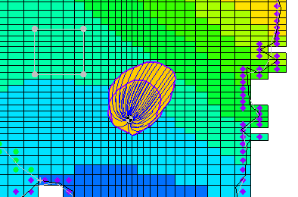

Figure 5 Both particle sets visible

# Tracking Particles from the Landfill

Next, perform forward tracking from a set of starting locations which coincide with the site of the proposed landfill.

## Creating a New Particle Set

Create a new particle set for the particles that will be created at the landfill by doing the following:

1. In the Project Explorer, right-click on the “File:Generic Folder.svg Particle Sets” folder and select **New Particle Set** to create a new “File:Particle Set Icon.svg particle set”.
2. Right-click “File:Particle Set Icon.svg particle set” and select **Rename**.
3. Type “Landfill” and press *Enter* to set the new name.
4. Right-click “File:Particle Set Icon.svg Landfill” and select **Properties…** to bring up the *Particle Sets* dialog.
5. From the *Direction* column drop-down on row *3,* select “Forward”.
6. Click **OK** to close the *Particle Sets* dialog.

## Defining the New Starting Locations

A new set of starting locations must be created at the site of the proposed landfill. The particles will be placed on the top of the ground water table to simulate leachate entering from the surface.

First, turn off the boundary fill option so the new pathlines are easier to see:

1. Select *MODPATH* | **Display Options…** to open the *Display Options* dialog.
2. Select “3D Grid Data” from the list on the left.
3. On the *Particles* tab in the *Capture zones* section, turn off the *Poly fill* option.
4. Click **OK** to close the *Display Options* dialog.

Before selecting the cells, make the recharge coverage the active coverage so that the landfill polygon is clearly visible.

1. In the Project Explorer*,* expand the “File:Map Folder.svg Map Data” folder and the “File:Conceptual Model Icon.svg East Texas” conceptual module.
2. Select the “File:Coverage Active Icon.svg Recharge” coverage to make it active.

To select the cells:

1. Using the **Select Polygons** File:GMS Select Polygon Tool.svg tool, select the landfill polygon (Figure 6).

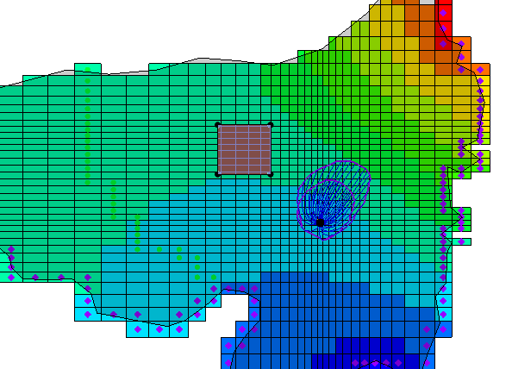

Figure 6 Landfill polygon

1. Right-click on the selected polygon and choose **Select Intersecting Objects…** to bring up the *Select Objects of Type* dialog.
2. Select **OK** to accept the defaults and close the *Select Objects of Type* dialog.

The 3D grid cells should now be selected.

1. Select *MODPATH |* **Create Particles at Selected Cells** to bring up the *Generate Particles* dialog.
2. From the *Distribute particles* drop-down, select “On water table surface”.
3. Turn off *More options*.
4. Click **OK** to close the *Generate Particles* dialog.
5. Click anywhere outside the grid to deselect the cells.

The model now has a set of pathlines starting at the landfill and terminating at the river (Figure 7).

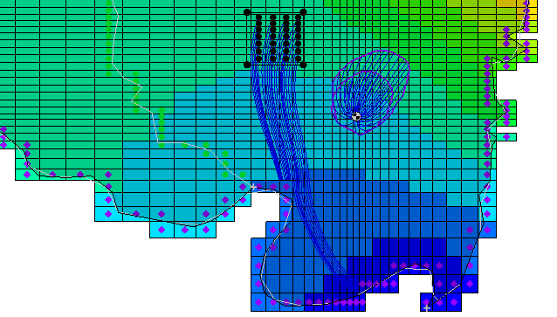

Figure 7 Pathlines from the landfill to the river

## Capturing Landfill Particles at the Well

Currently, no particles from the landfill are captured by the well. It’s necessary to increase the pumping rate in the well so that some of the particles from the landfill are captured.

1. In the Project Explorer, select “File:Coverage Active Icon.svg Sources&Sinks” to make it active.
2. Using the **Select Point/Node** File:GMS Select Node Tool.svg tool, double-click on the well on the right side of the model to open the *Attribute Table* dialog.
3. In the *Flow rate (m^3/d)* column, enter “-600.0”.
4. Click **OK** to close the *Attribute Table* dialog.
5. Select *Feature Objects |* **Map → MODFLOW** to bring up the *Map → Model* dialog.
6. Click **OK** to accept the defaults and close the *Map → Model* dialog.
7. Select *File |* **Save As…** to bring up the *Save As* dialog.
8. Enter “modpath.gpr” in the *File name* field.
9. Click **Save** to save the project and close the *Save As* dialog.
10. Select *MODFLOW |* **Run MODFLOW** to bring up the *MODFLOW* model wrapper dialog.

This shows the progress of MODFLOW.

1. When MODFLOW is finished, turn on *Read solution on exit* and *Turn on contours*.
2. Click **Close** to exit the *MODFLOW* dialog.

After the MODFLOW computed heads are imported into GMS, MODPATH will run again with the new MODFLOW solution. Notice that the capture zones for the well are larger than before and some of the particles from the landfill terminate at the well.

# Color by Zone Code

To easily identify the particles from the landfill that terminate at the well, it is useful to make them a different color.

First, turn off the display of the particles coming from the well.

1. In the Project Explorer, turn off “File:Particle Set Icon.svg 1500 days” and “File:Particle Set Icon.svg 3000 days”.
2. Switch to the **3D Grid** File:3D Grid Icon.svg module.

Now change the zone code for the cell containing the well:

1. In the Mini-Grid Toolbar, enter “2” in the *Lay (k)* field. 
2. Using the **Select Cells** File:Select 3D Cell Tool.svg tool, select the cell with the well in it. **Zoom**File:Zoom Tool Icon.svg in if needed.
3. Right-click on the selected cell and select **Properties…** to open the *3D Grid Cell Properties* dialog.
4. On the *MODFLOW* tab, in the *MODPATH Zone code* field, enter”2”.
5. Click **OK** to close the *3D Grid Cell Properties* dialog.
6. Select *MODPATH |* **Display Options…** to open the *Display Options* dialog.
7. Select “3D Grid Data” from the list on the left.
8. On the *Particles* tab, from the *Color* drop-down, select “Ending code”.
9. Click **OK** to close the *Display Options* dialog.

The pathlines that go from the landfill to the well should now be drawn in a different color (Figure 8).

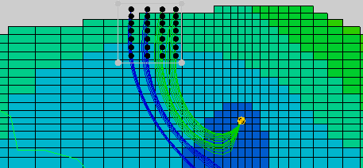

Figure 8 Pathlines going to well are different color

# Pathline Length/Time

One reason to do particle tracking is to find out how long it will take for particles to travel from one place to another. In this case, it is desirable to know how long it will take for particles to travel from the landfill to the well. GMS reports the length and travel time of selected pathlines.

1. Using the **Select Particle Starting Locations** File:Select Particle Start Location Tool.svg tool, click on one of the pathlines that goes from the landfill to the well.

Some statistics for the selected pathline are in the status bar at the bottom of the GMS window. One of the items is the time. Note the minimum time. Clicking on different pathlines one at a time and comparing their times could be done, but there’s a way to review combined data.

1. Using the **Select Particle Starting Locations** File:Select Particle Start Location Tool.svg tool, drag a box around all the start locations of pathlines going from the landfill to the well (**Zoom** File:Zoom Tool Icon.svg in if needed).

In the status bar at the bottom of the GMS window, notice the maximum, minimum, and average lengths and times for all the selected pathlines.

# Capture Zones by Zone Code

There is no closed boundary surrounding the pathlines originating from the landfill. By default, GMS only identifies capture zones for particles originating from wells. However, capture zones can be associated with particles originating from all cells with the same zone code.

This feature can be used to group several wells together in the same capture zone. For example, to know what the combined capture zone is for all the wells if there were several wells located close together in a well field.

This feature can also be used to show the “capture zone” for the landfill.

1. Select *MODPATH* | **Display Options…** to open the *Display Options* dialog.
2. Select “3D Grid Data” from the list on the left.
3. On the *Particles* tab in the *Capture zones* section, select *Delineate by zone code*.
4. Turn on *Poly fill*.
5. Click **OK** to close the *Display Options* dialog.

The capture zone for the landfill pathlines is now visible (Figure 9). Notice that the capture zone includes areas where there are no pathlines.

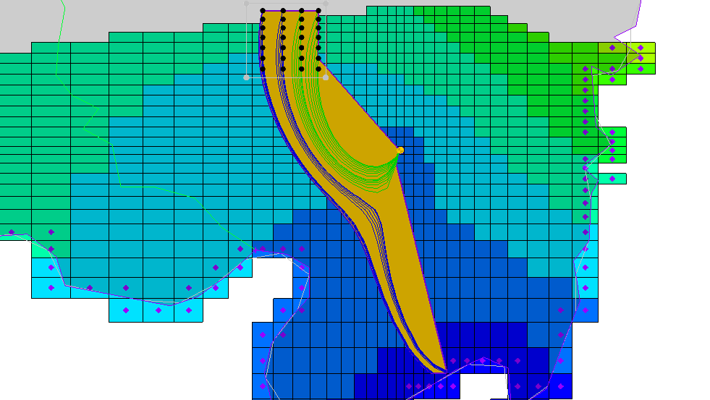

Figure 9 Capture zones including areas with no pathlines

To fix this, do as follows:

1. Select *MODPATH* | **Display Options…** to open the *Display Options* dialog.
2. Select “3D Grid Data” from the list on the left.
3. On the *Particles* tab, in the *Capture zones* section, in the *Thin triangle ratio* field, enter “0.9”.
4. Click **OK** to close the *Display Options* dialog.

The capture zone area should now appear similar to Figure 10.

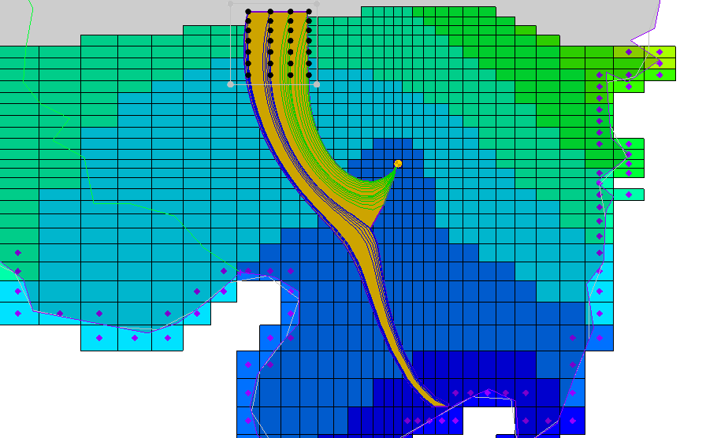

Figure 10 Modified capture zones

Notice how the boundary of the capture zone has been “sucked in” so that it corresponds more closely to the pathlines. This is what the thin triangle ratio does. If it is decreased too much, the capture zone will begin to look bad. The default was appropriate for the well capture zone seen earlier, but not for the landfill capture zone. This value may need adjusting to get a good-looking capture zone.

# Conclusion

This concludes the “MODPATH” tutorial. The following key concepts were discussed and demonstrated in this tutorial:

* MODPATH is available whenever a MODFLOW model is in memory. MODPATH requires a flow solution before pathlines can be computed.
* It is possible to create particle starting locations by using the **Generate Particles at Wells** or **Generate Particles at Selected Cells** commands.
* Particles are grouped into particle sets. Particle sets are used to control the tracking direction, the duration, and the display order.
* A number of different display options are available for pathlines, including displaying arrows, coloring by zone code, and displaying filled polygons representing capture zones (in plan view only).