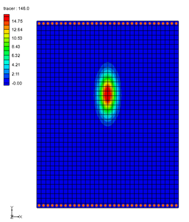

GMS 10.9

GMS 10.9 Tutorial

***MODFLOW – Advanced Transport***

MT3DMS dispersion, sorption, and dual domain options

Objectives

Learn about the dispersion, sorption, and dual domain options in MT3DMS.

Time

* 25–40 minutes

Required Components

* GMS Core
* MODFLOW Interface
* MT3D

Prerequisite Tutorials

* MT3DMS – Grid Approach

|  |
| --- |
| 1 Introduction 2  2 GMS User Interface 3  2.1 The Flow Model 3  3 Building the Transport Model 4  3.1 The Basic Transport Package 4  3.2 Saving the Project with a New Name 5  3.3 Defining the Initial Concentration 5  3.4 The Advection Package 6  3.5 Run Options 6  3.6 Run Options 6  3.7 Viewing the Solution 7  4 Adding Dispersion 8  4.1 The Dispersion Package 8  4.2 Saving the Simulation and Running MT3DMS 8  4.3 Viewing the Solution 9  5 Adding Sorption 9  5.1 Editing the Chemical Reaction Package 10  5.2 Saving the Simulation and Running MT3DMS 10  5.3 Viewing the Solution 10  6 Simulating Dual Domain Transport 11  6.1 Viewing the Solution 11  6.2 Saving the Simulation and Running MT3DMS 12  6.3 Viewing the Solution 12  7 Conclusion 13 |

# Introduction

This tutorial describes how to include some of the advanced transport options when performing an MT3DMS simulation within GMS. It also illustrates dispersion, sorption, and dual-domain transport.

The problem to be solved in this tutorial is a modification of the problem used in the “MT3DMS – Grid Approach” tutorial. However, the low K zone and the injection and extraction wells have been removed, leaving only a simple north-to-south, one-dimensional flow field as shown in Figure 1. The sides of the region are no-flow boundaries. The top and bottom are constant head boundaries. The initial condition for the plume consists of a small contaminant source zone near the upstream end of the model.

For this tutorial, four transport simulations will be run representing the following conditions:

Tracer transport: A simple advective flow.

Dispersion: Add dispersion and note the effect on the plume shape.

Sorption: Add dispersion, turn on sorption, and note the effect on the plume shape.

Dual domain: A dual domain simulation run where a separate set of transport options is specified for the mobile phase and the immobile phase.



Figure Sample flow and transport problem

# GMS User Interface

Do the following to get started:

1. If you have not yet done so, launch GMS.

If you have already been using GMS, select *File* | **New** to ensure the program settings are restored to the default state.

## The Flow Model

Before setting up the MT3DMS simulation, it is necessary to have a MODFLOW solution to be used as the flow field for the transport simulation. In the interest of time, import a previously created MODFLOW simulation.

1. Click **Open** File:Open Macro.svg to bring up the *Open* dialog.
2. Select “Project Files (*.gpr)” from the *Files of type* drop-down.

Browse to the *mt3dadv\mt3dadv* directory and select “flowmod.gpr”.

Click **Open** to import the project and exit the *Open* dialog.

Note that the head contours indicate a linear decrease in head from the north to the south (Figure 2).

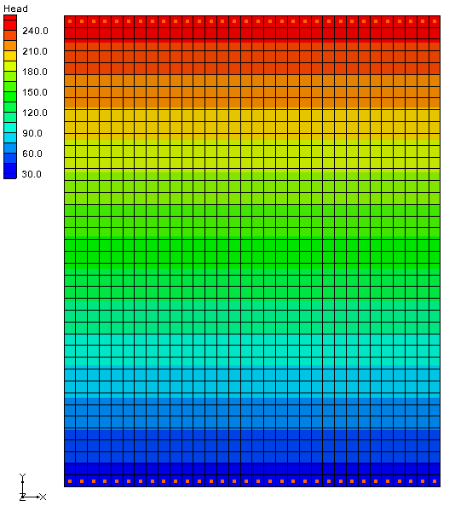

Figure Initial model showing linear decrease in head

# Building the Transport Model

With a flow solution imported, it is possible to set up the MT3DMS tracer transport simulation.

## The Basic Transport Package

First, initialize the MT3DMS simulation and set up the species:

1. Select *MT3DMS |* **New Simulation…** to open the *Basic Transport Package* dialog.

Click **Define Species…** to open the *Define Species* dialog.

Click **New** to create a new species in the spreadsheet.

Enter “tracer” in the *Name* column and click **OK** to close the *Define Species* dialog.

Next, select which packages to use.

Click **Packages…** to open the *MT3DMS/RT3D Packages* dialog.

Turn on *Advection package*, *Dispersion package*, and *Source/sink mixing package*.

Click **OK** to close the *MT3DMS/RT3D Packages* dialog.

The next step is to set up the stress periods. The flow simulation is steady state but the transport simulation will be transient. The simulation will be run for a one-year time period. To do this, use a single stress period (since the input values are constant) and allow MT3DMS to determine the appropriate transport step size.

Click **Stress Periods…** to bring up the *Stress Periods* dialog.

On row *1*, enter “365.0” in the *Length* column.

Scroll to the right and enter “0.0” in the *Trans. step size*.

A value of zero indicates that MT3DMS will automatically compute the appropriate transport step size.

Click **OK** to exit the *Stress Periods* dialog.

Specify the output options next:

Click **Output Control…** to open the *Output Control* dialog.

Select the *Print or save at specified times* option.

Click **Times*…*** to open the *Variable Time Steps* dialog.

Click **Initialize Values*…*** to open the *Initialize Time Steps* dialog.

For the *Initial time step size,* enter “18.25”.

For the *Maximum time step size,* enter“18.25”.

For the *Maximum simulation time,* enter “365”.

These values will result in 20 output time steps.

Click **OK** to close the *Initialize Time Steps* dialog.

Click **OK** to close the *Variable Time Steps* dialog.

Click **OK** to close the *Output Control* dialog.

Finally, it is necessary to define the porosity for the cells. This problem has a constant porosity of “0.3”. This is the default value in GMS, so no changes need to be made. The remaining options should remain at the default values for this tutorial.

1. Click **OK** to exit the *Basic Transport Package* dialog.

## Saving the Project with a New Name

Before continuing, save the project with a different name.

1. Select *File |* **Save As…** to bring up the *Save As* dialog.
2. Select “Project Files (*.gpr)” from the *Save as type* drop-down.

Enter “tracer.gpr” as the *File name*.

Click **Save** to save the project under the new name and close the *Save As* dialog.

## Defining the Initial Concentration

Next, edit the initial concentration for four of the cells near the top end of the model to define the initial state of the contaminant plume.

1. Hold the ctrl key down and select the cells “5,16,1”, “5,17,1”, “6,16,1”, and “6,17,1” (see Figure 3).

The cell indices (I,J,K) are displayed at the bottom of the GMS window.

Select *MT3DMS |* **Cell Properties…** to open the *3D Grid Cell Properties* dialog.

On the *MT3DMS* tab, in the lower section, enter “100.0” in the *tracer (mobile)* column on the *Starting conc.* row.

Click **OK** to close the *3D Grid Cell Properties* dialog.

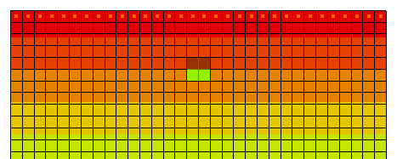

Figure 3 The four cells with initial contaminant concentrations

## The Advection Package

Now tell MT3DMS to always use the same MODFLOW solution to define the flow field. This allows saving the transport simulation under a different name without having to re-run MODFLOW.

1. Select *MT3DMS |* **Run Options…** to bring up the *Run Options* dialog.

Select *Single run with selected MODFLOW solution* and click **OK** to close the *Run Options* dialog.

## Run Options

The next step is to enter the data for the Advection package. This tutorial will use the *Third Order TVD scheme (ULTIMATE)* solution scheme. This is the default, so nothing needs to be changed.

## Run Options

It is now possible to save the simulation and run MT3DMS.

1. **Save** File:Save Macro.svg the project.

Select *MT3DMS |* **Run MT3DMS…**to bring up the *MT3DMS* dialog.

When the simulation is finished, turn on *Read solution on exit* and click **Close** to exit the *MT3DMS* dialog.

The model should appear similar to Figure 4.

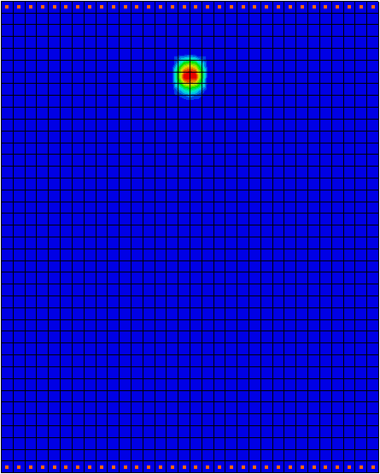

Figure 4 After the first MT3DMS run

## Viewing the Solution

To view the imported solution, do the following:

1. Fully expand the “File:3D Grid Folder.svg 3D Grid Data” folder in the Project Explorer.

Select the “File:Dataset Cells Active.svg tracer” dataset under the “File:Generic Folder Locked.svg tracer (MT3DMS)” solution.

Select the first time step (“18.25”) in the Time Step Window, then use the up and down arrows on the keyboard to step through the range of time steps associated with the solution.

Note that the plume does not spread out, but instead stays together as a concentrated slug of contaminant (Figure 5).

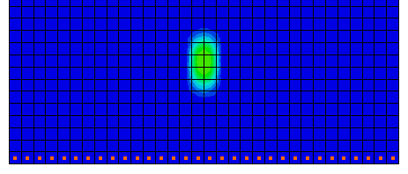

Figure Last time step, showing contaminants still concentrated together

# Adding Dispersion

Now add dispersion to the simulation to see how it affects the results.

## The Dispersion Package

Do the following to enter the data for the Dispersion package:

1. Select *MT3DMS |* **Dispersion Package…** to open the *Dispersion Package* dialog.

Click **Longitudinal Dispersivity…** to open the *Longitudinal Dispersivity* dialog.

Click **Constant → Grid…** to open the *Grid Value* dialog.

Enter “20.0” as the *Constant value for grid* and click **OK** to close the *Grid Value* dialog.

Click **OK** to exit the *Longitudinal Dispersivity* dialog.

In the spreadsheet on row *1*, enter “0.2” in both the *TRPT* and *TRVT* columns.

Click **OK** to exit the *Dispersion Package* dialog.

## Saving the Simulation and Running MT3DMS

Save the simulation under a different name and run MT3DMS.

1. Select *File |* **Save As…** to bring up the *Save As* dialog.
2. Select “Project Files (*.gpr)” from the *Save as type* drop-down.

Enter “dispersion.gpr” as the *File name*.

Click **Save** to save the project under the new name and close the *Save As* dialog.

Click **Run MT3DMS** File:Run MT3DMS Macro.svg to bring up the *MT3DMS* model wrapper dialog.

When MT3DMS finishes, turn on *Read solution on exit*.

Click **Close** to import the solution and exit the *MT3DMS* dialog.

## Viewing the Solution

Once again, do the following after reading in the solution:

1. Select the “File:Dataset Cells Active.svg tracer” dataset under the “File:Generic Folder Locked.svg dispersion (MT3DMS)” folder.

Select the first time step (18.25) in the Time Step Window.

Use the up and down arrows on the keyboard to step through the range of time steps associated with the solution.

Note that the plume still stays together as before, but spreads out a little more and dissipates more (Figure 6).

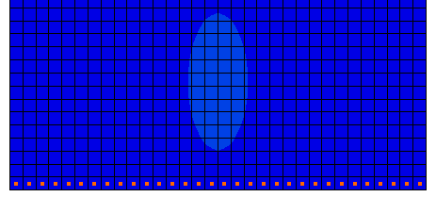

Figure 6 The contaminants dissipate more with dispersion (last time step)

# Adding Sorption

With the simple linear sorption option, the sorption and de-sorption of the contaminant is assumed to be a simple function of the contaminant concentration. The relationship between concentration and sorbed mass is defined by a linear isotherm. This theory assumes that the sorption is instantaneous. By contrast, a rate-limited sorption option is also available.

Turning on sorption has the effect of slowing the rate that the plume moves through the system. This effect can be expressed as a retardation factor that represents the ratio of the ground water flow rate to the plume migration rate. The retardation factor is computed as follows:



where:

❒ = bulk density

Kd = distribution coefficient (slope of the isotherm)

n = porosity

Note that the units used for  and Kd do not necessarily need to match the units used for the rest of the model, as long as they are consistent between  and Kd. The only place that these values are used is in the calculation of R.

## Editing the Chemical Reaction Package

The sorption options are specified in the Chemical Reaction package. Before editing the package data, it must first be turned on:

1. Select *MT3DMS |* **Basic Transport Package…** to open the *Basic Transport Package* dialog.

Click **Packages…** to open the *MT3DMS/RT3D Packages* dialog.

Turn on *Chemical reaction package* and click **OK** to exit the *MT3DMS/RT3D Packages* dialog.

Click **OK** to exit the *Basic Transport Package* dialog.

Now enter the sorption parameters:

Select *MT3DMS |* **Chemical Reaction Package…** to open the *Chemical Reaction Package* dialog.

In the first section, select “Linear isotherm” from the *Sorption* drop-down.

In the second section, enter “1600.0” as the *Bulk density*.

These units represent [kg/m3]. Note that this does not agree with the standard units for the model, but these units only need to agree with the Kd (first sorption constant) units.

In the spreadsheet, enter “0.0001154” in the *tracer* column of the *1st sorption const.* row.

Click **OK** to exit the *Chemical Reaction Package* dialog.

Note that these two values should result in a retardation factor of “2.0”.

## Saving the Simulation and Running MT3DMS

Now save the simulation under a different name and run MT3DMS.

1. Select *File |* **Save As…** to bring up the *Save As* dialog.
2. Select “Project Files (*.gpr)” from the *Save as type* drop-down.

Enter “sorption.gpr” as the *File name*.

Click **Save** to save the project under the new name and close the *Save As* dialog.

Click**Run MT3DMS**File:Run MT3DMS Macro.svg to bring up the *MT3DMS* model wrapper dialog.

When MT3DMS finishes, turn on *Read solution on exit*.

Click **Close** to import the solution and close the *MT3DMS* dialog.

## Viewing the Solution

Review the times steps in the solution by doing the following:

1. Select the “File:Dataset Cells Active.svg tracer” dataset under the “File:Generic Folder Locked.svg sorption (MT3DMS)” folder.

Select the first time step (18.25) in the Time Step Window and use the up and down arrows on the keyboard to step through the range of time steps associated with the solution.

Note that the plume still stays together as before, but spreads out a little more and dissipates more. The final step should be similar to the previous solution in Figure 6.

# Simulating Dual Domain Transport

Finally, turn on the dual domain transport option. The theory behind dual domain transport is that there are two distinct domains in a transport simulation: the mobile domain (the cracks and fissures where the majority of advective flow occurs) and the immobile domain (the unfractured mass of the aquifer where the primary transport mechanism is dispersion/diffusion). The dual domain option makes it possible to specify separate transport parameters for each of these domains. Numerous case studies have shown that a dual domain simulation may improve calibration and better represent field conditions.

To better illustrate the effect of the dual domain option, turn off the sorption option.

## Viewing the Solution

The dual domain option is accessed by editing the options in the Chemical Reaction package.

1. Select *MT3DMS |* **Chemical Reaction Package…** to bring up the *Chemical Reaction Package* dialog.

In the first section, select “Dual-domain mass transfer (without sorption)” from the *Sorption* drop-down.

For the *Variable input* option, select *Cell by cell*.

This allows specifying a unique value for the immobile phase initial condition in the four cells where the plume is initially defined. Next, edit the porosity for the immobile phase. This porosity is generally smaller than the porosity used in the mobile phase.

In the second section, click the **Edit…** button to the right of *Immobile porosity* to bring up the *Immobile Porosity Array* dialog.

Click **Constant → Grid…** to open the *Grid Value* dialog.

Enter “0.1” as the *Constant value for grid* and click **OK** to close the *Grid Value* dialog.

Click **OK** to exit the *Immobile Porosity Array* dialog.

Now specify the initial concentration of the immobile phase.

In the first section, turn on *Specify IC of sorbed phase*.

In the second section on the *IC sorbed phase* row, click the **Edit…** button in the *tracer* column to open the *IC of Phase Array* dialog.

In the array, select cell “5,16” (row 5, column 16) and enter “100.0”.

Repeat step 10 for cells “5,17”, “6,16”, and “6,17”.

Click **OK** to exit the *IC of Phase Array* dialog.

Finally, enter a value for the coefficient defining the mass transfer rate between the mobile and immobile phases.

Click the **Edit…** button in the *tracer* column of the *2nd sorption const.* row to bring up the *Second Sorption Constant Array* dialog.

Click **Constant → Grid…** to open the *Grid Value* dialog.

Enter “0.0005” as the *Constant value for grid* and click **OK** to exit the *Grid Value* dialog.

Click **OK** to exit the *Second Sorption Constant Array* dialog.

Click **OK** to exit the *Chemical Reactions Package* dialog.

## Saving the Simulation and Running MT3DMS

Now save the simulation under a different name and run MT3DMS.

1. Select *File |* **Save As…** to bring up the *Save As* dialog.
2. Select “Project Files (*.gpr)” from the *Save as type* drop-down.

Enter “dualdomain.gpr” as the *File name*.

Click **Save** to save the project under the new name and close the *Save As* dialog.

Select *MT3DMS |* **Run MT3DMS…** to bring up the *MT3DMS* dialog.

When MT3DMS finishes, turn on *Read solution on exit*.

Click **Close** to import the solution and close the *MT3DMS* dialog.

## Viewing the Solution

To review the solution:

1. Select the “File:Dataset Cells Active.svg tracer” dataset under the “File:Generic Folder Locked.svg dual domain (MT3DMS)” folder.

Select the first time step (18.25) in the Time Step Window and use the up and down arrows to view the different time steps.

The result should show a prolonged tail indicating a “bleeding pattern” due to the contaminant migrating from the immobile phase (Figure 7).

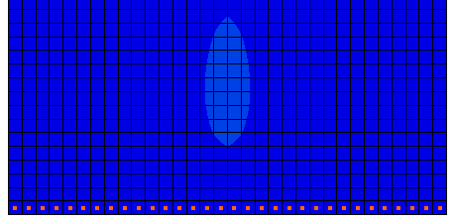

Figure 7 Prolonged contaminant tail on last time step of tracer dataset

Feel free to review the time steps for both the “File:Dataset Cells Active.svg tracer” and the “File:Dataset Cells Active.svg tracer (sorbed)”datasets to see how the simulation is affected over time. If desired, change the value of rate constant (second sorption constant) from 0.0005 to 0.0009 and compare the profiles for various mass-transfer constants

# Conclusion

This concludes the “MT3DMS – Advanced Transport” tutorial. The following key concepts were demonstrated and discussed in this tutorial:

* How to do a simple tracer simulation with MT3DMS.
* How to add dispersion to a transport simulation.
* How to add sorption to a transport simulation, and how to compute the retardation factor for a particular set of sorption coefficients.
* How to perform a dual-domain transport simulation.