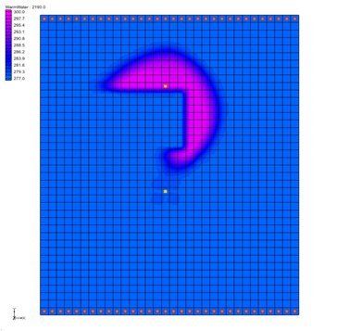

GMS 10.9

GMS 10.9 Tutorial

***MT3DMS – Heat Transport***

Simulate heat transport using MT3DMS

Objectives

This tutorial shows how to construct an MT3DMS model using the grid approach and how to simulate heat transport using MT3DMS.

Time

* 20–35 minutes

Required Components

* GMS Core
* MODFLOW Interface
* MT3D

Prerequisite Tutorials

* MT3DMS – Grid Approach

|  |
| --- |
| [1 Introduction 2](#_Toc110861203)  [1.1 Heat Transport Coefficients 3](#_Toc110861204)  [2 Getting Started 5](#_Toc110861205)  [2.1 The Flow Model 5](#_Toc110861206)  [3 The MT3DMS Basic Transport Package 6](#_Toc110861207)  [3.1 Species 6](#_Toc110861208)  [3.2 Packages 6](#_Toc110861209)  [3.3 Packages 6](#_Toc110861210)  [3.4 Output Control 6](#_Toc110861211)  [3.5 ICBUND Array 7](#_Toc110861212)  [3.6 Starting Concentration Array 7](#_Toc110861213)  [3.7 HTOP and Thickness Arrays 7](#_Toc110861214)  [3.8 Porosity Array 7](#_Toc110861215)  [4 Setting up the Packages 8](#_Toc110861216)  [4.1 The Advection Package 8](#_Toc110861217)  [4.2 The Dispersion Package 8](#_Toc110861218)  [4.3 The Chemical Reaction Package 8](#_Toc110861219)  [4.4 The Source/Sink Mixing Package 9](#_Toc110861220)  [5 Saving the Simulation and Running MT3DMS 10](#_Toc110861221)  [6 Viewing the Solution 11](#_Toc110861222)  [6.1 The Source/Sink Mixing Package 11](#_Toc110861223)  [6.2 Setting Up an Animation 12](#_Toc110861224)  [7 Conclusion 13](#_Toc110861225)  [8 Additional Reading 13](#_Toc110861226) |

# Introduction

The problem to be solved in this tutorial is an MT3DMSsimulation within GMS of heat transport (Figure 1). This is similar to one of the sample problems described in the MT3DMS documentation.[[1]](#footnote-1) It consists of a low K zone inside a larger zone. The sides of the region are no flow boundaries. The top and bottom are constant head boundaries that cause the flow to move from the top to the bottom of the region. A well injects into the aquifer warm water with an initial temperature of about 5˚C. This occurs for 3 months, after which it is turned off for 8 months.

This cycle is repeated for 3 years and then the simulation runs for an additional 3 years. A pumping well serves to withdraw some water migrating from the injection well. A transient flow solution will be provided and a transient transport simulation will be performed over a 6-year period.

This tutorial demonstrates and discusses opening a MODFLOW simulation and running MODFLOW, initializing MT3DMS and entering the data for several MT3DMS packages, running MT3DMS and importing the solution, and setting up an animation to visualize the solution.



Figure 1 Sample flow and transport problem

## Heat Transport Coefficients

Heat transport and solute transport are very similar. The following is a general form of the solute transport equation solved by MT3MDS:

 **(1)**

Where:

 is the bulk density (mass of the solids divided by the total volume) [ML-3]

 is the distribution coefficient of species *k* [L3M−1]

 is porosity

 is the concentration of species *k* [ML−3]

*t* is time [T]

is the molecular diffusion coefficient [L2T−1] for species *k*

 is the dispersivity tensor [L]

 is specific discharge [LT−1]

 is a fluid source or sink [T−1]

 is the source or sink concentration [ML−3] of species *k*

The similarity between heat transport and solute transport is shown in the following heat transport equation:[[2]](#footnote-2)

 **(2)**

Where:

is the density of the solid (mass of the solid divided by the volume of the solid) [ML−3]

is fluid density [ML−3]

 is the specific heat capacity of the solid [L2T−2−1]

 is the specific heat capacity of the fluid [L2T−2−1]

*T* is temperature []

 is the bulk thermal conductivity of the aquifer material [MLT−3−1]

*Ts* is source temperature []

Note that,, and *θ* are related by

=  *(*1 − *θ*) **(3)**

Additionally, there are retardation terms on the left side of both equations 1 and 2. For solute transport, retardation is caused by adsorption of solutes by the aquifer matrix material. With heat transport, retardation is caused by heat transfer between the fluid and solid aquifer matrix. MT3DMS can be used to represent thermal retardation by calculating the distribution coefficient (*Kd*) for the temperature species as a function of thermal properties:

 **(4)**

Therefore, substituting equations 3 and 4 into the left side of equation 2 will yield the following:

 **(5)**

Inspection of equations 1 and 2 also shows that heat conduction is mathematically equivalent to molecular solute diffusion. To represent heat conduction with MT3DMS, thermal diffusivity for the temperature species is calculated as follows:

 **(6)**

In GMS,  and  can be specified in the MT3DMS interface. is the distribution coefficient (slope of the isotherm), which can be specified in the Chemical Reaction Package. is the molecular diffusion coefficient (DMCOEF), which can be specified in the Dispersion Package.

# Getting Started

Do the following to get started:

1. If necessary, launch GMS.

If GMS is already running, select *File |* **New** to ensure that the program settings are restored to their default state.

## The Flow Model

Before setting up the MT3DMS simulation, a MODFLOW solution must exist to be used as the flow field for the transport simulation. In the interest of time, import a previously created MODFLOW simulation.

1. Click **Open** File:Open Macro.svg to bring up the *Open* dialog.
2. Select “Project Files (\*.gpr)” from the *Files of type* drop-down.

Browse to the *heat\_transport\heat\_transport\* directory and select “start.gpr”.

Click **Open** to import the project and exit the *Open* dialog.

The model should appear similar to Figure 2.

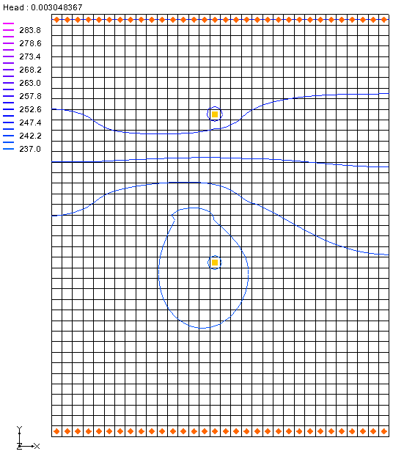

Figure 2 The initial model

# The MT3DMS Basic Transport Package

With a flow solution, it is possible to set up the MT3DMS transport simulation. Like MODFLOW,MT3DMS is structured in a modular fashion and uses a series of packages as input. Consequently, the GMS interface to MT3DMS is similar to the interface to MODFLOWand follows a similar sequence of steps to enter the input data.

First, initialize the MT3DMS simulation.

1. Fully expand “File:3D Grid Folder.svg 3D Grid Data” in the Project Explorer.

Right-click on “File:3D Grid Icon.svg grid” and select **New MT3DMS…** to bring up the *Basic Transport Package* dialog.

The MT3DMS options in the *Basic Transport Package* dialog are always required to be set. They define basic information such as stress periods, active/inactive regions, and starting concentration values.

## Species

Since MT3DMS is a multi-species model, it is necessary to define the number of species and a name for each species.

1. Click **Define Species…** to open the *Define Species* dialog.

Click **New** to create a new species.

In the *Name* column for the new species, enter “WarmWater”.

1. Click **OK** to close the *Define Species* dialog.

## Packages

Now to select which packages to use by doing the following:

1. Click **Packages…** to open the *MT3DMS/RT3D Packages* dialog.

Turn on Advection package, Dispersion package, Source/sink mixing package, and Chemical reaction package

1. Click **OK** to close the *MT3DMS/RT3D Packages* dialog

## Packages

Since the flow simulation is transient, the transport simulation must match the stress periods defined for the flow simulation. Therefore, it is possible to use the stress periods as defined by the MODFLOW simulation. No changes need to be made here at this time. The stress periods can be defined via the **Stress Periods…** button.

## Output Control

Next, specify the output options:

1. Click **Output Control…** to open the *Output Control* dialog.

Select *Print or save at specified times.*

Click **Times…** to open the *Variable Time Steps* dialog.

Click **Initialize Values…** to open the *Initialize Time Steps* dialog.

For the *Initial time step size,* enter “25.0”*.*

For the *Bias,* enter “1.0”.

For the *Maximum time step size,* enter “25.0”.

For the *Maximum simulation time,* enter “2200.0”.

These values will provide 100 output time steps.

Click **OK** to close the *Initialize Time Steps* dialog.

Click **OK** to close the *Variable Time Steps* dialog.

Click **OK** to close the *Output Control* dialog.

## ICBUND Array

The ICBUND array is similar to the IBOUND array in MODFLOW. The ICBUND array is used to designate active transport cells (ICBUND>0), inactive transport cells (ICBUND=0), and constant concentration cells (ICBUND<0). For this problem, all of the cells are active, so no changes are necessary. It is accessible via the **ICBUND…** button.

## Starting Concentration Array

The starting concentration array defines the initial condition for the contaminant concentration.

1. In the spreadsheet to the right of the column of buttons, check the box in the *Edit Per Cell* column of the *WarmWater* row*.*

Click the http://www.xmswiki.com/images/f/fc/Dot_dot_dot_button.png button in the *Starting Conc. Per Cell* columnto open the *Starting Concentrations – WarmWater* dialog*.*

Click **Constant → Grid…**to open the *Grid Value* dialog.

For the *Constant value for grid,* enter “278.0”.

This is the starting temperature of the warm water species in degrees Kelvin(about 5˚C).

Click **OK** to exit the *Grid Value* dialog.

Click **OK** to exit the *Starting Concentrations – WarmWater* dialog.

## HTOP and Thickness Arrays

MT3DMS uses the HTOP array and a thickness array to determine the layer geometry. However, the values for these arrays are determined by GMS automatically from the MODFLOW layer data, so no input is necessary. They are accessible via the **HTOP…** button.

## Porosity Array

Finally, define the porosity for the cells. The problem has a constant porosity of “0.3”. This is the default value in GMS, so no changes need to be made. It is accessible via the **Porosity…** button.

This completes the setting of the definitions and options in the *Basic Transport Package* dialog.

1. Click **OK** to exit the Basic Transport Package dialog.

# Setting up the Packages

## The Advection Package

The next step is to enter the data for the Advection package. This tutorial will use the Third Order TVD scheme (ULTIMATE) solution scheme. This is the default, so nothing needs to be done.

## The Dispersion Package

The molecular diffusion coefficient (DMCOEF) is specified in the Dispersion Package; in a heat transport simulation, DMCOEF represents thermal diffusivity .

1. Select MT3DMS | **Dispersion Package…** to bring up the *Dispersion Package* dialog.

Click **Longitudinal Dispersivity…** to open the *Longitudinal Dispersivity* dialog.

Click **Constant → Grid…** to open the *Grid Value* dialog.

Enter “0.5” as the *Constant value for grid* and click **OK** to close the *Grid Value* dialog.

Click **OK** to exit the Longitudinal Dispersivity dialog.

Enter “0.1” in both the *TRPT* and *TRVT* columns on row *1* in the spreadsheet.

Enter “2.15e-11” in the *DMCOEF* column .[[3]](#footnote-3)

Click **OK** to exit the Dispersion Package dialog.

## The Chemical Reaction Package

The sorption options are specified in the Chemical Reaction package. In a heat transport simulation, the sorption option represents thermal retardation. To enter the sorption parameters:

1. Select *MT3DMS |* **Chemical Reaction Package…** to open the *Chemical Reaction Package* dialog.

Select “Linear isotherm” from the *Sorption* drop-down.

In the second section, enter “1961.0” as the *Bulk density*.

Note that these units actually represent [kg/m3]. Once again, this does not agree with the standard units for the model, but these units only need to agree with the Kd (first sorption constant) units.

In the spreadsheet, enter “0.00021” in the *WarmWater* column on the *1st sorption const.* row.

Click **OK** to exit the *Chemical Reaction Package* dialog.

Note that these two values should result in a retardation factor of “1.41”. The retardation factor is calculated using the following formula:



Where:

❒ = bulk density

Kd = distribution coefficient (slope of the isotherm)

n = porosity

## The Source/Sink Mixing Package

Now define the data for the *Source/Sink Mixing* package so that the temperature of the water at the injection well can be specified.

1. Using the **Select Cells** File:Select 3D Cell Tool.svg tool, select the cell containing the injection well (the upper well, cell ID 304).

Right-click on the selected cell and select **Sources/Sinks…** to open the *MODFLOW/MT3DMS Sources/Sinks* dialog.

Select “MT3DMS: Point SS” from the list on the left.

Click **Add BC** to create a new entry in the spreadsheet.

Select “well (WEL)” from the drop-down in the *Type (ITYPE)* column.

Enter “298.0”in the *WarmWater* column.

Click **OK** to exit the *MODFLOW/MT3DMS Sources/Sinks* dialog.

Click outside the grid to deselect the cell.

Finally, it is necessary to define the constant temperature at the boundaries of the model.

Using the **Select Cells** File:Select 3D Cell Tool.svg tool, select all cells with the constant head BCs (orange diamond symbols) along the top and bottom boundaries of the grid. Do this by dragging a box around the cells at the top of the model and then holding down the *Shift* key and dragging a second box around the cells at the bottom of the model (see red boxes in Figure 3).

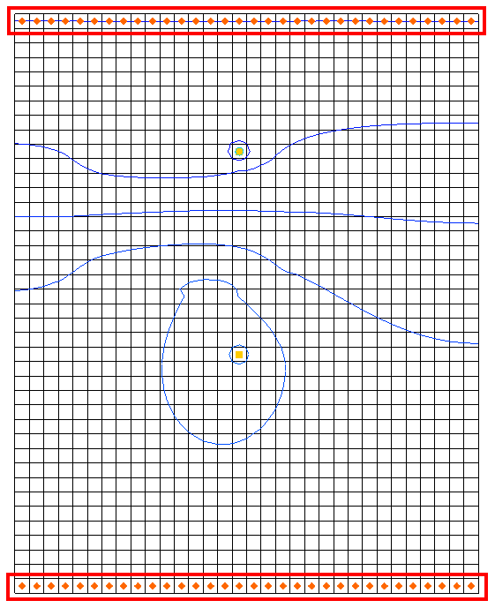

Figure 3 Selecting cells on the model boundary

Right-click on one of the selected cells and select **Sources/Sinks…** to open the *MODFLOW/MT3DMS Sources/Sinks* dialog.

Select “MT3DMS: Point SS” from the list on the left.

Click **Add BC** to create new entries in the spreadsheet for all the selected cells.

In the *All* row, enter “278.0” in the *WarmWater* column.

This applies this concentration to all of the boundary conditions.

Click **OK** to close the *MODFLOW/MT3DMS Sources/Sinks* dialog.

Click anywhere outside the grid to unselect the cells.

# Saving the Simulation and Running MT3DMS

Now save the simulation and run MT3DMS.

1. Select *File |* **Save As…** to bring up the *Save As* dialog.
2. Select “Project Files (\*.gpr)” from the *Save as type* drop-down.

Enter “heat.gpr” as the *File name*.

Click **Save** to save the project with the new name and close the *Save As* dialog.

Select *MODFLOW |* **Run MODFLOW** to bring up the *MODFLOW* model wrapper dialog.

When MODFLOW finishes, turn on *Read solution on exit* and *Turn on contours (if not on already)*.

Click **Close** to import the solution and close the *MODFLOW* dialog.

**Save** File:Save Macro.svg the project.

Select *MT3DMS |* **Run MT3DMS…**to bring up the *MT3DMS* model wrapper dialog.

When MT3DMS finishes, turn on *Read solution on exit*.

Click **Close** to import the solution and close the *MT3DMS* dialog.

The model should appear similar to Figure 4.

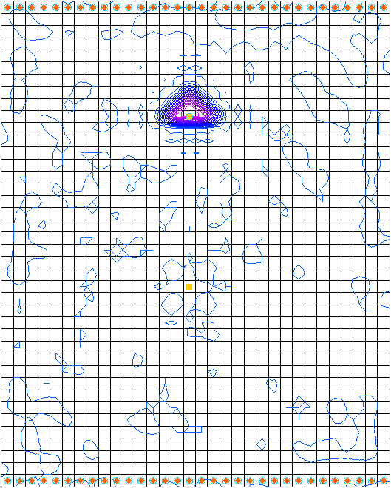

Figure 4 After MT3DMS is run

# Viewing the Solution

## The Source/Sink Mixing Package

When displaying plume data, the color fill option often provides excellent results.

1. Click **Contour Options** File:Contour Options Macro.svg to open the *Dataset Contour Options – 3D Grid – WarmWater* dialog.

In the *Contour method* section, select “Color Fill” from the first drop-down.

In the *Contour interval* section, turn on *Fill Continuous color range.*

Click **OK** to close the *Dataset Contour Options – 3D Grid – WarmWater* dialog.

Select the “File:Dataset Cells Active.svg WarmWater” dataset under “File:Generic Folder Locked.svg heat (MT3DMS)” in the Project Explorer.

Select the last time step (step 93) in the Time Step Window.

The model should appear similar to Figure 5.

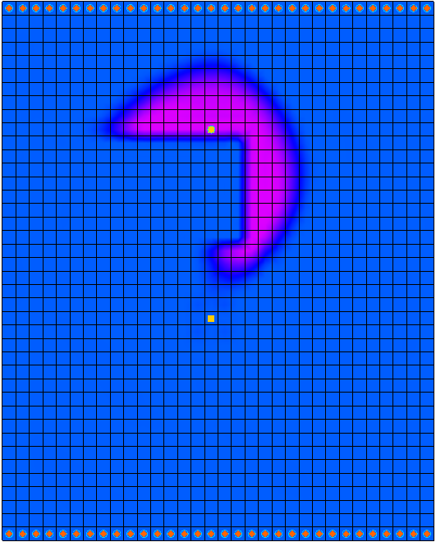

Figure 5 Contours on the last time step

Feel free to review other time steps to see how the temperature changes over time. When finished, notice the “File:Dataset Cells Active.svg WarmWater (sorbed)” dataset as well. Feel free to review the time steps for this dataset as well.

## Setting Up an Animation

It is possible to observe how the solution changes over the one-year simulation by generating an animation. To set up the animation, do the following:

1. Select *Display |* **Animate…** to open the *Options* page of the *Animation Wizard* dialog.
2. Next to *Animation file*, click on the browser 16px-Open_Macro button to open the *Save* dialog.
3. Enter “heat.gpr” as the *File name*.
4. Be certain that *Save as type* is set to “Animation file (\*mp4, \*avi)”.
5. Select **Save** to close the *Save* dialog.

In the *Options* section, turn on *Dataset*.

Click **Next** to go to the *Datasets* page of the *Animation Wizard* dialog.

Turn on Display clock.

Click **Finish** to generate the animation, close the *Animation Wizard* dialog.

If desired, open the MP4 file a media player application outside of GMS. Feel free to experiment with some of the other playback controls as desired.

# Conclusion

This concludes the “MT3DMS – Heat Transport” tutorial. The following key concepts were discussed and demonstrated in this tutorial:

* It is possible to perform a heat transport analysis using MT3DMS in GMS.
* The important inputs in a heat transport simulation are  and .
*  is the distribution coefficient (slope of the isotherm), which can be specified in the Chemical Reaction Package.
* is the molecular diffusion coefficient (DMCOEF), which can be specified in the Dispersion Package.

# Additional Reading

* Hecht-Méndez, J., Molina-Giraldo, N., Blum, P. and Bayer, P. (2010), “Evaluating MT3DMS for Heat Transport Simulation of Closed Geothermal Systems” in *Ground Water*, 48: 741–756. doi: 10.1111/j.1745-6584.2010.00678.x
* Langevin, C. D., Dausman, A. M. and Sukop, M. C. (2010), “Solute and Heat Transport Model of the Henry and Hilleke Laboratory Experiment” in *Ground Water*, 48: 757–770. doi: 10.1111/j.1745-6584.2009.00596.x

1. Zheng, Chunmiao and Wang, P. Patrick (December 1999). “A Two-Dimensional Application Sample” in *MT3DMS: A Modular Three-Dimensional Multispecies Transport Model for Simulation of Advection, Dispersion, and Chemical Reactions of Contaminants in Groundwater Systems; Documentation and User’s Guide*, Strategic Environmental Research and Development Program (SERDP), U.S. Army Corps of Engineers, Contract Report SERDP-99-1, pp. 152-154. <http://hydro.geo.ua.edu/mt3d/mt3dmanual.pdf> [↑](#footnote-ref-1)
2. Thorne, Danny; Langevin, Christian D.; and Sukop, Michael C. (2006). “Addition of simultaneous heat and solute transport and variable fluid viscosity to SEAWAT” in *Computers & Geosciences, 32(10)*, pp. 1758-1768. <http://plaza.ufl.edu/clang001/papers/thorne_et_al_2006.pdf> [↑](#footnote-ref-2)
3. This value is based on reference values from the German Engineer Association guidelines for thermal use of the underground (VDI-Richtlinie 4640 2001). [↑](#footnote-ref-3)