z

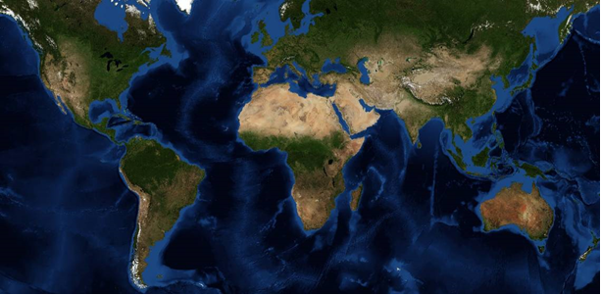

GMS 10.9

GMS 10.9 Tutorial

***Online Maps***

Using free, dynamic, online map data in GMS

Objectives

Learn how free online map data can quickly and easily be used to dynamically update background maps and aerial photography in GMS.

Time

* 10–20 minutes

Required Components

* An internet connection

Prerequisite Tutorials

* Getting Started

|  |
| --- |
| 1 Introduction 2  1.1 Getting Started 2  2 Adding Online Maps 2  3 Appearance 4  3.1 Changing the Display Order 4  3.2 Transparency 4  4 Exporting an Image File 4  5 Image Properties and Save Location 5  6 Map Locator 5  7 Other Online Maps 6  8 Conclusion 6 |

# Introduction

Online maps are free maps, aerial photos, and DEMs that can be downloaded from the internet and displayed in the background in plan view. When zooming in and out or panning the view, online maps download the required image data from the internet and update automatically. Depending on the speed of the internet connection, this usually takes just a few moments. Online maps can be saved locally as image files. Online maps can be helpful in the initial stages of setting up a groundwater model.

In this tutorial, the following topics will be covered:

* Add an online map showing an aerial photo of the area around Moab, Utah.
* Zoom and pan to see how the image updates automatically.
* Add a second online map and explore image order and transparency.
* Create a local image file from the online map.
* Use the *Map Locator*  to reposition the display.

## Getting Started

To get started, do the following:

1. If necessary, launch GMS.
2. If GMS is already running, select *File |* **New…** to ensure that the program settings are restored to their default state.

# Adding Online Maps

To start, add an online map. Before adding the map, notice the current projection displayed in the bottom right of the Graphics Window. It should say “No projection, Feet (U.S. Survey).” This means that no global projection has been defined.

1. Click the **Add Online Maps** File:Add Online Maps Icon.svg macro to bring up the *Map Locator* dialog.
2. In the *Search* field, enter “Moab, Utah” and click *Enter*.
3. Click **OK** to close the *Map Locator* dialog.

A warning will appear stating that a new global projection needs to be set. Had a matching projection already been set, then this warning would not have appeared.

1. Click **OK** to close the warning dialog and open the *Display Projection* dialog.

By default, the global projection of the image location selected in the *Map Locator* is populated in the *Display Projection* dialog.

1. Click **OK** to close the *Display Projection* dialog and open the *Get Online Maps* dialog.
2. Select *World Imagery* and click **OK** to exit the *Get Online Maps* dialog.

After a few moments (depending on speed of the internet connection), an aerial photo of the city of Moab, Utah will appear in the Graphics Window. Notice the projection displayed in the bottom right of the Graphics Window now says “UTM” and “NAD83...” Because the project had no data, GMS switched the display projection to UTM.

1. Using the scroll wheel on the mouse or the **Zoom** File:Zoom Tool Icon.svgtool, zoom out repeatedly. Notice that the image updates with different resolution images as the zoom level changes.
2. Use the **Pan**File:Pan Tool.svg tool to pan around the area. Notice how the image updates.

Notice the icon for the online map item in the Project Explorer looks like the typical image item icon but with the addition of a globe in the bottom right corner File:GIS Online Image Icon.svg, indicating it is an online map. As the image is downloading from the internet, the text next to the item in the Project Explorer will change to “(processing) World Imagery”. Once the download is complete, the “(processing)” is removed.

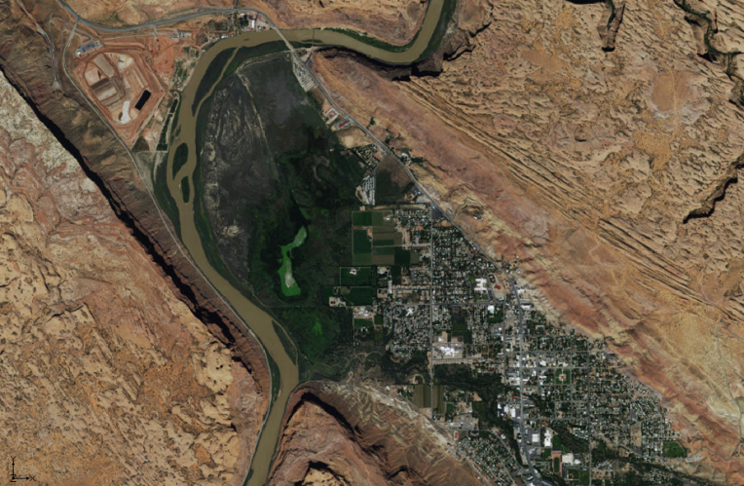

Figure 1 Online satellite map of Moab, Utah

The next step is to add a second online map.

1. Click the **Add Online Map** File:Add Online Maps Icon.svg macro to bring up the *Get Online Maps* dialog.

The *Map Locator*  dialog does not open this time because data already exists in the project.

1. Select *World Street Map* and click **OK** to close the *Get Online Maps* dialog.

After a few moments, a street map of the area will appear in the Graphics Window (Figure 2).

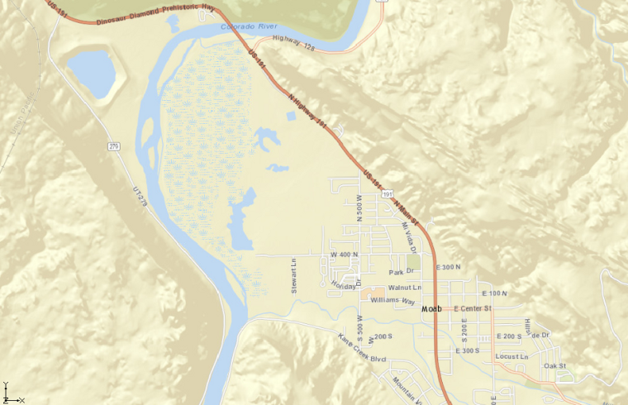

Figure 2 Online street map of Moab, Utah

# Appearance

GMS provides tools for how online maps are displayed in the Graphics Window.

## Changing the Display Order

Images are displayed top to bottom, in the order they appear in the Project Explorer. To change the order, do the following:

1. In the Project Explorer, select and drag the “File:GIS Online Image Icon.svg World Street Map” item so that it is underneath the “File:GIS Online Image Icon.svg World Imagery” item.

Notice that the aerial photo is visible once again.

1. Place the “File:GIS Online Image Icon.svg World Street Map” back on top by dragging it so it is above “File:GIS Online Image Icon.svg World Imagery”.

## Transparency

The transparency of online maps can be set just as with other images.

1. Right-click on the “File:GIS Online Image Icon.svg World Street Map” item in the Project Explorer and select **Transparency…** to bring up the *Layer Transparency* dialog.
2. Use the slider to change the *Transparency* to around “40%”.
3. Click **OK** to close the *Layer Transparency* dialog.

The “File:GIS Online Image Icon.svg World Imagery” will now be visible through the “File:GIS Online Image Icon.svg World Street Map” image.

# Exporting an Image File

A copy of the online map currently displayed in the Graphics Window can be saved as an image file. The image file is saved locally so it is accessible without an internet connection.

1. In the Project Explorer, right-click on “File:GIS Online Image Icon.svg World Street Map” and select **Export…** to bring up the *Resample and Export Raster* dialog.

It is often desirable to save the image at a higher resolution than is currently displayed on screen. Because the exported image is limited to the resolution at which it was saved, it will not update with higher resolution online imagery when zooming in.

1. Enter “2.0” in the *Resampling ratio* field.
2. Turn on *Add to project after saving*.
3. Click **OK** to close the *Resample and Export Raster* dialog and bring up the *Save As* dialog.
4. Enter “MoabStreetmap.tif” in the *File name* field.
5. Select “GeoTIFF Files (*.tif)” from the *Save as type* drop-down.
6. Click **Save** to export the file and close the *Save As* dialog.

Once the download and export is complete, a third image titled “File:GIS Image Icon.svg MoabStreetmap.tif” will appear in the Project Explorer.

# Image Properties and Save Location

To view the folder where the exported TIFF is located, do the following:

1. Right-click on the newly created “File:GIS Image Icon.svg MoabStreetmap.tif” and select **Open Containing Folder** to bring up the directory where the image file was saved.

The folder containing the exported image file will open in Windows Explorer.

To review the properties of the image that was just created, return to GMS and do the following:

1. Right-click on “File:GIS Image Icon.svg MoabStreetmap.tif” and select *Projection* | **Projection…** to bring up the *Projection – Project\GIS Layers\MoabStreetmap.tif* dialog.

This dialog displays the projection for the image that was saved with the image when it was exported.

1. Click **Cancel** to close the *Projection– Project\GIS Layers\MoabStreetmap.tif* dialog.

# Map Locator

When the first online map was downloaded, GMS opened the *Map Locator* dialog so that the desired map location could be entered because there was no project data. The *Map Locator* dialog can be used at any time to change the Graphics Window view to show different places on the globe.

1. Click the **Map Locator** File:Map Locator Macro.svg macro to bring up the *Map Locator* dialog. The current location in Moab will be shown.
2. Use the mouse scroll wheel or the **Zoom Out** File:MapLocatorZoomOut.png macro to zoom out as far as possible.

A map of the entire world should now be visible. From this point, it is possible to **Zoom In** Thumbnail for version as of 14:36, October 10, 2017 on any location in the world.

1. **Zoom in** Thumbnail for version as of 14:36, October 10, 2017 on a new location.
2. When done, click **OK** to close the *Virtual Earth Map Locator* dialog.

A warning dialog will appear stating the new location is outside of the current projection.

1. Click **OK** to close the warning and open the *Display Projection* dialog.
2. Accept the new projection and click **OK** to close the *Display Projection* dialog.

Notice the “File:GIS Online Image Icon.svg World Street Map” and “File:GIS Online Image Icon.svg World Imagery” will update to show the new location.

# Other Online Maps

At this point, the user may want to experiment with the other online map types available in the *Get Online Maps* dialog.

# Conclusion

This concludes the “Online Maps” tutorial. The following key concepts were discussed and demonstrated:

* Importing and using different free online maps.
* Changing the appearance of the imported maps.
* Saving an online map to be used offline.
* Using the **Map Locator** File:Map Locator Macro.svg to view any location in the world.