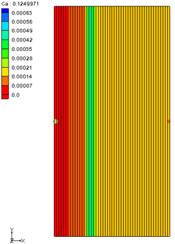

GMS 10.9

GMS 10.9 Tutorial

***PHT3D – Transport and Mineral Reactions***

PHT3D Geochemical Reactions

Objectives

This tutorial demonstrates transport and mineral reactions in PHT3D.

Time

* 20–30 minutes

Required Components

* GMS Core
* MODFLOW Interface
* MT3D
* PHT3D

Prerequisite Tutorials

* MT3DMS – Grid Approach

|  |
| --- |
| 1 Introduction 2  1.1 Description of Problem 2  2 Getting Started 3  3 Importing the Flow Model 3  3.1 Saving the Project with a New Name 3  4 Building the Transport Model 3  4.1 Initializing the Simulation 4  4.2 Specifying PHT3D Reaction Definitions 4  4.3 Specifying Initial Concentrations 4  4.4 Selecting Packages 5  4.5 Defining the Porosity Array 5  4.6 Setting Run Options 5  5 Advection Package 6  6 Dispersion Package 6  7 Adding Inflow Concentrations 6  7.1 Assigning Inflow Concentrations 6  8 Saving the Simulation and Running PHT3D 7  9 Viewing the Solution 8  9.1 Time Series Data Plot 8  10 Conclusion 8 |

# Introduction

PHT3D is a multi-component transport model for three-dimensional reactive transport in saturated porous media. It is developed and maintained by Henning Prommer and Vincent Post (2010).[1] PHT3D is a combination of MT3DMS and PHREEQC-2. PHREEQC-2 allows for a variety of low temperature, aqueous-geochemical reactions.

The simulation of mineral dissolution and precipitation reactions is one of the key features of PHT3D, and one or more of them will be included in many typical model applications. The case described in this tutorial was originally presented by Engesgaard and Kipp (1992)[2] for a model verification of their MST1D code against the CHMTRNS model by Noorishad et al. (1987).[3]

It involves a one-dimensional, model domain in which an aqueous water composition that is in equilibrium with two minerals, calcite and dolomite, is successively replaced, that is, flushed by water of a different chemical composition, leading to multiple precipitation-dissolution fronts. Dolomite is not present initially, but is formed temporally.

## Description of Problem

In order to follow the discretization chosen by Engesgaard and Kipp (1992), the project will create a model domain of 0.5 m length divided into 50 grid cells of 0.01 m length, 1 m width and 1 m height (50 columns, 1 row and 1 layer). A steady-state flow rate Qwell of 0.259 m3/d is required to achieve a pore-velocity of 0.083 m/d for the given porosity of 0.32. The total simulation time is 0.2430 days. It is divided into 210 time steps.

# Getting Started

Do the following to get started:

1. If GMS is not running, launch GMS.
2. If GMS is already running, select *File |* **New** to ensure the program settings are restored to the default state.

# Importing the Flow Model

Before setting up the PHT3D simulation, a MODFLOW solution must exist to be used as the flow field for the transport simulation. In the interest of time, import a previously created MODFLOW simulation.

1. Click **Open** File:Open Macro.svg to bring up the *Open* dialog.
2. Browse to the *\MineralReactions* folder and select “start.gpr”.
3. Click **Open** to import the file.

The flow model has already been created in this example (Figure 1).

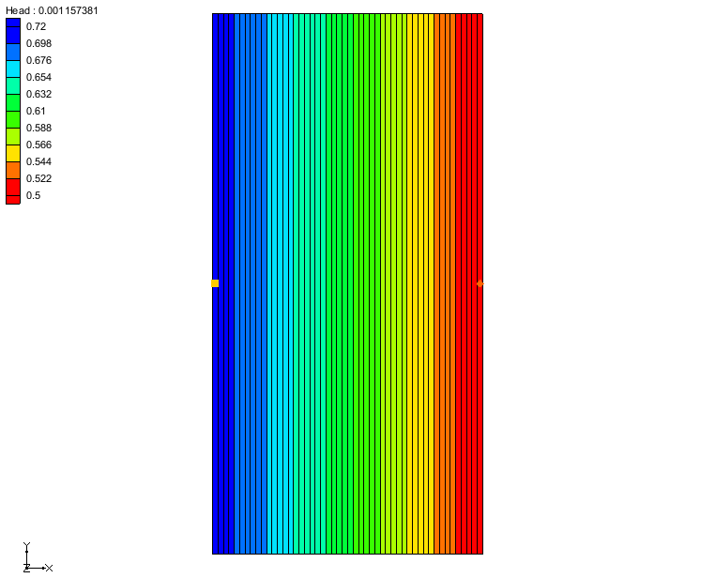

Figure 1 Flow model

## Saving the Project with a New Name

Before continuing, save the project with a new name.

1. Select *File* | **Save As…** to bring up the *Save As* dialog.
2. Enter **“**mineral_dis_pre.gpr” as the *File name* and click **Save** to exit the *Save As* dialog.

It is recommended to periodically save the project.

# Building the Transport Model

With a flow solution, it is possible to set up the PHT3D transport simulation.

## Initializing the Simulation

First, initialize the simulation.

1. Right-click in the blank area of the Project Explorer and select **Expand All**.
2. Right-click on “File:3D Grid Icon.svg grid” and select **New MT3DMS…** to open the *Basic Transport Package* dialog.
3. In the *Model* section, select *PHT3D.*

## Specifying PHT3D Reaction Definitions

In some cases, the next step would be to prepare a problem-specific reaction module. However, for simple problems, such as those that only include equilibrium reactions, this is not the case. All of the aqueous species, components, and minerals needed to simulate this LEA-based reactive transport problem are already included in the original PHREEEQC-2 database. This means that a user-defined set of equilibrium reactions does not need to be created. Instead, use the PHREEQC-2 database.

To specify the reaction definitions, do the following:

1. Click **Define Species…** to open the *PHT3D Options* dialog.

Notice that the first item in the list on the left is *General Options*. This dialog allows for the definition the species uses as well as PHT3D general options.

1. From the list on the left, select “Equilibrium Species”.

Because a PHREEQC database has not yet been selected, it is not yet possible to view any candidate equilibrium species. To select a PHREEQC database, do the following:

1. Next to *PHREEQC database,* click **Open** File:Open Macro.svg to bring up an *Open* dialog.
2. Select “pht3d_datab.dat” and click **Open** to import the file.

GMS has now imported the PHREEQC database and made available the different components included in the file. Now select the components to model by doing the following:

1. In the spreadsheet, in the *Active* column, turn on *Ca, Mg, Cl* and *C(4)*.

Note that *pH* and *pe* species are automatically included in all simulations.

1. From the list on the left, select “Equilibrium Minerals/Phases”.
2. In the spreadsheet, in the *Active* column, turn on *Calcite*and*Dolomite*.

The selection of species to include in the simulation is now completed.

1. Click **OK** to close the *PHT3D Options* dialog.

## Specifying Initial Concentrations

The next step is to specify the initial concentrations that define the hydrogeochemistry of the aquifer at the start of the simulation (Time = 0).

1. In the *Starting Conc. (moles/liter)* column, on the *Ca* row, enter “0.000123”.
2. Repeat step 1 for each of the components listed in Table 1 and Table 2.

Note that the aqueous concentrations are always defined in units of *mol/l*. In contrast, the unit for the initial concentrations of minerals is not mass per volume of water, i.e., *mol/l,* but is defined as mass per bulk volume, *mol/lvolume*.

Table 1 Aqueous concentrations used in this tutorial

|  |  |
| --- | --- |
| Aqueous component | Cinit (mol/lw) |
| Ca | 0.000123 |
| Mg | 0.0 |
| Cl | 0.0 |
| C(4) | 0.000123 |
| pH | 9.91 |
| pe | 4.0 |

Table 2 Mineral concentrations used in this tutorial

|  |  |
| --- | --- |
| Mineral | Cinit (mol/lv) |
| Calcite (*CaCO3*) | 0.00003906 |
| Dolomite (*CaMg(CO3)2*) | 0.0 |

## Selecting Packages

Next, select which packages to use.

1. Click **Packages…** to open the *MT3DMS/RT3D Packages* dialog.
2. Turn on *Advection package*, *Dispersion package*, and *Source/Sink mixing package*.
3. Click **OK** to close the *MT3DMS/RT3D Packages* dialog.

## Defining the Porosity Array

Finally, define the porosity for the cells. The problem has a constant porosity of 0.32.

1. Click **Porosity…** to open the *Porosity* dialog.
2. Click **Constant → Grid** to open the *Grid Value* dialog.
3. For *Constant value for grid,* enter “0.32”.
4. Click **OK** to close the *Grid Value* dialog.
5. Click **OK** to exit the *Porosity* dialog.
6. Click **OK** to exit the *Basic Transport Package* dialog.

## Setting Run Options

Next, tell MT3DMS to always use the same MODFLOW solution to define the flow field. This will allow the transport simulation to be saved under a different name without having to re-run MODFLOW.

1. Select *PHT3D |* **Run Options…** to open the *Run Options* dialog.
2. Select *Single run with selected MODFLOW solution* and click **OK** to close the *Run Options* dialog.

# Advection Package

The Advection Package has been included in the simulation. The default settings in the package will be used, so nothing needs to be changed.

# Dispersion Package

Now edit the inputs to the dispersion package by doing the following:

1. Select *PHT3D |* **Dispersion Package…** to open the *Dispersion Package* dialog.
2. Click **Longitudinal Dispersivity…** to open the *Longitudinal Dispersivity* dialog.
3. Click **Constant → Grid…** to open the *Grid Value* dialog.
4. For *Constant value for grid,* enter “0.0067”.
5. Click **OK** to close the *Grid Value* dialog.
6. Click **OK** to exit the *Longitudinal Dispersivity* dialog.
7. Click **OK** to exit the *Dispersion Package* dialog.

# Adding Inflow Concentrations

The flow model has been set up with an injection well on the left of the model and a constant head boundary condition on the right. The flow should move from left to right through the model grid. By default, water entering the model from the well will have a concentration of “0.0” for each of the species in the model. It is necessary to change the concentrations in the water from the injection well.

## Assigning Inflow Concentrations

1. Using the **Select Cells** File:Select 3D Cell Tool.svg tool, right-click on the left-most cell and select **Sources/Sinks…**to open the *MODFLOW/PHT3D Sources/Sinks* dialog. Zoom in if necessary.
2. Select “PH3TD: Point SS”from the list on the left.
3. Click **Add BC**to an entry in the spreadsheet.
4. Select “well (WEL)” from the drop-down on row *1* in the *Type (ITYPE)* column.
5. Using Table 3 found below, enter the values for each component in the corresponding column.

Table 3 Inflow Concentrations

|  |  |
| --- | --- |
| Aqueous component | C*inflow* (mol/lw) |
| Ca | 0.0 |
| Mg | 0.001 |
| Cl | 0.002 |
| C(4) | 0.0 |
| pH | 7.0 |
| pe | 4.0 |

1. Click **OK** to exit the *MODFLOW/PHT3D Sources/Sinks* dialog.

# Saving the Simulation and Running PHT3D

Before running PHT3D, the project needs to be saved.

1. **Save**File:Save Macro.svgthe project.
2. Select *MODFLOW |* **Run MODFLOW** to bring up the *MODFLOW* model wrapper dialog.
3. When the *MODFLOW* simulation finishes, turn on *Read solution on exit* and *Turn on contours (if not on already)*.
4. Click **Close** to exit the *MODFLOW* model wrapper dialog.
5. Select *PHT3D |* **Run PHT3D…**to bring up the *PHT3D* model wrapper dialog.
6. When the *PHT3D* simulation finishes, turn on *Read solution on exit* and click **Close** to exit the *PHT3D* model wrapper dialog.

The project should appear similar to Figure 2.

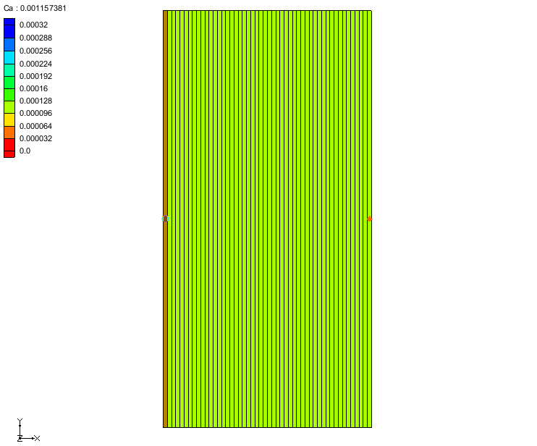

Figure 2 After PHT3D is run

# Viewing the Solution

After PHT3D finished running, GMS automatically imports the computed concentrations, mass files, and output file produced by PHT3D. All of this data is under a new folder in the Project Explorer called “mineral_dis_pre (PHT3D)”.

1. In the Project Explorer, expand “File:Generic Folder Locked.svg mineral_dis_pre (PHT3D)”.
2. Select the “File:Dataset Cells Active.svg Ca” dataset.
3. Below the Project Explorer, in the *Time Steps* window,select the first time step.
4. Use the arrows keys to view the different time steps.

## Time Series Data Plot

Next, generate the time series data plot related to the concentrations.

1. Select the “File:Dataset Cells Active.svg Dolomite” dataset.
2. Click **Plot Wizard** File:Plot Wizard Macro.svg to open the *Step 1 of 2* page of the *Plot Wizard* dialog.
3. From the list on the left, select “Active Dataset Time Series”.
4. Click **Finish** to close the *Plot Wizard* and generate the plot.
5. Using the **Select Cells** File:Select 3D Cell Tool.svg tool, select any cell on the model.

The concentration of dolomite over time should now be visible. Note that dolomiteis not present initially but is formed temporally.

# Conclusion

This concludes the “PHT3D – Transport and Mineral Reactions” tutorial. The following key concepts were discussed and demonstrated in this tutorial:

* How to define species in PHT3D using the original PHREEQC-2 database.
* How to specify the concentrations for a particular species.

1. Prommer, H., and Post, V. (2010). A reactive multicomponent transport model for saturated porous media. User’s Manual v2.10.
2. Engesgaard, P., and Kipp, K.L. (1992). A geochemical transport model for redox-controlled movement of mineral fronts in groundwater flow systems: A case of nitrate removal by oxidation of pyrite. Water Resource Research 28: 2829–2843.
3. Noorishad, J., Carnahan, C.L., and Benson, L.V. (1987). A report on the development of the non-equilibrium reactive chemical transport code CHMTRNS. (Berkeley, CA: Lawrence Berkeley Laboratory).