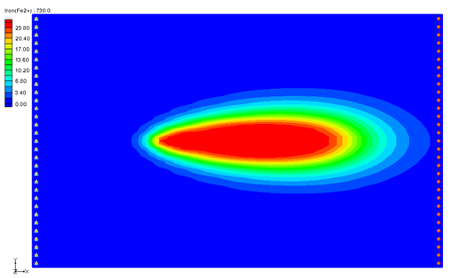

GMS 10.9

GMS 10.9 Tutorial

***RT3D – BTEX Degradation with Multiple Electron Acceptors***

Objectives

This tutorial shows how to use GMS and RT3D to model BTEX degradation using a multiple electron acceptor model.

Time

* 20–35 minutes

Required Components

* GMS Core
* MODFLOW Interface
* RT3D

Prerequisite Tutorials

* RT3D – Instantaneous Aerobic Degradation

|  |
| --- |
| 1 Introduction 2  1.1 Description of the Reaction Model 2  1.2 Description of Problem 5  1.3 Getting Started 5  2 Importing the MODFLOW Model 6  3 Building the Transport Model 6  4 Initializing the Model 6  5 The BTN Package 6  5.1 Starting Concentrations 7  5.2 Porosity 7  5.3 Stress Periods 7  5.4 Output Options 7  6 Assigning Concentrations to the Left Boundary 8  7 The Advection Package 8  8 The Dispersion Package 8  9 The Source/Sink Mixing Package 9  10 The Chemical Reaction Package 9  11 Running RT3D 10  12 Viewing the Results 10  12.1 Overlaying Contours 11  13 Other Post-Processing Options 12  14 Conclusion 12 |

# Introduction

This tutorial illustrates the steps involved in using GMS and RT3D to model BTEX degradation using a multiple electron acceptor model. Since the flow model used in this simulation is similar to the flow model used in the “RT3D – Instantaneous Aerobic Degradation” tutorial, the steps involved in building the flow model will not be described in this tutorial. A predefined version of the flow model will be used.

This tutorial will begin with importing a MODFLOW model followed by defining RT3D inputs and boundary conditions, running RT3D, and viewing results by overlaying the contours.

## Description of the Reaction Model

The reaction that will be simulated is biodegradation of BTEX compounds via different aerobic/anaerobic pathways using multiple electron acceptors. Five different processes considered in this model are Aerobic Respiration (AR), Denitrification (DN), Iron (III) Reduction (IR), Sulfate Reduction (SR), and Methanogenesis (MG). All of these biochemical reactions are assumed to occur in the aqueous phase, mediated by the existing subsurface microbes, and are expected to happen in the following sequence:

 (1)

The following reaction kinetic framework is used to model the degradation rate of hydrocarbon via different electron acceptor pathways:

 (2)

 (3)

 (4)

 (5)

 (6)

Where:

* rHC,O2 is the rate at which hydrocarbon is destroyed by utilizing oxygen,
* rHC,NO3 is the rate at which hydrocarbon is destroyed by utilizing Nitrate,
* rHC,Fe2+ is the rate at which hydrocarbon is destroyed by producing Fe2+ (or utilizing Fe3+),
* rHC,SO4 is the rate at which hydrocarbon is destroyed by utilizing sulfate,
* rHC,CH4 is the rate at which hydrocarbon is destroyed by producing methane,
* [O2] is the oxygen concentration [ML-3],
* kO2 is the first-order rate constant [T-1],
* Ko2 is the Monod half saturation constant [ML-3] (by setting all the half-saturation constants to a small value, zero-order dependency can be simulated with respect to the electron donor and hence a first-order degradation model with respect to hydrocarbon; the default values simulate this option), and
* Ki,o2 is the oxygen inhibition constant [ML-3] (by setting all inhibition constants to a small value, reactions can be forced to occur in a sequential fashion; the default values simulate this process).

Similar nomenclature is used to identify other Monod constants and inhibition coefficients.

Since the concentrations of Fe3+ and CO2 are not readily measurable under normal field conditions, these terms were replaced with the “assimilative capacity” for iron reduction and methanogenesis, defined as the following:

 (7)

 (8)

where [Fe2+max] and [CH4 max] are the maximum possible aquifer levels of these species that represent the aquifer’s maximum capacity for iron reduction and methanogenesis. Note: the concentration of CO2 used here is the CO2 evolved while the hydrocarbon is destroyed via methanogenesis, which may be thought of as the “Methanogenic Capacity” (MC) of the aquifer. Using these relations, iron (III) reduction and methanogenesis processes may be related back to measurable Fe2+ and CH4 concentration levels.

The total rate of hydrocarbon destruction, via all the above described processes, is the sum of each of the individual rates and is given as the following:

 (9)

Rates of electron acceptor utilization are given as the corresponding rate of hydrocarbon destruction multiplied by the appropriate yield coefficient (Y):

 (10)

 (11)

 (12)

 (13)

 (14)

The yield values (the mass ratio of electron acceptors removed or metabolic byproducts produced to total BTEX degraded) are as follows:

* Y02/HC = 3.14
* YNO3/HC = 4.9
* YFe2+/HC = 21.8
* YSO4/HC = 4.7
* YCH4/HC = 0.78

Typical values of all inhibition coefficients, except for KiFe3+, should be in the range of 1.0 to 0.01 mg/L. KiFe3+should always be set around 40% to 80% of the max Fe2+ value. Monod half-saturation constants should be in the range of 1.0 to 0.1 mg/L.

As pointed out in Lu et al.,[1] it is important to note that this model is based on several assumptions. The model should be used with caution only at sites where these assumptions are valid.

In summary, the key assumptions used in the model are:

1. The fuel chemical species benzene, toluene, ethylbenzene, and xylene are assumed to degrade at similar rates and, hence, are combined and modeled as a single electron donor species BTEX;
2. Production of Fe2+ and methane are restricted at a node to a “maximum-observed level”; however, the model assumes that an infinite supply of electron acceptors will be available for iron-reduction and methanogenic reactions;
3. More complex processes are not considered; these include processes such as the rate-limited interaction of bioavailable, solid-phase Fe3+ and aqueous-phase Fe2+, interaction of oxygen and Fe2+, and/or variations in the spatial pattern of methanogenic activity and CO2 availability;
4. Growth and decay of various microbial populations and their interactions with contaminants and aquifer solids are assumed to be negligible; and
5. All BTEX decay reactions are approximated as first-order reactions, and, hence, the model ignores the Monod limitation due to the electron donor (BTEX) availability.

Fortunately, these assumptions are expected to be reasonable approximations for most field sites. However, there will always be some exceptions.

## Description of Problem

The problem in this tutorial is the same as the problem described in “RT3D – Instantaneous Aerobic Degradation” tutorial. The site is a 510 m x 310 m section of a confined aquifer with a flow gradient from left to right. An underground storage tank is leaking fuel hydrocarbon contaminants at 2 m3/day at the location shown. Concentration of BTEX is 1000 mg/L. Initial levels of hydrocarbon, oxygen, nitrate, Fe2+, sulfate, and methane in the aquifer are assumed to be as follows: 0.0, 4.0, 20.0, 0.0, 10.0, and 0.0 mg/L, respectively. The reaction constants to be used are as follows:

|  |  |
| --- | --- |
| Constant | Value |
| Max Fe2+ | 25.0 mg/L |
| Max Methane | 30.0 mg/L |
| kHC,O2 | 0.1 day-1 |
| k HC,No3 | 0.008 day-1 |
| k HC,Fe3+ | 0.0005 day-1 |
| k HC,SO4 | 0.00025 day-1 |
| k HC,CH4 | 0.0001 day-1 |

Values of all inhibition coefficients, except KiFe3+, are assumed to be 0.01 mg/L and all Monod constants are assumed to 0.5 mg/L. The value of KiFe3+ is set at 12.5 mg/L (50% of max Fe). The yield values are the same as those described in the previous section.

The first part of the problem will be to import a previously computed MODFLOW flow model of the site. Using this flow field, a reactive transport model will then be defined using RT3D.

## Getting Started

Do the following to get started:

1. If GMS is not running, launch GMS.
2. If GMS is already running, select the *File |* **New** command to ensure the program settings are restored to the default state.

# Importing the MODFLOW Model

The first part of the simulation is to import the MODFLOW flow model. A steady state flow model has been previously computed and is supplied with the tutorial files.

1. Select the *File* | **Open…** command to bring up the *Open* dialog.
2. Locate the directory entitled *flowmod\flowmod*.
3. Select the file entitled “flowmod.gpr”.
4. Click **Open** to import the project file.

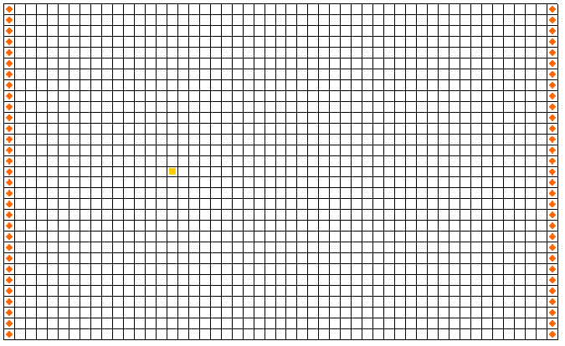

Figure 1 The MODFLOW flow model

# Building the Transport Model

Now that the flow model is imported, the next step is to set up the RT3D simulation. For this part of the simulation, select the reaction, define the reaction data, define the supplemental layer data needed by RT3D, and assign concentrations to the well.

# Initializing the Model

The first step is to initialize the RT3D data.

1. In the Project Explorer, expand the “File:3D Grid Folder.svg 3D Grid Data” folder.
2. Right-click on “File:3D Grid Icon.svg grid” and select **New MT3DMS*…*** to open the *Basic Transport Package* dialog.

# The BTN Package

The next step is to initialize the data in the Basic Transport Package. First, initialize the data, select RT3D as the transport model, and select the appropriate packages.

1. In the *Model* section, select the *RT3D* option.
2. Select **Packages…** to open the *MT3DMS/RT3D Packages* dialog.
3. Select the following packages:

* *Advection package*
* *Dispersion package*
* *Source/sink mixing package*
* *Chemical reaction package*

1. For the *RT3D reactions*, select the “Kinetic-Limited Deg. of BTEX w/ MEA” option.
2. Select **OK** to exit the *MT3DMS/RT3D Packages* dialog.

## Starting Concentrations

Note that in the *Layer Data* spreadsheet section of the dialog, the species associated with the reaction being modeled are listed by name. The next step is to define the starting concentration for each of these species. The default starting concentration is zero. Use the default value for BTEX, Fe2+, and methane, but use non-zero values for oxygen (4.0 mg/L), nitrate (20.0 mg/L), and sulfate (10.0 mg/L).

1. For *Oxygen,* in the *Starting Conc. (mg/l)* column,enter “4.0”.
2. For *Nitrate,* in the *Starting Conc. (mg/l)* column, enter “20.0”.
3. For S*ulfate,* in the *Starting Conc. (mg/l)* column, enter “10.0”.

## Porosity

The porosity to be used is 0.3. Since this is the default in GMS, nothing needs to be changed.

## Stress Periods

The next step is to define the stress periods. Since the injection rate of the well and the other boundary conditions do not change, a single stress period will be used.

1. Select **Stress Periods…** to open the *Stress Periods* dialog.
2. For *Length,* enter “730”.
3. For *Num Time Steps,* enter “10”.
4. Select **OK** to exit the *Stress Periods* dialog.

## Output Options

The next step is to define the output options. One binary solution file is created by RT3D for each of the species. By default, RT3D saves a solution at each transport step for each species. Since this results in large files containing more solutions than needed for the simple post-processing, it would be better to specify that a solution be saved every 73 days (every time step).

1. Select **Output Control…** to open the *Output Control* dialog.
2. Select the *Print or save at specified times* option.
3. Select **Times…** to open the *Variable Time Steps* dialog.
4. Select **Initialize Values…** to open the *Initialize Time Steps* dialog.
5. For *Initial time step size,* enter “73.0”.
6. For *Maximum time step size,* enter “73.0”.
7. For *Maximum simulation time,* enter “730.0”.
8. Select **OK** to exit the *Initialize Time Steps* dialog.
9. Select **OK** to exit the *Variable Time Steps* dialog.
10. Select **OK** to exit the *Output Control* dialog.

This completes the input for the *Basic Transport Package*.

1. Select **OK** to exit the *Basic Transport Package* dialog.

# Assigning Concentrations to the Left Boundary

The left boundary of the model is a constant head boundary. Since the head at the left boundary is greater than the head at the right boundary, the left boundary acts as a source and water enters the model from the left. Thus, the concentrations of the species at the left boundary must be defined. The simplest way to do this is to mark the cells as specified concentration cells. :

1. Using the **Select Cells** Select Cells tool, drag a box around the cells on the left boundary to select the column*.*
2. Right-click on any of the highlighted cells and select **Properties…** to open the *3D Grid Cell Properties* dialog.
3. Switch to the *RT3D* tab.
4. Change the *ICBUND* value to “–1”.
5. Select **OK** to close the *3D Grid Cell Properties* dialog.

# The Advection Package

The next step is to initialize the data for the Advection package.

1. Select the *RT3D* | **Advection Package…** command to open the *Advection Package dialog.*
2. From the *Solution scheme* drop-down menu, select “Standard finite-difference method”.
3. Select **OK** to close the *Advection Package* dialog.

# The Dispersion Package

The next step is to enter the data for the Dispersion package. The aquifer has a longitudinal dispersivity of 10.0 m and a transverse (horizontal) dispersivity of 3.0 m. The vertical dispersivity is assumed to be equal to the longitudinal dispersivity:

1. Select the RT3D | **Dispersion Package…** command to open the *Dispersion Package* dialog.
2. For *TRPT,* enter “0.3”.
3. Select **Longitudinal Dispersivity…** to open the *Longitudinal Dispersivity* dialog..
4. Select **Constant → Grid…** to open the *Grid Value* dialog.
5. Enter a value of “10.0”.
6. Select **OK** to close the *Grid Value* dialog.
7. Select **OK** to exit the *Longitudinal Dispersivity* dialog.
8. Select **OK** to exit the *Dispersion Package* dialog.

# The Source/Sink Mixing Package

Next to define the concentration at the spill location:

1. Using the **Select Cells** Select Cells tool, click on the cell containing the injection well (spill location).
2. Select the *RT3D* **| Point Sources/Sinks…** command to open the *MODFLOW/RT3D Source/Sinks* dialog.
3. Click the **Add BC** button near the bottom of the dialog.
4. Change the *Type* (ITYPE) to “well (WEL)”.
5. In the *BTEX* column, enter a concentration of “1000” (mg/L).
6. Select the **OK** button to exit *the MODFLOW/RT3D Source/Sinks* dialog.

# The Chemical Reaction Package

Next to initialize the Chemical Reaction package and define appropriate reaction rate constants:

1. Select the RT3D | **Chemical Reaction Package…** command to open the *RT3D Chemical Reaction Package* dialog.
2. In the *Reaction parameters* section, for *Max_Fe2+* enter “25.0”.
3. For *Max Methane* enter “30.0”.
4. For *kHCO2* enter “0.1”.
5. For *kHCNO3* enter “0.008”.
6. For *kHCFE3+* enter “0.0005”.
7. For *kHCSO4* enter “0.00025”.
8. For *kHCCH4* enter “0.0001”.

All monod constants, inhibition coefficients, and yield values, except KiFe 3+, will be left at the default values. The value of KiFe 3+ will be set at 12.5 mg/L (50% of max Fe).

1. For *kiFE3+* enter “12.5”.
2. Select **OK** to exit the *RT3D Chemical Reaction Package* dialog.

# Running RT3D

At this point, it is possible to save the model and run RT3D.

1. Select the *File* | **Save As…** command to bring up the *Save As* dialog.
2. Locate and open the directory entitled *flowmod\flowmod*.
3. Enter “btmod” for *the File name*.
4. Select **Save** to exit the *Save As* dialog.

Since the name of the project has changed, it is necessary to either use the Run Options command to tell RT3D where the MODFLOW solution is, or re-run MODFLOW.

1. Select the *MODFLOW* | **Run MODFLOW** command to start the *MODFLOW* model wrapper.
2. When the simulation is finished, select **Close** to exit the *MODFLOW* model wrapper.

The solution will automatically be imported.

To run RT3D:

1. Select the *RT3D* | **Run RT3D…** command to start the *RT3D* model wrapper.
2. Select **Yes** at the prompt to save the changes.
3. When the simulation is finished, select **Close** to exit the *RT3D* model wrapper.

GMS reads in the solution automatically.

# Viewing the Results

First, to view the BTEX solution at 730 days:

1. If necessary, expand the “File:Generic Folder Locked.svg btmod (RT3D)” folder.
2. In the Project Explorer, select “Cell scalar dataset – active BTEX”.
3. In the *Time Steps* window, select “730”.

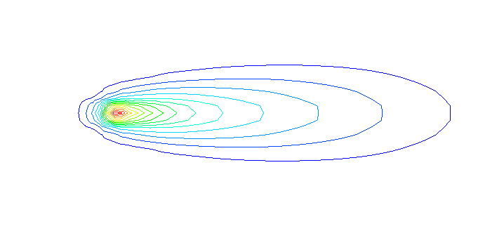

Figure 2 BTEX solution at 730 days

## Overlaying Contours

Next, it is possible to view concentration contours for the other species. When working with multiple species, it is often convenient to overlay contours of one species on top of contours from another species. As an example, this tutorial will overlay the contours of the other species on top of the BTEX contours. To do this, the display of the BTEX contours will need to be set to be in the background as a CAD layer.

Before creating the CAD layer, it is first necessary to turn off most of the display options other than the contours (to avoid saving the grid cell lines to the CAD file).

1. Select the **Display Options** Display Options macro to open the *Display Options* dialog.
2. Turn off *Cells edges*.
3. Switch to the *RT3D* tab.
4. Select the **Check None** button.
5. Switch to the *MODFLOW* tab.
6. Select the **Check None** button.
7. Select **OK** to close the *Display Options* dialog.

To create the CAD layer:

1. In the Project Explorer, right-click on the empty space then select **Convert to CAD** to open the *Save CAD* *data* dialog.
2. Enter “BTEX_contours” as the *File name*.
3. Select **Save** to create the CAD data.

Now to reset the display options and view the oxygen solution at 730 days:

1. Select the **Display Options** Display Options macro to open the *Display Options* dialog.
2. Turn on the *Layer Borders* option.
3. Select the **OK** button to close the *Display Options* dialog.
4. In the Project Explorer, select the “Cell scalar dataset – active Oxygen” dataset.

Now to turn on a color ramp and a legend:

1. Select the **Contour Options** Contour Options macro to open the *Dataset Contour Options – 3D Grid – Oxygen* dialog.
2. For *Contour method,* from the drop-down select “Color Fill”.
3. Change *Transparency* to “50”.
4. Select **OK** to exit the *Dataset Contour Options – 3D Grid – Oxygen* dialog.
5. In the *Time Steps* window*,* select “730”.

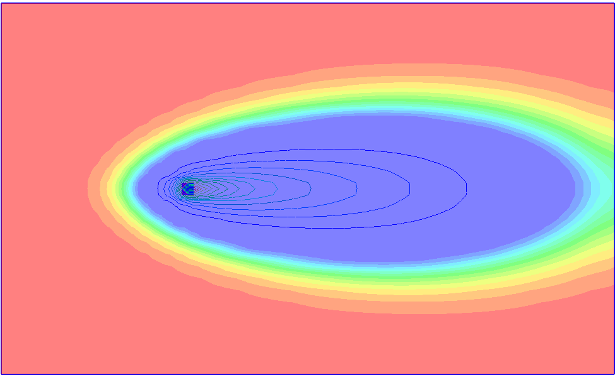

Figure 3 The Oxygen solution at 730 days

Next to view the nitrate solution at 730 days:

1. In the Project Explorer, select the “Cell scalar dataset – active Nitrate” dataset
2. In the *Time Steps* window*,* select “730”.

Finally, view the iron solution at 730 days.

1. In the Project Explorer, select the “Cell scalar dataset – active Iron (Fe2+)” dataset
2. In the *Time Steps* window*,* select “730”.

# Other Post-Processing Options

At this point, feel free to experiment with the other post-processing options, including film loop animation

# Conclusion

This concludes the “RT3D – BTEX Degradation with Multiple Electron Acceptors” tutorial. Continue to explore RT3D applications or close the program.

1. Lu, G., Clement, T.P., Zheng, C., and Wiedemeier, T.H. (1999). Natural attenuation of BTEX compounds: Model development and field-scale application. *Ground Water*. 37(5):707–717.