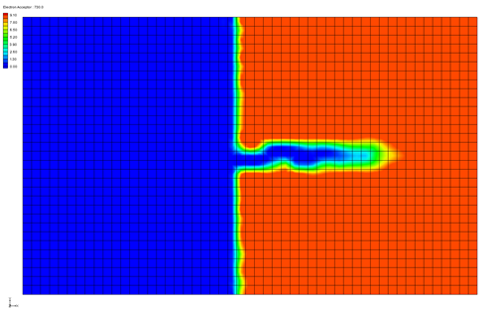

GMS 10.9

GMS 10.9 Tutorial

***RT3D – Double Monod Model***

Objectives

This tutorial shows how to use GMS and RT3D to model the reaction between an electron donor and an electron acceptor, mediated by an actively growing microbial population that exists in both soil and aqueous phases.

Time

* 25–40 minutes

Required Components

* GMS Core
* MODFLOW Interface
* RT3D

Prerequisite Tutorials

* RT3D – Instantaneous Aerobic Degradation

|  |
| --- |
| 1 Introduction 2  1.1 Description of the Reaction Model 2  1.2 Description of Problem 5  1.3 Getting Started 6  2 Importing the MODFLOW Model 6  3 Building the Transport Model 6  4 Initializing the Model 6  5 The Basic Transport Package 7  5.1 Starting Concentration 7  5.2 Porosity 7  5.3 Stress Periods 7  5.4 Output Options 8  6 Assigning Concentrations to the Left Boundary 8  7 The Advection Package 9  8 The Dispersion Package 9  9 The Source/Sink Mixing Package 9  10 The Chemical Reaction Package 10  11 Run MODFLOW 10  12 Running RT3D 10  13 Viewing the Results 10  13.1 Electron Donor 10  13.2 Electron Acceptor 11  13.3 Aqueous-Phase Bacteria 12  13.4 Solid-Phase Bacteria 12  13.5 Other Post-Processing Options 12  14 Conclusion 12 |

# Introduction

This tutorial illustrates the steps involved in using GMS and RT3D to model the reaction between an electron donor and an electron acceptor, mediated by an actively growing microbial population that exists in both soil and aqueous phases. Since the flow model used in this simulation is the same as the flow model used in the “RT3D – Instantaneous Aerobic Degradation” tutorial, the steps involved in building the flow model will not be described in this tutorial. A predefined version of the flow model will be used.

This tutorial will begin with importing a MODFLOW model then defining RT3D inputs and boundary conditions, running MODFLOW, running RT3D, and viewing the results.

## Description of the Reaction Model

Methods for enhancing in situ bioremediation of subsurface soil and groundwater involve injection or infiltration of a carbon source (or electron donor), nutrients, and other electron acceptors to stimulate the growth of native microbes. In addition, bioengineered suspension cultures of contaminant degrading organisms may be also added to increase the amount of attached and suspended biomass in the subsurface. These two types of active remediation techniques can be used to bioremediate contaminated source zones or to establish a biobarrier to prevent plume migration and/or to enhance plume attenuation. The successful use of subsurface microbes for bioremediation requires an understanding of coupled flow, transport, and reaction processes that control bacterial growth and migration patterns. The Dual-Monod model, available in the RT3D code, can be used to develop such understanding by simulating the coupled reactive transport and microbial growth. The model is developed in a general format; therefore, the interaction between any electron donor and acceptor mediated by any type of microbial population can be simulated by varying appropriate kinetic constants. Advanced users can modify this basic formulation and couple it with other packages, such as the sorption package, to simulate more realistic bioremediation scenarios (any such modified reaction models can be easily implemented via the user-defined reaction option).

Assuming the linear-equilibrium model for modeling sorption, and the Dual-Monod model for modeling bacterial growth, the fate and transport equation for an electron donor (hydrocarbon, for example) in a multi-dimensional saturated porous media can be written as follows:

 (1)

Where:

* [D] is the electron donor concentration in the aqueous phase [ML-3]
* [Ds] is the donor concentration in the sources/sinks [ML-3]
* *Dij* is the dispersion coefficient
* [X] is the aqueous phase bacterial cell concentration [ML-3]
* is the solid-phase cell concentration (mass of bacterial cells per unit mass of porous media [MM-1])
* [A] is the electron acceptor concentration in the aqueous phase [ML-3]
* RH is the retardation coefficient of the hydrocarbon, KD is the half-saturation coefficient for the electron donor [ML-3]
* KA is the half-saturation coefficient for the electron acceptor [ML-3]
* μm is the contaminant utilization rate [T-1]

The model assumes that the degradation reactions occur only in the aqueous phase, which is usually a conservative assumption.

The fate and transport of the electron donor (oxygen, for example) can be modeled using this equation:

 (2)

where YA/D is the stoichiometric yield coefficient, and RA is the retardation coefficient of the electron acceptor.

The fate and transport of bacteria in the aqueous phase can be described using this equation:

 (3)

where Katt is the bacterial attachment coefficient [T-1], Kdet is the bacterial detachment coefficient [T-1], and Ke is the endogenous cell death or decay coefficient [T-1].

The growth of attached-phase bacteria can be described using an ordinary differential equation of the form:

 (4)

The conceptual model used here for representing attached bacteria cells is similar to the macroscopic model described by Baveye and Valocchi (1989).[1] The model also assumes first-order kinetic expressions for representing bacterial attachment and detachment processes (Taylor and Jaffé, 1990; and Hornberger et al., 1992).[2] Permeability and porosity changes caused by bacterial growth are ignored in this formulation. However, if required, macroscopic models for biomass-affected porous-media properties described by Clement et al. (1996) may be integrated within this modeling approach.[3] It should be noted that a lot of active research is currently underway to gain an increased understanding of bacteria transport in porous media because currently available bacterial transport models (including the model used here) are arguably approximate. Therefore, application of this model to real situations should be always supported by field- or laboratory-scale data.

The reactive-transport model discussed above was set up as a RT3D reaction package with three mobile species (to represent electron donor, electron acceptor, and aqueous bacteria) and one immobile species (to represent attached soil bacteria). After employing the reaction-operator splitting strategy, the reaction package for the problem reduces to the following:

 (5)

 (6)

 (7)

 (8)

These four equations are coded into the double-monod reaction module.

## Description of Problem

The problem in this tutorial is similar to the problem described in the “RT3D – BTEX Degradation with Multiple Electron Acceptors” tutorial. The site is a 510 m X 310 m section of a confined aquifer with a flow gradient from left to right. An underground storage tank is leaking fuel hydrocarbon contaminants at 2 m3/day at the location shown. Source concentration of BTEX is 500 mg/L. It will be assumed that the aquifer is initially clean and has very low levels of aerobic bacterial activity. The fuel hydrocarbon compounds are expected to serve as the carbon source, resuscitating the bacterial cells and activating them into a growth mode. This is a common subsurface phenomenon that occurs in most fuel-contaminated sites. Several field studies have observed the presence of enhanced levels of microbial activity near a source region, and low background levels outside the plume. This example will simulate the transient changes in hydrocarbon, oxygen, and bacterial concentrations levels within the contaminated area.

Initial levels of hydrocarbon, oxygen, aqueous bacteria, and attached bacteria are respectively assumed to be as follows: 0.0 mg/L, 9.0 mg/L, 2 x 10-17 (value for X in mg/L), and 3.0 x 10-9 (value for  in mg of bacteria/mg of soil). Note the mass fraction unit used for representing soil bacterial cells will always yield small numbers. Using the value of soil porosity and bulk density, these numbers can be converted into standard mg/L units (liquid-volume basis) to get a better feel for bacterial concentration levels. For example, assuming ρ = 1.6 x 106 mg/L and φ = 0.3, the initial value of soil bacterial concentration can be expressed (when converted to a liquid volume basis using the formula ρ/φ) as 0.016 mg/L. While post-processing output concentration in GMS, the data calculator will be used to perform this unit conversion. This is recommended because extremely small numbers may not be displayed correctly in GMS.

Assumed values for other kinetic reaction constants are given below:

|  |  |  |
| --- | --- | --- |
| Constant | GMS Display | Value |
| μm | umax | 0.125 day-1 |
| KD | Ked | 0.12 mg/L |
| KA | Kea | 0.1 mg/L |
| Yx/D | Yx/ed | 0.05 |
| YA/D | Yea/ed | 3.0 |
| Kdecay | Kdecay | 0.001 day-1 |
| Katt | Katt | 70.0 day-1 |
| Kdet | Kdet | 1.0 day-1 |

Sorption is assumed to be negligible for this site, hence the values of all retardation coefficients are assumed to be unity.

The first part of the problem will be to import a previously computed MODFLOW flow model of the site. Using this flow field, a reactive transport model will be then be defined using RT3D.

## Getting Started

Do the following to get started:

1. If GMS is not running, launch GMS.
2. If GMS is already running, select *File |* **New** to ensure the program settings are restored to the default state.

# Importing the MODFLOW Model

The first part of the simulation is to import the MODFLOW flow model. A steady state flow model has been previously computed and is supplied with the tutorial files.

1. Click the **Open** File:Open Macro.svg button to bring up the *Open* dialog.
2. Locate and open the file entitled *flowmod\flowmod*.
3. Select the file entitled “flowmod.gpr”.
4. Click **Open** to import the file and exit the *Open* dialog.

At this point, a grid should appear.

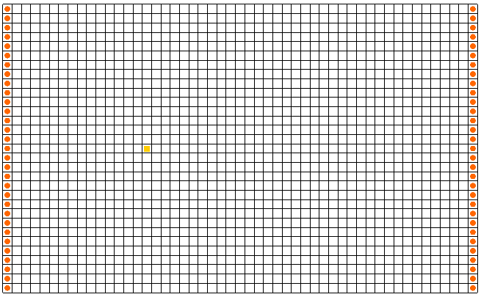

Figure 1 The grid imported with the flowmod.gpr file

# Building the Transport Model

Now that the flow model is imported, the next step is to perform the RT3D simulation. For this part of the simulation: select the reaction, define the reaction data, define the supplemental layer data needed by RT3D, define the boundary conditions, and assign concentrations to the well.

# Initializing the Model

To initialize the RT3D data:

1. In the Project Explorer, expand the “File:3D Grid Folder.svg 3D Grid Data” folder.
2. Right-click on “File:3D Grid Icon.svg grid” and select the **New MT3DMS…** command.

This initializes MT3DMS/RT3D and brings up the *Basic Transport Package* dialog.

# The Basic Transport Package

The next step is to set up the data in the Basic Transport Package. This will be completed by selecting RT3D as the transport model, selecting the appropriate packages, and initializing the starting concentrations.

1. In the *Model* section, select the *RT3D* option of the dialog.
2. Select **Packages…** to open the *MT3DMS/RT3D Packages* dialog.
3. Turn on the following packages:

* *Advection package*
* *Dispersion package*
* *Source/sink mixing package*
* *Chemical reaction package.*

1. For the *RT3D reactions* type, select the “Double Monod Model” option.
2. Select **OK** to exit the *MT3DMS/RT3D Packages* dialog.

## Starting Concentration

Note that in the *Starting Concentration* section of the dialog, the species associated with the reaction being modeled are listed by name. The next step is to define the starting concentration for each of these species. The default starting concentration is zero. This tutorial will use the default value for the electron donor, but will use non-zero values for the electron acceptor (9.0 mg/L), the aqueous phase bacteria (2x10-17 mg/L), and the solid phase bacteria (3x10-9 mg bacteria/mg of soil).

1. In the *Basic Transport Package* dialog, on the *Electron Acceptor* row, for *Starting Conc. (mg/l),* enter “9.0”.
2. For the *Aqueous-phase bacteria,* for *Starting Conc. (mg/l)*, enter “2e-17”.
3. For the *Soil-phase bacteria,* for *Starting Conc. (mg/l),* enter “3e-9”.

## Porosity

Next, it is necessary to consider the porosity, which should be set as 0.3. Since this is the default supplied by GMS, no changes need to be made.

## Stress Periods

Next to define the stress periods. Since the injection rate and the boundary conditions do not change, a single stress period with a length of 730 days (two years) will be used.

1. Select **Stress Periods…** to open the *Stress Periods* dialog.
2. For *Length,* enter “730”.
3. For *Num Time Steps,* enter “10”.
4. Select **OK** to exit the *Stress Periods* dialog.

## Output Options

It is now possible to define the output options. One binary solution file is created by RT3D for each of the species. By default, RT3D saves a solution at each transport step for each species. Since this results in large files containing more solutions than are needed for simple post-processing options, it would be good to specify that a solution be saved every 73 days (every time step).

1. Select **Output Control…** to open the *Output Control* dialog.
2. Select the *Print or save at specified times* option.
3. Select **Times…** to open the *Variable Time Steps* dialog.
4. Select **Initialize Values…** to open the *Initialize Time Steps* dialog.
5. For *Initial time step size,* enter “73.0”.
6. For *Maximum time step size,* enter “73.0”.
7. For *Maximum simulation time,* enter “730.0”.
8. Select **OK** to exit the *Initialize Time Steps* dialog.
9. Select **OK** to exit the *Variable Time Steps* dialog.
10. Select **OK**to exit the *Output Control* dialog.

This completes the input for the Basic Transport package.

1. Select **OK** to exit the *Basic Transport Package* dialog.

# Assigning Concentrations to the Left Boundary

The left boundary of the model is a constant head boundary. Since the head at the left boundary is greater than the head at the right boundary, the left boundary acts as a source and water enters the model from the left. Thus, the concentrations of the species at the left boundary must be defined. The simplest way to do this is to mark the cells as specified concentration cells.

1. Using the **Select Cells** File:Select 3D Cell Tool.svg tool, drag a box around the column of cells on the left boundary to select them.

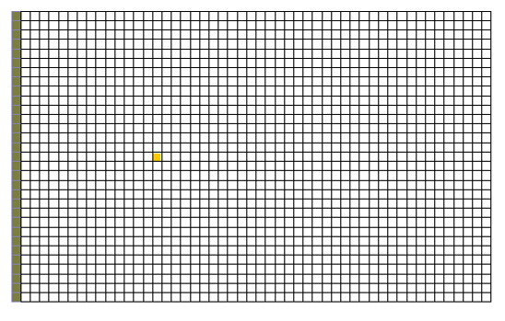

Figure 2 Selecting the cells on the left side of the grid

1. Select the *RT3D |* **Cell Properties…** command to open the *3D Grid Cell Properties* dialog.
2. Change the *ICBUND* value to “-1”.
3. Select **OK** to close the *3D Grid Cell Properties* dialog.

# The Advection Package

The next step is to initialize the data for the Advection Package.

1. Select the *RT3D* | **Advection Package…** command to open the *Advection Package* dialog.
2. For *Solution scheme,* from the drop-down, select the “Method of characteristics (MOC)”.
3. Select **OK** to exit the *Advection Package* dialog.

# The Dispersion Package

The next step is to enter the data for the Dispersion package. The aquifer has a longitudinal dispersivity of 10.0 m and a transverse (horizontal) dispersivity of 3.0 m.

1. Select the *RT3D* | **Dispersion Package…** command to open the *Dispersion Package* dialog.
2. For *TRPT,* enter “0.3”.
3. Select **Longitudinal Dispersivity…** to open the *Longitudinal Dispersivity* dialog.
4. Select **Constant → Grid** to open the *Grid Value* dialog.
5. Enter a value of “10.0”.
6. Select **OK** to close the *Grid Value* dialog.
7. Click **OK** to exit the *Longitudinal Dispersivity* dialog.
8. Select **OK** to exit the *Dispersion Package* dialog.

# The Source/Sink Mixing Package

Next, to define the concentration at the spill location:

1. Using the **Select Cell** File:Select 3D Cell Tool.svg tool, click on the cell containing the injection well (spill location).
2. Select the *RT3D* | **Point Sources/Sinks…** command to open the *MODFLOW/RT3D Sources/Sinks* dialog.
3. Click the **Add BC** button near the bottom of the dialog.
4. Change the *Type (ITYPE)* to “well (WEL)”.
5. In the *Electron Donor* column, enter a concentration of “500”(mg/L).
6. Select **OK** to exit the *MODFLOW/RT3D Sources/Sinks* dialog.

# The Chemical Reaction Package

Next, to initialize the Chemical Reaction package and define appropriate reaction rate constants:

1. Select the *RT3D |* **Chemical Reaction Package…** command to open the *RT3D Chemical Reaction Package* dialog.
2. In the *Reaction parameters* section, set *umax* to “0.125”.
3. Set the value of *Yea/ed* to “3.0”.

The rest of the constants will all be left at the default values.

1. Select **OK** to close the *RT3D Chemical Reaction Package* dialog.

# Run MODFLOW

Before running RT3D, it is necessary to first regenerate the MODFLOW solution.

1. Select the *File* | **Save As…** command to open the *Save As* dialog.
2. Enter “bacteria” for the *File name*.
3. Select **Save** to save the files and exit the *Save As* dialog.

To run MODFLOW:

1. Select the *MODFLOW* | **Run MODFLOW** command to launch the *MODFLOW* model wrapper.
2. When the *MODFLOW* simulation is finished, select **Close** to exit the *MODFLOW* dialog.

# Running RT3D

At this point, it is possible to save the model and run RT3D.

To run RT3D:

1. Select the *RT3D* | **Run RT3D…** command to launch the *RT3D* model wrapper.
2. Click **Yes** at the prompt to save the changes.
3. When the *RT3D* simulation is finished, select **Close** to exit the *RT3D* dialog.

# Viewing the Results

## Electron Donor

1. In the Project Explorer, expand the “File:Generic Folder Locked.svg bacteria (RT3D)” solution folder, and select the “File:Dataset Cells Active.svg Electron Donor” dataset.
2. In the *Time Steps* window*,* select “730”.

To display color-filled contours:

1. Select the **Contour Options** File:Contour Options Macro.svg button to open the *Dataset Contour Options – 3D Grid – Electron Donor* dialog.
2. Change the *Contour method* to “Color fill”.
3. Select **OK** to close the *Dataset Contour Options – 3D Grid – Electron Donor* dialog.

Recall that the electron donor solution represents the contaminant. The plume is moving from the left side to the right side, as expected.

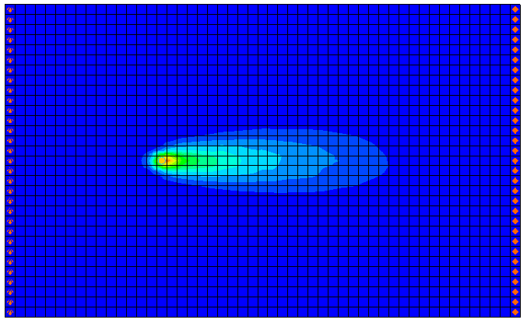

Figure 3 Electron Donor at 730 days

## Electron Acceptor

Next, to view the electron acceptor solution:

1. In the Project Explorer, select the “File:Dataset Cells Active.svg Electron Acceptor” dataset.

Note that the electron acceptor solution is the inverse of the electron donor solution. The minimum value (the blue region) corresponds to the location of the plume.

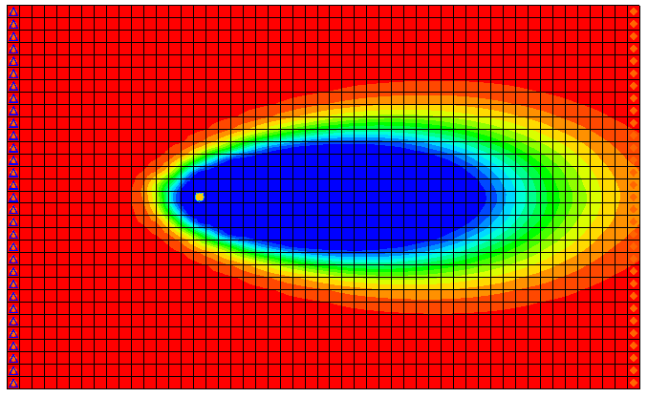

Figure 4 Electron Acceptor at 730 days

## Aqueous-Phase Bacteria

Next, to view the solution for the aqueous-phase bacteria:

1. In the Project Explorer, select the “File:Dataset Cells Active.svg Aqueous-phase bacteria” dataset.

Note that the bacteria are flourishing at the left end and around the edges of the plume where there is a combination of electron donors and electron acceptors.

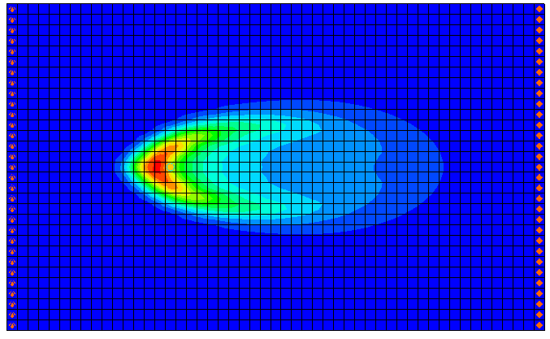

Figure 5 Aqueous-phase bacteria at 730 days

## Solid-Phase Bacteria

Finally, to view the solution for the solid-phase bacteria:

1. In the Project Explorer, select the “File:Dataset Cells Active.svg Solid-phase bacteria” dataset.

Note that the distribution of the soil bacteria is similar to the distribution of the aqueous-phase bacteria.

## Other Post-Processing Options

At this point, feel free to experiment with the other post-processing options, including film loop animation and time series plots.

# Conclusion

This concludes the “RT3D – Double Monod Model” tutorial.

1. 1 Baveye, P. and Valocchi, A.J. (1989). An Evaluation of Mathematical Models of the Transport of Biologically Reacting Solutes in Saturated Soils and Aquifers. *Water Resources Research*, 25(6): 1413–1421.
2. . Taylor, S.W., and Jaffé, P.R. (1990). Substrate and Biomass Transport in a Porous Medium. *Water Resources Research*, 26(9): 2181–2194; and Hornberger, G.M., Mills, A.L., and Herman, J.S. (1992). Bacterial Transport in Porous Media: Evaluation of a Model Using Laboratory Observations. *Water Resources Research*, 28(3): 915-938.
3. . Clement, T.P., Hooker, B.S., and Skeen, R.S. (1996). Macroscopic Models for Predicting Changes in Saturated Porous Media Properties Caused by Microbial Growth. *Ground Water,* 34(5): 934–942.