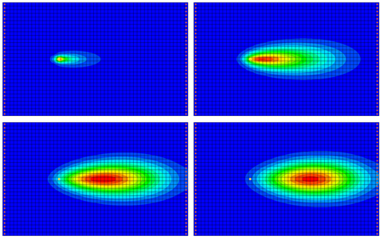

GMS 10.9

GMS 10.9 Tutorial

***RT3D – Sequential Anaerobic Degradation: PCE 🡢 TCE 🡢 DCE 🡢 VC***

Use RT3D to model sequential anaerobic degradation

Objectives

This tutorial illustrates the steps involved in modeling sequential anaerobic degradation of tetrachloroethene (PCE) using the RT3D model.

.

Time

* 10–25 minutes

Required Components

* GMS Core
* MODFLOW Model & Interface
* RT3D Model & Interface

Prerequisite Tutorials

* RT3D – Instantaneous Aerobic Degradation

|  |
| --- |
| 1 Introduction 2  1.1 Description of Problem 2  1.2 Description of Reaction 2  1.3 Getting Started 3  2 Importing the MODFLOW Model 3  3 Building the Transport Model 4  4 Initializing the Model 4  5 The Basic Transport Package 4  5.1 Starting Concentrations 5  5.2 Porosity 5  5.3 Stress Periods 5  5.4 Output Options 5  6 The Advection Package 6  7 The Dispersion Package 6  8 The Source/Sink Mixing Package 6  9 The Chemical Reaction Package 6  10 Run MODFLOW 7  11 Running RT3D 7  12 Viewing the Results 7  12.1 Creating a Time Series Plot 8  12.2 Other Post-Processing Options 9  13 Conclusion 9 |

# Introduction

This tutorial will use the problem described below. It will start with importing a MODFLOW model. Then the RT3D inputs and boundary conditions will be defined followed by running simulations for both MODFLOW and RT3D. Finally, a time series plot will be created to review the results.

## Description of Problem

The problem in this tutorial is similar to the problem described in the “RT3D – Instantaneous Aerobic Degradation” tutorial. The site is a 510 m x 310 m section of a confined aquifer with a flow gradient from left to right. An underground storage tank is leaking fuel hydrocarbon contaminants at 2 m3/day at the location shown. Concentration of tetrachloroethene (PCE) is 1000 mg/L. This high hypothetical concentration was selected to simulate a plume with considerable PCE mass and with a relatively low injection flow rate. Initial levels of PCE and its degradation products in the aquifer are assumed to be 0.0 mg/L. The tutorial will simulate a continuous spill event and compute the resulting PCE, trichloroethene (TCE), dichloroethene (DCE), and vinyl chloride (VC) contours after two years.

The first part of the problem will be to import a previously computed MODFLOW flow model of the site. Using this flow field, RT3D will then define a reactive transport model.

## Description of Reaction

The reaction being simulated is anaerobic PCE dechlorination with sequential, first-order, degradation kinetics. Degradation of PCE all the way to VC is assumed to be anaerobically favorable and the degradation kinetics are assumed to be first order in nature.

 (1)

The following set of equations describes the reaction kinetics framework:

 (2)

 (3)

 (4)

 (5)

Kinetic Constants (to be manually entered):

|  |  |  |
| --- | --- | --- |
| Constant | Value | Designation |
| k1 | 0.005 day-1 | PCE anaerobic constant |
| k2 | 0.003 day-1 | TCE anaerobic constant |
| k3 | 0.002 day-1 | DCE anaerobic constant |
| k4 | 0.001 day-1 | VC anaerobic constant |

The following constants (yields in mg/mg basis) are fixed internally:

|  |  |  |
| --- | --- | --- |
| Constant | Value | Designation |
| YTCE/PCE | 0.7920 | TCE:PCE stoichiometric yield |
| YDCE/TCE | 0.7377 | DCE:TCE stoichiometric yield |
| YVC/DCE | 0.6445 | VC:DCE stoichiometric yield |

## Getting Started

Do the following to get started:

1. If GMS is not running, launch GMS.
2. If GMS is already running, select the *File |* **New** command to ensure the program settings are restored to the default state.

# Importing the MODFLOW Model

The first part of the simulation is to import the MODFLOW flow model. A steady state flow model has been previously computed and is supplied with the tutorial files.

1. Select the *File* | **Open** command to bring up the *Open* dialog.
2. Navigate to *flowmod\flowmod.*
3. Select the file entitled “flowmod.gpr”.
4. Click **Open** to import the project file and exit the *Open* dialog.

At this point, a grid will appear.

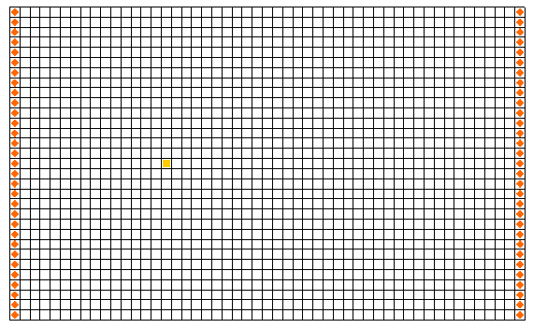

Figure 1 The MODFLOW grid

# Building the Transport Model

Now that the flow model is imported, the next step is to perform the RT3D simulation. For this part of the simulation, select the reaction, define the reaction data, define the supplemental layer data needed by RT3D, and assign concentrations to the well.

# Initializing the Model

The first step is to initialize the RT3D data.

1. In the Project Explorer, expand the “File:3D Grid Folder.svg 3D Grid Data” folder.
2. Right-click on the “File:3D Grid Icon.svg grid” item.
3. Select the **New MT3DMS…** command from the pop-up menu to open the *Basic Transport Package* dialog.

# The Basic Transport Package

The next step is to initialize the data in the Basic Transport Package. First, it is necessary to select RT3D as the transport model and to select the appropriate packages.

1. In the *Model* section, select the *RT3D* option.
2. Select **Packages…** to open the *MT3DMS/RT3D Packages* dialog.
3. Turn on the following packages:

*Advection package*

*Dispersion package*

*Source/sink mixing package*

*Chemical reaction package*

1. For the *RT3D reactions* drop-down menu, select the “Sequential Decay Reactions” option.
2. Select **OK** to exit the *MT3DMS/RT3D Packages* dialog.

## Starting Concentrations

Note that in the *Layer Data* section of the dialog, the species associated with the reaction being modeled are listed by name. The next step is to define the starting concentration for each of these species. By default, all of the starting concentrations are zero. Since the aquifer is assumed to be initially clean, accept the default values for starting concentrations.

## Porosity

Next, consider the porosity, which should be set as 0.3. Since this is the default supplied by GMS, no changes need to be made.

## Stress Periods

The next step is to define the stress periods. Since the injection rate of the well and the other boundary conditions do not change, a single stress period will be used.

1. Select **Stress Periods…** to open the *Stress Periods* dialog.
2. For *Length,* enter “730”.
3. For *Num time steps,* enter “10”.
4. Select **OK** to exit the *Stress Periods* dialog.

## Output Options

The next step is to define the output options. One binary solution file is created by RT3D for each of the species. By default, RT3D saves a solution at each transport step for each species. Since this results in large files containing more solutions than needed for the simple post-processing, it would be better to specify that a solution be saved every 73 days (every time step).

1. Select **Output Control…**to open the *Output Control* dialog.
2. Select the *Print or save at specified times* button.
3. Select **Times…** to open the *Variable Time Steps* dialog.
4. Select **Initialize Values…** to open the *Initialize Time Steps* dialog.
5. For *Initial time step size,* enter “73.0”.
6. For *Maximum time step size,* enter “73.0”.
7. For *Maximum simulation time,* enter “730.0”.
8. Select **OK** to exit the *Initialize Time Steps* dialog
9. Select **OK** to exit the *Variable Time Steps* dialog.
10. Select **OK** to exit the *Output Control* dialog.

This completes the input for the Basic Transport package.

1. Select **OK** to exit the *Basic Transport Package* dialog.

# The Advection Package

The next step is to initialize the data for the Advection package.

1. Select the *RT3D* | **Advection Package…** command to open the *Advection Package* dialog.
2. In the *Solution scheme* drop-down menu, select “Standard finite difference method”.
3. Select **OK** to close the *Advection Package* dialog.

# The Dispersion Package

The next step is to enter the data for the Dispersion package. The aquifer has a longitudinal dispersivity of 10.0 m and a transverse (horizontal) dispersivity of 3.0 m. The vertical dispersivity is not used since this is a one layer model.

1. Select the *RT3D* | **Dispersion Package…** command to open the *Dispersion Package* dialog.
2. For *TRPT*, enter “0.3”.
3. Select the **Longitudinal Dispersivity…** button to open the *Longitudinal Dispersivity* dialog.
4. Select the **Constant 🡢 Grid** button to open the *Grid Value* dialog.
5. Enter a value of “10.0”.
6. Select **OK** to exit the *Grid Value* dialog.
7. Select **OK** to exit the *Longitudinal Dispersivity* dialog.
8. Select **OK** to exit the *Dispersion Package* dialog.

# The Source/Sink Mixing Package

Next, to define the concentration at the spill location:

1. Using the **Select Cells** File:Select 3D Cell Tool.svg tool, click on the cell containing the injection well (spill location).
2. Select the *RT3D* | **Point Sources/Sinks…** command to open the *MODFLOW/RT3D Source/Sinks* dialog.
3. Click the **Add BC** button near the bottom of the dialog.
4. Change the *Type (ITYPE)* to “well (WEL)”.
5. In the *PCE* column, enter a concentration of “500”(mg/L).
6. Select **OK** to exit the *MODFLOW/RT3D Source/Sinks* dialog.

# The Chemical Reaction Package

Next, to initialize the chemical reaction package and define appropriate reaction rate constants:

1. Select the *RT3D |* **Chemical Reaction Package…** command to open the *RT3D Chemical Reaction Package* dialog.
2. In the *Reaction Parameters* section, change the *Kpce* value to “0.005”.
3. Set the value of *Ktce* to “0.003”.
4. Set the value of *Kdce* to “0.002”.
5. Set the value of *Kvc* to “0.001”.
6. Select **OK** to exit the *RT3D Chemical Reaction Package* dialog.

# Run MODFLOW

Before running RT3D, it is necessary to regenerate the MODFLOW solution.

1. Select the *File* | **Save As…** command to open the *Save As* dialog.
2. Enter “rtmod” for the *File name*.
3. Select **Save** to save the files and exit the *Save As* dialog.

To run MODFLOW:

1. Select the *MODFLOW* | **Run MODFLOW** command to launch the *MODFLOW* simulation.
2. When the *MODFLOW* simulation is finished, select **Close** to exit the *MODFLOW* dialog.

The MODFLOW solution is imported and displayed as contours on the grid.

# Running RT3D

It is now possible to save the model and run RT3D.

To run RT3D:

1. Select the *RT3D* | **Run RT3D…** command to launch the *RT3D* simulation.
2. Select **Yes** at the prompt to save the changes.
3. When the *RT3D* simulation is finished, select **Close** to exit the *RT3D* dialog.

GMS automatically reads in the RT3D solution.

# Viewing the Results

1. In the Project Explorer, expand “File:Generic Folder Locked.svg rtmod (RT3D)” if needed, then select the “File:Dataset Cells Active.svg PCE” dataset.
2. In the *Time Steps* window*,* select “730.0”.

To view color-fill contours:

1. Select the **Contour Options** File:Contour Options Macro.svg macro to open the *Dataset Contour Options – 3D Grid – PCE* dialog.
2. Change the *Contour method* to “Color Fill”.
3. Select **OK** to exit the *Dataset Contour Options – 3D Grid – PCE* dialog.

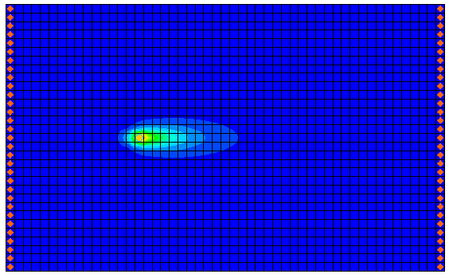

Figure 2 The PCE solution at 730 days

Next, view the other solutions at 730 days.

1. In the Project Explorer, select the “File:Dataset Cells Active.svg TCE” dataset.
2. In the *Time Steps* window*,* select “730.0”.
3. Repeat steps 6 and 7 for the “File:Dataset Cells Active.svg DCE” and “File:Dataset Cells Active.svg VC” datasets.

## Creating a Time Series Plot

Another highly effective tool for viewing RT3D solutions is a time series plot. A time series plot is used to display the variation of concentration vs. time for one or more species at a particular point in the model.

1. Select the **Plot Wizard** File:Plot Wizard Macro.svg macro to open the *Plot Wizard* dialog.
2. Select the *Active Dataset Time Series* option.
3. Select **Finish** to close the *Plot Wizard* dialog and open a plot window.
4. Use the **Select Cells** File:Select 3D Cell Tool.svg tool to select any cell in the grid downstream from the contaminant source.

The plot now shows the variation of *VC* concentration vs. time at the specified location in the grid. To view the concentrations for any contaminant at a different location, change the active dataset in the Project Explorer and the selected grid cell.

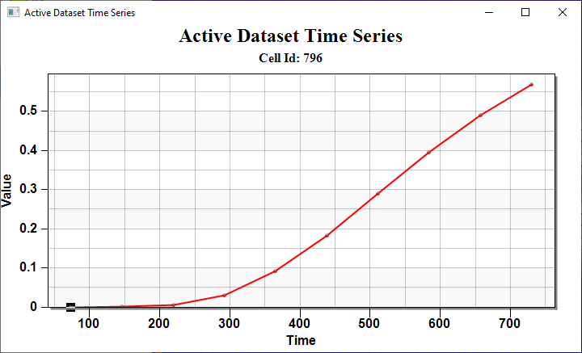

Figure 3 Active dataset time series plot for the VC solution

## Other Post-Processing Options

At this point, feel free to experiment with the other post-processing options, including film loop animations.

# Conclusion

This concludes the “RT3D – Sequential Anaerobic Degradation” tutorial. Continue to explore the RT3D model or exit the program.