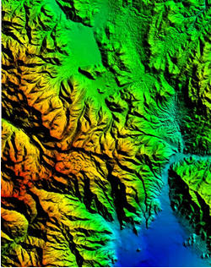

GMS 10.9

GMS 10.9 Tutorial

***Rasters***

Using rasters for interpolation and visualization in GMS

Objectives

This tutorial teaches how GMS uses rasters to support all kinds of digital elevation models and how rasters can be used for interpolation in GMS.

Time

* 15–30 minutes

Required Components

* None

Prerequisite Tutorials

* Geostatistics – 2D

|  |
| --- |
| [1 Introduction 2](#_Toc109982566)  [1.1 Getting Started 2](#_Toc109982567)  [2 Opening a Starting Project 2](#_Toc109982568)  [3 Importing Using Drag and Drop 3](#_Toc109982569)  [4 Viewing the Raster Properties 4](#_Toc109982570)  [5 Raster Shaders 5](#_Toc109982571)  [6 Downloading Elevation Data 5](#_Toc109982572)  [7 Manipulating Rasters 6](#_Toc109982573)  [7.1 Resampling 6](#_Toc109982574)  [7.2 Merging Rasters 6](#_Toc109982575)  [7.3 Trimming 7](#_Toc109982576)  [8 Converting and Interpolating Rasters 8](#_Toc109982577)  [8.1 Converting a Raster to 2D Scatter Points 8](#_Toc109982578)  [8.2 Convert Scatter Points to Rasters 9](#_Toc109982579)  [8.3 Interpolate to a TIN 10](#_Toc109982580)  [8.4 Raster Catalogs 11](#_Toc109982581)  [8.5 Interpolate to Feature Objects 12](#_Toc109982582)  [8.6 Interpolate to MODFLOW Layers 13](#_Toc109982583)  [9 Conclusion 14](#_Toc109982584) |

# Introduction

Rasters are regularly spaced, gridded data. In GMS, the term “raster” is typically used to refer to an image containing elevation data. A Digital Elevation Model, or DEM, is one type of a raster and is used to represent the surface of a terrain. DEM data is useful when building a groundwater model because it can be used to determine the ground surface elevation and the elevation of surface features such as drains and streams. DEMs can be used to represent the geologic layers beneath the surface, or they can be used like scatter points to represent any 2D dataset such as concentration of a contaminant in *X* and *Y*, flow rates, and so on.

In this tutorial, some DEM files representing the area around Park City, Utah, will be imported and used in various ways. Topics covered include importing DEMs, changing the display options, interpolating scatter points, MODFLOW layers, and feature objects, converting DEMs to scatter points, and creating a raster from scatter points.

## Getting Started

Do the following to get started:

1. If necessary, launch GMS.
2. If GMS is already running, select *File |* **New** to ensure that the program settings are restored to their default state.

# Opening a Starting Project

Start with opening a project which contains some existing data.

1. Click **Open** File:Open Macro.svg to bring up the *Open* dialog.
2. Select “Project Files (\*.gpr)” from the *Files of type* drop-down.
3. Browse to the *Tutorials\GIS\rasters* directory and select “start.gpr”.
4. Click **Open** to import the file and close the *Open* dialog.

This project contains a TIN and a coverage, but they are both turned off so nothing appears in the Graphics Window.

# Importing Using Drag and Drop

It is often easier to drag and drop DEM files into GMS.

1. Outside of GMS, browse to the *Tutorials\GIS\rasters* folder in Windows Explorer.
2. Select the following files (pay close attention to the file extensions as they aren't all the same), then drag and drop them into the GMS Graphics Window:

* “Brighton.tif”
* “HeberCity.tif”
* “PkCityE.asc”
* “PkCityW.bil”

The display should appear similar to Figure 1:

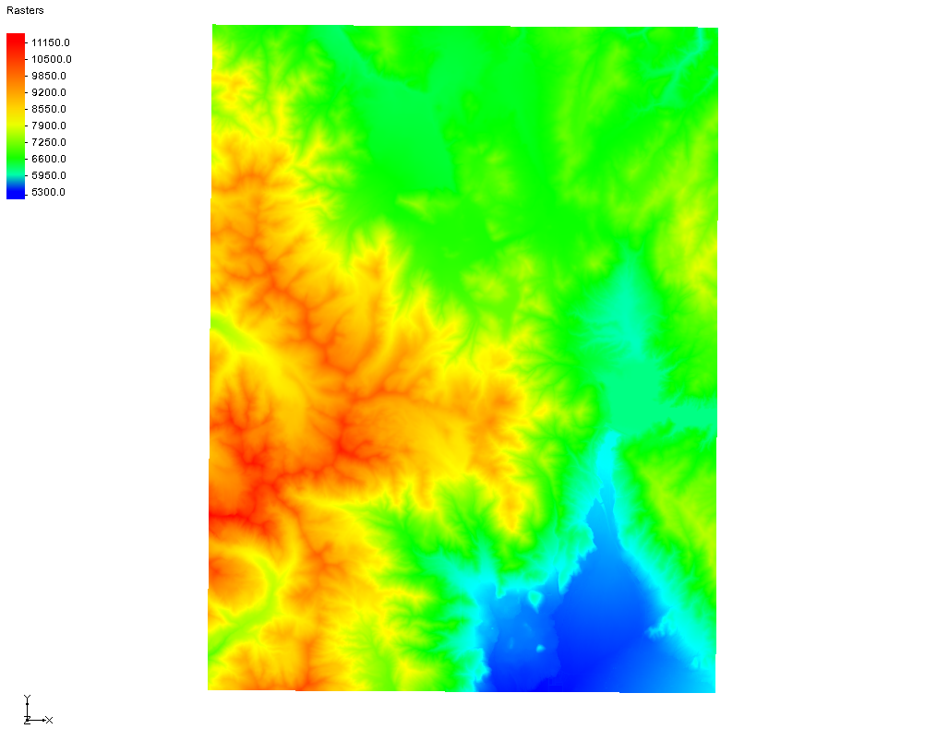

Figure Multiple DEMs loaded into GMS

Notice the raster File:GIS Raster Icon.svg icon in the Project Explorer which indicates the files contain elevation data. The DEMs were created in a geographic projection, meaning latitude and longitude, but GMS projects them on the fly to the UTM projection that GMS is already using so that they are displayed in the right place. The four rasters are located as shown in Figure 2.

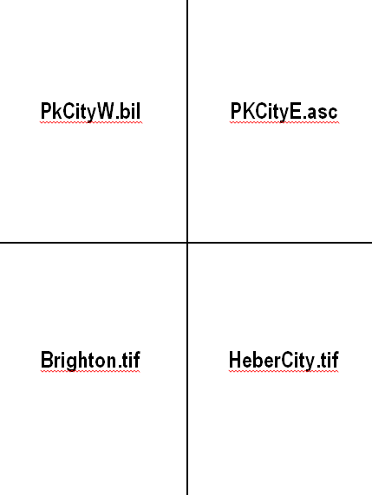

Figure Placement of rasters

# Viewing the Raster Properties

Review the raster properties by doing the following:

1. In the Project Explorer, right-click on “File:GIS Raster Icon.svg PkCityW.bil” and select **Properties…** to bring up the *Properties* dialog (Figure 3).

Notice that the pixel resolution and size is shown in addition to elevation data. In this case, the type is “EHdr” and the pixel size is about 30 meters (in the Y direction).

1. Click **Cancel** to exit the *Properties* dialog.
2. Repeat steps 1–2 for each of the remaining three rasters under “https://www.xmswiki.com/images/thumb/a/a5/GIS_Folder.svg/60px-GIS_Folder.svg.png GIS Layers”.

Notice that the results are two different DEM types (EHdr, GTiff) with two different pixel sizes (either approximately 10m or approximately 30m).

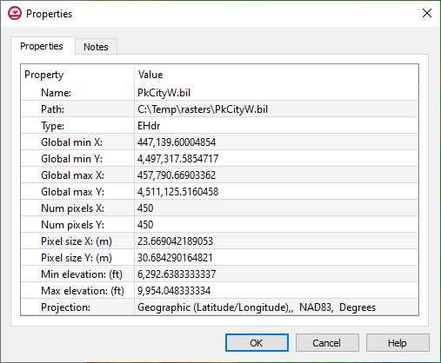

Figure Properties dialog

# Raster Shaders

Now review the raster display options again.

1. **Frame Image** File:Frame Macro.svg to see all the raster data.
2. In the Project Explorer, right-click on “File:GIS Raster Icon.svg PkCityW.bil” and select **Display Options** to bring up the *Raster Display Options* dialog.
3. Click on **Contour Options** button to open the *Raster Contour Options* dialog.
4. Click the **Color Ramp** button to open the *Choose color ramp* dialog.
5. Select the “HSV Shader” option.
6. Click **OK** to close the *Choose color ramp* dialog.
7. Click **OK** to close the *Raster Contour Options* dialog.
8. Click **OK** to close the *Raster Display Options* dialog.
9. Repeat steps 2–8 to try the “Color Ramp Shader” and the “Global Shader (feet)”.

The options in the *Rasters* section are currently the only display options available for rasters in GMS. Now to reset the display options to what they were previously:

1. In the Project Explorer, right-click on “File:GIS Raster Icon.svg PkCityW.bil” and select **Display Options** to bring up the *Raster Display Options* dialog.
2. Click on **Contour Options** button to open the *Raster Contour Options* dialog.
3. Click the **Color Ramp** button to open the *Choose color ramp* dialog.
4. Select the “Atlas Shader” option.
5. Click **OK** to close the *Choose color ramp* dialog.
6. Click **OK** to close the *Raster Contour Options* dialog.
7. Click **OK** to close the *Raster Display Options* dialog.

# Downloading Elevation Data

Elevation data for the area can be downloaded using the Online Maps feature. An internet connection is required for this next section to work correctly. A separate tutorial explains more about this feature.

1. Using the **Import From Web** https://www.xmswiki.com/images/thumb/a/ac/Get_Data_Tool.svg/60px-Get_Data_Tool.svg.png tool, click and drag a square over the raster files in the Graphics Window to bring up the *Data Services Options* dialog.
2. Scroll to the right and select the thumbnail entitled “Worldwide Elevation Data (Variable Resolution)”.
3. Click **OK** to close the *Data Services Options* dialog and bring up the *Save Web Services Data File(s)* dialog.
4. For the *File Name,* enter “Elevation” and click **Save**.
5. Click **Yes** when asked to confirm creating the new file.
6. Click **OK** to accept the default in the *Zoom level* dialog.

After a few moments, a new item will appear in the Project Explorer indicating that an online map is being downloaded. This map is different from the other available maps because it contains elevation data. It is not required for this tutorial, so it can be deleted by doing the following:

1. Right-click on “File:GIS Raster Icon.svg Elevation\_elev.tif” in the Project Explorer and select **Remove**.

# Manipulating Rasters

Rasters can be manipulated in several ways, including through resampling, merging, and trimming.

## Resampling

Rasters can be resampled to different resolutions. The Heber City raster is a higher resolution than the adjacent rasters, so it will be resampled to a lower resolution to demonstrate this feature.

1. In the Project Explorer, right-click on “File:GIS Raster Icon.svg HeberCity.tif” and select **Export…** to bring up the *Resample and Export Raster* dialog.
2. In both the *Num pixels X* and *Num pixels Y* fields, enter “450”.
3. Click **OK** to close the *Resample and Export Raster* dialog and open the *Save As* dialog.
4. In the *File name* field, enter "HeberCity2.tif".
5. From the *Save as type* drop-down, select “GeoTIFF Files (\*.tif)”.
6. Click **Save** to export the resampled raster and close the *Save As* dialog.

The new "File:GIS Raster Icon.svg HeberCity2.tif" raster should appear in the Project Explorer.

1. Right-click on the new "File:GIS Raster Icon.svg HeberCity2.tif" and select **Properties…** to bring up the *Properties* dialog.
2. Notice the *Num pixels X* and *Num pixels Y* are now both “450”.
3. Click **OK** to close the *Properties* dialog.

## Merging Rasters

Multiple rasters can be combined into one raster by first selecting multiple rasters in the Project Explorer:

1. In the Project Explorer, select “File:GIS Raster Icon.svg Brighton.tif” and "File:GIS Raster Icon.svg HeberCity.tif" while holding the *Ctrl* key.
2. Right-click on either selected raster and select *Convert To* | **Merged Raster** to bring up the *Save As* dialog.
3. Enter "Brighton\_merge.tif" in the *File name* field.
4. Select “GeoTIFF Files (\*.tif)” from the *Save as type* drop-down.
5. Click **Save** to save the merged raster and close the *Save As* dialog.
6. Uncheck all the rasters except "File:GIS Raster Icon.svg Brighton\_merge.tif" to verify it covers the area covered by the individual “File:GIS Raster Icon.svg Brighton.tif” and “File:GIS Raster Icon.svg HeberCity.tif” rasters (Figure 4).

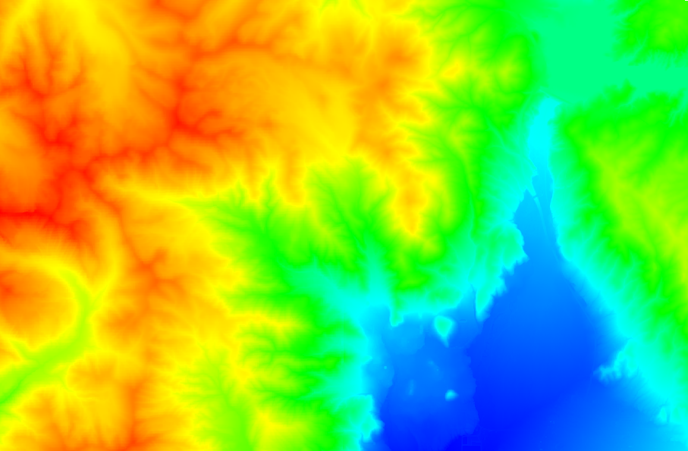

Figure Area covered by the merged rasters

## Trimming

A smaller raster can be created from a larger raster. This is called trimming.

1. In the Project Explorer, expand the “File:Map Folder.svg Map Data” folder, check the box next to “File:Coverage Active Icon.svg default coverage”, and select it to make it active.
2. Using the **Select Polygons** File:GMS Select Polygon Tool.svg tool, select all the polygons in the coverage by pressing *Ctrl-A* (or using *Edit* | **Select All**).
3. Right-click “File:GIS Raster Icon.svg Brighton\_merge.tif” and select *Convert To* | **Trimmed Raster** to bring up the *Trim Raster* dialog.
4. For *Coverage with polygons*, select “Map Data/default coverage”.
5. Enter “Brighton\_merge\_trim.tif” as the *Output raster*.
6. Click **OK** to close the *Trim Raster* dialog and run the tool.
7. When the tool finishes running, click **OK**.
8. Turn off all rasters except for the new one (“File:GIS Raster Icon.svg Brighton\_merge\_trim.tif”).

Notice that the new raster was trimmed to fit within the area of the selected polygons in the coverage (Figure 5).

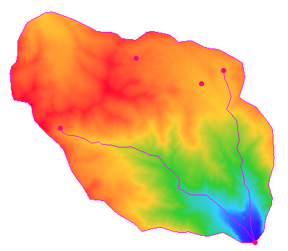

Figure 5 The TIF trimmed to the area of the coverage

|  |  |
| --- | --- |
| Desc-i_gray 100px | Rasters are trimmed to the area of the selected polygons. |

# Converting and Interpolating Rasters

Raster data can be converted into 2D scatter points, 2D grids, TINs, and UGrids. Scatter points can be converted into a raster.

## Converting a Raster to 2D Scatter Points

Convert a raster to 2D scatter points by doing the following:

1. Uncheck all rasters in the Project Explorer and press *Ctrl-U* to unselect all polygons.
2. In the Project Explorer, right-click on the “File:GIS Raster Icon.svg PkCityE.asc” item and select *Convert To* **| 2D Scatter** to bring up the *Raster → Scatter* dialog.
3. Click **OK** to create a new scatter point set and close the *Raster → Scatter* dialog.
4. Switch to **Oblique View** File:Oblique View Macro.svg to see the psuedo-3D view of the scatter points (Figure 6). Using **Zoom** File:Zoom Tool Icon.svg will reveal the surface is made of a large number of points.

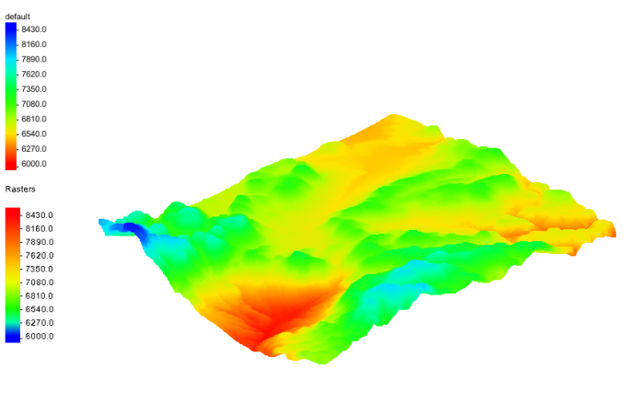

Figure Scatter points in oblique view

The process for converting to a 2D grid or UGrid is similar to the steps above, but will not be covered in this tutorial.

## Convert Scatter Points to Rasters

Scatter points can be converted to one or more rasters by doing the following:

1. Switch to **Plan View** File:Plan View Macro.svg.
2. In the Project Explorer, right-click on the “File:2D Scatter Icon.svgPkCityE.asc” 2D scatter set and select *Convert To* **| New Raster…** to bring up the *Scatter →Raster* dialog.

In this dialog, the interpolation scheme, the cell size of the raster, and how to define the boundary of the raster can all be set.

1. In the *Current interpolation options* section, click **Interpolation Options…** to bring up the *2D Interpolation Options* dialog.

This dialog is always used to specify 2D interpolation options in GMS, though these options are not used in this case.

1. Click **Cancel** to close the *2D Interpolation Options* dialog.

If more than one dataset is associated with the scatter set, then the *Create rasters for* drop-down can be used to specify all datasets or just the active dataset. If choosing all datasets, a separate raster will be created for each dataset.

The raster that these scatter points were created from had a cell size around 30 meters. The next steps will create a raster that is less dense by specifying a bigger cell size.

1. For the *Cell size,* enter “100.0”.
2. In the *Raster extents* section, select “Scatter set extents” from the drop-down.

It is possible to limit the extents of the new raster(s) by using polygons defined in a coverage. The raster will always be created as a rectangle, but if a polygon is used to define the extents, it is possible to optionally mask (or inactivate) the areas of the raster outside the polygon. For this tutorial, just use the extents of the scatter points.

1. Click **OK** to close the *Scatter →Raster* dialog and bring up the *Save As* dialog.
2. In the *File name* field, enter “default\_idw\_grad.tif” If not already entered.
3. Select “Tiff Files (\*.tif)” from the *Save as type* drop-down.
4. Click **Save** to close the *Save As* dialog.

A new raster file is created on disk and automatically loaded into GMS. Compare it to the original raster it is derived from.

1. Uncheck the “File:2D Scatter Icon.svgPkCityE.asc” 2D scatter dataset.
2. Turn on the “File:GIS Raster Icon.svgPkCityE.asc” raster.
3. Turn on and off the new “File:GIS Raster Icon.svg default\_idw\_grad.tif” raster.

Notice that the new raster is a lot less sharp than the original “File:GIS Raster Icon.svgPkCityE.asc” raster because when the “File:GIS Raster Icon.svgPkCityE.asc” raster was converted to scatter points, every other row was skipped and a larger cell size was used when interpolating the scatter points back to a raster.

## Interpolate to a TIN

The elevations of the raster can be interpolated to several other GMS data types. The next step is to interpolate to a TIN.

1. In the Project Explorer, expand and turn on the “File:TIN Folder.svg TIN Data” folder to reveal the “File:TIN Module Icon.svg watershed” TIN.

The "watershed" TIN is in a canyon that covers two rasters: “File:GIS Raster Icon.svg Brighton.tif” and “File:GIS Raster Icon.svg HeberCity.tif”. Notice it has a default dataset in which all the values are zero.

1. Uncheck all *GIS layers* except for “File:GIS Raster Icon.svg HeberCity.tif” and “File:GIS Raster Icon.svg Brighton.tif”.
2. While pressing the *Ctrl* key, select both the “File:GIS Raster Icon.svg Brighton.tif” raster and the “File:GIS Raster Icon.svg HeberCity.tif” raster.
3. Right-click one of the selected rasters and select *Interpolate To |* **TIN**.

Two new datasets were created on the TIN, one for each raster that was selected. From the TIN contours, notice that for the “Brighton.tif” dataset, only the eastern portion is active, up to the edge of the “Brighton” raster (Figure 7).

|  |  |
| --- | --- |
| Desc-i_gray 100px | When interpolating from multiple rasters, multiple datasets are created. |

1. Select the new “File:Dataset Cells Active.svg HeberCity.tif” dataset under the “File:TIN Module Icon.svg watershed” TIN.

Notice that only the western portion of the dataset is active, up to the edge of the “HeberCity.tif” raster.

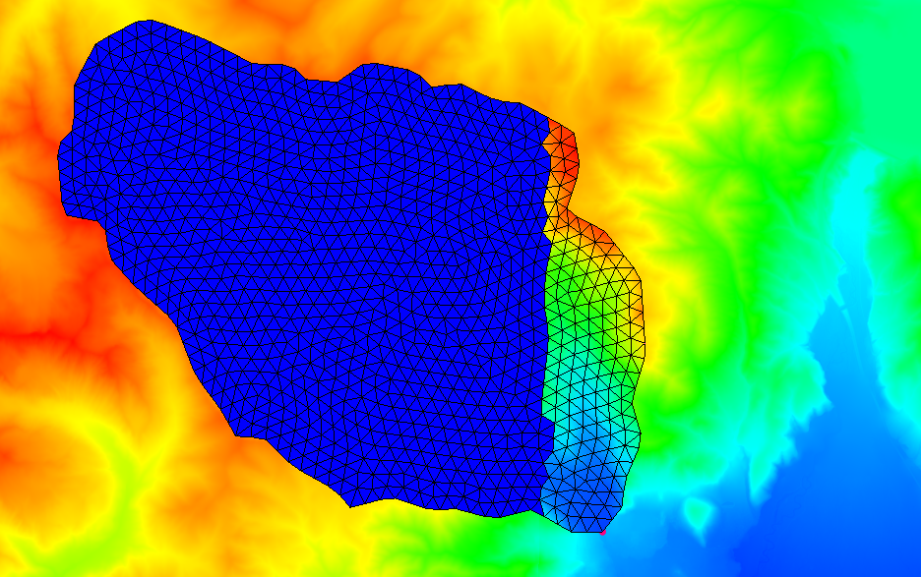

Figure Interpolated TIN dataset with inactive points outside the raster boundary

## Raster Catalogs

Instead of two TIN datasets, one dataset that spans both the Brighton.tif and HeberCity.tif rasters is desired. For this use a raster catalog. A raster catalog is simply multiple rasters grouped together for purposes of interpolation or for use with the **Horizons → Solids** command.

1. Select all the rasters File:GIS Raster Icon.svg in the Project Explorer by selecting the first one, and selecting the last one while holding down the *Shift* key.
2. Right-click on any of the selected rasters and select **New Raster Catalog** to bring up the *Raster Catalog* dialog.
3. Notice that all of the selected rasters are part of the catalog. Click **OK** to close the *Raster Catalog* dialog.

Now interpolate to the TIN again, but this time use the raster catalog.

1. Right-click on the “File:Scalar Dataset Active.svg Raster Catalog” and select *Interpolate To |* **TIN** to create a new “default\_idw\_grad.tif” TIN dataset.

The contours on the new TIN match the elevations of the rasters. The TIN also crosses over the boundaries of two rasters and GMS uses all the selected rasters to interpolate to the TIN (Figure 8).

|  |  |
| --- | --- |
| Desc-i_gray 100px | When interpolating from a raster catalog, one dataset is created. |

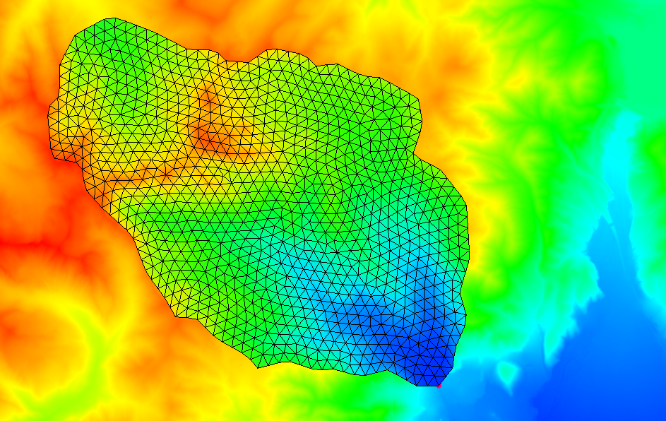

Figure Interpolated TIN based on raster catalog

## Interpolate to Feature Objects

It is also possible to interpolate from rasters to the *Z* values of feature objects.

1. In the Project Explorer, right-click in the empty space and select **Uncheck All** to hide everything.
2. Turn on the “File:Map Folder.svg Map Data” folder.
3. Switch to **Front View** File:Front View Macro.svg.

Notice that the feature objects in the coverage are all at an elevation of zero.

1. Select all the rasters File:GIS Raster Icon.svg in the Project Explorer by selecting the first one, and selecting the last one while holding down the *Shift* key.
2. Right-click on any of the selected rasters and select *Interpolate To* **| Active Coverage**.
3. Click **Frame Image** File:Frame Macro.svg.

Notice that the elevations of the feature objects in the coverage have been changed to match the elevation data from the rasters (Figure 9). In this case the raster catalog wasn't used, although it could have been and the results would have been the same. Since coverages cannot have multiple datasets like TINs can, there is no need to use the raster catalog in this case.

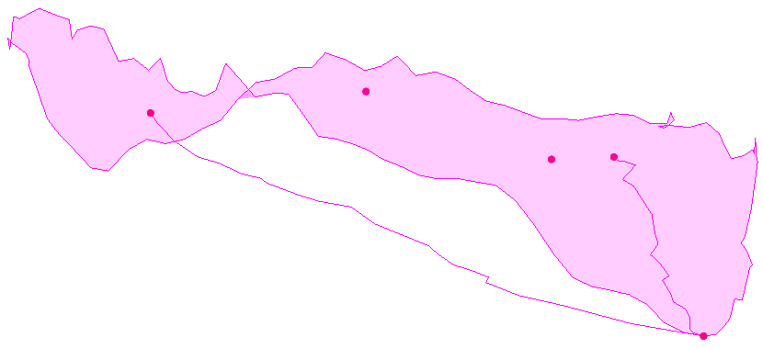

Figure Interpolated from rasters to Z values

## Interpolate to MODFLOW Layers

Scatter point data can be interpolated to MODFLOW top and bottom layer elevation arrays. This is covered in more detail in the “MODFLOW – Interpolating Layer Data” tutorial. Raster data can also be interpolated to MODFLOW elevation arrays, which will be done in this case:

1. Select **New** File:New Macro.svg and click **Don’t Save** when asked to save the current project.
2. Click **Open** File:Open Macro.svg to bring up the *Open* dialog.
3. Browse to the *Tutorials\GIS\rasters* directory and select “Project Files (\*.gpr)” from the *Files of type* drop-down.
4. Select “points.gpr” and click **Open** to import the project file and close the *Open* dialog.

This project is similar to the one from the “MODFLOW – Interpolating Layer Data” tutorial, but instead of scatter points, it uses rasters. Notice that the MODFLOW model layers are completely flat (Figure 10).

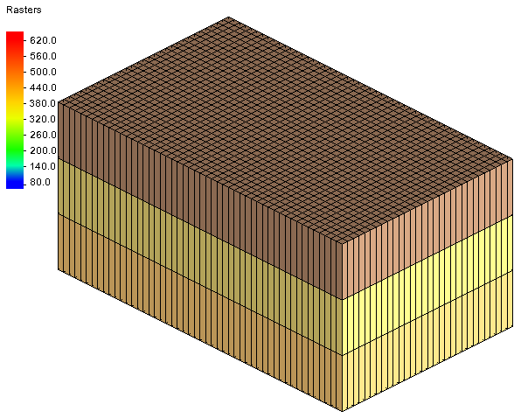

Figure MODFLOW layers

1. Expand the “File:GIS Folder.svg GIS Layers” folder to see the rasters.
2. Select all the rasters File:GIS Raster Icon.svg in the Project Explorer by selecting the first one, and selecting the last one while holding down the *Shift* key.
3. Right-click on a selected raster and select *Interpolate To* **| MODFLOW Layers…** to bring up the *Interpolate to MODFLOW Layers* dialog.

The mapping in the lower part of the dialog should already be set up. GMS automatically mapped the appropriate raster to the appropriate MODFLOW layer array based on the names of the rasters. For more information on this dialog, refer to the “MODFLOW – Interpolating Layer Data” tutorial.

1. Click **OK** to close the *Interpolate to MODFLOW Layers* dialog.
2. Click **Frame Image** File:Frame Macro.svg.The layer elevations are no longer flat (Figure 11).

The raster catalog could have been used and the results would have been the same.

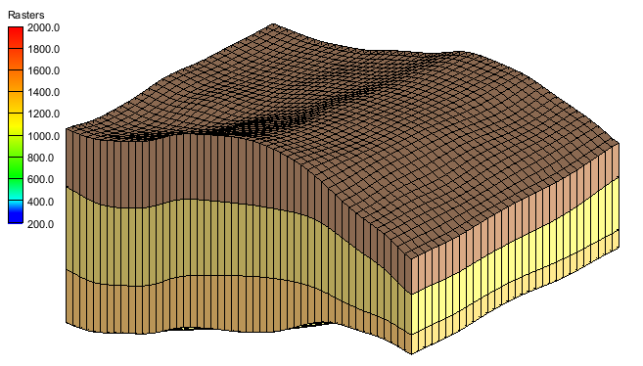

Figure MODFLOW layers after interpolating elevation data

# Conclusion

This concludes the GMS “Rasters” tutorial. The following topics were discussed:

* Rasters are images with elevation data.
* Rasters, like images, are 2D and only drawn in the background when in plan view, but they can appear 3D if hill shading is enabled.
* Rasters can be downloaded using the Online Maps feature.
* Rasters can be converted to 2D scatter sets and 2D grids.
* 2D scatter points can be converted into rasters.
* Rasters can be interpolated to many other GMS object types.
* When interpolating from multiple rasters, multiple datasets are created.
* When interpolating from a raster catalog, one dataset is created.