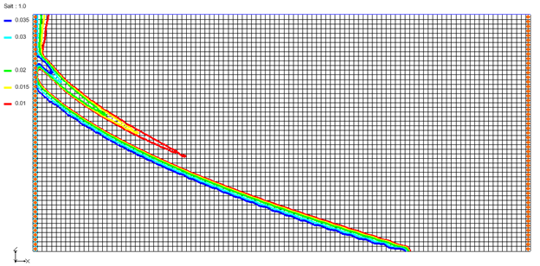

GMS 10.9

GMS 10.9 Tutorial

***SEAWAT – Goswami/Clement Experiment***

Simulate transient movement of a saltwater wedge using SEAWAT

Objectives

This tutorial shows how to simulate a transient saltwater intrusion dataset as presented in the Goswami/Clement experiment.

.

Time

* 30–45 minutes

Required Components

* GMS Core
* MODFLOW Interface
* MT3D
* SEAWAT

Prerequisite Tutorials

* MODFLOW – Grid Approach
* MT3DMS – Grid Approach

|  |
| --- |
| 1 Introduction 2  2 Getting Started 3  2.1 Importing the MODFLOW Project 3  2.2 Saving the Model with a New Name 4  3 Setting Up MT3DMS 4  3.1 Basic Transport Package 4  3.2 MT3DMS, Species, and Porosity 5  3.3 Dispersion Package 5  4 First SEAWAT Scenario (SS-1) 6  4.1 Initializing SEAWAT 6  4.2 Modifying the VDF Package 7  4.3 Saving and Running SEAWAT 7  4.4 Viewing the SS-1 Solution 7  5 Second SEAWAT Scenario (SS-2) 9  5.1 Saving the Model with a New Name 9  5.2 Initial Conditions for SS-2 9  5.3 Saving and Running SEAWAT 10  5.4 Viewing the SS-2 Solution 10  6 Third SEAWAT Scenario (SS-3) 12  6.1 Saving the Model with a New Name 12  6.2 Initial Conditions for SS-3 12  6.3 Saving and Running SEAWAT 13  6.4 Viewing the SS-3 Solution 13  7 Conclusion 16  8 Further Reading 16 |

# Introduction

This tutorial describes how to simulate the transient movement of a saltwater wedge in and out of an aquifer. This example problem is very similar to the experimental problem described in the 2007 Goswami and Clement article.[1] The experimental setup used for this problem is shown in Figure 1. Although this is an unconfined flow problem, the groundwater gradients used are small and hence the problem can be simplified and modeled as a confined flow saltwater intrusion problem.

The experimental system has a constant saltwater boundary in the left and constant freshwater boundary in the right. The salt concentration used was 37 kg/m3 (or 0.037 g/cm3) and the density was 1026 kg/m3 (or 1.026 g/cm3). This tutorial demonstrates the steps used to define MODFLOW, MT3DMS, and SEAWAT input data creating this simulation.

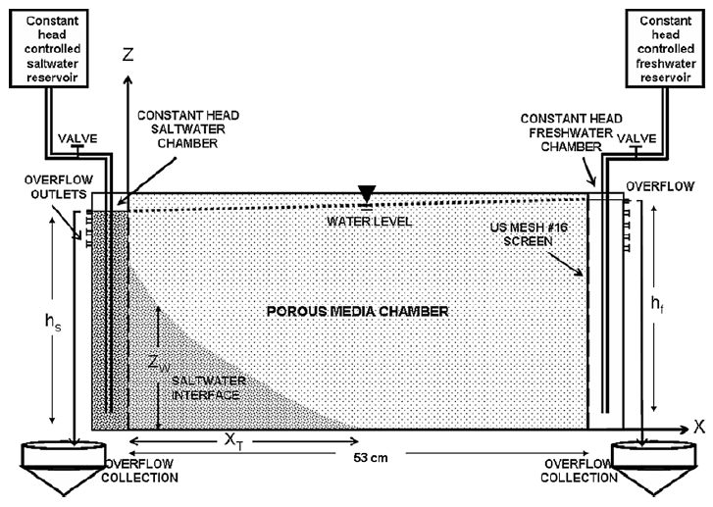

Figure 1 Experimental setup used

# Getting Started

Do the following to get started:

1. If necessary, launch GMS.
2. If GMS is already running, select *File |* **New** to ensure that the program settings are restored to their default state.

## Importing the MODFLOW Project

A MODFLOW simulation with the correct units, a 3D grid, the correct LPF options, and cell properties has been created for this tutorial. The grid is 53.5 by 2.7 by 25.5 cm (*xyz* dimensions). MODFLOW has been run to generate the vertical contour lines.

Import it by doing the following:

1. Click **Open** File:Open Macro.svg to bring up the *Open* dialog.
2. Select “Project Files (*.gpr)” from the *Files of type* drop-down.
3. Browse to the *saltwater* directory and select “start.gpr”.
4. Click **Open** to import the project and exit the *Open* dialog.

The project should appear similar to Figure 2.

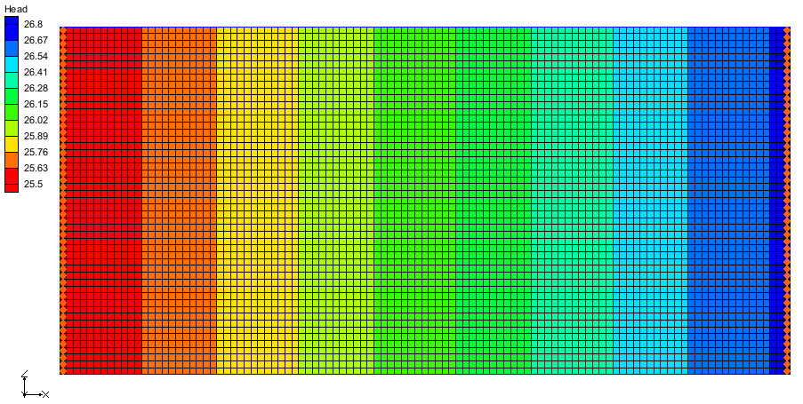

Figure 2 The imported MODFLOW project

## Saving the Model with a New Name

Before proceeding with the tutorial, save the project under a new name:

1. Select *File* | **Save As…** to bring up the *Save As* dialog.
2. Select “Project Files (*.gpr)” from the *Save as type* drop-down.
3. Enter “GC1.gpr” as the *File name*.
4. Click **Save** to save the project under the new name and close the *Save As* dialog.

# Setting Up MT3DMS

## Basic Transport Package

To start this process, first create a new MT3DMS simulation

1. Select “File:3D Grid Icon.svg grid”, then right-click on it and select **New MT3DMS…** to bring up the *Basic Transport Package* dialog.
2. Click **Stress Periods…** to bring up the *Stress Periods* dialog.
3. On row *1*, for *Length,* enter “80.0”, and for *Num Time Steps,* enter “8”.
4. Click **OK** to close the *Stress Periods* dialog.
5. Click **Output Control…** to bring up the *Output Control* dialog.
6. Below the *Retardation factor* section, select *Print or save at specified times*.
7. Click **Times…** to bring up the *Variable Time Steps* dialog.
8. Click **Initialize Values…** to bring up the *Initialize Time Steps* dialog.
9. For *Initial time step size,* enter “1.0”.
10. For *Bias,* enter “4.0”.
11. For *Maximum time step size,* enter “5.0”.
12. For *Maximum simulation time,* enter “80.0”.
13. Click **OK** to close the *Initialize Time Steps* dialog.

Notice that the spreadsheet in the *Variable Time Steps* dialog has been populated with time steps ranging from “1.0” up to “80.0”.

1. Click **OK** to close the *Variable Time Steps* dialog.
2. Click **OK** to close the *Output Control* dialog.

## MT3DMS, Species, and Porosity

Do the following to set up the MT3DMS options:

1. Click **Packages…** to bring up the *MT3DMS/RT3D Packages* dialog.
2. Turn on *Advection package*, *Dispersion package*, and *Source/sink mixing package* then click **OK** to close the *MT3DMS/RT3D Packages* dialog.
3. Click **Define Species…** to bring up the *Define Species* dialog.
4. Click **New** to add a new species to the spreadsheet.
5. In the *Name* column, enter “Salt” then click **OK** to close the *Define Species* dialog.
6. Click **Porosity…** to bring up the *Porosity* dialog.
7. Click **Constant → Grid…** to bring up the *Grid Value* dialog.
8. For *Constant value for grid,* enter “0.385”.
9. Click **OK** to close the *Grid Value* dialog.
10. Click **OK** to close the *Porosity* dialog.
11. Click **OK** to close the *Basic Transport Package* dialog.

## Dispersion Package

1. Select *MT3DMS* | **Dispersion Package…** to bring up the *Dispersion Package* dialog.
2. Click **Longitudinal Dispersivity…** to bring up the *Longitudinal Dispersivity* dialog.
3. Click **Constant → Grid…** to bring up the *Grid Value* dialog.
4. For *Constant value for grid,* enter “0.1” then click **OK** to close the *Grid Value* dialog.
5. Click **OK** to close the *Longitudinal Dispersivity* dialog.
6. Click **OK** to close the *Dispersion Package* dialog.
7. Using the **Select j** File:Select J Tool.svg tool, click the top left cell to select all boundary cells in the leftmost column.
8. Right-click and select **Sources/Sinks…** to bring up the *MODFLOW/MT3DMS Sources/Sinks* dialog.
9. From the list on the left, select “MT3DMS: Point SS”.
10. Click **Add BC** to create a new set of entries in the spreadsheet on the right.
11. In the *All* row of the spreadsheet, under *Type (ITYPE)*, use the drop-down to select “constant concentration”.
12. In the *All* row, for *Salt,* enter “0.037”.
13. Click **OK** to close the *MODFLOW/MT3DMS Sources/Sinks* dialog.
14. Select *MT3DMS* | **Check Simulation…** to bring up the *Model Checker* dialog.
15. Click **Run Check**.

There should be no errors or warnings.

1. Click **Done** to close the *Model Checker* dialog.

# First SEAWAT Scenario (SS-1)

## Initializing SEAWAT

The objective of the Goswami/Clement experiment was to generate three steady-state profiles and two sets of transient simulations described by the boundary conditions shown in Figure 3.[2] The saltwater head is fixed at 25.5 in all of the simulations. The freshwater head varies slightly in each simulation.

SEAWAT simulations use a combination of MODFLOW and MT3DMS packages along with VDF, a SEAWAT-specific package.

1. Right-click on “File:3D Grid Icon.svg grid” and select **New SEAWAT…** to bring up the *Global Options* dialog.
2. Turn on *Include transport in simulation*.
3. In the *Packages* section, turn on *Variable-Density Flow (VDF)*.
4. Click **OK** to exit the *Global Options* dialog.

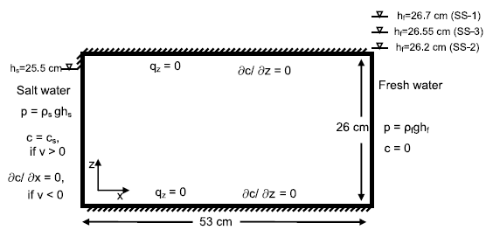

Figure 3 Boundary conditions simulated in the experimental study[3]

## Modifying the VDF Package

For the first scenario, simulate the effect of salinity on the fluid density.

1. Select *SEAWAT* | **VDF Package…** to open the *SEAWAT VDF Package* dialog.
2. For *Minimum fluid density (DENSEMIN)*, enter “1.0”.
3. For *Maximum fluid density (DENSEMAX),* enter “1.026”.

This helps convergence, especially when starting with freshwater as the initial condition.

1. In the *Fluid density calculation* section, for *Fluid density calc (MT3DRHOFLG),* enter “1”.

This indicates that the fluid density calculation will be done using the “Salt” species.

1. For *Reference fluid density (DENSEREF),* enter “1.0”.

This means the reference fluid density (freshwater, in this case) at 25˚C is 1000 kg/m3.

1. For *Density/conc. slope (DRHODC),* enter “0.7”.

This DRHODC value indicates that the density will vary linearly between 1.0 g/cm3 for freshwater and 1.026 g/cm3 for saltwater. DRHODC is estimated by dividing the density difference by the concentration difference. In this case, the result is the following:

|  |  |
| --- | --- |
| 1.026(g/cm3) - 1.0(g/cm3) | = 0.7 |
| 0.037(g/cm3) - 0.0(g/cm3) |

1. Click **OK** to close the *SEAWAT VDF Package* dialog.

## Saving and Running SEAWAT

Now, save the changes and run SEAWAT:

1. **Save** File:Save Macro.svg the project.
2. Click **Run SEAWAT** File:Run SEAWAT Macro.svg to bring up the *SEAWAT* model wrapper dialog.
3. When SEAWAT finishes, turn on *Read solution on exit* and *Turn on contours (if not on already)*.
4. Click **Close** to import the solution and close the *SEAWAT* dialog.

## Viewing the SS-1 Solution

Now, view the results of the SEAWAT model run:

1. In the Project Explorer, under “File:Generic Folder Locked.svg GC1 (MT3DMS)”, select “File:Dataset Cells Active.svg Salt”.
2. Click **Contour Options** File:Contour Options Macro.svg to bring up the *Dataset Contour Options – 3D Grid – Salt* dialog.
3. In the *Contour method* section, from the first drop-down select “Linear”, and from the second drop-down select “Specify each color”.
4. For *Line thickness,* enter “4”.
5. In the *Contour interval* section, from the drop-down select “Specified Values”, and to the right enter “5”.
6. In the spreadsheet, in row *1,* for *Start Value,* enter “0.01”.
7. In row *2,* for *Start Value,* enter “0.015”.
8. In row *3,* for *Start Value,* enter “0.02”.
9. In row *4,* for *Start Value,* enter “0.03”.
10. In row *5,* for *Start Value,* enter “0.035”.
11. Click **OK** to close the *Dataset Contour Options – 3D Grid – Salt* dialog.
12. Select time step 7 in the time step window.

The contours should appear similar to Figure 4. Feel free to review the other time steps as well.

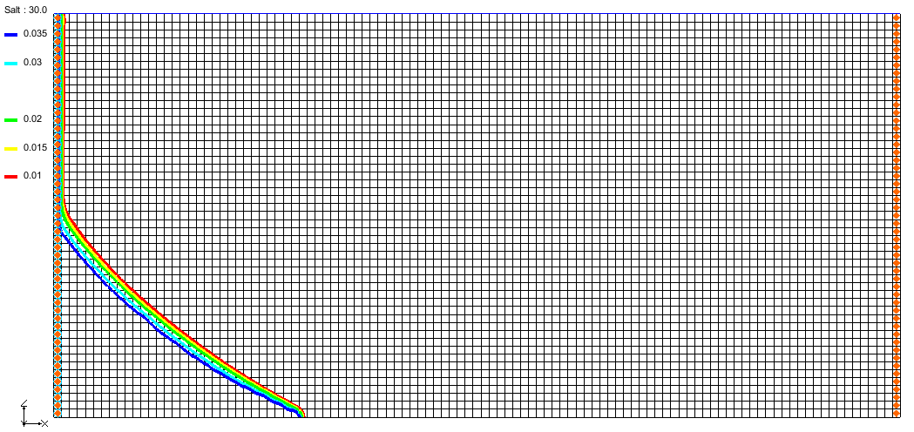

Figure 4 Contours showing steady state concentration of salt at 30 minutes

Notice that the system reaches a steady state at around 30 mins, when the toe of the wedge has moved about 15.5 cm to the right.

### Flow Budget

Now check the water budget:

1. In the Project Explorer, under “File:Generic Folder Locked.svg GC1 (MODFLOW)” select “File:Dataset Cells Active.svg Head”.
2. In the *Time Steps* window, select time step 3.
3. Using the **Select j** File:Select J Tool.svg tool, select the top left cell, then right-click and select **Flow Budget…** to bring up the *Flow Budget* dialog.

Notice that the *Total Zone Flow* in the *Flow In* column is about “83.14” (this is in cm3/min).

1. When done, click **OK** to close the *Flow Budget* dialog.
2. **Save** File:Save Macro.svg the project.

# Second SEAWAT Scenario (SS-2)

## Saving the Model with a New Name

First, save the model with a new name:

1. Select *File* | **Save As…** to bring up the *Save As* dialog.
2. Select “Project Files (*.gpr)” from the *Save as type* drop-down.
3. Enter “GC2.gpr” as the *File name*.
4. Click **Save** to save the project under the new name and close the *Save As* dialog.

## Initial Conditions for SS-2

The MODFLOW heads simulated in the SS-1 scenario will be used as the initial head condition for the SS-2 scenario. The steady state salt concentrations simulated for SS-1 will be used as the initial concentration condition. The freshwater head on the right will be decreased to 26.2 cm to allow the wedge to intrude further into the system.

### Head Values

First, apply the head values to the grid.

1. Under “File:Generic Folder Locked.svg GC1 (MODFLOW)”, select “File:Dataset Cells Active.svg Head”.
2. Select *MODFLOW* | **Global Options…** to bring up the *MODFLOW Global/Basic Package* dialog.
3. Turn off *Starting heads equal grid top elevations*.
4. Click **Starting Heads…** to bring up the *Starting Heads* dialog.
5. Click **3D Dataset → Grid…** to bring up the *Constant to Layer* dialog.
6. Select *Apply to variable head cells only* and click **OK** to bring up the *Select Dataset* dialog.
7. In the *Solution* section, under “File:Generic Folder Locked.svg GC1 (MODFLOW)”, select “File:Dataset Cells Active.svg Head”.
8. In the *Time Steps* window, select step 8 (value of “80.0”) and click **OK** to close the *Select Dataset* dialog.
9. Click **OK** to close the *Starting Heads* dialog.
10. Click **OK** to close the *MODFLOW Global/Basic Package* dialog.

### Salt Dataset Values

Next, adjust the salt dataset values for use in the new simulation.

1. Under “File:Generic Folder Locked.svg GC1 (MT3DMS)”, select “File:Dataset Cells Active.svg Salt”.
2. Select *MT3DMS* | **Basic Transport Package…** to bring up the *Basic Transport Package* dialog.
3. In the spreadsheet in the bottom right, check the box in the *Edit Per Cell* column.
4. In the *Starting Conc. Per Cell* column, click the http://www.xmswiki.com/images/f/fc/Dot_dot_dot_button.png button to bring up the *Starting Concentrations – Salt* dialog.
5. Click **3D Dataset → Grid…** to bring up the *Select Dataset* dialog.
6. In the *Solution* section, under “File:Generic Folder Locked.svg GC1 (MT3DMS)”, select “File:Dataset Cells Active.svg Salt”.
7. In the *Time Steps* window, select step 17 (value of “80.0”) and click **OK** to close the *Select Dataset* dialog.
8. Click **OK** to close the *Starting Concentrations – Salt* dialog.
9. Click **OK** to close the *Basic Transport Package* dialog.
10. Using the **Select j** File:Select J Tool.svg tool, select the top right cell in order to select the right column boundary cells.
11. Right-click on one of the selected cells and select **Properties…** to bring up the *3D Grid Cell Properties* dialog.
12. On the *MODFLOW* tab, in the *Starting head* row, enter “26.2”.
13. Click **OK** to close the *3D Grid Cell Properties* dialog.

The SEAWAT global options and VDF Package settings do not need to be adjusted for this scenario.

## Saving and Running SEAWAT

1. **Save** File:Save Macro.svg the project.
2. Click **Run SEAWAT** File:Run SEAWAT Macro.svg to bring up the *SEAWAT* model wrapper dialog.
3. When SEAWAT finishes, turn on *Read solution on exit* and *Turn on contours (if not on already)*.
4. Click **Close** to import the solution and close the *SEAWAT* dialog.

## Viewing the SS-2 Solution

1. In the Project Explorer, under “File:Generic Folder Locked.svg GC2 (MT3DMS)”, select “File:Dataset Cells Active.svg Salt”.
2. In the *Time Steps* window, select time step 2 (Figure 5).

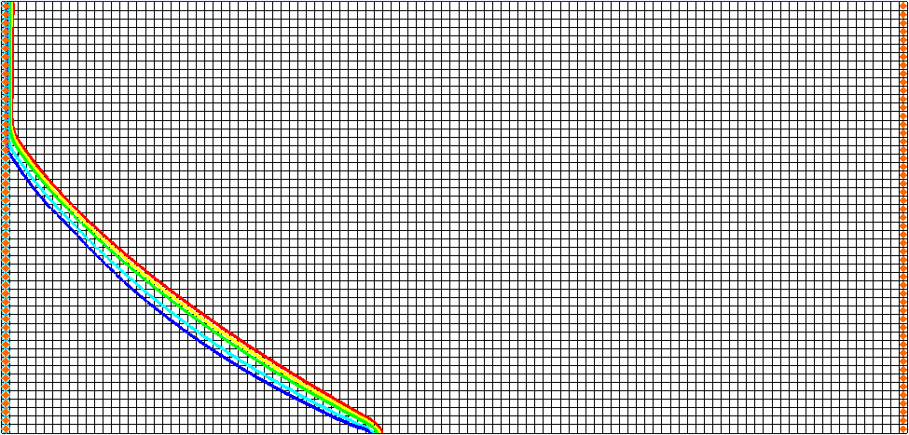

Figure 5 Time step 2 (after 5 minutes)

1. In the *Time Steps* window, select time step 4 (Figure 6).

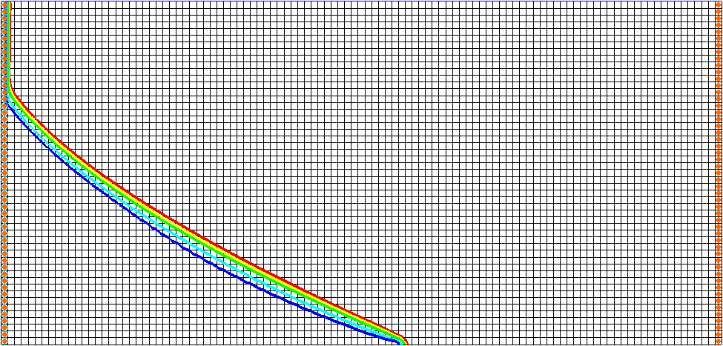

Figure 6 Time step 4 (after 15 minutes)

1. In the *Time Steps* window, select time step 12 (Figure 7).

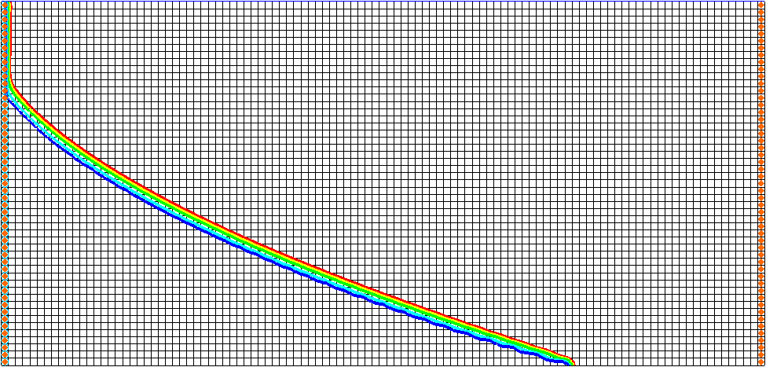

Figure 7 Time step 12 (after 55 minutes)

The figures above match the data from the Goswami/Clement experiment (Figure 8).

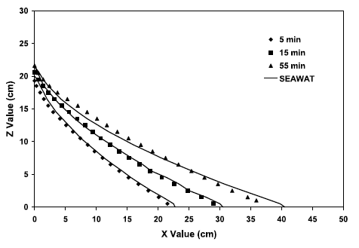

Figure 8 Transient salt wedge intrusion profiles from Goswami/Clement experiment[4]

The toe of the salt wedge predicted after 5, 15, and 55 minutes of simulation is at 22, 30, and 40 cm (respectively). It matches the data from the Goswami/Clement experiment. Compare the figures above to Figure 9, which shows the actual wedges from that experiment. The system is close to reaching steady-state conditions at about 60 to 80 minutes into the experiment.

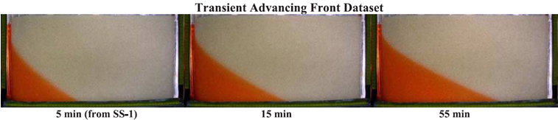

Figure 9 Actual wedges from the Goswami/Clement experiment[5]

1. **Save** File:Save Macro.svg the project.

# Third SEAWAT Scenario (SS-3)

## Saving the Model with a New Name

Now save the model with a new name.

1. Select *File* | **Save As…** to bring up the *Save As* dialog.
2. Select “Project Files (*.gpr)” from the *Save as type* drop-down.
3. Enter “GC3.gpr” as the *File name*.
4. Click **Save** to save the project under the new name and close the *Save As* dialog.

## Initial Conditions for SS-3

The MODFLOW heads simulated in the SS-2 scenario will be used as the initial head condition for the SS-3 scenario. The steady state salt concentrations simulated for SS-2 will be used as the initial concentration condition. The freshwater head on the right will be changed to 26.55 cm to allow the wedge to recede from the system.

### Apply Head Values

First, apply the head values to the grid:

1. Under “File:Generic Folder Locked.svg GC2 (MODFLOW)”, select “File:Dataset Cells Active.svg Head”.
2. Select *MODFLOW* | **Global Options…** to bring up the *MODFLOW Global/Basic Package* dialog.
3. Turn off *Starting heads equal grid top elevations*.
4. Click **Starting Heads…** to bring up the *Starting Heads* dialog.
5. Click **3D Dataset → Grid…** to bring up the *Constant to Layer* dialog.
6. Select *Apply to variable head cells only* and click **OK** to bring up the *Select Dataset* dialog.
7. In the *Solution* section, under “File:Generic Folder Locked.svg GC2 (MODFLOW)”, select “File:Dataset Cells Active.svg Head”.
8. In the *Time Steps* window, select step 8 (value of “80.0”) and click **OK** to close the *Select Dataset* dialog.
9. Click **OK** to close the *Starting Heads* dialog.
10. Click **OK** to close the *MODFLOW Global/Basic Package* dialog.

### Salt Dataset Values

Next, adjust the salt dataset values for use in the new simulation.

1. Under “File:Generic Folder Locked.svg GC2 (MT3DMS)”, select “File:Dataset Cells Active.svg Salt”.
2. Select *MT3DMS* | **Basic Transport Package…** to bring up the *Basic Transport Package* dialog.
3. In the spreadsheet in the bottom right, check the box in the *Edit Per Cell* column.
4. In the *Starting Conc. Per Cell* column, click the http://www.xmswiki.com/images/f/fc/Dot_dot_dot_button.png button to bring up the *Starting Concentrations – Salt* dialog.
5. Click **3D Dataset → Grid…** to bring up the *Select Dataset* dialog.
6. In the *Solution* section, under “File:Generic Folder Locked.svg GC2 (MT3DMS)”, select “File:Dataset Cells Active.svg Salt”.
7. In the *Time Steps* window, select step 17 (value of “80.0”) and click **OK** to close the *Select Dataset* dialog.
8. Click **OK** to close the *Starting Concentrations – Salt* dialog.
9. Click **OK** to close the *Basic Transport Package* dialog.
10. Using the **Select j** File:Select J Tool.svg tool, select the top right cell in order to select the right column boundary cells.
11. Right-click on one of the selected cells and select **Properties…** to bring up the *3D Grid Cell Properties* dialog.
12. On the *MODFLOW* tab in the *Starting head* row, enter “26.55”.
13. Click **OK** to close the *3D Grid Cell Properties* dialog.

The SEAWAT global options and VDF Package settings do not need to be adjusted for this scenario.

## Saving and Running SEAWAT

1. **Save** File:Save Macro.svg the project.
2. Click **Run SEAWAT** File:Run SEAWAT Macro.svg to bring up the *SEAWAT* model wrapper dialog.
3. When SEAWAT finishes, turn on *Read solution on exit* and *Turn on contours (if not on already)*.
4. Click **Close** to import the solution and close the *SEAWAT* dialog.

## Viewing the SS-3 Solution

1. In the Project Explorer, under “File:Generic Folder Locked.svg GC3 (MT3DMS)”, select “File:Dataset Cells Active.svg Salt”.
2. In the *Time Steps* window, select time step 3 (Figure 10).

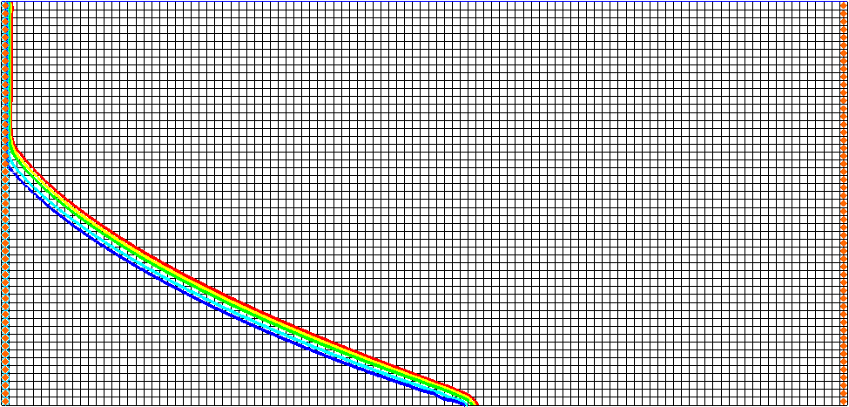

Figure 10 Time step 3 (after 10 minutes)

1. In the *Time Steps* window, select time step 4 (Figure 11).

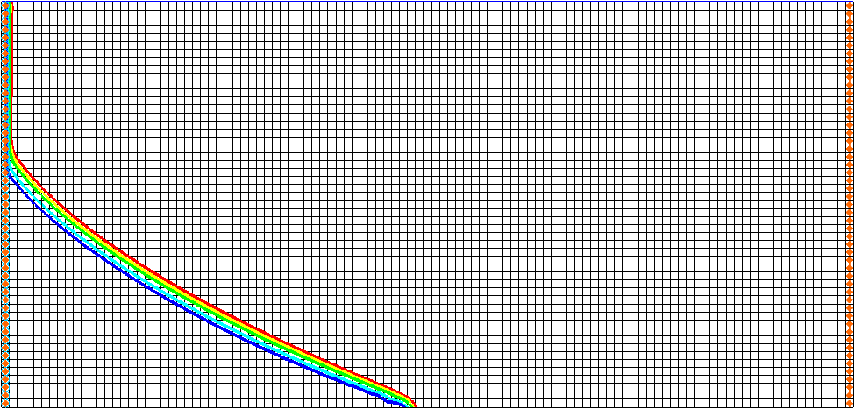

Figure 11 Time step 4 (after 15 minutes)

1. In the *Time Steps* window, select time step 6 (Figure 12).

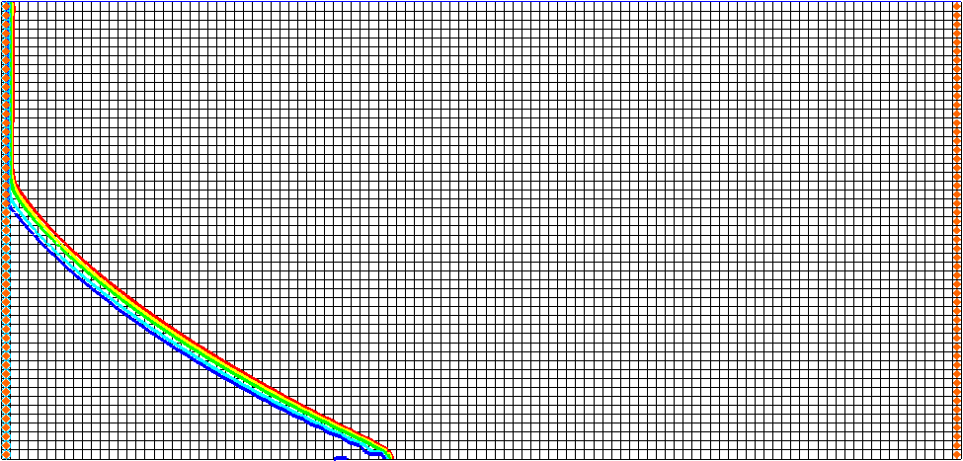

Figure 12 Time step 6 (after 25 minutes)

Notice that the figures above match the data from the Goswami/Clement experiment (Figure 13).

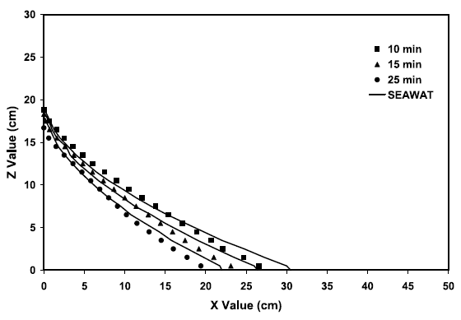

Figure 13 Transient salt wedge receding profiles from Goswami/Clement experiment[6]

Compare the figures above to Figure 14, showing the actual receding wedges from that experiment. Notice that the wedge recedes much more quickly than it intrudes.

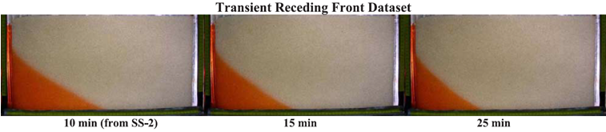

Figure 14 Actual receding wedges from the Goswami/Clement experiment

# Conclusion

This concludes the “SEAWAT – Goswami/Clement Experiment” tutorial. The following key concepts were discussed and demonstrated in this tutorial:

* SEAWAT combines MODFLOW and MT3DMS to solve variable density groundwater flow and solute transport problems.
* SEAWAT can be used to simulate the transient movement of transient saltwater wedges.
* Both model results and experimental data show that it takes more time to intrude than to recede.

## Further Reading

In addition to the Goswami and Clement (2007) article referenced in the tutorial, refer to the following journal articles to learn more about this topic. All the articles use SEAWAT to set up different types of experimental datasets involving density-coupled flows.

* Chang S.W., and T.P. Clement, (2013). “Laboratory and numerical investigation of transport processes occurring beneath a saltwater wedge” in *Journal of Contaminant Hydrology*, 147, pp. 14-24.
* Chang, S.W. and T.P. Clement, (2012). “Experimental and numerical investigation of saltwater intrusion dynamics in flux controlled groundwater systems” in *Water Resources Research, Vol. 48*, W09527.10 PP., doi:10.1029/2012WR012134, 2012.
* Goswami, R.R., T. P. Clement, and J. H. Hayworth, (2012). “Comparison of numerical techniques used for simulating variable-density flow and transport experiments” in *ASCE Journal of Hydrologic Engineering*, v.17 (2), pp.272-282.
* Chang, S. W, T. P. Clement, M. J. Simpson, and K. K Lee, (2011). “Does sea-level rise have an impact on saltwater intrusion?” in *Advances in Water Resources*, 34 (10), pp. 1283-1291.

1. Goswami, Rohit R. and Clement, T. Prabhakar, (2007). “Laboratory-scale investigation of saltwater intrusion dynamics” in *Water Resources Research*, Volume 43, W04418, doi:10.1029/2006WR005151, 2007. <http://onlinelibrary.wiley.com/doi/10.1029/2006WR005151/abstract>.
2. Goswami and Clement (2007), p. 1.
3. Goswami and Clement (2007), p. 6.
4. Goswami and Clement (2007), p. 8.
5. Goswami and Clement (2007), p. 5.
6. Goswami and Clement (2007), p. 8.