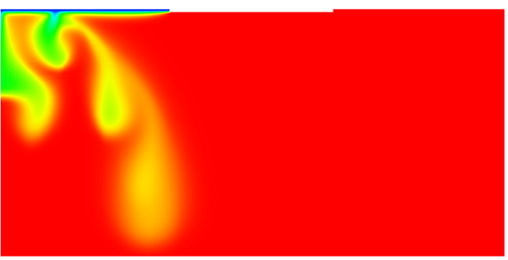

GMS 10.9

GMS 10.9 Tutorial

***SEAWAT – Hele-Shaw Experiment***

Simulate the Hele-Shaw salt lake experiment using SEAWAT in GMS

Objectives

This tutorial demonstrates how to construct and run a SEAWAT model in GMS using the grid approach. The model will mimic the Hele-Shaw salt lake experiment.

.

Time

* 10–20 minutes

Required Components

* GMS Core
* MODFLOW Interface
* MT3D
* SEAWAT

Prerequisite Tutorials

* MT3DMS – Grid Approach

|  |
| --- |
| [1 Introduction 2](#_Toc110598153)  [2 Getting Started 4](#_Toc110598154)  [2.1 Importing the existing model 4](#_Toc110598155)  [3 The SEAWAT Model 5](#_Toc110598156)  [3.1 Viewing the SEAWAT Inputs 5](#_Toc110598157)  [3.2 Saving and running the model 6](#_Toc110598158)  [4 Viewing the Solution 6](#_Toc110598159)  [4.1 Creating an Animation 7](#_Toc110598160)  [5 Conclusion 8](#_Toc110598161) |

# Introduction

The SEAWAT model is described as:

...a generic MODFLOW/MT3DMS-based computer program designed to simulate three-dimensional variable-density groundwater flow coupled with multi-species solute and heat transport. The program has been used for a wide variety of groundwater studies including those focused on brine migration in continental aquifers as well as those focused on saltwater intrusion in coastal aquifers. SEAWAT uses the familiar structure of MODFLOW and MT3DMS.[[1]](#footnote-1)

This tutorial explains how to perform a SEAWAT simulation within GMS by importing an existing SEAWAT simulation, running the simulation, and viewing the results. The first problem being solved in this tutorial is the salt lake problem used in the SEAWAT manual.[[2]](#footnote-2)

The design for the Hele-Shaw experiment is shown in [Figure 1]. Uniform evaporation of pure water occurs along line segment *AB,* leaving behind a salt-saturated fluid with a concentration of 110 grams per liter. Fluid with a potassium sulfate concentration of 84 grams per liter is injected at a constant head along segment *CD*. The remaining boundaries are impermeable. To prevent the fingers from forming too rapidly, the clear plates were tilted at an angle () of 5 degrees from the horizontal. This tilt is represented in SEAWAT-2000 by calculating input variables (hydraulic conductivity and specific storage) with the component of gravity (*g*) that is parallel with the plate (*g* sin ). [Figure 2] contains a list of the input variables for the salt lake problem.[[3]](#footnote-3)

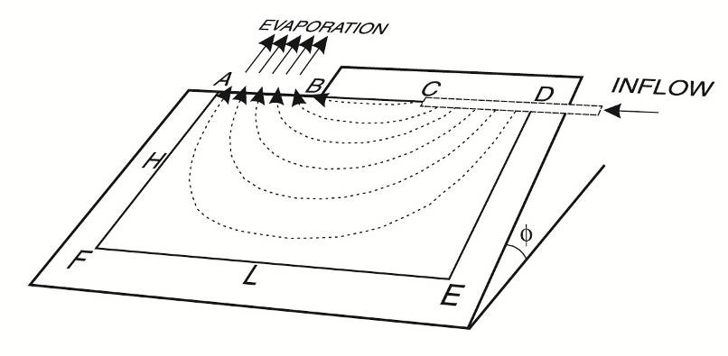

Figure Flow model from SEAWAT manual[[4]](#footnote-4)

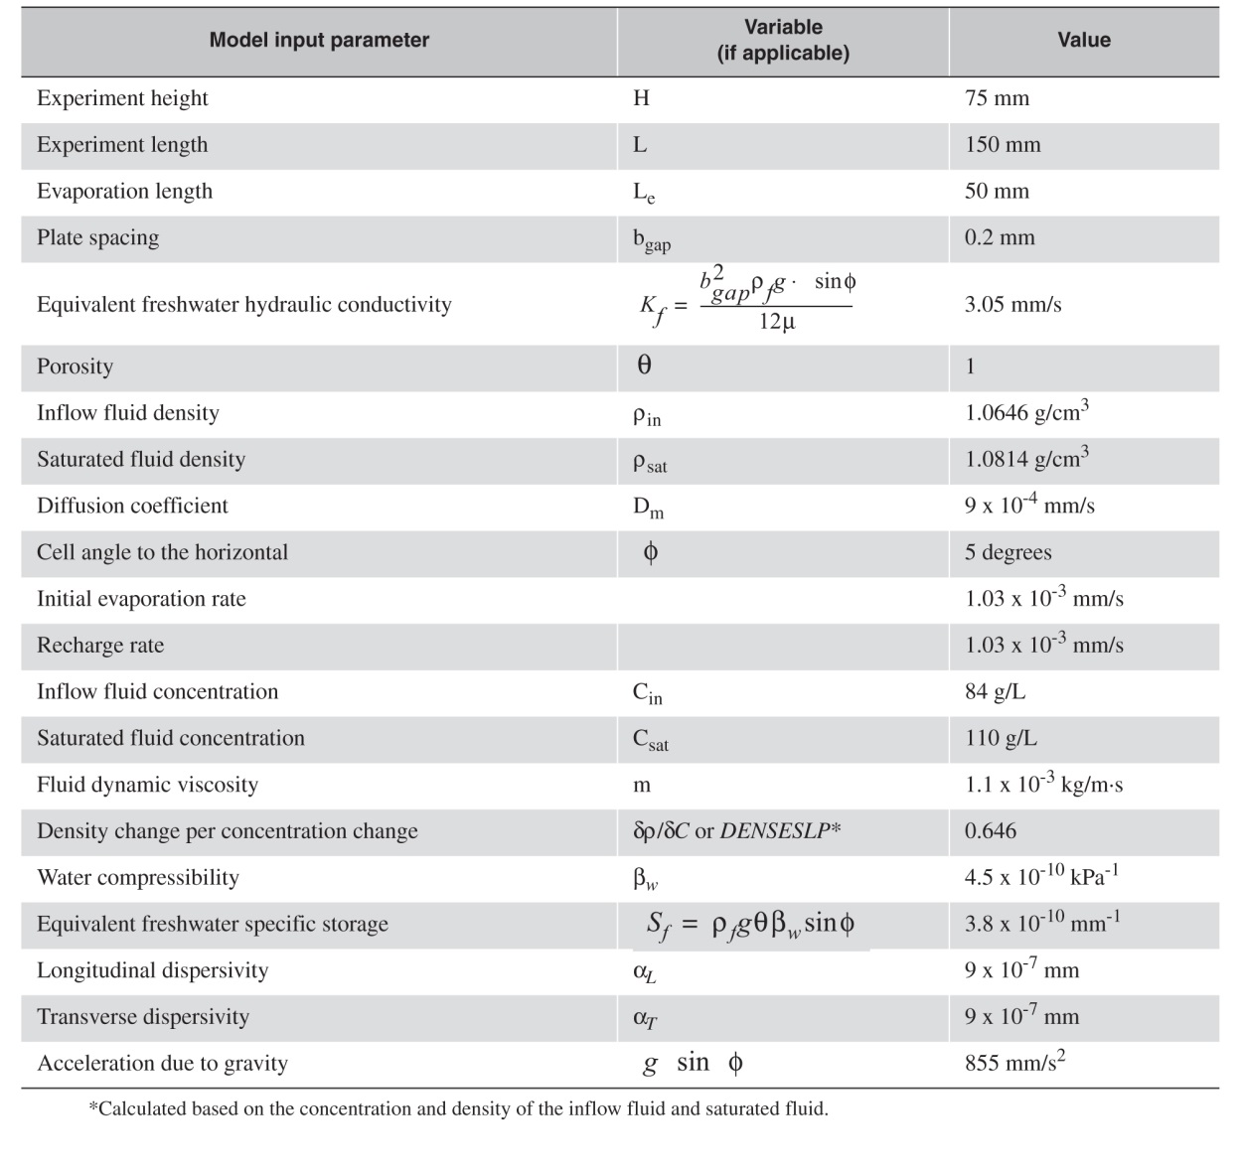

Figure Input parameters and values for Hele-Shaw salt lake experiment and SEAWAT 2000 simulation[[5]](#footnote-5)

“The SEAWAT-2000 model was run for 24,000 seconds (400 minutes) using 60 second transport time steps. The variable-density flow equation was solved using the PCG solver, and the implicit finite-difference method was used with the GCG Package to solve the transport equation.”[[6]](#footnote-6)

# Getting Started

Do the following to get started:

1. If necessary, launch GMS.
2. If GMS is already running, select *File |* **New** to ensure that the program settings are restored to their default state.

## Importing the existing model

Start with a SEAWAT model that has already been created.

1. Click **Open** File:Open Macro.svg to bring up the *Open* dialog.
2. Select “MODFLOW Name Files (\*.mfn;\*.nam)” from the *Files of type* drop-down.
3. Browse to the *saltlake* folder and select “seawat.nam”.
4. Click **Open** to exit the *Open* dialog and open the *SEAWAT Translator* dialog.
5. Click **OK** to begin importing the model.

The *SEAWAT Translator* should run and end with a message saying that SEAWAT terminated successfully.

1. Click **Done** to finish importing the file and close the *SEAWAT Translator* dialog.

A grid should appear in the main Graphics Window.

1. Switch to **Front View** File:Front View Macro.svg.
2. **Frame** File:Frame Macro.svg the project.

The view of the grid should appear with symbols representing specified head boundary conditions (Figure 3). SEAWAT uses a combination of MODFLOW and MT3DMS inputs; the MODFLOW and MT3DMS portions of the SEAWAT inputs are edited in GMS through the MODFLOW and MT3DMS interfaces, respectively. The SEAWAT interface includes the inputs that are specific to SEAWAT.

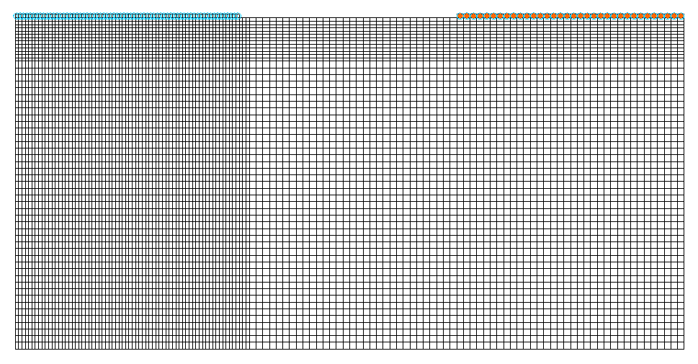

Figure Front view of imported SEAWAT model

# The SEAWAT Model

## Viewing the SEAWAT Inputs

Now to examine the inputs to the SEAWAT model:

1. Select *SEAWAT |* **Global Options…** to open the *Global Options* dialog.

Notice that this SEAWAT simulation includes transport and that *Variable Density Flow (VDF)* is turned on.

1. Click **OK** to exit the *Global Options* dialog.
2. Select *SEAWAT |* **VDF Package…** to open the *SEAWAT VDF Package* dialog.

The VDF package controls how density is calculated by SEAWAT.

1. In the *Fluid density calculation* section, notice that *Fluid density calc. (MT3DRHOFLG)* is set to “1”.

This indicates that the concentration of "species\_1" is used in the density calculations. *Reference fluid density (DENSREF)* is set to the value of the incoming fluid density shown in Figure 2. *Density/conc. slope (DRHODC)* is set to the value of density change per concentration change shown in Figure 2.

1. Notice that *Flow/transport coupling (NSWTCPL)* is set to “1”.

This indicates that the flow and transport are explicitly coupled. Refer to the SEAWAT documentation for more information on how these inputs affect the SEAWAT model.[[7]](#footnote-7)

1. Click **OK** to exit the *SEAWAT VDF Package* dialog.

## Saving and running the model

Now to save the model with a new name and run the model:

1. Select *File |* **Save As…** to bring up the *Save As* dialog.
2. From the *Save as type* drop-down, select “Project Files (\*.gpr)”.
3. For *File name,* enter “Saltlake.gpr”.
4. Click **Save** to save the project under the new name and close the *Save As* dialog.
5. Select *SEAWAT* | **Run SEAWAT…** to bring up the *SEAWAT* model wrapper dialog.
6. When the simulation is finished, turn on *Read solution on exit* and *Turn on contours (if not on already)*.
7. Click **Close** to import the solution and close the *SEAWAT* dialog.

# Viewing the Solution

Now to view the results of the SEAWAT model run:

1. In the Project Explorer, under “File:Generic Folder Locked.svg SaltLake (MT3DMS)”, select “File:Dataset Cells Active.svg species\_1”.
2. In the *Time Steps* window, select time step 8 (value of “23215.0”).

The solution should appear similar to Figure 4.

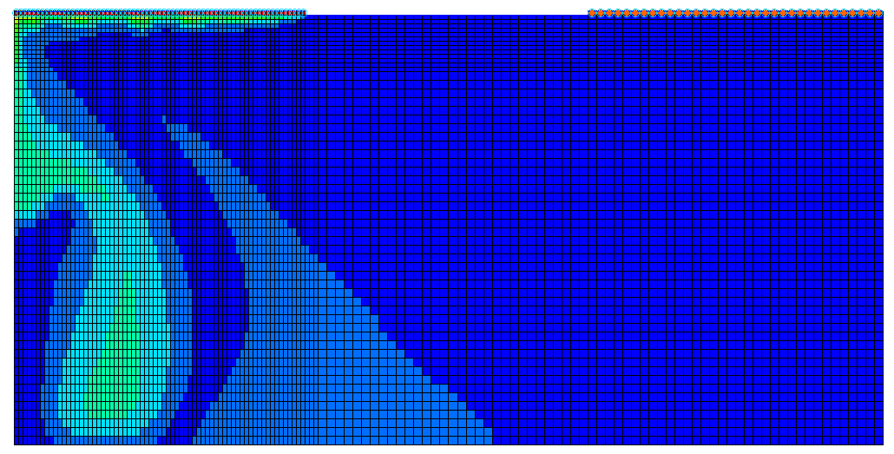

Figure SEAWAT solution

The model results look very similar to the result from the real experiment (Figure 5).

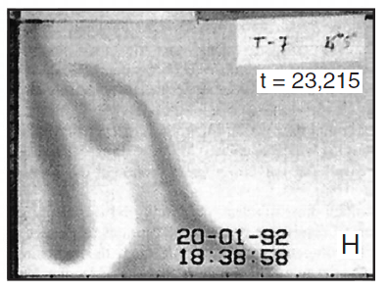

Figure Result from Hele-Shaw experiment of the salt lake problem at time step 23215s[[8]](#footnote-8)

If desired, step through the other time steps of the solution.

## Creating an Animation

Now to create an animation of the concentration over time:

1. Select *Display |* **Animate*...*** to bring up the *Animation Wizard* – *Options* dialog.

The defaults should work fine for creating an animation.

1. Next to *Animation file*, click on the browser 16px-Open_Macro to open the *Save* dialog.
2. Enter “seawat.mp4” as the *File name*.
3. Set *Save as type* to “Animation file (\*mp4, \*avi)”.
4. Select **Save** to close the *Save* dialog.
5. Click **Next>** to go to the *Animation Wizard* – *Datasets* dialog.
6. Click **Finish** to close the *Animation Wizard* dialog and create the animation.

When the animation has finished rendering, open an external animation application to view the file.

Feel free to change the contour options or rerun SEAWAT with different options and animate the results.

# Conclusion

This concludes the “MODFLOW – SEAWAT Hele-Shaw Experiment” tutorial. The following key concepts were discussed and demonstrated in this tutorial:

* SEAWAT, combining both MODFLOW and MT3D, can be used to solve variable density groundwater flow and solute transport equations.
* Import existing SEAWAT models into GMS easily.
* GMS has multiple options for viewing the results of a SEAWAT model run.

1. *SEAWAT: A Computer Program for Simulation of Three-Dimensional Variable-Density Ground-Water Flow and Transport*. U.S. Geological Survey. October 7, 2015. <http://water.usgs.gov/ogw/seawat/>. Accessed July 6, 2017. (Archived by WebCite at <http://www.webcitation.org/6ioGQwVBw>) [↑](#footnote-ref-1)
2. Langevin, Christian D.; Shoemaker, W. Barclay; and Guo, Weixing (2003). *MODFLOW-2000, the U.S. Geological Survey Modular Ground-Water Model–Documentation of the SEAWAT-2000 Version with the Variable-Density Flow Process (VDF) and the Integrated MT3DMS Transport Process (IMT)*: U.S. Geological Survey Open-File Report 03-426, 43 p. http://fl.water.usgs.gov/PDF\_files/ofr03\_426\_langevin.pdf. [↑](#footnote-ref-2)
3. Ibid, p. 24. [↑](#footnote-ref-3)
4. Langevin, et al (2003), p. 25. [↑](#footnote-ref-4)
5. Ibid, p. 25. [↑](#footnote-ref-5)
6. Langevin, et al (2003), p. 28. [↑](#footnote-ref-6)
7. Langevin, Christian. D.; Thorne, Daniel T., Jr.; Dausman, Alyssa M.; Sukop, Michael C.; and Guo, Weixing. (2007). “SEAWAT Version 4: A Computer Program for Simulation of Multi-Species Solute and Heat Transport” in U.S. Geological Survey *Techniques and Methods* *Book 6*, Chapter A22, p. 13. https://pubs.usgs.gov/tm/tm6a22/pdf/tm6A22.pdf. [↑](#footnote-ref-7)
8. Langevin, et al (2003), p. 26. [↑](#footnote-ref-8)