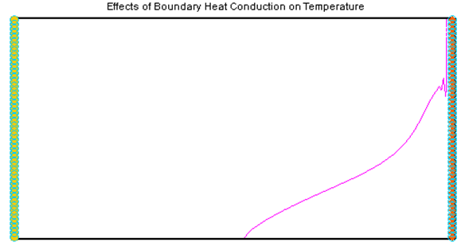

GMS 10.9

GMS 10.9 Tutorial

***SEAWAT – Thermal Effects***

Examine Thermal Effects on a SEAWAT Model

Objectives

This tutorial demonstrates how to simulate thermal effects in SEAWAT.

.

Time

* 30–45 minutes

Required Components

* GMS Core
* MODFLOW Interface
* MT3D
* SEAWAT

Prerequisite Tutorials

* SEAWAT – Concentration and Temperature Effects

|  |
| --- |
| 1 Introduction 2  2 Getting Started 3  2.1 Importing the Existing Model 3  2.2 Saving the Model with a New Name 3  3 Heat Conduction 4  3.1 Editing the Dispersion Package 4  3.2 Saving and Running SEAWAT 5  3.3 Viewing the Solution 5  4 Thermal Equilibrium 6  4.1 Saving the Model with a New Name 6  4.2 Enabling the Chemical Reaction Package 6  4.3 Editing the Chemical Reaction Package 6  4.4 Saving and Running SEAWAT 7  4.5 Viewing the Solution 8  5 Boundary Heat Conduction 8  5.1 Saving the Model with a New Name 9  5.2 Modifying the Boundary Conditions 9  5.3 Saving and Running SEAWAT 10  5.4 Viewing the Solution 10  6 Conclusion 11 |

# Introduction

This tutorial describes how to simulate heat conduction, thermal equilibrium, and boundary heat conduction using SEAWAT. The example problem (Figure 1) is very similar to the problem described in the SEAWAT documentation.[1]

This is a confined aquifer with an initial temperature of 5˚C. Warm freshwater is injected from the west side of the model at 1 m3/day. The initial concentration of salt in the model is 35 kg/m3.

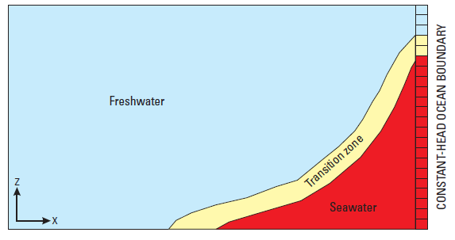

Figure 1 Site to be modeled with SEAWAT

This tutorial discusses and demonstrates importing an existing MODFLOW/MT3D simulation, running SEAWAT with different scenarios, and examining the results.

# Getting Started

Do the following to get started:

1. If GMS is not running, launch GMS.
2. If GMS is already running, select *File* | **New** to ensure the program settings are restored to the default state.

## Importing the Existing Model

Start with a model that has already been created.

1. Click **Open** File:Open Macro.svg to bring up the *Open* dialog.
2. Select “Project Files (*.gpr)” from the *Files of type* drop-down.
3. Browse to the *Case_Studies\Sample\Case2* folder and select “case2.gpr”.
4. Click **Open** to import the project and exit the *Open* dialog.
5. If necessary, fully expand the “File:3D Grid Folder.svg 3D Grid Data” folder.
6. Under “File:Generic Folder Locked.svg case2 (MODFLOW)”, select “File:Dataset Cells Active.svg Head” to make it active.

A model similar to Figure 2 should appear.

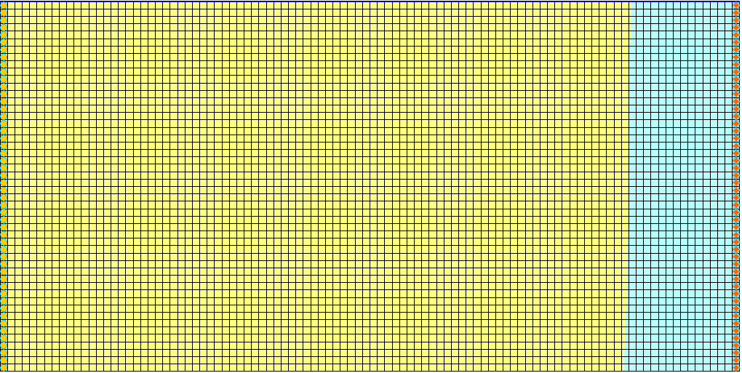

Figure 2 Initial model appearance

## Saving the Model with a New Name

Before making changes, save the model with a new name.

1. Select *File |* **Save As…** to bring up the *Save As* dialog.
2. Select “Project Files (*.gpr)” from the *Save as type* drop-down.
3. Enter “case3.gpr” as the *File name*.
4. Click **Save** to save the project under the new name and close the *Save As* dialog.

# Heat Conduction

The existing model simulates the effect of concentration and temperature on fluid density. Heat conduction is included in the simulation by specifying a value for bulk thermal diffusivity (). Calculate by using the following formula:

 (1)

where  is the porosity, is the reference fluid density,  is the specific heat capacity of the reference fluid, and  is the bulk thermal conductivity from solid () and fluid () thermal conductivities. Estimate  by using the following equation:

 (2)

The bulk thermal conductivity for a solid (calcite) is 3.59(1) (W/[m ˚K]). The bulk thermal conductivity for a fluid (freshwater) is 0.58(1) (W/[m ˚K]). The porosity in this model is 0.3. Using equation (2),  is estimated to be around 2.69 (W/[m ˚K]).

The specific heat capacity of freshwater () is about 4186 (J/kg ˚K). Freshwater density is about 1000 (kg/m3). Using equation (1), the bulk thermal diffusivity () is estimated to be around 0.185 m2/day (2.14 x 10-6 m2/s).

## Editing the Dispersion Package

The bulk thermal diffusivity () can be specified within the Dispersion Package (DSP input file).

1. Select *MT3DMS |* **Dispersion Package…** to open the *Dispersion Package* dialog.
2. Turn on *Specify DMCOEF for each species*.
3. On row *1,* for *DMCOEF – Temperature,* click the http://www.xmswiki.com/images/f/fc/Dot_dot_dot_button.png button (scroll to the right if necessary) to open the *DMCOEF – Effective Molecular Diffusion Coefficient* dialog.
4. Click **Constant → Grid**to open the *Grid Value* dialog.
5. For *Constant value for grid,* enter “0.185”.
6. Click **OK** to close the *Grid Value* dialog.
7. Click **OK** to exit the *DMCOEF – Effective Molecular Diffusion Coefficient* dialog.

The bulk thermal diffusivity of “0.185” has been assigned to all the cells in the model. Now assign the DMCOEF for Salt.

1. On row *1,* for *DMCOEF – Salt,* click the http://www.xmswiki.com/images/f/fc/Dot_dot_dot_button.png button to open the *DMCOEF – Effective Molecular Diffusion Coefficient* dialog.
2. Click **Constant → Grid**to open the *Grid Value* dialog.
3. For *Constant value for grid,* enter “1e-10”.
4. Click **OK** to close the *Grid Value* dialog.
5. Click **OK** to exit the *DMCOEF – Effective Molecular Diffusion Coefficient* dialog.
6. Click **OK** to exit the *Dispersion Package* dialog.

## Saving and Running SEAWAT

Now to save the changes and run SEAWAT:

1. **Save** File:Save Macro.svg the project.
2. Select *SEAWAT |* **Run SEAWAT…** to bring up the *SEAWAT* model wrapper dialog.
3. When SEAWAT finishes, turn on *Read solution on exit* and *Turn on contours (if not on already)*.
4. Click **Close** to import the solution and close the *SEAWAT* dialog.

## Viewing the Solution

Now to view the results of the SEAWAT model run:

1. Fully expand the “File:3D Grid Folder.svg 3D Grid Data” folder.
2. In the Project Explorer, under “File:Generic Folder Locked.svg case3 (MT3DMS)”,select “File:Dataset Cells Active.svg Salt”.
3. In the *Time Steps* window, select time step 8 (value of “4000.0”).

The model should appear similar to Figure 3.

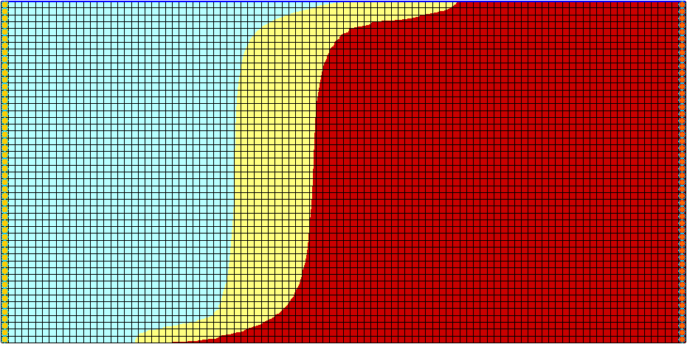

Figure 3 Salt dataset

1. In the Project Explorer, under “File:Generic Folder Locked.svg case3 (MT3DMS)”,select “File:Dataset Cells Active.svg Temperature”.

The salinity and temperature fields no longer have the same shape. The temperature field is much more diffuse than the salinity field (Figure 4). Also notice that the contouring options change when selecting either the “Salt” or “Temperature” datasets. This happens because display themes are being used. Please refer to the “GMS – Display Themes” tutorial for more details on how to use them.

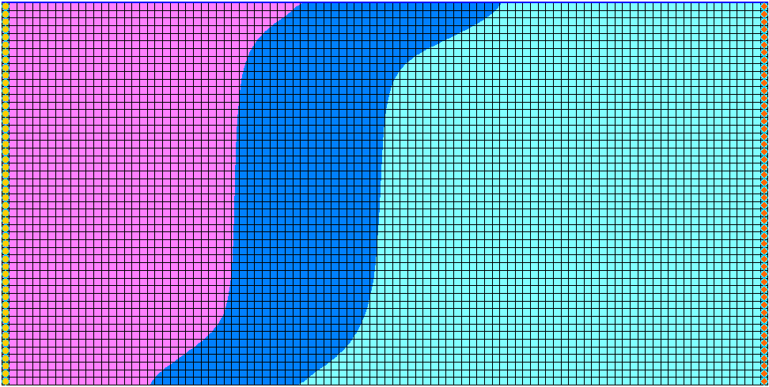

Figure 4 Temperature dataset

# Thermal Equilibrium

In this scenario, simulate the thermal equilibrium effect between the fluid (freshwater) and the solid (calcite). This effect can be simulated using the MT3DMS Reactions (RCT) Package.

## Saving the Model with a New Name

Now it’s time to start a new scenario. First, save the model with a new name.

1. Select *File |* **Save As…** to bring up the *Save As* dialog.
2. Select “Project Files (*.gpr)” from the *Save as type* drop-down.
3. Enter “case4.gpr” as the *File name*.
4. Click **Save** to save the project under the new name and close the *Save As* dialog.

## Enabling the Chemical Reaction Package

Enable the Chemical Reaction Package

1. Select *MT3DMS |* **Basic Transport Package…** to open the *Basic Transport Package* dialog.
2. Click **Packages…** to open the *MT3DMS/RT3D Packages* dialog.
3. Turn on *Chemical reaction package*.
4. Click **OK** to exit the *MT3DMS/RT3D Packages* dialog.
5. Click **OK** to exit the *Basic Transport Package* dialog.

## Editing the Chemical Reaction Package

The thermal equilibrium effect is activated only for the *Temperature* species by entering 1.7x10-4 [m3/kg] for Kd_temp (Distribution Coefficient – slope of the isotherm).

1. Select *MT3DMS |* **Chemical Reaction Package…** to open the *Chemical Reaction Package* dialog.
2. From the *Sorption* drop-down, select “Linear isotherm”.
3. Select *Cell by cell*.
4. To the right of *Bulk Density,* click **Edit…** to open the *Bulk Density Array* dialog*.*
5. Click **Constant → Grid…**to open the *Grid Value* dialog.
6. For *Constant value for grid,* enter “1760.0”.
7. Click **OK** to close the *Grid Value* dialog.
8. Click **OK** to exit the *Bulk Density Array* dialog.

This sets the *Bulk density* to “1760.0”. Note that these units actually represent [kg/m3]. These units do not agree with the standard units for the model, but these units only need to agree with the Kd (first sorption constant) units.

1. On the *1st sorption const.* row, in the *Temperature* column, click **Edit…** to open the *First Sorption Constant Array* dialog.
2. Click **Constant → Grid…** to open the *Grid Value* dialog.
3. For *Constant value for grid,* enter “0.00017”.
4. Click **OK** to close the *Grid Value* dialog.
5. Click **OK** to exit the *First Sorption Constant Array* dialog.

This sets the *1st sorption constant* to “0.00017” (actual units = [m3/kg]).

1. Click **OK** to exit the *Chemical Reaction Package* dialog.

Note that these two values should result in a retardation factor of “2.0”. The retardation factor is calculated using the following formula:



Where ** = bulk density, *Kd* = distribution coefficient (slope of the isotherm), and *n* = porosity.

## Saving and Running SEAWAT

Now it is possible to run SEAWAT.

1. **Save** File:Save Macro.svg the project.
2. Select *SEAWAT |* **Run SEAWAT…** to bring up the *SEAWAT* model wrapper dialog.
3. When SEAWAT finishes, turn on *Read solution on exit* and *Turn on contours (if not on already)*.
4. Click **Close** to import the solution and close the *SEAWAT* dialog.

## Viewing the Solution

Now view the results of the SEAWAT model run.

1. In the Project Explorer, under “File:Generic Folder Locked.svg case4 (MT3DMS)”,select “File:Dataset Cells Active.svg Temperature”.
2. In the *Time Steps* window, select time step 8 (value of “4000.0”).
3. Alternate between the “File:Dataset Cells Active.svg Temperature” datasets in “File:Generic Folder Locked.svg case4 (MT3DMS)” and “File:Generic Folder Locked.svg case3 (MT3DMS)”.

Notice that the temperature front in “case4” (Figure 5) is moving about half as fast as the temperature front in “case3” (Figure 6).

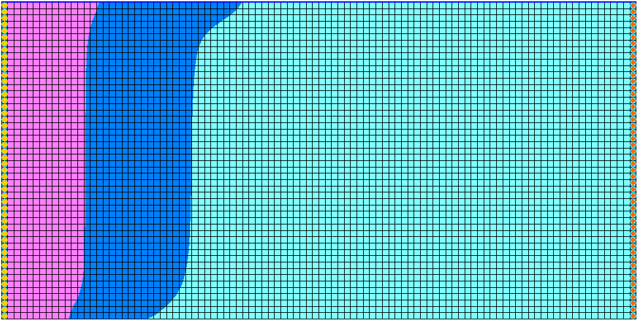

Figure 5 Time step 8 after thermal equilibrium SEAWAT run



Figure 6 Time step 8 after heat conduction SEAWAT run

# Boundary Heat Conduction

Now, look at the effect of boundary heat conduction in this case. Heat conduction at a seawater boundary is simulated using the MT3DMS constant concentration boundary condition (ITYPE = -1). This boundary condition allows advective and dispersive transport across the boundary. Without a dispersive flux, there is no heat conduction. The constant-head boundary (ITYPE = 1) does not allow dispersive transport to occur.

## Saving the Model with a New Name

Before making changes, save the model with a new name.

1. Select *File |* **Save As…** to bring up the *Save As* dialog.
2. Select “Project Files (*.gpr)” from the *Save as type* drop-down.
3. Enter “case5.gpr” as the *File name*.
4. Click **Save** to save the project under the new name and close the *Save As* dialog.

## Modifying the Boundary Conditions

Change the boundary condition of all the cells in the rightmost column of the model.

1. Using the **Select Cells** File:Select 3D Cell Tool.svg tool, drag a box around all the cells in the rightmost column (Figure 7).

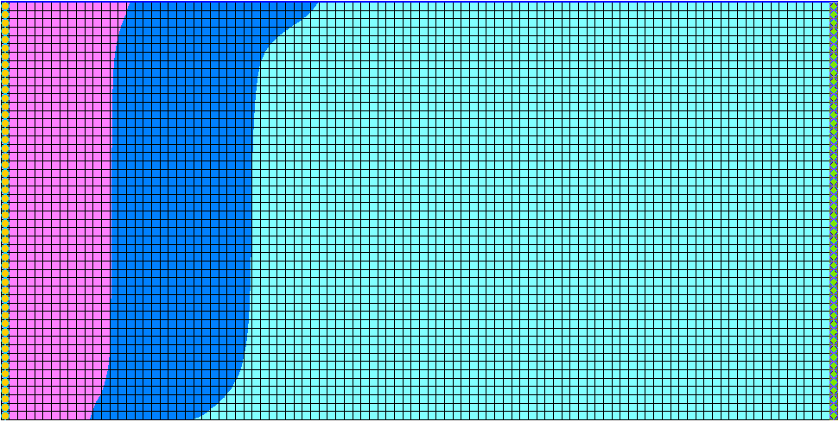

Figure 7 Select the rightmost column of cells in the model

1. Select *MT3DMS |* **Point Sources/Sinks…** to open the *MODFLOW/MT3DMS Sources/Sinks* dialog.

First, adjust the constant head boundary condition and add a new boundary condition.

1. From the list on the left, select “MT3DMS: Point SS”.
2. On the *All* row, in the *Temperature* column, enter “0.0”.
3. Click **Add BC**.

This causes GMS to generate 50 additional rows corresponding to the 50 cells selected on the east side of the model. Identify these new rows by the “0.0” value in the *Salt* column.

1. From the *Type (ITYPE)* drop-down, for each of the 50 new rows, select “constant concentration”. Each row must be entered individually.
2. For each of the 50 new rows, for *Salt*, enter “-1.0”. Each row must be entered individually.

Entering “-1.0” in the *Salt* column with the “constant concentration” *Type* inactivates *Salt* for those rows.

1. For each of the 50 new rows, for *Temperature* enter “5.0”. Each row must be entered individually.
2. Click **OK** to exit the *MODFLOW/MT3DMS Sources/Sinks* dialog.
3. Click anywhere outside the model to deselect the rightmost cells.

The heat boundary condition has been successfully set up for the model.

## Saving and Running SEAWAT

Now to save the changes and run SEAWAT:

1. **Save** File:Save Macro.svg the project.
2. Select *SEAWAT |* **Run SEAWAT…** to bring up the *SEAWAT* model wrapper dialog.
3. When SEAWAT finishes, turn on *Read solution on exit* and *Turn on contours (if not already on)*.
4. Click **Close** to import the solution and close the *SEAWAT* dialog.

## Viewing the Solution

View the results of the SEAWAT model run and compare the differences between the scenarios.

1. In the Project Explorer, under “File:Generic Folder Locked.svg case5 (MT3DMS)”, select “File:Dataset Cells Active.svg Temperature”.
2. In the *Time Steps* window, select the last time step.
3. Expand the “File:Display Theme Folder.svg Display Themes” folder and select “File:Display Theme Icon.svg Temperature_24”.

Notice the boundary heat conduction has some effect on the temperature near the vertical ocean boundary (Figure 8). In this example, the boundary heat conduction only slightly affects the simulated salinity.

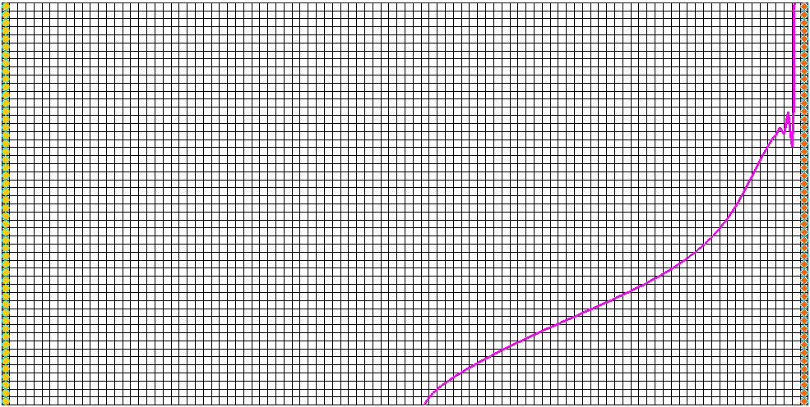

Figure 8 Boundary heat conduction effect

Feel free to explore the various display themes with the “File:Dataset Cells Active.svg Salt” and “File:Dataset Cells Active.svg Temperature” datasets.

# Conclusion

This concludes the “SEAWAT – Thermal Effects Case Studies” tutorial. The following key concepts were discussed and demonstrated in this tutorial:

* SEAWAT combines MODFLOW and MT3DMS to solve variable density groundwater flow and solute transport problems.
* SEAWAT can simulate heat conduction.
* SEAWAT can simulate thermal equilibrium between a solid (aquifer) and a fluid.
* SEAWAT can simulate boundary heat conduction.

1. Langevin, Christian. D.; Thorne, Daniel T., Jr.; Dausman, Alyssa M.; Sukop, Michael C.; and Guo, Weixing. (2007). “SEAWAT Version 4: A Computer Program for Simulation of Multi-Species Solute and Heat Transport” in U.S. Geological Survey *Techniques and Methods* *Book 6*, Chapter A22, p. 13. https://pubs.usgs.gov/tm/tm6a22/pdf/tm6A22.pdf.