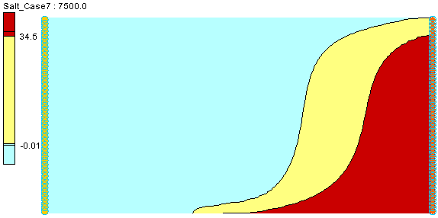

GMS 10.9

GMS 10.9 Tutorial

***SEAWAT – Viscosity and Pressure Effects***

Examine the Effects of Pressure on Fluid Density with SEAWAT

Objectives

This tutorial demonstrates how to simulate the effects of viscosity and how pressure impacts the fluid density in SEAWAT.

.

Time

* 15–30 minutes

Required Components

* GMS Core
* MODFLOW Interface
* MT3D
* SEAWAT

Prerequisite Tutorials

* SEAWAT – Thermal Effects

|  |
| --- |
| 1 Introduction 2  2 Getting Started 3  2.1 Importing the Existing Model 3  3 Adding the Effects on Fluid Viscosity 3  3.1 Modifying the VSC Package 3  3.2 Saving the Model with a New Name and Running SEAWAT 5  3.3 Viewing the Solution 6  4 Adding the Effects of Pressure on Fluid Density 7  4.1 Saving the model with a new name 7  4.2 Modifying the VDF Package 7  4.3 Saving and running SEAWAT 8  4.4 Viewing the Solution 8  5 Conclusion 8 |

# Introduction

This tutorial describes how to simulate the impact of concentration and temperature on fluid viscosity using SEAWAT. Then it examines the effects of pressure on fluid density.

The problem is a confined aquifer with an initial temperature of 5˚C (Figure 1). Warm freshwater is injected from the west side of the model at a 1 m3/day. The initial concentration of salt in the model is 35 kg/m3.

The tutorial looks at the effects of salinity and temperature on viscosity, and the effects of pressure on fluid density in this example. This example problem is very similar to the problem described in the SEAWAT documentation.[1]

This tutorial will discuss and demonstrate importing an existing SEAWAT simulation, running SEAWAT with different scenarios, and examining the results.

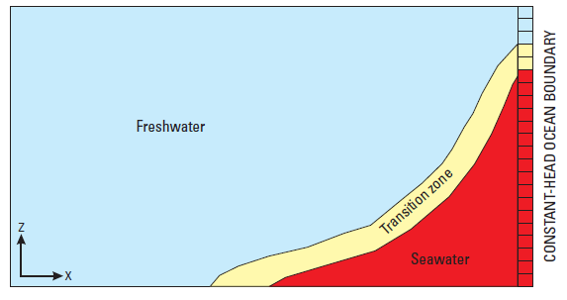

Figure 1 Site to be modeled with SEAWAT

# Getting Started

Do the following to get started:

1. If GMS is not running, launch GMS.
2. If GMS is already running, select *File* | **New** to ensure the program settings are restored to the default state.

## Importing the Existing Model

Start with a model that has already been created.

1. Click **Open** File:Open Macro.svg to bring up the *Open* dialog.
2. Select “Project Files (*.gpr)” from the *Files of type* drop-down.
3. Browse to the *Case_Studies\Sample\Case5* folder and select “case5.gpr”.
4. Click **Open** to import the project and exit the *Open* dialog.

The model should appear similar to Figure 2.

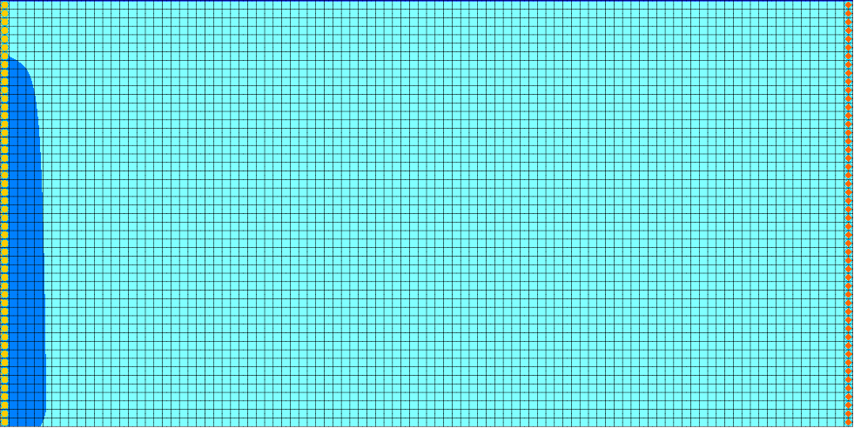

Figure 2 Initial model appearance – Head dataset

# Adding the Effects on Fluid Viscosity

Use the VSC package to simulate changes to the fluid viscosity.

1. Select *SEAWAT |* **Global Options…** to open the *Global Options* dialog.
2. Turn on *Viscosity (VSC)*.
3. Click **OK** to exit the *Global Options* dialog.

## Modifying the VSC Package

For the first scenario, simulate the effect of salinity on fluid viscosity in the simulation.

1. Select *SEAWAT |* **VSC Package…** to open the *SEAWAT VSC Package* dialog.
2. For *Fluid viscosity calc. (MT3DMUFLG),* enter “-1 *.*

This value means that the fluid viscosity will be calculated using one or more MT3DMS species. In this case, they are “Salt” and “Temperature”.

1. For *Reference viscosity (VISCREF),* enter “0.0008904”.
2. From the *Temp. affect on visc. (MUTEMPOPT)* drop-down, select “(1) eq. 18 A1*A2^[A3/(T+A4)]”.
3. For *Temp. species id (MTMUTEMPSPEC),* enter “2”.

The reference viscosity (*VISCREF*) is the viscosity of the reference fluid (warm freshwater).

*MUTEMPOPT* indicates which method (equation) is used to solve the fluid viscosity.

*MTMUTEMPSPEC* indicates the temperature species. In this project, the temperature species ID is “2”.

1. Turn on *Use default values for A1–A5*.

The default coefficients for this equation are specified according to SUTRA.[2] These default values are only valid for temperature in Celsius. Notice that GMS automatically fills in the values.

1. Click **Insert Row** http://www.xmswiki.com/images/f/fa/GMS_-_Insert_Row_icon.png to insert a species row into the spreadsheet.
2. Under *Species ID*, enter “1”.

Notice that the *Species Name* changed to “Salt”.

1. Under *DMUDC*, enter “1.923e-6”.
2. Under *CMUREF*, enter “0.0”.

*DMUDC* indicates the slope of the linear equation, which relates fluid viscosity to solute concentration.

*CMUREF* indicates the reference concentration for species. The entries should match those in Figure 3.

1. Click **OK** to exit the *SEAWAT VSC Package* dialog.

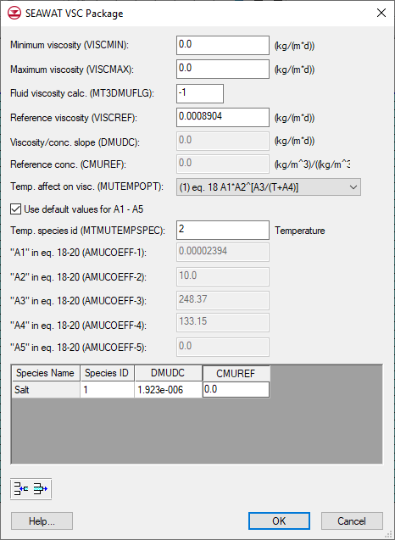

Figure 3 VSC Inputs

## Saving the Model with a New Name and Running SEAWAT

Now to save changes and run SEAWAT:

1. Select *File |* **Save As…** to bring up the *Save As* dialog.
2. Select “Project Files (*.gpr)” from the *Save as type* drop-down.
3. Enter “case6.gpr” as the *File name*.
4. Click **Save** to save the project under the new name and close the *Save As* dialog.
5. Select *SEAWAT |* **Run SEAWAT…** to bring up the *SEAWAT* model wrapper dialog.
6. When SEAWAT finishes, turn on *Read solution on exit* and *Turn on contours (if not on already)*.
7. Click **Close** to import the solution and close the *SEAWAT* dialog.

## Viewing the Solution

Now to view the results of the SEAWAT model run:

1. In the Project Explorer, fully expand the “File:3D Grid Folder.svg 3D Grid Data” folder.
2. Under “File:Generic Folder Locked.svg case6 (MT3DMS)”, select “File:Dataset Cells Active.svg Salt”.
3. In the *Time Steps* window, select time step 10 (value of “5000.0”).

The results from “case6” (Figure 4) and “case5” (Figure 5) are very similar. This suggests that viscosity variation has minimal effect on the simulated salinity and temperature in this case.

The figures show salt concentration at 5000 days.

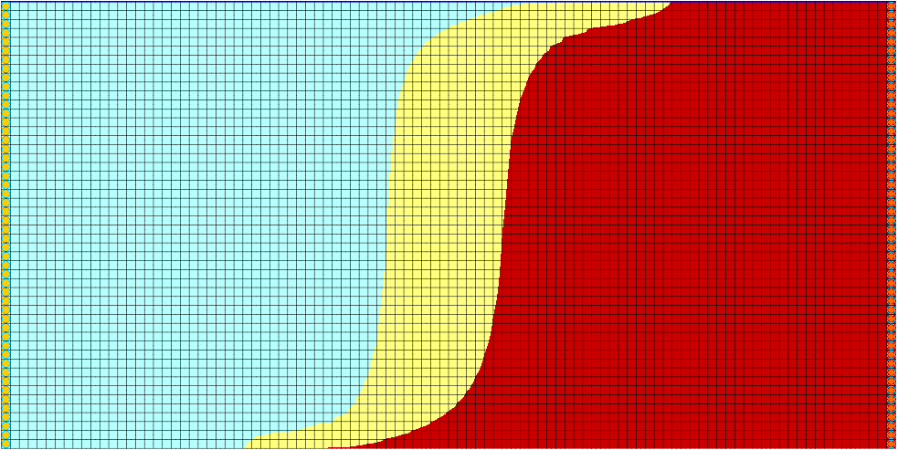

Figure 4 Case 6 – Time step 10

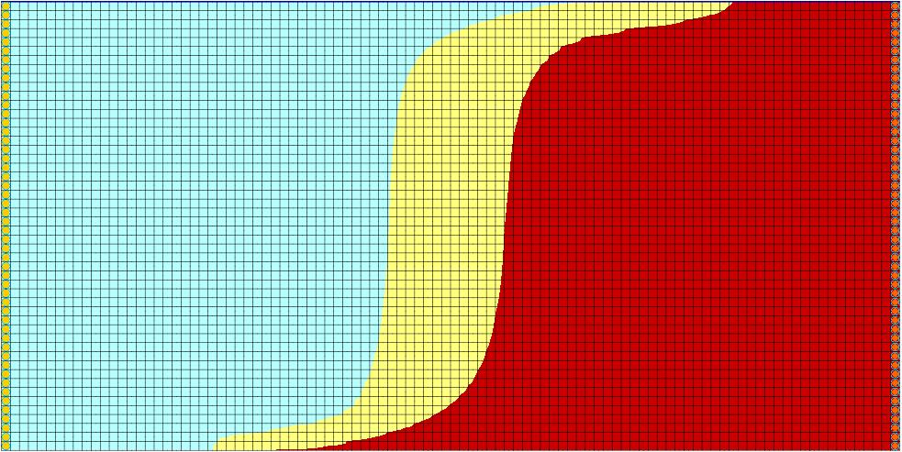

Figure 5 Case 5 – Time step 10

# Adding the Effects of Pressure on Fluid Density

For the next scenario, look at how pressure affects the fluid density.

## Saving the model with a new name

Now it is possible to start making changes for another scenario. First, save the model with a new name.

1. Select *File |* **Save As…** to bring up the *Save As* dialog.
2. Select “Project Files (*.gpr)” from the *Save as type* drop-down.
3. Enter “case7.gpr” as the *File name*.
4. Click **Save** to save the project under the new name and close the *Save As* dialog.

## Modifying the VDF Package

The pressure effects can be activated using the *DRHODPRHD* parameter.

1. Select *SEAWAT |* **VDF Package…** to open the *SEAWAT VDF Package* dialog.
2. For *Density/press. slope (DRHODPRHD),* enter “0.00446”.
3. For *Reference press. head (PRHDREF),* enter “0.0”.

The VDF inputs should be the same as those in Figure 6.

1. Click **OK** to exit the *SEAWAT VDF Package* dialog.

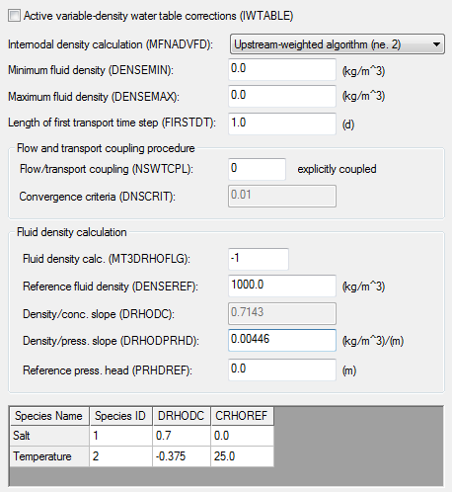

Figure 6 SEAWAT VDF Package dialog detail

## Saving and running SEAWAT

Now to save the changes and run SEAWAT:

1. **Save** File:Save Macro.svg the project
2. Select *SEAWAT |* **Run SEAWAT…** to bring up the *SEAWAT* dialog.
3. When SEAWAT finishes, turn on *Read solution on exit* and *Turn on contours (if not on already)*.
4. Click **Close** to import the solution and exit the *SEAWAT* dialog.

## Viewing the Solution

Now to view the results of the SEAWAT model run:

1. Under “File:Generic Folder Locked.svg case7 (MT3DMS)”**,** select “File:Dataset Cells Active.svg Salt”.
2. In the *Time Steps* window, select time step 10 (value of “5000.0”).

The compressibility of water due to pressure has very little effect on salinity and temperature (Figure 7) due to the shallow depth (500 m) of the aquifer in this case. The effect of pressure on fluid density is negligible for shallow aquifers.

Feel free to review and compare time steps for the “File:Dataset Cells Active.svg Salt” and “File:Dataset Cells Active.svg Temperature” datasets in the various solutions.

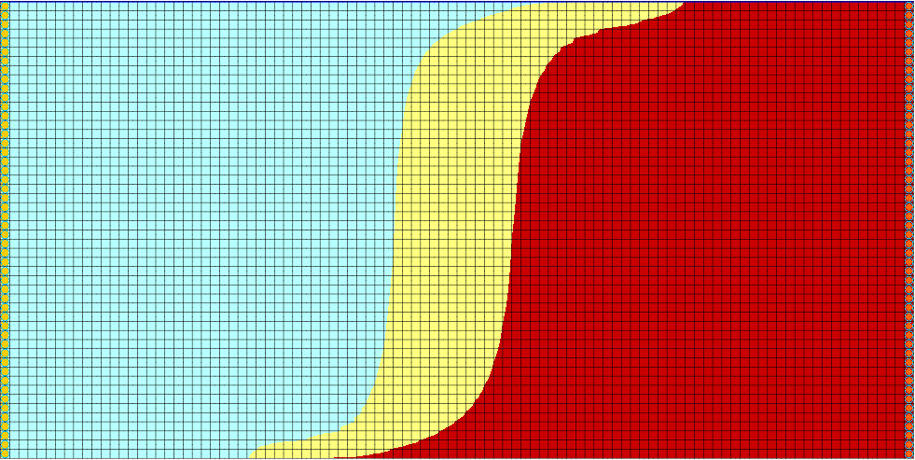

Figure 7 Case 7 – Time step 10

# Conclusion

This concludes the “SEAWAT Viscosity and Pressure Effects” tutorial. The following key concepts were discussed and demonstrated in this tutorial:

* SEAWAT combines MODFLOW and MT3DMS to solve variable density groundwater flow and solute transport problems.
* SEAWAT can simulate the effect of concentration and temperature on fluid viscosity.
* SEAWAT can simulate the effect of pressure on fluid density.

1. Langevin, Christian. D.; Thorne, Daniel T., Jr.; Dausman, Alyssa M.; Sukop, Michael C.; and Guo, Weixing. (2007). “SEAWAT Version 4: A Computer Program for Simulation of Multi-Species Solute and Heat Transport” in U.S. Geological Survey *Techniques and Methods* *Book 6*, Chapter A22, p. 13. <https://pubs.usgs.gov/tm/tm6a22/pdf/tm6A22.pdf>.
2. Voss, Clifford I. (1984). *A Finite-Element Simulation Model for Saturated-Unsaturated, Fluid-Density-Dependent Ground-Water Flow with Energy Transport or Chemically-Reactive Single-Species Solute Transport*: U.S. Geological Survey Water-Resources Investigations Report 84-4369, 407 p.