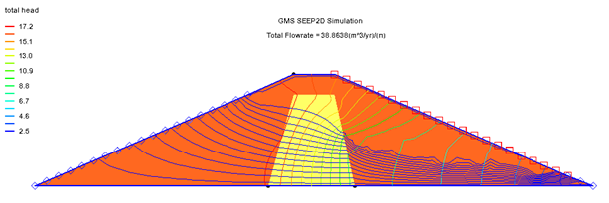

GMS 10.9

GMS 10.9 Tutorial

***SEEP2D – Earth Dam***

Use SEEP2D to complete seepage through an earth dam

Objectives

This tutorial will show how to use the SEEP2D interface in GMS to compute seepage through an earth dam. The tutorial will use different material properties for the shell and core of the dam. It will also use the exit-face boundary condition on the downstream slope.

Time

* 25–40 minutes

Required Components

* GMS Core
* SEEP2D

Prerequisite Tutorials

* Feature Objects

|  |
| --- |
| 1 Introduction 2  2 Getting Started 3  2.1 Setting the Units 3  2.2 Saving the Project 3  3 Creating the Conceptual Model Features 4  3.1 Defining a Coordinate System 4  3.2 Creating the Coverage 4  3.3 Assigning the Coordinates 5  3.4 Creating the Arcs 5  3.5 Creating the Polygons 6  3.6 Assigning the Material Properties and Zones 6  4 Assigning Boundary Conditions 7  4.1 Specified-Head Boundary Conditions 7  4.2 Exit-Face Boundary Conditions 8  4.3 Building the Finite Element Mesh 9  5 Setting the Analysis Options 11  6 Running SEEP2D 12  7 Viewing the Solution 12  8 Conclusion 14 |

# Introduction

This tutorial outlines the process of performing a SEEP2D simulation for an earth dam that includes an unsaturated zone. The modeled scenario, illustrated in Figure 1, features an earth dam constructed with anisotropic soil and a low-permeability core located in the interior.

Figure 1 Earth dam problem

This tutorial covers the following steps: creating a SEEP2D conceptual model, mapping the model to a 2D mesh, defining conditions for both saturated and unsaturated zones, converting the model to SEEP2D, and executing the SEEP2D simulation.

# Getting Started

Do the following to get started:

1. If necessary, launch GMS.

If GMS is already running, select *File |* **New** to ensure that the program settings are restored to their default state.

Right-click in the Project Explorer and select *New* | **Conceptual Model…** to open the *Conceptual Model Properties* dialog.

For the *Name*, enter “Earth Dam Model”.

From the *Type* drop-down, select “SEEP2D”.

Click **OK** to close the *Conceptual Model Properties* dialog.

A new “File:Conceptual Model Icon.svg Earth Dam Model” conceptual model should appear in the Project Explorer.

## Setting the Units

Before proceeding, the unit system to be used in the simulation must be defined. GMS will display the appropriate units next to each input field to help ensure consistency throughout the model setup.

1. Select *Edit* | **Units…** to open the *Units* dialog.
2. To the right of the *Length\** option, click the http://www.xmswiki.com/w/images/f/fc/Dot_dot_dot_button.png button to open the *Display Projection* dialog.
3. In both the *Horizontal* and *Vertical* sections, select “Meters” from the *Units* drop-down.
4. Click **OK** to close the *Display Projection* dialog.
5. From the *Time* drop-down, select “yr”.
6. From the *Mass* drop-down, select “kg”.
7. From the *Force* drop-down, select “N”.
8. Click **OK** to close the *Units* dialog.

## Saving the Project

Before proceeding, save the project as a GMS project file to preserve the current model setup.

1. Select *File |* **Save As…** to bring up the *Save As* dialog.

Browse to the *s2unc\s2unc\sample* directory.

Select “Project Files (*.gpr)” from the *Save as type* drop-down.

Enter “s2uncon.gpr” as the *File name*.

Click **Save** to create the project file and close the *Save As* dialog.

It is recommended to use the **Save** File:Save Macro.svg macro frequently while working on any project.

# Creating the Conceptual Model Features

The first step in setting up the model is to create the GIS features that define the problem geometry. Begin by entering a set of points that correspond to key locations within the geometry. Connect these points using arcs to form the outline of the problem domain. Once the outline is complete, convert the arcs into a closed polygon representing the problem area. The resulting arcs and the polygon will be used to generate the finite element mesh and assign boundary conditions for the solution.

## Defining a Coordinate System

Before creating the conceptual model features, a coordinate system must be established. In this tutorial, the coordinate system is defined with the origin located at the lower-left corner of the dam, as shown in Figure 2.

Figure 2 Coordinate system

## Creating the Coverage

The next step is to create a coverage that will define the boundary conditions and material properties for the model. This coverage will be used to assign head values, specify the exit face, and establish areal properties necessary for the SEEP2D simulation.

1. In the Project Explorer, right-click on the “File:Conceptual Model Icon.svg Earth Dam Model” model and select **New Coverage…** to open the *Coverage Setup* dialog.
2. For the *Coverage name*, enter “Profile lines”.
3. In the *Sources/Sinks/BCs* section, enable the “Head”, “Single Head Value for Arcs”, and “Exit Face” options.
4. In *the Areal Properties* section, enable the “All” option.
5. Click **OK** to exit the *Coverage Setup* dialog.

A new “File:Coverage Active Icon.svg Profile lines” coverage should appear in the Project Explorer.

## Assigning the Coordinates

With the coverage created, points can now be defined at key corner locations. These points will serve as references for constructing the arcs that outline the model boundary. While the Create Points File:Create Points Tool.svg tool can be used to manually place points, it is often more efficient to enter the coordinates directly into a spreadsheet.

|  |  |  |
| --- | --- | --- |
| Name | X | Y |
| A | 0 | 0 |
| B | 42 | 18 |
| C | 51 | 22 |
| D | 59 | 22 |
| E | 51 | 18 |
| F | 59 | 18 |
| G | 46 | 0 |
| H | 63 | 0 |
| I | 105 | 2 |
| J | 110 | 0 |

1. Right-click on the “File:Coverage Active Icon.svg Profile lines” coverage and select **Attribute Table…** to open the *Attribute Table* dialog.
2. Ensure that the “Points” option is selected from the *Feature type* drop-down.
3. Enter the coordinates as shown in the spreadsheet to the right.

Click **OK** to exit the *Attribute Table* dialog.

Click the **Display Options** File:Display Options Macro.svg macro to bring up the *Display Options* dialog.

Select “Map Data” from the list on the left.

To the right of *Points*, turn on *Labels*.

Click **OK** to close the *Display Options* dialog.

Click **Frame Image** File:Frame Macro.svg to center the view on the new points (Figure 3).

Point coordinates can be modified using the **Select Points/Nodes** File:GMS Select Node Tool.svg tool. To edit a point, select it and update its coordinates using the *XYZ* edit fields located at the top of the Graphics Window. Unnecessary points can be removed by selecting them and pressing the *Delete* key or by choosing *Edit* | **Delete** from the menu.



Figure 3 Points created in the profile lines coverage

## Creating the Arcs

With the corner nodes defined, arcs can now be created to represent the boundaries of both the shell and the core of the dam. This process can be completed as follows:

1. Select the “File:Coverage Active Icon.svg Profile lines” coverage to make it active.

Using the **Create Arc** File:GMS Create Arc Tool.svg tool, create a series of connected arcs outlining the perimeter of the dam by clicking on the following points in order: A–B–C–D–I–J–H–G–A.

As the arcs are created, points are converted to nodes and their labels will disappear.

Create the arcs outlining the core boundary by clicking on the following points in order: G–E–F–H.

The arc between points H and G was created in step 2 and does not need to be recreated.

## Creating the Polygons

With the arcs defined, polygons can now be constructed to represent the regions enclosed by the arc boundaries. These polygons will later be used to assign material zones within the model. To create the polygons, do the following:

1. Select the **Build Polygons** macro.

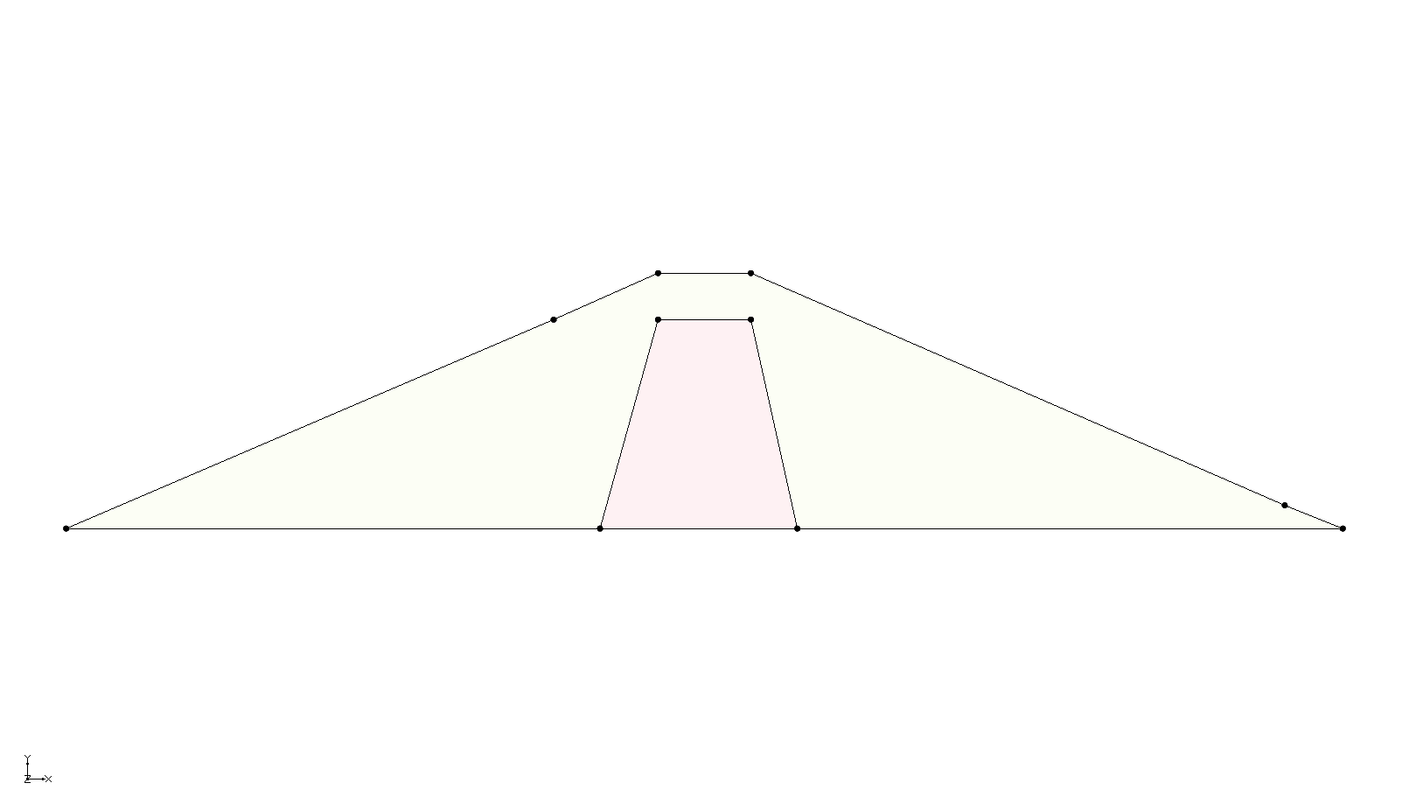

Figure 4 Polygons with default materials assigned (colors may vary)

## Assigning the Material Properties and Zones

The next step is to assign the material properties and define material zones. Once the polygons are generated, SMS automatically assigns default materials to each polygon. These assignments can be modified by creating custom materials for each of the two zones in the model. Each material should be given a unique name, color, and set of hydraulic properties to reflect the characteristics of the corresponding region.

1. Click the **Materials** File:GMS Materials Macro.svg macro to bring up the *Materials* dialog.
2. In the table under the *SEEP2D* tab, enter the following information:

|  |  |  |  |  |  |  |  |  |
| --- | --- | --- | --- | --- | --- | --- | --- | --- |
| **ID** | **Name** | **Color/Pattern** | **Transparency (%)** | **k1** | **k2** | **angle** | **Sat/Unsat linear front ho** | **Sat Unsat linear front kro** |
| 1 | Shell | Light orange | 0.0 | 46.0 | 18.0 | 0.0 | -0.3 | 0.001 |
| 2 | Core | Pale green | 0.0 | 46.0 | 1.8 | 0.0 | -1.2 | 0.001 |

Note: In the *Color/Pattern* column of the table, colors must be manually assigned by selecting the arrow next to the color block in each row.

Click **OK** to close the *Materials* dialog.

Using the **Select Polygons** File:GMS Select Polygon Tool.svg tool, double-click inside the core polygon to bring up the *Attribute Table* dialog.

In the *Color* column, click on the arrow next to the color block and select “Pale green”.

In the *Material* column, select “Core” from the drop-down.

Click **OK** to close the *Attribute Table* dialog.

Double-click on the larger polygon to open its *Attribute Table* dialog.

In the *Color* column, click on the arrow next to the color block and select “Light orange”.

In the *Material* column, select “Shell” from the drop-down.

Click **OK** to close the *Attribute Table* dialog.

Click anywhere outside the polygons in the Graphics Window to unselect the polygon.

The two polygons are now colored to reflect their material assignments (Figure 5).

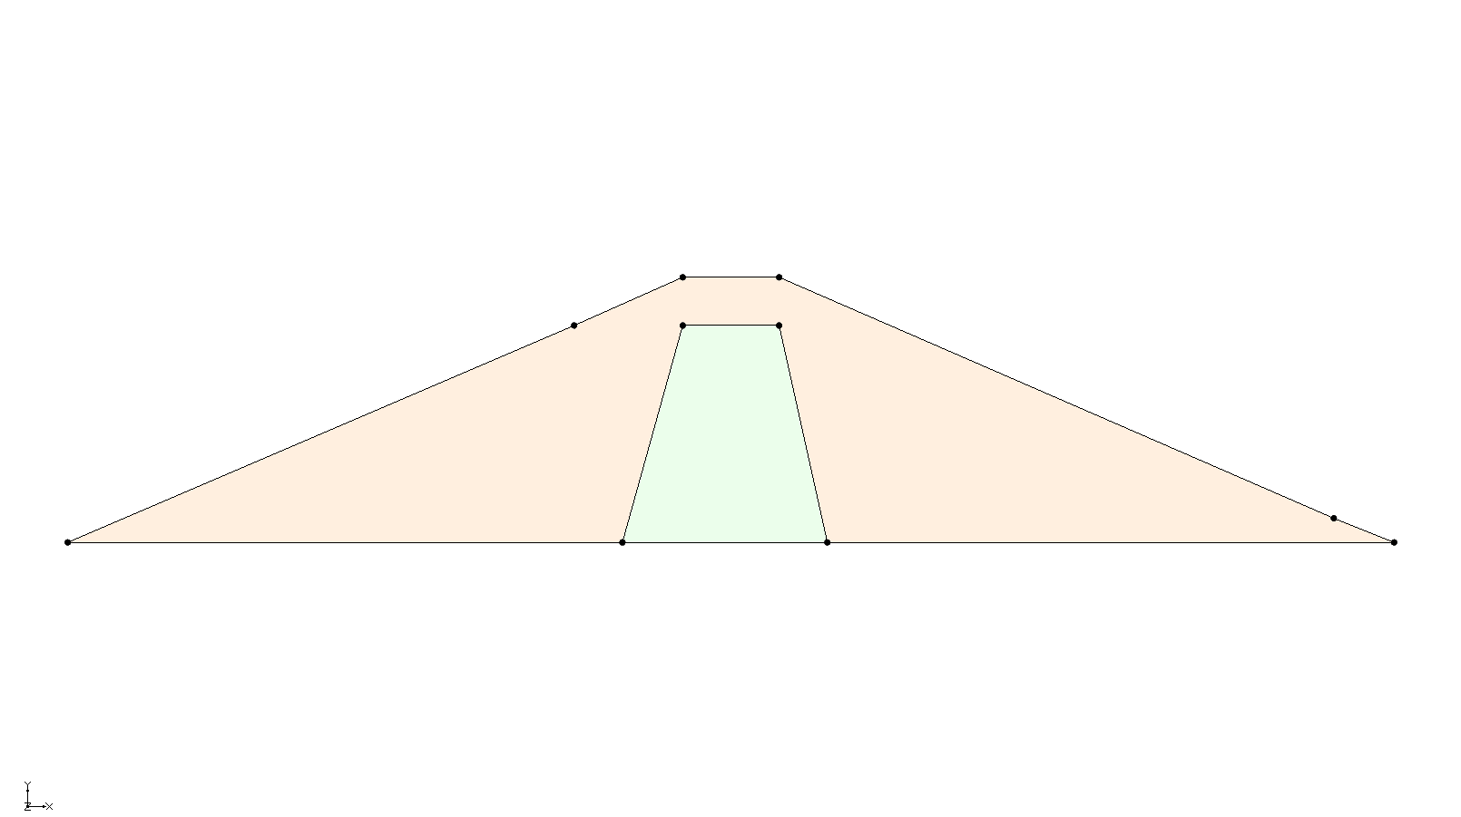

Figure 5 Showing the different material assignments

# Assigning Boundary Conditions

The next step in defining the model is to assign boundary conditions to the conceptual model. For this problem, three types of boundary conditions are used: no-flow boundaries (where flow is parallel to the boundary), specified-head boundaries, and exit-face boundaries. Boundaries without an explicitly assigned condition are treated as no-flow by default. No-flow boundaries are not discussed in detail in this tutorial.

## Specified-Head Boundary Conditions

To enter the specified-head boundary conditions, do the following:

1. Using the **Select Arcs** File:GMS Select Arc Tool.svg tool, double-click on the A–B arc on the left side (Figure 6) to bring up the *Attribute Table* dialog.

In the *Type* column, select “head” from the drop-down.

In the *Head (m)* column, enter “18.0”.

Click **OK** to close the *Attribute Table* dialog.

Repeat steps 1–4 with the I–J arc on the lower right side (Figure 6), entering “2.0” in the *Head (m)* column.

Click anywhere outside of the polygons to unselect the arc.

The arcs will now be blue, indicating they have specified-head boundary conditions (Figure 6).

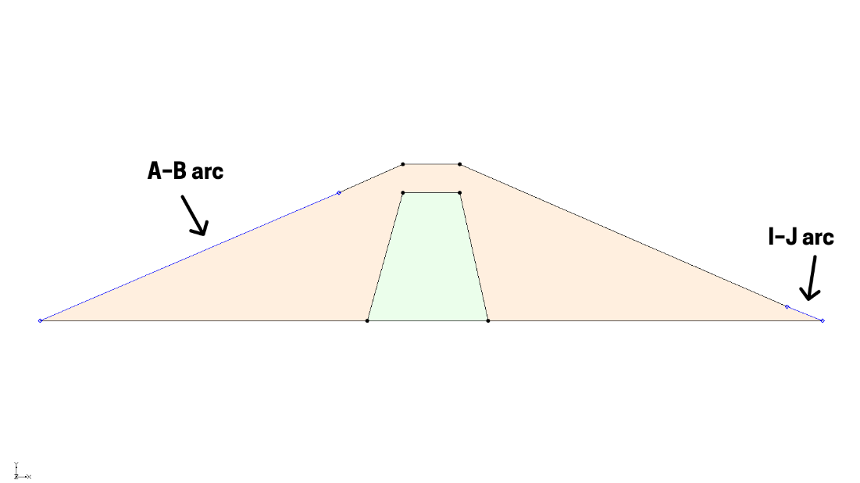

Figure 6 Specified-head boundaries

## Exit-Face Boundary Conditions

The final boundary condition to define is an exit face. Because the model represents an unconfined seepage condition, SEEP2D will iteratively determine the location of the phreatic surface. To assist in this process, all nodes on the mesh where the phreatic surface is expected to exit should be marked as exit-face nodes.

To define the exit-face boundary conditions, complete the following steps:

1. Using the **Select Arcs** File:GMS Select Arc Tool.svg tool, double-click on the D–I arc on the upper right (Figure 7) to bring up the *Attribute Table* dialog.
2. In the *Type* column, select “exit face” from the drop-down.

Click **OK** to exit the *Attribute Table* dialog.

Click anywhere outside the polygons to unselect the arc.

The arc will now appear red, indicating that an exit-face boundary condition has been assigned (Figure 7).

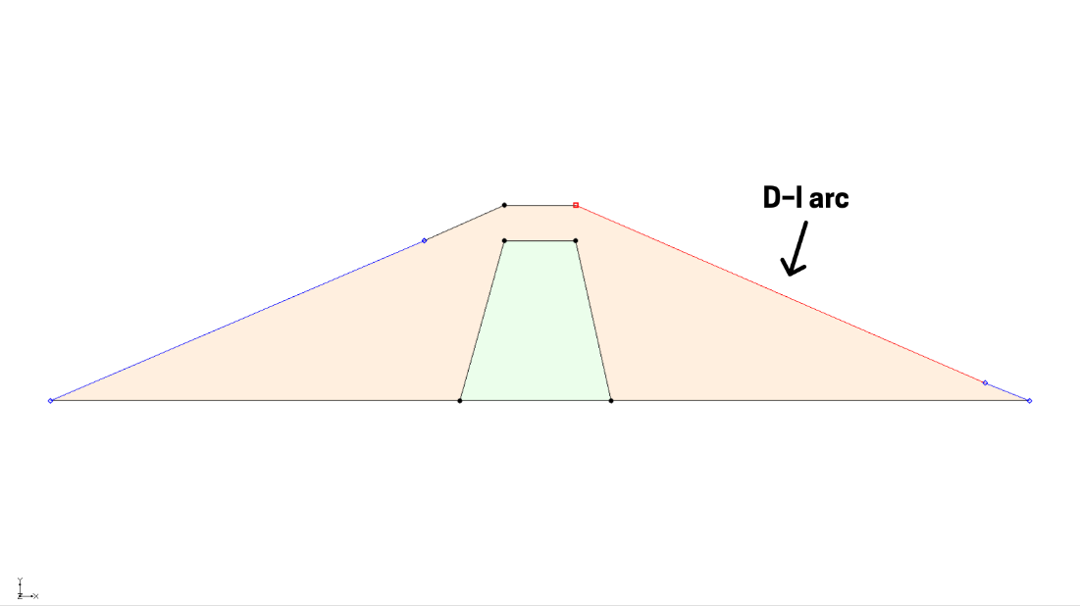

Figure 7 Exit-face boundary

## Building the Finite Element Mesh

The finite element mesh used by SEEP2D can now be generated. This mesh is automatically built from the arcs and polygons in the conceptual model. Each arc consists of two nodes and may include vertices. The segments between vertices are referred to as edges.

By default, all arcs contain one edge and no vertices. To control element density in the mesh interior, arcs must be subdivided to create appropriately sized edges before mapping to a 2D mesh.

1. Using the **Select Arcs** File:GMS Select Arc Tool.svg tool, drag a selection box around the entire model to select all arcs.
2. Select *Feature Objects |* **Redistribute Vertices…** to bring up the *Redistribute Vertices* dialog.

From the *Specify* drop-down, select “Specified spacing”.

Enter “2.5” for the *Average spacing*.

Click **OK** to close the *Redistribute Vertices* dialog.

Switch to the **Select Vertices** File:GMS Select Vertex Tool.svg tool.

Notice the vertex spacing (Figure 8). Vertices are hidden by default but become visible when the **Select Vertices** File:GMS Select Vertex Tool.svg tool is active.

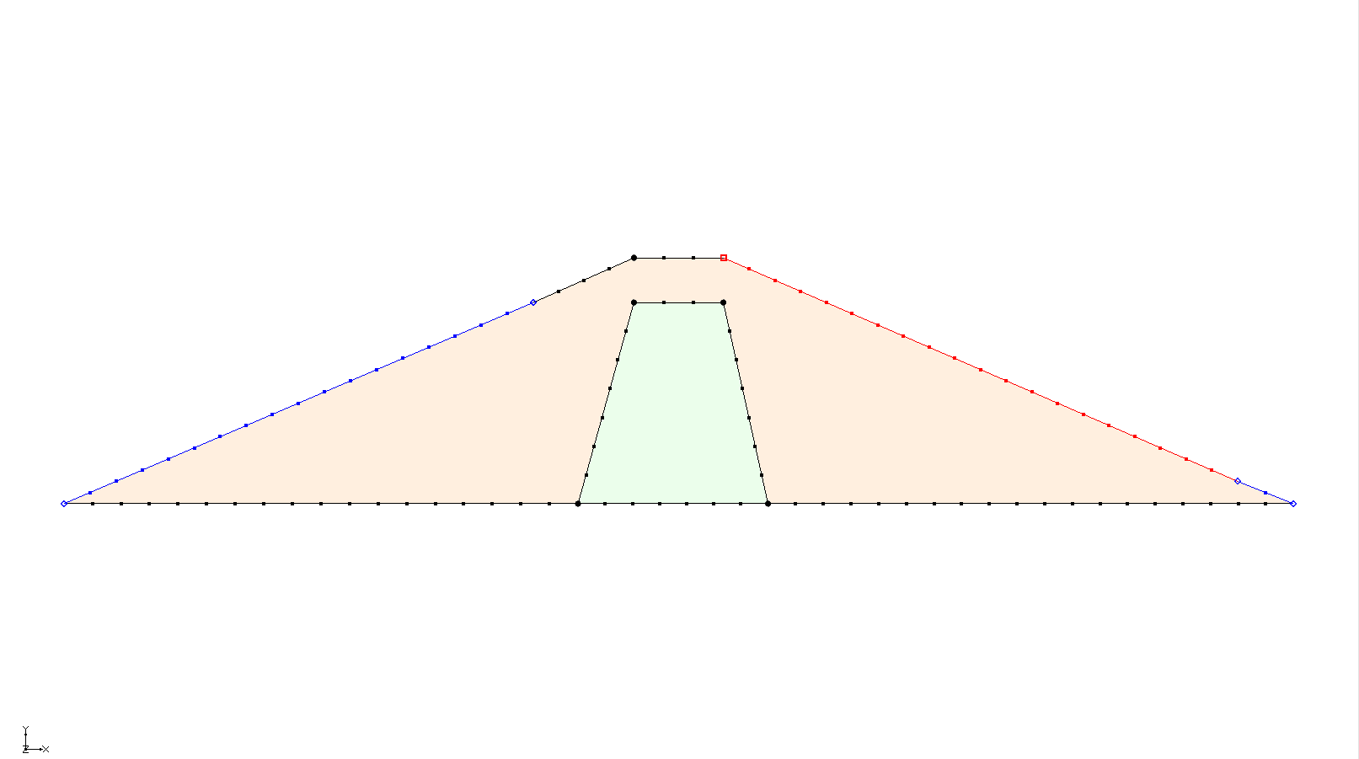

Figure 8 Evenly spaced vertices

To make the vertices always visible, do the following:

Click the **Display Options** File:Display Options Macro.svg macro to bring up the *Display Options* dialog.

Select “Map Data” from the list on the left.

Under the *Map* tab, turn on *Vertices*.

Click **OK** to close the *Display Options* dialog.

In this problem, most of the head loss occurs within the dam’s core. To improve accuracy in this region, the mesh should be refined to be denser within the core.

Using the **Select Arcs** File:GMS Select Arc Tool.svg tool, hold the *Shift* key and select the arcs that define the core polygon of the dam: G–E, E–F, F–H, H–G.

Select *Feature Objects |* **Redistribute Vertices…** to bring up the *Redistribute Vertices* dialog.

From the *Specify* drop-down, select “Specified spacing”.

Enter “1.0” for the *Average spacing*.

Click **OK** to close the *Redistribute Vertices* dialog.

At this point, it is possible to construct the mesh.

Click the **Map → 2D Mesh** File:Map to 2D Mesh Macro.svg macro to create the 2D mesh (Figure 9).

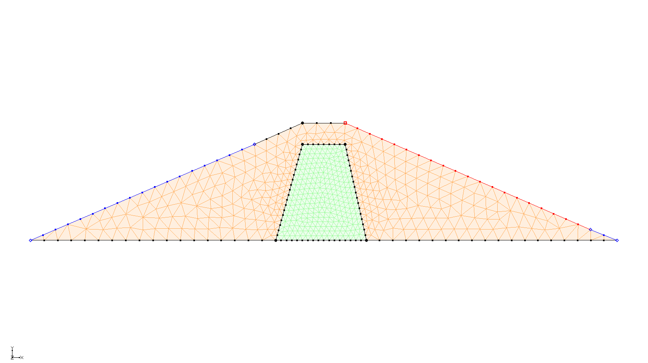

Figure 9 The 2D mesh has been created

The final step is to convert the conceptual model to a SEEP2D numerical model. This process assigns the boundary conditions defined on the feature objects to the node-based format required by SEEP2D.

Click the **Map → SEEP2D** File:Map to SEEP2D Macro.svg macro.

A set of blue and red symbols will appear on the model, indicating that the boundary conditions have been successfully assigned (Figure 10).

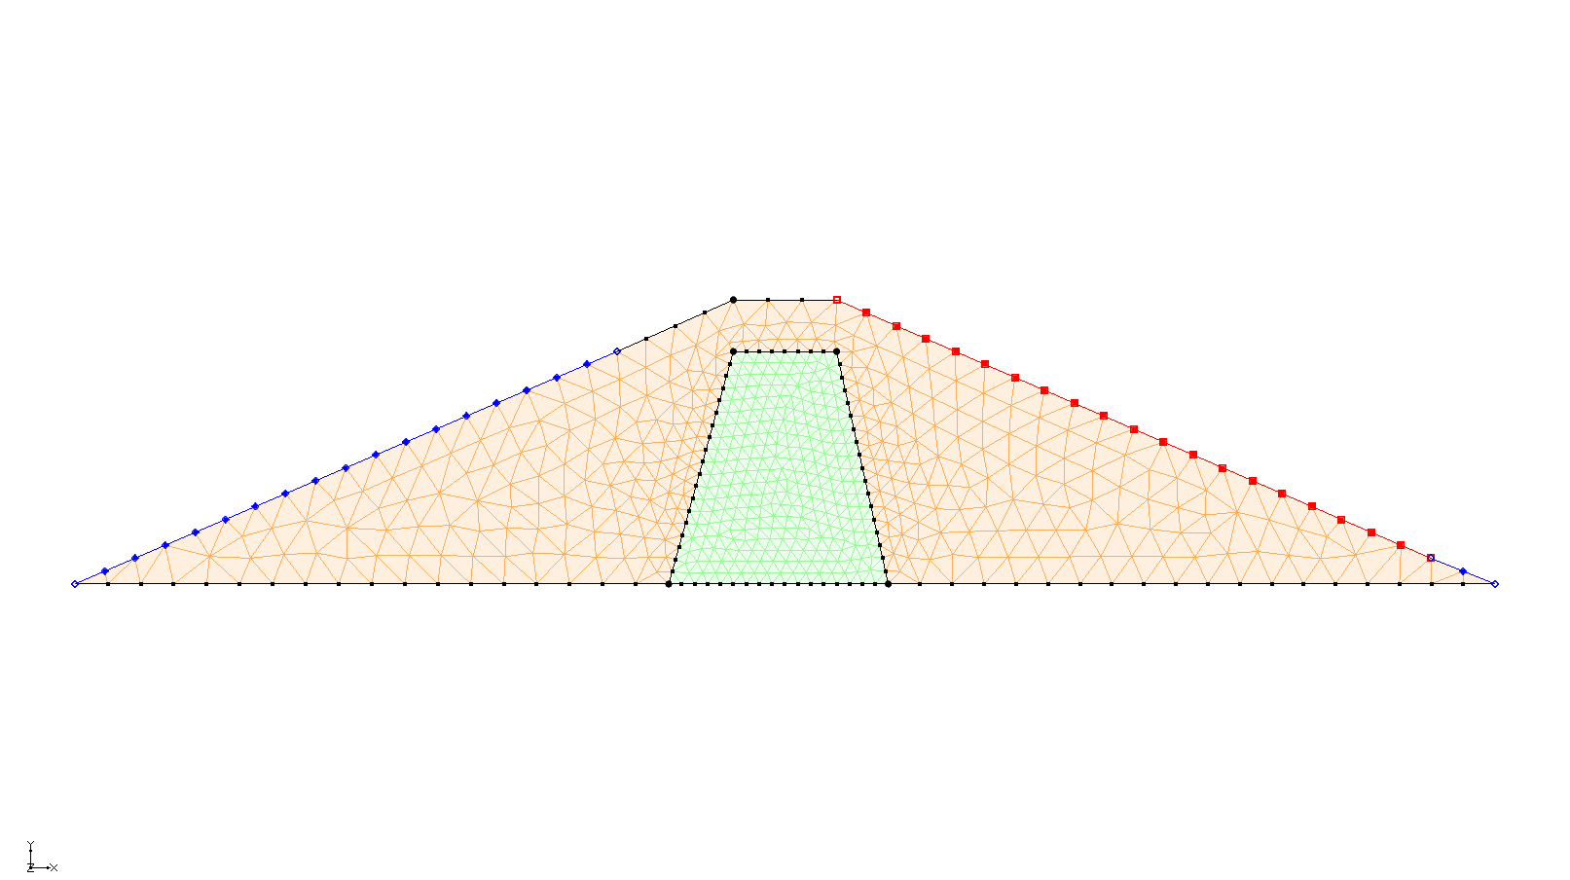

Figure 10 SEEP2D boundary conditions assigned

# Setting the Analysis Options

Before running the model, it is necessary to adjust the analysis options.

1. Save the model by clicking the **Save**File:Save Macro.svg macro.

Select *SEEP2D |* **Analysis Options…**to open the *SEEP2D Analysis Options* dialog.

For the *Unit weight of water*, enter “9810.0”.

SEEP2D provides two methods for computing relative conductivity in the unsaturated zone: the linear front method and the Van Genuchten method. The linear front method defines a linear decrease in relative conductivity from the saturated value to a user-defined minimum at a specified negative pressure head. The Van Genuchten method uses soil-specific parameters to model this variation. For this tutorial, the linear front method will be used. Detailed descriptions of both methods can be found in the “SEEP2D Primer”.

In the *Model type* section, select *Saturated/Unsaturated with linear front*.

Click **OK** to exit the *SEEP2D Analysis Options* dialog.

# Running SEEP2D

The model is now ready to run SEEP2D. Before starting the simulation, ensure all changes have been saved:

1. Click **Save** File:Save Macro.svg.

Click the **Run SEEP2D** File:Run SEEP2D Macro.svg macro to bring up the *Seep2d* model wrapper dialog.

When the solution is finished, turn on *Read solution on exit* and click **Close** to close the *Seep2d* model wrapper dialog.

GMS will automatically import the SEEP2D solution upon closing this dialog. Contour lines representing the solution will then appear on the dam model (Figure 11).

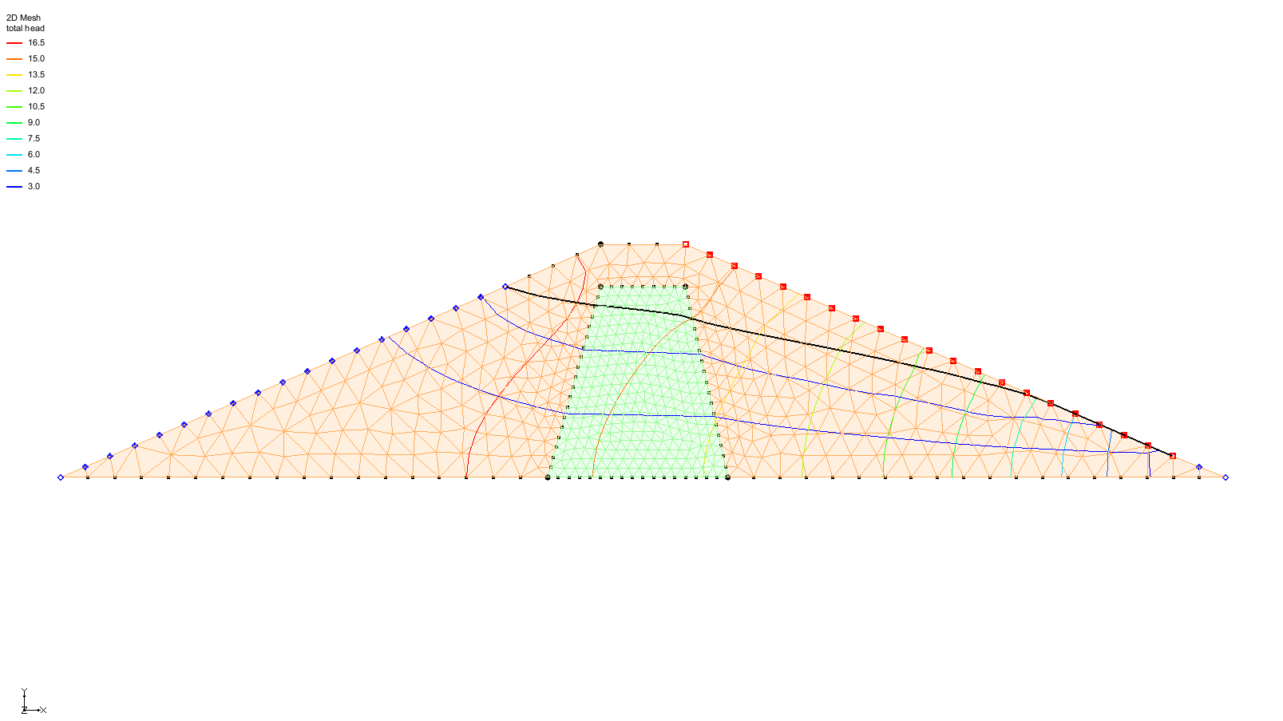

Figure 11 Contour lines after SEEP2D model run

# Viewing the Solution

The flow net plot should now be visible. To better view the flow net, nodes and elements can be hidden from the display.

1. Click the **Display Options** File:Display Options Macro.svg macro to bring up the *Display Options* dialog.

Select “2D Mesh Data” from the list on the left.

Under the *2D Mesh* tab, turn off *Nodes* and *Element edges*.

Turn on *Mesh boundary*.

Click **OK** to close the *Display Options* dialog.

Note that only a limited number of flow lines are displayed (Figure 12). GMS determines the number of flow lines to display based on the spacing of equipotential lines within a selected material. By default, this interval is calculated using the properties of the “Shell” material.

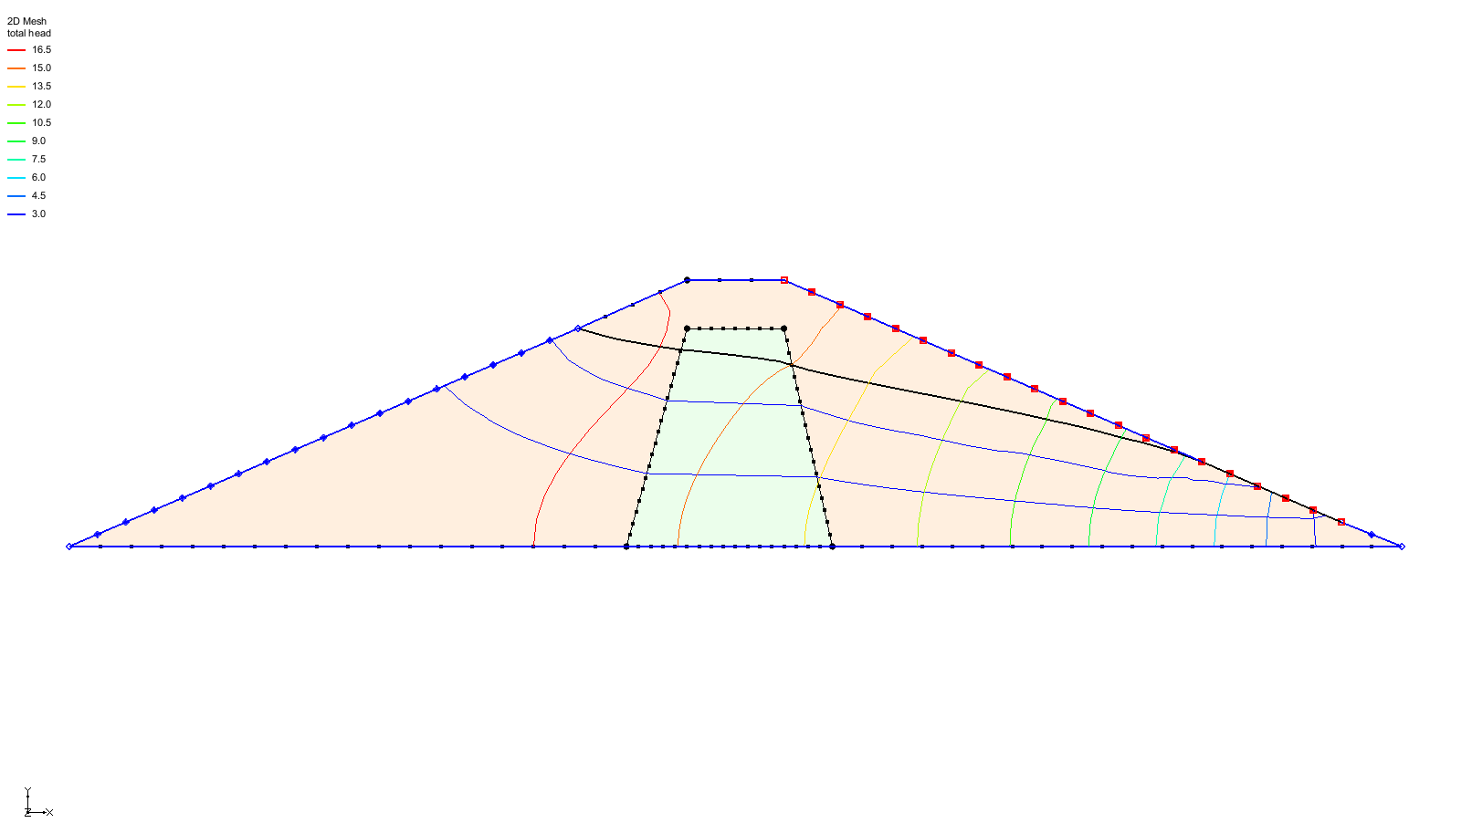

Figure 12 Less cluttered view with nodes and elements off and mesh on

To base the number of flow lines on the “Core” material, do the following:

1. Click the **Display Options** File:Display Options Macro.svg macro to bring up the *Display Options* dialog.

Select “2D Mesh Data” from the list on the left.

Under the *SEEP2D* tab, select “Core” from the *Base material* drop-down.

Ensure *Phreatic surface* is turned on.

Click **OK** to close the *Display Options* dialog.

Flow lines are now displayed throughout the model, along with the phreatic surface (Figure 13).

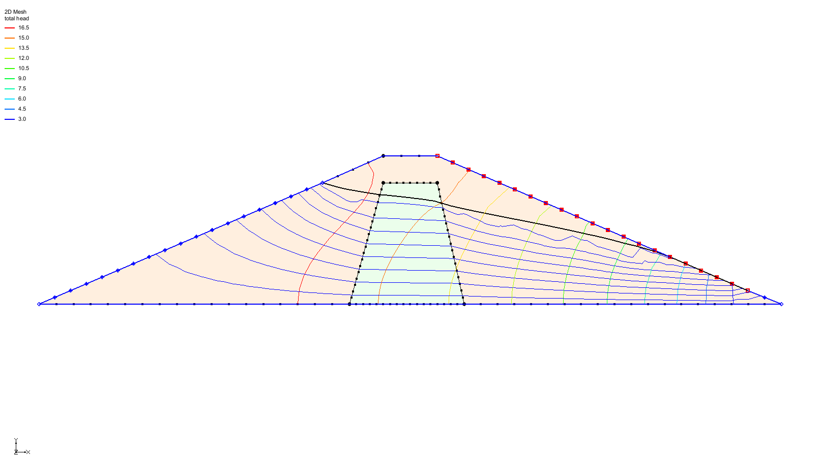

Figure 13 Flow lines and phreatic surface visible

# Conclusion

This concludes the “SEEP2D – Earth Dam” tutorial. The following topics were covered:

* SEEP2D can perform 2D unconfined flow modeling
* SEEP2D problems can be set up quickly and easily using the conceptual model approach
* Display a flow net and the phreatic surface in GMS