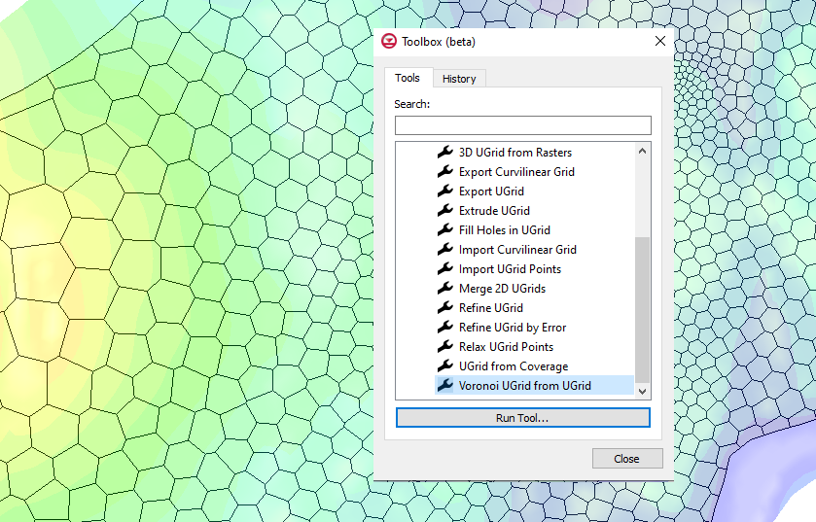

GMS 10.9

GMS 10.9 Tutorial

***Toolbox Introduction***

Learn to use the Toolbox tools in GMS

Objectives

Learn how to access and use a tool in the Toolbox in GMS. This tutorial will demonstrate how to convert a UGrid to a Voronoi UGrid. The tutorial will also demonstrate using the toolbox history.

Time

* 10–20 minutes

Required Components

* GMS Core

Prerequisite Tutorials

* Getting Started

|  |
| --- |
| 1 Introduction 2  2 Opening the Starting Project 2  3 Using the Toolbox 3  3.1 Convert to Voronoi UGrid 3  4 Rerunning a Tool Using History 4  4.1 Using Tools in History 4  5 Saving the History 5  6 Conclusion 5 |

# Introduction

The *Toolbox* in GMS contains “tools” which are routines that can be used to take various data as input in order to create new datasets, for instance. This tutorial will provide an introduction to using the *Toolbox* by using a previously developed 2D UGrid. This UGrid will be used in the tutorial to create a Voronoi UGrid. The *History* feature of the *Toolbox* will also be demonstrated.

# Opening the Starting Project

To open the simulation and solution data:

Select *File |* **Open…** to bring up the *Open* dialog.

Select “Project Files (*.gpr)” from the *Files of type* drop-down.

Browse to the *data file* folder for this tutorial and select “start.gpr”.

Click **Open** to import the project and exit the *Open* dialog.

If asked to delete existing data, click **Yes**.

The project should appear similar to Figure 1.

The project contains a 2D UGrid that will be used for creating additional UGrids using the Toolbox.

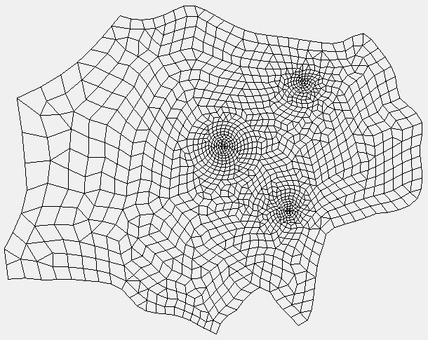

Figure 1 Initial project

# Using the Toolbox

The Toolbox contains multiple tools for generating new geometries, rasters, and datasets. It is accessed by doing the following:

1. Click the **Toolbox** File:Toolbox macro.png macro to open the *Toolbox* dialog.

The Toolbox dialog contains two tabs: Tools and History. The Tools tab contains a set of folders such as Datasets, Rasters, and Unstructured Grids. These folders can be expanded to show groups of tools available. Double-clicking on a tool name will bring up a dialog for entering the input for the tool run.

## Convert to Voronoi UGrid

The *Voronoi UGrid from UGrid* tool creates a Voronoi UGrid from an existing geometry. To use this tool, do the following:

1. In the *Tools* tab, expand the “File:Generic Folder.svg Unstructured Grids” folder.
2. Double-click on the **Voronoi UGrid from UGrid** tool to open the *Voronoi UGrid from UGrid* dialog.

This tool takes an existing UGrid and creates a new Voronoi UGrid. The Voronoi UGrid cells will be created around the points in the input UGrid.

In the *Voronoi UGrid from UGrid* dialog, notice the dialog is divided into two parts. The left side lists the inputs and outputs of the tool. This tool has only one input, and one output. Some tools have multiple inputs and/or outputs.

The right side of the dialog contains documentation about the tool. If GMS detects an internet connection and can access <https://www.xmswiki.com/>, the documentation comes from the XMS wiki. If the wiki is unreachable, only minimal documentation is presented.

1. For the *Input grid*, select “UGrid Data/start_mesh_tri_quad”.
2. For the *Output grid name*, enter “voronoi”.
3. Click **OK** to close the *Voronoi UGrid from UGrid* tool dialog and to start the progress window for the tool.

The progress window will show what the tool is doing and report any issues during the process. When the tool finishes, the statement “Successfully ran tool” appears at the top of the progress window.

1. Click **OK** to close the *Voronoi UGrid from UGrid* progress window.
2. Click **Close** to exit the *Toolbox* dialog.
3. In the Project Explorer, turn off “File:Ugrid-icon.png start_mesh_tri_quad”.

The new “File:Ugrid-icon.png voronoi’ UGrid will appear similar to Figure 2.

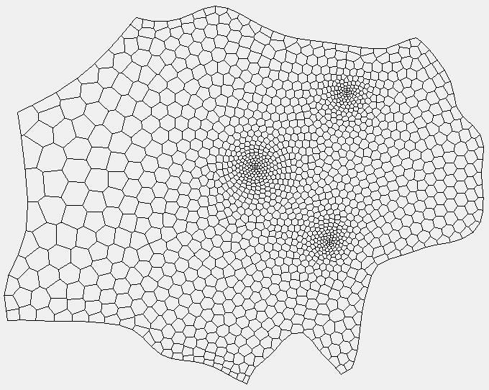

Figure 2 The generated Voronoi UGrid

# Rerunning a Tool Using History

The Toolbox keeps a history of all the tools that are run with a project. The history remembers the inputs used when a tool was run and can be used to rerun the tool with the same inputs. This can be a handy time-saving feature.

1. Click the **Toolbox** File:Toolbox macro.png macro to open the *Toolbox* dialog.
2. Select the *History* tab.

The *History* tab will show one or more folders depending how often the Toolbox has been used with the project. Each folder will be named with the date the tools in the Toolbox were used. Each folder can be expanded to give a list of tools that were used on that date.

## Using Tools in History

Using the *History* tab, the *Voronoi UGrid from UGrid* tool can be run again. To do this:

1. In the *History* tab, expand the top folder which should be named with today’s date.

Notice the *Voronoi UGrid from UGrid* tool is listed along with the date and time that it was run.

1. Select the *Voronoi UGrid from UGrid* tool.
2. Click the **Run Tool From History** button to open the *Voronoi UGrid from UGrid* tool dialog.

In the *Voronoi UGrid from UGrid* dialog, notice the *Input grid* is already defined, and is the same one chosen last time. The output name is also filled in with the name used last time. For tools with multiple inputs/outputs, having the fields already populated can be a nice time-saving feature.

1. Change the *Output grid name* to “voronoi 2”.
2. Click **OK** to close the *Voronoi UGrid from UGrid* tool dialog and start the progress window.
3. When the tool finishes running successfully, click **OK** to close the *Voronoi UGrid from UGrid* progress window.

Notice a new entry has been added in the *History* tab.

1. Click **Close** to exit the *Toolbox* dialog.

Notice the new “File:Ugrid-icon.png voronoi 2” UGrid that was created. This UGrid should appear identical to the previously generated Voronoi UGrid.

# Saving the History

The Toolbox saves a history of tools used with each project. To see how this works, complete the following:

1. Select *File* | **Save As** to open the *Save As* dialog.
2. For the *File name*, enter “voronoi.gpr”.
3. Click **Save** to close the *Save As* dialog.
4. Select *File* | **New**.
5. Select *File |* **Open…** to bring up the *Open* dialog.
6. Select “Project Files (*.gpr)” from the *Files of type* drop-down.
7. Browse to the *data file* folder for this tutorial and select “voronoi.gpr”.
8. Click **Open** to import the project and exit the *Open* dialog.
9. Click the **Toolbox** File:Toolbox macro.png macro to open the *Toolbox* dialog.
10. Select the *History* tab.

Notice that the *History* tab still shows the tools that were run today as well as other tool runs that might have been completed.

# Conclusion

This concludes the “Toolbox”tutorial. The following items were discussed:

* Tools are routines that take one or more inputs and produce one or more outputs.
* Tools can help with many different areas in GMS and model building.
* The *Toolbox History* can be used to rerun a tool and preserve previous field entries.
* The set of tools is currently limited but will expand greatly in the future.

Feel free to continue experimenting with the other tools in the Toolbox, or exit GMS.