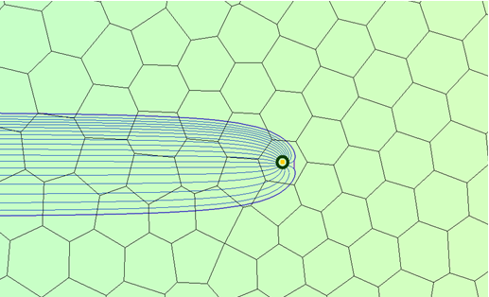

GMS 10.9

GMS 10.9 Tutorial

***Mod-PATH3DU***

A particle tracking program for MODFLOW-USG

Objectives

This tutorial gives an overview of GMS's interface for mod-PATH3DU.

Time

* 15–30 minutes

Required Components

* GMS Core
* MODFLOW Interface
* MODPATH/MP3DU Interface

Prerequisite Tutorials

* MODPATH

|  |
| --- |
| [1 Introduction 2](#_Toc201308462)  [1.1 Getting Started 2](#_Toc201308463)  [2 Opening an Existing Model 2](#_Toc201308464)  [3 Saving a Native Text Copy 3](#_Toc201308465)  [4 Running MODFLOW 3](#_Toc201308466)  [5 Creating a Backward Tracking mod-PATH3DU Model 4](#_Toc201308467)  [5.1 Adding Starting Locations 4](#_Toc201308468)  [5.2 Changing to Backward Tracking 5](#_Toc201308469)  [6 Saving and Running mod-PATH3DU 6](#_Toc201308470)  [7 Creating a Forward Tracking mod-PATH3DU Model 7](#_Toc201308471)  [7.1 Adding Starting Locations 7](#_Toc201308472)  [8 Saving and Running mod-PATH3DU 9](#_Toc201308473)  [9 Examining the Solution 9](#_Toc201308474)  [10 Conclusion 11](#_Toc201308475) |

# Introduction

The mod-PATH3DU model is a particle-tracking program written by Chris Muffles at S.S. Papadopulos & Associates. It is compatible with both structured and unstructured grids, as well as MODFLOW-USG. Given its similarity to MODPATH, it is recommended to become familiar with the MODPATH tutorial before starting this one.

This tutorial begins by opening a model that includes a MODFLOW-USG simulation, saving a native text copy of the model, and running MODFLOW on the saved text file. A new backward tracking mod-PATH3DU model will then be created, with tracking points placed at the well. The new model will be saved, mod-PATH3DU will be run, and the solution will be imported. Lastly, a new forward tracking mod-PATH3DU model with points on the side will be created.

## Getting Started

To start:

1. If necessary, launch GMS.
2. If GMS is already running, select *File |* **New** to ensure that the program settings are restored to their default state.

# Opening an Existing Model

The first step is to open a MODFLOW-USG model based on the example problem included with mod-PATH3DU. It is a one-layer Voronoi model, where flow moves from left to right. The cells on the left side are assigned a constant head cells value of “50.0”, while the cells on the right side are assigned a constant head value of “49.0”. A single CLN well, located in the center of the model, extracts water. Transparent, continuous, color-filled contours of head are enabled for visualization.

1. Click **Open** http://www.xmswiki.com/images/thumb/5/5d/Open_Macro.svg/60px-Open_Macro.svg.png to bring up the *Open* dialog.
2. Select “Project Files (\*.gpr)” from the *Files of type* drop-down.
3. Browse to the *\VoronoiModel\VoronoiModel* folder and select “Voronoi.gpr”.
4. Click **Open** to import the project and exit the *Open* dialog.

The project should appear similar to Figure 1.

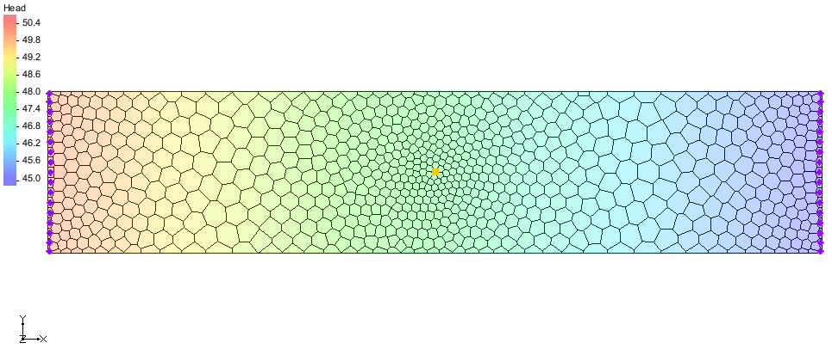

Figure 1 Starting MODFLOW-USG model from mod-PATH3DU examples

To save the project with a new name:

1. Select *File* | **Save As…** to open the *Save As* dialog.
2. Select “Project Files (\*.gpr)” from the *Save as type* drop-down.
3. Enter “mp3du.gpr” as the *File name*.
4. Click **Save** to save the project under the new name and close the *Save As* dialog.

# Saving a Native Text Copy

Since mod-PATH3DU reads MODFLOW files and uses its own internal version of MODFLOW, it cannot read GMS-formatted MODFLOW files that store array data in HDF5 format. As a result, it is necessary to save a native text copy of the MODFLOW simulation to be used by mod-PATH3DU.

1. In the Project Explorer, double-click on the “http://www.xmswiki.com/images/thumb/d/d2/MODFLOW_Package_Icon.svg/60px-MODFLOW_Package_Icon.svg.png Global” package to bring up the *MODFLOW Global/Basic Package* dialog.
2. In the *MODFLOW version* section, turn on *Save native text copy*.
3. Click **OK** to close the *MODFLOW Global/Basic Package* dialog.
4. **Save** File:Save Macro.svg the project so that the text copy of MODFLOW will be saved.

|  |  |
| --- | --- |
| Desc-i_gray 100px | mod-PATH3DU requires a native text version of the MODFLOW model. |

# Running MODFLOW

MODFLOW must be run again to generate a solution for the native text copy of the model. Since the typical approach involves running MODFLOW using the GMS-formatted version of the model, it will be necessary to run MODFLOW differently for this step.

1. Select *MODFLOW | Advanced* | **Run MODFLOW Dialog…** to bring up the *Run MODFLOW* dialog.
2. In the *MODFLOW version* section, turn on *USG*.
3. Click **Name file** File:Open Macro.svg to bring up the *Open* dialog.
4. Navigate to the *mp3du\_MODFLOW-Voronoi* folder.
5. Select “mp3du.mfn” and click **Open** to exit the *Open* dialog.

The dialog should appear similar to Figure 2.

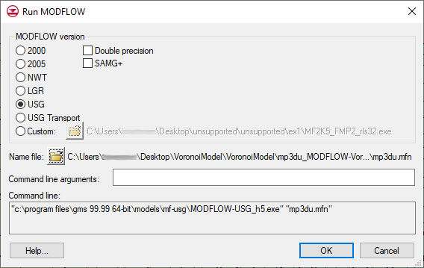

Figure 2 Run MODFLOW dialog

1. Click **OK** to exit the *Run MODFLOW* dialog and bring up a command prompt window.
2. When MODFLOW finishes running, close the command window by pressing any key.

|  |  |
| --- | --- |
| Desc-i_gray 100px | The *MODFLOW | Advanced* | **Run MODFLOW Dialog…** menu command allows MODFLOW to be run using any version of MODFLOW on any specified file name. |

# Creating a Backward Tracking mod-PATH3DU Model

The next step is to create the mod-PATH3DU model.

1. In the Project Explorer, right-click the “http://www.xmswiki.com/images/thumb/2/23/UGrid_3D_Locked.svg/60px-UGrid_3D_Locked.svg.png Voronoi” item and select **New mod-PATH3DU…** to create a new “File:UGrid Veronoi Icon.svg Voronoi” mod-PATH3DU model.
2. Right-click the “File:UGrid Veronoi Icon.svg Voronoi” simulation and select **Rename**.
3. Enter “backward” and press *Enter* to set the new name.

## Adding Starting Locations

1. Right-click “File:UGrid Veronoi Icon.svg backward” and select **Create Particles at Wells…** to bring up the *Generate Particles at Wells* dialog.
2. Click **OK** to accept the defaults and close the *Generate Particles at Wells* dialog.

|  |  |
| --- | --- |
| Desc-i_gray 100px | Starting locations can be generated at wells using the **Create Particles at Wells…** command. |

When using MODPATH, GMS would typically save and run MODPATH automatically, importing the pathlines. However, since GMS does not automatically run mod-PATH3DU, this must be done manually. The process for running mod-PATH3DU will be covered in the next section.

|  |  |
| --- | --- |
| Desc-i_gray 100px | mod-PATH3DU does not run automatically, unlike MODPATH. |

1. **Zoom** File:Zoom Tool Icon.svg in to the cell containing the well.

Notice the ring of starting locations created around the well (Figure 3).

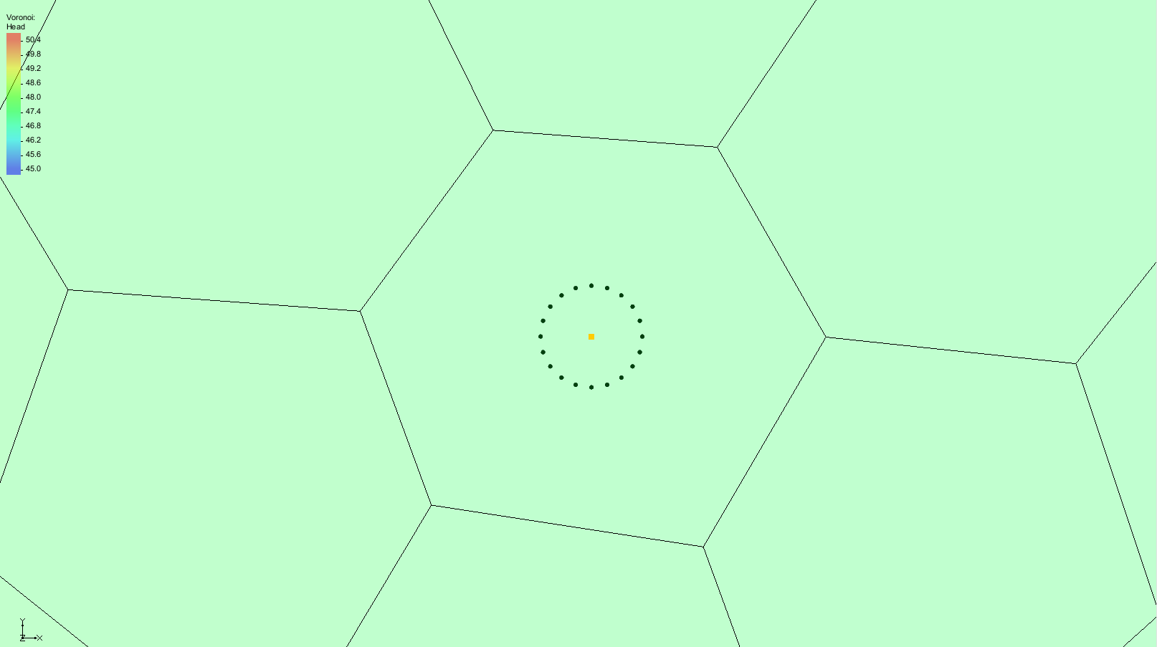

Figure 3 Ring of starting locations created around the well

1. **Frame** http://www.xmswiki.com/images/thumb/b/bd/Frame_Macro.svg/52px-Frame_Macro.svg.png the project to return to the previous view.

## Changing to Backward Tracking

With starting locations at the well, the next task is creating a backward tracking simulation.

1. Right-click “File:UGrid Veronoi Icon.svg backward” and select **Options…** to bring up the *mod-PATH3DU Options* dialog.
2. Select “Options” from the list on the left.
3. From the *DIRECTION* drop-down, select “Backward” (Figure 4).
4. Click **OK** to exit the *mod-PATH3DU Options* dialog.

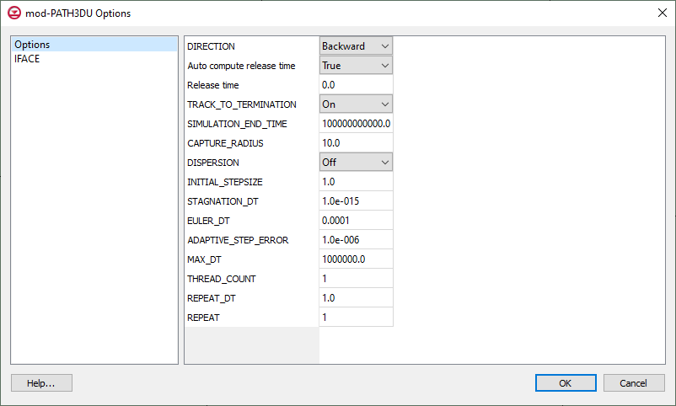

Figure 4 Selecting the direction

# Saving and Running mod-PATH3DU

Before running mod-PATH3DU, the changes must be saved.

1. **Save** http://www.xmswiki.com/images/thumb/0/00/Save_Macro.svg/53px-Save_Macro.svg.png the project. This will include the mod-PATH3DU input files.
2. Right-click “File:UGrid Veronoi Icon.svg backward” and select **Run mod-PATH3DU** to bring up the *MP3DU* model wrapper dialog (Figure 5).

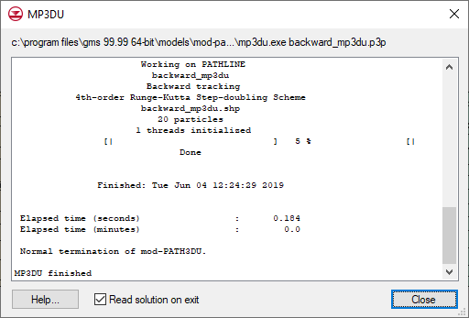

Figure 5 mod-PATH3DU model wrapper

When mod-PATH3DU finishes, the line “Normal termination of mod-PATH3DU.” should appear near the bottom of the *MP3DU* model wrapper dialog.

1. When mod-PATH3DU finishes, make sure *Read solution on exit* is turned on and click **Close** to exit the *MP3DU* model wrapper dialog.

GMS will import the pathline solution file and display the pathlines. The result should appear similar to Figure 6.

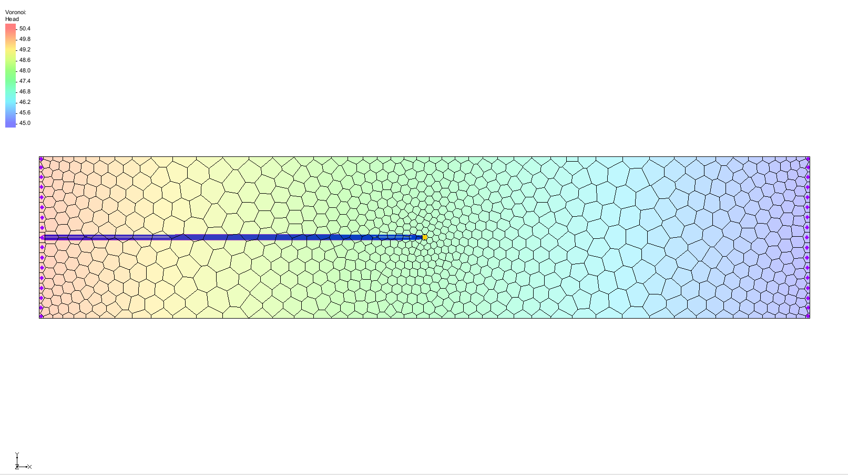

Figure 6 Pathline solution showing pathlines tracking backward from the well

1. If desired, **Zoom** http://www.xmswiki.com/images/thumb/d/df/Zoom_Tool_Icon.svg/56px-Zoom_Tool_Icon.svg.png in and examine the pathlines.
2. Click the **Save** File:Save Macro.svg macro to save the project with the solution.

# Creating a Forward Tracking mod-PATH3DU Model

To create a new mod-PATH3DU model with starting locations along the left edge of the model that track forward:

1. In the Project Explorer, right-click “File:UGrid 3D Locked.svg Voronoi” and select **New mod-PATH3DU…** to create a new “File:UGrid Veronoi Icon.svg Voronoi” mod-PATH3DU model.
2. Right-click “File:UGrid Veronoi Icon.svg Voronoi” and select **Rename**.
3. Enter “forward” and press *Enter* to set the new name.

|  |  |
| --- | --- |
| Desc-i_gray 100px | Multiple mod-PATH3DU simulations can exist in GMS at the same time. |

## Adding Starting Locations

1. **Zoom** File:Zoom Tool Icon.svg in on the left side of the UGrid.
2. Using the **Select Cells** File:Select UGrid Cell Tool.svg tool, hold down the *Shift* key and select the five cells along the left side of the grid, in the area where the existing pathlines are located (Figure 7).

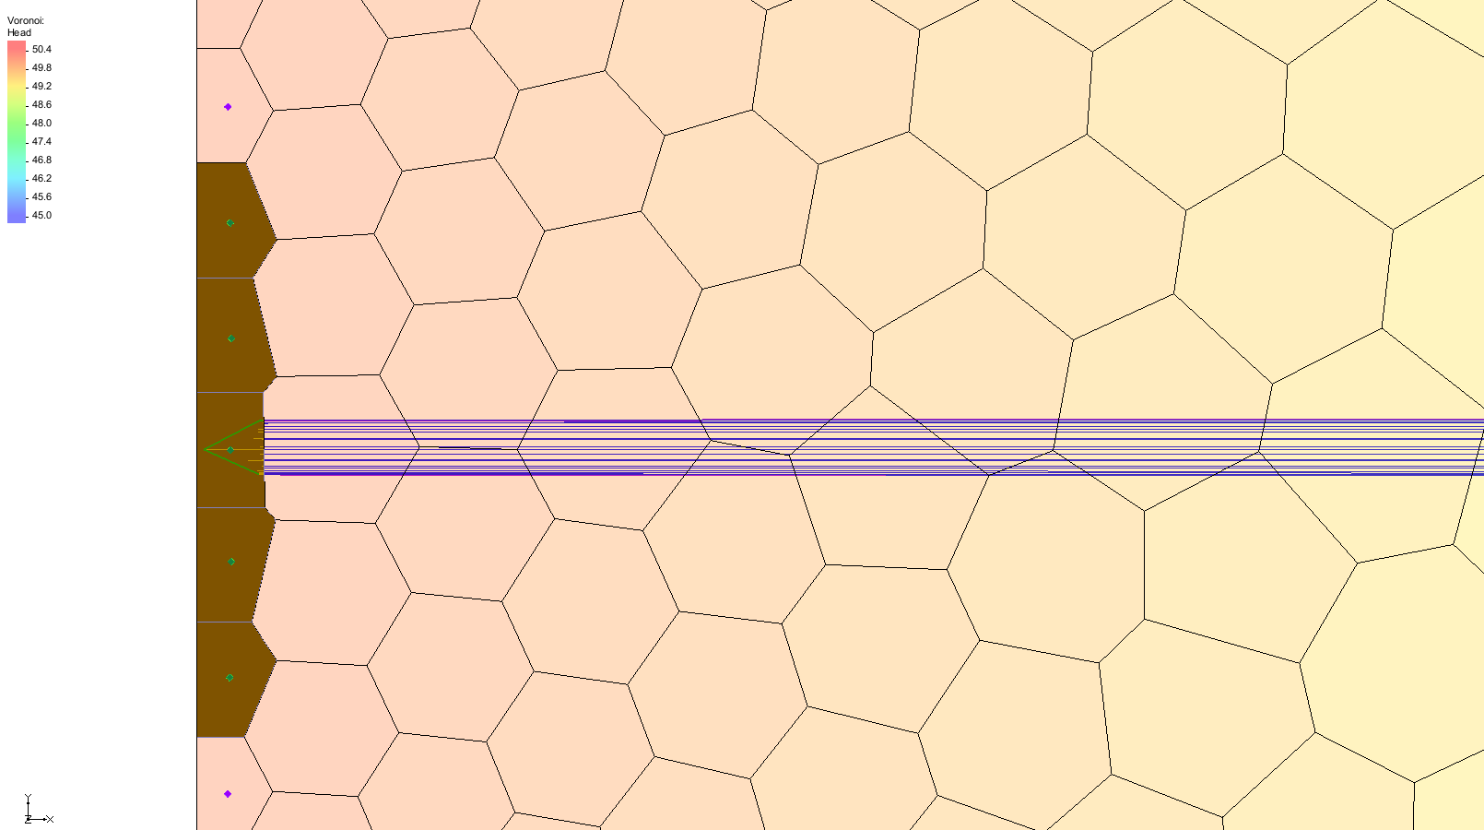

Figure 7 Selected cells on the left side of the UGrid

1. Right-click on any of the selected cells and select **Create mod-PATH3DU Particles…** to bring up the *Generate Particles* dialog.
2. Under *Number of particles*, adjust the slider to “4”.
3. Click **OK** to close the *Generate Particles* dialog.

Each cell now contains up to four starting locations (Figure 8).

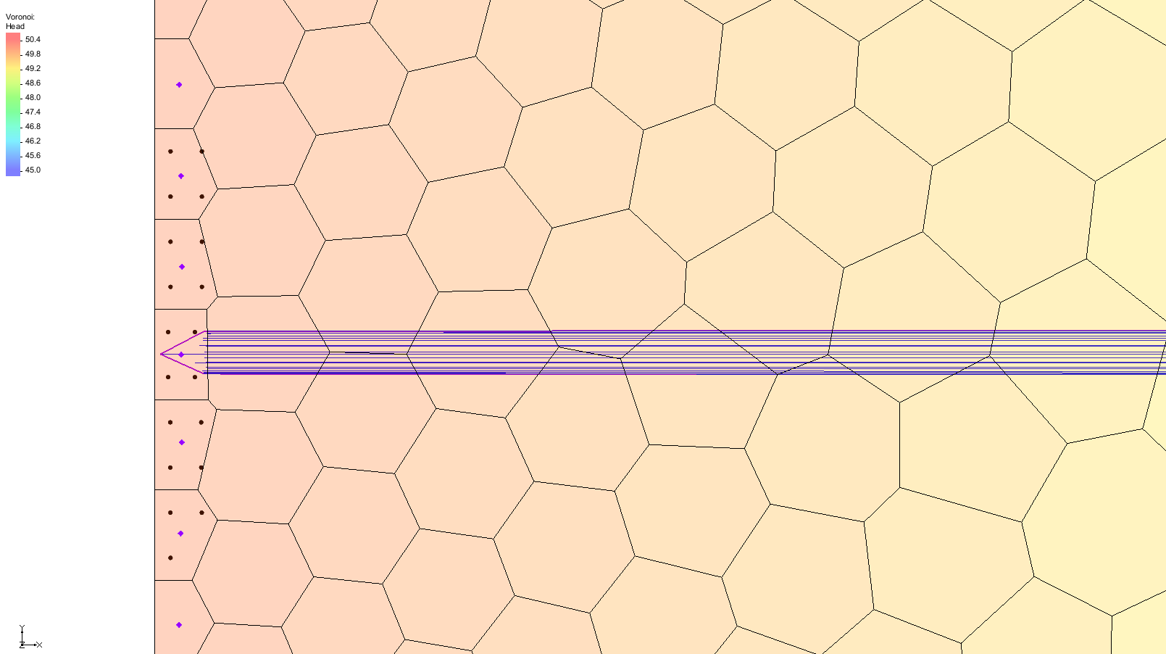

Figure 8 Starting locations in the selected cells

1. If desired, **Zoom** http://www.xmswiki.com/images/thumb/d/df/Zoom_Tool_Icon.svg/56px-Zoom_Tool_Icon.svg.png in and see how GMS arranged the starting locations.

Because Voronoi cells are irregularly shaped, some cells may end up with fewer particles. This occurs because GMS generates particles in a square pattern based on the cell extents as a guide, and then eliminates particles that fall outside the cell borders.

|  |  |
| --- | --- |
| Desc-i_gray 100px | Starting locations can be created inside cells by selecting cells and using the **Create mod-PATH3DU Particles…** command. |

# Saving and Running mod-PATH3DU

Before running mod-PATH3DU again, it is recommended to save the project.

1. **Save** File:Save Macro.svg the project.
2. Right-click “File:UGrid Veronoi Icon.svg forward” and select **Run mod-PATH3DU** to bring up the *MP3DU* model wrapper dialog.
3. When mod-PATH3DU finishes, make sure *Read solution on exit* is turned on and click **Close** to exit the *MP3DU* model wrapper dialog.

GMS then imports the pathline solution file and displays the path lines (Figure 9).

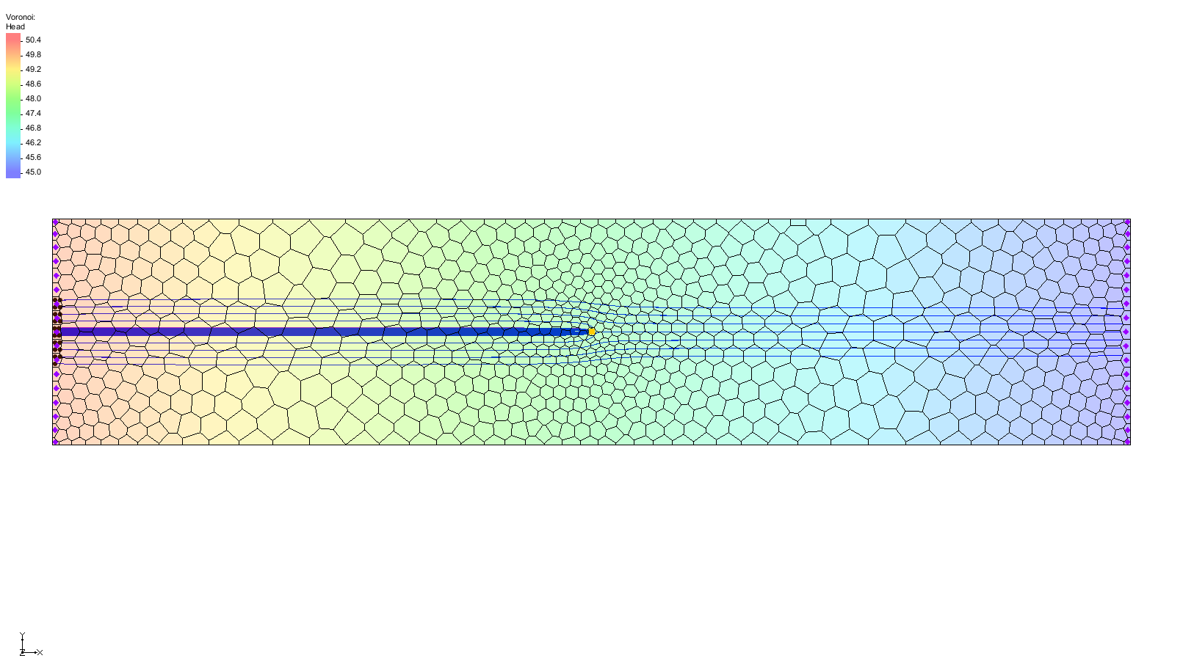

Figure 9 Pathline solution showing pathlines tracking backward from the well

1. If desired, **Zoom** http://www.xmswiki.com/images/thumb/d/df/Zoom_Tool_Icon.svg/56px-Zoom_Tool_Icon.svg.png in and examine the pathlines.
2. **Save** File:Save Macro.svg the project with the solution.

# Examining the Solution

To take a closer look at the pathlines:

1. In the Project Explorer, turn off the “File:UGrid Veronoi Icon.svg backward” simulation.
2. **Zoom** File:Zoom Tool Icon.svg in on the well (Figure 10).

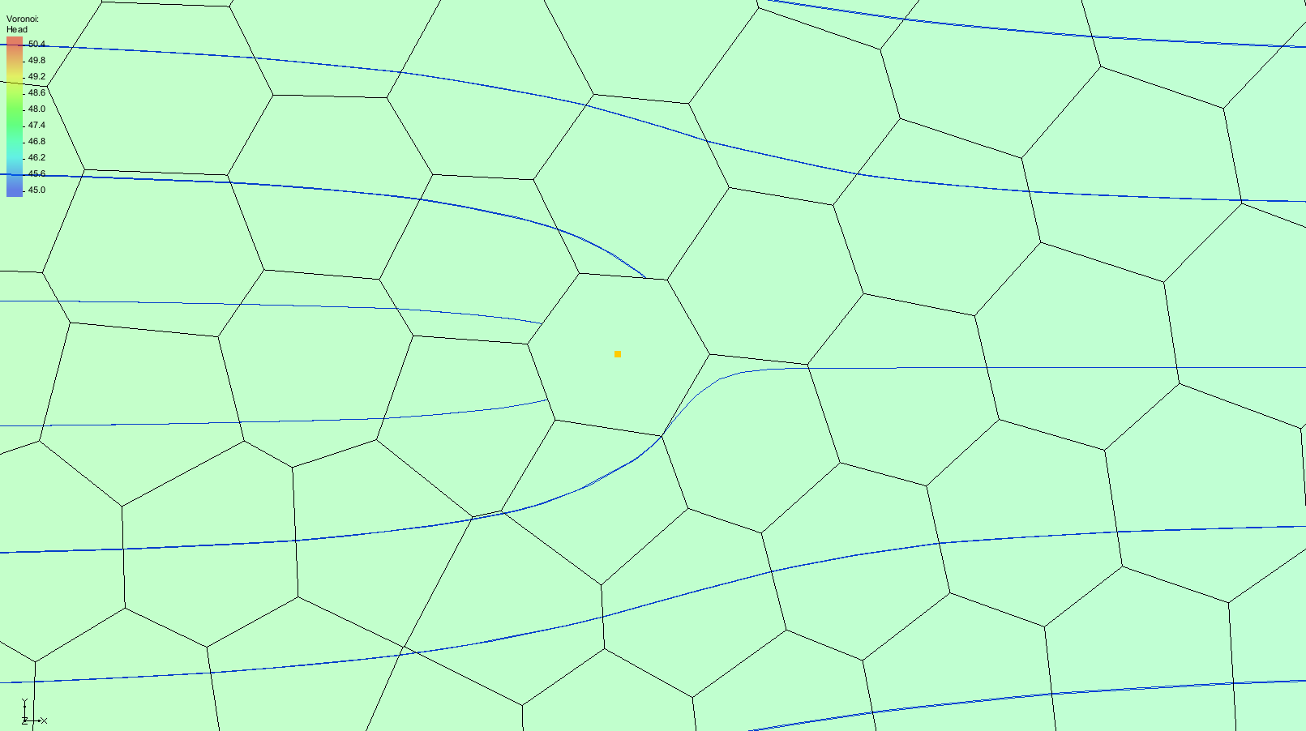

Figure 10 Forward tracking pathlines around the well

1. **Frame** http://www.xmswiki.com/images/thumb/b/bd/Frame_Macro.svg/52px-Frame_Macro.svg.png the project.
2. Click **Display Options** File:Display Options Macro.svg to bring up the *Display Options* dialog.
3. Select “UGrid: Voronoi – [Active]” from the list on the left.
4. Turn on *Define UGrid specific options*.
5. Under the *Particles* tab, turn on *Direction arrows.*

A number of other display options related to starting locations and pathlines are available here.

1. Click **OK** to close the *Display Options* dialog.

Flow direction is now shown (Figure 11).

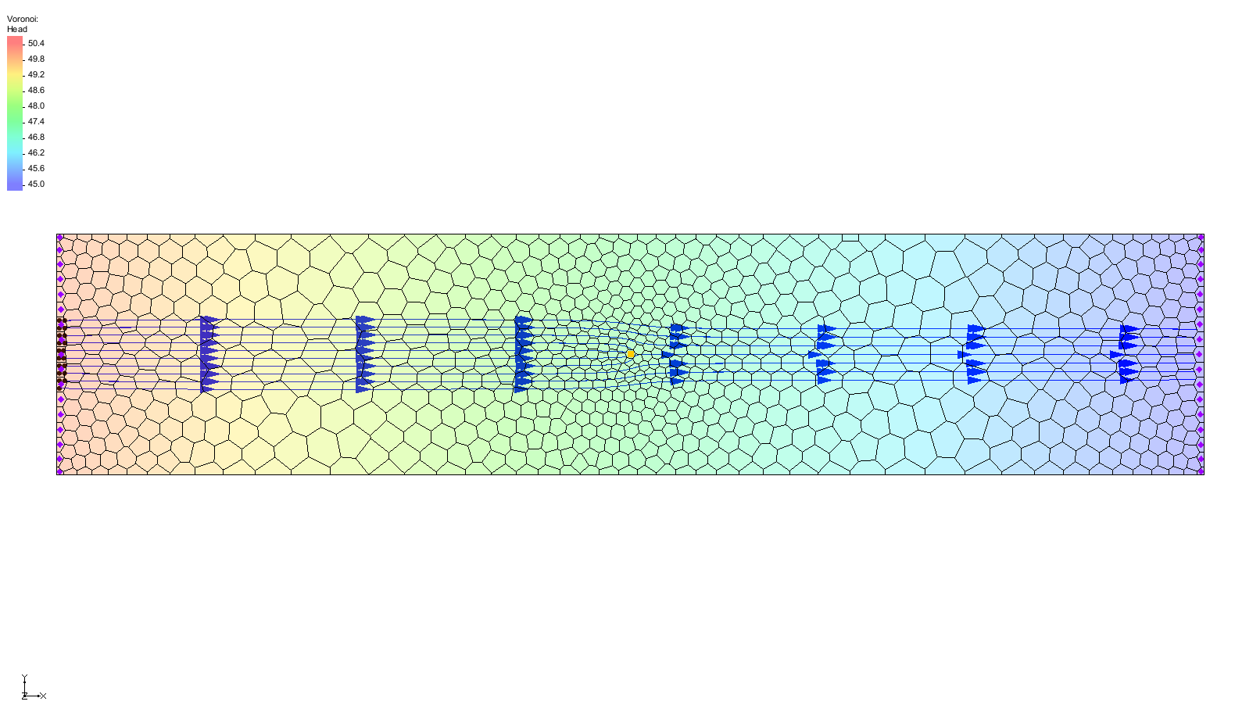

Figure 11 Flow direction arrows are visible

# Conclusion

This concludes the “mod-PATH3DU” tutorial. The following key concepts were discussed and demonstrated:

* GMS includes an interface to mod-PATH3DU
* mod-PATH3DU requires a native text version of the MODFLOW model
* The *MODFLOW | Advanced* | **Run MODFLOW Dialog…** menu command can be used to run MODFLOW with any version of MODFLOW on any specified file
* Starting locations can be generated at wells using the **Create Particles at Wells…** command
* mod-PATH3DU does not run automatically like MODPATH
* Multiple mod-PATH3DU simulations can exist in GMS simultaneously
* Starting locations can be created inside cells by selecting cells and using the **Create mod-PATH3DU Particles…** command