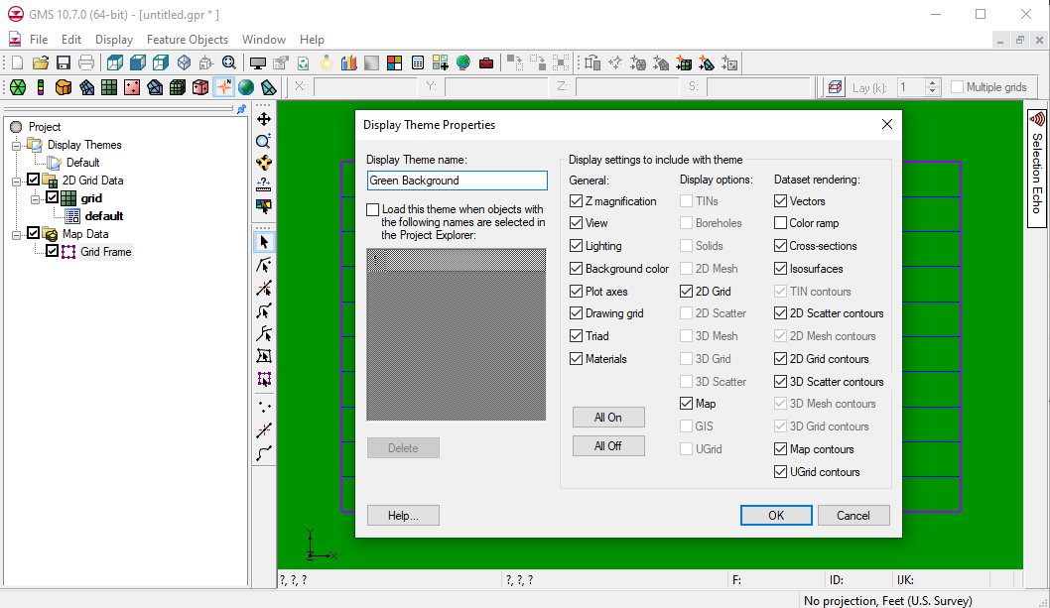

GMS 10.9

GMS 10.9 Tutorial

***Display Themes***

Quickly save and restore display options

Objectives

This tutorial describes display themes. Display themes are a powerful way to create and save display options for later use. Using display themes allows quickly changing the look of the data.

Time

* 5–10 minutes

Required Components

* GMS Basic

Prerequisite Tutorials

* Getting Started

|  |
| --- |
| 1 Introduction 2  2 Getting Started 2  3 Create 2D Grid and Display Themes 2  3.1 Creating a 2D Grid 2  3.2 Creating a Default Display Theme 3  3.3 Graphics Window 3  3.4 Creating the Display Theme 4  4 Change Display Options 4  5 Automatically Loading Display Themes 5  6 Conclusion 5 |

# Introduction

GMS has many display options. Display options are used to change how data appears without actually changing the data. For example, it is possible to change the colors of the feature objects—the points, arcs, and polygons.

Display themes are a way to save the current display options so that the user can quickly return to them again. This tutorial will show how to create a theme and then save it so it can be loaded later.

# Getting Started

To get started, do the following:

1. Launch GMS.
2. If GMS is already running, select *File |* **New** to ensure that the program settings are restored to the default state.

# Create 2D Grid and Display Themes

A 2D grid must first be created in order to see how it is affected by display themes.

## Creating a 2D Grid

To create a 2D grid, do the following:

1. Right-click in the empty space of the Project Explorer and select *New |* **Grid Frame**.

A grid frame will appear in the Graphics Window.

1. Right-click on “File:Grid Frame Icon.svg Grid Frame” in the Project Explorer and select *Map To |* **2D Grid** to bring up the *Create Finite Difference Grid* dialog.
2. Click **OK** to accept the defaults, create the grid, and close the *Create Finite Difference Grid* dialog.

A 2D grid will now be within the boundaries of the grid frame (Figure 1).

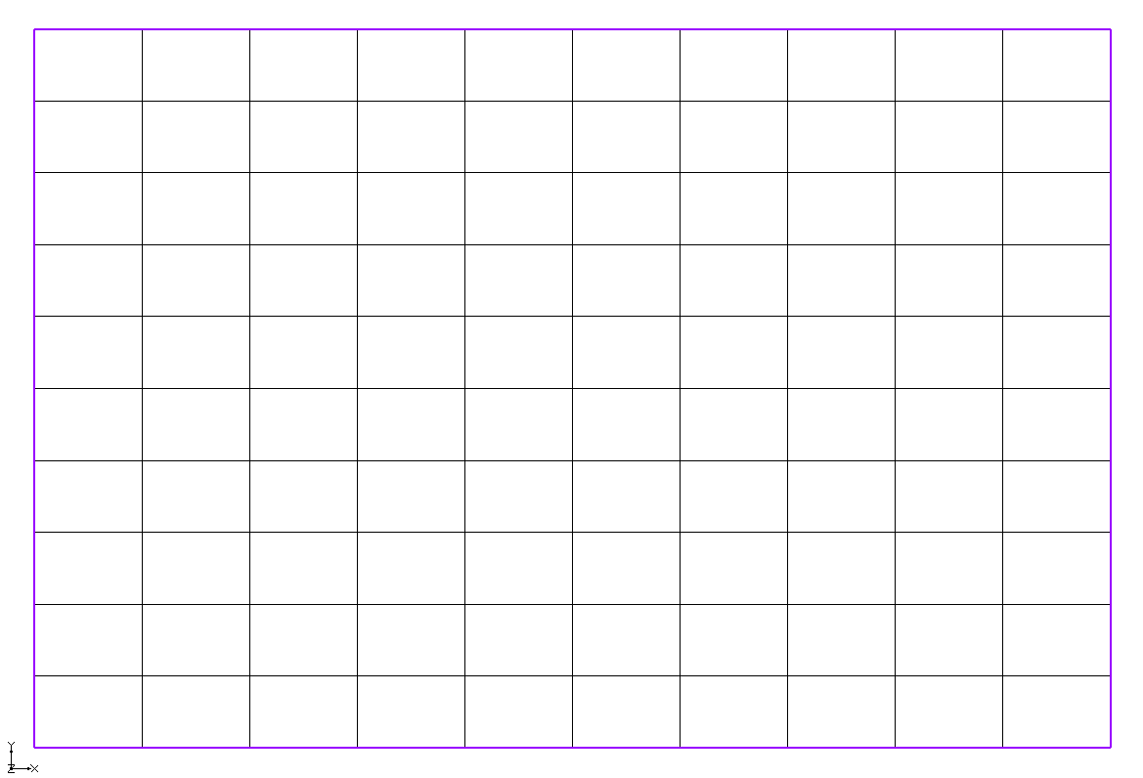

Figure The 2D grid within the grid frame

## Creating a Default Display Theme

To create a new display theme, do the following:

1. Right-click on a blank space in the Project Explorer and select *New |* **Display Theme…** to bring up the *Display Theme Properties* dialog.

This dialog will be covered in more detail below.

1. Turn off the *Auto name* option.
2. In the *Name* field, enter “Default”.
3. Click **OK** to close the *Display Theme Properties* dialog.

A new “https://www.xmswiki.com/images/thumb/c/ca/Display_Theme_Icon.svg/56px-Display_Theme_Icon.svg.png Default” entry will appear under “https://www.xmswiki.com/images/thumb/a/a0/Display_Theme_Folder.svg/60px-Display_Theme_Folder.svg.png Display Themes” in the Project Explorer.

## Graphics Window

Now do the following to change the display options and create another display theme:

1. Click **Display Options** File:Display Options Macro.svg to bring up the *Display Options* dialog.
2. Below the list on the left, select “Green” from the *Background color* drop-down arrow button.
3. Enter “100” in the *Triad size* field.
4. Select “2D Grid Data” from the list on the left.
5. On the *2D Grid* tab, select “Blue” from the *Cell edges* drop-down arrow button.
6. Select “Specified” from the *Color* drop-down below *Cell edges*.
7. Click **OK** to close the *Display Options* dialog.

The background in the Graphics Window will now be green (Figure 2).

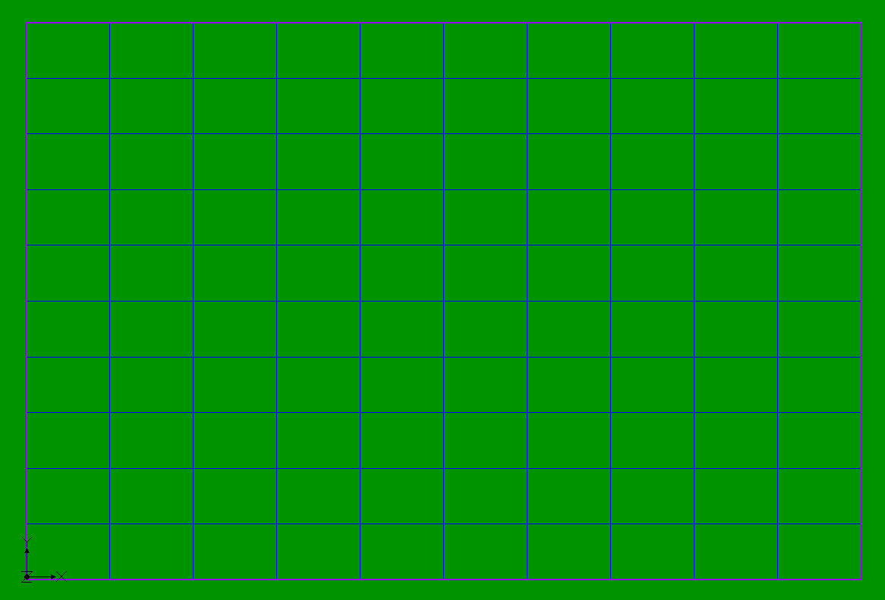

Figure The background is now green and the grid lines are blue

## Creating the Display Theme

1. Right-click on a blank space in the Project Explorer and select *New |* **Display Theme…** to bring up the *Display Theme Properties* dialog.
2. Turn off the *Auto name* option.
3. In the *Name* field, enter “Green background”.
4. Click **OK** to close the *Display Theme Properties* dialog.

A new “https://www.xmswiki.com/images/thumb/c/ca/Display_Theme_Icon.svg/56px-Display_Theme_Icon.svg.png Green background” entry will appear under “https://www.xmswiki.com/images/thumb/a/a0/Display_Theme_Folder.svg/60px-Display_Theme_Folder.svg.png Display Themes” in the Project Explorer.

1. Select the “https://www.xmswiki.com/images/thumb/c/ca/Display_Theme_Icon.svg/56px-Display_Theme_Icon.svg.png Default” theme in the Project Explorer.
2. Select the “https://www.xmswiki.com/images/thumb/c/ca/Display_Theme_Icon.svg/56px-Display_Theme_Icon.svg.png Green background” theme in the Project Explorer.

Selecting on a display theme changes the display options to whatever they were when that theme was created.

# Change Display Options

To change the display options saved with a display theme, do the following:

1. Click on **Display Options** File:Display Options Macro.svg to bring up the *Display Options* dialog.
2. Below the list on the left, select “Red” from the *Background color* drop-down arrow button.
3. Click **OK** to exit the *Display Options* dialog. The background will now be red.
4. Right-click on “https://www.xmswiki.com/images/thumb/c/ca/Display_Theme_Icon.svg/56px-Display_Theme_Icon.svg.png Green background” and select **Update With Current Display**.
5. Switch between “https://www.xmswiki.com/images/thumb/c/ca/Display_Theme_Icon.svg/56px-Display_Theme_Icon.svg.png Default” and “https://www.xmswiki.com/images/thumb/c/ca/Display_Theme_Icon.svg/56px-Display_Theme_Icon.svg.png Green background” to see that the red background color is now associated with “https://www.xmswiki.com/images/thumb/c/ca/Display_Theme_Icon.svg/56px-Display_Theme_Icon.svg.pngGreen background”.

# Automatically Loading Display Themes

Display themes can be loaded automatically when the user selects other objects (objects other than display themes) in the Project Explorer.

1. Select “https://www.xmswiki.com/images/thumb/c/ca/Display_Theme_Icon.svg/56px-Display_Theme_Icon.svg.png Default” to restore the display options to the default values.
2. Right-click on “https://www.xmswiki.com/images/thumb/c/ca/Display_Theme_Icon.svg/56px-Display_Theme_Icon.svg.png Green background”and select **Properties…** to bring up the *Display Theme Properties* dialog.
3. On the left side, turn on *Load this theme when objects with the following names are selected in the Project Explorer*.
4. Enter “2D Grid Data” on line *1* of the list below that.
5. Click **OK** to close the *Display Theme Properties* dialog.
6. Select “File:2D Grid Folder.svg 2D Grid Data” in the Project Explorer.

Notice that the “https://www.xmswiki.com/images/thumb/c/ca/Display_Theme_Icon.svg/56px-Display_Theme_Icon.svg.png Green Background” theme (which is now red) was loaded.

1. Select “https://www.xmswiki.com/images/thumb/c/ca/Display_Theme_Icon.svg/56px-Display_Theme_Icon.svg.png Default” to restore the display options to the default values.
2. Click on any other entry in the Project Explorer (including the “File:2D Grid Icon.svg grid” below “File:2D Grid Folder.svg 2D Grid Data”).

Notice that the “https://www.xmswiki.com/images/thumb/c/ca/Display_Theme_Icon.svg/56px-Display_Theme_Icon.svg.png Green background” theme is only loaded when the user clicks on the “https://www.xmswiki.com/images/thumb/c/ca/Display_Theme_Icon.svg/56px-Display_Theme_Icon.svg.png Green background” theme or on the “File:2D Grid Folder.svg 2D Grid Data” folder. The theme looks for the name of the item, not the type. For example, if a TIN was named “File:TIN Module Icon.svg 2D Grid Data,” it would also trigger the “https://www.xmswiki.com/images/thumb/c/ca/Display_Theme_Icon.svg/56px-Display_Theme_Icon.svg.png Green background” theme.

# Conclusion

This concludes the “Display Themes” tutorial. Topics covered include using display themes to quickly save and restore display options, including just a subset of display options in a theme, and setting a theme to automatically load based on the name of an item in the Project Explorer.