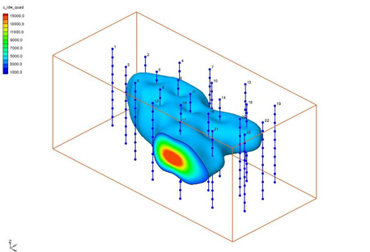

GMS 10.9

GMS 10.9 Tutorial

Geostatistics – 3D

Learning the various 3D interpolation methods available in GMS

Objectives

Explore the various 3D interpolation algorithms available in GMS, including IDW and kriging. Visualize the results of interpolation though cross sections and isosurfaces.

Time

* 30–45 minutes

Required Components

* Geostatistics
* GMS Basic

Prerequisite Tutorials

* Geostatistics – 2D

|  |
| --- |
| 1 Introduction 2  1.1 Getting Started 2  2 Importing a Scatter Point Set 2  3 Display Data Colors 3  4 Z Magnification 4  5 Creating a Bounding Grid 4  6 Simple IDW Interpolation 5  7 Displaying Isosurfaces 6  7.1 Interior Edge Removal 7  7.2 Specified Range 7  7.3 Using the Vertical Anisotropy Option 8  8 Interpolation 9  8.1 IDW Interpolation with Gradient Planes 9  8.2 IDW Interpolation with Quadratic Functions 9  8.3 Other Interpolation Schemes 10  9 Viewing the Plume with a Cross Section 10  9.1 Using the Truncation Option 11  10 Setting up a moving Cross Section Animation 12  10.1 Display Options 12  10.2 Setting Up and Playing the Animation 13  11 Setting up a Moving Isosurface Animation 13  12 Conclusion 14 |

# Introduction

Three-dimensional geostatistics (interpolation) can be performed in GMS using the 3D Scatter Point module. The module is used to interpolate from sets of 3D scatter points to 3D meshes and 3D grids. Several interpolation schemes are supported, including kriging. Interpolation is useful for defining initial conditions for 3D ground water models or for 3D site characterization.

This tutorial describes and demonstrates the tools for manipulating 3D scatter point sets and the interpolation schemes supported in GMS. This includes importing a scatter point set, creating a bounding grid, creating isosurfaces by interpolating scatter points to a 3D grid using different interpolation methods, creating cross sections, making a moving cross section animation, and making a moving isosurface animation.

## Getting Started

Do the following to get started:

1. If necessary, launch GMS.
2. If GMS is already running, select *File |* **New** to ensure that the program settings are restored to their default state.

# Importing a Scatter Point Set

It is first necessary to import a 3D scatter point set. These are similar to 2D scatter point sets except that each point has a *z* coordinate (elevation) in addition to *xy* coordinates. As with the 2D scatter point set, one or more scalar datasets can be associated with each scatter point set. These can represent values such as contaminant concentration, porosity, hydraulic conductivity, and so on.

The 3D scatter point set that will be imported and used with this tutorial has previously been exported to a text file using a spreadsheet application. The file was imported into GMS using the *Import Wizard*, and then saved as a GMS project file. Refer to the “Geostatistics – 2D” tutorial for details on using the *Import Wizard.*

To import the project, do as follows:

1. Click **Open** File:Open Macro.svg to bring up the *Open* dialog.
2. Select “All Files (*.*)” from the *Files of type* drop-down.
3. Browse to the *geos3d* directory and select “tank.gpr”.
4. Click **Open** to import the project and close the *Open* dialog.
5. Switch to **Oblique View** File:Oblique View Macro.svg.

A set of points should appear on the screen (Figure 1).

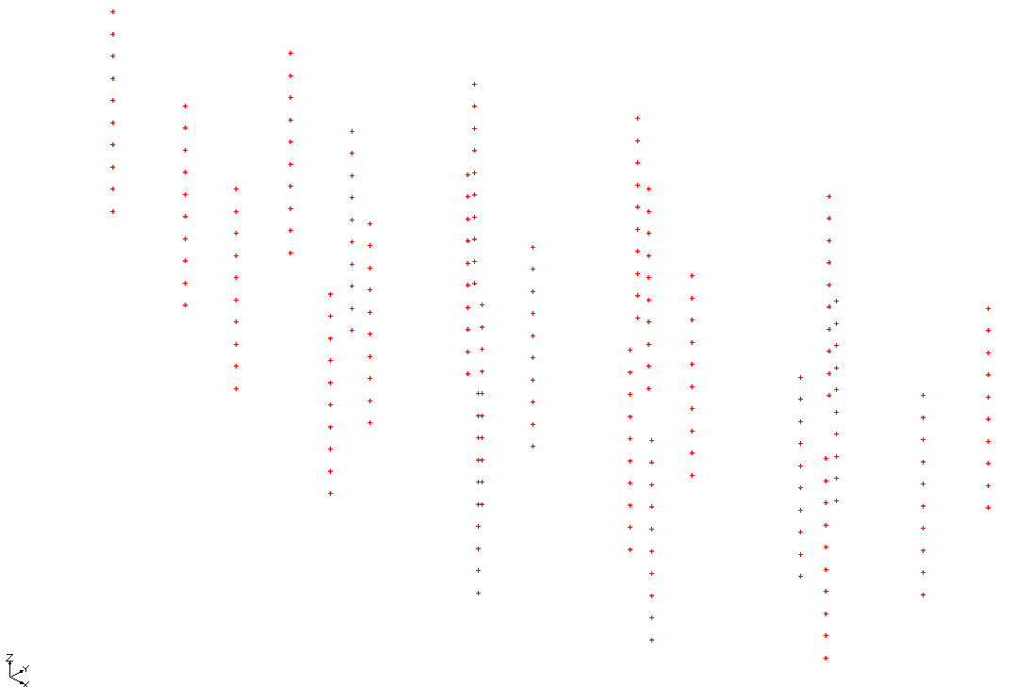

Figure 1 Oblique view of set of contaminant concentration points

Notice that the points are arranged in vertical columns (Figure 1). This hypothetical set of points represents a set of measurements of contaminant concentration in the vicinity of a leaky underground storage tank. Each column of points corresponds to a borehole or the path of a penetrometer along which concentrations were measured at uniform intervals. The goal of the tutorial is to use the tools for 3D geostatistics in GMS to interpolate from the scatter points to a grid and generate a graphical representation of the plume.

# Display Data Colors

Next, it is necessary to change the display options so that the color of each point is representative of the concentration at that point.

1. Click **Display Options** File:Display Options Macro.svg to bring up the *Display Options* dialog.
2. From the list on the left select “3D Scatter Data”.
3. On the *3D Scatter Point Set* tab, turn on *Contours*.
4. To the right of *Contours,* click the **Options…** button to bring up the *Dataset Contour Options – 3D Scatter Points – c* dialog.
5. At the bottom left of the dialog, turn on *Legend*.
6. Click **OK** to exit the *Dataset Contour Options – 3D Scatter Points – c* dialog.
7. Click **OK** to exit the *Display Options* dialog.

Notice that most of the values are zero (Figure 2). The nonzero values are all at about the same depth in the holes. This pattern is fairly common when dealing with light non-aqueous phase liquids (LNAPLs) that form a pancake-shaped plume and float on the water table.

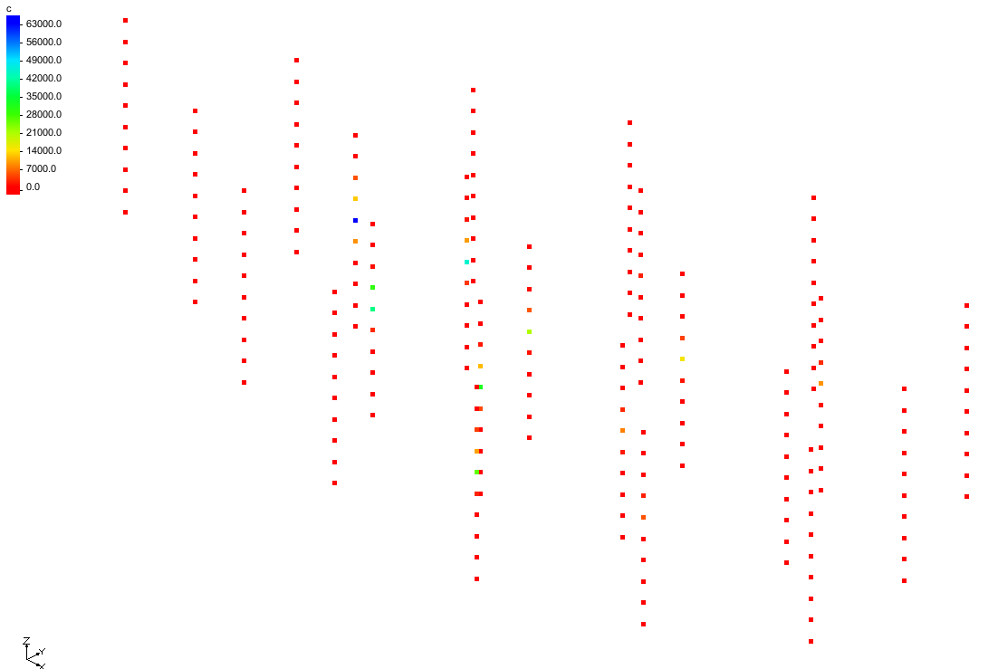

Figure Contaminant concentrations shown with contour coloring

# Z Magnification

It is necessary to magnify the *z* coordinate so that the vertical variation in the data is more apparent.

1. Click **Display Options** File:Display Options Macro.svg to bring up the *Display Options* dialog.
2. Below the list on the left, for *Z magnification* enter “2.0”.
3. Click **OK** to close the *Display Options* dialog.
4. **Frame** File:Frame Macro.svg the project.

# Creating a Bounding Grid

To generate a graphical representation of the contaminant plume, first create a grid that bounds the scatter point set. It will then be possible to interpolate the data from the scatter points to the grid nodes. The grid will be used to generate isosurfaces.

Do the following to create the grid:

1. In the Project Explorer, expand all of the entries.
2. Right-click on “File:3D Scatter Icon.svg tank.sp3” and select **Bounding 3D Grid…** to bring up the *Create Finite Difference Grid* dialog.

Notice that the *x*, *y*, and *z* dimensions of the grid are already defined. The default values shown in the dialog cause the grid to extend beyond the scatter points by 10% on each side. Default values have also been entered for the number of cells in each direction.

1. In the *Orientation / type* section, from the Type drop-down, select “Mesh Centered”.

Two types of grids are supported in GMS: cell-centered and mesh-centered. While cell-centered is appropriate for groundwater models (MODFLOW), the mesh-centered approach is more appropriate when the grid will be used solely for interpolation.

1. Click **OK** to close the *Create Finite Difference Grid* dialog.
2. **Frame** File:Frame Macro.svg the project.

A 3D bounding grid encompassing the scatter point set should appear (Figure 3).

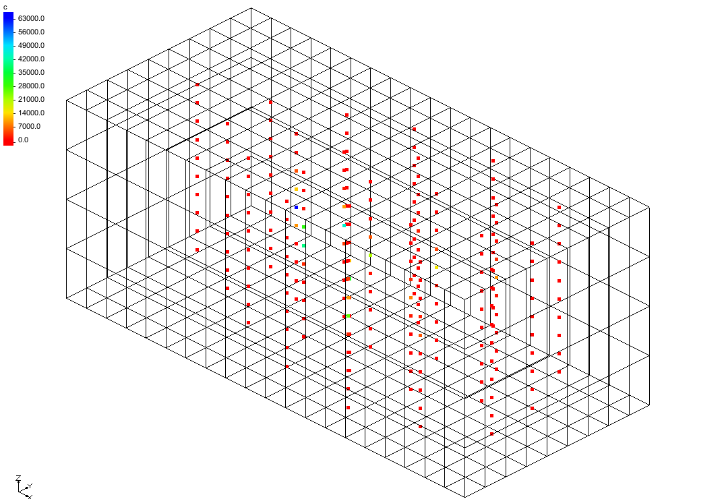

Figure The 3D bounding grid

# Simple IDW Interpolation

An interpolation scheme needs to be selected next. First use the inverse distance weighted interpolation scheme (IDW).

1. In the Project Explorer, select “File:3D Scatter Icon.svg tank.sp3” to make it active.
2. Select Interpolation | **Interpolation Options…** to bring up the *3D Interpolation Options* dialog.
3. In the *Interpolation method* section, select Inverse distance weighted.
4. Click **Options…** to bring up the *3D* IDW Interpolation Options dialog.
5. In the Nodal function section, select Constant *(Shepard’s method)*.
6. In the Computation of interpolation weights section, select Use subset of points.
7. Click the **Subset…** button to bring up the Subset Definition dialog.
8. Select Use nearest ___ pts, and for the number of points enter “64”.
9. Click **OK** to exit the Subset Definition dialog.
10. Click **OK** to exit the *3D* IDW Interpolation Options dialog.
11. Click **OK** to exit the *3D Interpolation Options* dialog.
12. Select *Interpolation* | **Interpolate → 3D Grid** to bring up the *Interpolate → Object* dialog.
13. Click **OK** to accept the defaults and close the *Interpolate → Object* dialog.

# Displaying Isosurfaces

Now that interpolation has been completed on the nodes of the 3D grid, there are several ways to visualize the contaminant plume. One of the most effective ways is to use isosurfaces. Isosurfaces are the three-dimensional equivalent of contour lines representing a surface of a constant value (contaminant concentration, in this case).

To define and display isosurfaces, do the following:

1. Click **Display Options** File:Display Options Macro.svg to bring up the *Display Options* dialog.
2. From the list on the left select “File:3D Grid Icon.svg 3D Grid Data”.
3. On the *3D Grid* tab in the top section, turn off Cell edges and turn on Grid shell.
4. In the *Active dataset* section, turn on Isosurfaces.
5. To the right of Isosurfaces, click the **Options…** button to bring up the *Isosurface Options* dialog.
6. On the first row of the table, in the *Upper Value* column enter “3000.0”.
7. On the second row, in the *Fill Between* column check the box.
8. In the section on the right, turn on *Isosurface faces*.
9. Click **OK** to exit the Isosurface Options dialog.
10. Click **OK** to exit the Display Options dialog.
11. **Frame** File:Frame Macro.svg the project.

The isosurface should now be visible (Figure 4).

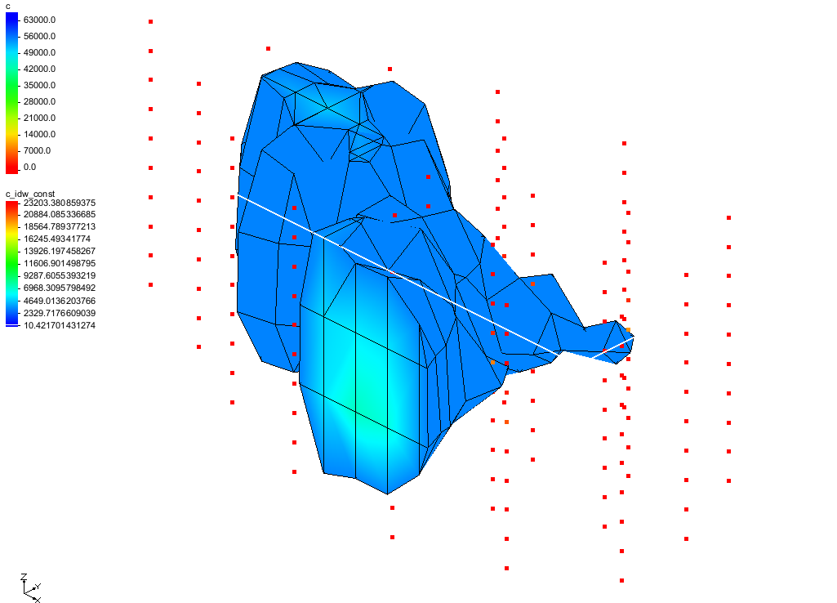

Figure Visible isosurface

## Interior Edge Removal

A series of edges are draped over the isosurface plot. These edges represent the intersection of the isosurface with the grid cells. The edges are displayed to help visualize the spatial variation or relief in the isosurface. However, it is sometimes useful to inhibit the display of the edges in some areas. For example, in the regions where the plume intersects the grid, the isosurface is flat. It is advisable to turn off the display of the edges in this area since they provide little benefit.

1. In the Project Explorer select the “File:3D Grid Folder.svg 3D Grid Data” folder to make it active.
2. Select Grid | **Isosurface Options…** to bring up the *Isosurface Options* dialog.
3. In the section on the right, turn on the Interior edge removal option.

This removes the edges between adjacent planar facets that are coplanar.

1. Click **OK** to close the *Isosurface Options* dialog.

## Specified Range

Notice that the shell of the isosurface is all one color, but the interior of the isosurface (where the isosurface intersects the grid boundary) varies in color according to the contaminant concentration. To show more distinct color variation, do the following:

1. Select Grid | **Isosurface Options…** to bring up the *Isosurface Options* dialog.
2. In the section on the right, turn on Contour specified range.
3. For Minimum value enter “3000”, and for Maximum value enter“9000”.
4. Click **OK** to close the *Isosurface Options* dialog.

The isosurface should appear similar to Figure 5.

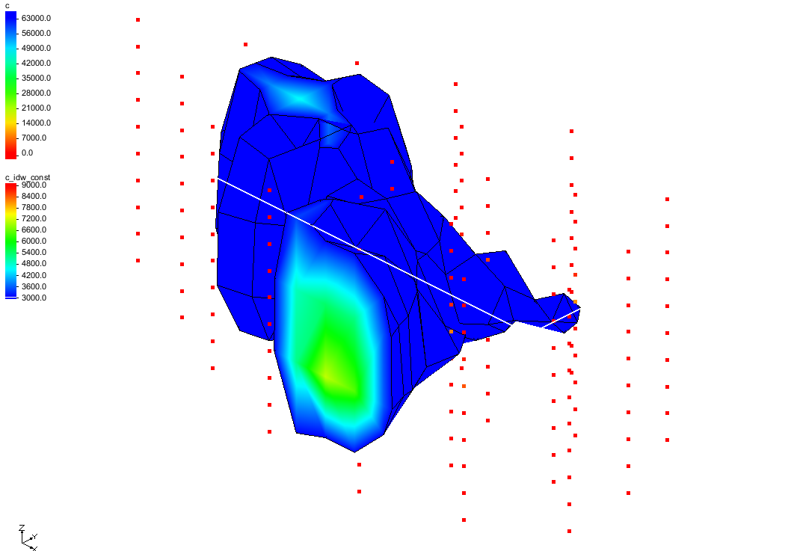

Figure Isosurface with contouring

## Using the Vertical Anisotropy Option

The scatter points being used were obtained along vertical traces. This means the distances between scatter points along the vertical traces are significantly smaller than the distances between scatter points along the horizontal plane. This disparity in scaling causes clustering and can be a source of poor results in some interpolation methods.

The effects of clustering along vertical traces can be minimized using vertical anisotropy. The *z* coordinate of each of the scatter points is multiplied by one over the vertical anisotropy parameter prior to interpolation. Thus, if the vertical anisotropy parameter is less than 1.0, scatter points along the same vertical axis appear farther apart, and scatter points in the same horizontal plane appear closer together.

As a result, points in the same horizontal plane are given a higher relative weight than points along the *z* axis. This can result in improved accuracy, especially in cases where the horizontal correlation between scatter points is expected to be greater than the vertical correlation (e.g., horizontal layering of soils, spreading of the plume on the top of the water table).

To change the vertical anisotropy, do the following:

1. In the Project Explorer select the “File:3D Scatter Folder.svg 3D Scatter Data” folder to make it active.
2. Select Interpolation | **Interpolation Options…** to bring up the *3D Interpolation Options* dialog.
3. In the *Anisotropy* section, for the Vertical Anisotropy enter “0.4”.
4. Click **OK** to close the *3D Interpolation Options* dialog.
5. Select *Interpolation |* **Interpolate → 3D Grid** to bring up the *Interpolate → Object* dialog.
6. For the *Interpolated dataset name,* enter “c_idw_const2”.
7. Click **OK** to close the *Interpolate → Object* dialog.

More correlation now exists in the horizontal direction (Figure 6).

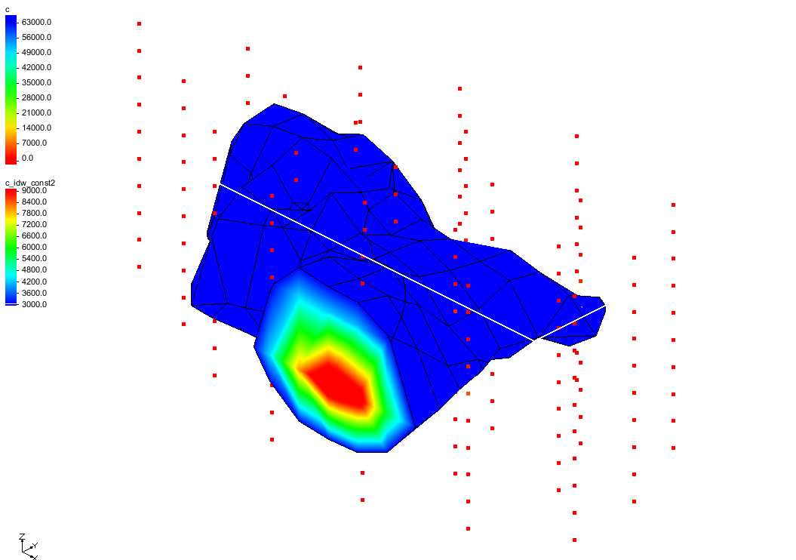

Figure Isosurface contours using vertical anisotropy

# Interpolation

## IDW Interpolation with Gradient Planes

As discussed in the “Geostatistics—2D” tutorial, IDW interpolation can often be improved by defining higher order nodal functions at the scatter points. The same is true in three dimensions. The next step will be to use IDW interpolation with gradient plane nodal functions.

1. Select Interpolation | **Interpolation Options…** to bring up the *3D Interpolation Options* dialog.
2. In the *Interpolation method* section, to the right of the Inverse distance weighted option, click the **Options…** button to bring up the *3D IDW Interpolation Options* dialog.
3. In the Nodal function section, select the Gradient plane option.
4. Click **OK** to exit the *3D IDW Interpolation Options* dialog.
5. Click **OK** to exit the *3D Interpolation Options* dialog.
6. Select *Interpolation |* **Interpolate → 3D Grid** to bring up the *Interpolate → Object* dialog.
7. Click **OK** to accept the defaults and close the *Interpolate → Object* dialog.

The Graphics Window will appear similar to Figure 7.

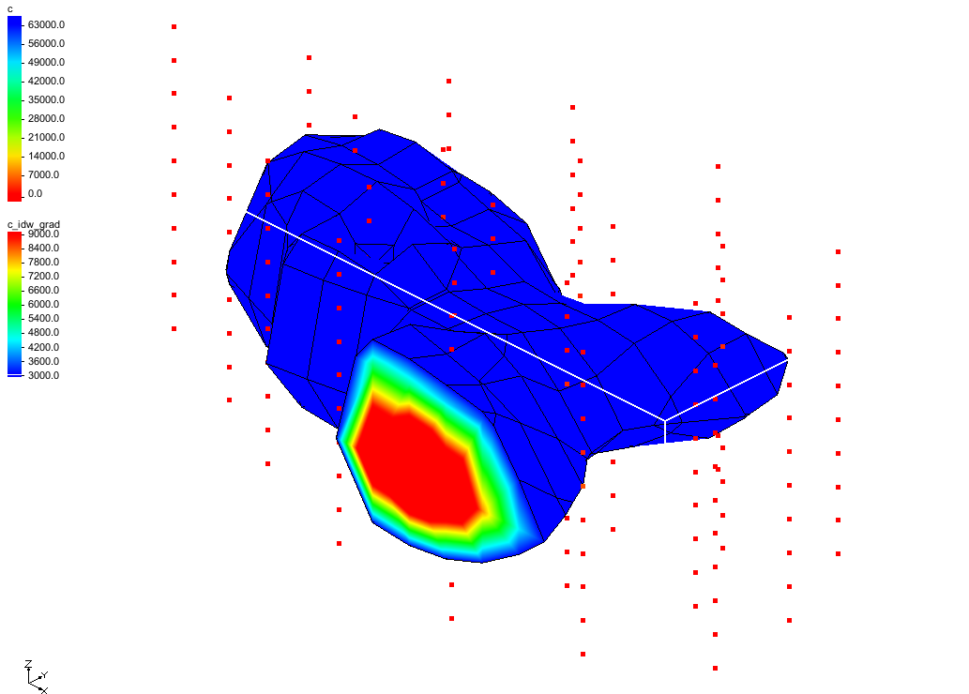

Figure IDW with gradient planes

## IDW Interpolation with Quadratic Functions

Next, try IDW interpolation with quadratic nodal functions.

1. Select Interpolation | **Interpolation Options…** to bring up the *3D Interpolation Options* dialog.
2. In the *Interpolation method* section, to the right of Inverse distance weighted, click the **Options…** button to bring up the *3D IDW Interpolation Options* dialog.
3. In the Nodal function section, select Quadratic.
4. In the *Computation of nodal function coefficients* section, select *Use all points*.
5. Click **OK** to exit the *3D IDW Interpolation Options* dialog.
6. Click **OK** to exit the *3D Interpolation Options* dialog.
7. Select *Interpolation |* **Interpolate → 3D Grid** to bring up the *Interpolate → Object* dialog.
8. Click **OK** to accept the defaults and close the *Interpolate → Object* dialog.

The Graphics Window will appear similar to Figure 8. Notice how the contour of the isosurface layers has changed slightly from that in the previous section.

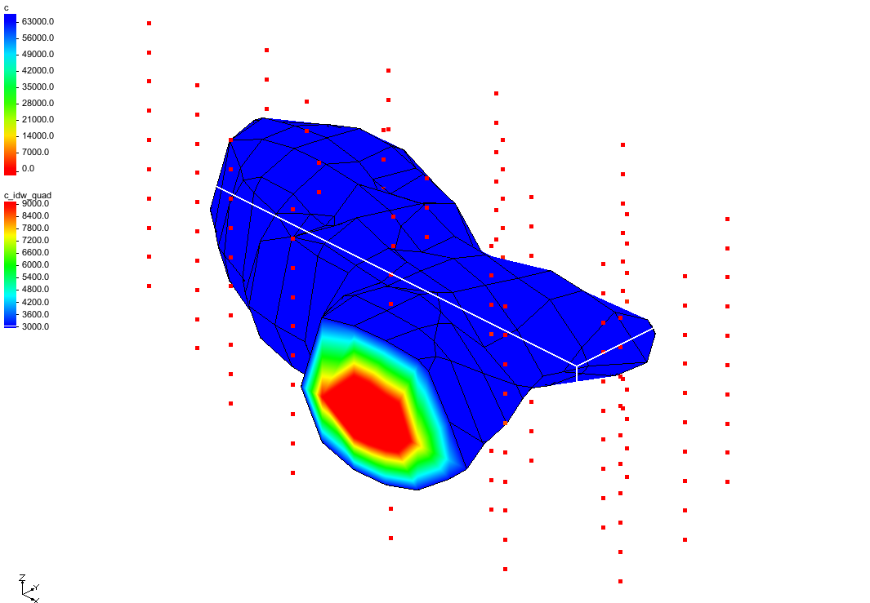

Figure IDW using quadratic functions

## Other Interpolation Schemes

Two other 3D interpolation schemes (natural neighbor interpolation and kriging) are supported in GMS. However, these schemes will not be reviewed in this tutorial. Feel free to experiment with these techniques at a later time.

# Viewing the Plume with a Cross Section

While isosurfaces are effective for displaying contaminant plumes, it is often useful to use color-shaded cross sections to illustrate the variation in the contaminant concentration.

To do this, first cut a horizontal cross section through the center of the plume:

1. In the Project Explorer, select the “File:3D Grid Folder.svg 3D Grid Data” folder.
2. Switch to **Side View** File:Side View Macro.svg.
3. Using the **Create Cross Section** File:Create Cross Section Tool.svg tool, click to the left of the grid, moving the cursor to the right of the grid, and double-clicking at the end to cut a horizontal cross section through the grid and the middle of the isosurface.
4. Switch to **Oblique View** File:Oblique View Macro.svg.

To turn off the display of the isosurfaces and make the contours visible on the cross section, do the following:

1. Click **Display Options** File:Display Options Macro.svg to bring up the *Display Options* dialog.
2. From the list on the left, select “3D Grid Data”.
3. On the *3D Grid* tab in the *Active dataset* section, turn off Isosurfaces.
4. From the list on the left, Select “Cross Sections”.
5. In the first section on the *Cross Sections* tab, turn on Interior edge removal.
6. In the *3D Grid* section, turn on Contours.
7. To the right of *Contours,* click the **Options…** button to bring up the *Dataset* *Contour Options – 3D Grid – c_idw_quad* dialog.
8. In the *Contour method* section, from the drop-down select “Color fill”.
9. Click **OK** to close the *Dataset Contour Options* dialog.
10. Click **OK** to close the *Display Options* dialog.

The isosurface will disappear, and the contours will be visible on the cross section. (Figure 9)

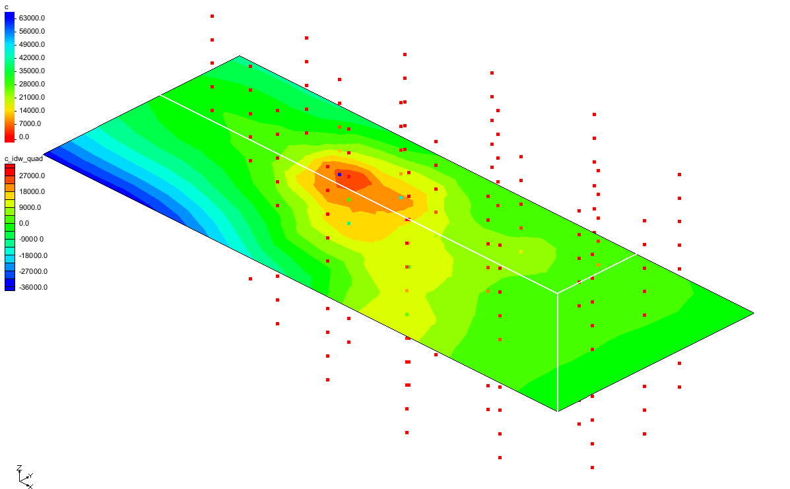

Figure Cross section with contours

## Using the Truncation Option

Notice the range of contaminant concentration values shown in the color legend at the upper left corner of the Graphics Window (Figure 9). A large percentage of the values are negative. This occurs due to the fact that a higher order nodal function was used. Both the quadratic and the gradient plane nodal functions infer trends in the data and try to preserve those trends.

In some regions of the grid, the values at the scatter points are decreasing when moving away from the center of the plume. This decreasing trend is preserved by the interpolation scheme; moreover, the interpolated values approach zero and eventually become negative in some areas.

However, a negative concentration does not make sense. This problem can be avoided by truncating the values in order to force all negative values to have a value of zero.

1. In the Project Explorer, select the “File:3D Scatter Folder.svg 3D Scatter Data” folder.
2. Select Interpolation | **Interpolation Options…** to bring up the *3D Interpolation Options* dialog.
3. In the section on the lower right, turn on Truncate values.
4. Select *Truncate to min/max of dataset*.
5. Click **OK** to close the *3D Interpolation Options* dialog.

Because the interpolation options were changed, the data needs to be reinterpolated:

1. Select *Interpolation* | **Interpolation → 3D Grid** to bring up the *Interpolate → Object* dialog.
2. For the *Interpolated dataset name,* enter “c_idw_quad_trunc”.
3. Click **OK** to close the *Interpolate → Object* dialog.

Notice that the minimum value listed in the color legend is zero (Figure 10).

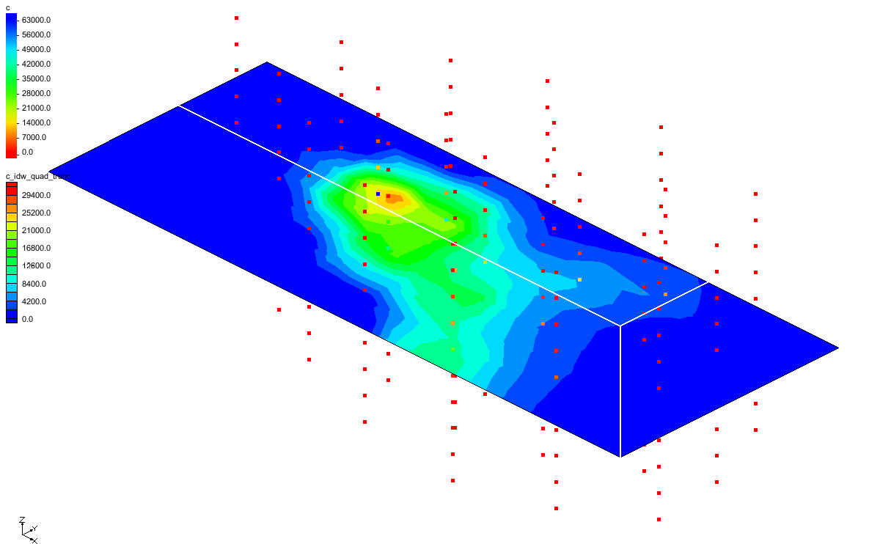

Figure Truncated values

# Setting up a moving Cross Section Animation

It is possible to create several cross sections at different locations in the grid to illustrate the spatial variation of the plume. This process can be automated using the animation utility in GMS. An animation can be generated showing a color-shaded cross section moving through the grid.

## Display Options

Before setting up the animation, delete the existing cross section, turn off the color legend, and reset the contour range.

1. In the Project Explorer, select the “File:3D Grid Folder.svg 3D Grid Data” folder.
2. Using the **Select Cross Sections** File:Select Cross Section Tool.svg tool, select the cross section by clicking on it, then press the *Delete* key.
3. Select Grid | **Isosurface Options…** to bring up the *Isosurface Options* dialog.
4. Turn on *Contour* specified range.
5. For Minimum value enter “1000.0”, and for Maximum value enter “15000.0”.
6. Click **OK** to close the *Isosurface Options* dialog.

## Setting Up and Playing the Animation

To set up the animation:

1. Select Display | **Animate…** to bring up the *Animation Wizard – Options* dialog.
2. In the *Options* section, turn on *Cross sections / Isosurfaces* and click **Next** to go to the *Animation Wizard – Cross Sections / Isosurfaces* dialog.
3. Turn on the Animate cutting plane over specified XYZ range section.
4. Turn on Z.
5. Click **Finish** to close the *Animation Wizard* dialog.

Open a media player application outside of GMS and open the mp4 file. Feel free to adjust the speed of the animation to allow more time to examine each cross section. When finished, close the application and return to GMS.

# Setting up a Moving Isosurface Animation

Another effective way to visualize the plume model is to generate an animation showing a series of isosurfaces corresponding to different isovalues.

To set up the animation, do as follows:

1. Select Display | **Animate…** to bring up the *Animation Wizard – Options* dialog.
2. In the *Options* section, turn on *Cross sections / Isosurfaces* and click **Next** to go to the *Animation Wizard – Cross Sections / Isosurfaces* dialog.
3. Turn off the Animate cutting plane over XYZ range section.
4. Turn on the Animate isosurface over specified data range section.
5. For the Begin value, enter “1000.0”.
6. For the End value, enter “15000.0”.
7. Turn on *Cap above* and *Display values*.
8. Click **Finish** to close the *Animation Wizard* dialog.

Open a media player application outside of GMS and open the mp4 file. Feel free to adjust the speed of the animation to allow more time to examine each layer of the isosurface. When finished, close the application and return to GMS.

# Conclusion

This concludes the “Geostatistics – 3D” tutorial. The key concepts discussed and demonstrated in this tutorial include the following:

* There are several 3D interpolation algorithms available in GMS.
* Mesh-centered grids are better than cell-centered grids if using interpolation and not using MODFLOW.
* Isosurfaces can be used to visualize the results of an interpolation.
* Vertical anisotropy can be used to help overcome the problem of grouping that is common with data collected from boreholes.