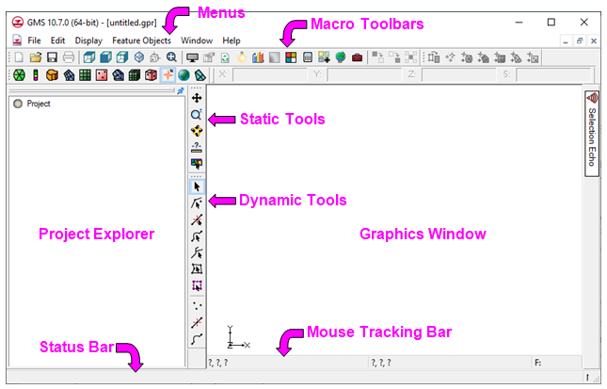

GMS 10.9

GMS 10.9 Tutorial

***Getting Started***

An introduction to GMS

Objectives

This tutorial introduces GMS and covers the basic elements of the user interface. It is the first tutorial that new users should complete.

Time

* 20–30 minutes

Required Components

* GMS Core
* Subsurface
* Geostatistics
* MODFLOW Interface

Prerequisite Tutorials

* None

|  |
| --- |
| [1 Introduction and Getting Started 2](#_Toc109222484)  [1.1 Registering GMS 2](#_Toc109222485)  [2 GMS User Interface 4](#_Toc109222486)  [2.1 Modules 5](#_Toc109222487)  [2.2 Project Explorer 6](#_Toc109222488)  [2.3 Graphics Window 7](#_Toc109222489)  [2.4 Static Tools 8](#_Toc109222490)  [2.5 Tracking, Selection, Status Bar, and XYZS 8](#_Toc109222491)  [3 Projections 9](#_Toc109222492)  [4 Online Maps 10](#_Toc109222493)  [5 Importing Data and Display Options 11](#_Toc109222494)  [6 Saving the Project 13](#_Toc109222495)  [7 Feature Objects 13](#_Toc109222496)  [8 Creating a UGrid 15](#_Toc109222497)  [9 Creating a MODFLOW Simulation 15](#_Toc109222498)  [10 Printing 16](#_Toc109222499)  [11 Stratigraphy Modeling 16](#_Toc109222500)  [12 Geostatistics 17](#_Toc109222501)  [13 Conclusion 20](#_Toc109222502) |

# Introduction and Getting Started

This is the first tutorial all new GMS users should complete. It introduces the GMS user interface and the most commonly used tools and commands. Other tutorials build on the information introduced in this tutorial.

This tutorial does not go in-depth on any one topic, but gives a general overview of several topics and refers to other tutorials for a more complete coverage. The purpose of this tutorial is to familiarize the user with the GMS interface and capabilities.

The following will be introduced and briefly covered in this tutorial:

* The GMS user interface, static tools, and display options.
* The *File* | **New…** command.
* Projections and coordinate systems.
* Importing an online map and importing a shapefile.
* Printing and saving the project.
* Creating feature objects, UGrids, and MODFLOW simulations.
* Stratigraphy modeling, including boreholes, cross sections, and solids.
* Using geostatistics with scatter points.

To get started, do the following:

1. Launch GMS.
2. If GMS is already running, select *File* | **New…** to ensure that the program settings are restored to their default state. A dialog may appear asking to save changes. Click **Don’t Save** to clear all data. The Graphics Window of GMS should refresh to show an empty space.

## Registering GMS

Registering enables GMS with a valid license. Without a license, GMS runs as the free "Community Edition" and many features are not available. The user’s license may not include all components covered in the tutorial. A free evaluation license can be requested that enables everything in GMS for two weeks, allowing completion of the tutorial.

If GMS has not been registered, do the following to register GMS:

1. Select *Help* | **Register…** to bring up the *Aquaveo License Registration* dialog.
2. If the user has a valid license, the dialog will indicate that this copy of GMS is licensed. If the user does not have a valid license, skip to step 6.

If the user has a valid license, make sure the required components listed at the beginning of this tutorial are enabled by doing the following:

1. Click on **Advanced Options…** to bring up the *Aquaveo License Registration – Advanced* dialog. The dialog will display the GMS release date in the title bar.
2. Click on the **Details…** button for the relevant license to bring up the *Aquaveo License Registration – License Details* dialog.

If the user has a valid license, the dialog should appear similar to Figure 1. If any of the required components are not enabled, enable them by requesting an evaluation license, or skip the parts of the tutorial that require them.

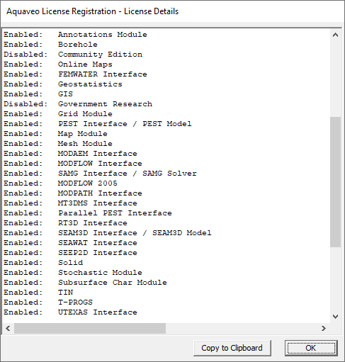

Figure 1 Enabled components

1. If an evaluation license is needed for components that aren’t already enabled, click the **Request License…** button and skip to step 8. Otherwise, click the **OK** or **Close** buttons on all of the *Aquaveo License Registration* dialogs and skip to the next section of the tutorial.
2. If the copy of GMS is not licensed and the *Aquaveo License Registration* dialog indicates so, click on **Advanced Options…** to bring up the *Aquaveo License Registration – Advanced* dialog.
3. Click the **Request License…** button and continue to step 8.
4. In either case, clicking the **Request License…** button will open a web page in the default browser for requesting a software license. Click **Evaluate** and complete the form to request the license. After submitting, an email with the license code will be sent to the email address as entered in the form.
5. From the *Aquaveo License Registration* – *Advanced* dialog, click on **Add License…** to bring up the *Aquaveo License Registration* – *Add License* dialog (as seen in Figure 2)
6. Enter the code from the email in the *License Code* field.
7. Click **OK** to close the *Aquaveo License Registration – Add License* dialog.
8. Click **Close** to close the *Aquaveo License Registration – Advanced* dialog.
9. Click **OK** to close the *Aquaveo License Registration* dialog.

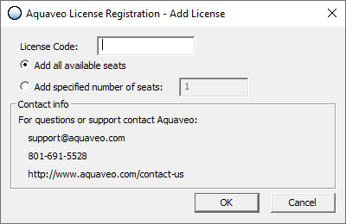

Figure 2 Aquaveo License Registration – Add License dialog

# GMS User Interface

Start with looking at the different parts of the GMS user interface (Figure 3).

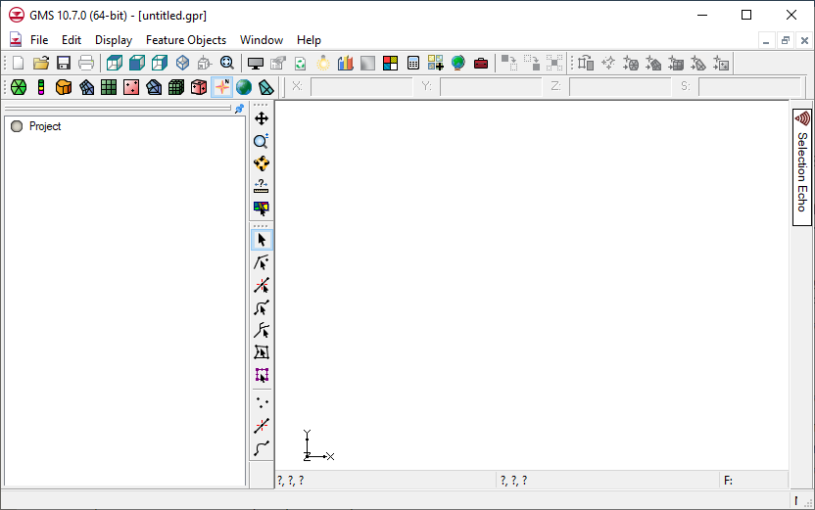

**Mouse Tracking Bar**

**Status Bar**

**Menus**

**Macro Toolbars**

**Static Tools**

**Dynamic Tools**

**Graphics Window**

**Project Explorer**

Figure 3 The GMS window

The toolbars at the top can be grouped into three categories:

* Macro toolbars, most of which are shortcuts for various menu commands:



* The Module toolbar:



* The *XYZS* toolbar:



The Project Explorer, Static Tools, Dynamic Tools, and the Graphics Window occupy the middle from left to right. Be aware that most toolbars can be moved around the GMS window.

At the bottom are the Status Bar and the Mouse Tracking Bar.

## Modules

There are currently twelve modules in GMS and each module focuses the user interface on a different type of data. Only one module is active at a time, so switching to a different module will cause different toolbars and menus to appear. If a tool or menu command can’t be immediately located, it may be in a different module.

1. Click on **UGrid** 2D UGrid item in the Modules toolbar.

Notice that the menus and dynamic tools change when changing modules. The menus and dynamic tools now look like this:





Figure 4 UGrid module menus and dynamic toolbar

These are the menus and tools that correspond with UGrid objects. A UGrid is an unstructured grid composed of 2D or 3D cells and the cells can be of any type (triangles, quadrilaterals, etc.).

1. Click on **Map** File:Map Module Icon.svg in the Modules toolbar.

Notice that the menus and dynamic tools have changed. Now the menus and tools deal with feature object data. This type of data will be discussed later.





Figure 5 Map module menus and dynamic tools

## Project Explorer

The Project Explorer displays the objects and data that are in the project.

1. Right-click in the Project Explorer and select *New* | **UGrid 3D…** to bring up the *New UGrid* dialog.
2. Click **OK** to accept the defaults and close the *New UGrid* dialog.

A new 3D UGrid will appear in the Graphics Window. Notice that GMS automatically switched to the **UGrid** 2D UGrid item module. A wireframe view of the UGrid will appear in the Graphics Window. A number of items will also appear in the Project Explorer (Figure 6).

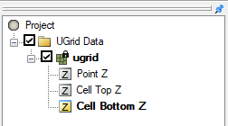

Figure 6 Project Explorer showing the UGrid items

In the Project Explorer, the item at the top is the  Project item and everything else appears below it. The next item here is the “120px-Generic_Folder UGrid Data” folder. This folder is where all UGrids are placed as they are created. Clicking on this item switches to the UGrid module, thus changing the menus and dynamic tools. This is a way to change modules without using the Modules toolbar.

Below the “120px-Generic_Folder UGrid Data” folder is the “ ugrid” that was just created, and below it are datasets named "120px-Elevation_Data_Active Point Z", “120px-Elevation_Data_Active Cell Top Z”, and “120px-Elevation_Data_Active Cell Bottom Z”. The datasets are simply arrays of values associated with a geometric object. A dataset can represent anything such as elevations, contaminant concentrations, head, and so forth. In this case, there is one value in the dataset for every UGrid cell.

1. Turn off the display of the “ ugrid” by unchecking its box (check to check2 ) in the Project Explorer. The “ ugrid” is no longer visible in the Graphics Window.
2. Turn on the “ ugrid”. It is visible again in the Graphics Window.

## Graphics Window

The Graphics Window is the main window where things are displayed. To see how the Graphics Window displays 3D data, do the following:

1. Click the **Front View** File:Front View Macro.svg macro.

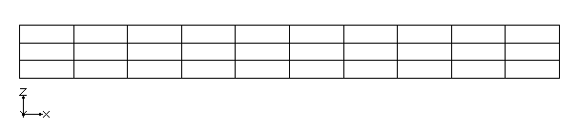

Figure 7 UGrid in front view

This is the view of the UGrid from the front (Figure 7). The *XYZ* triad in the bottom-left corner of the window shows the orientation of the current view. In this view, the UGrid has three layers of cells.

1. Click the **Oblique View** obliqueView macro.

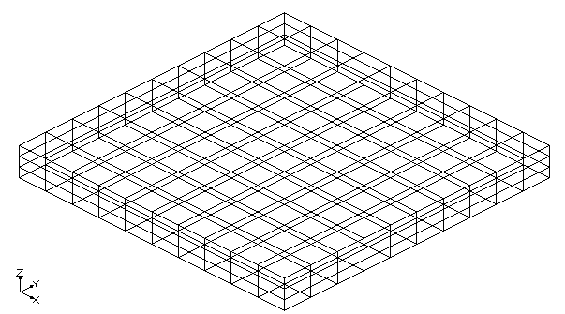

Figure 8 Oblique view of UGrid

Now the UGrid is displayed from an oblique angle, or a 3D view (Figure 8).

1. Switch back to **Plan View** File:Plan View Macro.svg. This returns the project to the top-down view.

## Static Tools

The Static Tools are tools used with the mouse in the Graphics Window. "Static" means that they don't change as modules change. There is always one tool active at any given time, either one of the static tools or one of the dynamic tools. The three most commonly used static tools are covered below:

1. Select the **Pan** File:Pan Tool.svg tool.
2. Click and drag the mouse in any direction in the Graphics Window. Notice that the UGrid moves as the mouse is dragged around in the window.
3. **Frame** File:Frame Macro.svg, or center, the displayed objects in the window.
4. Switch to the **Zoom** File:Zoom Tool Icon.svg tool.
5. Click somewhere in the Graphics Window to zoom in.
6. Right-click to zoom out.
7. Click and drag a box to zoom in to the area within the box. Zooming can also be done by moving the mouse wheel.
8. **Frame** File:Frame Macro.svg the display again.
9. Select the **Rotate** File:Rotate Tool.svg tool.
10. Click and drag the mouse in the Graphics Window. Notice the UGrid rotates as the mouse is dragged.

The **Measure** measure tool is used to measure distances in the Graphics Window with the mouse. Feel free to switch to Plan View and try it out.

## Tracking, Selection, Status Bar, and XYZS

1. **Frame** File:Frame Macro.svg the display and switch back to **Plan View** File:Plan View Macro.svg.
2. Using the **Select Cells** File:Select UGrid Cell Tool.svg tool, move the mouse around inside the Graphics Window.
3. If the UGrid is locked, right-click on “ ugrid” in the Project Explorer and select **Lock/Unlock Editing** from the menu.

Notice that the *XYZ* coordinates and the "F" and "ID" values in the Mouse Tracking bar change as the mouse is moved (Figure 9). The *XYZ* values are the real-world coordinates of the mouse. The *F* value is the scalar value of the dataset in the cell that the mouse is currently over. The *ID* is the number of the cell the mouse is currently over. If the mouse is not currently over a cell then the *F* and *ID* values are not updated.

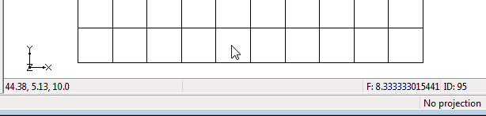

**XYZ Coordinates**

**Dataset value and ID of cell under cursor**

Figure 9 Mouse Tracking bar shows XYZ coordinates, dataset value, and cell ID

1. Using the **Select Cells** File:Select UGrid Cell Tool.svg tool, click on any of the cells in the UGrid (Figure 10). Notice that several items of information about the selected cell are displayed in the Status bar at the bottom of the main GMS screen.

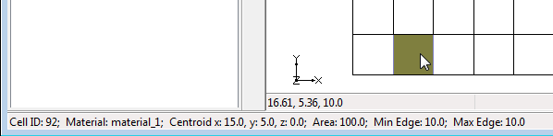Figure 10 Status bar showing selected cell information

**Selected Cell Info**

The *XYZS* toolbar is located above the Graphics Window (Figure 11).



Figure 11 XYZS Toolbar

The XYZ coordinates of the center of the cell are also displayed here. UGrids are not editable, so the XYZ fields are read-only. But the dataset value for the cell is displayed in the "S" field and is editable when the appropriate dataset is selected in the Project Explorer. The “S” is the hydraulic head, the value for the liquid pressure above a geodetic datum. The *XYZS* toolbar can be used to change selected object locations or dataset values.

1. Enter a new value in the *S* field and press the *Tab* or *Enter* key to set it.

# Projections

GMS can display things in real-world projections, and many projections are supported. The projection of any data added to a project will be recognized and displayed in its real-world location.

1. Click on **New** File:New Macro.svg, and click **Don’t Save** when asked to save changes.

In a new project, the projection has not been set. The display project is set by doing the following:

1. Use the *Display* | **Display Projection**… command to bring up the *Display Projection* dialog.
2. In the dialog, turn on the *Global projection* option. This will automatically open the *Horizontal Projection* dialog if this option was not previously selected.
3. In the *Filter strings* field, enter, “NAD 1983 UTM Zone 10N”. This will reduce the number of visible options in the data tree above.
4. In the data tree, open the *Projected Coordinate Systems* folder, then the *UTM* folder, and finally the *NAD 1983* folder.
5. Select “NAD 1983 UTM Zone 10N”. This is the correct setting for the project.
6. Click **OK** to close the *Horizontal Projection* dialog.
7. Click **OK** to close the *Display Projection* dialog.
8. Move the mouse around and notice that the mouse tracking now shows the latitude and longitude as well as the UTM coordinates in meters. Also notice the current display projection is shown in the status bar (Figure 12).

GMS Coordinates and UTM showing in the Mouse Tracking bar

Figure 12 Latitude, longitude and projection displayed in status bars

Data in a different projection will be reprojected on-the-fly to any selected display projection so that all data is displayed together correctly. If the data is not in a projection, the display projection can be set to *No projection* and still allow work to be done.

# Online Maps

GMS can be used for many purposes but the most typical purpose is to build a groundwater model. A good way to start building a model is to start with a map or aerial photo of the site. Free internet imagery can be imported using the *Online Maps* tool.

1. Click the **Add Online Maps** File:Add Online Maps Icon.svg button to open the *Map Locator* dialog. This map window allows navigation to any location on the Earth quickly and easily.
2. In the *Search* field, type “Lake Tahoe, CA” and click *Enter*. After a moment, the edge of Lake Tahoe will appear in the *Map Locator* dialog.
3. Use the zoom and pan tools in the *Map Locator* dialog so that Lake Tahoe is located in the center as shown in Figure 13.
4. Click **OK** to close the *Map Locator* dialog and open the *Get Online Maps* dialog (Figure 14).

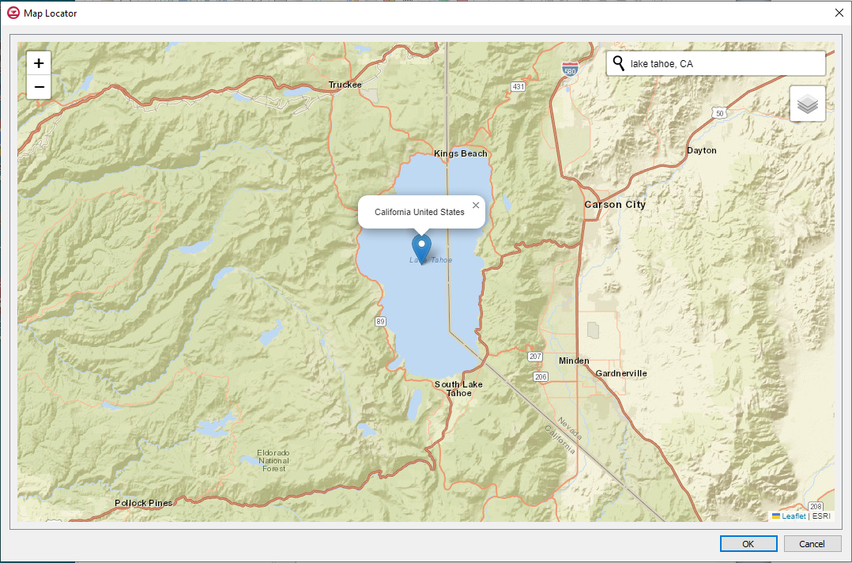

Figure 13 Map Locator dialog

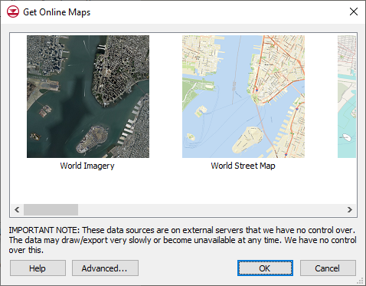

Figure 14 Get Online Maps dialog

1. Select the *World Imagery* item and click **OK** to close the *Get Online Maps* dialog.

Depending on the speed of the user’s internet connection and the speed of the computer being used, a photo of Lake Tahoe should appear in the Graphics Window after a short time, and a new GIS layer will appear in the Project Explorer. With an internet connection, this map is dynamic and will update as it is panned and zoomed. It takes some time to update the map because the image has to be retrieved from the internet every time.

Online maps are covered in more detail in another tutorial entitled “Online Maps”.

# Importing Data and Display Options

GMS can import lots of different types of data. A shapefile will be imported to illustrate.

1. Click the **Open** File:Open Macro.svg macro to bring up the *Open* dialog.
2. Navigate to the GettingStarted/GettingStarted folder.
3. Select “All Files (\*.\*)” from the *Files of type* drop-down.
4. Select “watershed.shp” and click the **Open** button to import the file and close the *Open* dialog.

This simple shapefile contains a watershed boundary line. It's a black line so it is not easy to see against a real photo.

To fix that, do the following:

1. Click **Display Options** File:Display Options Macro.svg to open the *Display Options* dialog (Figure 15).

The *Display Options* dialog allows for the changing and setting of many display options. This dialog is used regularly.

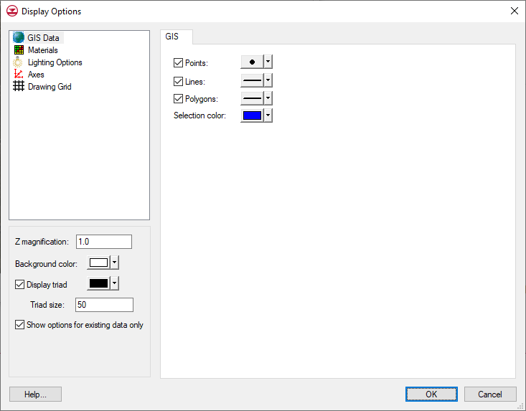

Figure 15 Display Options dialog

1. Select “GIS Data” from the list on the left.
2. On the *GIS* tab, click on the wide button to the right of *Lines* (the button to the left of the drop-down arrow button) to bring up the *Line Properties* dialog (Figure 16).

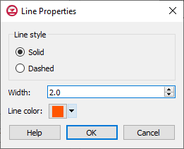

Figure 16 Line Properties dialog

1. Select the *Solid* radio button and enter “2.0” in the *Width* field.
2. Click on the color button to the right of *Line color* to bring up the *Select* *Color* dialog.
3. Select one of the orange boxes from the color samples in the *Basic colors* section.
4. Click **OK** to close the *Select* *Color* dialog.
5. Click **OK** to close the *Line Properties* dialog.
6. Click **OK** to close the *Display Options* dialog.

The watershed boundary line should be more visible now.

In addition to shapefiles, GMS can import many different types of files, including CAD files, a variety of image file types, DEM data, and text CSV files. For more about using shapefiles, please refer to the “GIS” tutorial.

# Saving the Project

All of the files which are part of the project (shapefiles, images, CAD files, etc.) are just referenced in the project file, so it is a good practice to save the project where these external files are located. This keeps all the files together in case the project needs to be shared or moved to another computer.

GMS project files have a GPR extension. It is recommended to save often as the project is being built. To save the project, do the following:

1. Click the **Save** File:Save Macro.svg macro to bring up the *Save As* dialog*.*
2. Navigate to the *GettingStarted/GettingStarted* folder, and enter "tahoe.gpr" in the *File name* field.
3. Select “Project Files (\*.gpr)” from the *Save as type* drop-down list.
4. Click **Save** to save the project and close the *Save As* dialog.

# Feature Objects

The most powerful way to build a groundwater model is by using a conceptual model made of feature objects (Figure 17). Feature objects are used to conceptually represent the important parts of the model such as wells, rivers, boundaries, etc. For more about feature objects, please refer to the tutorial entitled “Feature Objects”.



Figure 17 Examples of feature objects

To define the model boundary with an arc, do the following:

1. Turn off “File:GIS Online Image Icon.svg World Imagery” in the Project Explorer so that the watershed boundary is more visible.
2. Switch to the **Map** File:Map Module Icon.svg module.
3. Using the **Create Arc** File:GMS Create Arc Tool.svg tool, create a simple arc as shown in Figure 18 by clicking in the Graphics Window. Click on the starting point (indicated by the red arrow in Figure 18) to close the arc to form a polygon. Note: Hit the *Backspace* key to remove the last point clicked, if needed.

If a mistake is made, select the arc with the **Select Arcs** File:GMS Select Arc Tool.svg tool and delete it, then switch back to the **Create Arc** File:GMS Create Arc Tool.svg tool and start again. There is no undo option in GMS.

This illustrates the basic idea of feature objects which are used for many things in GMS. In this case, the first part of the conceptual model—the model boundary—was created. If a real model was being created, more precision in creating the boundary arc would be required.

Creating the boundary arc by converting the shapefile to feature objects directly is a very effective and precise method. For example, more detail can be added to the conceptual model, including points for wells, arcs for rivers, and polygons for the lake boundary. Attributes would be added to these items such as pumping rates, depths, and recharge rates. For more information on how to build a groundwater model using a conceptual model, please see the tutorial “MODFLOW – Conceptual Model Approach I”.

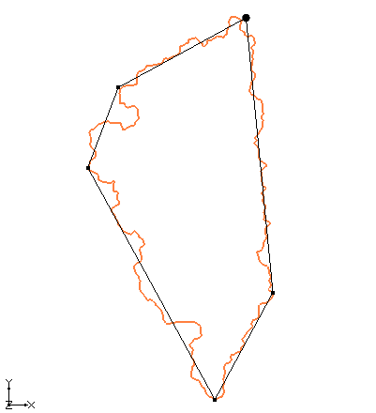

Figure 18 Creating an arc for the watershed boundary

Although a closed polygon was formed with the arc, GMS doesn't know it is a polygon there until the polygons are built. This allows GMS to know the model area.

1. Click the **Build Polygons** File:Build Polygons Macro.svg macro.

The interior of the polygon is now filled with a transparent grey color. If it doesn't look like this, the arc is probably not closed and there is a gap somewhere. Try creating it again.

# Creating a UGrid

After the conceptual model is created using feature objects, create a grid for the numerical model by doing the following:

1. Click the **Map → UGrid**  macro. This opens the *Map → UGrid* dialog.
2. In the *X-Dimension* section, select the *Number of cells* radio button and enter “20” into *Number of cells*.
3. In the *Y-Dimension* section, select the *Number of cells* radio button and enter “30” into *Number of cells*.
4. Accept the defaults for everything else and click **OK** to close the *Map → UGrid* dialog. The project should appear similar to Figure 19.

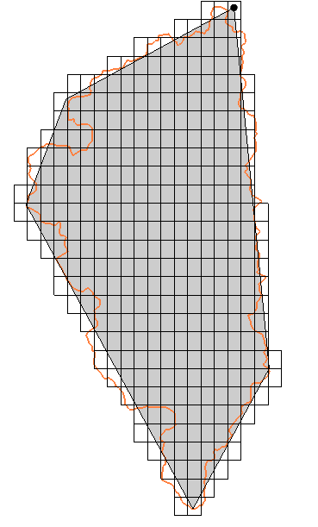

Figure 19 UGrid created in area of conceptual model

This is the second way to create a UGrid discussed in this tutorial. There are other ways explained in the “UGrid Creation” tutorial. UGrids can be created so that they are refined around wells, rivers, and lakes (points, arcs, and polygons) in the conceptual model.

# Creating a MODFLOW Simulation

Now that a UGrid is completed, a MODFLOW simulation can be created. GMS supports other numerical models but MODFLOW is the most widely used.

1. In the Project Explorer, right-click on the “ ugrid” item and select **New MODFLOW…** to bring up the *MODFLOW Global/Basic Package* dialog.

This is where the fundamental aspects of the model are set, such as which packages to use and whether the model is steady-state or transient.

1. Accept the defaults and click **OK** to close the *MODFLOW Global/Basic Package* dialog.

With a conceptual model, a UGrid, and a MODFLOW simulation all created, the next step is mapping the conceptual model to the UGrid using the **Map→MODFLOW** command. This command intersects the feature objects with the UGrid cells, and transfers the attributes from the conceptual model to the UGrid. The MODFLOW simulation can also be edited directly on the grid in a cell-by-cell fashion.

For the purposes of this tutorial, this is as far as this project will be taken. There are a number of tutorials on the Aquaveo website about the building of MODFLOW models.

# Printing

A very common task is printing or otherwise getting image data out of GMS. There are a number of ways to get image data from GMS and there is a tutorial on the subject called “Printing and Exporting Images”.

1. Select *File |* **Page Setup…** to bring up the *Page Setup* dialog.

The *Page Setup* dialog allows control over such things as the margins, paper size, and orientation of the printed output.

1. Click **Cancel** to close the *Page Setup* dialog.
2. Click the **Print** File:Print Icon.svg macro to bring up the *Print* dialog.

The *Print* dialog allows selecting the printer to which the print job information will be sent, as well as a number of other options.

1. Click **Cancel** to close the *Print* dialog.

Both *File* | **Save As…** and *Edit* | **Screen Capture...** capture the Graphics Window to an image file. The second option creates a higher resolution image. All of this is reviewed in more detail in the “Printing and Exporting Images” tutorial.

# Stratigraphy Modeling

Another common use of GMS is for stratigraphy modeling. This involves creating a model of the geology of a site. This could be for the sole purpose of site characterization or for later use in constructing a groundwater model.

1. Click the **New** File:New Macro.svg macro. If prompted to save, select **Save** to bring up the *Save As* dialog.
2. Enter "tahoe.gpr" in the *File name* field.
3. Select “Project Files (\*.gpr) from the *Save as type* drop-down list.
4. Click **Save** to save the project and close the *Save As* dialog.
5. If asked to replace the existing file, click **Yes**.
6. Click the **Open** File:Open Macro.svg macro to bring up the *Open* dialog.
7. Navigate to the *GettingStarted/GettingStarted* folder and select “Project Files (\*.gpr)” from the *Files of type* drop-down.
8. Select “stratigraphy.gpr” and click **Open** to import the file and close the *Open* dialog.

The Graphics Window will now appear similar to Figure. Boreholes and cross sections will be visible.

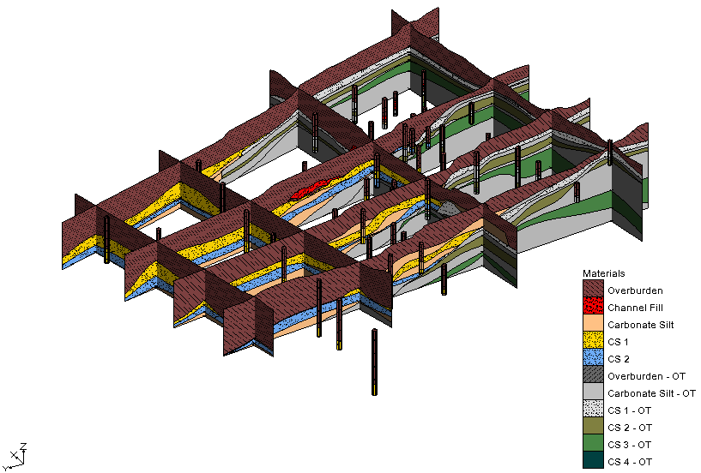

Figure 20 Boreholes and cross sections

1. Use **Rotate** File:Rotate Tool.svg and **Zoom** File:Zoom Tool Icon.svg to examine the data.

Feel free to experiment with the various selection and creation tools in the **Boreholes** http://www.xmswiki.com/w/images/a/a4/Icon_BH.gif module. Several tutorials explain how to create this sort of data, including “TINs, Boreholes and Cross Sections”, and “Horizons and Solids”.

# Geostatistics

The last commonly used feature of GMS discussed here is geostatistics, otherwise known as interpolation.

1. Click the **New** File:New Macro.svg macro. If prompted to save, select **Don’t Save.**
2. Click the **Open** File:Open Macro.svg macro to bring up the *Open* dialog.
3. Navigate to the *GettingStarted/GettingStarted* folder and select “Project Files (\*.gpr)” from the *Files of type* drop-down.
4. Select “geos2d.gpr” and click **Open** to import the file and close the *Open* dialog.

The Graphics Window should now appear similar to Figure 21, showing a 2D grid.

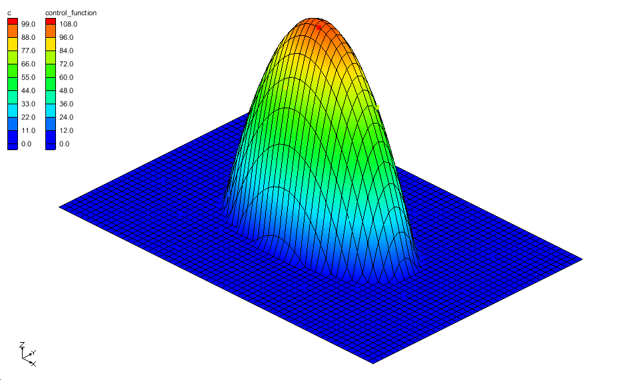

Figure 21 2D grid with interpolated values

1. Use **Rotate** File:Rotate Tool.svg and **Zoom** File:Zoom Tool Icon.svg to examine the data.

This shows a 2D grid surface whose Z values have been warped to match dataset values. The datasets were generated by interpolating from a few scatter points to every grid cell corner.

1. Switch to **Plan View** File:Plan View Macro.svg.
2. In the Project Explorer, right-click and select **Expand All**. Any collapsed folders should now be fully expanded.
3. Turn off “File:2D Grid Icon.svg grid” in the Project Explorer.

The scatter points, which are the source of the interpolation, are now visible. The points are colored according to their dataset value, with higher values colored red and lower values colored blue. The dataset in this case could represent a contaminant plume but in this case it is a perfectly elliptical plume derived from a mathematical function in order to illustrate how interpolation works.

1. Turn on “File:2D Grid Icon.svg grid”.
2. Right-click on the “File:2D Scatter Icon.svg plumedat” scatter point set and select *Interpolate To* | **2D Grid** to bring up the *Interpolate → Object* dialog.

Right-clicking on items in the Project Explorer opens context menus with commands specific to the item clicked.

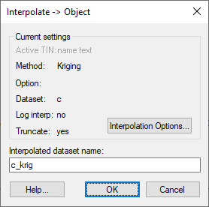

Figure 22 Interpolate → Object dialog

1. Click the **Interpolation Options**… button to bring up the *2D Interpolation Options* dialog.

This dialog allows choosing from many different interpolation options. Each interpolation method has its strengths and weaknesses. Inverse distance weighted will be used in this tutorial for simplicity.

1. In the *Interpolation method* section, select the *Inverse distance weighted* radio button.

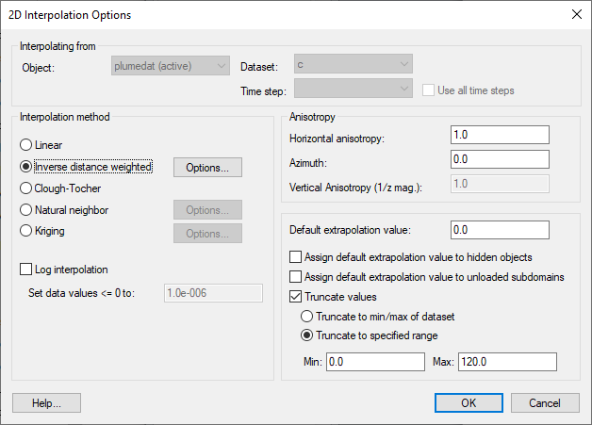

Figure 23 2D Interpolation Options dialog

1. Click **OK** to close the *2D Interpolation Options* dialog.
2. Enter "idw" in the *Interpolated dataset name* field.
3. Click **OK** to close the *Interpolate → Object* dialog.

A new dataset named "File:Dataset Cells Active.svg idw" is added under the 2D grid and the contours change to reflect the new dataset.

1. In the Project Explorer, click on the various datasets File:Dataset Cells Active.svg under the grid and see how the contours change.
2. Switch to **Oblique View** obliqueView.
3. Again click on the various datasets File:Dataset Cells Active.svg under the grid. The ↑ *Up* and ↓ *Down* arrow keys can also be used to change datasets once the first dataset has been selected.

The Z values of the grid are warped to match the active dataset values. This is the default behavior for 2D surfaces. GMS also supports 3D interpolation to 3D objects, such as a UGrid. To learn more about geostatistics and interpolation, please refer to the “Geostatistics – 2D” and “Geostatistics – 3D” tutorials.

# Conclusion

This concludes the “Getting Started” tutorial for GMS. The following information was discussed in this tutorial:

* The GMS user interface, static tools, and display options.
* The *File* | **New…** command.
* Projections and coordinate systems.
* Importing an online map, and importing a shapefile.
* Printing and saving the project.
* Creating feature objects, UGrids, and MODFLOW simulations.
* Stratigraphy modeling, including boreholes, cross sections, and solids.
* Using geostatistics with scatter points.