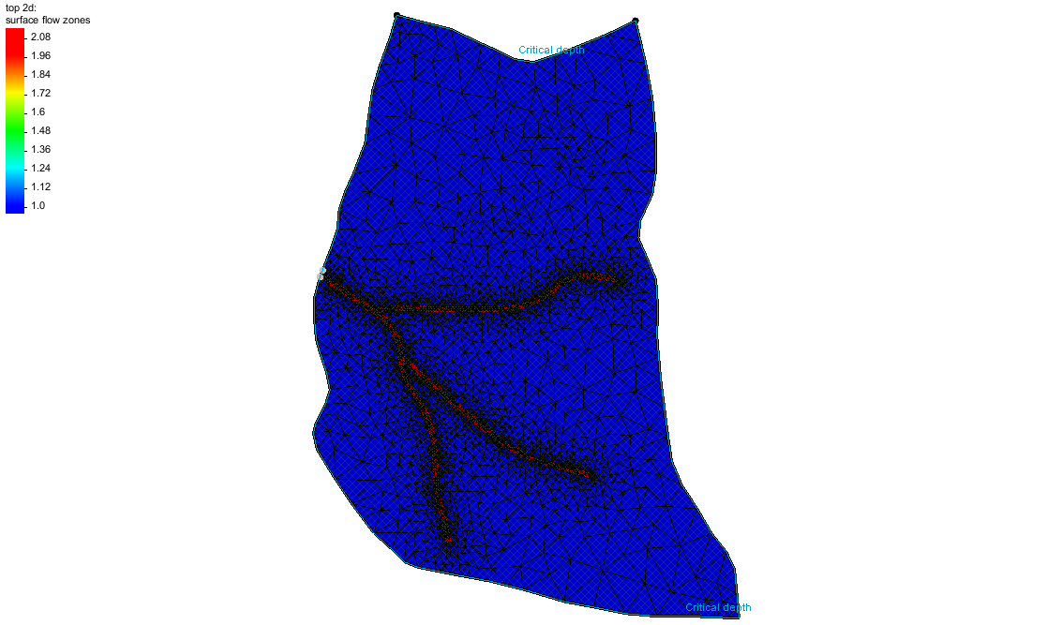

GMS 10.9

GMS 10.9 Tutorial

***HydroGeoSphere – Surface Flow and Evapotranspiration***

Build a HydroGeoSphere model in GMS

Objectives

This tutorial demonstrates how to add surface flow and evapotranspiration to a HydroGeoSphere model in GMS.

Time

* 25–45 minutes

Required Components

* GMS Core
* HydroGeoSphere Model & Interface

Prerequisite Tutorials

* Getting Started
* HydroGeoSphere – Porous Media Domain

|  |
| --- |
| 1 Introduction 2  2 Basic Workflow 3  3 Getting Started 4  3.1 Domains 5  4 Simulation Control 5  5 Zones 5  5.1 Surface Flow Domain 6  5.2 ET Domain 7  6 Material Properties 8  6.1 Surface Flow Domain 8  6.2 ET Domain 9  7 Boundary Conditions 10  7.1 Surface Flow Domain 10  7.2 ET 12  8 Save the Project and Simulation 12  9 Run Grok 13  10 Run Phgs 13  11 Read the Solution 13  12 Conclusion 13 |

# Introduction

This tutorial demonstrates how to build a HydroGeoSphere (HGS) model in GMS. It is based off the *Intro to HydroGeoSphere[1]* tutorial from Aquanty. Refer to that tutorial and the *HydroGeoSphere Reference Manual* as needed.

In the *Intro to HydroGeoSphere* tutorial, the “R5 Catchment” model is developed. From that tutorial:

The model is quite simple compared to many ‘real world’ models that you may build. But it contains sufficient complexity that it is perfectly suited to demonstrate the overall HydroGeoSphere workflow. The intention of this tutorial is not to perfectly recreate the catchment, but to teach the process of creating a small watershed model in HGS. In fact, several of the inputs for the R5 model are completely arbitrary (e.g. the delineation of soil types and associated hydraulic properties, boundary condition values, etc.).

The R5 catchment covers a small (approximately 0.1 km2) rangeland catchment near Oklahoma City (Figure 3). The defined model includes basic flow in the porous medium and surface/overland flow domains, and includes evapotranspiration.[2]

The *HydroGeoSphere – Porous Media Domain* tutorial covers creating a model of the porous media domain, and this tutorial adds the surface flow and evapotranspiration domains.

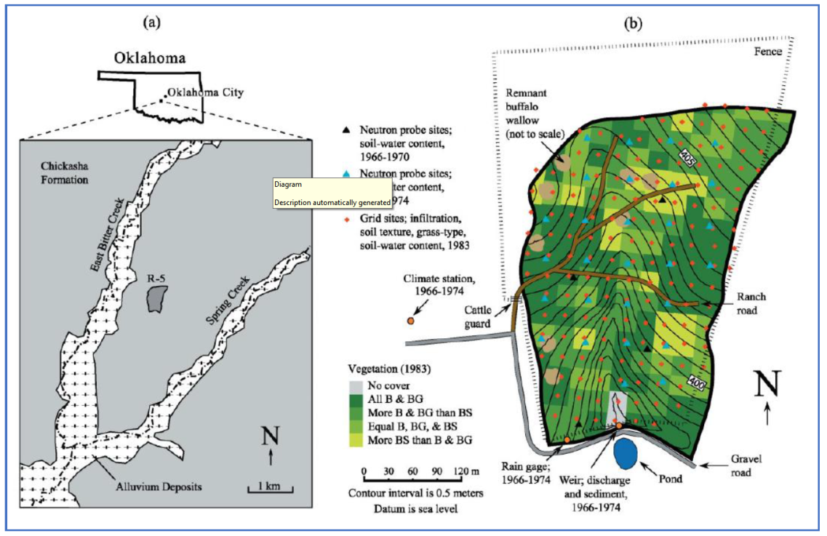

Figure HydroGeoSphere Intro Tutorial, figure 3, pg. 14

# Basic Workflow

From the *Intro to HydroGeoSphere* tutorial, the basic HGS workflow consists of 5 steps:

1. Data inputs are prepared (e.g. various GIS files, 2D grid/mesh files, etc.).
2. Configure an input data file (the GROK file) for the model pre-processor.
3. Use executables (*.exe) to generate the model input files and solve the simulation.
   1. Grok.exe – compiles the GROK file, generates input files for the numerical simulator
   2. Phgs.exe – reads model input files, performs the numerical simulation (i.e. it ‘solves’ the model)
   3. Hsplot.exe OR hgs2vtu.exe – reformats model outputs for visualization
4. Visualize, analyze, and interpret model results.
5. Iterate on the model to add complexity, perform scenario analysis, calibrate, etc.[3]

Note that a GROK file is prepared and then the grok.exe runs. During the run, grok.exe reads the GROK file and prepares the actual model input files. Only then can the model (phgs.exe) be run.

The HydroGeoSphere workflow is followed pretty closely when using GMS. The basic steps to build an HGS model in GMS—and how these steps relate to the HydroGeoSphere workflow—are as follows:

1. Create the conceptual model (HGS step 1).
2. Create a 3D UGrid for the porous media domain (HGS step 1).
3. Create a 2D UGrid for the 2D domains: surface flow, ET (HGS step 1).
4. Save the simulation, which creates the GROK file (HGS step 2).
5. Run grok.exe on the GROK file to prepare input files for phgs.exe (HGS step 3a).
6. Run phgs.exe (HGS step 3b).
7. Read the solution and visualize the results (HGS step 4).
8. Iterate on the model to add complexity, perform scenario analysis, calibrate, etc.… (HGS step 5, not covered in this tutorial).

# Getting Started

Do as follows to get started:

1. If necessary, launch GMS.
2. If GMS is already running, select *File |* **New** to ensure that the program settings are restored to their default state.
3. Click **Open** File:Open Macro.svg to bring up the *Open* dialog.
4. Select “Project Files (*.gpr)” from the *Files of type* drop-down.
5. Browse to the *hgs-olf_et\hgs-olf_et* folder and select “start.gpr”.
6. Click **Open** to import the project and exit the *Open* dialog.

The project should be visible in the Graphics Window (Figure 2). The project contains a 2D UGrid and a 3D UGrid. The porous media domain and initial simulation has already been defined.

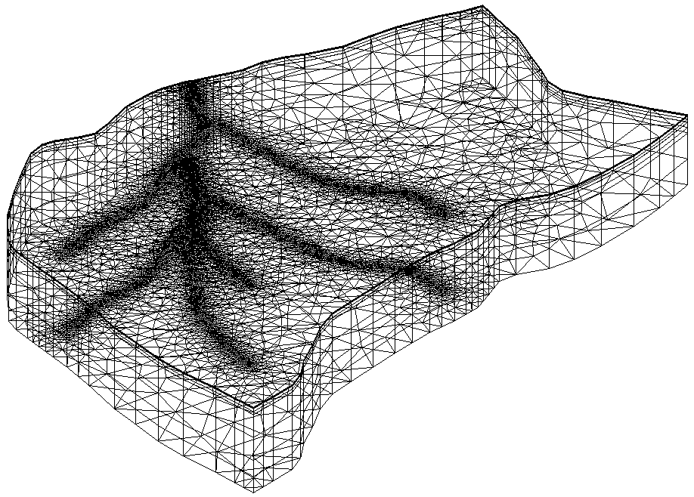

Figure The initial project

Before continuing, it is recommended to save the project with a new name.

1. Select *File |* **Save As…** to bring up the *Save As* dialog.

Browse to the directory for this tutorial*.*

Select “Project Files (*.gpr)” from the *Save as type* drop-down.

Enter “hgs_olf_et.gpr” as the *File name*.

Click **Save** to save the project and close the *Save As* dialog.

## Domains

HydroGeoSphere uses “domains” to describe different parts of the hydrosphere. There are several domains, but the only ones used in this tutorial include:

* Surface flow or overland flow (olf): fluid flow on the surface
* ET (et): evapotranspiration

Although the surface flow and ET domains are 2D in nature, HydroGeoSphere only uses one 3D grid. In GMS both a 3D grid and a 2D grid are used to help prepare the inputs and to display the results when the surface flow and/or ET domains are being modeled. The “File:Ugrid lock 3D.png top 2d” UGrid will be used for the surface flow and ET domains.

1. Turn the “File:Ugrid lock 3D.png 3d” UGrid on and off to see that the “File:Ugrid lock 3D.png top 2d” UGrid is simply a 2D UGrid at the top of the “File:Ugrid lock 3D.png 3d” UGrid.
2. When done, switch to **Plan View** File:Plan View Macro.svg.

# Simulation Control

Simulation parameters can now be assigned.

1. Right-click the “ R5” simulation and select **Simulation Control…** to open the *Simulation Control* dialog.

Many HydroGeoSphere inputs are set in the *Simulation Control* dialog. Besides parameters that are traditionally associated with HydroGeoSphere simulation control, this dialog also includes time stepping, output, zones, and initial conditions.

1. Select the *General* tab and turn on the following options:

* *Surface flow*
* *ET*

1. Click **OK** to close the *Simulation Control* dialog.

# Zones

HydroGeoSphere uses the idea of “zones” to divide the model domain into different areas. Properties such as hydraulic conductivity are associated with one or more zones and thus can vary spatially. Different zones can be used for different domains (porous media domain, surface flow domain etc.).

In GMS, zones are defined using cell-based datasets. These datasets can be created in a variety of ways. Hydraulic conductivity and other properties are defined on “materials”, and materials are assigned to one or more zones.

This tutorial will demonstrate zone datasets for the surface flow and ET domains.

## Surface Flow Domain

The 2D UGrid is used for the surface flow, (or overland flow) domain, and the ET domain. For surface flow, there will be two zones. Most cells will be in zone 1 which will be assigned to a “Grassland” material. Cells around the roads will be assigned to zone 2 and assigned to a “Ranch Road” material.

1. Turn off the “File:Ugrid lock 3D.png 3d” UGrid.
2. Select the “File:Ugrid lock 3D.png top 2d” UGrid to make it active.
3. Right-click on the “File:Ugrid lock 3D.png top 2d” UGrid and select **Z Values → Cell Dataset.** A new cell-based dataset named “File:Dataset Cells Active.svg elevation” will appear in the Project Explorer.
4. Right-click on the “File:Dataset Cells Active.svg elevation” dataset under “File:Ugrid lock 3D.png top 2d” UGrid and select **Rename**.
5. Enter “surface flow zones” as the new name.
6. Right-click on the “File:Ugrid lock 3D.png top 2d” UGrid and select **Lock / Unlock Editing.**

To assign values for zone 1 (“Grassland”),do the following:

1. With the **Select Cells** File:Select UGrid Cell Tool.svgtool active, use *Ctrl + A* to select all cells.
2. Change the dataset value *S* to “1.0”.

To assign values for zone 2 (“Ranch Road”),do the following:

1. Remain in **Plan View** File:Plan View Macro.svg.
2. Under the “Map Data folder Map Data” folder, turn on and select the “File:Coverage Active Icon.svg zones” coverage to make it active.
3. Using the **Select Polygons** File:GMS Select Polygon Tool.svg tool, select the polygon representing the roads.
4. Right-click and select the **Select Intersecting Objects…** command to open the *Select Objects of Type* dialog.
5. Select the *Active UGrid cells* option and click **OK** to close the *Select Objects of Type* dialog.
6. Change dataset value *S* to “2.0”.
7. Deselect the polygon.
8. Click the **Contour Options** File:Contour Options Macro.svg macro to open the *Dataset* *Contour Options – UGrid – surface flow zones* dialog.
9. Change the *Contour method* to “Block Fill”.
10. Click **OK** to close the *Contour Options – UGrid – surface flow zones* dialog.
11. Click **Yes** at the message to turn on contours.

The surface flow zones dataset now has values of 2 along the roads, and a value of 1 everywhere else.

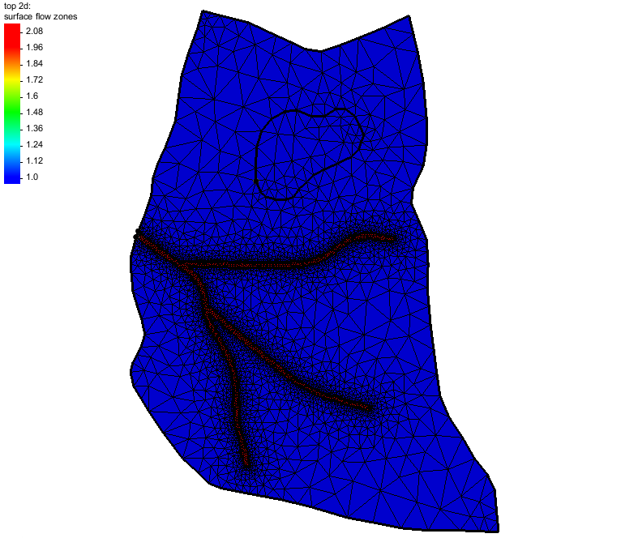

Figure The surface flow dataset with assigned values

Set surface flow zones by doing the following:

1. In the Project Explorer, double-click on the “ R5” simulation to open the *Simulation Control* dialog.
2. Select the *Zones* tab.
3. Turn on the *Read surface flow zones from file* option.
4. Click the **Select Dataset…** button to open the *Select Dataset* dialog.
5. Select the “File:Dataset Cells Active.svg surface flow zones” dataset under the “3D UGrid item top 2d” UGrid.
6. Click **OK** to close the *Select Dataset* dialog.
7. Click **OK** to close the *Simulation Control* dialog.

## ET Domain

For ET, the zone encompasses all the top faces.

Start with creating the ET zones dataset by doing the following:

1. Right-click the “File:Dataset Cells Active.svg surface flow zones” dataset and select **Duplicate**.
2. Right-click on the “File:Dataset Cells Active.svg surface flow zones (2)” dataset and select **Rename**.
3. Enter “et zones” as the new name.
4. With the **Select Cells** File:Select UGrid Cell Tool.svg tool active, use *Ctrl + A* to select all cells.
5. Change the dataset value *S* value to “1.0”.

Now set the ET zones by doing the following:

1. Double-click on the “ R5” simulation in the Project Explorer to open the *Simulation Control* dialog.
2. Select the *Zones* tab.
3. Turn on the *Read ET zones from file* option.
4. Click the **Select Dataset…** button to open the *Select Dataset* dialog.
5. Select the “File:Dataset Cells Active.svg et zones” dataset under the “3D UGrid item top 2d” UGrid.
6. Click **OK** to close the *Select Dataset* dialog.
7. Click **OK** to close the *Simulation Control* dialog.

# Material Properties

Properties such as hydraulic conductivity are associated with HydroGeoSphere materials. This idea is similar to traditional GMS materials, but HydroGeoSphere materials are completely separate from the traditional GMS materials. Multiple HydroGeoSphere materials can be defined, and materials are assigned to domains and to one or more zones. Note that if material property values are not assigned, then a default value will be applied. This example will create three materials. In this case, each material will be assigned to one zone, but a material can be assigned to multiple zones.

## Surface Flow Domain

Now define two materials with the surface flow domain.

1. Right-click on the “ R5” simulation and select **Materials…** to open the *Materials* dialog.

### Create the “Grassland” Material

1. Click **Add Row** File:GMS MODFLOW 6 - Add Row button.png to add a new material.
2. Change the new material name to “Grassland”.
3. Change the *Domain* to “Surface flow” and ensure that *Zones* is set to “1”.
4. Turn on *X friction* and enter “0.3”.
5. Turn on *Y friction* and enter “0.3”.
6. Turn on *Rill storage height* and enter “0.01”.
7. Turn on *Coupling length* and enter “0.01”.

### Create the “Ranch Road” Material

1. Click **Add Row** File:GMS MODFLOW 6 - Add Row button.png to add a new material.
2. Change the new material name to “Ranch Road”.
3. Change the *Domain* to “Surface flow” and change *Zones* to “2”.
4. Turn on *X friction* and enter “0.03”.
5. Turn on *Y friction* and enter “0.03”.
6. Turn on *Rill storage height* and enter “0.002”.
7. Turn on *Coupling length* and enter “0.01”.

## ET Domain

Now define a material with the ET domain.

1. Click **Add Row** File:GMS MODFLOW 6 - Add Row button.png to add a new material.
2. Change the new material name to “et1”.
3. Change the *Domain* to “ET” and ensure the *Zones* is set to “1”.
4. Turn on *Evaporation depth* and set it to “3”.
5. Turn on *EDF quadratic decay function*.
6. Turn on *Root depth* and set it to “3”.
7. Turn on *RDF quadratic decay function*.
8. Turn on *LAI tables* and click the **Table…** button to open the *XY Series Editor* dialog.
9. Change the *Number of rows* to “2”.
10. Enter the following into the table:

|  |  |
| --- | --- |
| **time** | **lai** |
| 0.0 | 2.08 |
| 1e41 | 2.08 |

1. Click **OK** to close the *XY Series Editor* dialog.
2. Turn on *Transpiration fitting parameters* and enter the following values:
   1. *C_1* set to “0.1”.
   2. *C_2* set to “0.05”.
   3. *C_3* set to “2.0”.
3. Turn on *Transpiration limiting pressure head* and enter the following values:
   1. *Hwp_et* set to “-150”.
   2. *Hfc_et* set to “-3.8”.
   3. *Ho_et* set to “0”.
   4. *Han_et* set to “0”.
4. Turn on *Evaporation limiting pressure head* and enter the following values:
   1. *He2_et* set to “-1.5”.
   2. *He1_et* set to “-0.5”.
5. Turn on *Canopy storage parameter* and set the value to “0.0”.
6. Turn on *Initial interception storage* and set the value to “0.0”.

All the materials have now been set.

1. Click **OK** to exit the *Materials* dialog.

# Boundary Conditions

Boundary conditions are defined on feature objects in GMS coverages. When the model is saved, GMS intersects the features with the UGrid to find the grid components (nodes, cells, faces, or segments) that should be associated with the boundary conditions, and writes the boundary conditions to the GROK file.

## Surface Flow Domain

The surface flow domain includes critical depth boundary conditions on the boundary arcs and a rain boundary condition over all the top faces.

Start with creating a coverage that contains the outer boundary. This coverage will be reused for the surface flow and ET domains. To create the coverage:

1. In the Project Explorer, turn off “File:Generic Folder.svg UGrid Data”.
2. Right-click on the “File:Coverage Active Icon.svg zones” coverage and select **Duplicate**.
3. Right-click on “File:Coverage Active Icon.svg Copy of zones” and select **Rename**.
4. Enter “outer boundary” for the new name.
5. Right-click on the “File:Coverage Active Icon.svg outer boundary” coverage and select *Coverage Type* | *HydroGeoSphere* | **Boundary Conditions**.
6. Using the **Select Arc** File:GMS Select Arc Tool.svg tool, select the arc in the middle of the model that defines the clay lens area and press the *Delete* key.
7. Repeat the previous step to delete the arc representing the area of the roads so that only the outer boundary arc remains.
8. Select *Feature Objects* | **Build Polygons**.

 To create the surface flow domain coverage:

1. Right-click on the “File:Coverage Active Icon.svg outer boundary” coverage and select **Duplicate**.
2. Right-click on “File:Coverage Active Icon.svg Copy of outer boundary” and select **Rename**.
3. Enter “surface flow BCs” for the new name.
4. In the Project Explorer, turn off all the coverages except for “File:Coverage Active Icon.svg surface flow BCs”.

A boundary condition needs to be assigned to the top edge. To do this, separate the top edge to be a feature arc.

1. Using the **Select Vertices** File:GMS Select Vertex Tool.svg tool, hold down the *Shift* key and select the top left and right corners.
2. Right-click and select **Vertex → Node**.
3. Using the **Select Points\Nodes** File:GMS Select Node Tool.svg tool, select the two nodes on the left side of the polygon.
4. Right-click and select **Node → Vertex**.

To define the critical depth boundary conditions:

1. Using the **Select Arc** File:GMS Select Arc Tool.svg tool, double-click the top arc to open the *Arc Properties* dialog.

Different types of boundary conditions are listed on the left. Parameters for the boundary condition are shown on the right. Only one boundary condition can be assigned to each feature object.

1. In the list on the left, turn on *Critical depth*.
2. For the *Name*, enter “CritDepth_outlet”.
3. Turn on *Map to grid boundary*.
4. Click **OK** to close the *Arc Properties* dialog.

This tells GMS that the arc is to be intersected with the outer boundary of the grid and not the interior.

1. Using the **Select Arc** File:GMS Select Arc Tool.svg tool, double-click the bottom arc to open the *Arc Properties* dialog.
2. In the list on the left, turn on *Critical depth*.
3. For the *Name* enter “CritDepth_rest”.
4. Turn on *Map to grid boundary*.
5. Click **OK** to close the *Arc Properties* dialog.

To define the rain boundary condition:

1. Using the **Select Polygons** File:GMS Select Polygon Tool.svg tool, double-click the polygon to open the *Polygon Properties* dialog.
2. In the list on the left, turn on *Rain*.
3. For the *Name* enter “Precip”.
4. For the *Constant* value enter “5.555e-7”.
5. Click **OK** to close the *Polygon Properties* dialog.

The boundary conditions are now defined for the surface flow domain but still need to be included in the “ R5” simulation.

1. Right-click on the “File:Coverage Active Icon.svg surface flow BCs” coverage and select *Apply to* | **HydroGeoSphere Simulations → R5**.

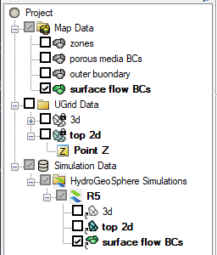

Figure The HydroGeoSphere Simulation in the Project Explorer

## ET

Evapotranspiration will be assigned as a boundary condition on all the top faces.

1. Right-click on the “File:Coverage Active Icon.svg outer boundary” coverage and select **Duplicate**.
2. Right-click on “File:Coverage Active Icon.svg Copy of outer boundary” and select **Rename**.
3. Enter “et BCs” for the new name.
4. Using the **Select Polygons** File:GMS Select Polygon Tool.svg tool, double-click the polygon to open the *Polygon Properties* dialog.
5. In the list on the left, turn on *Potential evapotranspiration*.
6. For the *Name* enter “PET1”.
7. For the *Constant* value enter “3e-8”.
8. Click **OK** to close the *Polygon Properties* dialog.

The boundary conditions for the evapotranspiration have now been defined.

1. Right-click on the “File:Coverage Active Icon.svg et BCs” coverage and select *Apply to* | **HydroGeoSphere Simulations → R5**.

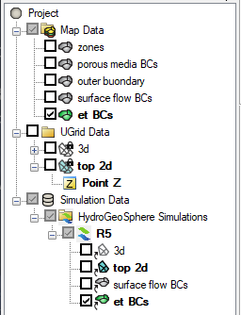

Figure The HydroGeoSphere simulation in the Project Explorer

# Save the Project and Simulation

Before continuing, complete the following:

1. **Save** File:Save Macro.svg the project.

This saves the GMS project files but not the HydroGeoSphere simulation files. To create the files for the HydroGeoSphere simulation, the simulation needs to be saved.

1. Under the “ R5” simulation, right-click on the “porous media BCs” coverage and select **Remove**.
2. Right-click on the “ R5” simulation and select **Save Simulation** to open the *Saving HydroGeoSphere Simulation* dialog.
3. When finished, click **OK** to close the *Saving HydroGeoSphere Simulation* dialog.

Saving the simulation creates the GROK file and the other files that it refers to. The data in the files is based on the parameters set for the simulation in GMS. To view these files:

1. Right-click on the “ R5” simulation and select **Open Containing Folder** to open a Windows File Explorer.

The opened file explorer shows the directory where GMS saved the model files.

1. In a separate Windows File Explorer dialog, browse to the *\hgs-olf_et\hgs-olf_et* folder.
2. Drag the file “R5o.hgs_output_files.txt” file from the “hgs-olf_et” folder and drop it in the “R5” folder.
3. Close both Windows File Explorer dialogs and return to GMS.

# Run Grok

1. Right-click the “ R5” simulation and select the **Run grok** command to open a run dialog.

The “Run grok.exe” dialog appears. The output from grok.exe is displayed. It should only take a few seconds for grok.exe to finish. When it is done, there may be some warnings at the bottom of the output but there should not be any errors.

1. When the process finishes, click **OK**.

# Run Phgs

Now that the input files have been prepared by running grok.exe, the model is ready to be run.

1. Right-click the “ R5” simulation and select the **Run phgs** command.

The “Run phgs.exe” dialog appears. The progress dialog shows a plot of the residual error versus time, and the output from phgs.exe. It will take a few minutes for phgs.exe to finish.

1. When the process finishes, click **OK**.

# Read the Solution

1. Right-click the “ R5” simulation and select **Read Solution** to start the *Read Solution* progress dialog.

When GMS is done reading the solution, the *Read Solution* progress dialog should disappear automatically if there are no errors.

A new Solution folder was added under the R5 simulation containing links to datasets that were added under “R5 (HydroGeoSphere)” folders under the “3d” and “top 2d” UGrids. The *HydroGeoSphere – Post-Processing* tutorial has more information about how to examine the solution.

# Conclusion

This concludes the “HydroGeoSphere – Surface Flow and Evapotranspiration” tutorial.

1. Aquanty Guide for New Users, Intro to HydroGeoSphere Tutorial download at <https://www.aquanty.com/s/HGS_Intro_Tutorial.zip>
2. HydroGeoSphere Intro Tutorial, pg. 13
3. HydroGeoSphere Intro Tutorial, pg. 13