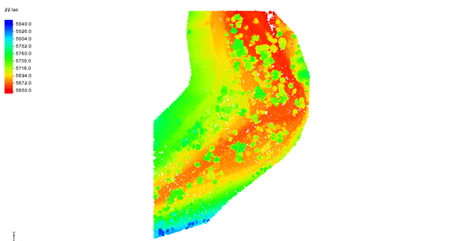

GMS 10.9

GMS 10.9 Tutorial

***Lidar***

Using lidar for interpolation and visualization in GMS

Objectives

This tutorial teaches how lidar data can be used in GMS for display and interpolation.

Time

* 10–20 minutes

Required Components

* GMS Core

Prerequisite Tutorials

* Getting Started

|  |
| --- |
| [1 Introduction 2](#_Toc109917840)  [1.1 Getting Started 2](#_Toc109917841)  [2 Importing Lidar Data 2](#_Toc109917842)  [3 Lidar Display Options 4](#_Toc109917843)  [3.1 Filtering Lidar 4](#_Toc109917844)  [3.2 Contours 5](#_Toc109917845)  [3.3 Color by classification 6](#_Toc109917846)  [3.4 Number of points displayed 6](#_Toc109917847)  [3.5 Bounding box 7](#_Toc109917848)  [3.6 Trimming Lidar 7](#_Toc109917849)  [4 Exporting a Filtered Lidar 8](#_Toc109917850)  [5 Converting Lidar to a Raster 9](#_Toc109917851)  [6 Interpolate Lidar to a UGrid 10](#_Toc109917852)  [7 Filling holes when Interpolating 12](#_Toc109917853)  [8 Multiple Lidar Files 12](#_Toc109917854)  [9 Conclusion 12](#_Toc109917855) |

# Introduction

Lidar stands for Light Detection and Ranging. A lidar file typically contains many 3D points representing features on the Earth’s surface.

Lidar data can be used in GMS for display and interpolation to other objects. A number of features exist to efficiently handle the large amount of data that is typical with lidar, such as options to display a subset of points and exclude points. To maintain efficiency, individual points cannot be selected or edited.

In this tutorial, a lidar file representing the area around Boulder, Colorado, will be imported and used in various ways. Topics covered include:

* Importing a lidar file
* Filtering lidar
* Changing the display options
* Exporting lidar
* Interpolating to ugrids
* Creating a raster from a lidar file

## Getting Started

Do the following to get started:

1. If necessary, launch GMS.
2. If GMS is already running, select the *File |* **New** menu item to ensure that the program settings are restored to their default state.

# Importing Lidar Data

Start with opening a file containing lidar data. Lidar data is typically very dense and the files can be very large.

1. Click the **Open** http://www.xmswiki.com/images/thumb/5/5d/Open_Macro.svg/60px-Open_Macro.svg.png macro to bring up the *Open* dialog.
2. From the *Files of type* drop-down, select “Raster/DEM Files”.
3. Browse to the *lidar\lidar* directory of this tutorial and select “22.las”.
4. Click the **Open** button to close the *Open* dialog.

The Graphics Window should appear similar to Figure 1. This is a lidar of almost one million points located near Boulder, Colorado. Only 50,000 points are being displayed due to the current display options.

Notice in the status bar in the bottom right of the GMS window, the projection is being displayed. The projection information was included in the lidar file and GMS set the display projection to match it. For more information on projections, refer to the “Projections” tutorial.

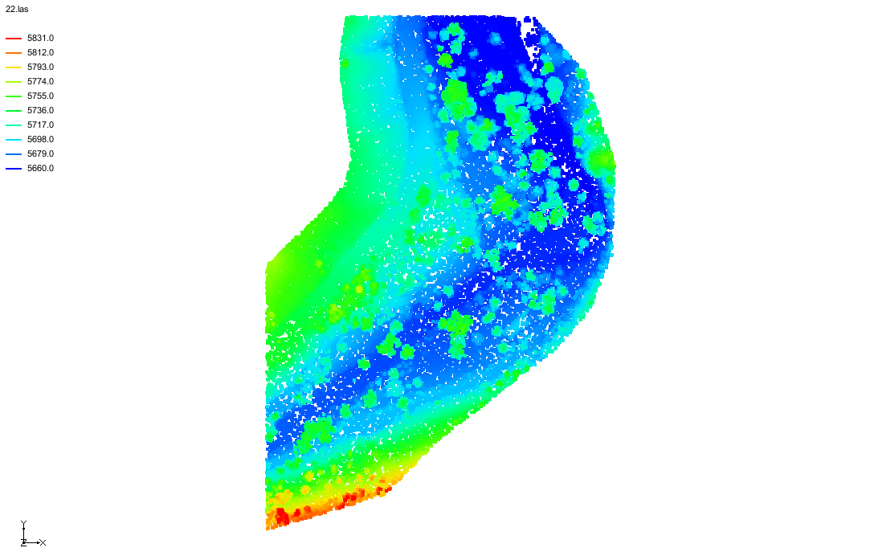

Figure 1 Lidar data in GMS

1. Zoom in and out on the raster using the mouse wheel or the **Zoom** http://www.xmswiki.com/images/thumb/d/df/Zoom_Tool_Icon.svg/56px-Zoom_Tool_Icon.svg.png tool. If zooming in far enough, individual points can be seen as in Figure 2.
2. When done zooming in, click on the **Frame** Frame macro to fit the extents of the data to the screen.

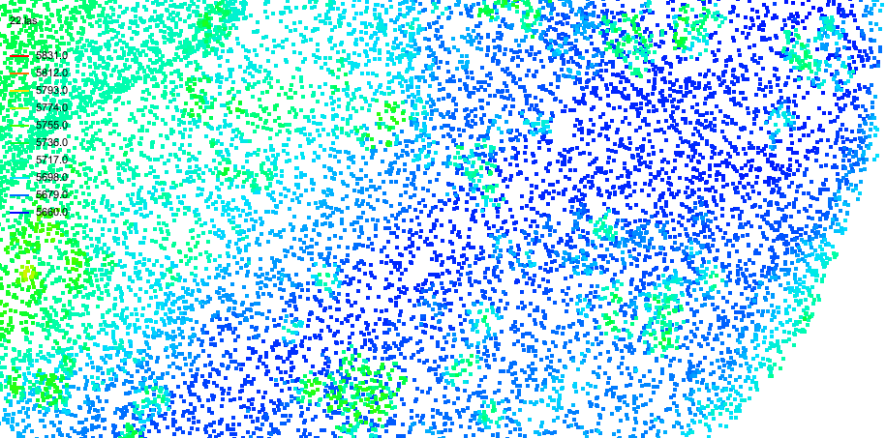

Figure 2 Lidar points

# Lidar Display Options

Each lidar file has its own display options. This differs from how GMS works with most other objects. The lidar display options are accessed by right-clicking on the lidar items in the Project Explorer.

In the *Project Explorer*, right-click on “File:GIS Vector Icon.svg 22.las”, and then select the **Display Options…** context menu item to bring up the *Lidar Display Options* dialog.

A screenshot of Lidar Display Options dialog with sections including Selected files, Points, Exclude point options, and Bounding box.


Figure 3 Lidar Display Options dialog

## Filtering Lidar

Lidar use classifications and return types for each point, signifying a possible trait the points have. The classifications have been given a name based on possible terrain types, however they may not actually represent the given name.

It is possible to filter out points from the display that do not meet certain criteria. On the right side of the dialog, there is an *Exclude by* section. Notice that it currently has *Classification* selected. Below this section is a table listing each existing classification. Notice that each classification is currently checked except “Low Point (Noise)”.

1. In the *Exclude point options* section of the *Lidar Display Options* dialog, in the table, check “Low Point (Noise)”.
2. Click the **Apply** button. If necessary, move the dialog to the side so the graphics window can be seen.

The display should now look something like Figure 4. Notice that by including the extreme values the contour coloring provides a less interesting picture. Note that by turning off the “Low Point (Noise)” points they will not be used if interpolating from “File:GIS Vector Icon.svg22.las”. By default, extreme values are not displayed when importing a lidar file.

|  |  |
| --- | --- |
| Desc-i_gray 100px | Filtering affects the points that are used when interpolating from lidar. |

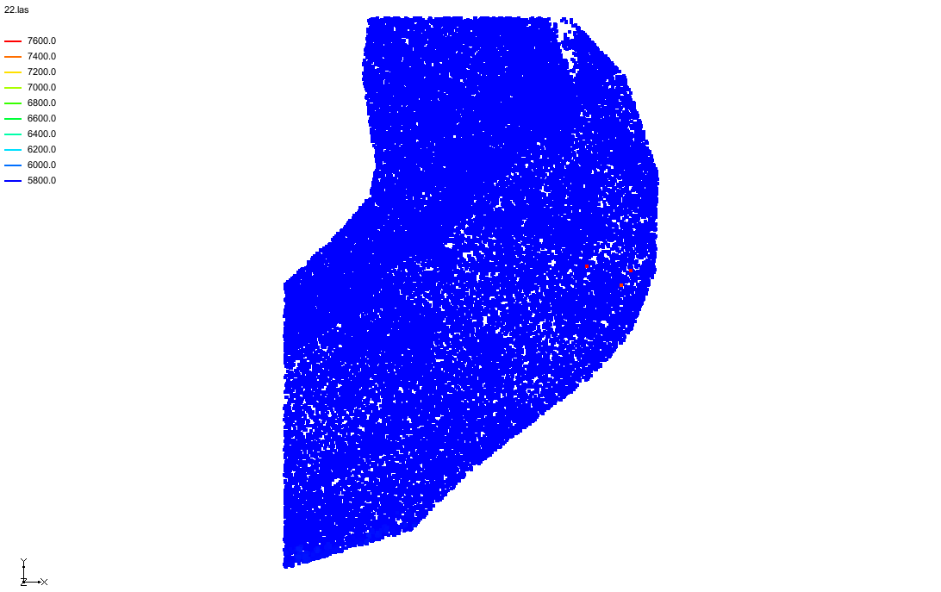

Figure 4 Lidar data filtering out one classification

1. Uncheck the “Low Point (Noise)” checkbox to return to the previous display options.
2. In the *Exclude by* section, click the *Return Type* radio button. Notice that the table below changes.
3. Check the *Second but not-last* checkbox then click the **Apply** button.

The display should now look similar to Figure 5.

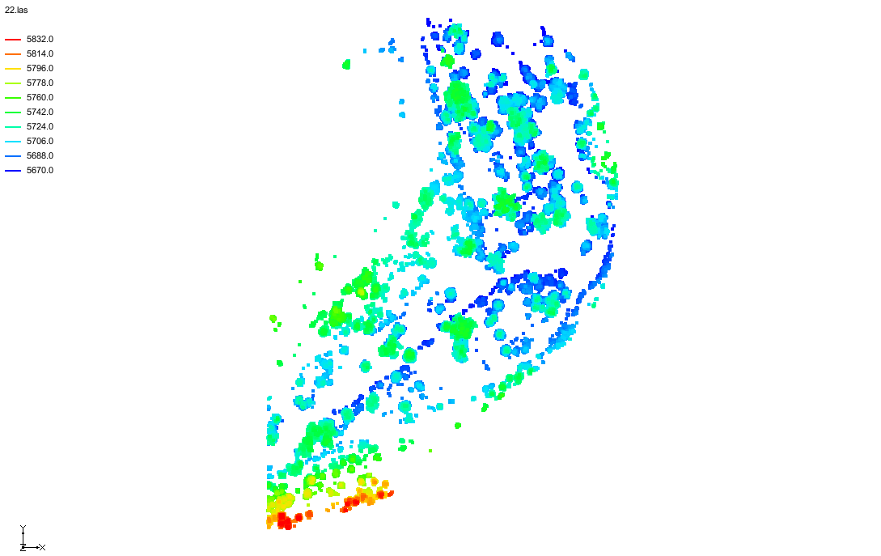

Figure 5 Lidar data filtered by a return type

1. Change the filter back to *Classification* and click the **Apply** button to return to the original display options.

## Contours

1. In the *Points* section, make sure that *Contours* is selected.
2. Click the **Options…** button next to *Contours* to open the *Lidar Contour Options* dialog*.*

The lidar contour options are the same contour options that are used throughout GMS, although some things are disabled.

1. Click the **Color Ramp…** button to open the *Choose color ramp* dialog.
2. Select the *Hue 1* color palette.
3. Click the **Reverse** File:Palette forward.svg button. This reverses the color to value pairings.
4. Click the **OK** button to close the *Choose color ramp* dialog.
5. Click the **OK** button to close the *Lidar Contour Options* dialog.
6. Click the **Apply** button in the *Lidar Display Options* dialog.

Notice that the contours are still visible, but now blue is used for the maximum value instead of the minimum value.

## Color by classification

Now to look at assigning classification specific colors:

1. In the *Points* section, select *Color by classification*.
2. In the table on the right of the dialog, change the color of “Unclassified” to green, “Ground” to brown, and “Water” to blue.
3. Click the **Apply** button.

The display should now look similar to Figure 6.

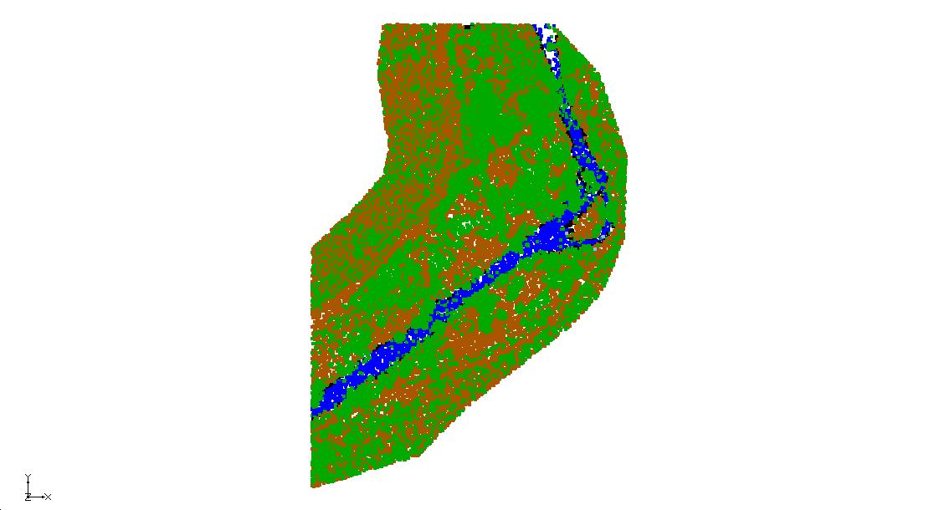

Figure 6 Points colored by classification

## Number of points displayed

In the *Points* section of the *Lidar Display Options* dialog, notice that the *Total number of points in file* is more than the *Number of points displayed*. Because lidar files typically have a lot of points, GMS only displays the number of points specified in order to speed up the display of the lidar file. However, when the lidar is used as an interpolation source, GMS uses all the points in the file, not just those being displayed.

|  |  |
| --- | --- |
| Desc-i_gray 100px | The number of points displayed does NOT affect the points used when interpolating from lidar. |

1. In the *Lidar Display Options* dialog, in the *Points* section, compare the *Total number of points in the file* and the *Number of points displayed*.
2. Change the *Max number of points displayed* to 100,000 and click the **Apply** button.

Notice there are more points being displayed.

## Bounding box

With some files, it can be hard to identify the extents of the lidar. To resolve this issue:

1. In the *Lidar Display Options* dialog, in the *Bounding box* section, check the box marked *Show bounding box.*
2. Click the **OK** button to close the *Lidar Display Options* dialog.
3. Click the **Oblique View** http://www.xmswiki.com/images/thumb/c/cd/Oblique_View_Macro.svg/49px-Oblique_View_Macro.svg.png macro.

Notice that this created a box around the extents of the lidar. The box style can be changed by clicking the **Options…** button next to the *Show bounding box* option.

## Trimming Lidar

Sometimes the lidar covers an area much larger than the area of interest. Lidar can be trimmed to the area of interest. Note that when a trimmed lidar is used as an interpolation source, only the trimmed area is used.

|  |  |
| --- | --- |
| Desc-i_gray 100px | Trimming affects the points that are used when interpolating from lidar. |

1. Switch to plan view by clicking on the **Plan View** File:Plan View Macro.svgmacro.
2. Use the **Zoom** http://www.xmswiki.com/images/thumb/d/df/Zoom_Tool_Icon.svg/56px-Zoom_Tool_Icon.svg.png tool to zoom in on the right side of the points as shown in Figure 7.

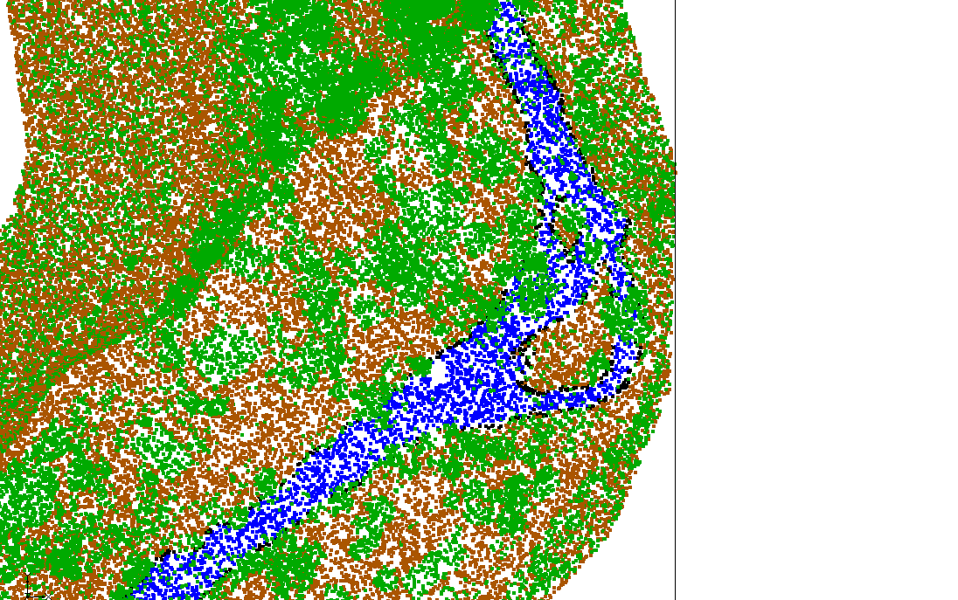

Figure 7 Zoomed in on right side

1. In the *Project Explorer*, return to the *Lidar Display Options* dialog by right-clicking on “File:GIS Vector Icon.svg 22.las” and selecting the **Display Options…** command.
2. In the upper-right corner, check *Exclusion extents*, then click the **Options…** button next to it to being up the *Lidar Exclusion Extents* dialog.
3. Turn on the *X/Y* checkbox option.
4. Click the **Update**button. This sets the *Min* and *Max* values in the table.

The **Update** button gets the X and Y extents of the current view and updates the values in the table below. For the **Update** button to work, the display must be in Plan View. The min and max X, Y, and Z values can also be edited manually if desired.

1. Click the **OK** button to close the *Lidar Exclusions Extents* dialog.
2. Click the **OK** button to close the *Lidar Display Options* dialog.
3. Switch to **Oblique View** http://www.xmswiki.com/images/thumb/c/cd/Oblique_View_Macro.svg/49px-Oblique_View_Macro.svg.png.

Notice the lidar extents have been trimmed and the display should look something like Figure 8.

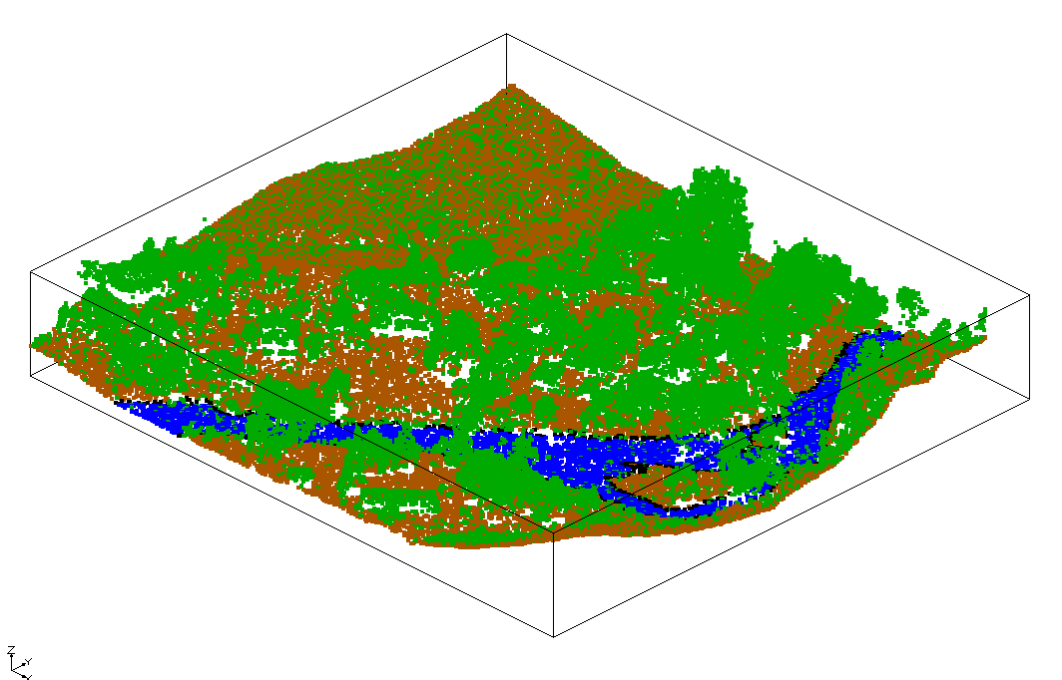

Figure 8 Trimmed lidar

# Exporting a Filtered Lidar

GMS can export a filtered lidar file. The exported file will only include the filtered points.

1. In the *Project Explorer*, right-click on “File:GIS Vector Icon.svg 22.las”, and click **Export…** to open the *Lidar File* dialog.
2. For the *File Name,* enter “22\_filtered”.
3. Click the **Save** button to close the *Lidar File* dialog and export the lidar file.

If desired, the file could be changed by using the drop-down menu and saved as a \*.laz file (compressed). A \*.laz file is the same as a \*.las file but compressed.

1. Click the **New** File:New Macro.svg macro.
2. Select the **Don’t Save** button at the prompt.
3. Click the **Open** http://www.xmswiki.com/images/thumb/5/5d/Open_Macro.svg/60px-Open_Macro.svg.png macro to bring up the *Open* dialog**.**
4. From the *Files of type* drop-down, select “Raster/DEM Files”.
5. Select the “22\_filtered.las” file and click the **Open** button.

The display should appear similar to Figure 9.

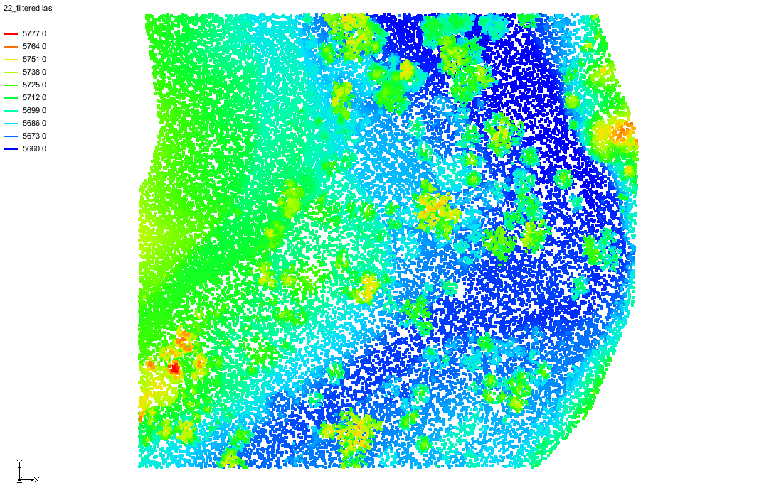

Figure 9 Filtered lidar

1. In the *Project Explorer*, right-click on “File:GIS Vector Icon.svg 22\_filtered.las”, and then select the **Display Options** context menu item to bring up the *Lidar Display Options* dialog.

Notice in the *Classification* table “Low Point (Noise)” is no longer present, because when exporting the previous lidar file, “Low Point (Noise)” was filtered out.

1. Click the **Cancel** button to close the *Lidar Display Options* dialog.

# Converting Lidar to a Raster

Lidar data can be converted into a raster. Unlike lidar, rasters are uniformly gridded data. Since rasters can also be used as a source of interpolation, it can be useful to convert the lidar to a raster that has fewer data points and then use the raster for interpolation thereafter. In this case, the raster would use less memory and would draw faster than the lidar.

Convert a lidar to a raster by doing the following:

1. In the *Project Explorer*, right-click on “File:GIS Vector Icon.svg 22\_filtered.las”, then click the *Interpolate To*| **Raster…** context menu item to open the *Interpolate Lidar to Raster* dialog.
2. Change the *Cell size* to “2”.

Notice that the cells (X Y) boxes changed their values to fit the *Cell size*.

1. Click the **OK** button to close the *Interpolate Lidar to Raster* dialog and open the *Raster File* dialog.
2. Click the **Save** button to close the *Raster File* dialog without changing the default filename.
3. Uncheck “File:GIS Vector Icon.svg 22\_filtered.las” in the *Project Explorer*.

The raster now in the display should look similar to Figure 10.

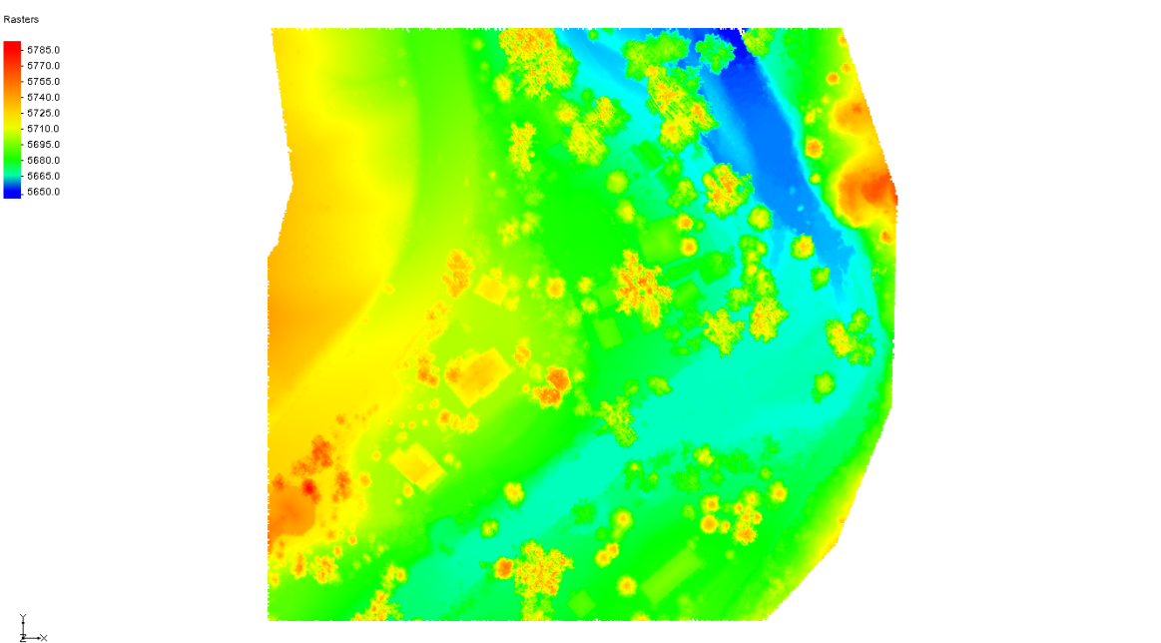

Figure 10 Raster converted from lidar

# Interpolate Lidar to a UGrid

Lidar can be interpolated to a UGrid. Start with importing a 2D UGrid.

1. In the *Project Explorer*, turn off “File:GIS Raster Icon.svg 22\_filtered.tif” and turn on “File:GIS Vector Icon.svg 22\_filtered.las”.
2. Click the **Open** http://www.xmswiki.com/images/thumb/5/5d/Open_Macro.svg/60px-Open_Macro.svg.png macro to bring up the *Open* dialog**.**
3. From the *Files of type* drop-down, select “All Files (\*.\*)”.
4. Select the “ugrid.vtu” file and click the **Open** button.

This is a 2D grid that is in a location where a groundwater model will be created.

1. A warning may appear regarding setting the projection. Click the **OK** button to open the *Projections – Project\UGrid\ugrid* dialog.
2. Select *Global projection* which should be set to “NAD83(NSRS2007) / NAD83(NSRS2007) / Colorado North (ftUS)” to georeference the file and click the **OK** button to close the *Projections – Project\UGrid\ugrid* dialog.
3. In the *Project Explorer,* right-click on “File:GIS Vector Icon.svg 22\_filtered.las” and click the *Interpolate to*| **UGrid** contextmenu item to open the *Interpolate Lidar to UGrid* dialog.

The target UGrid can be specified, but it should already be set to the one that was just opened so it does not need to be changed. The lidar can be interpolated to either the UGrid points (cell corners) or to the cell centers. The area average radius defines a square surrounding each point being interpolated to, with the length of each square side equaling twice the radius. The lidar points found within each box are averaged to determine the interpolated value at the UGrid point, as shown in Figure 11.

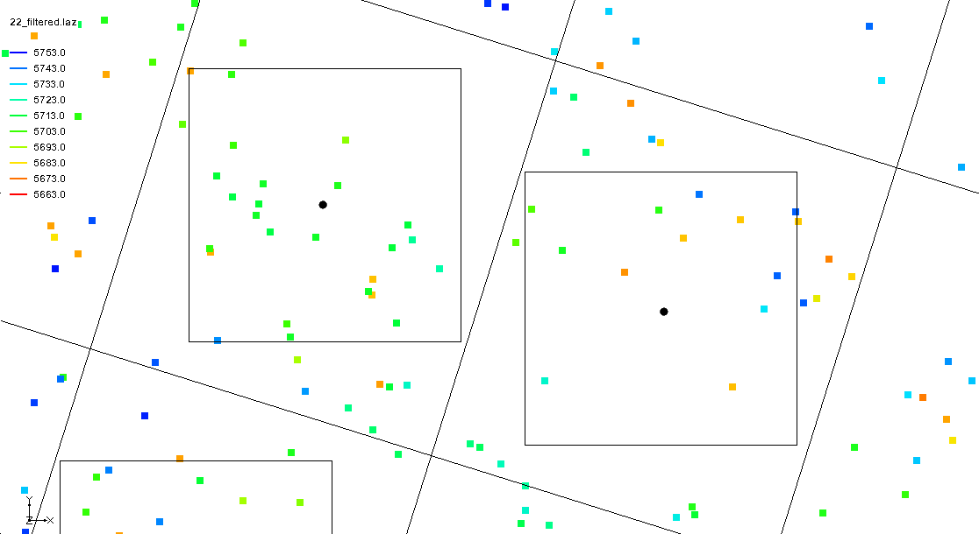

Figure 11 Area average radius defining boxes around cell centers

1. In the *Target dataset location* section, select *Cell centers*.
2. Click the **OK** button to close the *Interpolate Lidar to UGrid* dialog.

Notice that a new dataset appeared under “File:UGrid 2D Locked.svg ugrid” in the Project Explorer, titled “File:Dataset Cells Active.svg 22\_filtered”. To see the interpolated values of the UGrid, turn on contours for the UGrid.

1. Click the **Display Options** File:Display Options Macro.svg macro to open the *Display Options* dialog.
2. From the list on the left, select “UGrid: ugrid – [Active]”.
3. Turn on *Define UGrid specific options* by checking the checkbox.
4. In the lower section, check on *Face contours.*
5. Select the **Options…** button next to *Face contours* to bring up the *Dataset Contour Options – UGrid – 22\_filtered* dialog.
6. In the *Contour method* section, from the *Contour method* drop-down, select “Block Fill”.
7. Click the **OK** button to close the *Dataset Contour Options – Ugrid – 22\_filtered* dialog.
8. Click the **OK** button to close the *Display Options* dialog.
9. Turn off “File:GIS Vector Icon.svg 22\_filtered.las” by unchecking the checkbox.

The display should now look something like Figure 12.

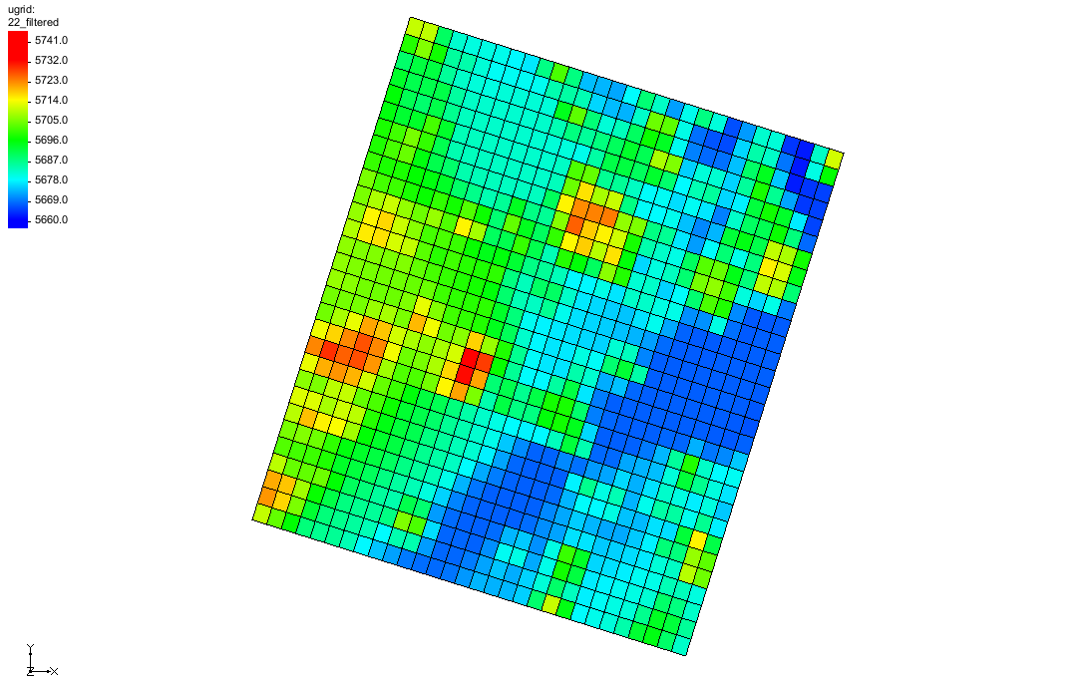

Figure 12 UGrid with interpolated values

# Filling holes when Interpolating

When interpolating from a lidar to create a raster or to create a new dataset on a UGrid, there may be sparse areas in the lidar that would potentially leave “holes” in the raster or dataset. GMS will attempt to fill these holes by interpolating from the raster or UGrid cells around the hole, if the hole is surrounded by cells that have valid data. Sparse areas that are not completely surrounded by cells with valid data will be left with “no data” values.

# Multiple Lidar Files

Multiple lidar files can be used when creating rasters and interpolating to UGrids. This is demonstrated in the “Lidar with Multiple Files” tutorial.

# Conclusion

This concludes the GMS “Lidar” tutorial. The following topics were discussed and demonstrated:

* Lidar are images with elevation data.
* Lidar can be filtered and trimmed to show the desired data.
* Lidar can be exported.
* Lidar can be converted to rasters or interpolated to UGrids.