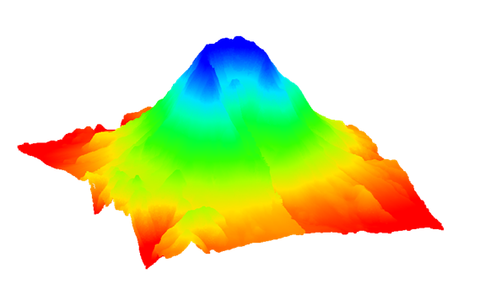

GMS 10.9

GMS 10.9 Tutorial

***Lidar with Multiple Files***

Using multiple lidar files for interpolation in GMS

Objectives

This tutorial teaches how multiple lidar files can be used in GMS for display and interpolation to rasters and UGrids.

Time

* 10–20 minutes

Required Components

* GMS Core

Prerequisite Tutorials

* Lidar

|  |
| --- |
| 1 Introduction 2  1.1 Getting Started 2  2 Importing Multiple Lidar Files 2  3 Merging Lidar Files 4  3.1 Exporting a Merged Lidar File 4  3.2 Importing a Merged Lidar File 4  4 Converting Lidar to a Raster Using Multiple Files 5  5 Interpolate Lidar to a UGrid Using Multiple Files 6  6 Conclusion 7 |

# Introduction

Lidar is commonly used to collect elevation and shallow bathymetric data, which can be saved as point clouds or rasters. These datasets can be imported into GMS for use in various projects. If multiple lidar files are loaded into GMS, they can be used to collectively generate rasters, interpolate to UGrids, or be merged for convenience.

For discussion of the basic lidar interface in GMS, please refer to the “Lidar” tutorial. It is recommended that tutorial be completed prior to this tutorial.

## Getting Started

Do the following to get started:

1. If necessary, launch GMS.
2. If GMS is already running, select *File |* **New** to ensure that the program settings are restored to their default state.

# Importing Multiple Lidar Files

Begin by opening four lidar files containing data from Mount St. Helens, a volcano located in Washington State in the United States that erupted violently in 1980.

Open the four files by doing the following:

1. Click **Open** File:Open Macro.svg to bring up the *Open* dialog.
2. Browse to the *\lidarWithMultipleFiles\lidarWithMultipleFiles* directory.
3. Select “Raster/DEM Files” from the *Files of type* drop-down.
4. While holding the *Shift* key down, select “mounnelst.las”, “mounnwlst.las”, “mounselst.las”, and “mounnswlst.las”.
5. Click **Open** to close the *Open* dialog and import the files.

After several seconds, the Graphics Window should appear similar to Figure 1. By default, GMS displays a maximum of 50,000 points per lidar file, so 200,000 points are being drawn. The total number of points is over 23 million.

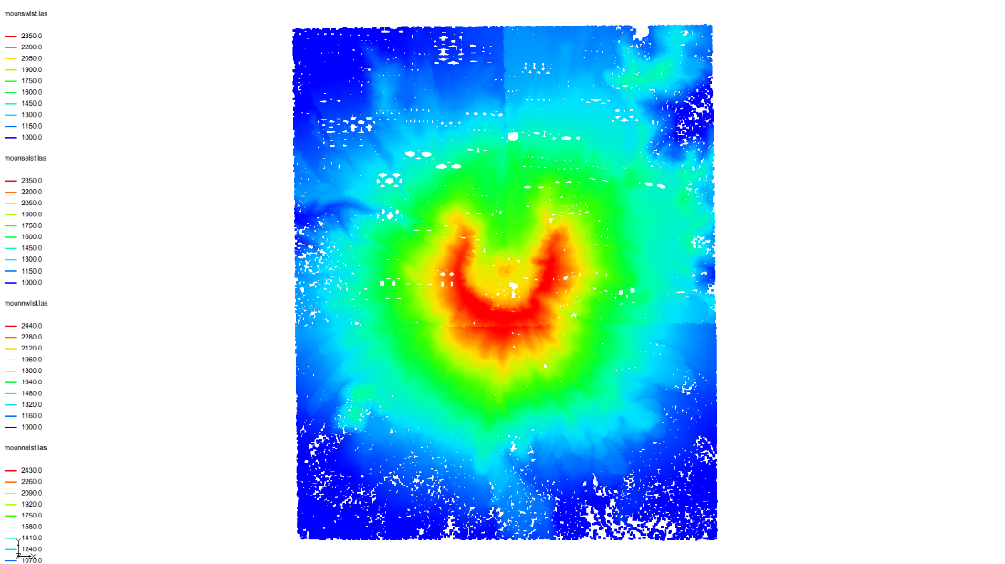

Figure 1 Mount St. Helens lidar files

Now change the perspective to be able to see the elevation more clearly.

1. Switch to **Oblique View** File:Oblique View Macro.svg.

The project should now appear similar to Figure 2.

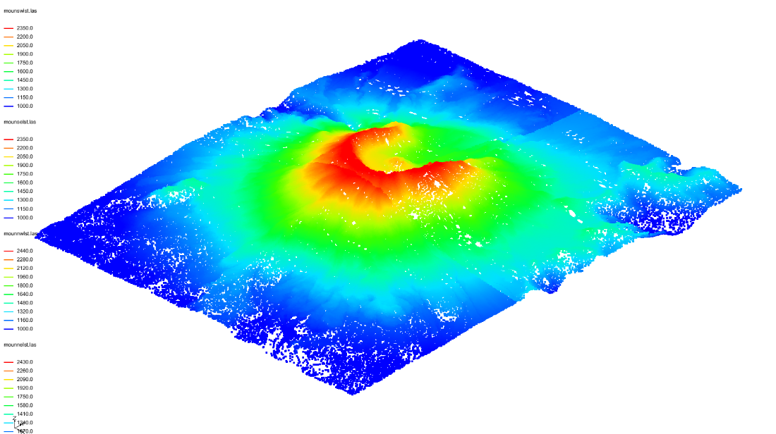

Figure 2 In oblique view

Now return the view to the top-down, or **Plan View**, by doing the following:

1. Switch to **Plan View** File:Plan View Macro.svg.

Note that the edges of each lidar file are visible as breaks in the color shading. This occurs because each file has its own display settings, including separate minimum and maximum values used for contouring. One way to correct this is to set a consistent contour range across all files. Alternatively, merging the lidar files into a single dataset, as shown in the next section, will also resolve the issue.

# Merging Lidar Files

Multiple lidar files can be merged into one file. GMS creates a new lidar file that contains the data of all the individual files.

## Exporting a Merged Lidar File

1. In the Project Explorer, select all four Mount St. Helens lidar files by selecting the first file, holding down the *Shift* key, and selecting the last file.
2. Right-click on any of the selected files and select the **Merge…** command to open the *Lidar File* dialog.
3. Enter “all.laz” in the *File name* field and click **Save**.

It may take several seconds to create the merged file. The LAZ format is a compressed lidar format.

## Importing a Merged Lidar File

To import the file that was just created:

1. Click **Open** File:Open Macro.svg to bring up the *Open* dialog.
2. Select “Raster/DEM Files” from the *Files of type* drop-down.
3. Select the “all.laz” file.
4. Click **Open** to close the *Open* dialog.
5. In the Project Explorer, turn off the original four LAS files.

Note that the merged file appears sparser because only 50,000 points are being drawn to represent a full dataset of 23 million points (Figure 3). This can be changed by increasing the number of points displayed in the *Lidar Display Options* dialog.

Also note that the coloration is now smooth with no sharp breaks. This is because there is only one minimum and maximum range used for contouring.

For the remainder of the tutorial, the original four lidar files will be used, so the merged lidar file can be removed.

1. In the Project Explorer, right-click the “File:GIS Vector Icon.svg all.laz” file and select **Remove**.
2. Turn on the four LAS files.

Figure 3 View of merged files

# Converting Lidar to a Raster Using Multiple Files

A raster can be created from multiple lidar files. If the files overlap, the overlapping data will be averaged to get the raster values.

Convert all the lidar to a raster by doing the following:

1. In the Project Explorer, select all four lidar files using the *Shift* key.
2. Right-click on any of the selected files and choose the *Interpolate To* **| Raster** command to open the *Interpolate* *Lidar to Raster* dialog.
3. Accept all of the default values and click **OK** to open the *Raster File* dialog.
4. Change the *File name* to “all” and click **Save** to close the *Raster File* dialog.
5. In the Project Explorer, turn off the original four LAS files.

The raster should appear similar to Figure 4.

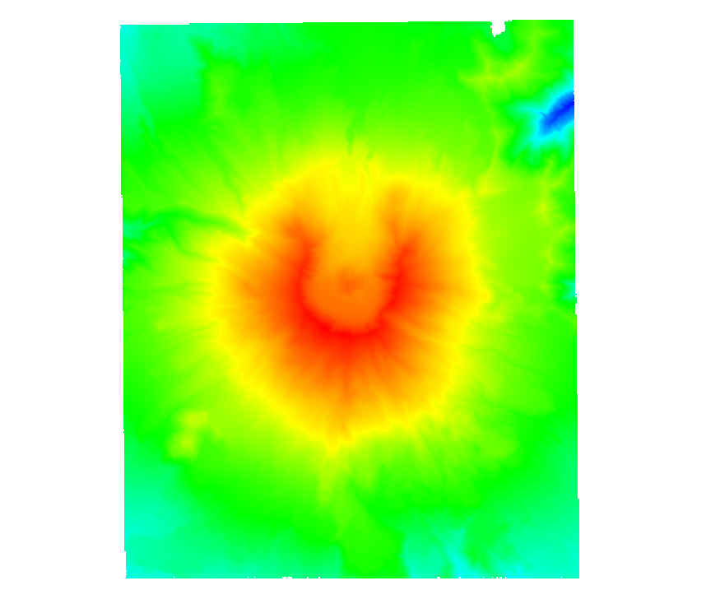

Figure 4 Raster converted from multiple lidar files

The rest of the tutorial does not use the raster file, so it can be deleted.

1. In the Project Explorer, right-click the “File:GIS Raster Icon.svg all.tif” file and select **Remove**.
2. Turn on “File:GIS Folder.svg GIS Layers” to turn on all of the lidar files.

# Interpolate Lidar to a UGrid Using Multiple Files

Multiple lidar files can be interpolated to a UGrid in the same way the raster was created. If the files overlap, the data values in the overlapping regions are averaged during interpolation.

Start with importing a 2D UGrid.

1. Click **Open** File:Open Macro.svg to bring up the *Open* dialog.
2. Select “All Files (*.*)” from the *Files of type* drop-down.
3. Select “multipleLidar.vtu” and click **Open***.*

This is a 2D grid that is in a location where a groundwater model could be created.

1. Select all of the LAS files in the Project Explorer.
2. Right-click on any of the selected files and select *Interpolate To* **| UGrid** to open the *Interpolate Lidar to UGrid* dialog.
3. In the *Target dataset location* section, select *Points*.
4. Enter “all” as the *New dataset name*.
5. Click **OK** to close the *Interpolate Lidar to UGrid* dialog.

Once it is done processing, notice the new “File:Dataset Points Active.svg all” dataset under the “http://www.xmswiki.com/images/thumb/a/a9/UGrid_3D_Folder.svg/60px-UGrid_3D_Folder.svg.png UGrid Data” folder in the Project Explorer. To see the interpolated values of the UGrid, turn on contours for the UGrid.

1. Click the **Display Options** File:Display Options Macro.svg macro to open the *Display Options* dialog.
2. Select “UGrid: multipleLidar – [Active]” from the list on the left.
3. Check *Define UGRID specific options.*
4. Check *Face contours.*
5. Click on **Options…** next to *Face contours* to bring up the *Dataset Contour Options – UGrid – all* dialog.
6. From the *Contour method* drop-down, select “Block Fill”.
7. Click **OK** to close the *Dataset Contour Options – UGrid – all* dialog.
8. Click **OK** to close the *Display Options* dialog.
9. Uncheck “File:GIS Folder.svg GIS Layers” in the Project Explorer.
10. Switch to **Plan View** File:Plan View Macro.svg.

The display should now appear similar to 5.

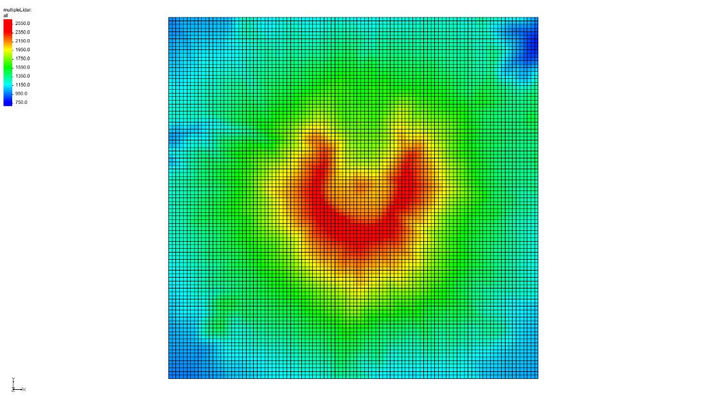

Figure 5 UGrid with interpolated values from multiple lidar

# Conclusion

This concludes the GMS “Lidar with Multiple Files” tutorial. The following topics were discussed and demonstrated:

* Multiple lidar can be displayed and used for interpolation to rasters and UGrids
* GMS can merge multiple lidar files into a single lidar file
* Lidar files each have their own display options