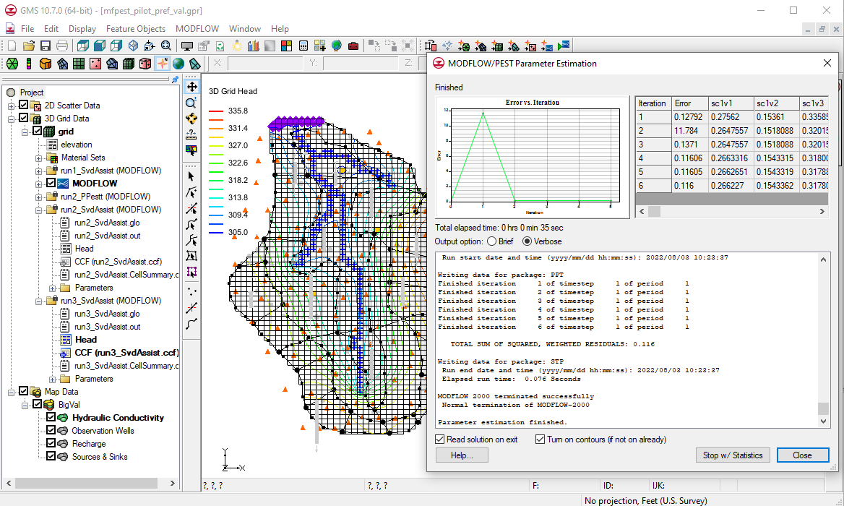

GMS 10.9

GMS 10.9 Tutorial

***MODFLOW – Advanced PEST***

Parallel PEST, SVD-Assist, Pilot Points

Objectives

Learn how to parameterize a MODFLOW model and run PEST to obtain optimal parameter values. Experiment with truncated singular value decomposition (SVD), SVD-Assist, and Parallel PEST.

Time

* 50–70 minutes

Required Components

* GMS Core
* MODFLOW Interface
* Geostatistics
* PEST
* Parallel PEST

Prerequisite Tutorials

* MODFLOW – PEST Pilot Points

|  |
| --- |
| [1 Introduction 2](#_Toc110415159)  [1.1 Getting Started 2](#_Toc110415160)  [2 Parallel PEST 3](#_Toc110415161)  [2.1 Saving the Project and Running Parallel PEST 4](#_Toc110415162)  [3 Parallel PEST with SVD-Assist 5](#_Toc110415163)  [3.1 Specifying a Precomputed Jacobian 6](#_Toc110415164)  [3.2 Changing the Regularization Option 7](#_Toc110415165)  [4 Multiple Parameters Using Pilot Points 8](#_Toc110415166)  [4.1 Creating a Second Set of Pilot Points 9](#_Toc110415167)  [4.2 Creating the New HK Parameter 10](#_Toc110415168)  [4.3 Using Pilot Points with RCH Parameter 10](#_Toc110415169)  [4.4 Saving the Project and Running PEST 11](#_Toc110415170)  [5 A Note on Highly Parameterized Models 12](#_Toc110415171)  [6 Conclusion 13](#_Toc110415172) |

# Introduction

The “MODFLOW – Automated Parameter Estimation” tutorial describes the basic functionality of PEST provided in GMS. It illustrates how to parameterize a MODFLOW model and run PEST to obtain optimal parameter values. This tutorial describes several PEST features, including Truncated Singular Value Decomposition (SVD), SVD-Assist, and Parallel PEST.

Each of these features is intended to decrease the amount of time necessary for PEST to complete the optimization process. The SVD options focus on identifying and removing insensitive parameters from the model inversion process, while Parallel PEST speeds up the inversion process by running more models simultaneously.

The model in this tutorial is the same model featured in the “MODFLOW – Model Calibration” tutorial. The model includes observed flow data for the stream and observed heads at a set of scattered observation wells. The conceptual model for the site consists of a set of recharge and hydraulic conductivity zones. These zones will be marked as parameters, and an inverse model will be used to find a set of recharge and hydraulic conductivity values that minimize the calibration error. It will utilize two methods for model parameterization: polygonal zones and pilot point interpolation.

This tutorial will demonstrate and discuss:

* Opening a MODFLOW model and solution.
* Running the model and solution with just Parallel PEST.
* Using SVD and SVD-Assist.
* Using SVD and SVD-Assist with a different regularization option.
* Using SVD and SVD-Assist with multiple parameters and sets of pilot points.

## Getting Started

Do the following to get started:

1. If necessary, launch GMS.
2. If GMS is already running, select *File |* **New** to ensure that the program settings are restored to their default state.
3. If asked to save changes, click **Don’t Save** to close the dialog and restore GMS to a default state.

# Parallel PEST

All of the steps required to run PEST must also be followed to run Parallel PEST. The only additional inputs required are to 1) specify the number of models that can be run simultaneously by PEST, and 2) specifying a “WAIT” variable. The WAIT variable is described by the PEST documentation as the amount of time that PEST and PSLAVE will pause at certain strategic places in their communication. Normally, the default value should work fine. However, if either PEST or PSLAVE reports a sharing violation on the hard drive, then increase the value of the WAIT variable.

To illustrate Parallel PEST and SVD-Assist, start with an existing project.

1. Click **Open** File:Open Macro.svg to bring up the *Open* dialog.
2. Select “Project Files (\*.gpr)” from the *Files of type* drop-down.
3. Browse to the *advPEST/advPEST* directory and select “run1\_SvdAssist.gpr”.
4. Click **Open** to import the project file and exit the *Open* dialog.

A MODFLOW model should appear with a solution and a set of map coverages (Figure 1). Three of the coverages are the source/sink, recharge, and hydraulic conductivity coverages used to define the conceptual model. The active coverage contains a set of observed head values from observation wells. In the source/sink coverage, an observed flow value has been assigned to the stream network.

1. Select *MODFLOW |* **Global Options…** to open the *MODFLOW Global/Basic Package* dialog.
2. In the *Run options* section, select *Parameter Estimation.*
3. Click **OK** to exit the *MODFLOW Global/Basic Package* dialog.
4. Select *MODFLOW |* **Parameter Estimation…** to open the *PEST* dialog.
5. For the *Max number of iterations* *(NOPTMAX),* enter “2”.
6. In the *Parallel PEST* section, turn on *Use Parallel Pest*.
7. Click **OK** to exit the *PEST* dialog.

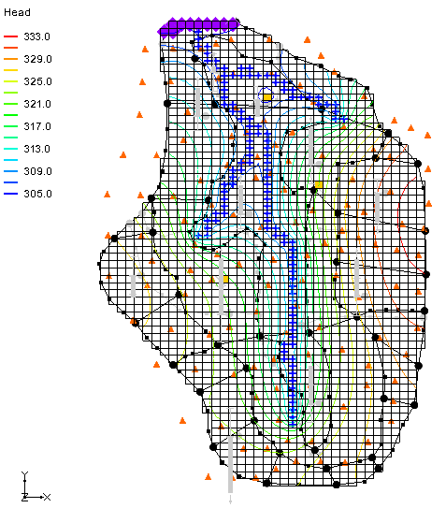

Figure 1 Initial model

## Saving the Project and Running Parallel PEST

Now to save the project prior to running parallel PEST:

1. Select *File |* **Save As…** to bring up the *Save As* dialog.
2. Browse to the *advPEST/advPEST* directory.
3. Select “Project Files (\*.gpr)” from the *Save as type* drop-down.
4. Enter “run2\_PPest.gpr” as the *File name*.
5. Click **Save** to export the file under the new name and close the *Save As* dialog.
6. Click **Run MODFLOW** File:Run MODFLOW Macro.svg to bring up the *MODFLOW/PEST Parameter Estimation* dialog.

At this point, a number of new command prompt windows are created. These are called “slaves”, and the number created depends on the number of available cores on the computer being used. This number can also be specified manually in the *Parallel PEST* section of the *PEST* dialog (the same dialog accessed in the previous section). The command prompts running PSLAVE are initially minimized.

The *MODFLOW/PEST Parameter Estimation* dialog reads the output from Parallel PEST and updates the model error and parameter values for each PEST iteration. If the **Abort** button is clicked prior to the MODFLOW run finishing, all of the Parallel PEST processes will be terminated. Once the MODFLOW run finishes, the **Abort** button will change to **Close**. Clicking the **Stop w/ Statistics** button causes Parallel PEST to stop at its current iteration.

Parallel PEST may take a few minutes to run two iterations with the current model, depending on the speed of the computer. MODFLOW is run 129 times for each of the PEST iterations—once for each pilot point being estimated.

1. Once the MODFLOW parameter estimation has finished, turn on *Read solution on exit* and *Turn on contours (if not on already).*
2. Click **Close** to exit the *MODFLOW/PEST Parameter Estimation* dialog.

There should be no visible changes in the displayed model.

# Parallel PEST with SVD-Assist

Now to run Parallel PEST again with the SVD-Assist option turned on. This process is particularly advantageous for models that have hundreds or thousands of parameters (such as pilot points).

SVD-Assist involves 3 basic steps. First, PEST runs MODFLOW once for every parameter in order to compute a matrix. This information is used to create super parameters that are combinations of the parameters originally specified.

Second, SVDAPREP is run to create a new PEST control file. The options for SVDAPREP are entered by clicking the **SVD-Assist Options…** button in the *PEST* dialog. For more information on each of these options, see the PEST manual.[[1]](#footnote-1) The most important option entered is the *Specify # super param,* set to “No” by default. When this option is set to “No”, the information written to the SVD file will be used to specify the number of super parameters.

Third, PEST runs using the new control file written by SVDAPREP. This should result in significantly fewer model runs for each PEST iteration. This often results in an order of magnitude reduction in the number of runs required for each PEST iteration.

1. Select *MODFLOW |* **Parameter Estimation…** to open the *PEST* dialog.
2. For the *Max number of iterations* (*NOPTMAX),* enter “15”.
3. In the *SVD options* section, turn on *Use SVD* and *Use SVD-Assist*.
4. Click **OK** to exit the *PEST* dialog.
5. Select *File |* **Save As…** to bring up the *Save As* dialog.
6. Select “Project Files (\*.gpr)” from the *Save as type* drop-down.
7. Enter “run2\_SvdAssist.gpr” as the *File name* and click **Save** to exit the *Save As* dialog.
8. Click **Run MODFLOW** File:Run MODFLOW Macro.svg to bring up the *MODFLOW/PEST Parameter Estimation* dialog.

Note: Each PEST iteration only requires 11 or 22 MODFLOW runs after the initial run of 129. When PEST finishes running, the error should be about “0.1”.

1. When PEST finishes, turn on *Read solution on exit* and *Turn on contours (if not on already)*.
2. Click **Close** to exit the *MODFLOW/PEST Parameter Estimation* dialog.

The model will change slightly (Figure 2). Feel free to compare the differences between   
“File:Generic Folder Locked.svg run2\_PPest (MODFLOW)” and “File:Generic Folder Locked.svg run2\_SvdAssist (MODFLOW)”.

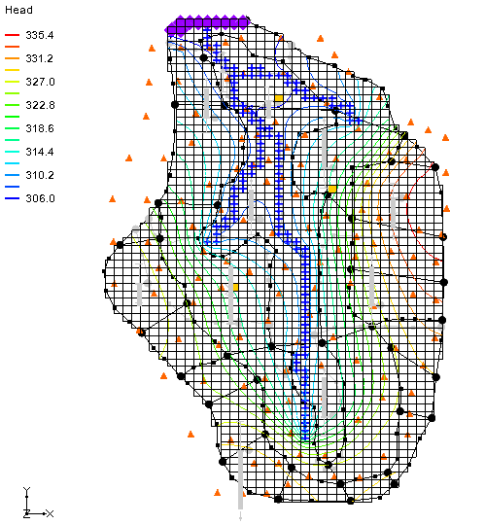

Figure 2 Changes after PEST run with SVD-Assist

When PEST runs with SVD-Assist, the parameter values are not written to the PAR file because this file contains the values for the super parameters. The base parameter values are written to a BPA file.

1. Select *MODFLOW |* **Parameters…** to bring up the *Parameters* dialog.
2. Click **Import Optimal Values…** to bring up the *Open* dialog.
3. Browse to the *advPEST/advPEST/run2\_SvdAssist\_MODFLOW* directory and select “run2\_SvdAssist.bpa”.
4. Click **Open** to exit the *Open* dialog.
5. Click **OK** to close the *Parameters* dialog.

## Specifying a Precomputed Jacobian

The first step in the SVD-Assist process can be skipped when rerunning the model. The Jacobian and SVD files must be specified, then SVDAPREP is run followed by Parallel PEST.

1. Select *MODFLOW |* **Parameter Estimation…** to open the *PEST* dialog.
2. Click on the **SVD-Assist Options…** button to open the *SVD-Assist Options* dialog.
3. Change the value of the *Specify Jacobian file* row to “Yes”.
4. Outside of GMS, open a new Windows Explorer window and browse to the *advPEST/advPEST/run2\_SvdAssist\_MODFLOW* directory.
5. Find the full path and file name, for the *Jacobian file path* field, from the previous run. The file will have a \*.jco extension. Example: *C:\advPEST\advPEST\run2\_SvdAssist\_MODFLOW\run2\_svdassist.jco*.
6. Find the full path and file name, for the *SVD file path* field, from the previous run. The path will be similar to the following: *C:\advPEST\advPEST\run2\_SvdAssist\_MODFLOW\run2\_svdassist.svd*.
7. Once these paths have been entered into the *SVD-Assist Options* dialog, click **OK** to exit the *SVD-Assist Options* dialog.
8. Click **OK** to exit the *PEST* dialog.

### Saving the Project

Before continuing, save the project with a new file name.

1. Select *File |* **Save As…** to bring up the *Save As* dialog.
2. Select “Project Files (\*.gpr)” from the *Save as type* drop-down.
3. Enter “run3\_SvdAssist.gpr” as the *File name* and click **Save** to exit the *Save As* dialog.

### Running PEST

With all of the changes saved, PEST can now be run.

1. Click **Run MODFLOW** File:Run MODFLOW Macro.svg to bring up the *MODFLOW/PEST Parameter Estimation* dialog.

PEST will take several minutes to run. When PEST is finished, a “Parameter estimation finished” message will appear in the text portion of the window and the **Abort** button will change to **Close**.

1. When PEST finishes, turn on *Read solution on exit* and *Turn on contours (if not on already)*.
2. Click **Close** to exit the *MODFLOW/PEST Parameter Estimation* dialog.

When PEST is finished running the solution will be the same as that computed in Section 3.

## Changing the Regularization Option

Now try it with the regularization option set to use the *Preferred value regularization* method.

1. Select MODFLOW | **Parameter Estimation…** to open the *PEST* dialog.
2. In the *Tikhonov regularization (only used with pilot points)* section, turn off *Preferred homogeneous regularization* and turn on *Preferred value regularization*.
3. Click **OK** to close the *PEST* dialog.

### Saving the Project

Before continuing, save the project with a new file name.

1. Select *File* | **Save As…** to bring up the *Save As* dialog.
2. Select “Project Files (\*.gpr)” from the *Save as type* drop-down.
3. Enter **“**mfpest\_pilot\_pref\_val.gpr” as the *File name*.
4. Click **Save** to close the *Save As* dialog.

### Prior Information Equations

If desired, compare the different prior information equations written from GMS by looking at the RPF files in the MODFLOW directories. The prior information equations for *Preferred homogenous regularization*, found in the “run2\_SvdAssist.rpf” file in the *advPEST\advPEST\run2\_SvdAssist\_MODFLOW* directory, should look like Figure 3.

GMS 10_1 - MODFLOW-AdvancedPest- run_SvdAssist_rpf

Figure 3 First entries in the run2\_SvdAssist.rpf file

Notice that these equations define a relationship between the different pilot points. In addition, the weight applied to these equations changes as shown by the last number written to each line. In contrast, the prior information equations for *Preferred value regularization*, found in the “mfpest\_pilot\_pref\_val.rpf” file in the *advPEST\advPEST\mfpest\_pilot\_pref\_val\_MODFLOW* directory, have the same weight applied and define a preferred value for each point (Figure 4).

GMS 10_1 - MODFLOW-AdvancedPest- mfpest_pilot_pref_val_rpf

Figure 4 First entries in the mfpest\_pilot\_pref\_val.rpf file

### Running PEST

The next step is to run PEST.

1. Click **Run MODFLOW** File:Run MODFLOW Macro.svg to bring up the *MODFLOW/PEST Parameter Estimation* dialog.

PEST will take several minutes to run. When PEST is finished, a “Parameter estimation finished” message will appear in the text portion of the window.

1. Once PEST is finished, turn on *Read solution on exit* and *Turn on contours (if not on already).*
2. Click **Close**to exit the *MODFLOW/PEST Parameter Estimation* dialog.

If desired, view the new HK field by importing the optimal values and examining the contours as was done previously.

# Multiple Parameters Using Pilot Points

In GMS, pilot points can be used with HK and RCH parameters. Also, there can be multiple HK (or RCH) parameters that use the same or different pilot points.

Because the problem will be changed to use HK and RCH parameters, the Jacobian and SVD files needs to be unspecified. Do this by using the following steps.

1. Select MODFLOW | **Parameter Estimation…** to open the *PEST* dialog.
2. Click on the **SVD-Assist Options…** button to open the *SVD-Assist Options* dialog.
3. Change the value of the *Specify Jacobian file* row to “No”.
4. Click **OK** to exit the *SVD-Assist Options* dialog.
5. Click **OK** to close the *PEST* dialog.

Next, create a second HK parameter and a new set of pilot points.

1. In the Project Explorer, turn off “File:3D Grid Folder.svg 3D Grid Data”.
2. Fully expand the “File:Map Folder.svg Map Data” folder so the individual coverages under the   
   “File:Conceptual Model Icon.svg BigVal” conceptual model are visible.
3. Select the “File:Coverage Active Icon.svg Hydraulic Conductivity” coverage to make it active.
4. Using the **Select Polygons** File:GMS Select Polygon Tool.svg tool, double-click the polygon surrounding the river in the middle of the model to bring up the *Attribute Table* dialog.
5. In the *Horizontal K* column enter “-60.0” (ft/d).
6. Click **OK** to close the *Attribute Table* dialog*.*
7. Right-click on the “File:Coverage Active Icon.svg Hydraulic Conductivity” coverage and select *Map To |* **MODFLOW/MODPATH**.

## Creating a Second Set of Pilot Points

Another scatter point set needs to be created for the new HK parameter by first creating a 2D grid and converting it to a scatter point set.

1. In the Project Explorer, right-click on the empty space and select *New |* **2D Grid…** to open the *Create Finite Difference Grid* dialog.
2. In the *X-Dimension* section, enter “2240.0” as the *Origin*, “4075.0” (ft) as the *Length*, and “3” for the *Number cells*.
3. In the *Y-Dimension* section, enter “700.00” for the *Origin*, “11100.0” (ft) for the *Length*, and “5” for the *Number cells*.
4. In the *Z-Dimension* section, enter “0.5” for the *Origin*. This value is assigned to the scatter points created from the grid
5. In the *Orientation / type* section, select “Cell centered” from the *Type* drop-down.

Figure 5 shows how it should appear.

1. Click **OK** to exit the *Create Finite Difference Grid* dialog.

A new “File:2D Grid Icon.svg grid” will appear under the “File:2D Grid Folder.svg 2D Grid Data” folder in the Project Explorer, and a new grid will appear on the model in the Graphics Window.

1. Right-click “File:2D Grid Icon.svg grid” and select *Convert To* **| 2D Scatter Points** to bring up the *Scatter Point Set Name* dialog.
2. For *New scatter point set name* enter “HK\_60”.
3. Click **OK** to close the *Scatter Point Set Name* dialog.

A new “File:2D Scatter Icon.svg HK\_60” scatter point set should appear under the “File:2D Scatter Folder.svg 2D Scatter Data” folder in the Project Explorer.

1. Right-click on “File:2D Grid Icon.svg grid” under the “File:2D Grid Folder.svg 2D Grid Data” folder and select **Delete** to remove the 2D grid.

Figure 5 Create Finite Difference Grid dialog

## Creating the New HK Parameter

A new parameter should now be created for the new pilot points.

1. Select *MODFLOW |* **Parameters…** to open the *Parameters* dialog.
2. Click **Initialize From Model**.

This updates the spreadsheet with data from the new scatter point set.

1. In the *Name* column, on the row with “HK\_60”, turn on the boxes in the *Param. Est. Solve* column and the *Log Xform* column.
2. In the *Value* column, on the row with “HK\_60”, select “<Pilot points>” from the drop-down.
3. In the *Value* column, click on the Blank button from Parameters dialog button above the drop-down to open the *2D Interpolation Options* dialog.
4. In the *Interpolating from* section, from the *Object* drop-down, select “HK\_60 (active)”.
5. Click **OK** to exit the *2D Interpolation Options* dialog.
6. Click **OK** to exit the *Parameters* dialog.

## Using Pilot Points with RCH Parameter

Pilot points can be used to estimate recharge with the model. For the RCH parameter, use the same set of pilot points that the “HK\_30” parameter uses, but create a new dataset with starting values for the RCH parameter.

1. Right-click the “File:Coverage Active Icon.svg Recharge”coverage and select **Attribute Table…** to open the *Attribute Table* dialog.
2. Select “Polygons” from the *Feature type* drop-down.
3. In the *All* row, in the *Recharge rate (ft/d)* column, enter “-150.0”.
4. Click **OK** to close the *Attribute Table* dialog.
5. Right-click on the “File:Coverage Active Icon.svg Recharge”coverage and select *Map To |* **MODFLOW/MODPATH**.

### Creating New Starting Values for the RCH Parameter

Create a new dataset on the HK scatter set to provide the starting values for the RCH parameter.

1. Select “File:2D Scatter Icon.svg HK” in the Project Explorer to make it active.
2. Select *Edit |* **Dataset Calculator…** to bring up the *Data Calculator* dialog.
3. In the *Expression* field, enter “1e-5”.
4. In the *Result* field, enter “RCH”.
5. Click **Compute** button to create a new dataset with all values equal to “1.0e-5”.
6. Click **Done** to exit the *Data Calculator* dialog.

### Editing the RCH Parameters

Now to edit the RCH parameters to use pilot points:

1. Select *MODFLOW |* **Parameters…** to open the *Parameters* dialog.
2. Delete the “RCH\_180” and “RCH\_210” parameters by selecting any cell in the row and clicking the **Delete** button.
3. For parameter “RCH\_150,” in the *Value* column, select “<Pilot points>” from the drop-down.
4. In the *Value* column for parameter “RCH\_150”, click on the Blank button from Parameters dialog button above the drop-down arrow to open the *2D Interpolation Options* dialog.
5. In the *Interpolating from* section, select “HK (active)” from the *Object* drop-down and “RCH” from the *Dataset* drop-down.
6. Click **OK** to exit the *2D Interpolation Options* dialog.
7. Select **OK** to exit the *Parameters* dialog.

## Saving the Project and Running PEST

Before running PEST, it is recommended the project be saved under a new name.

1. Select *File* | **Save As…** to bring up the *Save As* dialog.
2. Select “Project Files (\*.gpr)” from the *Save as type* drop-down.
3. Enter **“**mfpest\_pilot\_2zones.gpr” as the *File name* and click **Save** to close the *Save As* dialog.

When pilot points are assigned to both HK and RCH parameters, the prior information equations for the HK and RCH parameters are assigned to different regularization groups. This helps PEST to differentiate weighting among pertinent prior information equations. In other words, PEST works better with this option.

1. Click **Run MODFLOW** File:Run MODFLOW Macro.svg to bring up the *MODFLOW/PEST Parameter Estimation* dialog.

PEST will take several minutes to run. When PEST is finished, a “Parameter estimation finished” message will appear in the text portion of the window and the **Abort** button will change to **Close**.

1. Once PEST is finished turn on *Read solution on exit* and *Turn on contours (if not on already)*.
2. Click **Close**to exit the *MODFLOW/PEST Parameter Estimation* dialog.

If desired, turn on the “File:3D Grid Folder.svg 3D Grid Data” folder and compare the various solutions to see the differences between them. The final solution for the “File:Generic Folder Locked.svg mfpest\_pilot\_2zones (MODFLOW)” solution should appear similar to Figure 6.

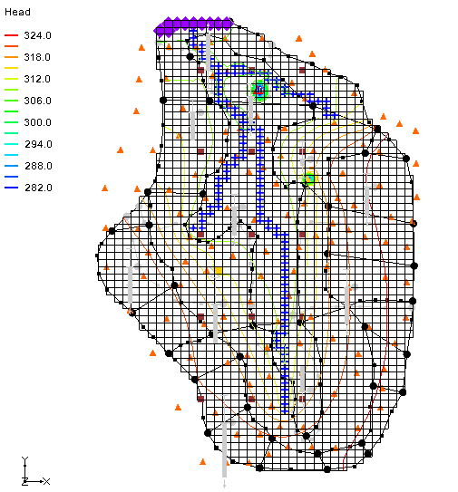

Figure 6 The final solution for mfpest\_pilot\_2zones (MODFLOW)

View the new HK field if desired by importing the optimal values and examining the contours as was done previously. It is possible to view the final hydraulic conductivity field calculated by PEST by selecting the “File:Dataset Cells Active.svg HK” item in the Project Explorer below the   
“File:MODFLOW Package Icon.svg LPF” package under the “File:MODFLOW Folder.svg MODFLOW” item. Note that the file default is configured for *Display key values* instead of *Display final array values*, which can be changed in the *Display Options* dialog.

# A Note on Highly Parameterized Models

The model that was just created has over 100 parameters. This is a fairly simple MODFLOW model that converges rather quickly; most real-world problems take longer to run. In such cases, it may not be practical to run MODFLOW over 100 times for each PEST iteration. However, using SVD-Assist with PEST can dramatically reduce the number of model runs required for each PEST iteration. When combining SVD-Assist with Parallel PEST, it becomes practical to use PEST with models containing hundreds or even thousands of parameters.

# Conclusion

This concludes the “MODFLOW – Advanced PEST” tutorial. The following key concepts were discussed and demonstrated in this tutorial:

* GMS supports the SVD option for PEST.
* It is possible to use Parallel PEST from GMS.
* It is possible to run SVD-Assist from GMS by simply turning on the option. When using pilot points and the **Import Optimal Values…** button is clicked, a new dataset is created for the 2D scatter points.
* It is possible to view the final hydraulic conductivity field calculated by PEST by selecting the “HK” item in the Project Explorer below the “LPF” package.
* It is possible to use pilot points with HK and RCH parameters and assign pilot points to different parameter zones.

1. *PEST: Model-Independent Parameter Estimation User Manual Part I: PEST, SENSAN, and Global Optimisers* (2017). Watermark Numerical Computing, pp.199-219. <http://www.pesthomepage.org/getfiles.php?file=newpestman1.pdf> [↑](#footnote-ref-1)