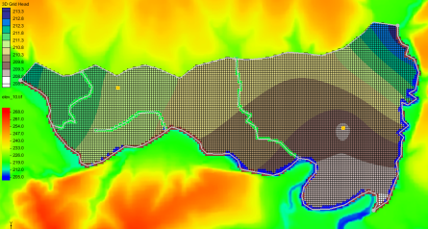

GMS 10.9

GMS 10.9 Tutorial

***MODFLOW – Conceptual Model Approach 3***

Build a multi-layer MODFLOW model using advanced conceptual model techniques

Objectives

The conceptual model approach involves using the GIS tools in the Map module to develop a conceptual model of the site being modeled. The location of sources/sinks, layer parameters such as hydraulic conductivity, model boundaries, and all other data necessary for the simulation can be defined at the conceptual model level without a grid.

Time

* 35–50 minutes

Required Components

* GMS Core
* Geostatistics
* MODFLOW Interface

Prerequisite Tutorials

* MODFLOW – Conceptual Model Approach 1 and 2
* MODFLOW – Interpolating Layer Data

|  |
| --- |
| 1 Introduction 2  1.1 Getting Started 3  2 Importing the Project 4  3 Saving the Project 4  4 Creating the Grid 4  5 Initializing the MODFLOW Data 5  6 Defining the Active/Inactive Zones 5  7 Redefining the Hydraulic Conductivity 6  7.1 Creating the Layer 2 Coverage 7  8 Interpolating Layer Elevations 7  8.1 Interpolating the Surface Elevations 7  8.2 Interpolating the Layer Elevations 8  8.3 Interpolating the Layer Elevations 8  8.4 Interpolating the Layer Elevations 8  9 Converting the Conceptual Model 9  10 Checking and Saving the Simulation 10  11 Running MODFLOW 10  12 Viewing the Water Table in Side View 11  13 Fixing the Well 11  14 Conclusion 13 |

# Introduction

This tutorial builds on the “MODFLOW – Conceptual Model Approach 1” and “MODFLOW – Conceptual Model Approach 2” tutorials. In those tutorials, a one-layer model using the conceptual model approach was built. The top and bottom elevations were all the same, meaning the model was completely flat.

This tutorial takes that model and makes it more complex and realistic. It is modified to have two layers and varying top and bottom elevations that match the terrain and geology. One of the wells will be assigned to layer 2.

The problem solved in this tutorial is a site in East Texas as illustrated in Figure 1. This tutorial evaluates the suitability of a proposed landfill site with respect to potential groundwater contamination. The results of this simulation are used as the flow field for a particle tracking and a transport simulation in the MODPATH and MT3DMS tutorials.

The simulation models the groundwater flow in the valley sediments bounded by the hills to the north and the two converging rivers to the south. A typical north-south cross section through the site is shown in Figure 1b. The site is underlain by limestone bedrock which outcrops to the hills at the north end of the site. There are two primary sediment layers: an upper layer modeled as an unconfined and a lower layer modeled as confined.

The boundary to the north is a no-flow boundary, and the remaining boundary is a specified head boundary corresponding to the average stage of the rivers. The system is primarily recharged through rainfall. Creek beds in the area are usually dry but occasionally flow due to influx from the groundwater. The tutorial model represents these creek beds using drains. Two production wells in the area are included in the model.

Although the site modeled in this tutorial is an actual site, the landfill and the hydrogeologic conditions at the site have been fabricated. The stresses and boundary conditions used in the simulation were selected to provide a simple—yet broad—sampling of the options available for defining a conceptual model.



Figure 1 Site to be modeled in this tutorial: (a) plan view of site and (b) typical north-south cross section through site

This tutorial will discuss and demonstrate:

* Creating a two-layer grid from the conceptual model
* Interpolating scatter points to MODFLOW layer data
* Mapping the conceptual model to MODFLOW
* Adjusting the well depth
* Checking the simulation and running MODFLOW
* Viewing the results

## Getting Started

Do the following to get started:

1. If necessary, launch GMS.
2. If GMS is already running, select *File |* **New** to ensure that the program settings are restored to their default state.

# Importing the Project

The first step is to import the East Texas project. This opens the MODFLOW model, the solution, and all other files associated with the model.

To import the project, do as follows:

1. Click **Open** File:Open Macro.svg to bring up the *Open* dialog.
2. Select “Project Files (*.gpr)” from the *Files of type* drop-down.
3. Browse to the *\modfmap3\modfmap3* directory and select “start.gpr”.
4. Click **Open** to import the project and close the *Open* dialog.

The Graphics Window will appear as in Figure 2.

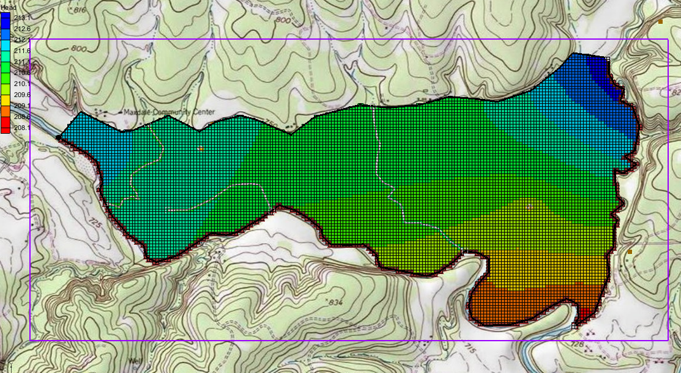

Figure 2 After importing the project

# Saving the Project

Before making any changes, save the project under a new name.

1. Select *File* | **Save As…** to bring up the *Save As* dialog.
2. Select “Project Files (*.gpr)” from the *Save as type* drop-down.
3. Enter “EastTexas3.gpr” as the *File name*.
4. Click **Save** to save the file under the new name and close the *Save As* dialog.

Be sure to periodically **Save** File:Save Macro.svg throughout the tutorial.

# Creating the Grid

Start with creating a new two-layer grid.

1. Select *Feature Objects* | **Map → 3D Grid** to get the first of two warning messages.
2. Click **OK** at the warning dialog to delete the existing grid.
3. Click **OK** to delete the existing MODFLOW simulation and open the *Create Finite Difference Grid* dialog.

Notice that the grid is dimensioned using the data from the grid frame. If a grid frame does not exist, the grid is defaulted to surround the model with approximately 5% overlap on the sides.

1. Under the *X-Dimension* and *Y-Dimension* sections, select *Cell size* and enter “20.0”.
2. In the *Z-Dimension* section, select *Number cells* and enter “2” in the field to the right.
3. Click **OK** to close the *Create Finite Difference Grid* dialog.

The new grid will appear in the Graphics Window (Figure 3).

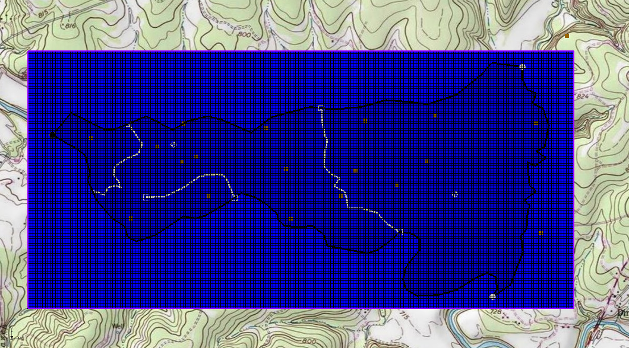

Figure 3 The two layer grid

# Initializing the MODFLOW Data

Now that the grid is constructed, the next step is to convert the conceptual model to a grid-based numerical model. Before doing this, the MODFLOW data must first be initialized:

1. Right-click on the “File:3D Grid Icon.svg grid”in the Project Explorer and select **New MODFLOW…** to bring up the *MODFLOW Global/Basic Package* dialog.
2. Click **OK** to accept the defaults and close the *MODFLOW Global/Basic Package* dialog.

# Defining the Active/Inactive Zones

Now that the grid has been created and MODFLOW has been initialized, the next step is to define the active and inactive zones of the model. This is accomplished automatically using the information in the map coverage. However, the existing map coverages are set up for a one-layer grid. They will need to be modified to apply to both layers of the grid.

1. Select the “File:Coverage Active Icon.svg Rivers” coverage to make it active.
2. Right-click on “File:Coverage Active Icon.svg Rivers” and select **Coverage Setup…** to open the *Coverage Setup* dialog.
3. Under the *Sources/Sinks/BCs* section, turn on *Layer range*.
4. Click **OK** to close the *Coverage Setup* dialog.

Turning on the *Layer range* option overwrites the *Default Layer Range* and allows each feature object in the coverage to be assigned to its own layer range. New objects created on the coverage after this option is active will automatically use the full layer range. Existing objects will need to be modified.

1. Using the **Select Polygons** File:GMS Select Polygon Tool.svg tool, select the polygon.
2. Click the **Properties** File:GMS Properties Macro.svg macro to bring up the *Attribute Table* dialog.
3. Scroll to the far right in the table and confirm that the layer assignment for the *From layer* is “1” and the *To layer* is “2”.
4. Click **OK** to close the *Attribute Table* dialog.

Other coverages and feature objects do not need to be adjusted at this time.

1. Click anywhere outside the polygon to unselect it.
2. Select *Feature Objects |* **Activate Cells in Coverage(s)**.

The Graphics Window should appear similar to Figure 4.

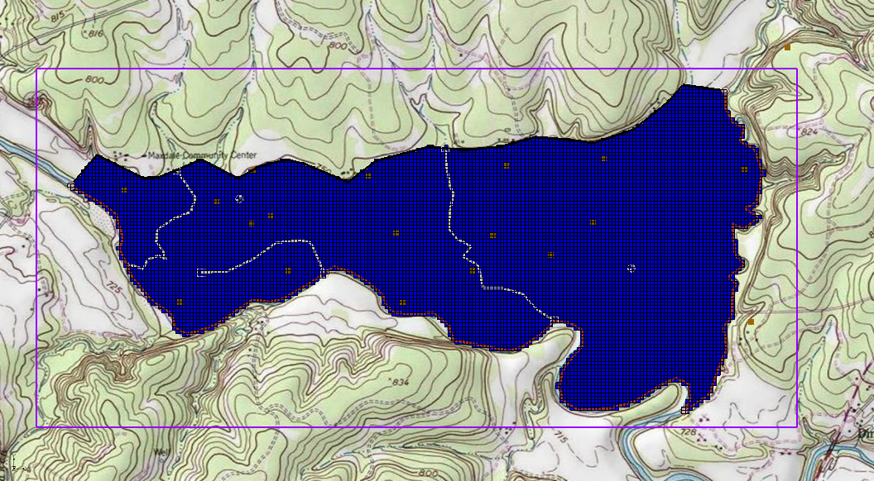

Figure 4 Only the active zones are highlighted

Each of the cells in the interior of any polygon in the local sources/sinks coverage is designated as active and each cell which is outside of all of the polygons is designated as inactive. Notice that the cells on the boundary are activated such that the no-flow boundary at the top of the model approximately coincides with the outer cell edges of the cells on the perimeter while the specified head boundaries approximately coincide with the cell centers of the perimeter cells.

# Redefining the Hydraulic Conductivity

The “MODFLOW – Conceptual Model Approach 2” tutorial simulated a one-layer model. This tutorial simulates a two-layer model, making it necessary to define the hydraulic conductivity for the second layer. Similar to the previous tutorial, the second layer uses constant values.

## Creating the Layer 2 Coverage

To facilitate the two-layer model simulation, create the “Aquifer Layer 2” coverage by copying the “Aquifer Layer 1” coverage.

1. Right-click on “File:Coverage Active Icon.svg Aquifer Layer 1”and select **Duplicate…** to create a new   
   “File:Coverage Active Icon.svg Copy of Aquifer Layer 1” coverage.
2. Right-click on “File:Coverage Active Icon.svg Copy of Aquifer Layer 1” and select **Coverage Setup…** to bring up the *Coverage Setup* dialog.
3. Enter “Aquifer Layer 2” as the *Coverage name*.
4. Below the three columns, set the *Default layer range* to go from “2” to “2”.
5. Click **OK** to close the *Coverage Setup* dialog.
6. Right-click on “File:Coverage Active Icon.svg Aquifer Layer 2” and select **Attribute Table…** to bring up the *Attribute Table* dialog.
7. Select “Polygons” from the *Feature type* drop-down.
8. In the spreadsheet, enter “10.0” in the *Horizontal K (m/d)* column.
9. Click **OK** to close the *Attribute Table* dialog.

# Interpolating Layer Elevations

Now it is necessary to define the layer elevations. Since this tutorial uses the LPF package, top and bottom elevations are defined for each layer regardless of the layer type. For a two-layer model, it is necessary to define a layer elevation array for the top of layer 1 (the ground surface), the bottom of layer 1, and the bottom of layer 2. It is assumed that the top of layer 2 is equal to the bottom of layer 1.

One way to define layer elevations is to import a set of scatter points defining the elevations and interpolate the elevations directly to the layer arrays. This can be done with scatter points as well as the rasters. In this case, use a raster for the top of the grid and scatter points for the elevations of the bottom of layer 1 and the bottom of layer 2.

Layer interpolation is covered in depth in the “MODFLOW – Interpolating Layer Data” tutorial.

## Interpolating the Surface Elevations

To interpolate the ground surface elevations to the MODFLOW grid, do the following:

1. In the Project Explorer, expand the “File:GIS Folder.svg GIS Layers” folder.
2. Right-click on the “File:GIS Raster Icon.svg elev_10.tif” raster and select *Interpolate To |* **MODFLOW Layers…** to bring up the *Interpolate to MODFLOW Layers* dialog.

This dialog tells GMS which datasets to interpolate to which MODFLOW arrays. The dialog is explained fully in the “MODFLOW – Interpolating Layer Data” tutorial.

1. Select “elev_10.tif” in the *Rasters* section and “Top Elevations Layer 1” in the MODFLOW data section.
2. Click **Map** to add them to the *Dataset → MODFLOW data* section.
3. Click **OK** to perform the interpolations and close the *Interpolate to MODFLOW Layers* dialog.

## Interpolating the Layer Elevations

To interpolate the layer elevations for the bottom of layers 1 and 2, do the following:

1. In the Project Explorer, expand the “File:2D Scatter Folder.svg 2D Scatter Data” folder.
2. Right-click on the “File:2D Scatter Icon.svg elevs” scatter set and select *Interpolate To |* **MODFLOW Layers…** to bring up the *Interpolate to MODFLOW Layers* dialog.

Notice that GMS automatically mapped the *Bottom Elevations Layer 1* and *Bottom Elevations Layer 2* arrays to the appropriate datasets based on the dataset name. No additional mappings need to be performed here.

1. Click **OK** to perform the interpolations and close the *Interpolate to MODFLOW Layers* dialog.

Now that the interpolation is finished, hide the scatter point sets, GIS layers, and the grid frame.

1. Turn off the “File:Grid Frame Icon.svg Grid Frame”, the “File:GIS Folder.svg GIS Layers” folder, and the “File:2D Scatter Folder.svg 2D Scatter Data” folder.

## Interpolating the Layer Elevations

To check the interpolation, view a cross section.

1. Select the “File:3D Grid Folder.svg 3D Grid Data” folder in the Project Explorer.
2. Using the **Select Cell** File:Select 3D Cell Tool.svg tool, select a cell somewhere near the center of the model.
3. Switch to **Side View**File:Side View Macro.svg.
4. Use the arrows in the *Mini-grid Toolbar* to view different columns in the grid.

Note that on the right side of the cross section, the bottom layer pinches out and the bottom elevations are greater than the top elevations (Figure 5). This must be fixed before running the model.

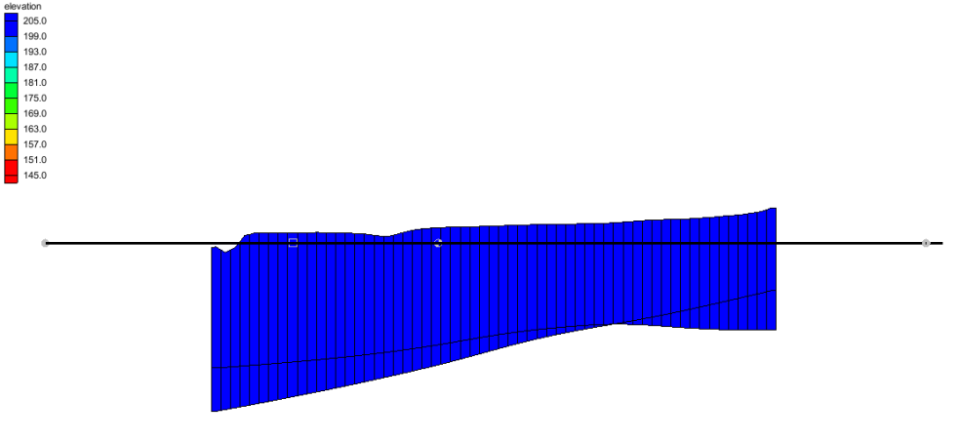

Figure 5 Cross section before elevations are corrected

## Interpolating the Layer Elevations

GMS provides a convenient set of tools for fixing layer array problems. These tools are located in the *Model Checker* and are explained fully in the “MODFLOW – Interpolating Layer Data” tutorial.

1. Select *MODFLOW |* **Check Simulation…** to bring up the *Model Checker* dialog.
2. Click **Run Check** to check the model for errors.

Notice that many errors were found for layer 2. There are several ways to fix these errors. This tutorial will use the *Truncate to bedrock* option. This option makes all cells below the bottom layer inactive.

1. Click **Fix Layer Errors…** to bring up the *Fix Layer Errors* dialog.
2. In the *Correction method* section, select *Truncate to bedrock* and click **Fix Affected Layers**.
3. Click **OK** to exit the *Fix Layer Errors* dialog.
4. Click **Run Check** to check the model for errors.

Notice that all the errors have been fixed. The various warnings are acceptable for the purposes of this tutorial and can be ignored.

1. Click **Done** to exit the *Model Checker* dialog.

Another way to view the layer corrections is in plan view.

1. Switch to **Plan View** File:Plan View Macro.svg.
2. In the *Mini-grid* *Toolbar* , click the up arrow up to view the second layer.

Notice that the cells at the northern edge of the model in layer 2 are inactive (Figure 6).

1. Switch back to the top layer by clicking the down arrow down.

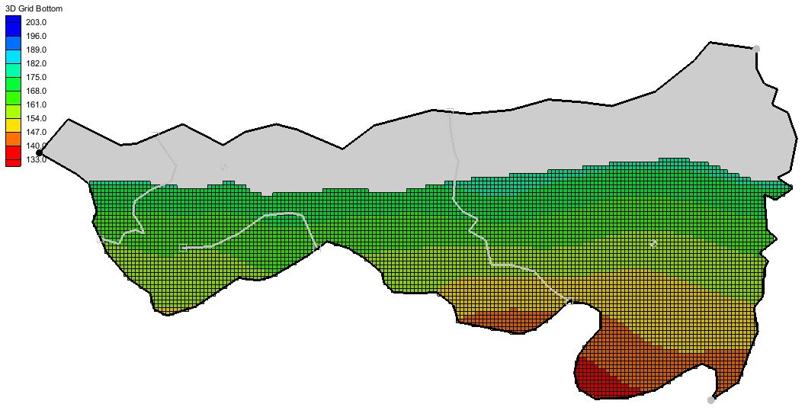

Figure 6 Inactive cells in layer 2

# Converting the Conceptual Model

It is now possible to convert the conceptual model from the feature object-based definition to a grid-based MODFLOW numerical model.

1. Right-click on the “File:Conceptual Model Icon.svg East Texas” conceptual model and select *Map To |* **MODFLOW/MODPATH** to bring up the *Map → Model* dialog.
2. Select *All applicable coverages* and click **OK** to close the *Map → Model* dialog.

Notice that the cells underlying the drains, wells, and specified head boundaries were all identified and assigned the appropriate sources/sinks (Figure 7). The heads and elevations of the cells were determined by linearly interpolating along the specified head and drain arcs. The conductances of the drain cells were determined by computing the length of the drain arc overlapped by each cell and multiplying that length by the conductance value assigned to the arc. In addition, the recharge and hydraulic conductivity values were assigned to the appropriate cells.

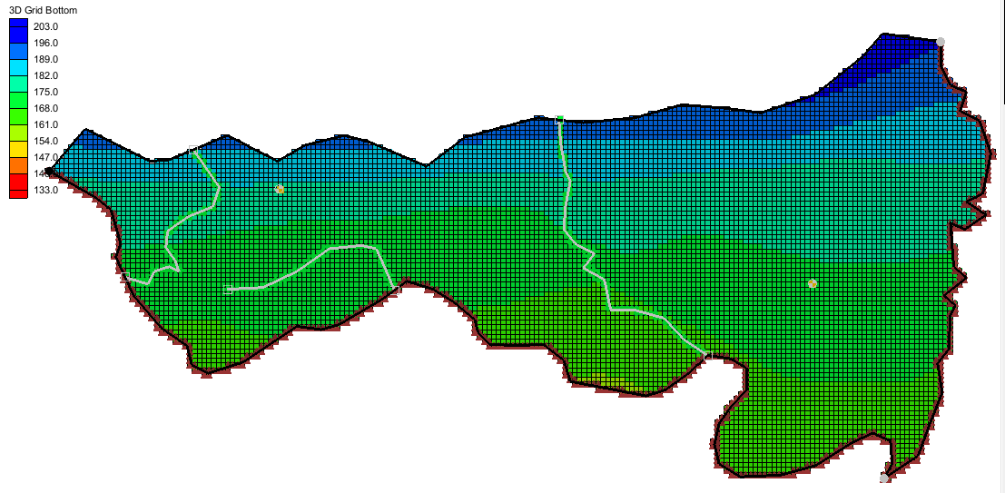

Figure 7 The model after conversion

# Checking and Saving the Simulation

At this point, the MODFLOW data has been completely defined, and it is possible to run the simulation. First, run the *Model Checker* again to see if GMS can identify any mistakes that may have been made.

1. Select the “File:3D Grid Folder.svg 3D Grid Data” folder in the Project Explorer to switch to the 3D Grid module.
2. Select *MODFLOW* | **Check Simulation…** to bring up the *Model Checker* dialog.
3. Click **Run Check**. There should be no errors. Any warnings listed are acceptable for the purposes of this tutorial and can be ignored.
4. Click **Done** to exit the *Model Checker* dialog.
5. **Save** File:Save Macro.svg the project.

Saving the project not only saves the MODFLOW files but it saves all data associated with the project including the feature objects and scatter points.

# Running MODFLOW

It is now possible to run MODFLOW.

1. Select *MODFLOW |* **Run MODFLOW** to bring up the *MODFLOW* model wrapper dialog. The process should be completed quickly.
2. When the solution is completed, turn on *Read solution on exit* and *Turn on contours (if not on already)* and click **Close** to exit the *MODFLOW* model wrapper dialog.

The Graphics Window should appear similar to Figure 8. To view the contours for the second layer, do as follows:

1. Click the up arrow up in the *Mini-grid* *Toolbar*.
2. After viewing the contours, return to the top layer by clicking the down arrow.

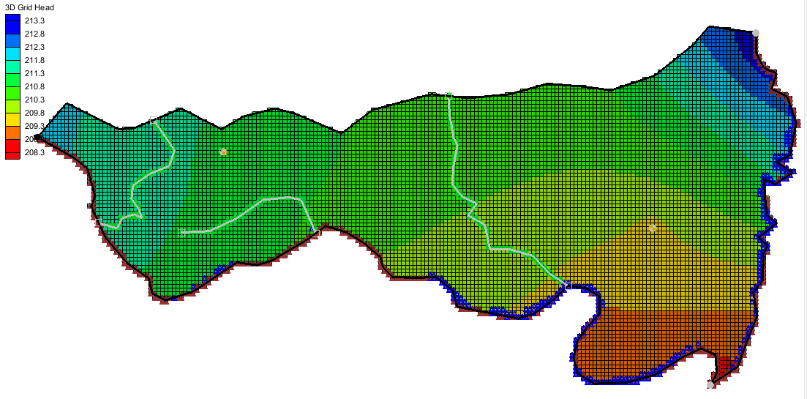

Figure 8 Contours of layer 1 after the model run

Notice the flooded cells (indicated by the small blue symbols) along parts of the river boundaries. These areas are flooded at generally less than one foot and show how the water table is very near the surface in those areas.

# Viewing the Water Table in Side View

An interesting way to view a solution is in side view.

1. Using the **Select Cell** File:Select 3D Cell Tool.svg tool, select a cell somewhere near the well on the right side of the model.
2. Switch to **Side View** File:Side View Macro.svg.

Notice that the computed head values are used to plot a water table profile.

1. Use the arrow buttons arrow in the *Mini-grid Toolbar* to move back and forth through the grid.

Notice the well does not extend into the second layer as shown in Figure 9. This will need to be fixed.

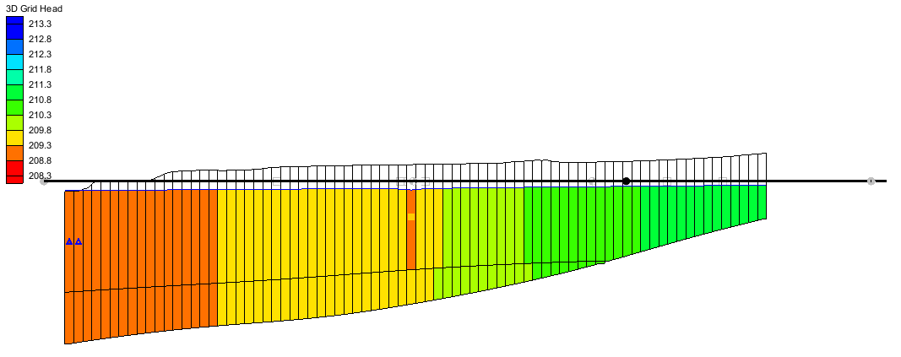

Figure 9 Side view of the model

# Fixing the Well

The well on the right side currently only extends to the bottom of the first layer. To fix this, do the following:

1. Switch to **Plan View** File:Plan View Macro.svg.
2. Select “https://www.xmswiki.com/images/thumb/7/71/Coverage_Active_Icon.svg/56px-Coverage_Active_Icon.svg.png Wells” to make it active.
3. Right-click on “https://www.xmswiki.com/images/thumb/7/71/Coverage_Active_Icon.svg/56px-Coverage_Active_Icon.svg.png Wells” and select **Coverage Setup…** to open the *Coverage Setup* dialog.
4. Turn on *Layer range* under the *Sources/Sinks/BCs* section.
5. Click **OK** to close the *Coverage Setup* dialog.
6. Using the **Select Points/Nodes** https://www.xmswiki.com/images/thumb/a/a3/GMS_Select_Node_Tool.svg/56px-GMS_Select_Node_Tool.svg.png tool, double-click on the well on the right side to bring up the *Attribute Table* dialog.
7. Scroll to the far right in the table and confirm that the layer assignment for the *From layer* is “1” and the *To layer* is “2”.
8. Click **OK** to close the *Attribute Table* dialog.

Modifying the number of layers included in a well does not change the well flow to be partitioned. Well flow is not split between layers but written to each layer individually.

Next, add the changes to the simulation.

1. Right-click on the “File:Conceptual Model Icon.svg East Texas” conceptual model and select *Map To |* **MODFLOW/MODPATH** to bring up the *Map → Model* dialog.
2. Select *All applicable coverages* and click **OK** to close the *Map → Model* dialog.

With the changes to the well applied to the simulation, run MODFLOW again.

1. Click **Save** File:Save Macro.svg.
2. Select *MODFLOW |* **Run MODFLOW** to bring up the *MODFLOW* model wrapper dialog. The process should be completed quickly.
3. When the solution is completed, turn on *Read solution on exit* and *Turn on contours (if not on already)* and click **Close** to exit the *MODFLOW* model wrapper dialog.

The results of these changes can be reviewed by doing the following:

1. Select the “File:3D Grid Folder.svg 3D Grid Data” folder in the Project Explorer.
2. Using the **Select Cell** File:Select 3D Cell Tool.svg tool, select a cell somewhere near the well on the right side of the model.
3. Switch to **Side View** File:Side View Macro.svg.

The well now extends to the second layer creating a cone of depression (Figure 10).

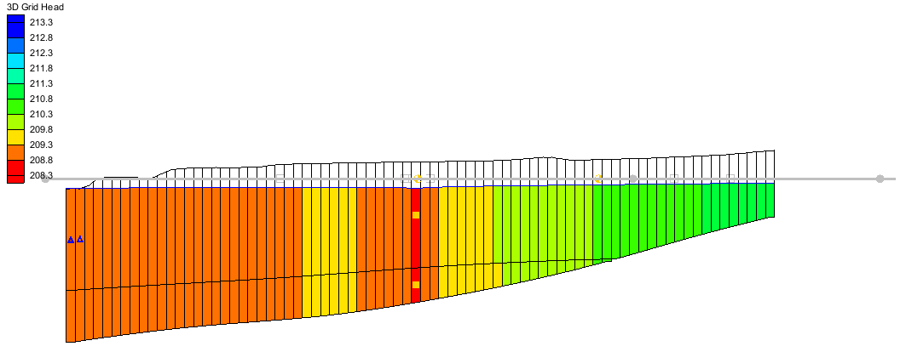

Figure 10 Side view of the model with well depression visible

# Conclusion

This concludes the “MODFLOW – Conceptual Model Approach 3” tutorial. The following topics were discussed and demonstrated:

* Creating a 3D grid with multiple layers.
* Elevations for boundary conditions, such as drains, can be specified using a raster.
* It is possible to specify things like layer elevations and hydraulic conductivities using polygons in the conceptual model, but that will result in stair-step-like changes. For smoother transitions, it is possible to use 2D scatter points and interpolation.